**AES**

1. **Introduction**

This project is a web-based system. There will be a dashboard displaying useful information. The layout of dashboard is *customizable*, *scalable* and *responsive*.

1. **Project Objectives**

A layout can be customized with a scalable, responsive dashboard.

A content management system (CMS) and web services

1. **Project Specifications**

* Use Case Diagram

View data

Edit data

Craete data

Delete data

View all User

Add User

User

Role

Login

User

Admin

* Use Case Description

|  |  |
| --- | --- |
| View data | |
| Name | All data |
| Actor | User, Admin |
| Preconditions | Log in |
| Triggers | Click the “All [name]”button on the top menu |
| Main success scenarios | 1. Click on the name you want to query in the left menu bar. 2. Click "All [name]" in the new menu bar that pops up. |
| Termination outcome | Jump to the corresponding all data interface |

|  |  |
| --- | --- |
| Edit data | |
| Name | Edit data |
| Actor | User, Admin |
| Preconditions | Log in |
| Triggers | Click the “Edit” button after each line of data. |
| Main success scenarios | 1. Click the “Edit” button after each line of data. 2. Edit data in the jumped page. 3. Click the save button below |
| Termination outcome | Update this data from the database Jump to the corresponding all data interface |

|  |  |
| --- | --- |
| Delete data | |
| Name | Delete data |
| Actor | User, Admin |
| Preconditions | Log in |
| Triggers | Click the “Delete” button after each line of data. |
| Main success scenarios | 1. Click the “Delete” button after each line of data. 2. Confirm the information you want to delete 3. Click the Delete button below |
| Termination outcome | Delete this data from the database and Jump to the corresponding all data interface |

|  |  |
| --- | --- |
| Create data | |
| Name | Create data |
| Actor | User, Admin |
| Preconditions | Log in |
| Triggers | Click the "create new" button on all data or click on "Add new data" in the menu bar. |
| Main success scenarios | 1. Click the "create new" button on all data or click on "Add new data" in the menu bar. 2. Fill in the information. 3. Click the create button below. |
| Termination outcome | Create this data from the database and Jump to the corresponding all data interface |

|  |  |
| --- | --- |
| Delete User | |
| Name | Delete User |
| Actor | Admin |
| Preconditions | Log in |
| Triggers | Click the “Delete” button after each line of data. |
| Main success scenarios | 1. Click the “Delete” button after each line of data. 2. Confirm the information you want to delete 3. Click the Delete button below 4. Confirm password |
| Termination outcome | Delete this data from the database and Jump to the corresponding all data interface |

|  |  |
| --- | --- |
| Create User | |
| Name | Create User |
| Actor | Admin |
| Preconditions | Log in |
| Triggers | Click the "create new" button on all data or click on "Add new data" in the menu bar. |
| Main success scenarios | 1. Click the "create new" button on all data or click on "Add new data" in the menu bar. 2. Fill in the information. 3. Click the create button below. 4. Confirm password |
| Termination outcome | Create this data from the database and Jump to the corresponding all data interface |

1. **Project Implementation**

* Technology & Hardware used

.Net core 2.1

.SQL Server 2016

C#

IIS

* Development Environment

Microsoft SQL Server Management Studio 17

Visual Studio 2017

Window 10 64bit

* Supporting Libraries

NuGet:

Bootstrap:

Install-Package bootstrap

Install-Package bootstrap.sass

SixLabors.ImageSharp:

Install-Package SixLabors.ImageSharp -Version 1.0.0-beta0007

EPPlus：

Install-Package EPPlus -Version 4.5.3.2

Plugins:

JCrop : <http://code.ciaoca.com/jquery/jcrop>

Bootstrap-fileinput: <http://plugins.krajee.com/file-input>

bootstrap-suggest-plugin: <https://github.com/lodev09/bootstrap-suggest>

* System Implementation/Architecture

Change data

Return data



SQL Server Database

CMS API

CMS

Return data

Change data

Return data

Send request

View

* Database Design

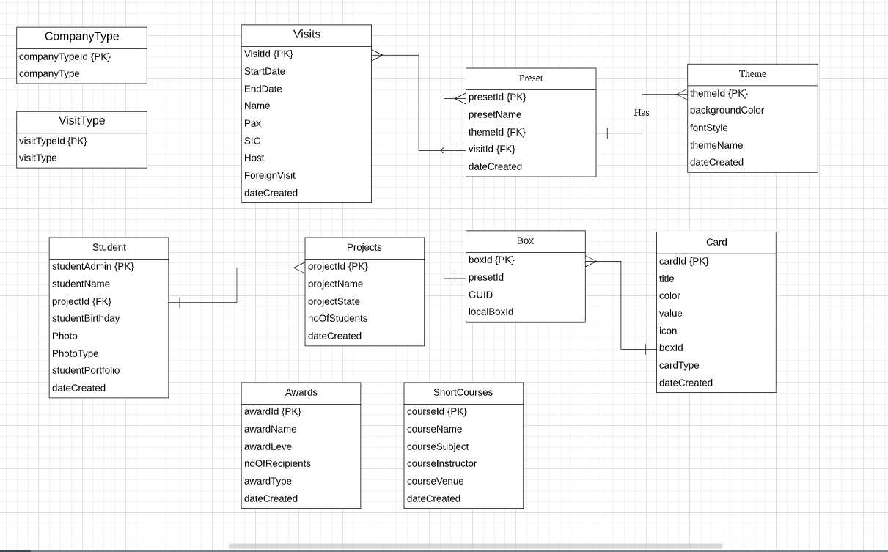

1. **Source and References**

* <https://github.com/yogyogi/ASP.NET-Core-CMS>
* <https://themefisher.com/products/free-bootstrap-admin-dashboard-template/>
* <http://www.lanrentuku.com/tupian/beijingtupian/24jingti-beijingtupian.html>
* <https://www.cnblogs.com/TwinklingZ/p/6924412.html>
* <https://www.cnblogs.com/GuZhenYin/p/8194726.html>

1. **Tacit Knowledge**

* Reusable Components

1. **How It Works**



1. **Reflections**

First of all, I am honoured to be able to come to NYP to do the project. I have learned a lot during these 12 weeks. Most of these things were not taught back in China, so I have learned many new things. For example, .Net core, SQL Server, API, CMS, C#. I have not learned these before. After exploring and learning these new technologies, I managed to completed the project using the technologies I have never used before. Throughout this process, I learned to do research and gather information in several ways to improve and optimize my code. Not only did I learn new things, but also improved my coding skills in the process. I also learned things that I did not know of prior to this project such as CMS, Web Service, the use of a database project workflow, MVC, cropping images, storing images in the database, and importing Excel sheets. All these are not possible to learn from books, but can only be learned by doing real projects and gaining experience from them. This will be a valuable experience in my life. For the first time, I’ve experienced the real feeling of doing projects in a company, and I have met many friends who have broadened my horizons. Another point is that my English has also improved a lot. Even though I only had three months to do this project, I have learned a lot. Finally, I would like to thank the teachers and students of NYP for their care and hospitality. Thank you for giving me the opportunity to do this project as this will be very helpful for my future self-development.