CS 516000 FPGA Architecture & CAD Final Project

1. 獨力完成 111062697 吳律穎

2.

How to compile：

In 111062697_final_project/ directory, enter the following command:

$ make

It will generate the executable file "topart" in "

If you want to remove it, please enter the following command:

$ make clean

How to execute：

In 111062697_final_project/ directory, enter the following command:

Usage: ./[exe] ./input/[input.txt] ./output/[output.txt]

e.g.

./topart ./input/B1.txt ./output/output1.txt

3. 執行結果: Fixed 和 Partition size 都有pass, 且執行時間並未超過10min

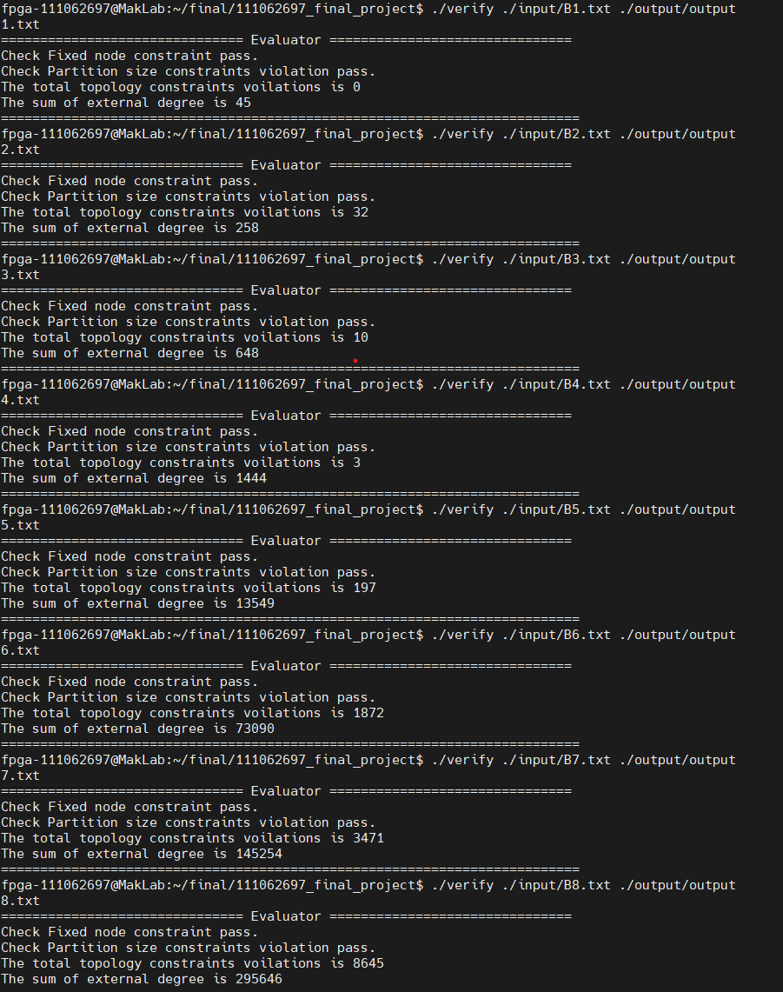

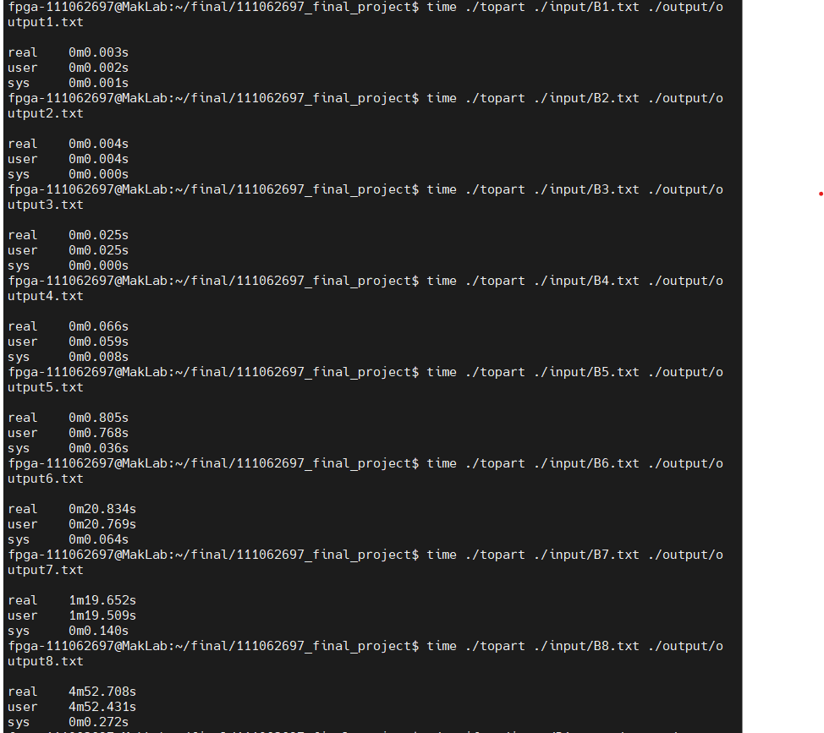

4. Describing the details

演算法的部分依照Reference paper來實作，可是沒有實現B部分的Candidate FPGA-driven Coarsening，其餘部分都有做出來