Homework 5: Automated P&R for Analog Circuits

1. 111062697 吳律穎

2. --HOW to Compile

In src/, enter the following command:

$ make

It will generate the executable file "hw5" in "../bin/".

If you want to remove it, please enter the following command:

$ make clean

--How to run

In src/ directory, enter the following command:

Usage: ../bin/[exe] [number of current sources] [def file path]

e.g.

../bin/hw5 4 ../output/CS_4.def

In "HW5/bin/", enter the following command:

Usage: ./[exe] [number of current sources] [def file path]

e.g.

./hw5 4 ../output/CS_4.def

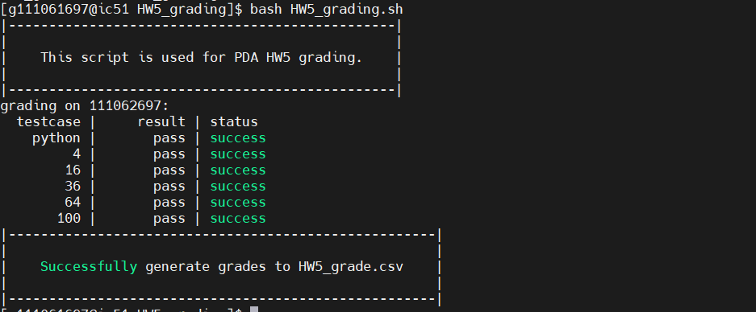

3.

Step1:

每行有n3_num = source^(1/2)個M3, 每列有1/2*M3個M4

每邊有cs_per_slide = (source*4)^(1/2)個CS

建立DIE的範圍, CS_WIDTH + SPCEING + M3/4

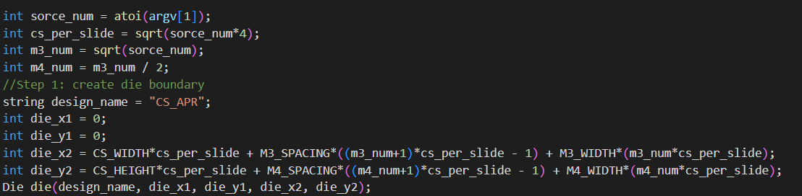

Step2:

建立CS的array, 共((source*4)^(1/2))* ((source*4)^(1/2))個CS

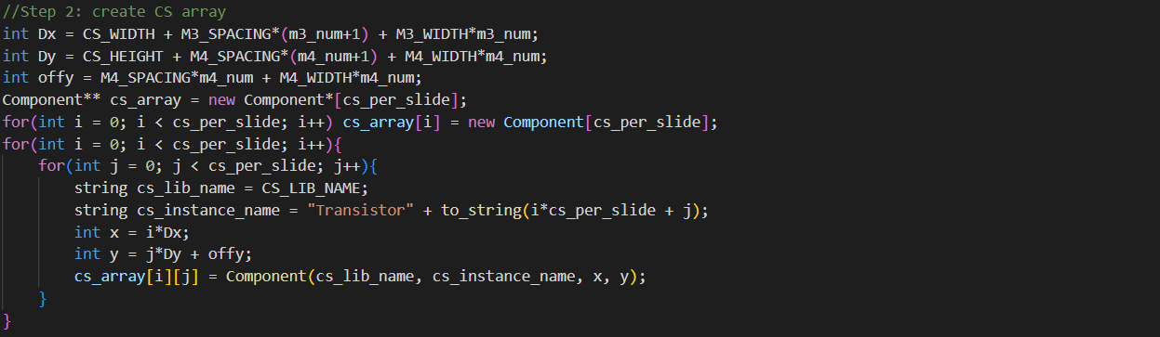

Step3:

建立ME3, 每行n3_num個M3, 共cs_per_slide個行

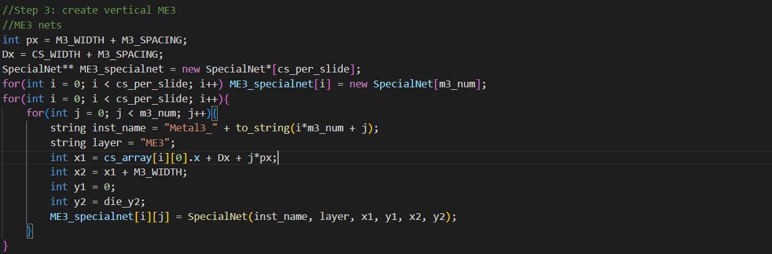

Step4:

建立ME4 drain, 分成左上左下右上右下四個區塊計算其座標, 每塊有CS_per_slide*CS_per_slide個要計算

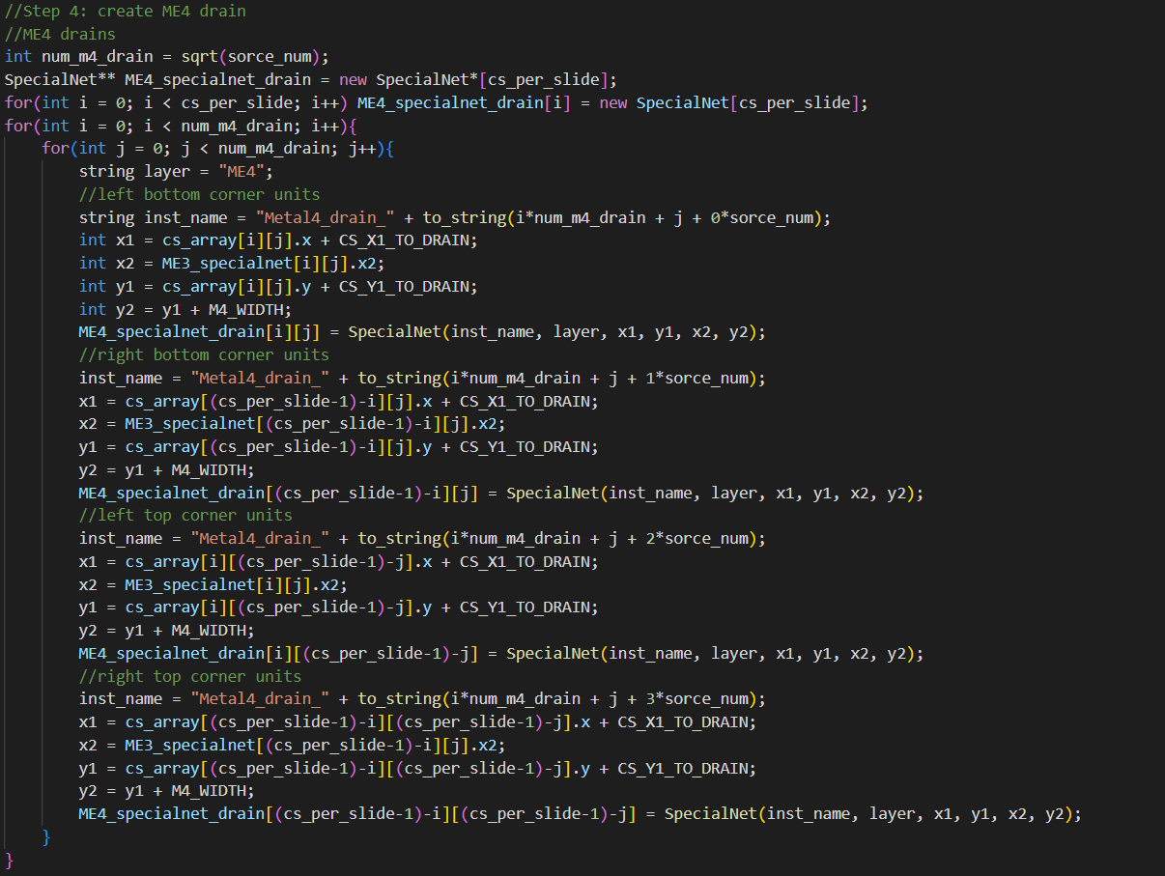

Step5:

建立ME4 port, 每列m4_num個ME4, 共CS_per_slide列

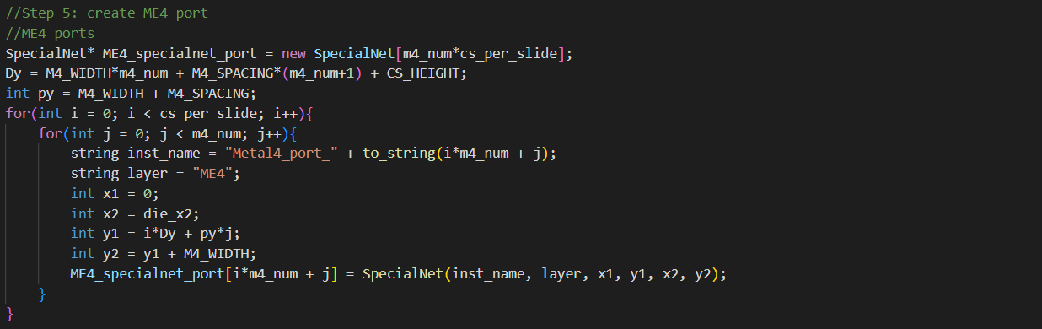

Step6:

建立ME4 drain到ME3的via, 左下由下而上由左而右, 其他跟他mirror

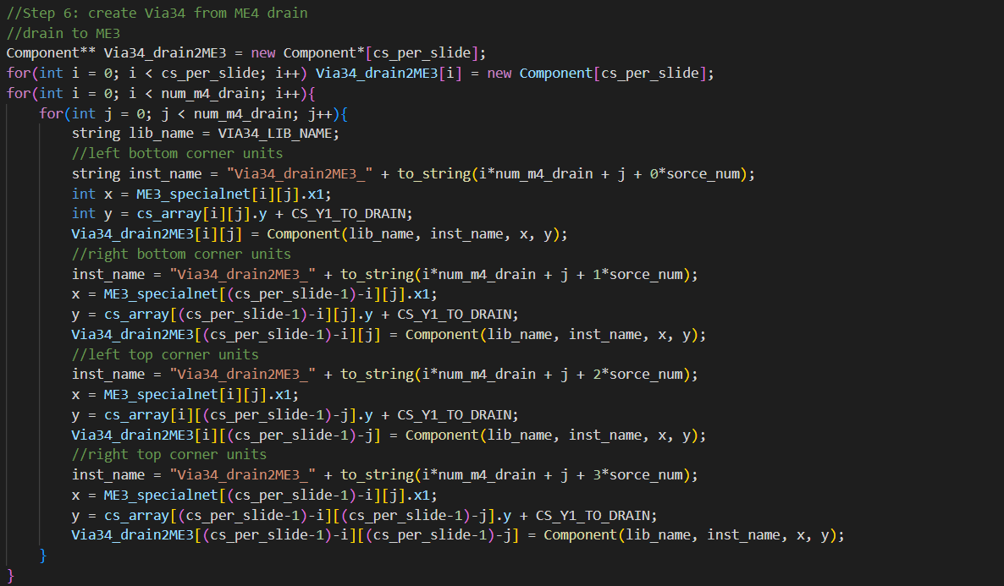

Strp7:

建立ME3到ME4 port的via, 分為左右兩塊，由下而上由外而內去計算

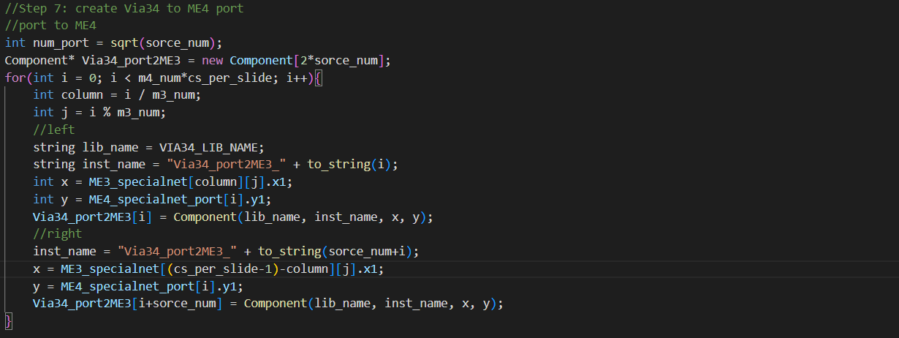

Step8:

寫入DEF檔

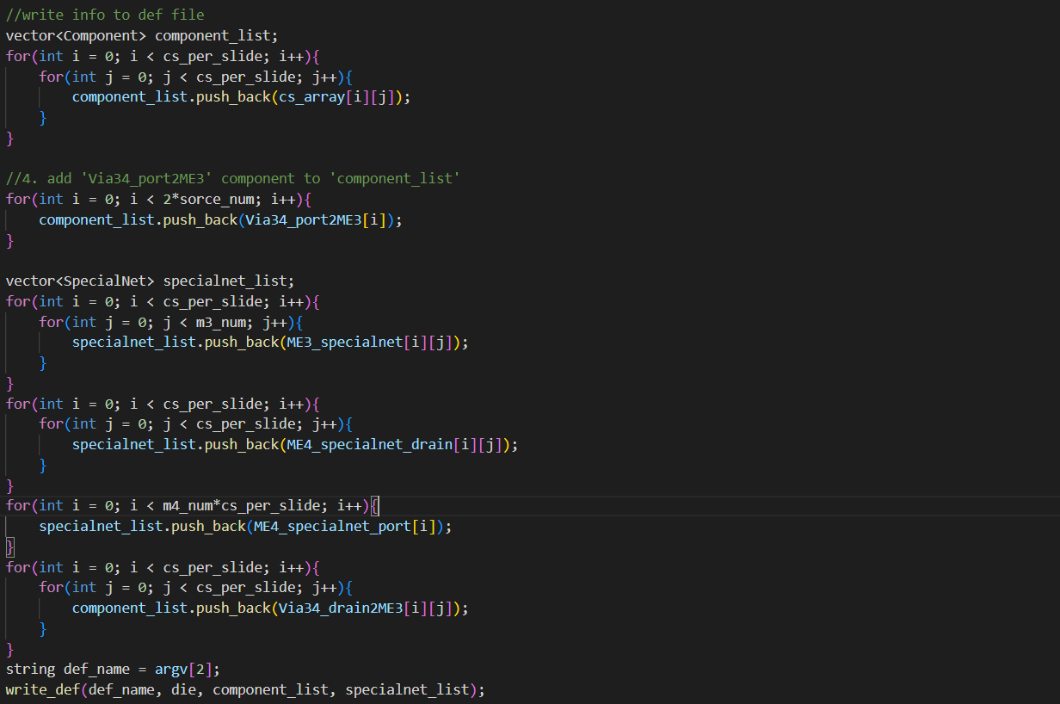

4.

Python:

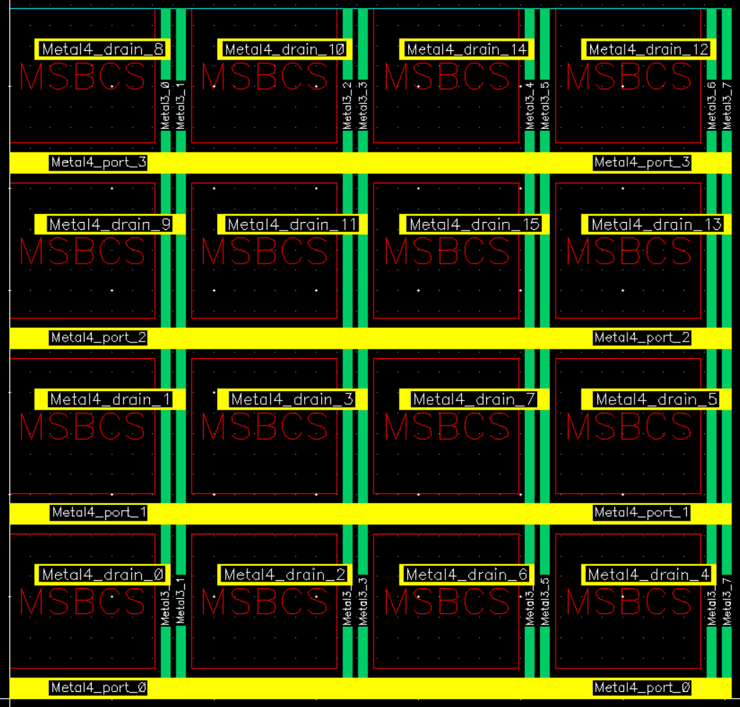

C++ :

4 :

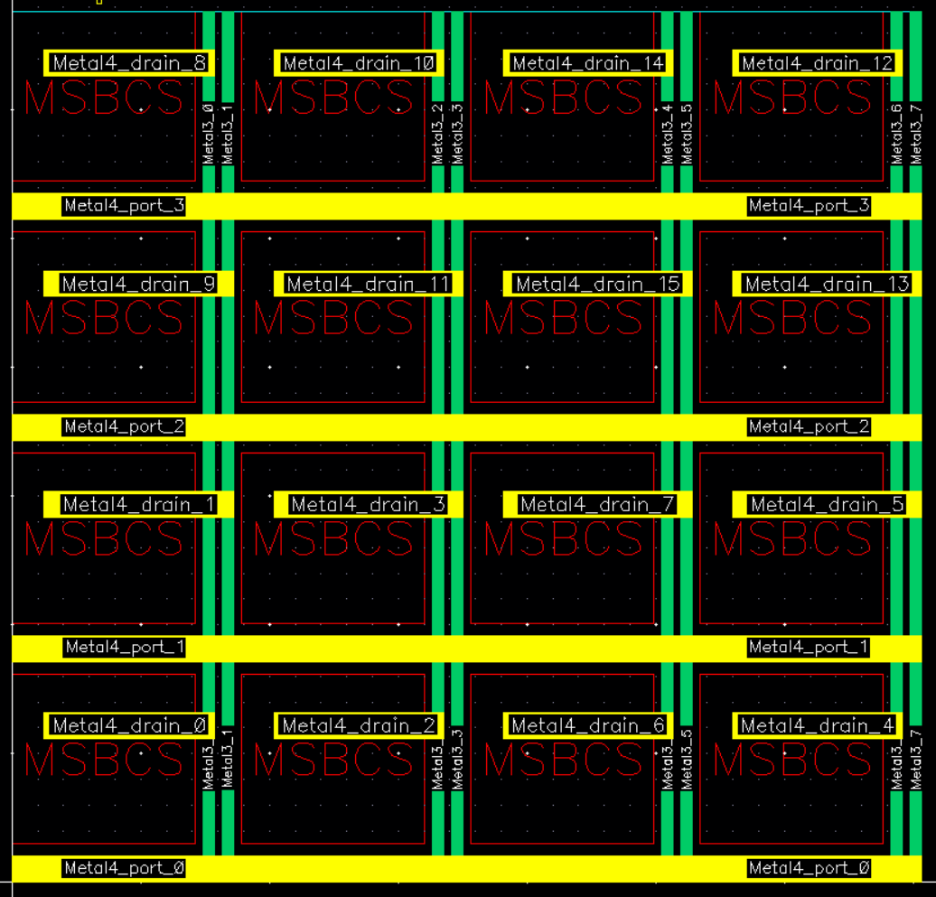

16 :

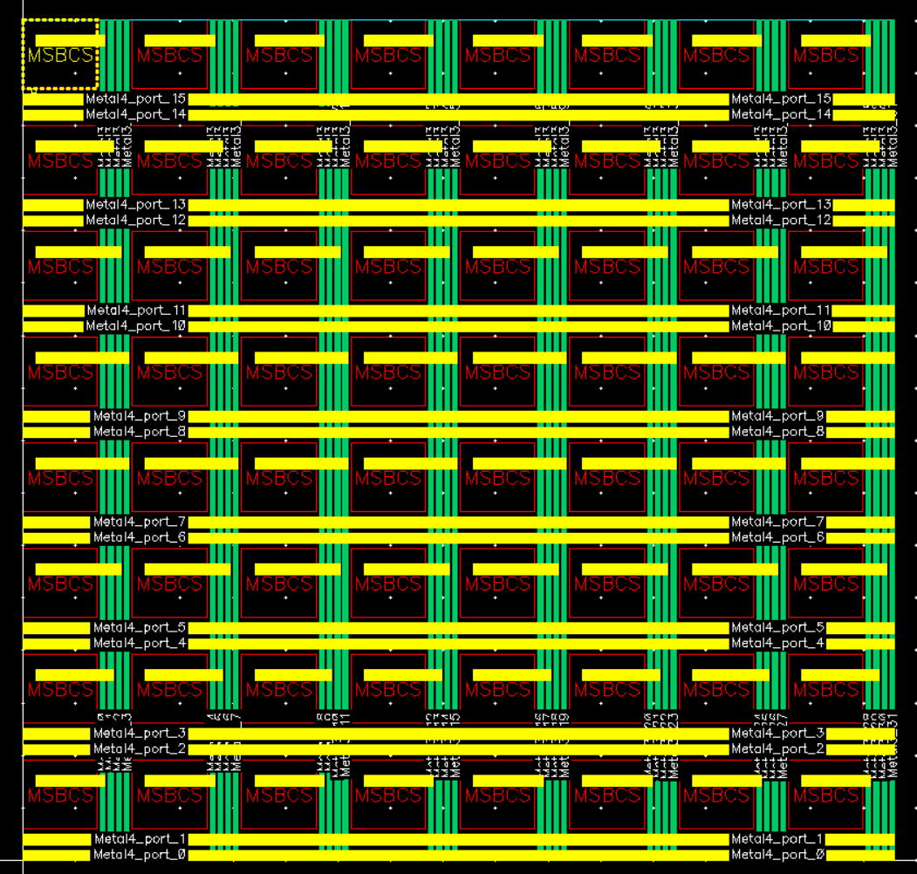

36 :

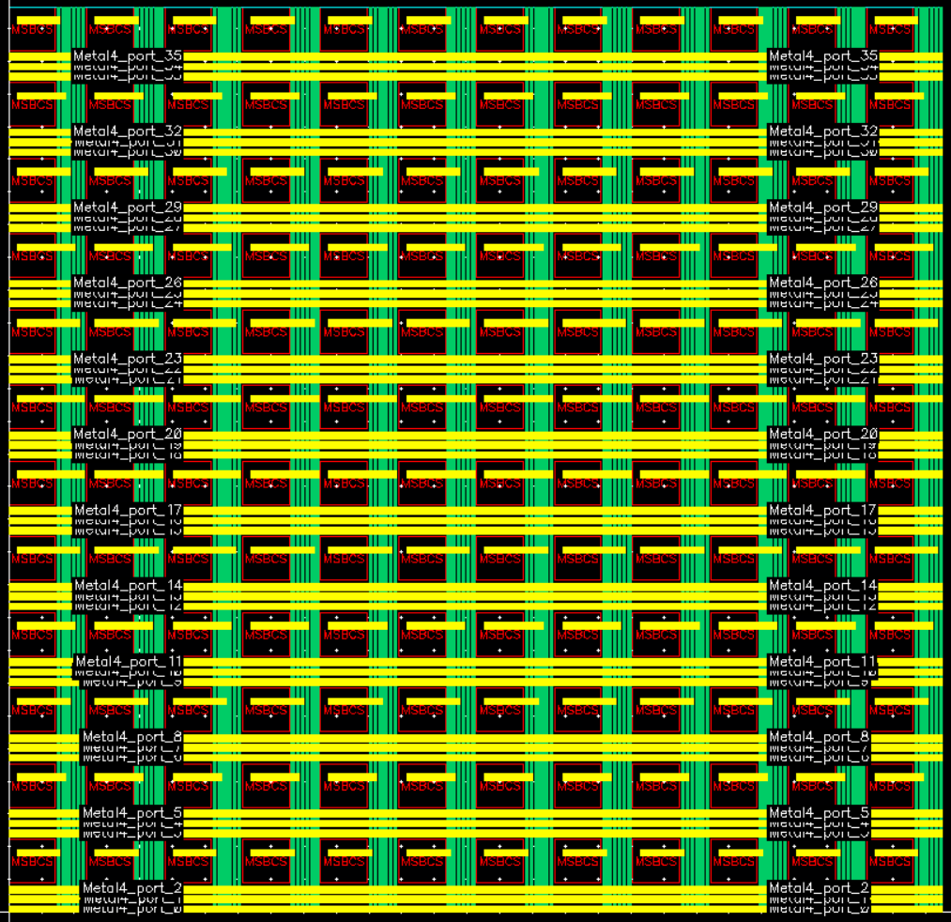

64 :



100 :

