COSC2196

Introduction to Information Technology

**Report Assignment 3**

**Group 4**

**TechHeads**

**Sonam Shahi s3925300**

**George Tsolomitis S3932394**

**Desmond Knowles S3934611**

**Sameh Abdelhamid s9967839**

**Website Location**

[**https://s9967839.github.io/A3New/**](https://s9967839.github.io/A3New/)

**Github Repo**

[**https://github.com/s9967839/s9967839.github.io/tree/main/A3New**](https://github.com/s9967839/s9967839.github.io/tree/main/A3New)

**Presentation**

<https://www.youtube.com/watch?v=RNN4PcC8UDI>

Table of Contents

Team Profile 3

Test Outcomes 6

Project Plan 7

OVERVIEW 7

AIM 7

*Plans & Progress* 8

DESCRIPTION 10

ROLES 11

SCOPE AND LIMITS 12

TOOLS AND TECHNOLOGIES 13

TESTING 14

TIMEFRAME 16

RISKS 17

SKILLS REQUIRED 18

WIREFRAME 19

GROUP PROCESSESS AND COMMUNICATIONS 20

Group Reflections 21

Reference List 23

Team Profile

**Team Profiles:**

**Name:** Sameh Abdelhamid

**Student Number:** S9967839

**Student Email:** [s9967839@student.rmit.edu.au](mailto:s9967839@student.rmit.edu.au)

**Student GitHub Pages**  
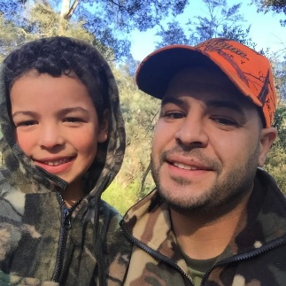

The above picture was taken of me, during a deer hunting trip with my 5 year old son at Lake Eildon. I arrived in Australia when I was 3 years old with my parents, from Egypt. I was born in Cairo and migrated here with them in search for a better life. I've grown up in Australia, and consider myself Australian, even though I wasn't born here, this is the only home that I know. I enjoy camping and hunting as well as 4 wheel driving. I spent a lot of my time in the garage building cars and motorbikes. I'm not qualified but have done this all my life and love it. My 3 boys love camping and working in the garage and I am hoping they grow up to have this kind of lifestyle as I believe it builds good resilience and problem solving skills. I've completed a diploma in visual arts/multimedia and currently work in the IT field and have done so for the last 20 years.

**Name:**Sonam Shahi  
**Sudent Number:**s3925300  
**Student Email:**[s3925300@student.rmit.edu.au](mailto:s3925300@student.rmit.edu.au)  
[**Student GitHub Pages**](https://sierrashahi.github.io/)  
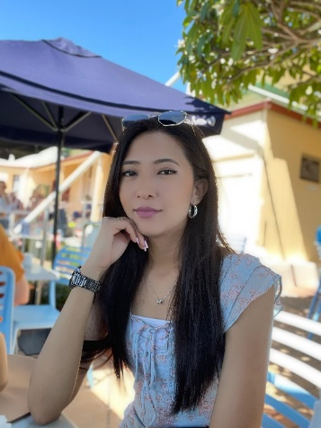  
My name is Sonam Shahi, and I am from the beautiful country of the Himalayas-Nepal. I can speak Nepalese, Hindi, and English. I moved to Australia in 2015 and currently living with my husband in Sydney. I started my own small online business in 2019, which provides traditional attires to the Hindu community living in Australia. Before moving to Australia, I lived in Qatar for two years, working for an airline. I love traveling and exploring new places, learning their culture, trying their food, and learning about their history. I got the opportunity to travel to few countries and meet new people when I lived in Qatar. I have a strong affection towards dogs and miss my 13-year-old dog, who is back home. Besides, I am always thinking of ways to help stray dogs back home, whether through donations to social workers who provide shelter to stray dogs or by spreading awareness through social media. My interest in IT started when I was in high school back home. I had the opportunity to choose computer science as an optional subject and quickly became interested in it. I am amazed how IT has helped transform the lives of so many people, including myself, especially during pandemic. From getting in touch with my family back home to running my online business, IT has played a massive part in transforming my life, and I am looking forward to a great career.

**Name:**Desmond Knowles  
**Sudent Number:**S3934611  
**Student Email:**[S3934611@student.rmit.edu.au](mailto:S3934611@student.rmit.edu.au)  
[**Student GitHub Repo**](https://github.com/Dazerath/Assessment-1)  
  
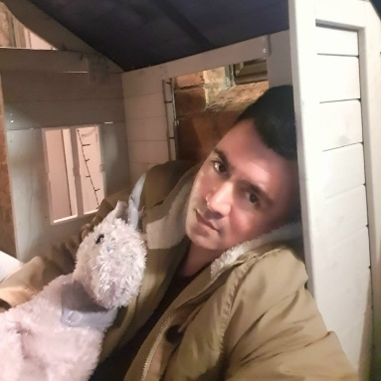  
My name is Desmond Knowles, I’m 34 and from New South Wales. I was born in Auckland, New Zealand and moved to Australia when I was 3 years old. I am part Cookislander, Niuean and Caucasian. Most people aren't familiar with Niue so I'll explain that Niue is a small Island nation in the Pacific just west of the Cook Islands. I enjoy playing video games, watching sci-fi and anime, karaoke and playing guitar.

**Name:**George Tsolomitis  
**Sudent Number:**S3932394  
**Student Email:**[s3932394@student.rmit.edu.au](mailto:s3932394@student.rmit.edu.au)  
[**Student GitHub Repo**](https://github.com/GeorgeTsolomitis3932394/Assignment1)  
  
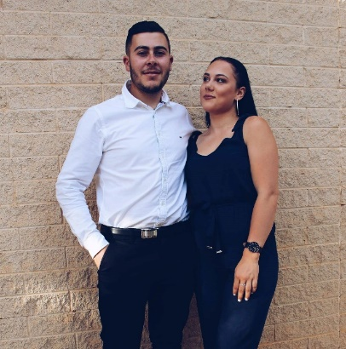  
My name is George Tsolomitis, I am 25 years old, and I am from South Australia. I come from a Greek background as my grandparents and my dad are from Greece who travelled to Australia a number of years ago. I have previously completed my year 12 studies and was going to continue on to complete a degree in Graphic Design, however after taking a year off, I decided I had a change of heart. I am currently working in a Financial Planning firm and have been studying to become a Financial Planner, then to go on and complete my Accounting degree. My ultimate long-life goal is to study more into IT as I am interested in technology and artificial intelligence. I do speak the Greek language and have been to Greece a number of times however Covid and restrictions have stopped me from going again. Going to Greece is a big experience for me as I love seeing where my dad grew up and where my ancestors come from. In my free time, when I am not working or studying, I am building cars in my shed which is one of my hobbies and has been since I was a young kid. I love to restore objects, whether that is cars, computers, and electrical appliances. I remember as a kid, I had a battery, some wires, a motor from a remote-control car, and come fins from a remote-control helicopter. I put them all together and made a small fan, which is an easy task but I felt so accomplished. I also use my down time for gaming with friends and spending time with my partner.

Test Outcomes

Test outcomes for each team member in three different tests and how this information may be helpful when working in a team.  
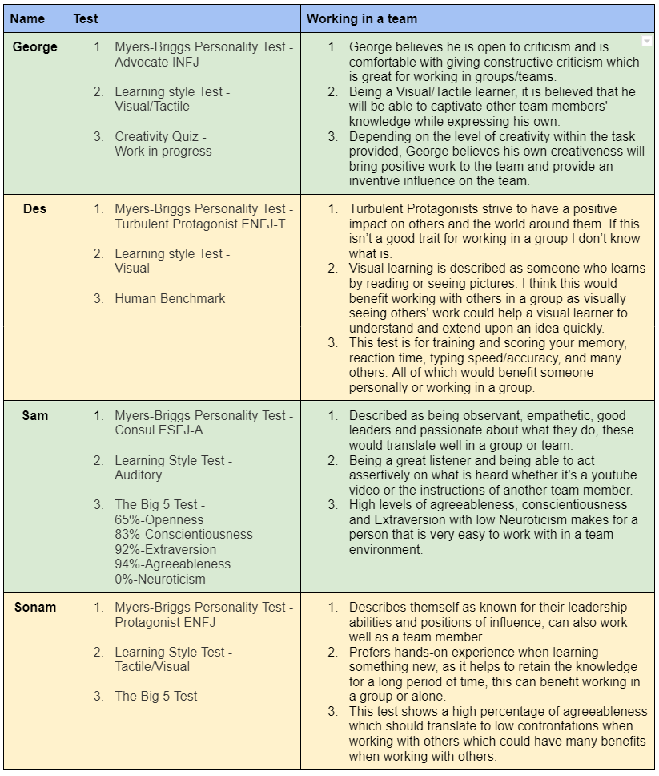

Project Plan

# OVERVIEW

The concept of the application that I have come up with is a system which integrates with pay pass on a user’s mobile phone, and upon buying an item, the user is prompted if they would like to round up the transaction to the next dollar and donate the funds to a number of organisations that have opted in. The user will select the charity when setting up their account, and if they purchase a coffee for $3.80, they will get a quick prompt to donate 0.20c to the charity. They can click yes or no. Upon clicking yes, the funds will be sent to the organisation. The non-profit orgs will be based on helping the deforestation issue that we face in today’s global crisis. They will range from teams that re-plant, to companies that are assisting with the Amazon deforestation and palm oil issues.

# AIM

The aim of this project idea is to create a mobile application that will be integrated into the user’s digital wallet (Apple Pay or Google Pay), and once activated, the user will be prompted to make “Chump Change Donations” to an organisation of their choosing by rounding up their purchase to the nearest dollar or a specific amount selected by the user. Our end goals with this mobile application is to help prevent deforestation and raise money to help various teams re-plant the many hectares that have been lost over the years. It is also being designed to assist companies with the deforestation of the Amazon, along with the palm oil issues that we are currently experiencing.  
From 2015 through to 2020, the deforestation rate was estimated at approximately 10 million hectares per year (“The State of the World’s Forests 2020” 2020). The aim here is to show user’s that we can save our forests if we all helped out just a little bit at a time, as this project is one that will grow over a period of time. Our goal for this is to be able to help those organisations that are re-planting the forests and create more funds for them to continue to work towards their goals.  
The unsustainable palm oil production has had the largest impact to tropical forests and the devastation. This has led to an extensive amount of loss within the habitat for endangered species which can lead to major soil erosion (“WWF - Palm oil” 2018).  
Our aim is to try and save the forests around the world with our project idea, and to raise enough money for organisations that are working hard to accomplish their goals. If we become successful and we save the endangered species and their habitat, then we will not only be achieving our larger, main goal, but also our minor goals.

# Plans & Progress

The story of this project began in 2010, when our founder Mr Sam Abdelhamid, traveled to the amazon on a backpacking adventure. Upon this journey, he was planning on touring the world and seeing the sights, but to his shock, when he visited the amazon, he could not believe his eyes. There were millions and millions of acres of amazon burnt away. Some were re forested into palm, for palm oil, cocoa, coffee, all sorts of things. He was upset and wanted to find more. It was here that his passion for saving trees was born. Upon speaking to the locals he found that there was a balance that needed to be respected between the forest, the world, and the livelihood of the people that live here. They too need to earn a living from the forest and they are unable to function or feed their families without using the forest to their advantage. Sure, the rest of the world needed to use the forest, but they weren’t in the current predicament that they were. Where they needed to generate money to feed their starving families.

Between 2015 and 2020, the rate of deforestation was estimated at 10 million hectares (fao, n.d.). This is an alarming rate of deforestation and one that needs to be solved for future generations. Many studies have also linked global warming to the deforestation, as well as numerous other global impacts. The only way to deal with this is to have a long-term mitigation plan in place. Pay pass uptake has grown significantly and recent research has shown that cardholders use pay pass card more often (at a rate 52% more than not having a pay pass) (datamonitor, 2006). There are many organisations around the world that are buying land, planting trees, and finding ways to employ people in underprivileged areas that rely on logging. These organisations are in desperate need of funding, and this app could generate millions of dollars of funds by using small amounts of donations.

The product that will be built is a smartphone application that will sit inside the user’s digital wallet (integrated with apple pay or google pay). When a user has activated a credit card for pay pass on this application, they will be prompted to setup “chump change donations”. Upon selecting this, a list of organisations which have been vetted to be authentic will be selected. The user can select any one organsiation – these organisations will be non for profits which are hand selected by the team that qualify for deforestation duties. The qualities that we will look for include but are not limited to the following

• amazon conversationalists (working with areas of the amazon forest to buy land for conservation

• rainforest replantation teams

• sustainable logging organisations, helping the logging industry and the global use for wood by aggressive replanting.

The app will be registered as an apple pay/google pay beneficiary, when a purchase is made using the rfid on the user’s phone, the app will calculate the amount to the next dollar value and request the user to opt in or opt out for donation. Upon opting in, the transaction will be debited using the smartphones pay app and sent to the organsiation of choice. The user can opt out of the application at any stage by de-registering from their digital wallet. The user can also decline the rounding up every time if they have had a change of heart. The system relies purely on people’s generosity for this global crisis and does not in any way want to deceptively make transactions. The technical limitations of this require that the chump change application is a registered application to be added to google pay/apple pay. Organisations will apply and be vetted for their suitability to be part of the chump change system. They will need to meet certain criteria to qualify for receiving the funds. Only established organisations with strict requirements to deforestation will be allowed to partake in the system. This application is limited strictly to smartphones and people who are using pay pass. It will not directly impact or deal with the banks and will act as a standard purchase being made from the user’s device as they would any retail transaction. The transactions will not cost the user anything as it will be dealt with as a credit card transaction.

So it was clear, that we couldn't just ban the logging. We needed something sustainable that would generate an income stream for the people of the amazon. We needed a way in which we could create jobs, that helped save the forest, a means of alternative income which also helped the world. There were options but we weren’t sure what they were. So this is where chump change came in. We decided that we could buy plots of land in the amazon, effectively owning them, and then we would hire people to help reforest, or plant trees that were native, that also produced income. Such as fruit trees, that were native, and dense habitats for the animals, and sustainable logging practices that worked all over the world. This would solve both issues and still keep the balance happy.

We have conducted so much research into this application. The hardest thing that we have found which is a major roadblock, is the funding. People love the idea, but no one wants to give a lot of money to the cause. There are a few government grants which help substantially but don't really get us there. We have decided that we have to self fund, and try and recoup the money during the app's inception. In addition to this, we also found that testing the system with credit card systems is really hard and we don't know how its going to happen. We did find a pay pass test bed that we can integrate into but its only really for low level volume transactions. This should still be ok for testing but its going to be hard in the real world to make sure it does the right rounding. Performance is another issue, we want to make sure that the system can run quickly o otherwise we will lose lots of transitions from people who didn’t see the message.

Other than those issues, we found that everything else is quite easy to build and we believe we can deliver this application on time and on budget with the scope that we have discovered. It is simple enough to be easy, but complex enough to add a great amount of value.

# DESCRIPTION

The product that will be built is a smartphone application that will sit inside the user’s digital wallet (integrated with Apple Pay or Google Pay). When a user has activated a credit card for pay pass on this application, they will be prompted to setup “Chump Change Donations”. Upon selecting this, a list of organisations which have been vetted to be authentic will be selected. The user can select any one organsiation – these organisations will be non for profits which are hand selected by the team that qualify for deforestation duties. The qualities that we will look for include but are not limited to the following  
  
• Amazon conversationalists (working with areas of the amazon forest to buy land for conservation  
• Rainforest replantation teams  
• Sustainable logging organisations, helping the logging industry and the global use for wood by aggressive replanting.  
  
The app will be registered as an Apple pay/Google Pay beneficiary, when a purchase is made using the RFID on the user’s phone, the app will calculate the amount to the next dollar value and request the user to opt in or opt out for donation. Upon opting in, the transaction will be debited using the smartphones pay app and sent to the organsiation of choice. The user can opt out of the application at any stage by de-registering from their digital wallet. The user can also decline the rounding up every time if they have had a change of heart. The system relies purely on people’s generosity for this global crisis and does not in any way want to deceptively make transactions. The technical limitations of this require that the Chump Change application is a registered application to be added to Google pay/Apple pay. Organisations will apply and be vetted for their suitability to be part of the Chump Change System. They will need to meet certain criteria to qualify for receiving the funds. Only established organisations with strict requirements to deforestation will be allowed to partake in the system. This application is limited strictly to smartphones and people who are using pay pass. It will not directly impact or deal with the banks and will act as a standard purchase being made from the user’s device as they would any retail transaction. The transactions will not cost the user anything as it will be dealt with as a credit card transaction.  
  
FUNDING  
We have investigated funding streams and have identified there are government grants for green initiatives. These are applied as grants for applications that assist in reaching carbon neutral.  
In order to achieve this, we would need to ensure that there are initiatives locally (In Australia). This can be achieved by sourcing local green companies that support re-forestation on the mainland.  
In order to assist with onboarding users we have determined that we can run competition campaigns that provide several gifts monthly (randomly) for donation providers. These gifts will be provided from application sponsors that we will source during campaigns.

# ROLES

Project Manager  
  
The Project Manager is one the most critical and primary roles for our Chump Change project, who will be responsible for overseeing the project from start to finish. The project manager will ensure that the project's budget and other requirements are met (It project manager job description [updated for 2022]). The other responsibilities include tracking and monitoring our project's progress and providing a report on it. Besides, it is also essential to monitor any risks and opportunities for the project. Hence, the Project manager will identify and manage those opportunities and threats for successfully completing and implementing the Chump Change project.  
  
Lead Developer  
  
Lead Developer is an integral part of the project who will be responsible for directing and guiding the team in coding, designing, testing, and analysing the Chump Change application development. The Lead Developer will know the most and the latest coding languages and directing the team to deliver the best using latest technology trend (Totempool, Lead developer job description: 2021). He/She will also welcome opinions, ideas and constructive criticisms from the team members to deliver the best quality project.  
  
Junior Developer  
  
Junior Developer is required in this project to support the development team and to evaluate, assess and recommend software solutions. They will collaborate with an architect, lead Developer, and other team members and work to troubleshoot software issues, debug code, and assist in continuous improvement throughout the project's life cycle (Burns et al., 2019). Junior developers will also be responsible for constant learning about new advances in technologies.  
  
System Tester We plan to successfully provide the bug free and high-quality work before it goes live; therefore, System testers are required to ensure that the project is fit for use. They will be responsible for running all levels and kinds of tests, from automated to manual tests. They will also perform duties like analysis of the software and systems and prevent any issues relating to the system. The system testers will conduct system testing according to our defined procedures and standards (Software Tester Job Description, nd) and collaborate with developers to improve the test coverage.  
  
Security Tester  
  
It is essential to identify any vulnerabilities and exploitations that may come across during our project implementation. Security tester is one of the significant roles and integral part of our Chump Change project to discover any security breaches and possible threats to the system. Security Testers will carry out tasks like running tests and security audits, designing new tests, and writing reports on any findings (Penetration tester work history). They will be responsible for providing advice on how to reduce potential threats and risks.  
  
Performance Tester  
  
Performance Tester is another critical role in our project who will be responsible for the quality check of Chump Change and make sure that it meets the requirement and is reliable before it goes live. If the performance testers find any bugs, they will analyse the root cause and work with the development team to fix it (List of performance test engineer responsibilities and duties 2021). Besides, performance testers will develop automated test scenarios to conduct performance testing and ensure that all the critical components are working well. Performance testers will also be responsible in preparing test summary reports and coordinating with management for review

SCOPE AND LIMITS

**Project Scope Statement**  
  
Project start date: 21st February 2022  
Project end date: 04th July 2022  
  
**Project Objective**  
  
By 04th July 2022, Chump Change application will be integrated with Apple Pay or Google Pay that will prompt users to set up “Chump Change Donations” with the option of opting in and out when the user activates credit card or pay pass. The donation amount will go to the non-profit organisations who are involved in mitigating today’s global crisis-deforestation.  
  
**Team Members**  
  
- 1 Project Manager working 40 hours a week.  
- 1 Lead Developer working 38 hours a week.  
- 1 Junior Developer working 34 hours a week.  
- 1 System Tester working 38 hours a week.  
- 1 Security tester working 38 hours a week.  
- 1 Performance Tester working 40 hours a week.  
  
**MILESTONES**

- Planning: February 21-March 15  
- Design and Development: March 16 -May 15  
- Testing and Reviewing: May 16- June 15  
- Deployment and Maintenance: June 16-July 04  
  
**Deliverables**  
  
- We promise our customers that 100% of fund raised through “Chump Change” will be donated to highly rated non-profit organisations.  
- The success of the project will be measured based on ratings and reviews from customers and positive results from the non-profit organisations after receiving the donations.  
- To become one of the largest contributors of funding to solve global deforestation.  
  
**Project Limitations and Exclusions**  
  
- The application can be used only in smartphones and people who uses pay pass.  
- Only selected organisations can be a part of Chump Change to receive donations.  
- Non-profit organisation will be selected based on certain criteria like their positive work history, reviews, and ratings.

# TOOLS AND TECHNOLOGIES

Our project requires a diverse range of software and tools such as ‘XCode’ and ‘Android Studio,’ which will allow us to build our mobile application for Apple and Android devices. By doing so, we are able to reach more users on a wider scale, which gives our project idea more potential. Both software’s require licencing to be able to sell a mobile application on each platform, along with having an Australian Business Number. Running and selling an application is classified as a business, which required any sole trader or company, to have an ABN.  
For our team to be able to create such an application, we would require a level of hardware in order to complete our main goals and continue to run the application full-time. The development workstation, or hardware, should meet or exceed the requirements listed below:  
• At least 250GB of free disk space for code checking  
• An additional 150GB to build the application  
• Intel i5 CPU (i7 is recommended)  
• 8GB RAM (16GB is recommended)  
• Resolution display of 1920 x 1080  
• Multiple monitor setup is recommended, however not required (Recommendation is for efficiency purposes)  
• Solid State Drive (SSD), or an additional Hard Disk Drive (HDD)  
The specifications listed above are a recommendation that should be met in order to build the simplest applications, and in this case, the recommendations should meet, or exceed our needs.  
Our mobile application will be cloud hosted, and we have decided to utilise ‘Amazon Web Services’ (AWS) as our cloud host. AWS provides web hosting solutions for many businesses, which includes non-profits with low-cost website and web application deliveries.  
GitHub will be utilised as our main application for version controlling our code, which will assist the team with collaborating and keep track of the different code being used. GitHub will retain any changes that have been made to the original code, when they were made and by whom. Given that both Sameh and Desmond have had experience with using GitHub, it makes sense to use this strength to our advantage.  
Our project will be managed by Trello, using Kanban boards which will show user stories, testing, along with tracking and monitoring of progression. Trello can be extremely helpful when managing projects and collaborating with teams. It will help our team to keep track of the work being completed and separate tasks for each department of the project. Sameh, our team leader, has previously worked with Trello and has recommended that we utilise this to create a better workflow and smoother transitions to each department.

TESTING

The purpose of the testing stage is to validate that the application is scalable and available across multiple platforms, and its functionality, consistency, and usability are all up to standard. One of our goals is to reach as many users as possible and to get people utilising our application on a daily basis with little to no issues, which is why we want our application to be of high-quality.  
A test case denotes a feature or functionality that, in a way, requires a number of actions in a sequenced order to gain validation of said feature. Basically, the test cases will allow our team to analyse the steps, information, requirements, and conditions of each feature, in order to verify them.  
Once we have completed multiple layers of testing and we are happy with the outcome, we will release our application to the public and begin our advertisements. This will help grow our user count. Our test users will range from people who use different devices, such as different brands of mobile phones that utilise the iOS or Android systems, along with those that use their smart watches, or any other smart device utilising those operating systems. Test users will most likely be those that enjoy donating to different causes, which we will find by advertising online that we are seeking mobile application testers.  
Test Case 1: As a user of the system, I would like to be able to make a payment, and then be notified of the rounding amount.  
• Once the user makes a payment, our system should send a notification within the mobile application to alert the user, along with an email confirmation and receipt of the rounded amount.  
Test Case 2: As an everyday user of this system, I would like to be able to see how much I have donated in total to each organisation.  
• The system will track every donation that a user makes within the mobile application, and will illustrate the total amount that has been donated to each individual organisation. This is purely to show the user how much they contributed over time.  
Test Case 3: When using this application every day, I would like it to be able to operate in the background without having to access the application every time I buy an item.  
• With the application being linked to Apple Pay or Google Pay, every time a purchase is being made, the system will automatically detect the transaction. Just before the transaction is submitted, the application will send the user a notification to round up to the nearest dollar, or a specific amount, and donate to one of the selected organisations.  
Test entry criteria provides the essential items that are required to be completed prior to testing. In this case, it is essential for us to undertake the entry testing as it will provide us with a rough idea of what we will require for testing and how we will undertake those tests. It can be a great way to be able to maintain quality, efficiency, effectiveness, and ensure that conditions are met for our mobile application.  
Test exit criteria illustrates what is required to be completed prior to the completion of the testing phase. This will assist in minimising the risk that is being taken during the testing process, which could change the outcome of the application if conditions are not met. Expansion and enhancement processes, along with many others, can assist our development by understanding the conditions and expectation.  
The system should validate that it can run with minimal CPU usage whilst other native applications are running simultaneously. Our performance testing procedure will consist of speed tests, application response time, the consistency and steadiness, which are standard tests that should occur when creating an application. We will also complete a scalability test, which will help to govern the load that the application can handle and if it can handle being utilised while other applications are being used in the background. These tests are undertaken to ensure that we have minimal issues once the application is rolled out, and we can iron out all of the technical bugs before users can experience them.  
Security testing is one of the most important tests before releasing an application, which involves identifying the weaknesses and exposures in code. By exploiting the applications weaknesses, we are able to rectify them and make the application more impervious to security threats.

# TIMEFRAME

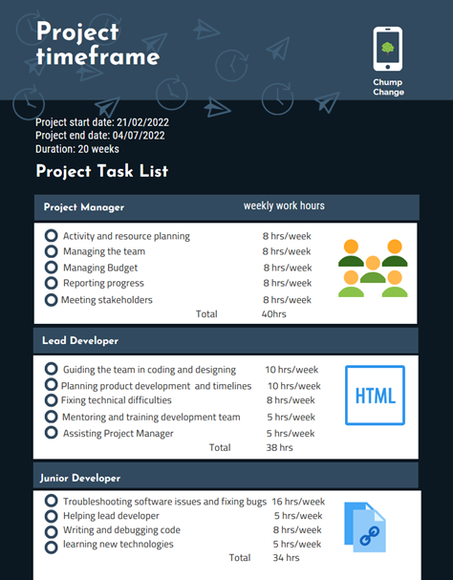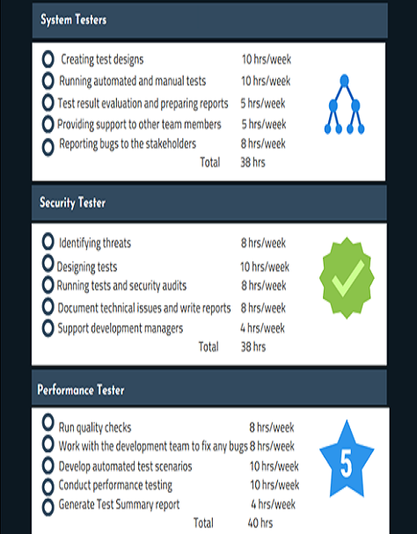Each team member contributed 5- 6 hours on the assignment each week from week 7 to 12. We have shown the milestones and processes of our group in the diagram below.  
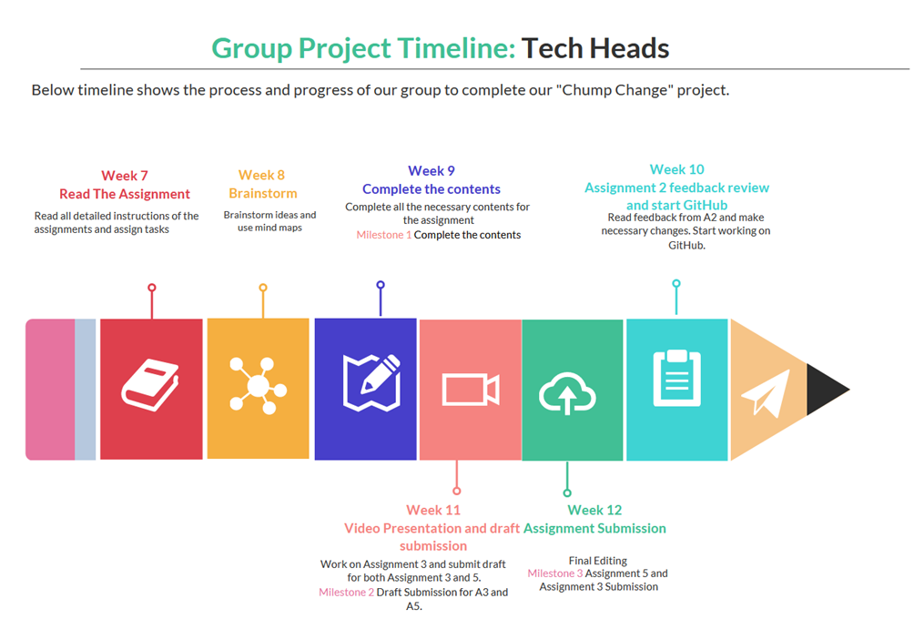  
We have estimated a total of 20 weeks to complete our project with a total team of 6. Below are the roles, duties, and estimated working hours for each team member.

RISKS  
  
Our motivation in this not-for-profit organisation is to lessen the impact of deforestation by creating an easy way for people to donate a small amount to eco-friendly organisations. These organisations employ people in underprivileged areas so they don’t have to continue their previous reliance on logging. We’d also like to donate to organisations that buy land to replant forests.  
  
There are many risks involved with creating a not-for-profit like ours. We are motivated by afforestation/reforestation and are creating a smart phone app to allow people to round up the cost of something to the nearest dollar when paying for everyday items. The money that is rounded up is donated to the user’s chosen charities. There’s a risk that there are too many other organisations with a similar app or too many organisations within the limited scope of our project. We would lessen certain financial risks by opening up our app to not just charities involved in reforestation but broadening our app to include other charities.  
  
There is a similar app to ours called ‘Round up app’. They allow all not for profit organisations to use their app and platform with no start-up costs and they charge a $15 dollar a month charge that comes out of the donations they receive. The user can then choose what charity they would like to donate to and create a limit on those donations for the month. Since this is already a well established app/platform, we run the risk of being overlooked if we don’t find a way to differentiate ourselves from the competition.  
  
Our project currently appeals to a limited market, those who are motivated by charity and the environment. Limiting that potential market is a risk in itself. There are other similar apps that instead of giving to charity, they save your own money with each rounded up purchase for your own personal savings. You are able to set financial goals to reach. Some apps may even manage the funds for you with a percentage return on your account balance. I believe our app could potentially lessen risks by offering more choice in where our clients finances are being used. Even if clients don’t want to give to charity we can advertise a percentage or the funds we charge to use the app will go to charitable causes.  
  
Since our app involves online monetary transactions, it will be a risk if we don’t have a very secure platform. This could incur some reasonably large start up costs for high-end software and to hire someone to install and run it. Being a not for profit, it may be harder to get an investment and raise funds for such software and employees.

# SKILLS REQUIRED

The following skills are required for the development of this project  
• Apple and Android developers  
• AWS system engineers or experts  
• CI/CD pipeline experts  
• Project manager to oversee the program  
• System testers to ensure the application works as per the user stories/requirements  
• Performance testers to validate throughput of the system  
  
  
OUTCOME

If the project is successful, the application will be launched publicly, and revenue will be generated. This type of solution is not a fast one and relies on volume and time to be successful. What we aim to achieve is generating millions of dollars globally to the deforestation issue. Over the next few generations, we aim to be one of the largest contributors of funding to solving global deforestation. The next steps would be to try and find a solution to bring on large multinational organisations to assist in donating with Chump Change. This has not been thought out yet, but there can be other solutions not limited to pay pass that could assist. One of them may be to team up with suppliers where invoices include a donation component, but this will be a new phase of the application.

WIREFRAME

We have conceptualised the app with a wireframe on how it will work when a payment is made.

* Make a purchase and tap your phone for pay pass
* App detects the rounding amount to nearest dollar
* App asks if you would like to donate this amount

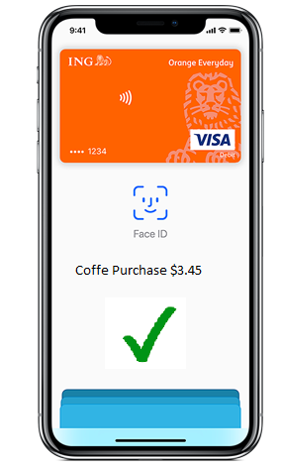 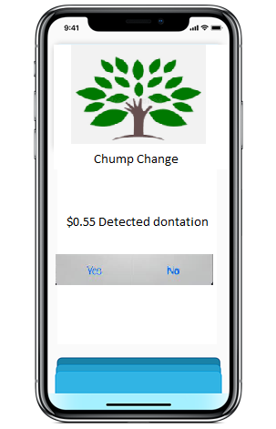

# GROUP PROCESSESS AND COMMUNICATIONS

Our group have demonstrated a good team cohesion and communication skill. We were open, supportive, respectful, and honest to each other. We had team meetings twice a week for 30-60 minutes and conversations in teams once every two days to keep track of where everyone was at their tasks. Our schedules for team meetings also worked out well. We will continue doing the same to continue our project. We will set aims for every week and assign tasks accordingly to achieve them. We will allocate work hours every week for each team member. We will meet two or three times a week via Teams and continue our conversation during the week in the Teams to keep track of our activities. We will work on contributing the tasks according to our knowledge and skills. We will encourage each other by appreciating the work done, rewarding them and helping team member who struggles to complete the task. We will try to make our meetings fun and engaging by conducting various team games. We understand the importance of being considerate and empathetic to each other. We will avoid team conflicts by keeping each other informed if any team member is unable to attend the meeting. We will share our primary contact details in case of any no shows during team meetings, so we can reach out to them to see if everything is alright.

Group Reflections

#### SONAM SHAHI

Our team demonstrated an excellent connection, showed great communication and effective team player skills. The feedback from assignment 2 and our experience working as a group in assignment 2 helped us understand our areas of strengths and the areas where we lacked. We utilised our time for assignment 3 and 4 to improve ourselves and bring the best out of all. We started our planning as soon as we submitted assignment 2, so we had a lot of time to improve. We had organised more meetings this time compared to our last group work. I really enjoyed the meetings in the teams as it was fulfilled like always. Besides, the team members' contributions were tremendous. It was easier to understand the assignment task clearly as we discussed the requirements together. Giving and receiving feedback from the team members on each other's work gave me confidence and motivation to complete the task.  
Overall, our group 'Tech heads' performed well by showing flexibility, openness, honesty, enthusiasm, and dedication. I must say that this experience has improved my collaboration, communication and teamwork skill along with new technical skills.

#### SAMEH ABDELHAMID

Overall, the team was just fantastic. Everyone really worked well together. People made time for the meetings and they were very attentive and they did the work they said. It was surprising how comfortable everyone was after the first meeting where we had a good ice breaker and people were not scared to say where they felt insecure (with certain technologies etc). and this was great as we were able to focus on what needed to be done and we could allocate tasks out well. The one thing i think that could be improved if were able to have more collaboration sessions where we did the work during the meetings instead of talking. That would have knocked out a lot of the work quickly. The one thing I've learnt about groups is that when you work hard initially to build rapport and come together and share common stories (not work related) you manage to work better as a team because people feel more comfortable. This was definitely the way in our team and we had great dynamic.  
I don’t think the GitHub activity reflects the effort at all. Because some of us didn't feel comfortable with GitHub and with HTML, we shared the load and focused on working on people’s strengths. Some of the teams were better and quicker at HTML and took the load and others worked offline and uploaded to google drive. This was great for our team.

#### DESMOND KNOWLES

I believe my team worked very well together. The communication was great, group members were well mannered, supportive and well informed. It’s hard to say what could be improved because this is everyone’s first time working together. If I had to choose something I would probably choose to work together on tasks more often as a live exchange of information and ideas should be one of the fastest ways to communicate and complete work together. This is my first university group project I’ve done and I was surprised by how seamless the group worked together. 10/10 would group with again. I think one thing I’ve learned at least about this group is they can be trusted to get the work done, there were no slackers here, everyone put in the effort. I don’t think the github activity accurately reflects the group’s work on this assignment as it doesn’t cover many of the other areas that group members worked on and there were also times when multiple team members might have worked on an individual idea but it was only pushed onto the website by one person.

#### GEORGE TSOLOMOTIS

The team worked amazingly together and everyone was so welcoming and understanding. The teamwork that was involved was absolutely outstanding and couldn’t have asked for a better group of people to do assignment 2 with. Everyone put their 100% in and that is what you want from a team. I always looked forward to our meetings because it was a chance for us to come together and discuss our roles within the assignment and then once we had completed that, we discussed other topics outside of the assignment from our personal lives. I definitely think that we could have had more meetings, which could have been an improvement, only because every meeting that we had, we got to know more about each other and by the second meeting I felt comfortable enough to provide the feedback and marks that I received from assignment 1. One thing that surprised me was how GitHub actually works. I have never used GitHub before this subject and now that I have an idea about it, it has really become a game changer for me. I think there was more effort put in away from GitHub. One thing that I have learnt from working in a group is to always express your strengths and weaknesses, because there will always be a task that will best suit you and that will help the rest of the team.

Reference List

**George**

“The State of the World’s Forests 2020” 2020, *www.fao.org*, viewed 30 January 2022, <https://www.fao.org/state-of-forests/en/#:~:text=Between%202015%20and%202020%2C%20the,80%20million%20hectares%20since%201990.>

“WWF - Palm oil” 2018, *Wwf.org.au*, viewed 30 January 2022, <https://www.wwf.org.au/what-we-do/food/palm-oil#gs.o5bg8i>

**Sonam**

“IT Project Manager Job Description | Indeed” 2022, *Indeed.com*, viewed 31 January 2022, <https://www.indeed.com/hire/job-description/it-project-manager>

Totempool 2021, “Lead Developer Job Description | Free PDF | Totempool,” *Totempool.com*, viewed 31 January 2022, <https://totempool.com/job-descriptions/lead-developer/>

“Junior Software Developer Job Description Template - Comeet” 2019, *Comeet*, viewed 20 February 2022, <https://www.comeet.com/resources/job-descriptions/junior-software-developer#popup2>

Betterteam 2020, “Software Tester Job Description,” *Betterteam*, viewed 4 February 2022, <https://www.betterteam.com/software-tester-job-description>

“Penetration Tester Resume Examples” 2015, *Jobhero.com*, viewed 4 February 2022, <https://www.jobhero.com/resume/examples/information-technology/penetration-tester>

“List of Performance Test Engineer Responsibilities and Duties” 2021, *Great Sample Resume*, viewed 4 February 2022, <https://www.greatsampleresume.com/job-responsibilities/computer-software/performance-test-engineer>

‌