# Technologies Used

For the development of backend, I have used following technologies

* Spring boot
* MySQL Database
* Docker

For the development of the front end (rest client), I have used following technologies

* HTML
* jQuery
* Bootstrap

# Backend

## Project Structure

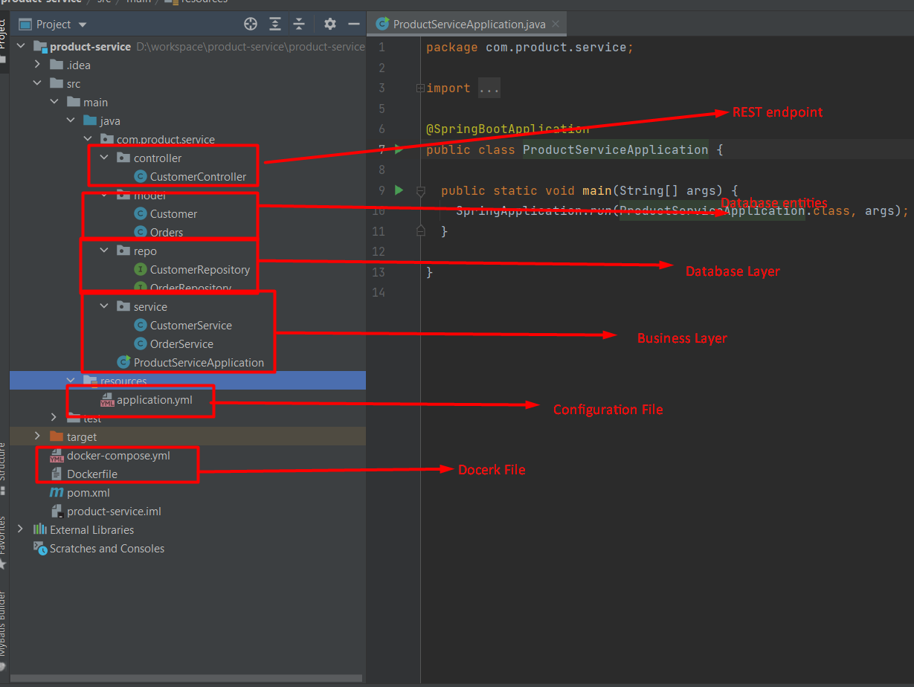

## Database Configurations

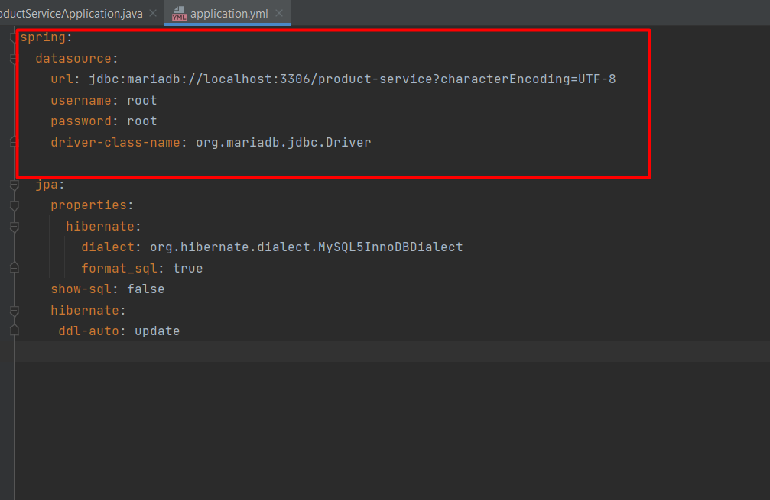

# Postman Requests

**Get Customer List**

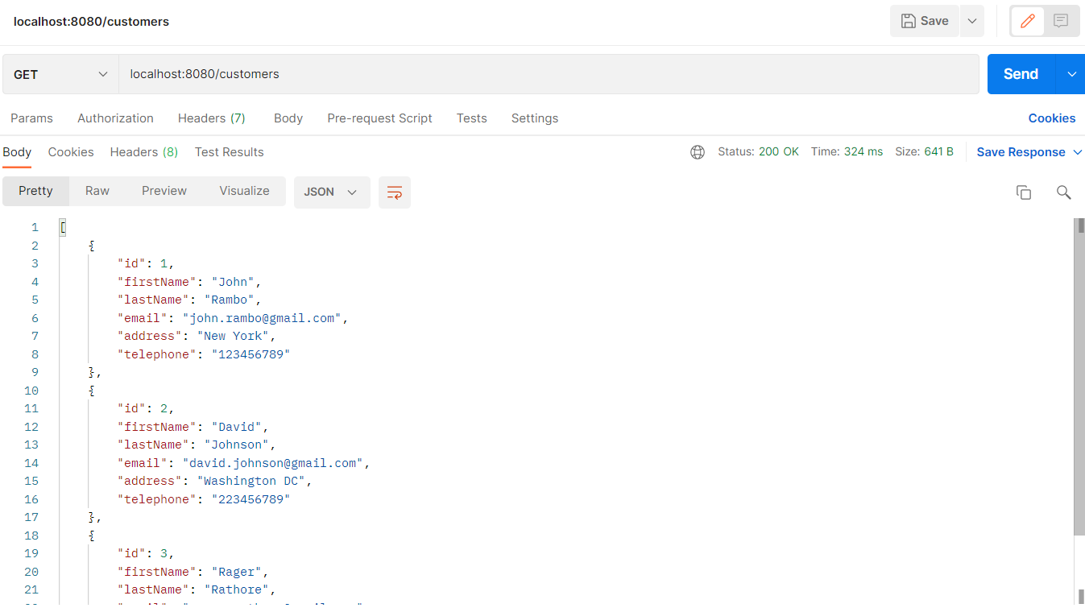

**Get Customer**

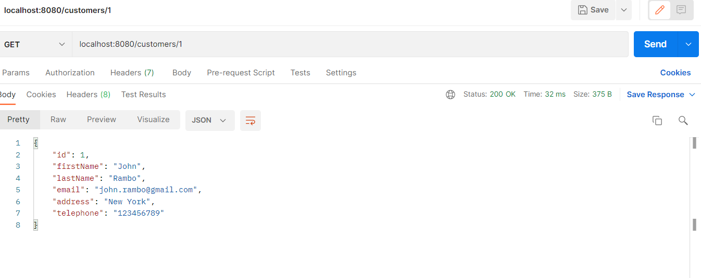

**Get Customer Orders**

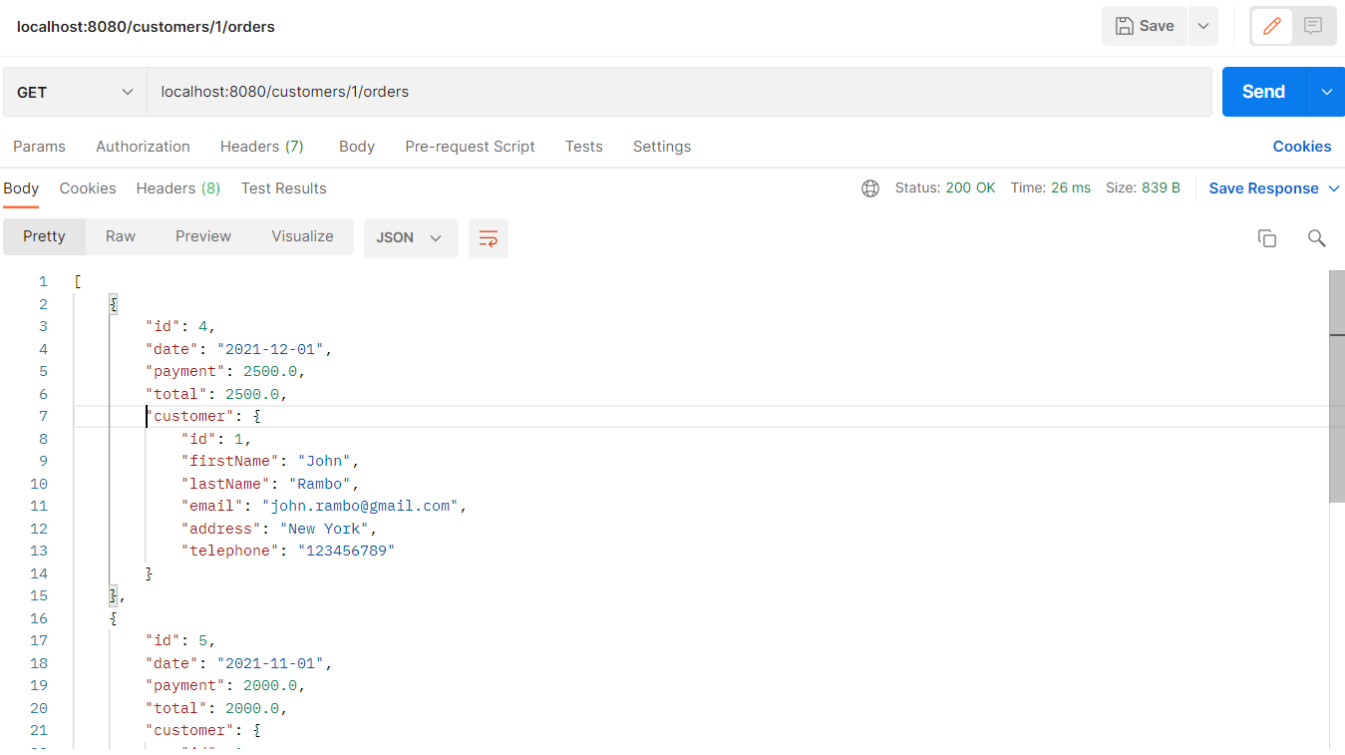

**Get Order Details**

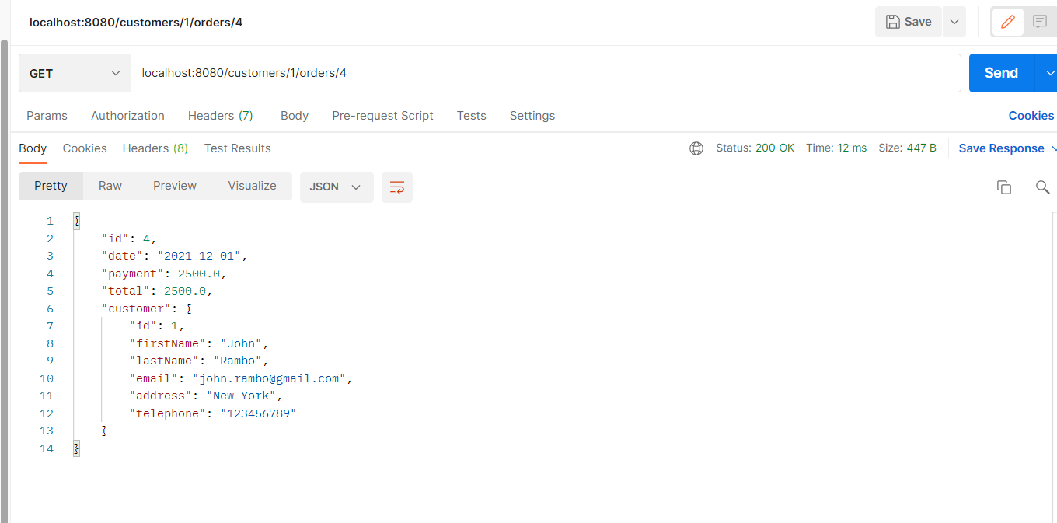

# Rest Client

**Customer List**  
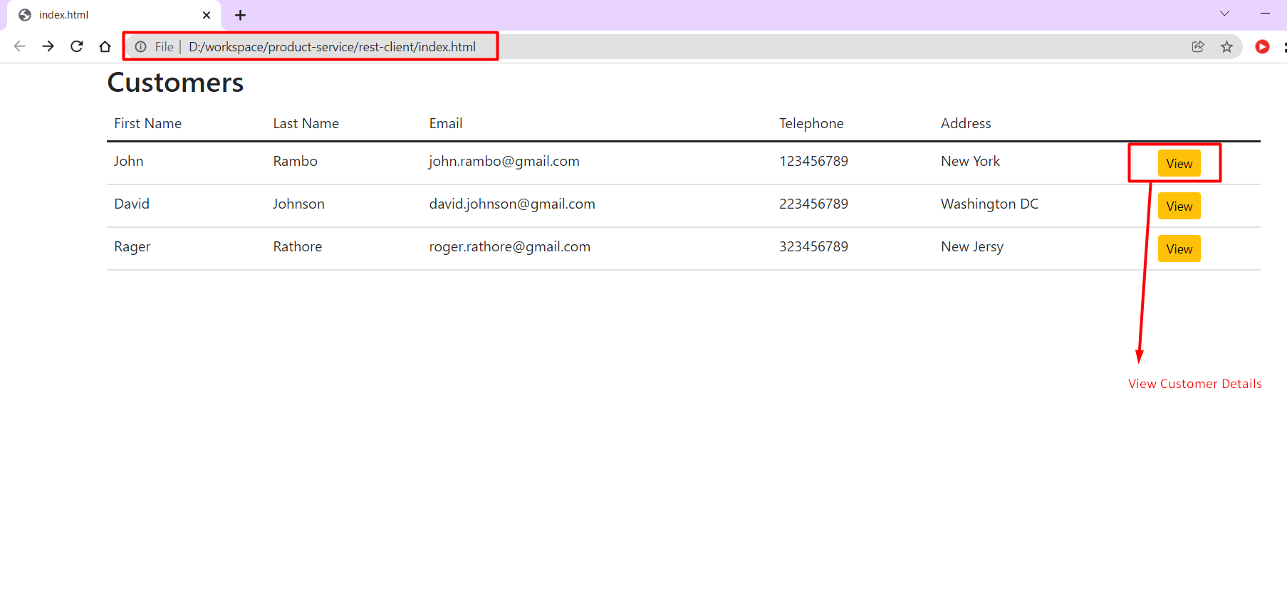

**Customer Details**

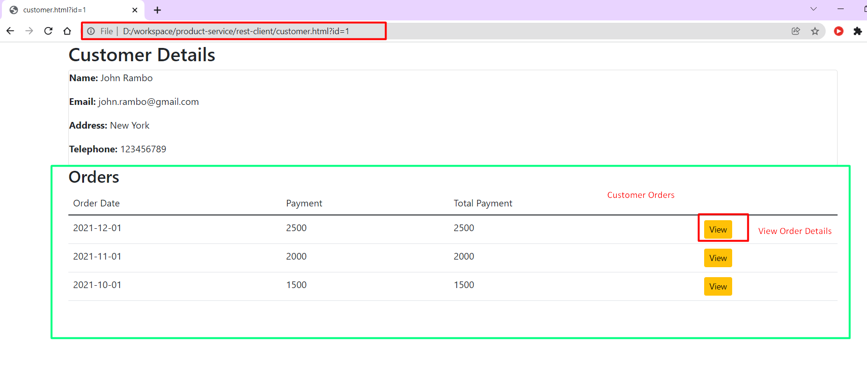

**Order Details**

