Deleted the old 500 testcases in mongo db and created the json for 6354 test cases.
Please find the below screen shots for the reference.

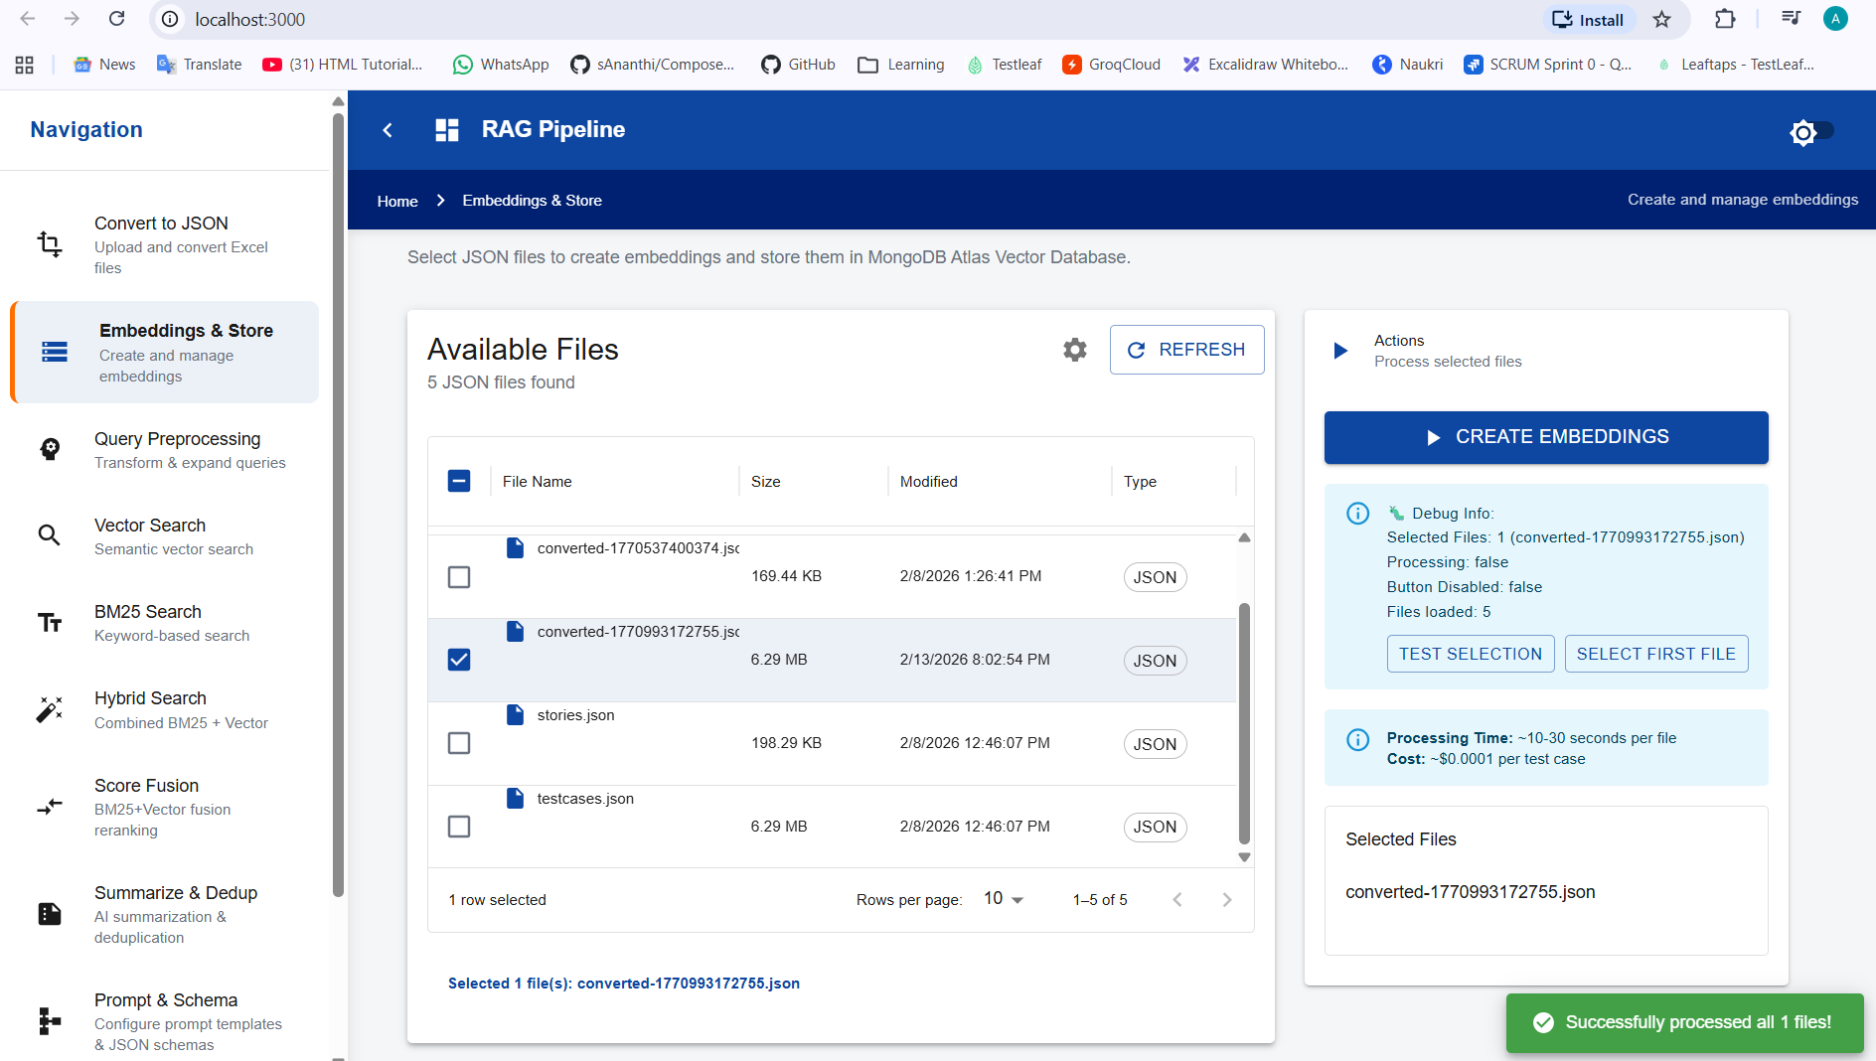

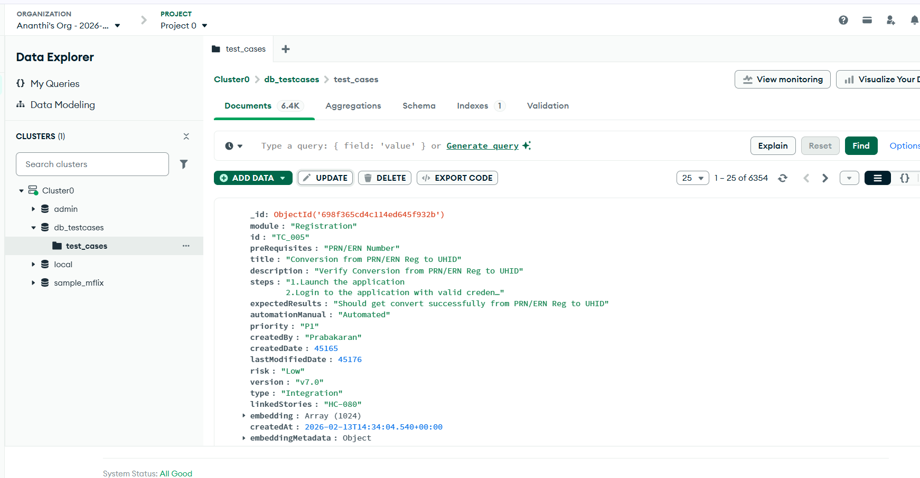
2. Created the collection named user_stories and vector index as vector_index_user_story

{
"fields": [
{
"type": "vector",
"path": "embedding",
"numDimensions": 1024,
"similarity": "cosine"
},
{
"type": "filter",
"path": "id"
},
{
"type": "filter",
"path": "module"
},
{
"type": "filter",
"path": "title"
},
{
"type": "filter",
"path": "description"
},
{
"type": "filter",
"path": "steps"
},
{
"type": "filter",
"path": "expectedResults"
},
{
"type": "filter",
"path": "risk"
},
{
"type": "filter",
"path": "priority"
}
]
}

Selected the userstories.json file and created the embeddings.