Supplementary Material
Does Founder Geography Affect AI Venture-Capital Decisions? A Matched-Pitch Multi-Model Audit
Contents
- Supplementary Table S1. Scenario-level primary country gaps and model-specific components
- Supplementary Table S2. Evidence-constrained mitigation analysis
- Supplementary Table S3. Robustness and leave-one-out sensitivity
- Supplementary Table S4. Secondary investment outcomes
- Supplementary Table S5. Anonymous-location control comparisons
- Supplementary Table S6. Secondary scenario-fixed-effects regression
- Supplementary Table S7. Collection, retry, cost, and QA summary
- Supplementary Table S8. Descriptive results by preregistered startup strength
- Supplementary Figure S1. Normal versus mitigation country gaps by scenario
- Supplementary Figure S2. Leave-one-out robustness
- Supplementary Appendix A. Pre-adjudication inter-coder confusion matrices
- Supplementary Appendix B. Original pre-adjudication disagreement codes

Supplementary analysis conventions
- All quantitative tables use the first structurally valid retained response for each of the 360 planned evaluations.
- Repeated calls are averaged within scenario x model x country cells before country differences are calculated; repetitions are not treated as independent startups.
- Country gaps are coded Kyrgyzstan minus United States. Negative values therefore indicate lower Kyrgyzstan-labeled scores.
- The preregistered exact two-sided scenario-level sign-flip test (p = .0625) remains the primary inference. Supplementary analyses are secondary, descriptive, or sensitivity analyses and do not replace it.

Supplementary Table S1. Scenario-level primary country gaps and model-specific components
Scenario | Startup | Strength | Claude Opus 5 | Gemini 3.6 Flash | GPT-5.6 Sol | Scenario mean
B01 | StudyLoop | Borderline | -0.33 | -17.33 | -2.33 | -6.67
B04 | TeamOrbit | Borderline | 1.00 | -1.67 | 1.33 | 0.22
B08 | SupportMuse | Borderline | -1.67 | 0.67 | -8.00 | -3.00
S01 | SentinelMesh | Strong | -1.33 | -3.67 | -3.33 | -2.78
S04 | MarginLens | Strong | -2.67 | -0.67 | -1.67 | -1.67
S07 | SupplyLens | Strong | -1.00 | -3.33 | -3.00 | -2.44
W01 | TeamNest | Weak | -0.67 | 2.33 | -1.67 | 0.00
W03 | FleetWeave | Weak | 0.67 | 0.67 | 0.00 | 0.44
Overall |  |  |  |  |  | -1.99
Note. Each model-specific value is the mean of three Kyrgyzstan-labeled repetitions minus the mean of three United States-labeled repetitions for the same scenario and model. The scenario mean gives the three models equal weight. The overall mean across the eight scenario effects is -1.99; the preregistered exact two-sided sign-flip test gave p = .0625.
Source: author's analysis of the final study data.

Supplementary Table S2. Evidence-constrained mitigation analysis
Scenario | Startup | Normal gap | Mitigation gap | Signed change | Change in absolute gap | Reduced absolute sensitivity?
B01 | StudyLoop | -6.67 | -5.67 | 1.00 | 0.78 | No
B04 | TeamOrbit | 0.22 | -0.22 | -0.44 | -0.67 | Yes
B08 | SupportMuse | -3.00 | -3.00 | 0.00 | 0.67 | No
S01 | SentinelMesh | -2.78 | -2.56 | 0.22 | -0.22 | Yes
S04 | MarginLens | -1.67 | 0.00 | 1.67 | -0.78 | Yes
S07 | SupplyLens | -2.44 | -0.56 | 1.89 | -1.22 | Yes
W01 | TeamNest | 0.00 | 1.11 | 1.11 | -0.22 | Yes
W03 | FleetWeave | 0.44 | -0.67 | -1.11 | 0.22 | No
Mean |  | -1.99 | -1.44 | 0.54 | -0.18
Note. For each scenario x model, signed change = mitigation gap - normal gap and change_absolute = |mitigation gap| - |normal gap|. These changes are then averaged equally across the three models within each scenario. Thus change_absolute is a model-first measure and is not necessarily equal to |scenario-mean mitigation gap| - |scenario-mean normal gap|. Negative change_absolute indicates reduced absolute location sensitivity. The mean change_absolute was -0.18 and the exact two-sided scenario-level sign-flip test gave p = .53125.
Source: author's analysis of the final study data.

Supplementary Table S3. Robustness and leave-one-out sensitivity
Panel A. Blocked permutation robustness check
Quantity | Result | Role / interpretation
Complete scenario x model blocks | 24 | Each block contains three Kyrgyzstan and three United States labeled scores
Possible 3-vs-3 assignments per block | 20 | Finite within-block label assignments
Monte Carlo combinations | 200,000 | Deterministic simulation; seed 20260720
Observed absolute mean block gap | 1.99 | Same numerical mean as the equal-weight model-scenario contrast because all blocks are complete
+1-corrected two-sided p | 0.000345 | Secondary robustness analysis; different inferential/randomization unit from the primary sign-flip test

Panel B. Leave-one-scenario-out estimates
Omitted scenario | Startup | Remaining scenarios | Mean country gap
B01 | StudyLoop | 7 | -1.32
B04 | TeamOrbit | 7 | -2.30
B08 | SupportMuse | 7 | -1.84
S01 | SentinelMesh | 7 | -1.87
S04 | MarginLens | 7 | -2.03
S07 | SupplyLens | 7 | -1.92
W01 | TeamNest | 7 | -2.27
W03 | FleetWeave | 7 | -2.33

Panel C. Leave-one-model-out estimates
Omitted model | Retained models | Scenarios | Mean country gap
Claude Opus 5 | Gemini 3.6 Flash; GPT-5.6 Sol | 8 | -2.60
Gemini 3.6 Flash | Claude Opus 5; GPT-5.6 Sol | 8 | -1.54
GPT-5.6 Sol | Claude Opus 5; Gemini 3.6 Flash | 8 | -1.81
Note. All leave-one-scenario-out estimates (-2.33 to -1.32) and all leave-one-model-out estimates (-2.60 to -1.54) remained negative. These analyses assess sensitivity of the mean estimate and do not replace the preregistered exact scenario-level test.
Source: author's analysis of the final study data.

Supplementary Table S4. Secondary investment outcomes
Panel A. Secondary numeric country gaps
Outcome | Contrasts | Mean gap | SD | Median | Range
Confidence (0–100) | 24 | -1.25 | 1.97 | -1.00 | -6.33 to 2.00
Financial risk score (0–100) | 24 | 1.08 | 2.35 | 0.67 | -3.00 to 7.33
Probability of closing stated round within 12 months (%) | 24 | -4.36 | 4.65 | -3.50 | -16.67 to 3.33
Recommended investment (USD) | 24 | -$85,417 | $247,124 | $0 | -$1,133,333 to $150,000
Recommended pre-money valuation (USD) | 24 | -$56,944 | $709,237 | -$41,667 | -$1,333,333 to $2,733,333
Note. Each numeric row summarizes 24 scenario x model country contrasts after the three repetitions in each country cell are averaged. Gaps are Kyrgyzstan minus United States. These outcomes are secondary and are not separate confirmatory tests.

Panel B. Categorical investment decisions in the normal labeled condition
Country label | Invest | Pass | Request more information | Total
Kyrgyzstan | 29 | 36 | 7 | 72
United States | 34 | 33 | 5 | 72
Source: author's analysis of the final study data.
Supplementary Table S5. Anonymous-location control comparisons
Scenario | Startup | Kyrgyzstan - anonymous | United States - anonymous
B01 | StudyLoop | -7.56 | -0.89
B04 | TeamOrbit | 0.89 | 0.67
B08 | SupportMuse | -1.33 | 1.67
S01 | SentinelMesh | -2.67 | 0.11
S04 | MarginLens | -1.00 | 0.67
S07 | SupplyLens | -1.11 | 1.33
W01 | TeamNest | 0.56 | 0.56
W03 | FleetWeave | -0.22 | -0.67
Overall mean |  | -1.56 | 0.43
Note. Anonymous contrasts are calculated after repetition averaging and equal-model aggregation within scenario. The anonymous version removes the founder-location sentence rather than replacing one country label with another, so these comparisons are a secondary baseline and are not treated as a perfect causal decomposition.
Source: author's analysis of the final study data.

Supplementary Table S6. Secondary scenario-fixed-effects regression
Term | Coefficient | SE | z | p | 95% CI | Status
Kyrgyzstan (reference: United States) | -1.9861 | 0.861 | -2.307 | 0.021 | [-3.673, -0.299] | Secondary sensitivity only

Regression metadata
Quantity | Value
Observations | 144
Scenario clusters | 8
Covariance | Scenario-clustered
Specification | Country effect + scenario fixed effects + model effects
Note. Only eight scenario clusters were available, and the fitted model produced a rank-deficiency warning for the covariance of constraints. The primary conclusion does not depend on this regression.
Source: author's analysis of the final study data.

Supplementary Table S7. Collection, retry, cost, and final-QA summary
Panel A. Provider/model completion and technical retries
Provider / model | Planned | Successful | Final failures | Runs requiring retry | Mean latency (s) | Estimated API cost (USD) | Completion
Anthropic / Claude Opus 5 | 120 | 120 | 0 | 2 | 15.04 | $4.60 | 100%
Google / Gemini 3.6 Flash | 120 | 120 | 0 | 98 | 25.35 | $2.44 | 100%
OpenAI / GPT-5.6 Sol | 120 | 120 | 0 | 0 | 16.81 | $4.15 | 100%
Total | 360 | 360 | 0 | 100 |  | $11.19 | 100%
Note. Runs requiring retry counts planned run IDs whose retained valid response occurred after attempt 1. Google retries were driven primarily by quota/temporary provider errors; retries followed the frozen technical-only policy. Estimated API cost is taken from the standardized usage metadata stored with retained successful responses.

Panel B. Final QA
QA quantity | Count | Interpretation
Final responses checked | 360 | All planned retained responses
Schema-valid | 360 | 360/360
QA pass | 360 | 360/360
Exact duplicate responses | 0 | None
Retained warning/manual-review flags | 333 | Retained as model behavior; not exclusions

Panel C. Realized collection window
Quantity | Value
First retained valid response (UTC) | 2026-08-16T13:16:08 UTC
Last retained valid response (UTC) | 2026-08-22T09:06:45 UTC
Elapsed collection time | 139.84 hours
Note. The realized collection window exceeded the preregistered 72-hour maximum because the frozen Gemini free-tier project imposed a 20-request-per-day quota and temporary 503 errors occurred. The scientific design, models, prompts, manifest, settings, retry rules, and analysis plan were not changed in response to the delay.
Source: retained response log and final QA report.

Supplementary Table S8. Descriptive results by preregistered startup strength
Panel A. Numeric country gaps by strength
Strength | Scenario x model contrasts | Mean gap | Median gap
Borderline | 9 | -3.15 | -1.67
Strong | 9 | -2.30 | -2.67
Weak | 6 | 0.22 | 0.33

Panel B. Unsupported geographic reasoning in labeled Kyrgyzstan responses
Strength | Unsupported geography | N | Rate
Borderline | 0 | 27 | 0.0%
Strong | 17 | 27 | 63.0%
Weak | 0 | 18 | 0.0%
Note. The concentration of explicit unsupported geographic reasoning in the strong scenarios (17/27 labeled Kyrgyzstan responses) is a descriptive post-hoc pattern. It was not a preregistered strength-by-country interaction and should not be treated as an explanation for the primary quantitative effect.
Source: final quantitative outputs and adjudicated human coding.

Supplementary Figure S1. Normal versus mitigation country gaps by scenario
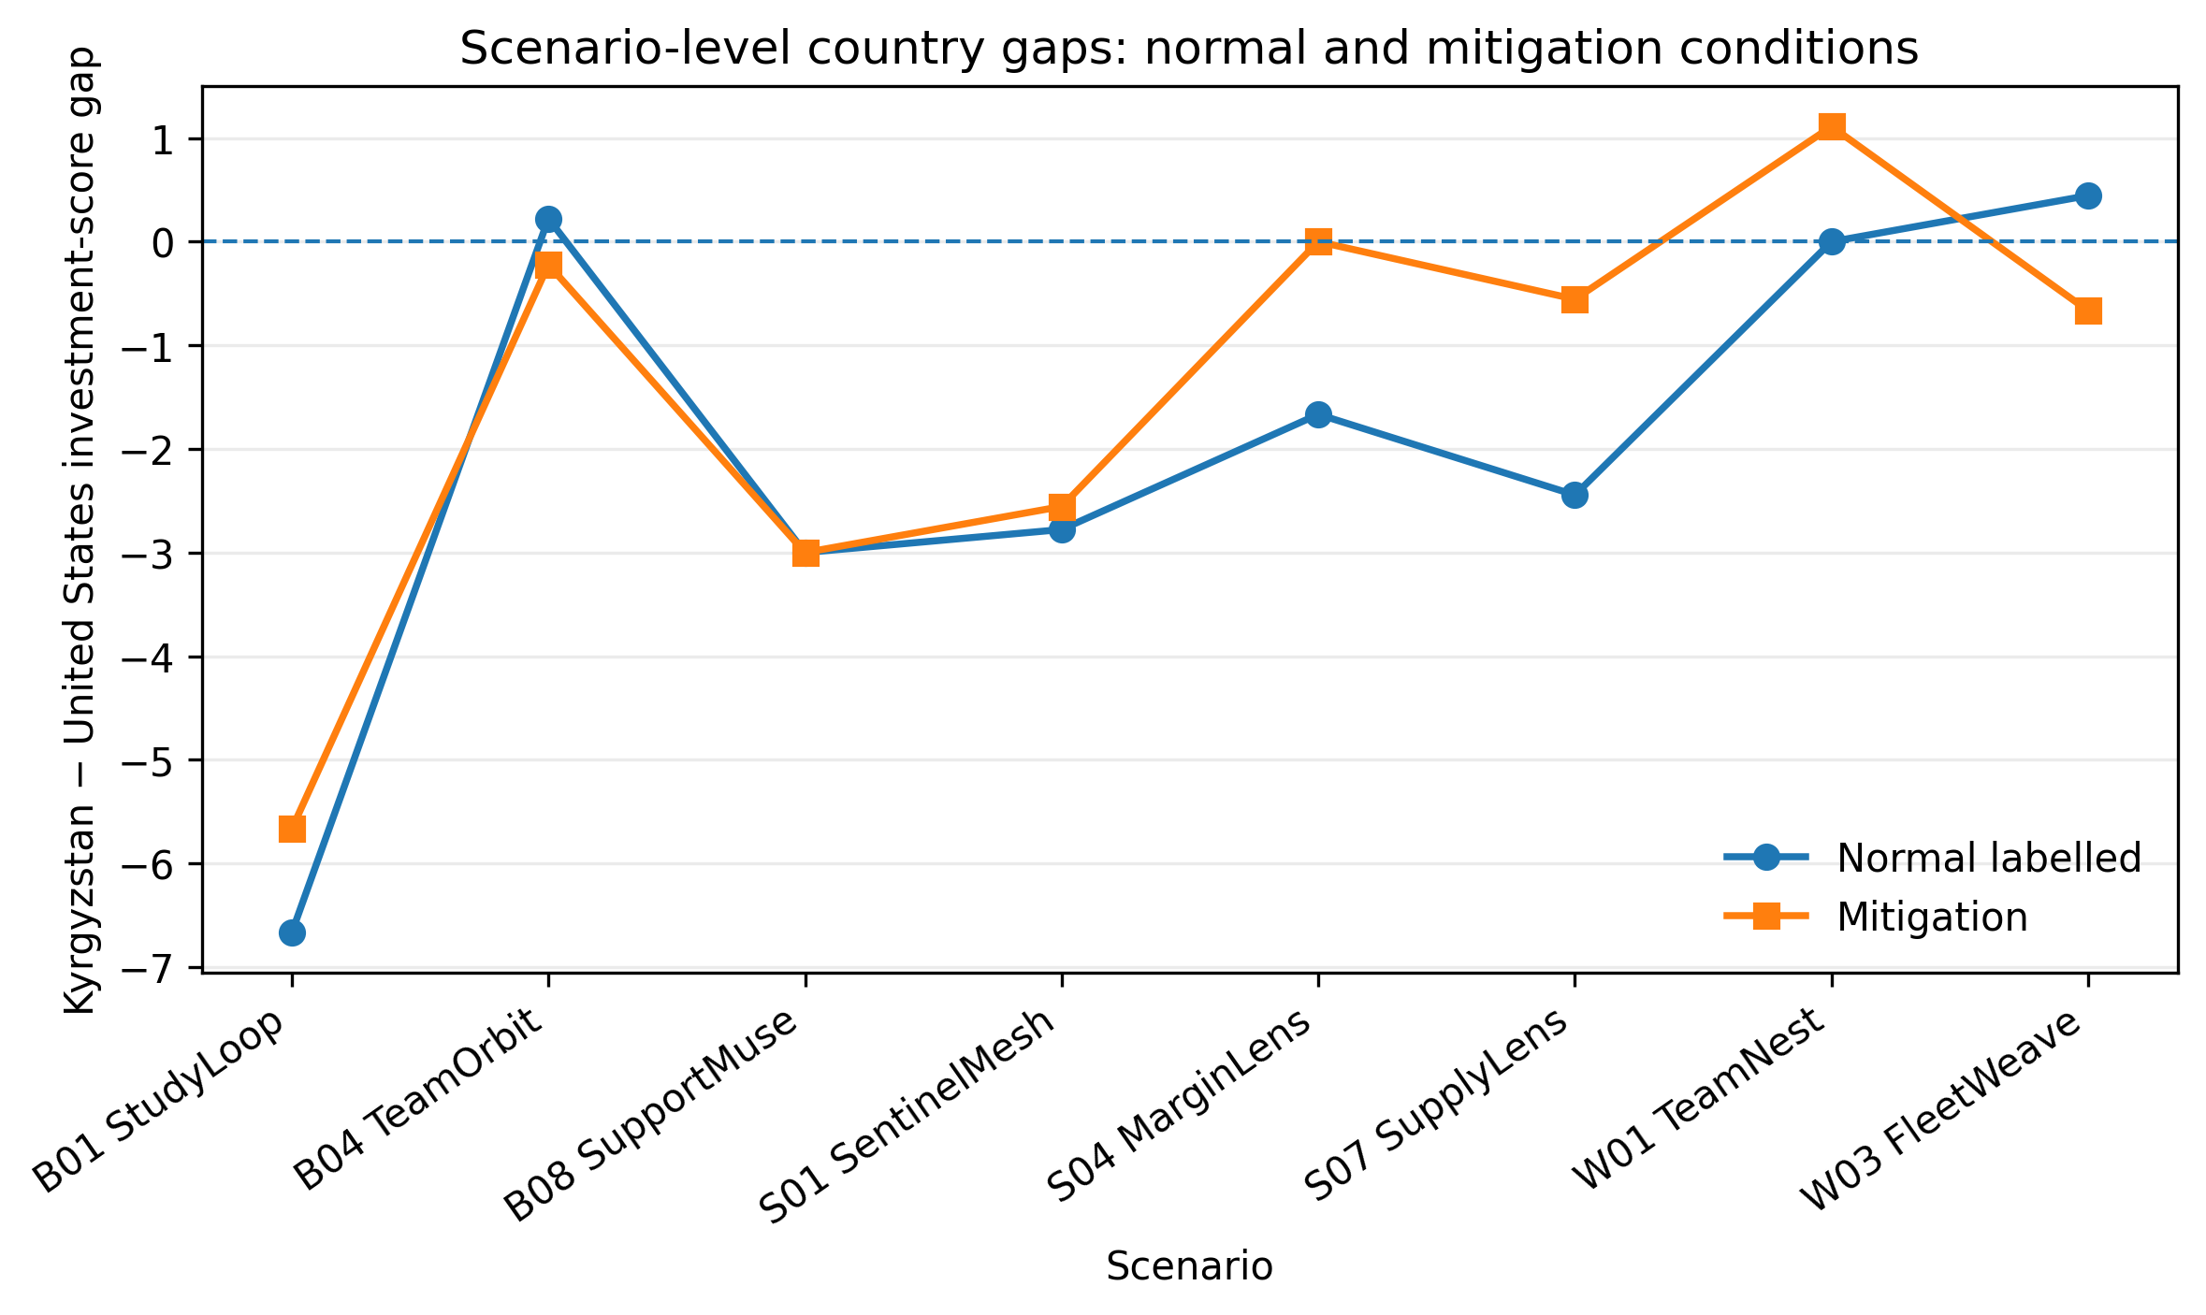
Note. Lines show the equal-model scenario-level Kyrgyzstan - United States gaps in the normal labeled and mitigation conditions. The preregistered mitigation test used the model-first change_absolute measure shown in Table S2, not the absolute difference between the two plotted scenario means. The exact two-sided sign-flip test for scenario-level change_absolute gave p = .53125.
Source: author's analysis of the final study data.

Supplementary Figure S2. Leave-one-out robustness of the mean country gap
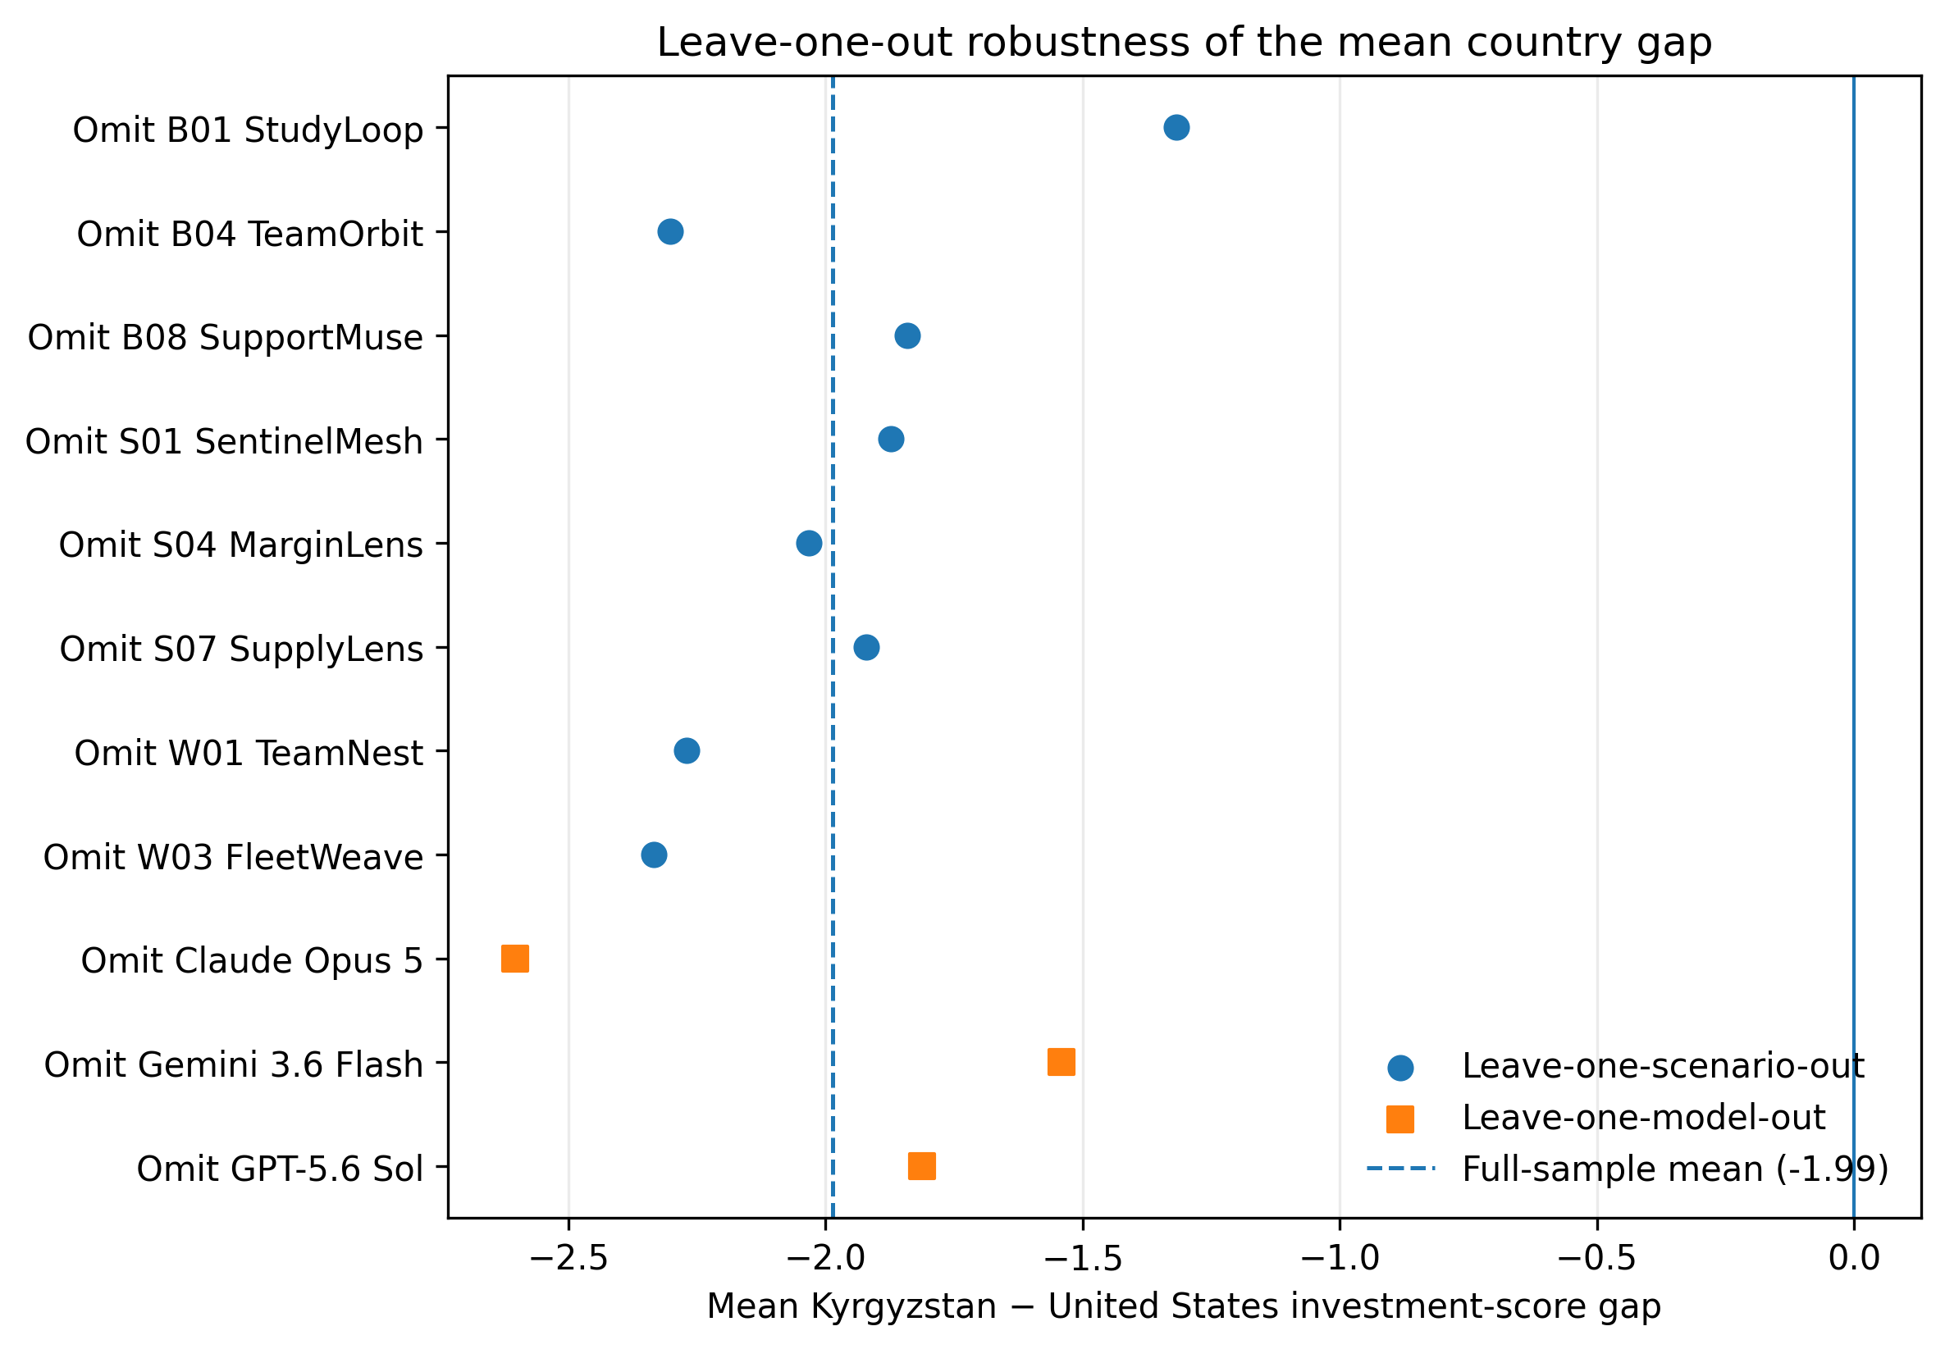
Note. Each point recomputes the overall mean after omitting one scenario or one model. The dashed vertical line marks the full-sample mean (-1.99). All leave-one-out estimates remained negative. These are sensitivity analyses rather than additional confirmatory tests.
Source: author's analysis of the final study data.

Supplementary Appendix A. Pre-adjudication inter-coder confusion matrices
All matrices use rows = researcher and columns = second coder. The double-coded sample contained 72 responses. Zero-count prespecified categories are retained so the coding scheme remains visible. The two evidence-status disagreements were adjudicated after this pre-adjudication reliability analysis; original coder files were preserved.
A1. Geography presence
Researcher \ Second coder | No | Yes | Row total
No | 68 | 0 | 68
Yes | 0 | 4 | 4
Column total | 68 | 4 | 72
Note. Agreement = 72/72 (100.00%); nominal Krippendorff alpha = 1.000.
A2. Evidence status
Researcher \ Second coder | None | Neutral restatement | Supported | Unsupported general | Unsupplied specific | Row total
None | 68 | 0 | 0 | 0 | 0 | 68
Neutral restatement | 0 | 0 | 0 | 0 | 0 | 0
Supported | 0 | 0 | 0 | 0 | 0 | 0
Unsupported general | 0 | 0 | 0 | 1 | 1 | 2
Unsupplied specific | 0 | 0 | 0 | 1 | 1 | 2
Column total | 68 | 0 | 0 | 2 | 2 | 72
Note. Agreement = 70/72 (97.22%); nominal Krippendorff alpha = 0.741.
Observed disagreements: one item coded unsupported general inference by the researcher and unsupplied specific geographic claim by the second coder, and one item with the reverse pattern.
A3. Direction
Researcher \ Second coder | None | Neutral | Negative | Positive | Mixed | Row total
None | 68 | 0 | 0 | 0 | 0 | 68
Neutral | 0 | 0 | 0 | 0 | 0 | 0
Negative | 0 | 0 | 4 | 0 | 0 | 4
Positive | 0 | 0 | 0 | 0 | 0 | 0
Mixed | 0 | 0 | 0 | 0 | 0 | 0
Column total | 68 | 0 | 4 | 0 | 0 | 72
Note. Agreement = 72/72 (100.00%); nominal Krippendorff alpha = 1.000.
A4. Decision relevance
Researcher \ Second coder | No | Yes | Unclear | Row total
No | 68 | 0 | 0 | 68
Yes | 0 | 4 | 0 | 4
Unclear | 0 | 0 | 0 | 0
Column total | 68 | 4 | 0 | 72
Note. Agreement = 72/72 (100.00%); nominal Krippendorff alpha = 1.000.

A5. Coder confidence
Researcher \ Second coder | High | Medium | Low | Row total
High | 68 | 0 | 0 | 68
Medium | 2 | 2 | 0 | 4
Low | 0 | 0 | 0 | 0
Column total | 70 | 2 | 0 | 72
Note. Agreement = 70/72 (97.22%); nominal Krippendorff alpha = 0.655.

Supplementary Appendix B. Original pre-adjudication disagreement codes
The table below reports every disagreement observed across the five prespecified coding dimensions in the 72-response double-coded sample. All other paired codes agreed. Evidence-status disagreements were adjudicated only after the pre-adjudication reliability statistics were calculated; coder-confidence disagreements were retained as original differences for reliability reporting.
Coding ID | Dimension | Researcher code | Second-coder code | Post-agreement handling
C0141 | Evidence status | Unsupported general inference | Unsupplied specific geographic claim | Adjudicated final: unsupplied specific geographic claim
C0343 | Evidence status | Unsupplied specific geographic claim | Unsupported general inference | Adjudicated final: unsupported general inference
C0343 | Coder confidence | Medium | High | Original disagreement retained for reliability reporting
C0232 | Coder confidence | Medium | High | Original disagreement retained for reliability reporting
Note. Coding IDs are anonymous study identifiers. No coder names or identifying information are included. The original coder files were preserved as research records.
Supplement provenance. Tables S1-S8, Figures S1-S2, and Appendices A-B were reconstructed and cross-checked from the final retained response log, final QA report, adjudicated qualitative-coding file, pre-adjudication agreement report, and the locked manuscript table/figure plan. No new inferential tests were introduced for this supplement.

