Acme Quarterly Report

1. Overview
This document tests DOCX extraction: headings, paragraphs, lists, tables and embedded images.

1.1 Highlights
- Revenue grew 12 percent
- Churn fell to 3 percent
- Two new regions launched
- Close the books
- Publish results
- Plan next quarter

2. Financial Table
Segment | FY2024 |  | FY2023
Segment | H1 | H2 | H1 | H2
North America | 1,200 | 1,350 | 1,100 | 1,250
Europe | (450) | 520 | 480 | (510)
Asia Pacific | $980 | $1,020 | 50% | 45%
Note: figures unaudited, USD thousands

3. Chart
Figure: Quarterly Revenue Bar Chart
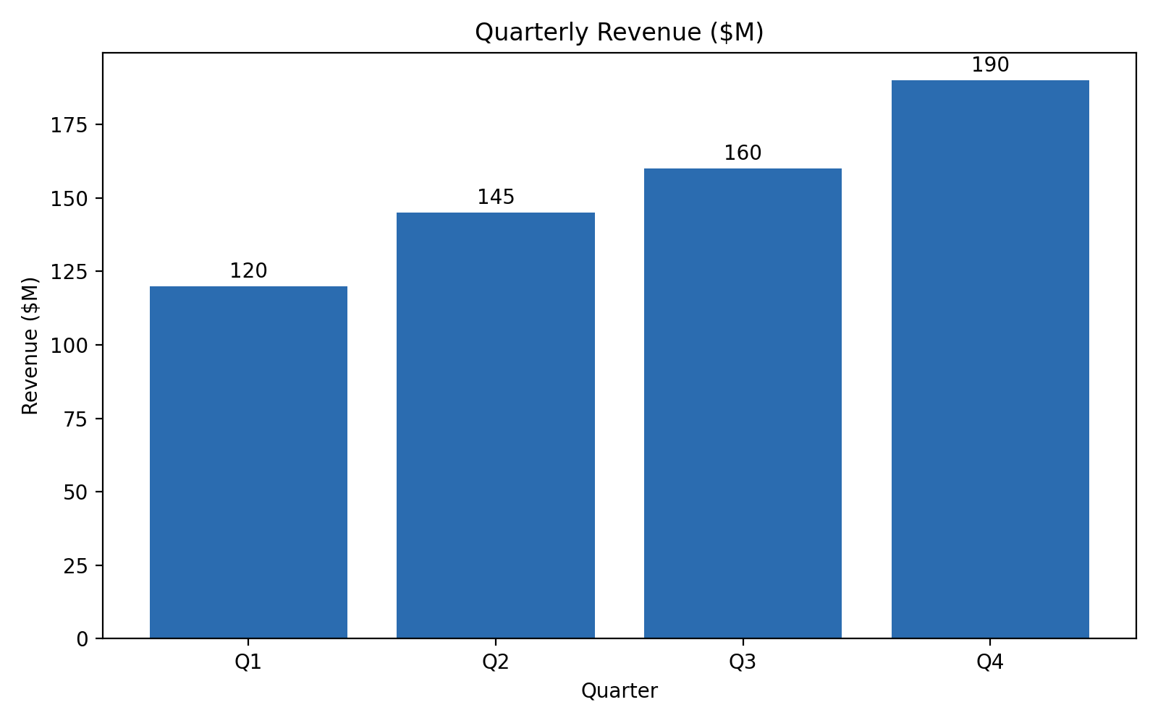
End of document.

