Description

This app helps inhabitants to shop online and make purchases without any physical fatigue. This application will become the best seller among companies. So, the buyer can add the product of his choice to the basket and buy it later.

Context Diagram

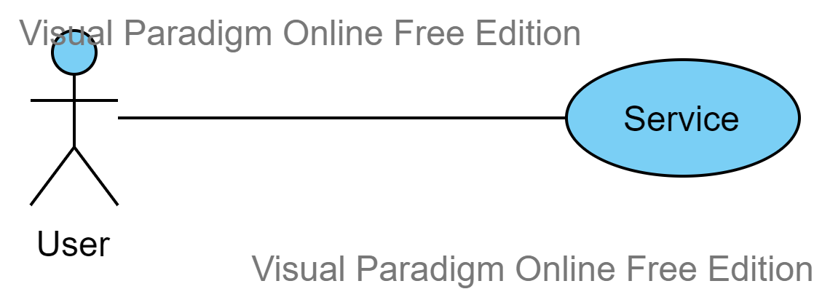

Functional Requirements

|  |  |
| --- | --- |
| Requirement ID | Description |
| F1 | Search product |
| F1.1 | Search by name |
| F1.2 | Search by category |
| F2 | Show popular products |
| F3 | Show list of products |
| F3.1 | Show price |
| F3.2 | Show description of product |
| F4 | Show product page |
| F4.1 | Choose size |
| F4.2 | Choose color |
| F4.3 | Add to basket |
| F5 | Manage basket |
| F5.1 | Show list of products |
| F5.2 | Delete some products from the basket |
| F5.3 | Show total price |

Design decision

|  |  |
| --- | --- |
| F.1 | The system should be object oriented. |

Use Case Diagram

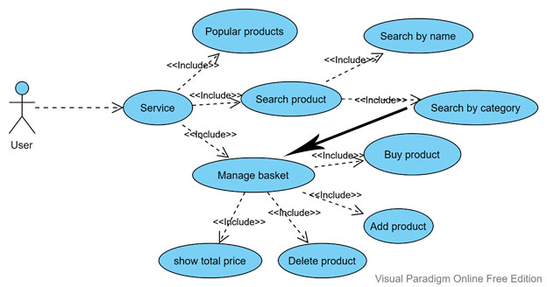

Scenarios

|  |  |
| --- | --- |
| Step | Description |
| 1 | Open home page |
| 2 | Browse popular products |
| 3 | Choose one |
| 4 | Open product page |
| 5 | Choose attributes |
| 6 | Add to basket |
| 7 | Go to basket |
| 8 | Delete some products |
| 9 | Buy |

**Glossary**

**API-**application programming interface for app.

**Basket-**virtual basket to gather items before buying

**Brand-**name of popular product

**Customer-**user

**Discounts-**that product which in the sale

**Scene-** the screen which appears on user`s device

**JavaFX-**deploy rich client applications that operate consistently across diverse platforms.

**FXML-** the structure for building a user interface separate from the application logic

**Shipping-**manufacture and packing of goods and will controlled by shipping or logistic company

**UI-** user may interact with to use a digital product or service. Like screens, touchscreens, keyboards, sounds and even light.

System Design

