4.(20pt) 寫出3x3的表格，設置一個 “新增下方列” 按鈕，按下之後在最後增加一列(10pt)，另外設置一個新增上方列按鈕，按下之後在最前面新增一列(10pt)。

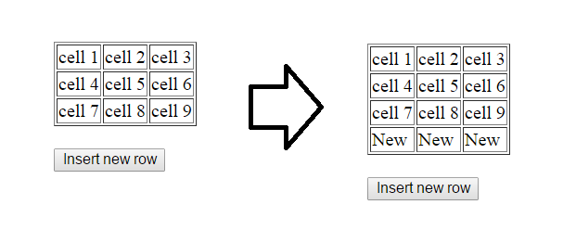

<!DOCTYPE html>

<html>

<head>

<style>

table, td {

border: 1px solid black;

}

</style>

</head>

<body>

<table id="myTable">

<tr>

<td>cell1</td>

<td>cell2</td>

<td>cell3</td>

</tr>

<tr>

<td>cell4</td>

<td>cell5</td>

<td>cell6</td>

</tr>

<tr>

<td>cell7</td>

<td>cell8</td>

<td>cell9</td>

</tr>

</table>

<br>

<button type="button" onclick="myFunction()">Insert new row</button>

<script>

function myFunction() {

var table = document.getElementById("myTable");

var row = table.insertRow(3);

var cell7 = row.insertCell(0);

var cell8 = row.insertCell(1);

var cell9 = row.insertCell(2);

cell7.innerHTML = "NEW";

cell8.innerHTML = "NEW";

cell9.innerHTML = "NEW";

}

</script>

</body>

</html>