Figure 1: Creating Cluster (Instance Hosted)

Figure 2: Create a database user

Figure 1 & Figure 2 represents steps to follow on MongoDB Atlas website (https://cloud.mongodb.com/).

Figure : Connecting to instance

Figure : Create Database and initial collection (Create a simple database schema and attach to the instance)

Figure : Create a collection

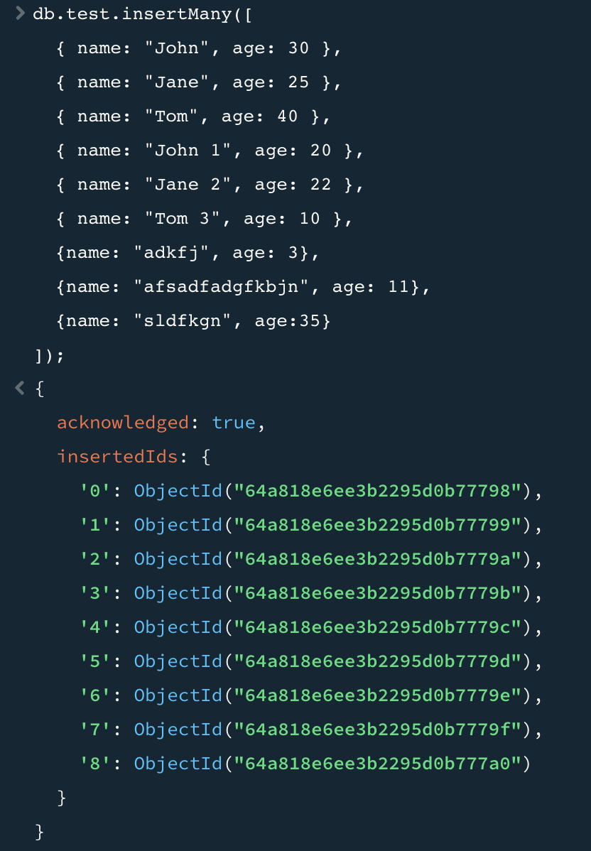

Figure : Insert Query (A query to insert multiple records and result)

Figure : Retrieval query to get all records. (A query to retrieve multiple records and result)

Figure : Update query with old record (A query to update a record and result)

Figure : Retrieve modified record (A query to retrieve a specific record and result)

Figure 10: Database connected using created admin user

Figure 11: Sample Database schema

Figure 3, Figure 4, Figure 5, Figure 6, Figure 7, Figure 8 & Figure 9 is done on MongoDB Compass application.

Caption represents description of steps performed.