Computer Communications and Networks (COMN)
2022/23, Semester 1

Assignment 2 Results Sheet

Forename and Surname: | Samuel Jacob
Matriculation Number: | s1940522

Question 1 – Number of retransmissions and throughput with different retransmission timeout values with stop-and-wait protocol. For each value of retransmission timeout, run the experiments for 5 times and write down the average number of retransmissions and the average throughput.

Retransmission timeout (ms) | Average number of  retransmissions | Average throughput  (Kilobytes per second)
5
10
15
20
25
30
40
50
75
100

Question 2 – Discuss the impact of retransmission timeout value on the number of retransmissions and throughput. Indicate the optimal timeout value from a communication efficiency viewpoint (i.e., the timeout that minimizes the number of retransmissions while ensuring a high throughput).

Question 3 – Experimentation with Go-Back-N. For each value of window size, run the experiments for 5 times and write down the average throughput.

 | Average throughput (Kilobytes per second)
Window Size | Delay = 5ms | Delay = 25ms | Delay = 100ms
1
2
4
8
16
32
64
128
256

Create a graph as shown below using the results from the above table: 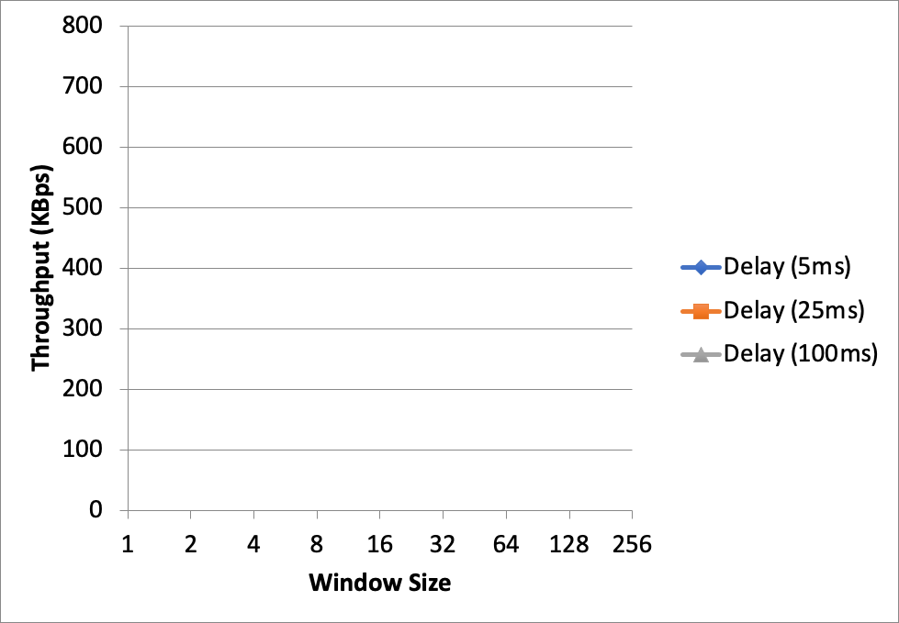

Question 4 – Discuss your results from Question 3.

Question 5 – Experimentation with Selective Repeat. For each value of window size, run the experiments for 5 times and write down the average throughput.

 | Average throughput (Kilobytes per second)
Window Size | Delay = 25ms
1
2
4
8
16
32

Question 6 - Compare the throughput obtained when using “Selective Repeat” with the corresponding results you got from the “Go Back N” experiment and explain the reasons behind any differences.

Question 7 – Experimentation with iperf. For each value of window size, run the experiments for 5 times and write down the average throughput.

 | Average throughput (Kilobytes per second)
Window Size (KB) | Delay = 25ms
1
2
4
8
16
32

Question 8 - Compare the throughput obtained when using “Selective Repeat” and “Go Back N” with the corresponding results you got from the iperf experiment and explain the reasons behind any differences.

