D1 mini pro

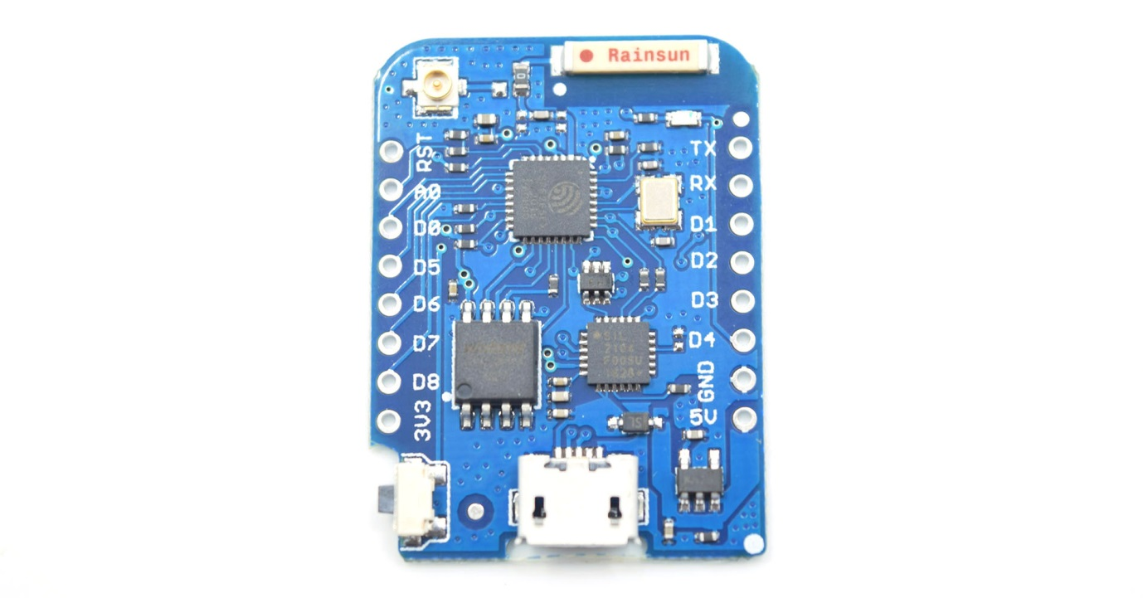

PreviousNext

**Description:** The D1 mini Pro is a mini wifi board based on ESP-8266EX. ([Buy it](https://www.aliexpress.com/store/product/WEMOS-D1-mini-Pro-16M-bytes-external-antenna-connector-ESP8266-WIFI-Internet-of-Things-development-board/1331105_32724692514.html))

**Features:**

* 11 digital input/output pins
* Interrupt/pwm/I2C/one-wire
* 1 analog input(3.2V max input)
* 16M bytes(128M bit) Flash
* External antenna connector
* Built-in ceramic antenna
* New CP2104 USB-TO-UART IC
* Same size as D1 mini, but more light

**Tutorial:**

* [Get started in Arduino](https://www.wemos.cc/tutorial/get-started-arduino.html)
* [Get started in NodeMCU](https://www.wemos.cc/tutorial/get-started-nodemcu.html)

**Technical specs**

|  |  |
| --- | --- |
| **Microcontroller** | **ESP-8266EX** |
| Operating Voltage | 3.3V |
| Digital I/O Pins | 11 |
| Analog Input Pins | 1(Max input: 3.2V) |
| Clock Speed | 80MHz/160MHz |
| Flash | 16M bytes |
| Length | 34.2mm |
| Width | 25.6mm |
| Weight | 2.5g |

  สำคัญมากเพราะขาไม่ตรงกัน เช่น D3 ต้องกำหนดเป็น GPIO0 ดูตัวอย่าง GPS_read.ino

**Pin**

|  |  |  |
| --- | --- | --- |
| **Pin** | **Function** | **ESP-8266 Pin** |
| TX | TXD | TXD |
| RX | RXD | RXD |
| A0 | Analog input, max 3.3V input | A0 |
| D0 | IO-*------------------------ | GPIO16 |
| D1 | IO, SCL | GPIO5 |
| D2 | IO, SDA | GPIO4 |
| D3 | IO, 10k Pull-up | GPIO0 |
| D4 | IO, 10k Pull-up, BUILTIN_LED | GPIO2 |
| D5 | IO, SCK | GPIO14 |
| D6 | IO, MISO | GPIO12 |
| D7 | IO, MOSI | GPIO13 |
| D8 | IO, 10k Pull-down, SS | GPIO15 |
| G | Ground | GND |
| 5V | 5V | - |
| 3V3 | 3.3V | 3.3V |
| RST | Reset | RST |

[**All of the IO pins have interrupt/pwm/I2C/one-wire support except D0**](https://www.wemos.cc/product/d1-mini-pro.html)

**OLED ขนาดจอภาพ 64x48 (0.66 นิ้ว) ได้อักษรดังนี้**

โหมด (0) oled.setFontType(0)

ได้อักษร หนึ่งบรรทัด 10 ตัว และได้ 6 บรรทัด โดยตำแหน่งเริ่มหัวแต่ละบรรทัดคือ 0, 8, 16 ,24 32 ,40

**ตัวอย่างโปรแกรมแสดงผล**

oled.setFontType(0);

for(int i=0;i<48;i=i+8){

oled.setCursor(0, i);

oled.print(String(i));

}

oled.display(); // Draw the memory buffer