Lab 11: Training from scratch

Shido Nakajima

04/28/2023

04/28/2023

**OBJECTIVE:** The objective of this lab was to gain deeper understandings of the MATLAB deep learning functions, and ultimately be able to build and train a CNN of my own.

**METHODS:** For sections A and B, I simply followed the directions given in the documentation.

For section C, I searched up an image from the web and resized using imresize(I,[28 28]), which was then converted to gray scale by im2gray(I). Then, using classify(net,I) as in the directions and the example, I classified the image from the web.

**RESULTS:**

Section A:

How many layers are listed?

15 layers

How many convolutional layers?

3 convolutional layers

How many Fully connected layers

1 fully connected layer

In the deepest (highest number is the last of these) convolutional layer, how many feature maps (number of filters) are present?

32 feature maps

How many images were in the validation set?

2500 images

Section B:

1. From 0.9872 to 0.9964, an increase of 0.092.
2. Original accuracy graph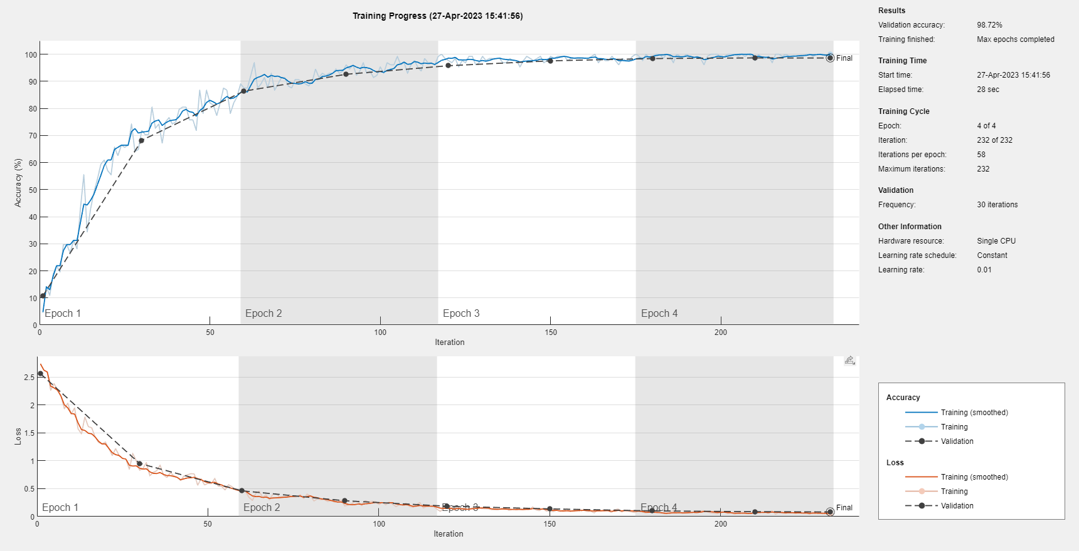

Learning rate of 0.001, number of epochs of 10

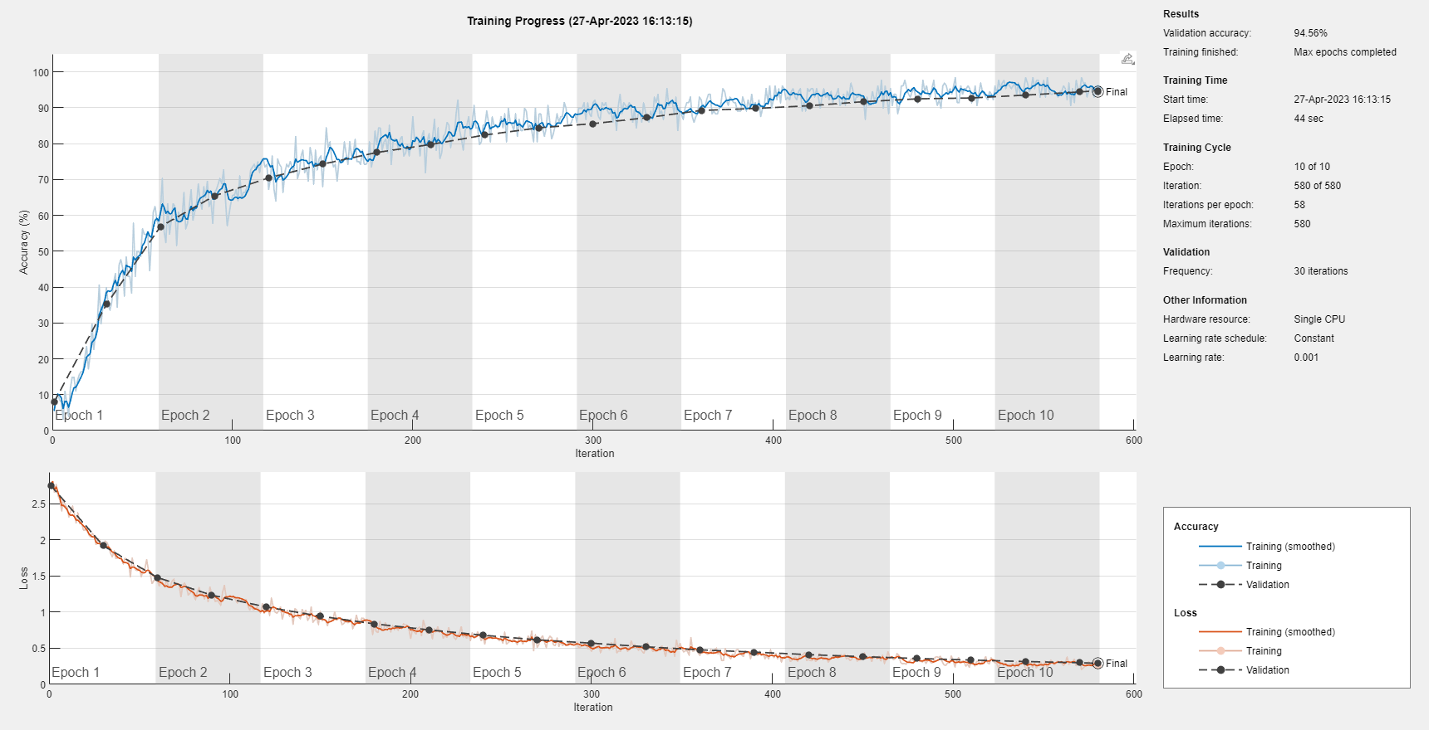

The validation accuracy decreased as compared to the original. The plotted data on the graph are much finer, with much more noise-like irregularities in the validation accuracy. Additionally, the original graph approached accuracy of 100% much faster than the altered training.

1. The accuracy changed from 0.9872 to 0.9936, with an increase of 0.064. This does make sense, as increasing the number of feature maps is increasing the number of features that the layer can detect, which effectively allows more robust detection of features.

Section C:

The classification that this image was given was 8 with a score of 0.8596 (the score for classification of 2 was 0.0697). I believe that this is due to a few factors: the insufficient training of the neural network, the amount of additive design to the original illustration, and the limited size of the input image. Since the training options were set to be done in a short amount of time for numbers without any additive design, it can be said that the training was not enough or unfit for classifying numbers with this much degree of added elements. Additionally, the logo ribbon at the bottom most likely made the classification think that this image was the number 8. Finally, the blurred input image makes the added features seem merged to the actual number itself, making it difficult for the classification to distinct the shape of the number from everything else.

**CONCLUSION:** Through the lab I was able to further understand each of the options and arguments that the neural network was intaking, allowing me to edit and make neural networks myself.