Samuel Ndegwa Mwaniki

1.

2.a) Using an appropriate application of your choice, show the design and implementation of horizontal scaling, documenting the design decisions.

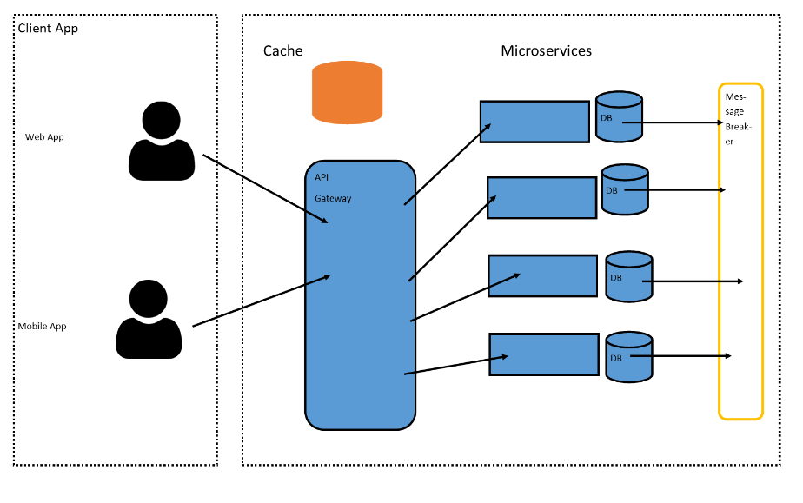
2. b) Diagram and describe how cache systems can go wrong and mitigation strategies.
c) HealthIT implements system observability for the health of the systems it implements. Diagram the definitions and typical architectures of system observability pillars.

system observability pillars
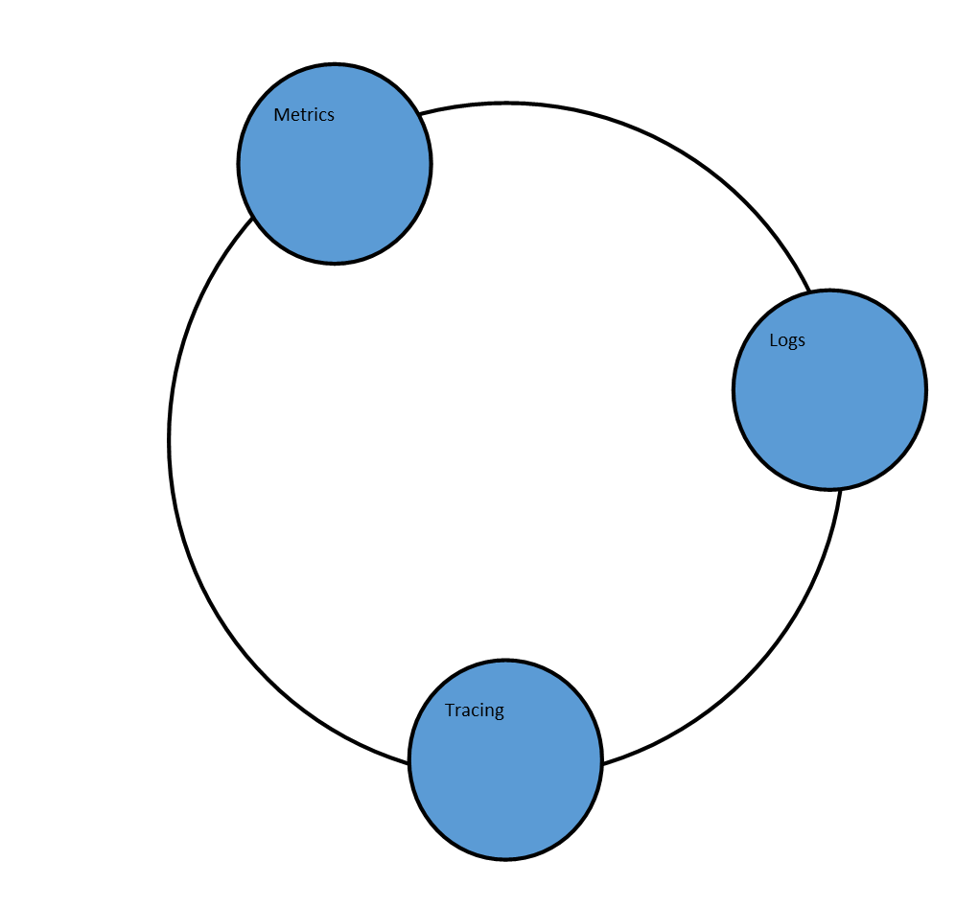

3. a) Using an RDBMS of your choice, write the query that would be used to identify the duplicates and send the output to a csv file, indicating the pros and cons of each of the three methodologies.

Answer
SQL Query to get the duplicate.

new_list = SELECT phone_numbers,id_numbers FROM beneficiaries_table GROUP BY phone_number, id_number HAVING (COUNT(phone_number)>1) AND (COUNT(id_number)>1);

#Export to excel using python

with xlsxwriter.Workbook('test.xlsx') as workbook:
worksheet = workbook.add_worksheet()

for row_num, data in enumerate(new_list):
worksheet.write_row(row_num, 0, data)

b) Dead tuples. Why do they exist? How can they be managed? How can they be avoided?

Answer
Dead tuples occure when a row is deleted or updated in a database especially in PostgreSQL.
Dead tuples can be managed by reclaiming the spaces. This can be done by use of VACCUUM, VACCUM ANALYZE, or VACCUM .
Dead tuples can be avoided by use of ON CONFLICT DO NOTHING clause

c) Using RDBMS of your choice, design and implement replication using schematic representation and detailed description.

d) What is database sharding? Why is it important? Describe the different strategies
for implementing database sharding using a diagram.

Answer
Database sharding is the process of storing a large database across multiple machines.

Database sharding prevents a scenario where by the application fails due to the failure of the computer hosting the database. Failure of one of the computers does not shut down the application because it can operate with other functional shards.


