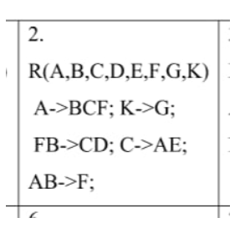

1. A -> B; A1+ = {ACFE} 1
2. A -> C; A2+ = {ABFCED} (~~1~~ 3 ~~5~~)

9 ← 3 ← 9

2 ← 3

1. A -> F; A3+ = {ABCDEF} (~~1~~ 9)
2. K -> G; K4+ = {K} 1
3. FB -> C; FB5+ = {FBD} 1
4. FB -> D; FB6+ = {FBCAEB} 1
5. C -> A; C7+ = {CE} 1
6. C -> E; C8+ = {CABFD} 1
7. AB -> F; AB9+ = {ABF} (3)

1. A -> B 1. A -> BF

3. A -> F 3. K -> G

4. K -> G 4. FB -> CD

5. FB -> C 7. C -> AE

6. FB -> D

7. C -> A

8. C -> E

R1(KG) R1(ABCDEFK)

R2(CAE) R2(BCDFK)

R3(BFCD) R3(BFK)

R4(BFK)

1) A -> BF; 3) K -> G; 4) FB -> CD; 7) C -> AE;

|  |  |  |  |  |  |  |  |  |
| --- | --- | --- | --- | --- | --- | --- | --- | --- |
|  | **A** | **B** | **C** | **D** | **E** | **F** | **G** | **K** |
| **R1** | b11 | b12 | b13 | b14 | b15 | b16 | a7 | a8 |
| **R2** | a1 | b22, a2 | a3 | b24 | a5 | b26, a6 | b27 | b28 |
| **R3** | b31, a1 | a2 | a3 | a4 | b35, a5 | a6 | b37 | b38 |
| **R4** | b41, a1 | a2 | b43, a3 | b44, a4 | b45, a5 | a6 | b47, a7 | a8 |