What People Want?



Idea:

Many people want something near their homes or in their region. So this application will try to make people`s wishes come true. And it will help to a new businessmen.For example: Somebody want a swimming pool in his city, can write «I want a new swimming pool,in the my city». If some people will want this thing too, they can click(tap) «I want too». And this «wish» will be more popular. So if some businessman will think what he should open or build,he can open this application and watch what is the most popular in some location. After that he can choise the most profitable service. So we make a application that will help to businessmans to open their business and make more comfortable life to simple peoples.

Instruction:   
1)You need to download and install app(url will be later).2)You should to tap «Sign Up»(main_page ),and  
feel all fields.(registration_page). (main_page)

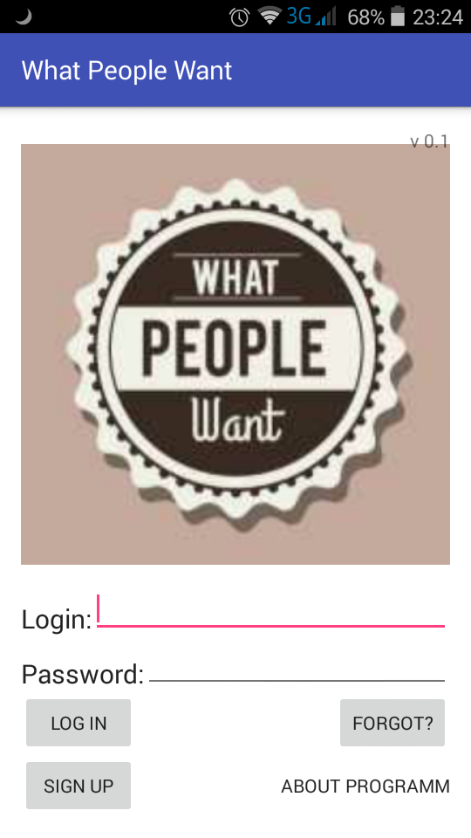

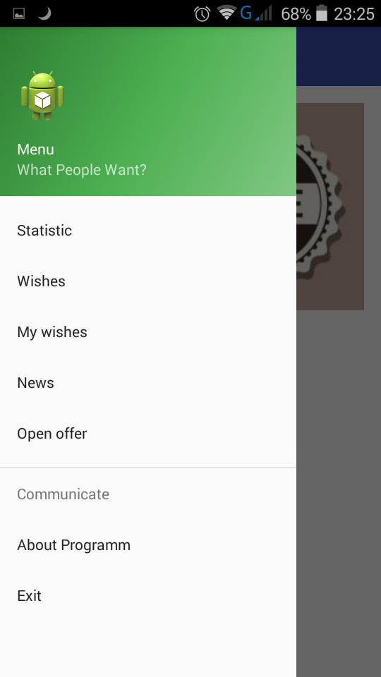  
3)In your page will be your data.

4)If you are just a user and want something you can tap to wishes and in this page you will write what you want and where you want it. And if soem peoples like it they will can tap «Like» in the News.

5)If you are businessman or employer. If you finded profitable proposition , you can tap to «Open offer » and write like «I will build/start a <business> in the <city,street>».

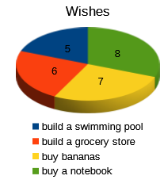 6) After that peoples can say: Finally I will have what I wanted.

7) If you want know more about us and our application. You can tap «About us» in the menu or in the main_page.

8)In the page «Statistic» will be statistic about some business in some region. For example:Some peoples want pool in the city, some people want bakery, some people want a new clothe shop.And in pie chart will be ratio of this wishes.

9)In the page «My wishes» will be all user`s wishes.

10) In the page «News» will be everything that connected to their wishes.

Help/contanct:

If you have some questions or offers you can write to e-mails:

k-mustafin@bk.ru

rishat.sabirov@bk.ru

Specifications:

It will be work on android 4.0 and upper.

Registration:

Then you downloaded and first time openned application you should to regist! So in (main_page) you will tap to «Sign up», and feel all fields. It is important to feel all fields, because all this things we should know.

You will should write: Password, Name, Surname, City, Country and E-mail.

Credits:

Android client created by Mustafin Kamil,  
on API and Database parts worked Sabirov Rishat,  
tutor, teacher Nafikov Danil Rashidovich.

License:

Copyright (C) 2016 Mustafin Kamil&Sabirov Rishat.  
Under MIT license.