Airline Ticket Management System

Computer programming project report

CSL-113

Semester BSCS-(1-A) Fall 2019

Submitted to:

Faiza Khan

Submitted by:

Abdullah Abdul Wahid - 02-134192-015

Fazeel Zafar – 02-134192-010

Date : 27-12-2019

Index

Abstract ---------------------------------------------------------------------------------------------- Page 3

Introduction ------------------------------------------------------------------------------------------ Page 4

Related Work ----------------------------------------------------------------------------------------- Page 5

Detail Design and Solution ----------------------------------------------------------------------- Page 6-7

Hardware & Software Specification ------------------------------------------------------------ Page 7

Results --------------------------------------------------------------------------------------------- Page 8-11

Testing & Validation --------------------------------------------------------------------------- Page 12-16

Lesson ---------------------------------------------------------------------------------------------- Page 17

References ----------------------------------------------------------------------------------------- Page 18

**Abstract**

The main purpose of designing the Airline Ticketing system is to deal with all the data management and methodologies related to booking a ticket. It includes creating, editing, viewing or deleting a ticket. All of the common needs of a consumer while booking tickets manually are covered by this project. A lot of different methods are used here and the requirements of a user are met phenomenally. From selecting the seat to confirming their reservation, most of the things are covered in this project. This software efficiently collects all the data required in the reservation of a ticket and processes it to generate a ticket after checking all the content comprehensively. It is easy to use and very user friendly with step by step procedural inputs and outputs. Overall, this project can be used in a very wide scope and has potential to improve the lives of a common user who likes to travel a lot.

**Introduction:**

Purpose & Motivation:

In the designing of this project we aimed at making the ticket booking process extremely easy and compact for the average user. It has simple steps that go through the entire process efficiently and it allows the user to change or edit his details at any given point. It aims at making it simple and effective. An average user can sit at the kiosk, register himself as a user and book the ticket within minutes along with the options to edit and delete his reservations without any hassle of dealing with people or social interaction. The motivation of this project is obviously to improve the efficiency and ease out the process of booking tickets and saving the user from having to travel or interact with others as well as the need to wait in Queues and other hassles.

Aims & Reasons:

We aimed to achieve a simple and comprehensive user interface in order to make it easy and simple to book a ticket. Overall this project checks most of the needs of a user. Of course every software has room for improvement and this one is no different. With a little bit of fine tuning, this project can be deployed commercially and it will make the hassles at the airport / booking places very less and more user friendly. The reason to do this is to improve the entire process as well as make it quicker and easier for the end user who has to go through a number of obstacles just to have a simple reservation booked.

**Related Work:**

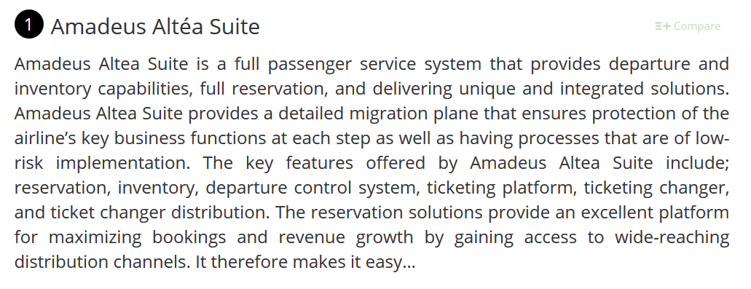

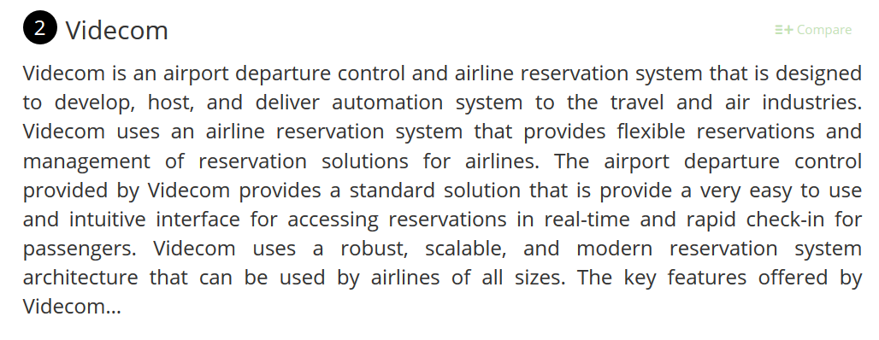

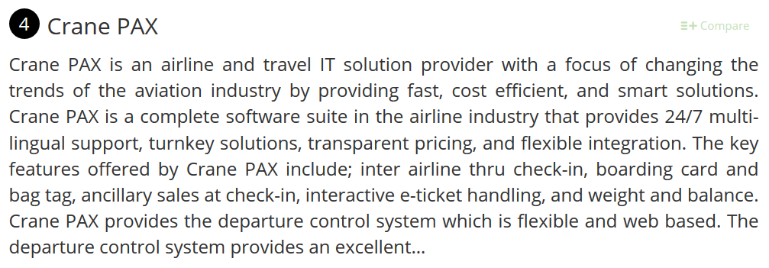

**Detail Design and Solution:**

**Project Functionality Description:**

* + First of all the system will show up an Introduction screen.
  + After that, a new screen will open with 3 options.
  + 1) Registration.
  + The user to input his information to register himself as a user and then the login screen will popup.
  + 2) Already existing users will go the login screen through this option.
  + The login screen will let you input the registered details and verify them with the saved ones to see if it’s an already existing user or not. Accordingly you can move on.
  + 3) This option lets you exit the program.
  + After the login screen, the MAIN screen of the program appears. Also on this screen a one time session number will be generated. This is the number that will be used for all processing of tickets in this particular session.
  + There are a total of 6 options available here.
  + 1) Create new ticket.
  + This option lets you create a new reservation. It will take all the necessary details , let you choose a seat from the displayed, and go through the payment method before confirming your reservation.
  + 2) Edit ticket.
  + This option will allow the user to enter the session number with which the ticket was booked, and then the user can edit all the different details here the way he wants to.
  + 3) Delete ticket.
  + This feature will allow the user to delete his booked tickets using the same session number.
  + 4) Print ticket.
  + This feature will allow the user to display the specific ticket that they booked using the session number and then it can be printed in hard copy form.
  + 5) Luggage allowance details.
  + This option will display all the information regarding the luggage allowance of the flight.
  + 6) Exit.
  + This option will exit the program.

This program only has the user module.

**Hardware and software specifications**

**Hardware requirement :**

* OS:Window 7
* Hard Drive: 40GB
* RAM: 256 MB

**Software requirement**

* Java language
* Net beans IDE 7.0.1
* MS SQL server 2005
* U can add diagrams like this to show functionalities

**Results:**

Here is the registration method:

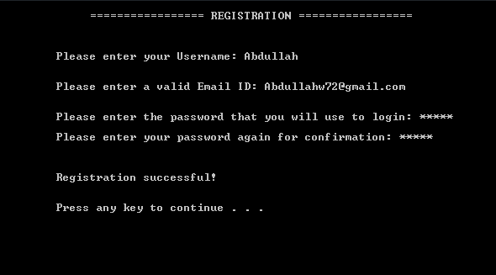

After registration. User can login using the registered details.

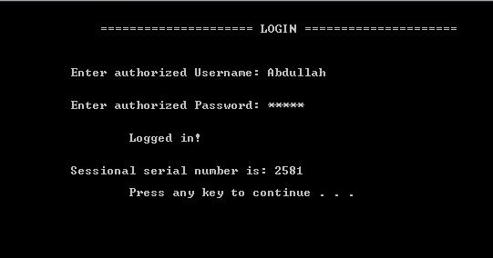

After that, the main menu appears as follows:

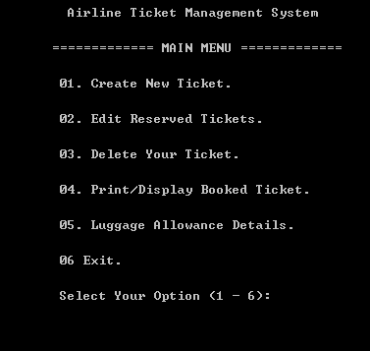

Option 1 is used to book a ticket:

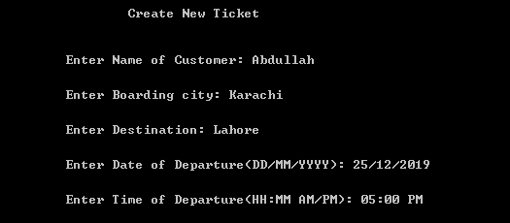

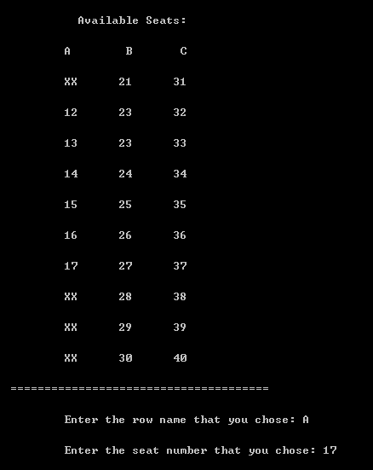

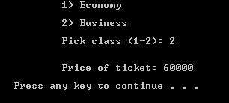

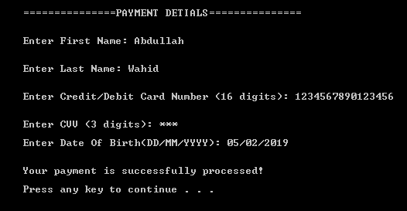

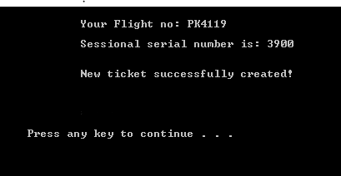

**Testing and Validation**

Testing is an essential part of a program. We have used effective strategies for most of the values being taken by user. Data input is verified either by the present data in filing for verification or by the standards/syntax of the data to make sure it’s in the correct form as it’s supposed to be.. Many inputs are re-taken if the data is not correct and the correction checking will continue to go on until a fully correct data is input, through loops. The data will then be used for further processing after it is made sure that it is correctly input. Testing is extremely important for an efficient program.

.. some examples of our testing are as follows:

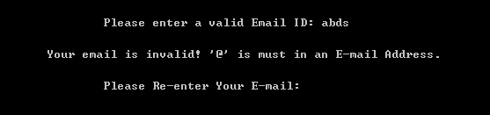

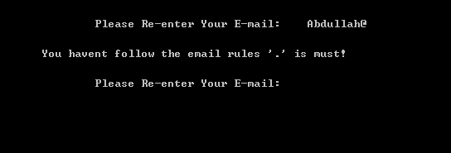

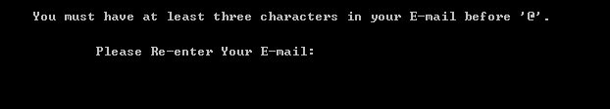

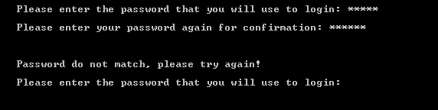

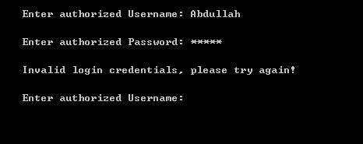

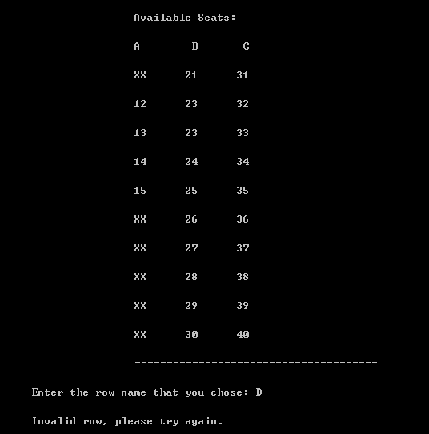

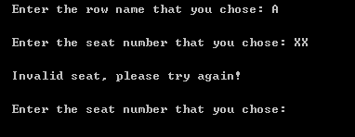

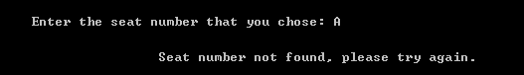

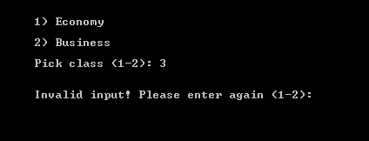

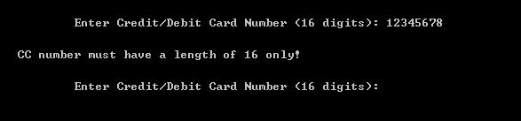

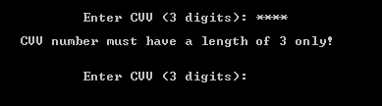

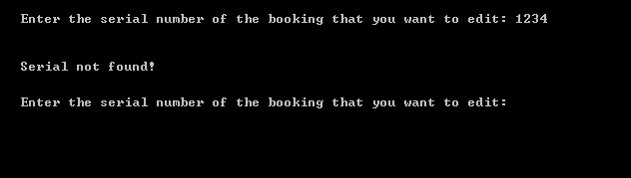

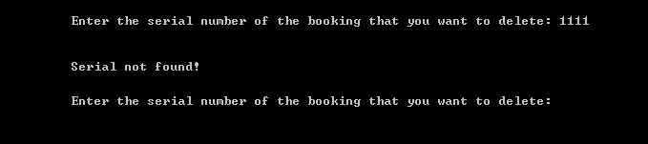

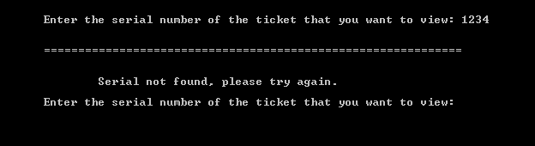

**Lesson Learnt:**

The Evaluation is very important. What **lessons were learnt during the course of the project**? Evaluate (with hindsight) both the product and the process of its production. Don’t forget to sell your work**! Tell the reader what was good, what was achieved.** Be honest about limitations – these can be suggestions for future work. (yaha aap limitations ki heading me discuss krege k ye ye kam mera system abho nahi krskta h. future work me btaskte h k ye ye behtri improvement askti h kaam me.)

Effective project management was learned through the handling of this project. The ability to develop effective solutions to complex problems as well as thorough debugging was learnt. In order for the system to be effective, a lot of thorough thinking needs to be done and all possible problems need to be identified and solved before hand. Breaking down the problem is a key method that we have learned through the development of this project. Making user friendly UI and error correction was also learned.

A lot was achieved with this project. Effective processing of tickets and managing them was learnt here. It is very easy to book the tickets with this platform and even easier to change/delete them. It’s easy to keep track of your booked tickets, and the fact that all the data is saved and nothing is lost during processing.

Limitations

The product is itself decent at this point and can use some improvements to make it much better . Every system has it’s own limitations and this is no different. There needs to be a better, cleaner interface with more interactive-ness and the feeling of it being a bit more alive and alight. This system cannot achieve the proper payment system right now but it can be done in the future. Also the seating system is a little bit limited and needs improvement. Some inputs have no verification/validation which also needs to be added.

**References**

<https://www.predictiveanalyticstoday.com/top-airline-reservation-system/>

<https://www.capterra.com/airline-reservation-system-software/>

<https://stackoverflow.com>

<https://www.getapp.com/hospitality-travel-software/airline-reservation-system/>

<https://en.wikipedia.org/wiki/Airline_reservations_system>

<https://www.provab.com/airline-reservation-system.html>