CKPC React Native
Mobile Architecture Overview
Feature-sliced Expo (React Native) application
Prepared for architecture review
Author: Sudhakar | Repo: github.com/sPRajapati/CKPC-React-Native-Architecture

Contents

1. Executive Summary
This document describes the architecture of the CKPC React Native application: a production-oriented Expo app built on a feature-sliced structure. The goal is a codebase that scales with the team, keeps a clear separation of concerns, and is straightforward to test, extend, and operate.
Key characteristics:
- Feature-first organization — every feature owns its screens, components, services, state, and types in one folder.
- Clear state split — Redux Toolkit for client/session state, React Query for server state.
- Strict conventions — a single import alias (@/), dot-notation module naming, one-directional layer dependencies.
- Enterprise-ready cross-cutting concerns — token refresh, global error handling, an observability seam, secure storage, theming, localization, and white-labeling.
- Fully open-source dependency stack (MIT / ISC / Apache-2.0) with automated quality gates.

2. Technology Stack
Concern | Choice | Why
Runtime / tooling | Expo (managed), React Native, TypeScript | Fast iteration, OTA-ready, strong typing
Navigation | React Navigation (native-stack + tabs) | Standard, declarative, deep-link ready
Client state | Redux Toolkit + react-redux | Predictable session/UI state, typed
Server state | TanStack React Query | Caching, refetch, retries built in
HTTP | Axios (interceptors) | Token injection + 401 handling in one place
Localization | i18next + react-i18next | English + Spanish, device-aware
Storage | expo-secure-store + AsyncStorage | Keychain/Keystore for tokens, async for prefs
Testing | Jest + Testing Library | Unit + reducer + service coverage

3. Architecture Principles
- Feature-first. Everything a feature needs lives under features/<feature>/. Features are self-contained and can be reasoned about, tested, or removed in isolation.
- Shared, not global. Cross-feature building blocks live in shared/. App-wide plumbing lives in api/, store/, navigation/, i18n/.
- One-directional dependencies. UI depends on logic, logic on state, state on services, services on transport. Nothing lower reaches back up.
- State by ownership. Data we own (session, UI) is Redux; data we cache from the server is React Query. The two never store the same thing.
- One import style. The @/ alias points at src/. Cross-feature imports use @/; only intra-folder imports are relative.

4. Project Structure
src/
api/ axios, interceptors, endpoints, React Query client, dev mock
store/ configureStore + typed hooks (slices live in features)
navigation/ RootNavigator, Auth/App navigators, navigationRef, routes
i18n/ i18next setup + locales (en, es)
shared/ components (atomic), theme, storage, config, hooks,
session, security, monitoring, feedback, utils, types
features/
auth/ auth.slice, auth.api, screens, hooks, refreshSession
home/ home.api, useHomeData (React Query), screens
profile/ profile.slice, screen, hook
settings/ settings.slice, screen (theme/language/notifications)

5. Layered Architecture
Within a feature, code is organized into layers with a single direction of dependency:
Layer | Responsibility | Example
Presentation | Render UI, capture input, call the feature hook | LoginScreen.tsx
Screen logic | Validation + orchestration (hooks) | useAuthForm.ts
State | Client/session state via slices + thunks | auth.slice.ts
Service | Typed endpoint calls (what to call) | auth.api.ts
Transport | How requests are sent: base URL, token, 401 | axios.ts + interceptors.ts
Cross-cutting: navigation (Auth vs App switch, navigationRef), shared (UI, theme, storage, config, monitoring, feedback), and i18n.

6. State Management Strategy
The single most important technical decision is the split between client state and server state.
Aspect | Redux Toolkit | React Query
Owns | Session, auth token, UI toggles | Server data (e.g., Home feed)
Examples | auth.slice, settings.slice | useHomeData (useQuery)
Gives you | Predictable, typed mutations | Caching, dedup, refetch, retries
Rule of thumb | State we own | A cache of data we do not own

7. Data Flow — Login Example
A user enters credentials and taps Log in. The request travels down the layers and the result flows back up:
- UI — LoginScreen calls login({ email, password }) from useAuthForm.
- Screen logic — useAuthForm validates input; if valid, dispatches loginThunk and returns the unwrapped promise.
- State — loginThunk sets loading, then calls the auth service.
- Service — auth.api posts to the login endpoint, returning a typed ApiResponse.
- Transport — the request interceptor attaches the token; in dev with no backend, a mock returns a canned success.
- Back up — on success, applyAuth writes token + user into Redux and persists them (SecureStore + AsyncStorage).
- Navigation — RootNavigator observes state.auth.token and swaps the Auth stack for the App (tabs). No manual navigation call.
Error handling: validation errors short-circuit before any request; server/network errors are normalized and surfaced on screen; a 401 on any later request triggers a single silent token refresh + retry before falling back to logout.

Application & API Workflow Diagram
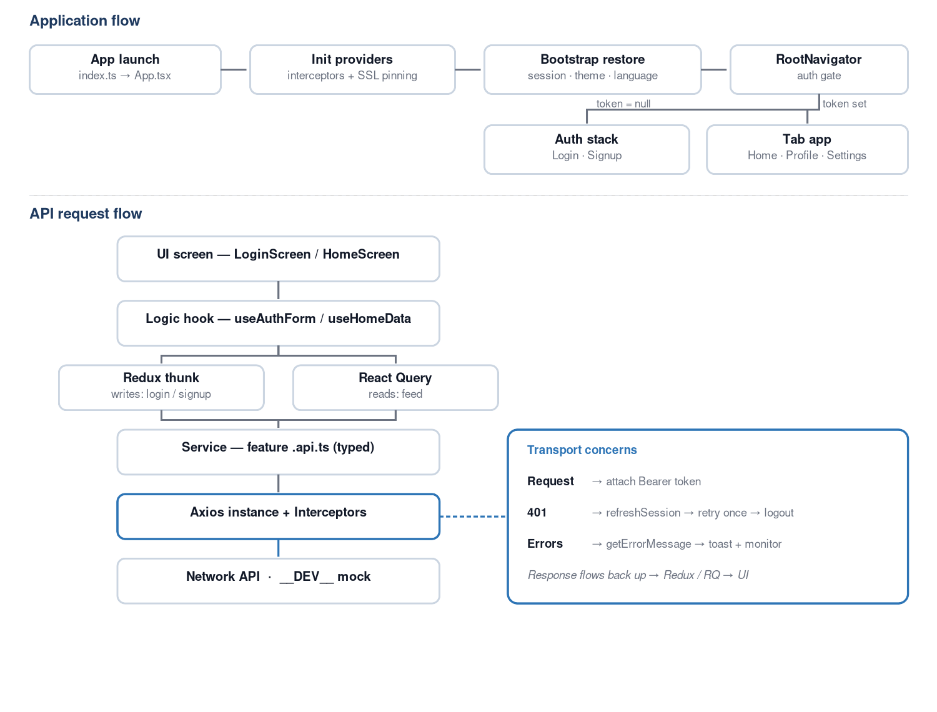

8. Cross-Cutting Concerns

Authentication & Session
- Token persisted in SecureStore (Keychain/Keystore); user in AsyncStorage; session restored on startup via hydrateAuth.
- Central logout coordinator used by both the logout button and the 401 handler.
- Token refresh: on 401 the interceptor calls refreshSession (de-duplicated) and retries once before logging out.

Resilience & Observability
- Global ErrorBoundary catches render crashes and reports to the monitoring seam.
- Toast system surfaces errors consistently; React Query errors auto-report and auto-toast.
- Vendor-agnostic monitoring interface (logEvent / captureError / setUser) — swap in Sentry/Firebase without touching call sites.

Security
- SSL public-key pinning scaffolded (disabled until certificates are provided).
- Secure token storage; no secrets committed; dev-only mock gated behind __DEV__.

Theming, Localization & White-label
- Light/dark theme with persisted mode; navigation and screens are theme-aware.
- i18next with English + Spanish, device detection, and persisted language choice.
- White-label via app.config.ts (APP_BRAND) with runtime brand config through expo-constants.

9. Enterprise Capabilities
Capability | Status | Location
Session persistence + startup restore | Implemented | auth.slice, storageUtils, AppBootstrap
Token refresh on 401 | Implemented | api/interceptors, refreshSession
Global error boundary + toast | Implemented | app/ErrorBoundary, shared/feedback
Monitoring / analytics seam | Implemented | shared/monitoring
Theme (light/dark, persisted) | Implemented | shared/theme
White-label / multi-brand | Implemented | app.config.ts, brandConfig
Permissions module | Implemented (optional deps) | shared/permissions
SSL pinning | Scaffolded | shared/security/sslPinning

10. Conventions
- Feature folders: kebab-case (auth, home, bill-payment).
- Logic modules: dot-notation (auth.slice.ts, auth.api.ts, auth.types.ts).
- Components: PascalCase.tsx. Hooks: useX.ts.
- Imports: @/ for cross-feature/shared; relative only within a folder.
- UI: atomic design under shared/components (atoms / molecules / organisms / templates).

11. Quality & Tooling
- TypeScript strict mode across the codebase.
- ESLint (Expo config + filename-case rule).
- Husky pre-commit runs typecheck; commit-msg enforces Conventional Commits (commitlint).
- Jest test suite (validation, auth slice incl. refresh, dev mock) — all passing.
- GitHub Actions CI: install, typecheck, lint, test on every push and PR.

12. Dependencies & Licensing
Every dependency is free and open-source, safe for commercial use, with no copyleft (GPL/AGPL) obligations.
License | Count | Notes
MIT | 35 packages | React, React Native, Expo, Redux, React Query, navigation, tooling
ISC | 1 (lucide-react-native) | Functionally equivalent to MIT
Apache-2.0 | 1 (typescript) | Permissive, includes patent grant
Note: the libraries are free. Optional hosted services (e.g., Expo EAS cloud build/OTA) have free and paid tiers, but local builds cost nothing.

13. Deliberate Exclusions & Roadmap
Intentionally excluded to keep the MVP lean (add when a real requirement appears):
- Analytics/notifications vendors, web support, and committed native folders (managed Expo generates them).
- Demo-only content (sample product/user services).
Recommended next tier:
- Runtime response validation (zod) and react-hook-form on forms.
- React Query offline persistence + offline banner; FlashList for long lists.
- Enforced module boundaries (eslint-plugin-boundaries); dependency-cycle checks in CI.
- Biometric unlock, idle session timeout, EAS Update (OTA) with forced-update gate.

14. Getting Started
npm install --legacy-peer-deps
npm run typecheck && npm test
npx expo start # press a (Android) / i (iOS)
Dev login (offline mock): test@example.com / Password123. The Home feed reads from a live public API to demonstrate React Query behavior.

