Ideation Phase
Empathize & Discover
Date | 17 October 2026
Team ID
Project Name | StaffSync — Human Resource Management System
Maximum Marks | 4 Marks

Empathy Map Canvas
Understand the needs, frustrations and behaviour of the three groups of people who use an HR management system every day — HR administrators, managers and employees — before defining the problems StaffSync must solve.
Evidence basis: StaffSync has no recorded user interviews, surveys or observation notes. The personas and statements below are assumptions drawn from the problems that StaffSync’s requirements (docs/PHASE-0-REQUIREMENTS.md) and implemented features address. They should be validated with real HR staff, managers and employees.
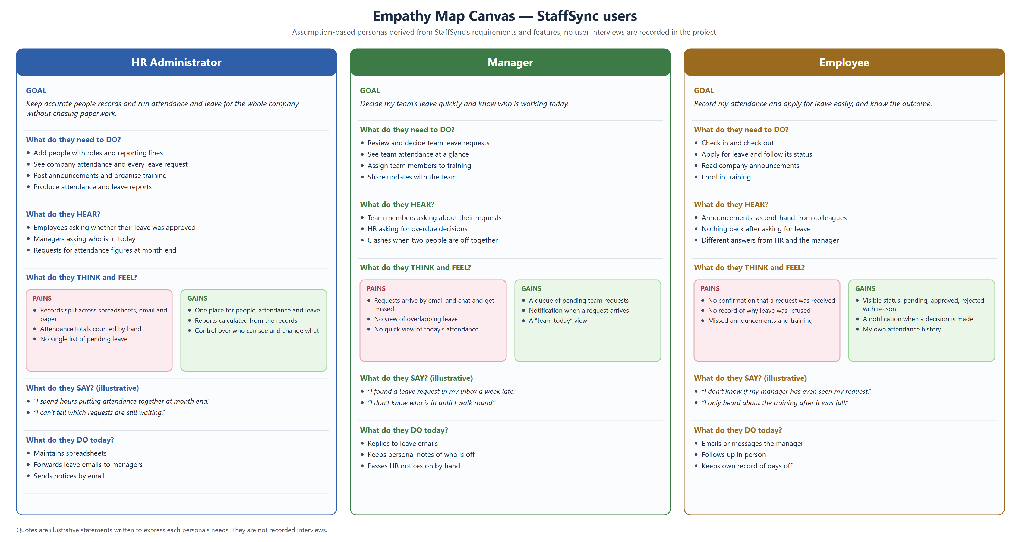
Figure 1 — Empathy map canvas for StaffSync’s three user roles

Canvas content by role
The same content as the canvas, as a table so it can be read and reviewed line by line.
Canvas area | HR Administrator | Manager | Employee
Goal | Keep accurate people records and run attendance and leave for the whole company without chasing paperwork. | Decide the team’s leave quickly and know who is working today. | Record attendance and apply for leave easily, and know the outcome.
What do they need to DO? | Add people with roles and reporting lines; see company attendance and every leave request; post announcements and organise training; produce attendance and leave reports. | Review and decide team leave; see team attendance at a glance; assign team members to training; share updates with the team. | Check in and out; apply for leave and follow its status; read announcements; enrol in training.
What do they HEAR? | Employees asking whether leave was approved; managers asking who is in; month-end requests for attendance figures. | Team members asking about requests; HR asking for overdue decisions; clashes when two people are off together. | Announcements second-hand; nothing back after asking for leave; different answers from HR and the manager.
THINK & FEEL — Pains | Records split across spreadsheets, email and paper; attendance counted by hand; no single list of pending leave. | Requests by email and chat get missed; no view of overlapping leave; no quick view of today’s attendance. | No confirmation a request was received; no record of why leave was refused; missed announcements and training.
THINK & FEEL — Gains | One place for people, attendance and leave; reports calculated from the records; control over who sees and changes what. | A queue of pending team requests; a notification when one arrives; a “team today” view. | Visible status (pending, approved, rejected with reason); a notification on decision; own attendance history.
What do they SAY? (illustrative) | “I spend hours putting attendance together at month end.” “I can’t tell which requests are still waiting.” | “I found a leave request in my inbox a week late.” “I don’t know who is in until I walk round.” | “I don’t know if my manager has even seen my request.” “I only heard about the training after it was full.”
What do they DO today? | Maintains spreadsheets; forwards leave emails; sends notices by email. | Replies to leave emails; keeps personal notes of who is off; passes HR notices on by hand. | Emails or messages the manager; follows up in person; keeps own record of days off.

How the canvas shaped StaffSync
Pain | StaffSync response (implemented) | Where in the product
Records scattered; counted by hand | Attendance recorded at check-in and check-out; reports calculated by the server | Attendance pages; HR Reports (`/api/reports/*`)
Leave requests lost in email | Leave requests stored with status; managers see a pending team queue; the manager (or HR when there is no manager) is notified | Leave pages; notifications (`notificationService.leaveRequested`)
No outcome or reason for the employee | Status shown to the employee; a rejection requires a reason; the employee is notified of every decision | `PUT /api/leaves/:id/reject` requires `rejectionReason`; `leaveDecided` notification
Missed announcements and training | Announcements targeted by audience with a notification; training shows seats left and enrolment | Announcements and Training pages
Unclear who can do what | Three roles enforced on the server for every request | `protect` + `authorize(roles)` middleware
Reference: https://www.mural.co/templates/empathy-map-canvas

