Ideation Phase
Define the Problem Statements
Date | 17 October 2026
Team ID
Project Name | StaffSync — Human Resource Management System
Maximum Marks | 2 Marks

Customer Problem Statement Template
To define the core problems HR administrators, managers and employees face when attendance, leave and company communication are handled by spreadsheet, email and word of mouth, and to use those problems to guide the development of StaffSync.
Evidence basis: StaffSync has no recorded user interviews, surveys or observation notes. The personas and statements below are assumptions drawn from the problems that StaffSync’s requirements (docs/PHASE-0-REQUIREMENTS.md) and implemented features address. They should be validated with real HR staff, managers and employees.
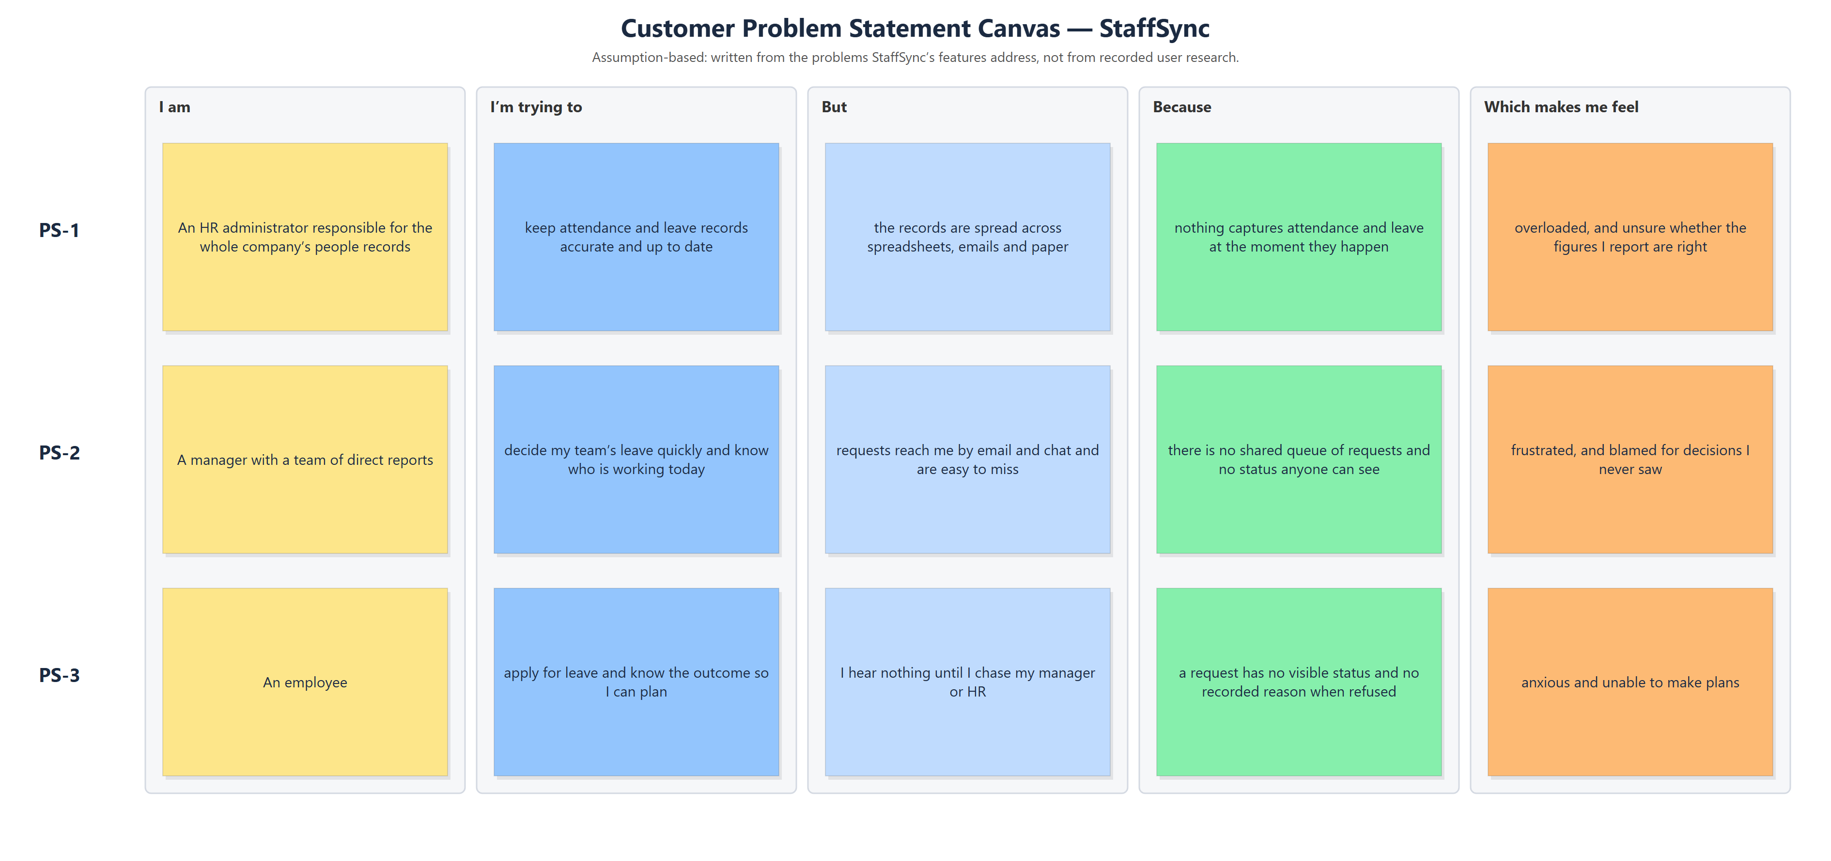
Figure 1 — Customer problem statement canvas
Reference: https://miro.com/templates/customer-problem-statement/
Problem Statement (PS) | I am (Customer) | I’m trying to | But | Because | Which makes me feel
PS-1 | An HR administrator responsible for the whole company’s people records | keep attendance and leave records accurate and up to date | the records are spread across spreadsheets, emails and paper | nothing captures attendance and leave at the moment they happen | overloaded, and unsure whether the figures I report are right
PS-2 | A manager with a team of direct reports | decide my team’s leave quickly and know who is working today | requests reach me by email and chat and are easy to miss | there is no shared queue of requests and no status anyone can see | frustrated, and blamed for decisions I never saw
PS-3 | An employee | apply for leave and know the outcome so I can plan | I hear nothing until I chase my manager or HR | a request has no visible status and no recorded reason when refused | anxious and unable to make plans

Traceability to the empathy map and the solution
PS | Empathy map pain (A1) | StaffSync requirement that answers it (B1)
PS-1 | HR: records split across tools; totals counted by hand | FR-4 Attendance, FR-5 Leave, FR-7 Reports
PS-2 | Manager: requests missed; no view of today | FR-5 Leave (team queue, decisions), FR-6 Dashboards, FR-10 Notifications
PS-3 | Employee: no confirmation, no reason | FR-5 Leave (status, mandatory rejection reason), FR-10 Notifications

