Ideation Phase
Brainstorm & Idea Prioritization Template
Date | 17 October 2026
Team ID
Project Name | StaffSync — Human Resource Management System
Maximum Marks | 4 Marks

Brainstorm & Idea Prioritisation
Brainstorming gives everyone an open space to suggest solutions, favouring volume over value at first and building on each other’s ideas. The ideas are then grouped and ranked by importance and feasibility, so the most valuable, achievable features are built first.
Evidence basis: no record of a brainstorming session (participants, date, sticky notes) exists in the project. This document reconstructs the idea set from what was built (git history, phases 1–21, 6–8 October 2026) and what was considered and left open (README “Known limitations”). The importance and feasibility placements are a retrospective judgement, not session votes.
Reference: https://www.mural.co/templates/brainstorm-and-idea-prioritization

Step 1 — Team gathering, collaboration and the problem statement
Item | Content
Participants | Not recorded. The git history has a single author (`sprashasti`).
Problem selected | PS-2 and PS-3 together (A2): leave and attendance are handled by email and memory, so managers miss requests and employees never learn the outcome.
“How might we…” | How might we give HR, managers and employees one trustworthy place where attendance and leave are recorded once, decided visibly and reported automatically?
Ground rules | Stay on topic · defer judgement · go for volume · build on others’ ideas · encourage wild ideas · be visual

Step 2 — Brainstorm, idea listing and grouping
Group | Ideas
A. People and access | Three roles (Employee, Manager, HR) enforced on the server · accounts created by HR, no self-registration · employee profiles with department, designation and reporting line · several companies on one installation, each isolated · last active HR can never be removed
B. Daily operations | One-click check-in and check-out with server time · half day under 4 hours · leave application with approve / reject workflow · overlap detection · decide-once rule · per-employee time zones · leave balances and allowances · public-holiday calendar · employee cancels own leave · biometric or GPS check-in
C. Communication | In-app notifications for leave, announcements and training · announcements targeted by audience · training sessions with seats, enrolment and assignment · email notifications · real-time chat
D. Insight | A dashboard per role · HR reports for attendance, leave, departments and training · exports to spreadsheet · performance reviews
E. Adoption and operations | Company self sign-up · public demo with sample data reset nightly · platform administrator console with suspend and audit log · plans and billing · native mobile app · payroll

Step 3 — Idea prioritisation
Each idea is placed by importance (value to HR, managers and employees) and feasibility (effort, complexity, dependencies). Blue ideas have been built; amber ideas have not.
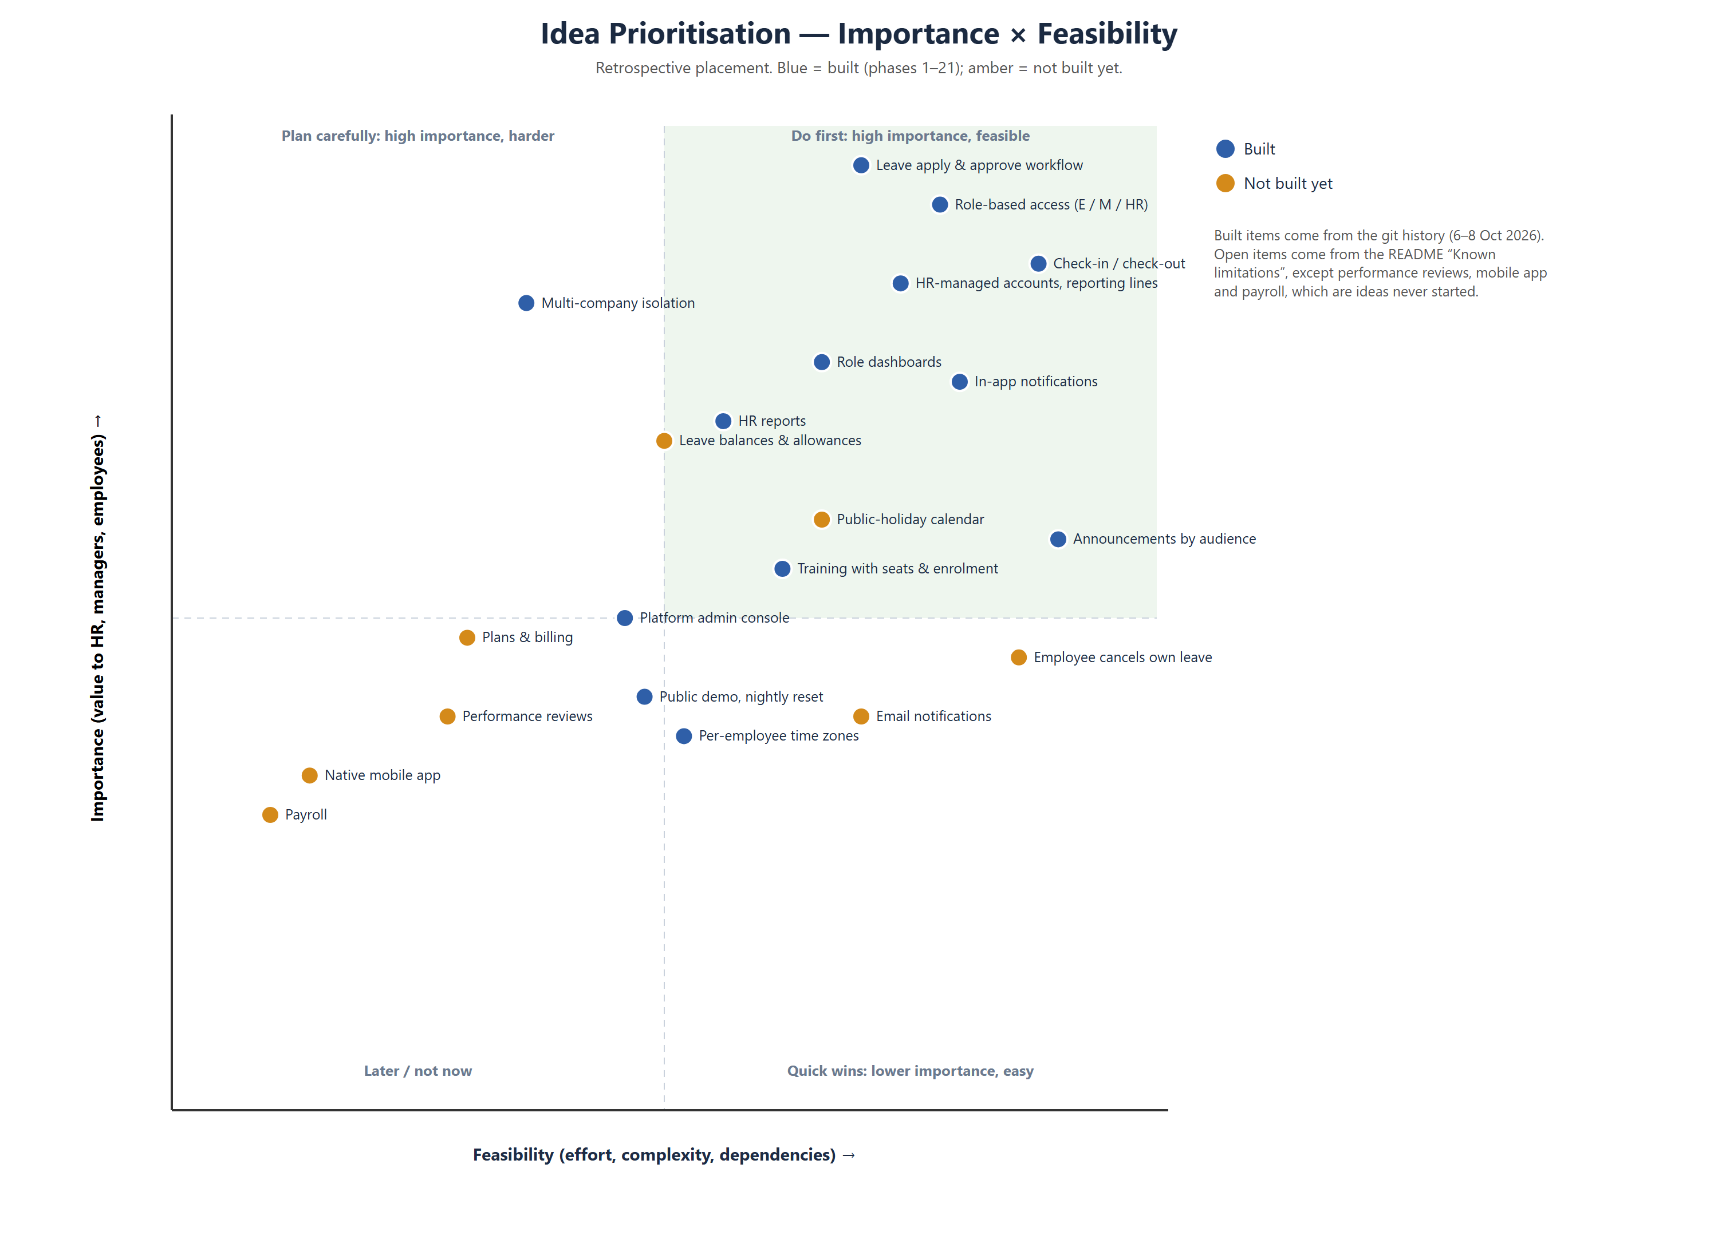
Figure 1 — Importance × feasibility grid
Priority bucket | Ideas | Outcome (verified)
High importance, feasible — do first | Leave workflow; role-based access; check-in / check-out; HR-managed accounts and reporting lines; notifications; dashboards; HR reports; announcements; training | Built in phases 4–13 (7 October 2026)
High importance, harder — plan carefully | Multi-company isolation | Built in phase 19 (8 October 2026), with a written plan (docs/PHASE-19-MULTITENANCY-PLAN.md)
Medium importance — when capacity allows | Public demo; platform admin console; per-employee time zones | Built (phases 8, 20, 21)
Next candidates | Leave balances and allowances; public-holiday calendar; employee cancels own leave; email notifications | Not built — listed in README “Known limitations”
Later / not now | Plans and billing; performance reviews; native mobile app; payroll; biometric or GPS check-in; real-time chat; spreadsheet export | Not built and not started

