Requirement Analysis
Data Flow Diagram & User Stories
Date | 17 October 2026
Team ID
Project Name | StaffSync — Human Resource Management System
Maximum Marks | 4 Marks

Data Flow Diagrams
A Data Flow Diagram (DFD) shows how information moves through StaffSync: who supplies and receives it (external entities), what the system does with it (processes) and where it is kept (data stores). The diagrams use Yourdon–DeMarco notation and were drawn from the API routes, controllers, services and Mongoose models.

DFD Level 0 — Context diagram
The whole system as one process, with every external entity and the main flows.
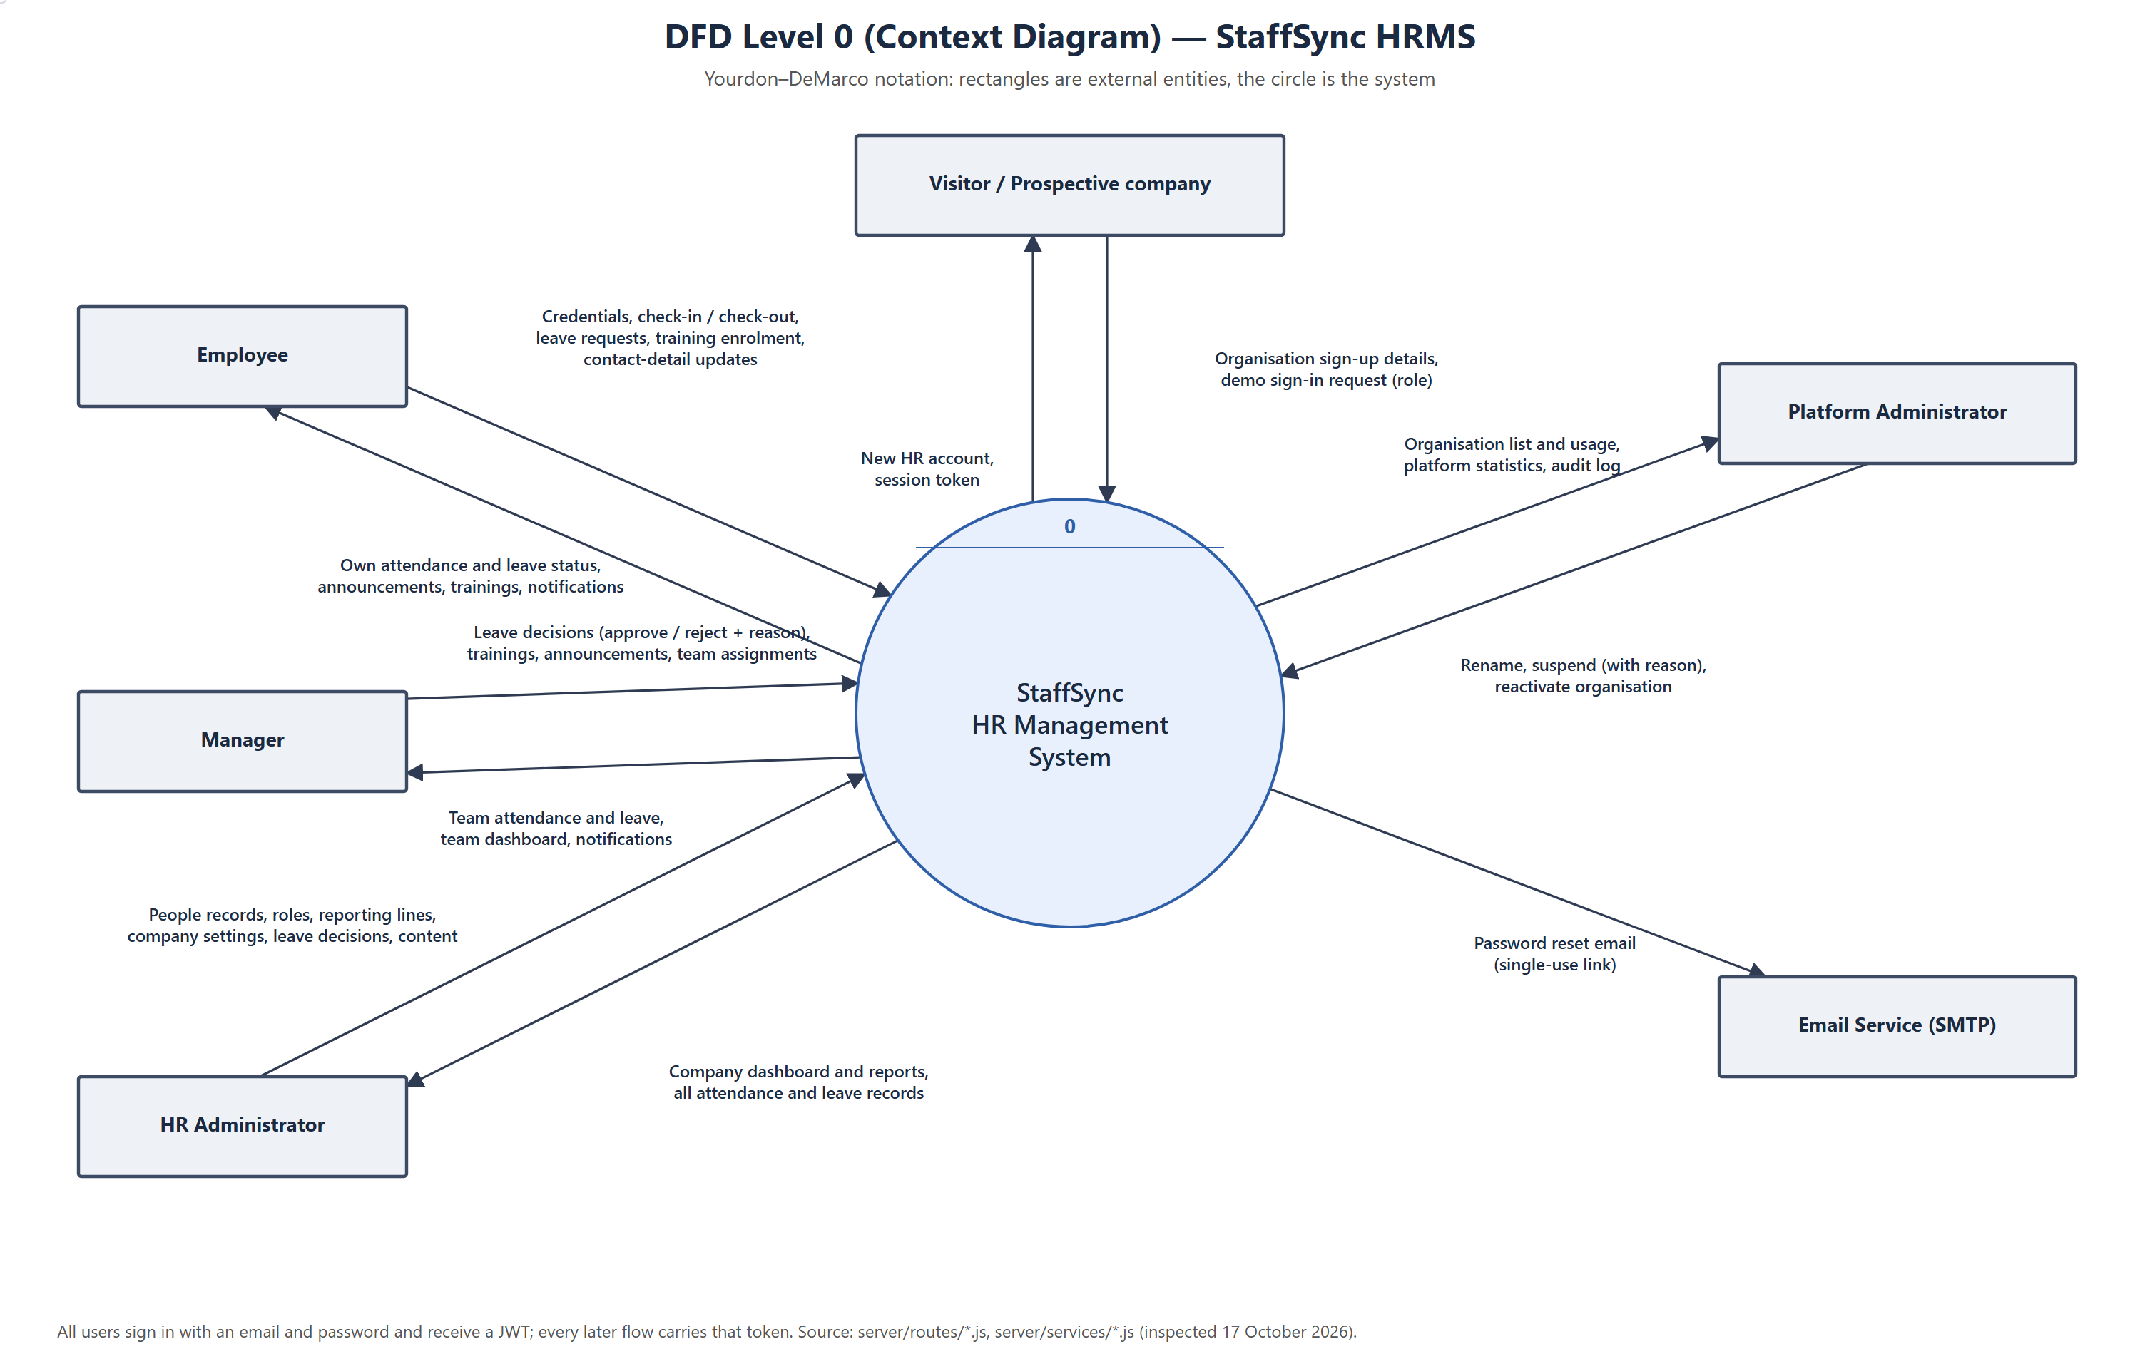
Figure 1 — DFD Level 0 (context diagram)

DFD Level 1
The nine main processes inside StaffSync and the MongoDB collections they read and write.
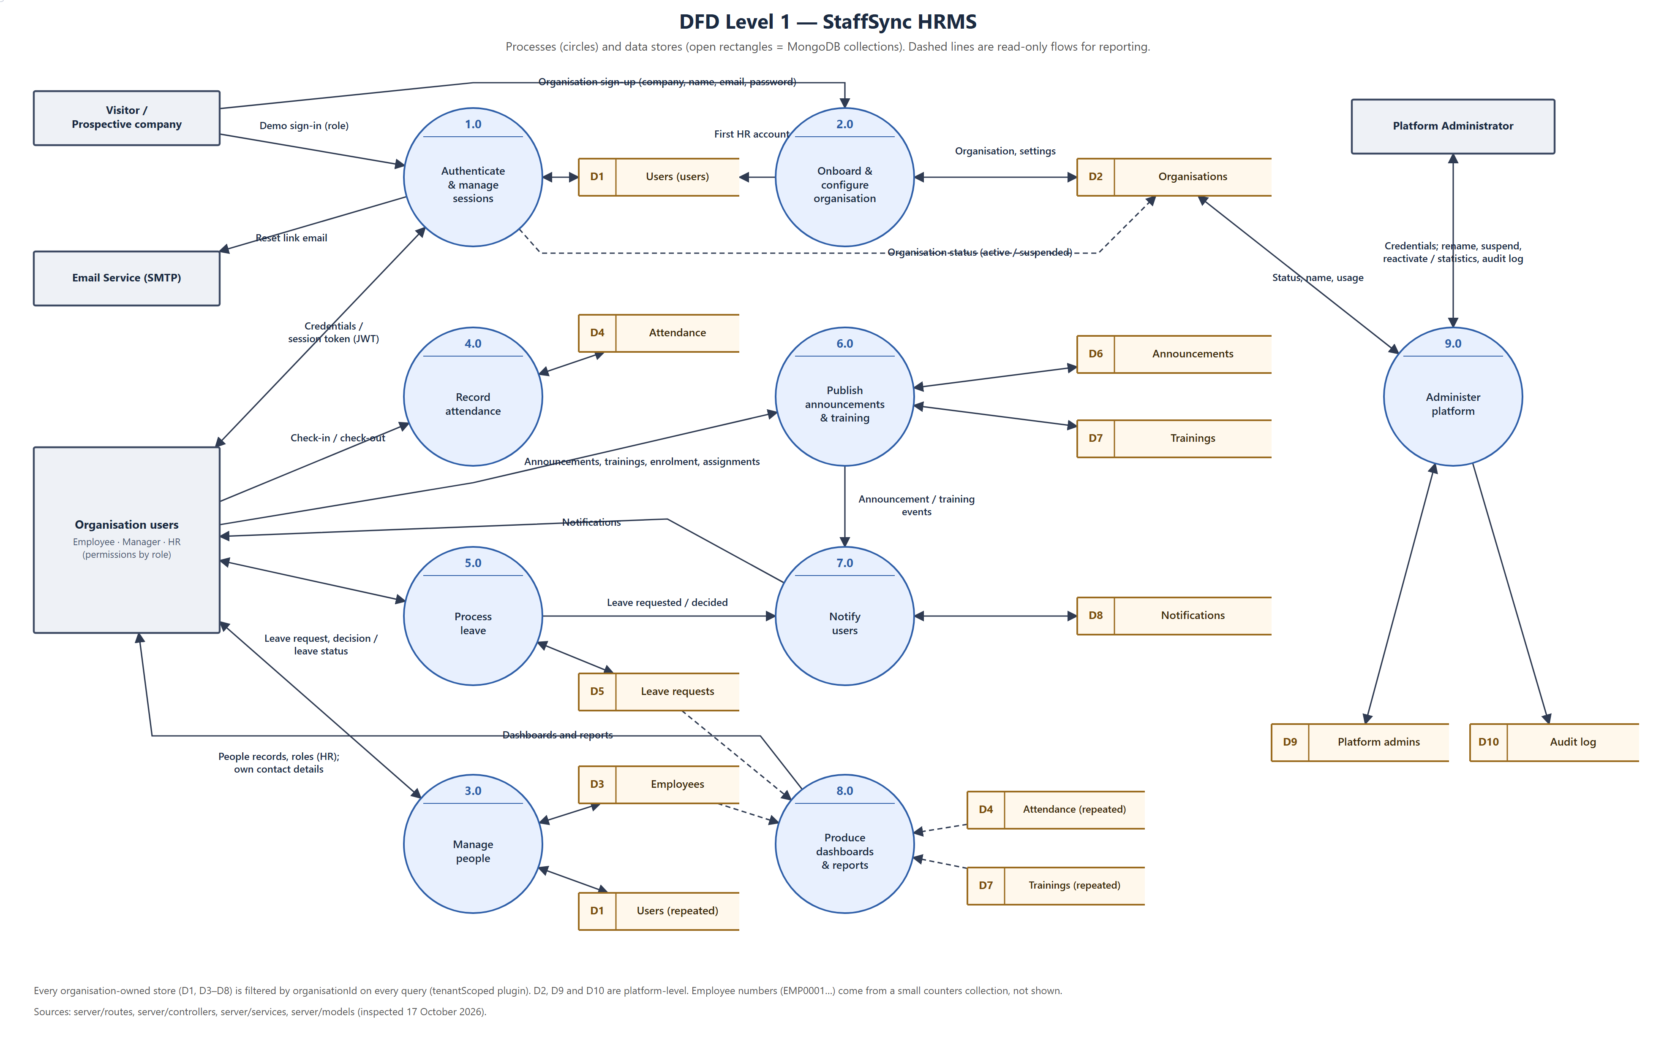
Figure 2 — DFD Level 1

Processes
No. | Process | Implemented in
1.0 | Authenticate and manage sessions | `controllers/authController.js`, `middleware/authMiddleware.js`, `services/passwordResetService.js`, `controllers/demoController.js`
2.0 | Onboard and configure organisation | `controllers/organisationController.js`
3.0 | Manage people | `controllers/employeeController.js`
4.0 | Record attendance | `controllers/attendanceController.js`
5.0 | Process leave | `controllers/leaveController.js`
6.0 | Publish announcements and training | `controllers/announcementController.js`, `controllers/trainingController.js`
7.0 | Notify users | `services/notificationService.js`, `controllers/notificationController.js`
8.0 | Produce dashboards and reports | `controllers/dashboardController.js`, `controllers/reportController.js`, `services/statsService.js`
9.0 | Administer platform | `controllers/platformController.js`

Data stores
No. | Store (collection) | Model | Scope
D1 | users | `models/User.js` | Organisation-owned
D2 | organisations | `models/Organisation.js` | Platform-level
D3 | employees | `models/Employee.js` | Organisation-owned
D4 | attendances | `models/Attendance.js` | Organisation-owned
D5 | leaves | `models/Leave.js` | Organisation-owned
D6 | announcements | `models/Announcement.js` | Organisation-owned
D7 | trainings | `models/Training.js` | Organisation-owned
D8 | notifications | `models/Notification.js` | Organisation-owned
D9 | platformadmins | `models/PlatformAdmin.js` | Platform-level
D10 | platformauditlogs | `models/PlatformAuditLog.js` | Platform-level
— | counters (employee numbers; not drawn) | `models/Counter.js` | Platform-level, keyed per organisation

User Stories
User story table for StaffSync. Each story is linked to a functional requirement in B1. “Release” is the development phase in which it was delivered, from the git history; there were no separately planned sprints (see C1).
User Type | Functional Requirement (Epic) | User Story Number | User Story / Task | Acceptance Criteria | Priority | Release
Visitor | FR-2 | US-01 | As a company representative, I can sign up my organisation and become its first HR user. | Organisation and HR account created together; I land on the HR dashboard; an email already in use is refused (409). | High | Phase 19
All users | FR-1 | US-02 | As a user, I can log in with my email and password. | Valid details return a token and open my role’s dashboard; wrong details show “Invalid email or password”; the 6th failure in 15 minutes is refused (429). | High | Phase 4
All users | FR-1 | US-03 | As a user, I can reset a forgotten password by email. | Same reply whether or not the email exists; the link works once and expires after 30 minutes; all sessions end. | Medium | Phase 15+
All users | FR-1 | US-04 | As a user, I can change my password. | Current password required; other devices are signed out. | Medium | Phase 15
HR | FR-3 | US-05 | As HR, I can add a person with a role, department, designation and manager. | Person created with the next EMP number; duplicate email refused; the manager must be an active manager in my organisation, with no reporting loop. | High | Phase 6
HR | FR-3 | US-06 | As HR, I can deactivate and reactivate a person. | Deactivated users are signed out at once and keep their history; I cannot deactivate myself or the last HR. | High | Phase 6
Employee | FR-3 | US-07 | As an employee, I can update my phone and address. | Only those fields change; other fields are refused. | Medium | Phase 6
Employee | FR-4 | US-08 | As an employee, I can check in and check out. | Server time is used; a second check-in the same day is refused (409); under 4 hours is a half day. | High | Phase 7
Employee | FR-4 | US-09 | As an employee, I can see my attendance history. | Newest first, paginated, filterable by date. | Medium | Phase 7
Manager | FR-4 | US-10 | As a manager, I can see my team’s attendance. | Only direct reports appear. | Medium | Phase 7
Employee | FR-5 | US-11 | As an employee, I can apply for leave. | Request saved as Pending; my manager (or HR) is notified; overlapping, past or over-60-day requests are refused with a reason. | High | Phase 8
Manager | FR-5 | US-12 | As a manager, I can approve or reject my team’s leave. | Only my direct reports’ pending requests; rejection needs a reason; a decided request cannot be decided again (409); never my own. | High | Phase 8
Employee | FR-5 | US-13 | As an employee, I can see the status of my leave requests. | Status, approver and rejection reason shown; I am notified of the decision. | High | Phase 8
HR | FR-5 | US-14 | As HR, I can see and decide any leave request. | All requests with status and department filters; same rules as managers. | High | Phase 8
All roles | FR-6 | US-15 | As a user, I see a dashboard for my role. | Figures come from the API, not fixed values. | High | Phase 9
HR | FR-7 | US-16 | As HR, I can run attendance, leave, department and training reports. | Totals match the underlying records; date range validated. | Medium | Phase 9
HR / Manager | FR-8 | US-17 | As HR or a manager, I can post an announcement for an audience. | Only that audience sees it and is notified; managers edit only their own posts. | Medium | Phase 10
HR / Manager | FR-9 | US-18 | As HR or a manager, I can create a training with a capacity. | Dates and capacity validated; managers edit only their own trainings. | Medium | Phase 10
Employee | FR-9 | US-19 | As an employee, I can enrol in and withdraw from a training. | Refused when full or already started. | Medium | Phase 10
All users | FR-10 | US-20 | As a user, I can read my notifications and mark them read. | Unread count updates; mark all read sets it to zero. | Medium | Phase 11
Visitor | FR-11 | US-21 | As a visitor, I can try the demo as HR, a manager or an employee without signing up. | One click opens that role’s dashboard; demo data resets nightly. | Low | Phase 20
Platform admin | FR-12 | US-22 | As a platform administrator, I can suspend and reactivate an organisation. | A reason is required; its users are refused at once; the action is in the audit log. | Medium | Phase 21
HR | FR-2 | US-23 | As HR, I can set my company’s time zone and working days. | Saved per organisation; other organisations are unaffected. | Medium | Phase 19

