Project Design Phase
Solution Architecture
Date | 17 October 2026
Team ID
Project Name | StaffSync — Human Resource Management System
Maximum Marks | 4 Marks

Solution Architecture
StaffSync is a three-tier web application: a React single-page app in the browser, an Express 5 REST API on Node.js, and MongoDB. In production one Render web service runs the API and also serves the built React app, so both share one address. Every request passes the same ordered chain of middleware before it reaches business logic, and every database query is limited to the caller’s organisation. The architecture aims for:

Solution architecture diagram
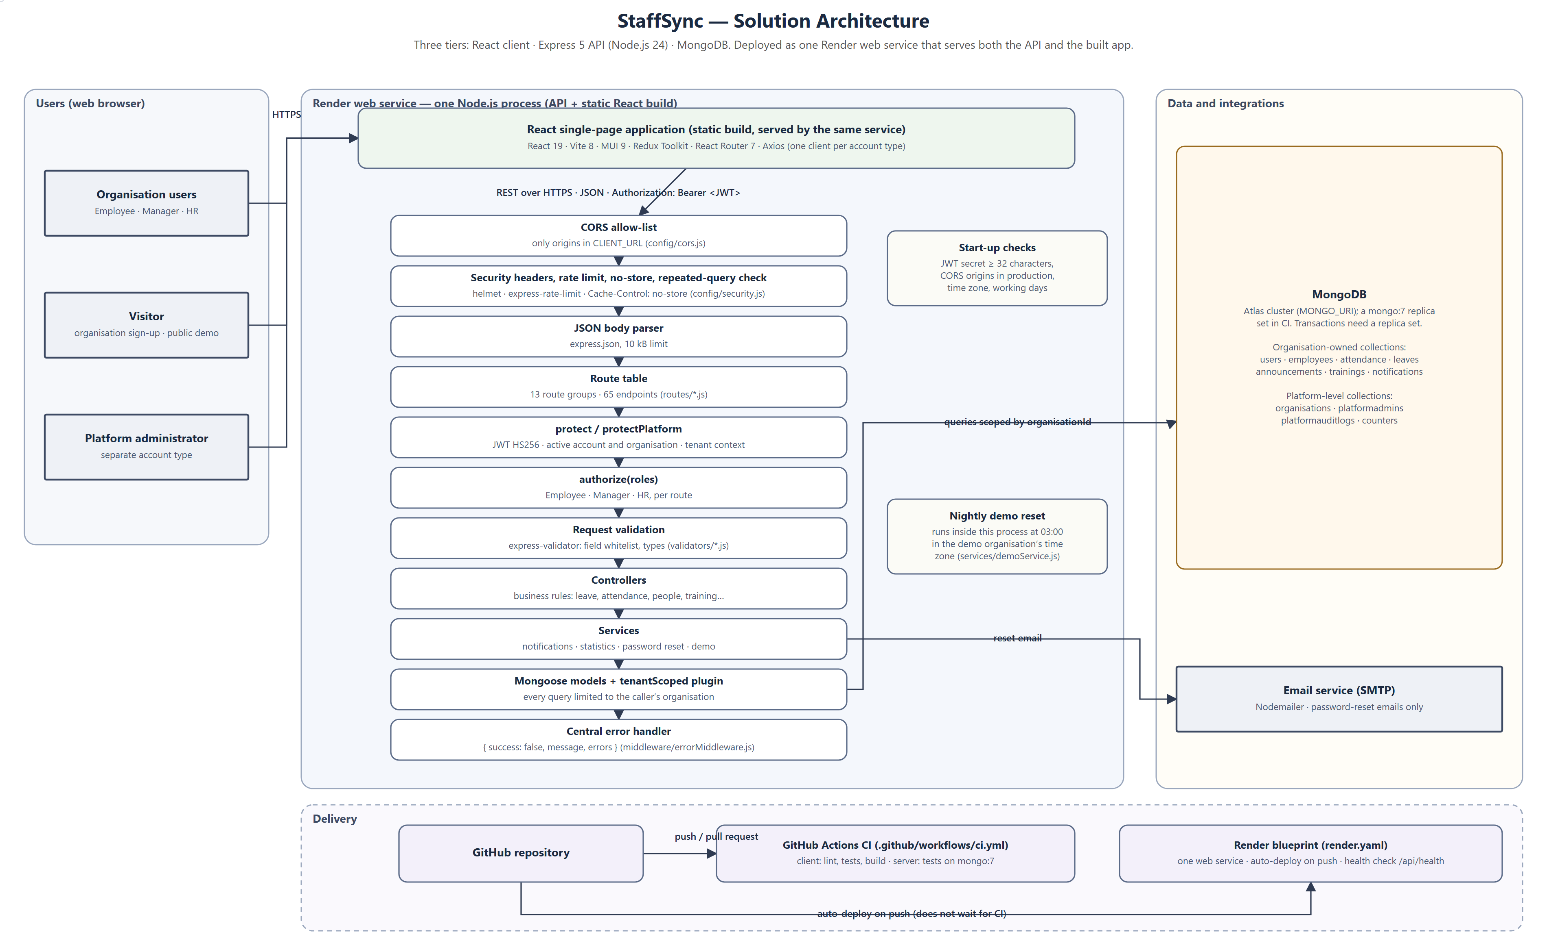
Figure 1 — StaffSync solution architecture

Components
Tier / component | Responsibility | Source
React SPA | Pages for each role; session in Redux; route guards for convenience (the API enforces access) | `client/src` (routes, pages, store)
API clients | Two Axios instances (organisation users, platform admins); attach the token; turn errors into readable messages | `client/src/services/api.js`
Security middleware | CORS allow-list, Helmet headers, rate limits, no-store caching, repeated-query rejection | `server/config/cors.js`, `server/config/security.js`
Authentication | Verify JWT; load user, employee and organisation in one aggregation; enter the organisation context | `server/middleware/authMiddleware.js`
Authorisation | Role check per route; ownership and team checks in controllers | `authorize()` in `server/middleware/authMiddleware.js`; controllers
Validation | Whitelist of fields and types per endpoint | `server/validators/*.js`, `server/middleware/validate.js`
Controllers and services | Business rules; notifications; statistics; password reset; demo reset | `server/controllers`, `server/services`
Data access | Mongoose models; `tenantScoped` plugin scopes every operation | `server/models`
Errors | One handler; consistent JSON; no internal details in production | `server/middleware/errorMiddleware.js`
Database | MongoDB Atlas; replica set required for the sign-up transaction | `MONGO_URI`
Email | Password-reset emails through SMTP | `services/passwordResetService.js`
Delivery | GitHub Actions CI (lint, tests, build); Render blueprint with health check and auto-deploy | `.github/workflows/ci.yml`, `render.yaml`

Request lifecycle example — approving a leave request
The sequence below follows one request through the architecture, showing where authentication, authorisation, validation, the atomic update and the notification happen.
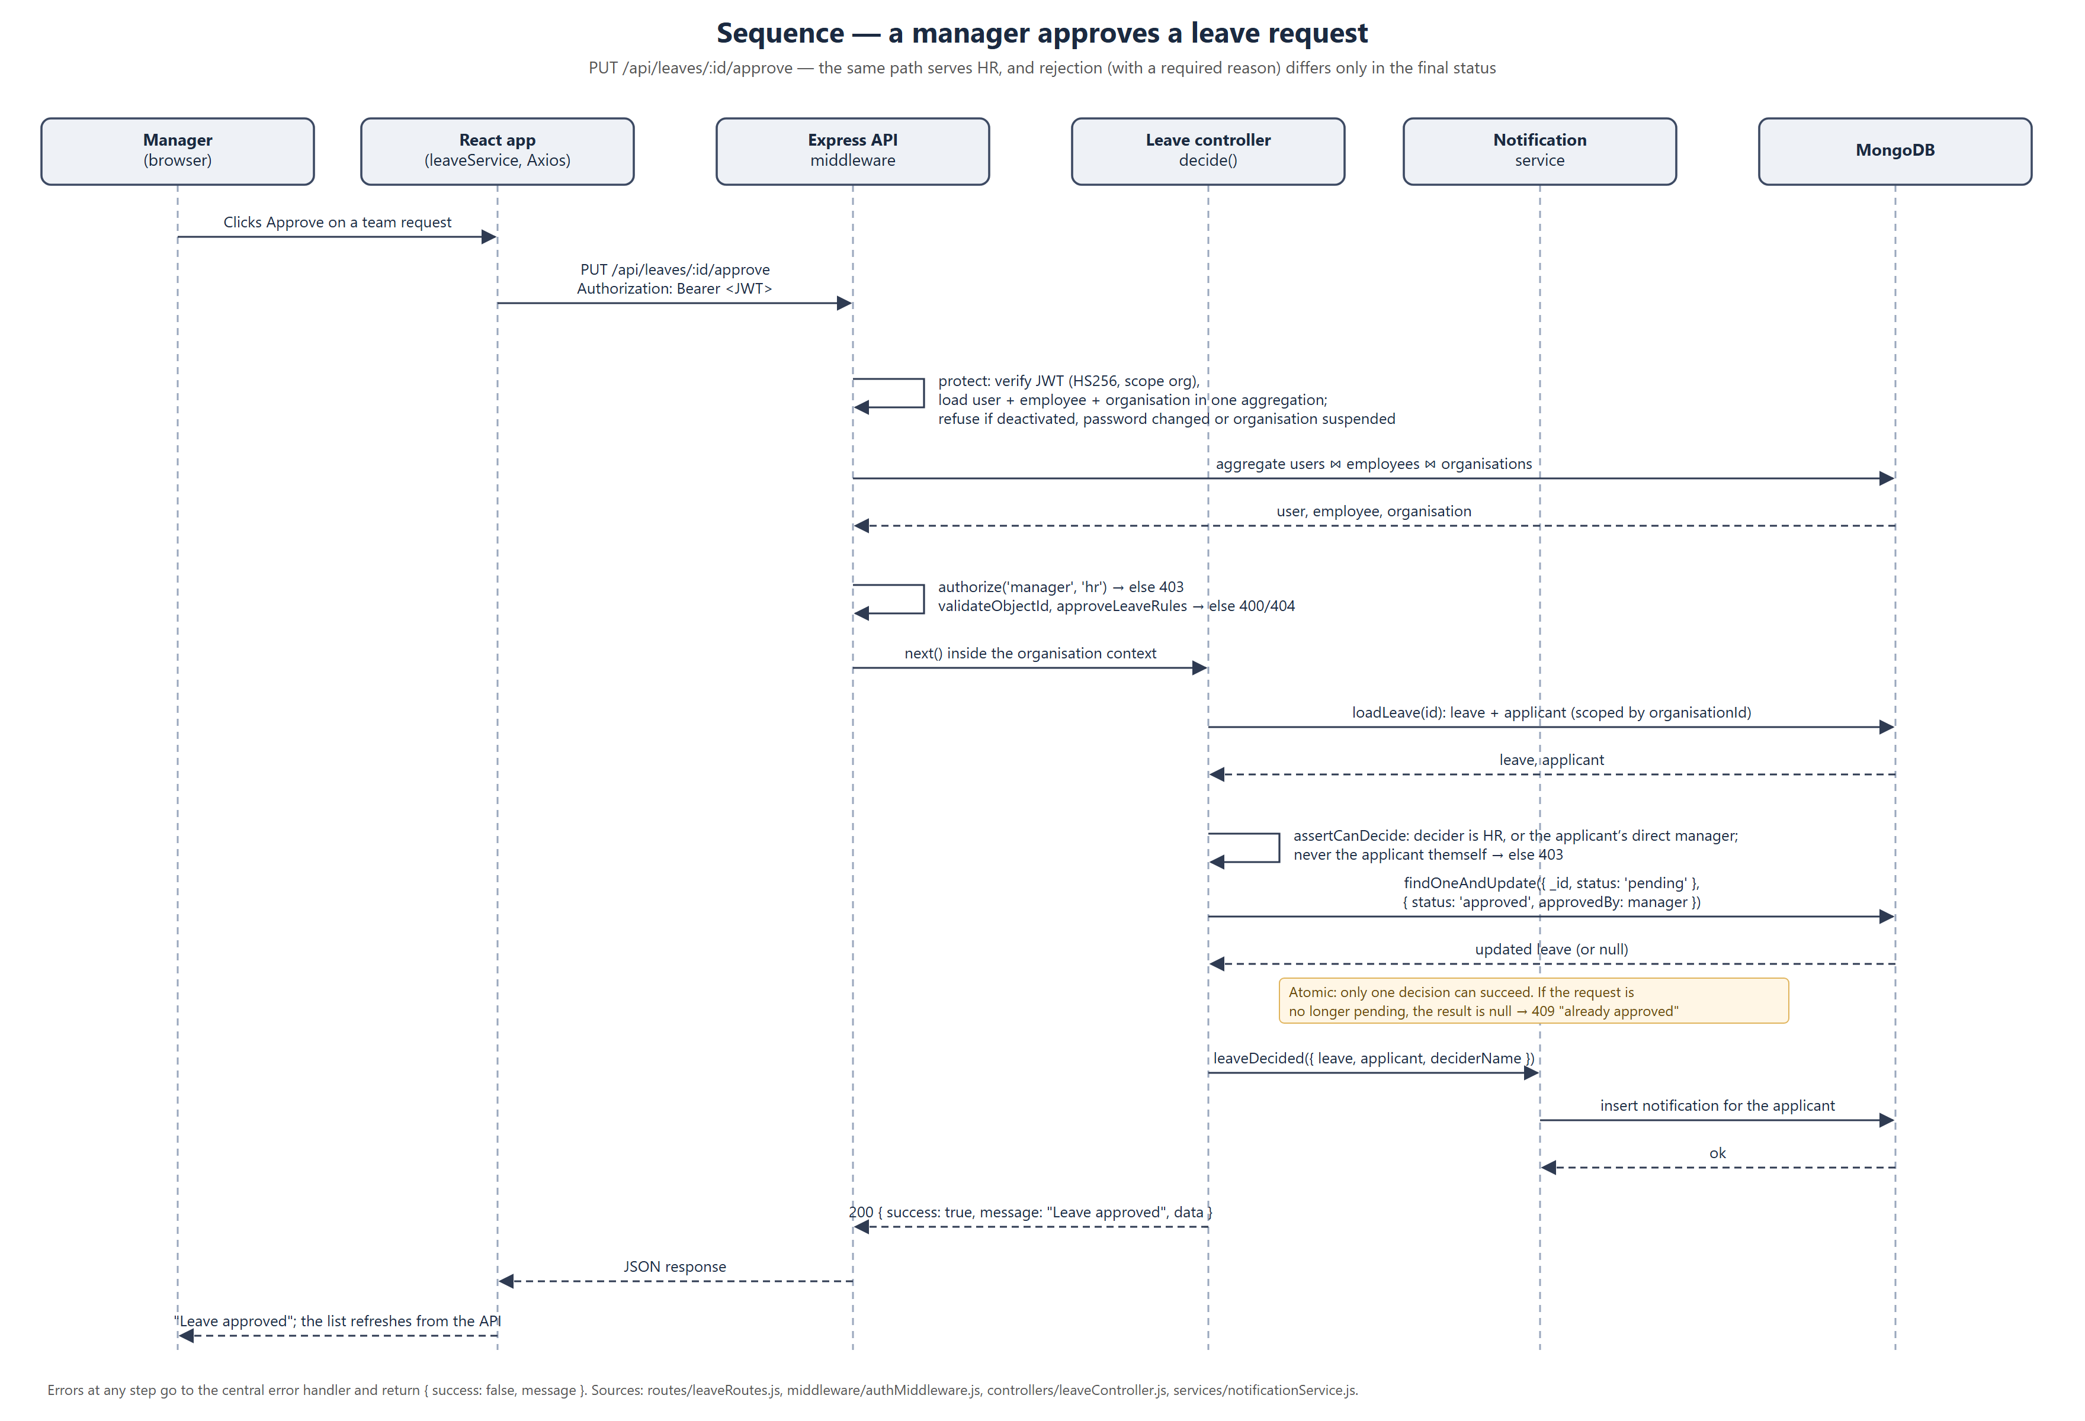
Figure 2 — Sequence for PUT /api/leaves/:id/approve

Deployment view
Item | Configuration (from render.yaml)
Service | One Render web service, Node.js 24, free plan, region Singapore
Build | Install server production dependencies; install client and build it with Vite
Start | `npm start --prefix server`; the server also serves the built client
Health check | `/api/health` (reports API status and database connection)
Secrets | `JWT_SECRET` generated by Render; `MONGO_URI` and SMTP settings entered in the dashboard
Deployment status | Configured, not verified live: no deployment URL is recorded in the project

Architecture decisions
Decision | Reason | Trade-off
Token in localStorage, sent as a Bearer header | Works when the app and API are on different domains without CSRF tokens | Exposed to XSS; mitigated by React escaping, a strict script CSP on served pages and token expiry
Isolation in a Mongoose plugin, not in each controller | A forgotten filter cannot leak another company’s data; unscoped queries throw | Platform-level code must opt out explicitly with runAsPlatform()
Atomic findOneAndUpdate for leave decisions | Guarantees one decision even under simultaneous clicks | A second decider gets 409 instead of a silent overwrite
Single service for API and app | One address, simpler CORS and deployment | The API and front end scale together
In-memory rate limiting | No extra infrastructure | Limits reset on restart and are per instance

