IHT-MK1 Harness Tester
Features, working principle and pin support

1. What it is
IHT-MK1 tests wire harnesses of up to 256 pins. It checks which pins are connected, how much resistance each wire has, and whether any wire leaks to its neighbours at 500 V.
One microcontroller (STM32G474) on the Control Card runs everything. The Matrix Card and the HV Cards have no processor of their own: they are switches, ADCs and drivers controlled by that one microcontroller. A PC program (the GUI) sends commands over a USB serial link and shows the results.

2. Block diagram
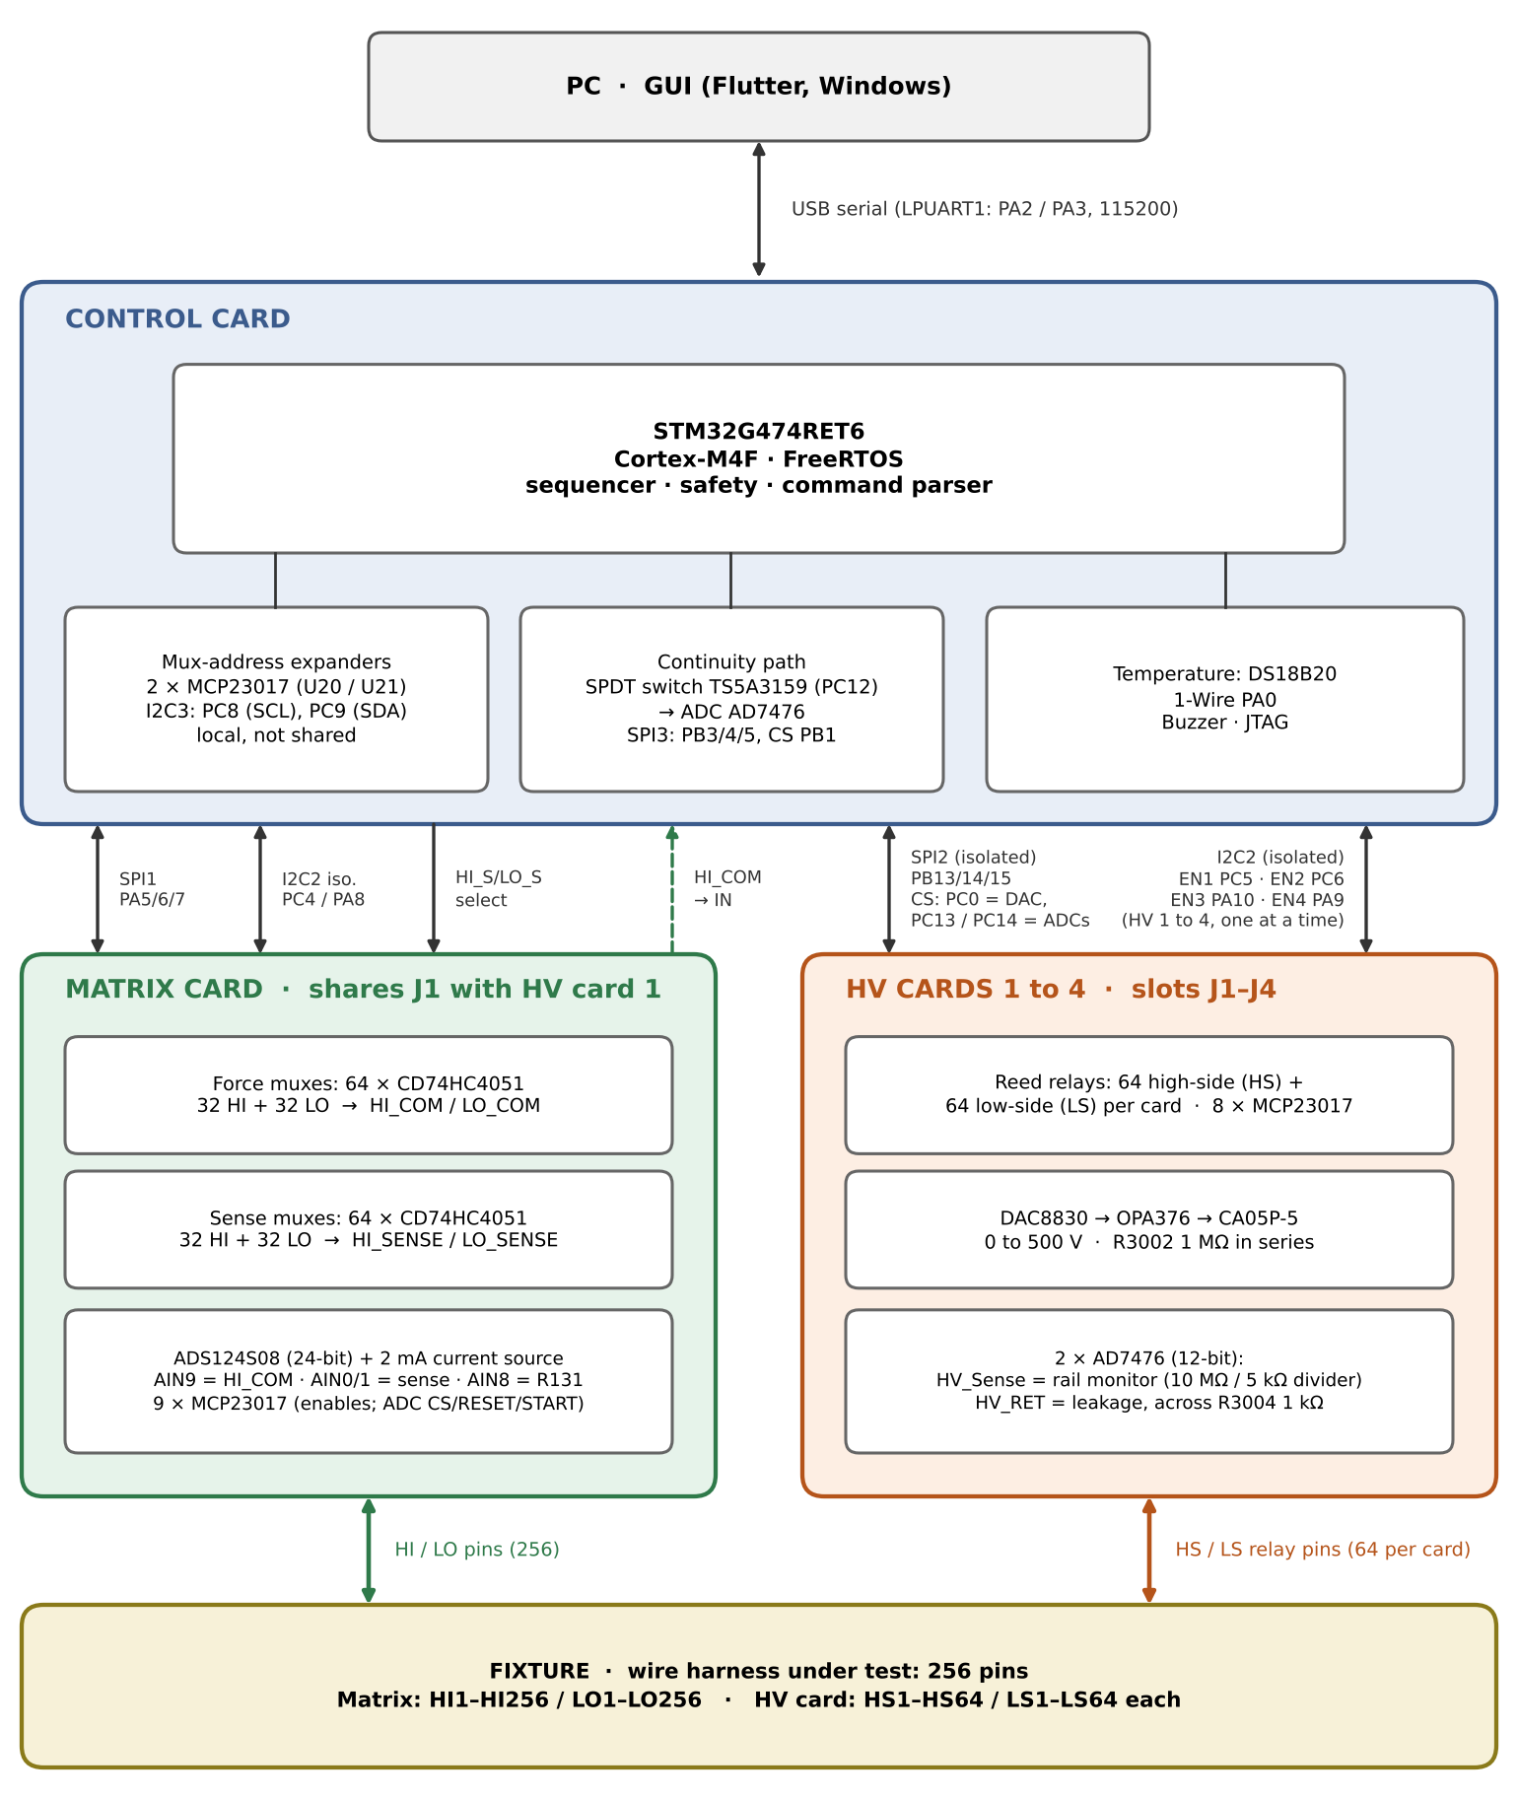
Figure 1. System block diagram with the buses and microcontroller pins used.

3. Features
11 features: 3 main tests and 8 Support Tools.
# | Feature | What it does
1 | Continuity | Finds which pins are joined by a wire.
2 | Resistance | Measures the resistance of each wire (modified 4-wire method).
3 | Insulation (500 V) | Checks that a wire does not leak to any other conductor.
4 | Netlist and limits | Loads up to 256 expected pin pairs and the pass limit.
5 | Discover scan | Finds all connections without a netlist.
6 | Manual path and sweep | Reads one chosen pin pair, or one pin against all 256.
7 | Self-calibration | Takes a resistance reading and shows whether the reference was used.
8 | Bus scan | Checks that every card chip answers.
9 | Temperature read | Reads the Control Card temperature sensor.
10 | HV safety | Arm, abort, fault latch, watchdog and a high-voltage self-test.
11 | Reports and history | Saves every run; exports CSV and PDF.

4. Main tests: how they work

4.1 Continuity
- Idea: a wire between pin A and pin B pulls a pulled-up input low.
- How: the Matrix Card connects pin A to HI_COM and pin B to LO_COM. HI_COM reaches the Control Card input, which has a 10 kΩ pull-up to 3.3 V. LO_COM has a 100 Ω pull-down. The AD7476 ADC (12-bit, SPI3) reads that input.
- Result: a connected wire reads low (about 0.1 V, because the 10 kΩ pull-up is shorted through two muxes and 100 Ω); no wire reads near 3.3 V (see section 5). It runs in two modes: verify (check the netlist pairs) and discover (scan every pair).

4.2 Resistance
- Idea: push a known current through the wire and measure the voltage across it.
- How: the ADS124S08 current source sends 2 mA through HI_COM, the wire, LO_COM and a 100 Ω reference resistor (R131, 0.01 %). The same chip (24-bit) reads the voltage between the two pins, then reads again with the current off and subtracts it to remove offsets. The gain is chosen automatically (128 down to 1).
- Reference: it also reads the voltage across R131, so resistance = wire voltage ÷ R131 voltage × 100 Ω. The current source's own tolerance cancels out.
- Result: pass if the resistance is at or below the limit (default 5 Ω, set from the GUI).
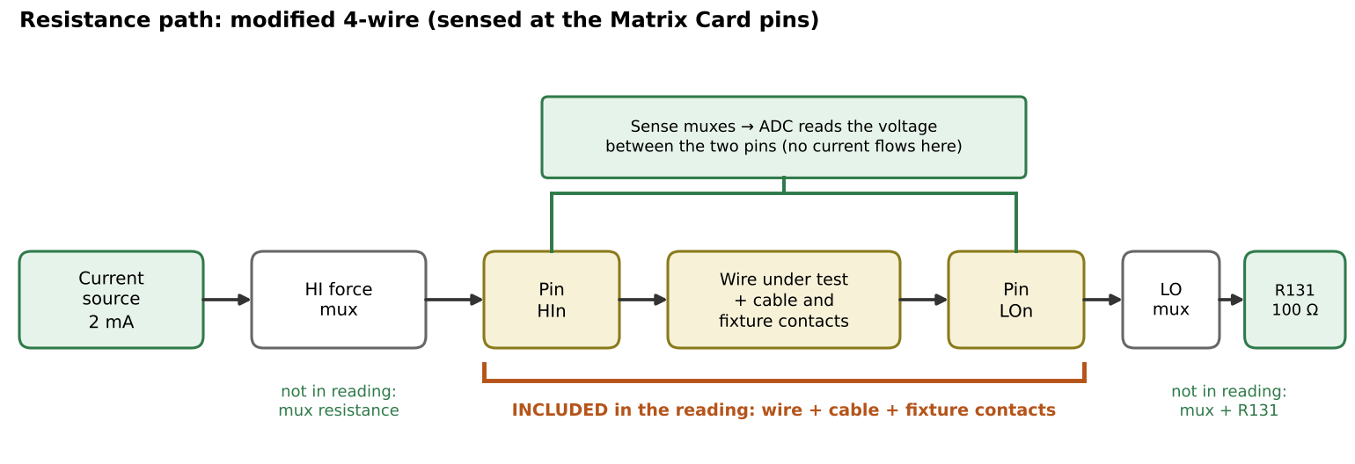
Figure 2. Force muxes carry the current; separate sense muxes read the voltage at the same two pins.
Modified 4-wire. Each pin has two mux paths on the Matrix Card: one forces current, one senses voltage, and both meet at the same card pin. So the mux resistance (about 100–250 Ω each) is not in the result. It is 4-wire at the card pins, not at the wire itself: the cable and fixture contacts between the pin and the wire are included.

4.3 Insulation (500 V)
- Idea: apply 500 V to one net and measure the leakage into every other conductor.
- How: after the operator arms HV, the firmware runs a self-test (100 V with all relays open, checking the rail rises). For each net, the HV Card closes the net's high-side relay and every other low-side relay except the net's own. Only then does the DAC8830 raise the CA05P-5 supply to 500 V. Leakage flows through R3002 (1 MΩ) and R3004 (1 kΩ), and an AD7476 reads the voltage across R3004. Voltage is removed before the relays open.
- Result: fail if the leakage voltage is 0.045 V or more, which means insulation below about 10 MΩ. The limit scales with the test voltage.
- Safety: DAC at 0 V means HV off; the supply bleeds down through a 10 MΩ divider; any fault forces everything safe; a hardware watchdog (about 0.5 s) resets a hung controller.

5. Pass and fail conditions
Test | PASS | FAIL | Other
Continuity | ADC input between 0.02 V and 0.5 V (wire present, typically about 0.1 V). | ADC input at or above 3.0 V: open, no wire. In verify mode, an expected pair that reads open is a fail. | Any other voltage (for example 0 V, or a very high-resistance path) is flagged as an error. Discover mode only lists the pairs that pass.
Resistance | Resistance is at or below the limit (default 5 Ω, set from the GUI). | Resistance above the limit, or no reading possible (open circuit: the ADC saturates at every gain). | Each point reports the resistance in milliohms.
Insulation | Leakage voltage below 0.045 V at 500 V, which means insulation above about 10 MΩ. | Leakage voltage at or above 0.045 V (insulation below about 10 MΩ). The limit scales with the test voltage. | The run is refused if HV is not armed or the HV self-test fails. A measurement error is counted as a fail.
Every run ends with a count of passes and fails. Any fault stops the run and forces the instrument safe.

6. Support Tools
Tool | What it does and how
Netlist and limits | The GUI imports an Excel netlist and sends up to 256 pin pairs (HI pin, LO pin) over serial. They are kept in RAM. The maximum resistance is set from the GUI.
Discover scan | Runs the continuity test on all 256 × 256 pairs (65,536) to find every connection. Takes about 2 minutes.
Manual path and sweep | Closes one chosen pin pair and shows the reading. A sweep tests one high-side pin against all 256 low-side pins.
Self-calibration | Runs one resistance reading on a chosen pair and reports whether the R131 reference worked.
Bus scan | Probes every I2C chip on the Matrix Card and the ADS124S08 identity, and reports OK or fault.
Temperature read | Reads the DS18B20 sensor on the Control Card (1-Wire, PA0), in 0.1 °C steps.
HV safety | HV must be armed before an insulation run. Abort, a safe command and a fault latch (cleared by command) are always available. The instrument sends a heartbeat so a lost link is noticed.
Reports and history | The GUI stores every run on the PC and exports CSV and PDF reports.

7. Pin support
256 harness pins (numbered 1 to 256). Any pin can act as the HI side or the LO side, so 256 × 256 = 65,536 pairs are possible.
Item | Count and detail
Harness pins | 256 (HI1–HI256 and LO1–LO256 on the Matrix Card)
Matrix muxes | 128 × CD74HC4051: 32 HI force, 32 LO force, 32 HI sense, 32 LO sense (8 channels each)
Matrix control | 9 × MCP23017 on I2C2, plus 2 × MCP23017 on the Control Card (I2C3)
HV Card relays | 64 high-side + 64 low-side reed relays per card, driven by 8 × MCP23017
HV Cards | 4 cards × 64 = 256 pins (slots J1 to J4)
Card connectors | 4 × 50-pin: J1 is shared by the Matrix Card and HV Card 1; J2, J3, J4 hold HV Cards 2, 3, 4
Card enables | EN1 = PC5 (HV Card 1) · EN2 = PC6 (HV Card 2) · EN3 = PA10 (HV Card 3) · EN4 = PA9 (HV Card 4). One is on at a time.
Microcontroller interfaces | SPI1, SPI2, SPI3, I2C2, I2C3, LPUART1, 1-Wire, GPIO for card enables and chip-selects (see Figure 1)
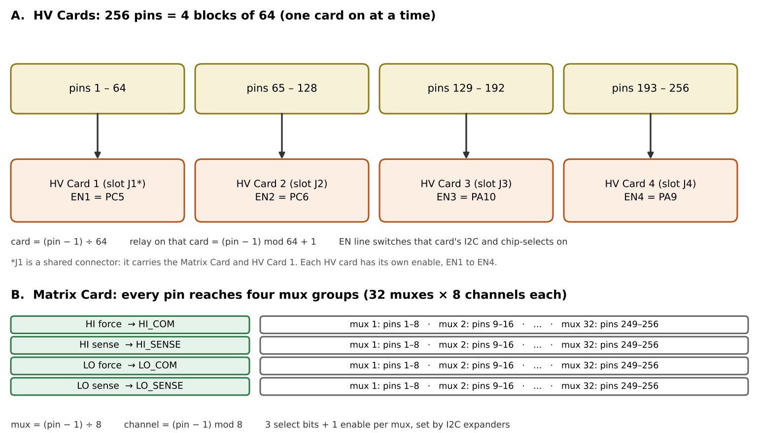
Figure 3. How 256 pins map to HV Cards (top) and to Matrix Card muxes (bottom).

