HT_MK1 Harness Tester

User Manual

Document ID | HT_MK1_UM
Revision | 1.1.0
Date | 22-10-2026
Project | HT_MK1 Harness Tester

Approval of Document:
 | Name | Designation | Date
Prepared By |  |  | 22-10-2026
Reviewed By |  |  | 22-10-2026
Approved By |  |  | 22-10-2026

Table of Revision
Version | Note/ Comment | Date
1.0.0 | Initial release | 26-08-2026
1.1.0 | Reissued in the standard document format; updated for the Mode 1 / Mode 2 / Auto scan GUI | 22-10-2026

Distribution List (For limited distribution only)
S. No. | Name | Organization / Department
1
2
3

Contact Details
S. No. | Name | Communication Details
1
2
Registered Office Address:

Contents
1 Introduction 5
1.1 Purpose 5
1.2 Audience 5
1.3 Related Documents 5
2 System Overview 5
3 Safety 5
3.1 High Voltage 5
3.2 Arming 6
3.3 Abort 6
3.4 "Safe to Handle" 6
4 Getting Started 6
4.1 Launching the Application 6
4.2 Connecting to the Instrument 6
4.3 Screen Layout 7
5 Loading a Netlist 7
6 Running a Test 10
6.1 Mode 1: Continuity and Resistance 10
6.2 Mode 2: Insulation 12
6.3 Auto Scan 14
6.4 Reading Results 15
7 Viewing Results and History 15
7.1 Run History 15
7.2 Exporting a Report 16
8 Troubleshooting 16
8.1 Common Messages 16
8.2 If the Connection Is Lost 17
8.3 Faults 17
9 Glossary 17

List of Figures
Figure 1: The Run screen when the GUI is first connected, before a netlist is loaded. 7
Figure 2: The Select the MTX netlist dialog. 8
Figure 3: The Confirm the connector layout dialog. 9
Figure 4: The Continuity screen after a passing run: result tiles and the wiring diagram. 10
Figure 5: The Resistance screen after a passing run, ranked by margin to the limit. 11
Figure 6: The Run screen after a failed continuity run: the verdict shows FAIL and the Faults panel lists the open nets. 12
Figure 7: The handover prompt shown once Mode 1 passes. 12
Figure 8: The pre-energize confirmation. Energize 500 V is enabled only after the box is ticked. 13
Figure 9: The Insulation screen after a run: relay state and HV rail. 13
Figure 10: The prompt shown when insulation is requested before Mode 1 has passed. 14
Figure 11: The Auto scan screen after a scan. 15
Figure 12: The Results screen: pass rate, run history and per-test reports. 16

List of Tables
Table 1: Test sections 5
Table 2: Screen areas 7
Table 3: Fault codes 15
Table 4: Common messages 17
Table 5: Glossary 17

Introduction

Purpose
This manual explains how to operate the HT_MK1 harness tester using the GUI application: starting the software, connecting to the instrument, loading a netlist, running each test, and reading the results.

Audience
Operators running tests on the HT_MK1. No programming or electronics background is assumed.

Related Documents
- HT_MK1 GUI Functional Description: what every screen, section and button of the GUI does.
- HT_MK1 System Overview: what the instrument measures and how.
- HT_MK1 Code Walkthrough: for engineers maintaining the firmware or GUI software.
- HT_MK1 Flashing Procedure: for programming a unit's firmware.
- HT_MK1 Functional Test Procedure: for the formal acceptance test of a built unit.

System Overview
The HT_MK1 tests up to 256 wires in a harness. The GUI groups the tests into two modes and one survey tool:
Section | Test | Harness on | Checks
Mode 1 | Continuity | Matrix connector (J-MTX) | Each wire is connected where it should be, and not touching any other wire.
Mode 1 | Resistance | Matrix connector (J-MTX) | Each connected wire's resistance is within its allowed limit.
Mode 2 | Insulation test | HV connector (J-HV) | Each wire holds the required insulation at 500 V DC, with no leakage.
Auto scan | Connection survey | Matrix connector (J-MTX) | Finds which pins are connected. It needs no netlist and is not a pass or fail test.
Table 1: Test sections
Mode 1 is run with the harness on the Matrix connector. Mode 2 is run with the harness moved to the HV connector. The GUI tracks which connector is in use and asks you to confirm each move. Mode 2 is normally unlocked only after Mode 1 passes. You can choose Continue anyway to run insulation without Mode 1; the skipped tests are recorded in the log.

Safety

High Voltage
WARNING: The insulation test applies up to 500 V DC to the harness under test. Never touch the harness, the HV connector, or the test fixture while a test is running or while the system is armed.
While high voltage is present the GUI replaces its status bar with a red and yellow striped banner reading HIGH VOLTAGE LIVE - J-HV ENERGIZED.

Arming
Insulation testing needs an explicit confirmation before it runs. The GUI shows a checklist and a tick box; the Energize 500 V button stays disabled until you tick the box. The GUI then arms the instrument and starts the run. Arming on its own does not apply high voltage; running the test does. Before you tick the box, confirm the harness is on the HV connector and that no one is in contact with it.

Abort
To stop a test, press the round Stop button (or Esc) while it is running. To stop a test and make sure high voltage is removed, use one of these controls. All of them tell the instrument to stop, discharge any high voltage and open all relays:
- Stop (the round button, or Esc) while a test is running.
- Abort & discharge in the high-voltage banner, shown whenever high voltage is live.
- Emergency discharge in the Safety panel of the Insulation screen. It is always available.
IMPORTANT: After any abort, wait for the green HV Safe indicator before touching the harness. The result of an aborted test is discarded: it gets no verdict and no report.

"Safe to Handle"
IMPORTANT: Wait for the green HV Safe indicator in the status bar before handling the harness. Do not assume it is safe simply because a test has finished. If the connection to the instrument is lost, treat the system as unsafe until it reconnects and shows HV Safe again. Right after connecting, the indicator reads HV state unknown until the instrument reports safe.

Getting Started

Launching the Application
Double-click the HT_MK1 GUI program. No separate installation is needed. The window opens maximized. (The Demo program has a built-in simulator and needs no instrument; nothing it shows is a measurement.)

Connecting to the Instrument
1. Connect the instrument to the PC with the USB cable and power it on.
2. In the status bar, open the port list and choose the instrument's serial port (the ST-LINK Virtual COM Port). Press the refresh button if it is not listed.
3. Press Connect. The link indicator turns green (Link COM<n>) and the state indicator shows Idle.
4. Enter the DUT ID and your name in Operator. They are written into every report made afterwards.
NOTE: The DUT ID and Operator fields are shown in the status bar only when the window is wide enough (more than 1600 logical pixels). On a smaller window they are in the Test details panel on the Run screen.

Screen Layout
Area | Shows
Navigation rail (left) | Switches between screens: Run, Continuity and Resistance (Mode 1), Insulation (Mode 2), Auto scan, Netlist and Results.
Status bar (top) | Connection state, the loaded MTX and HV netlist names, which connector the harness is on, DUT ID and Operator, the HV Safe indicator and the state indicator.
Log bar (bottom) | The latest message. Press Expand to see all messages since start-up.
Table 2: Screen areas
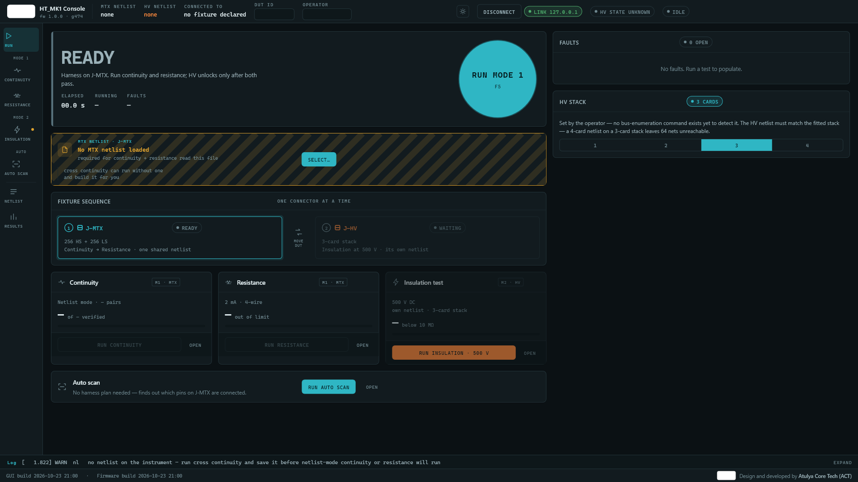
Figure 1: The Run screen when the GUI is first connected, before a netlist is loaded.

Loading a Netlist
A netlist is the list of wire connections a harness is expected to have. Continuity and resistance need the MTX netlist, and insulation needs the HV netlist. The instrument keeps the MTX pin pairs only until it is powered off, so load the netlist each session.
1. On the Run screen press Select... in the MTX netlist strip. (You can also use the Netlist screen.)
2. Press Browse for a netlist file (.xlsx)... and choose the file. Only Excel .xlsx files are accepted.
3. If the file contains connector information, the Confirm the connector layout dialog appears. Check that each connector has the right shape and name, then press Apply.
4. The strip now shows the file name and the number of connections. The log confirms netlist uploaded to the instrument.
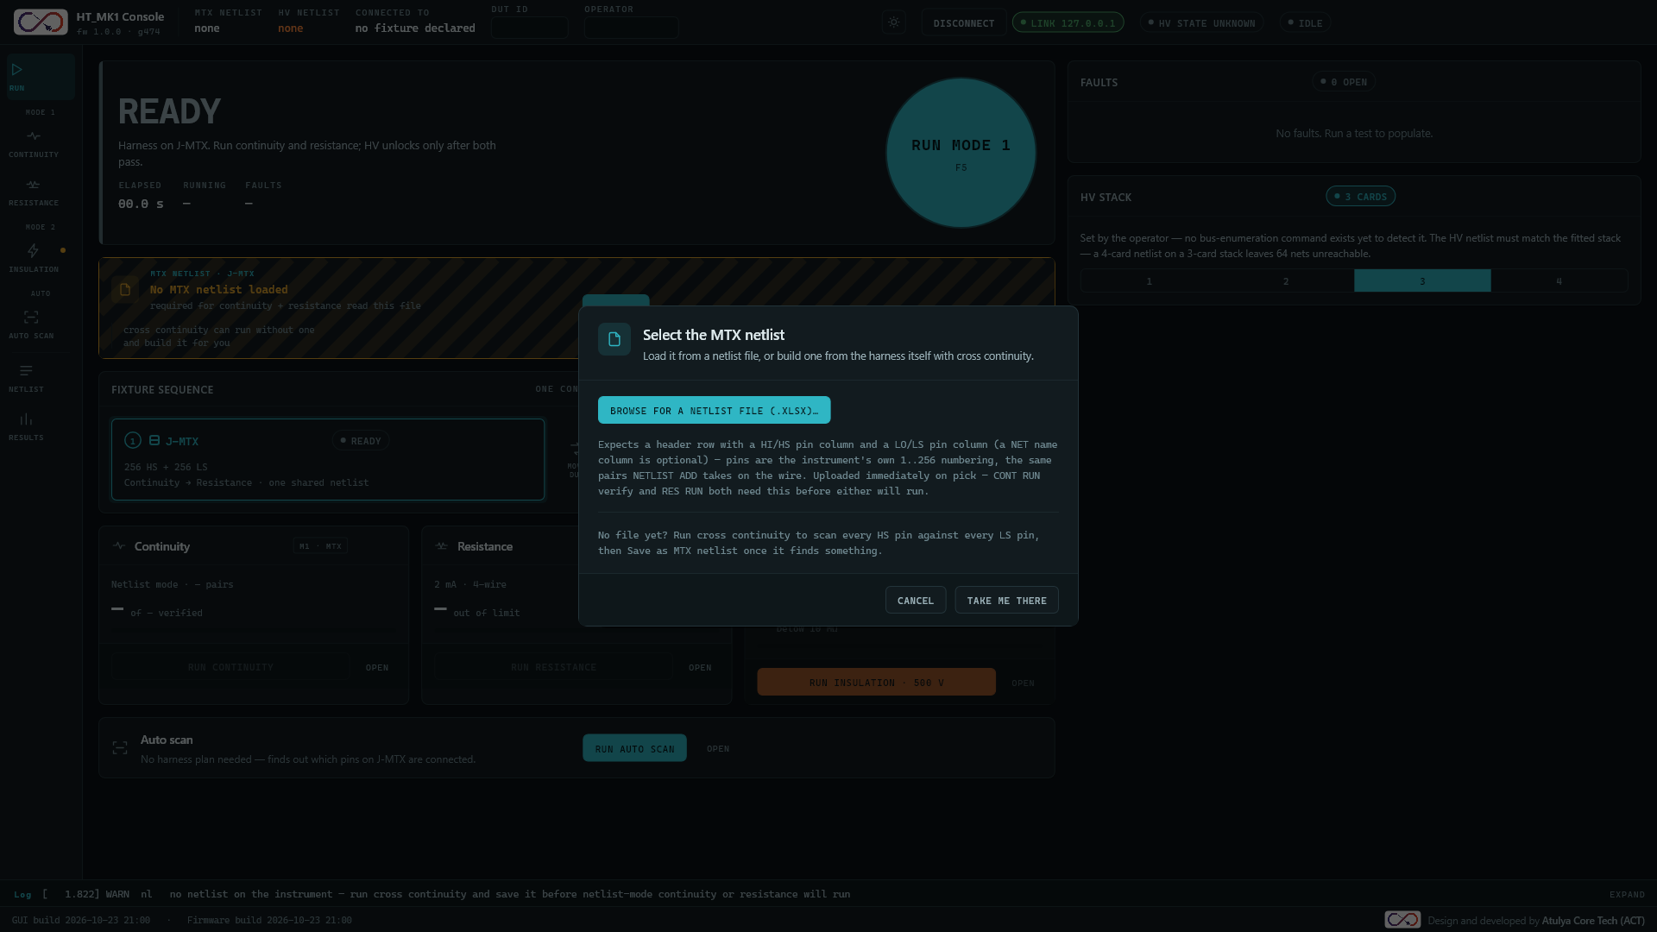
Figure 2: The Select the MTX netlist dialog.
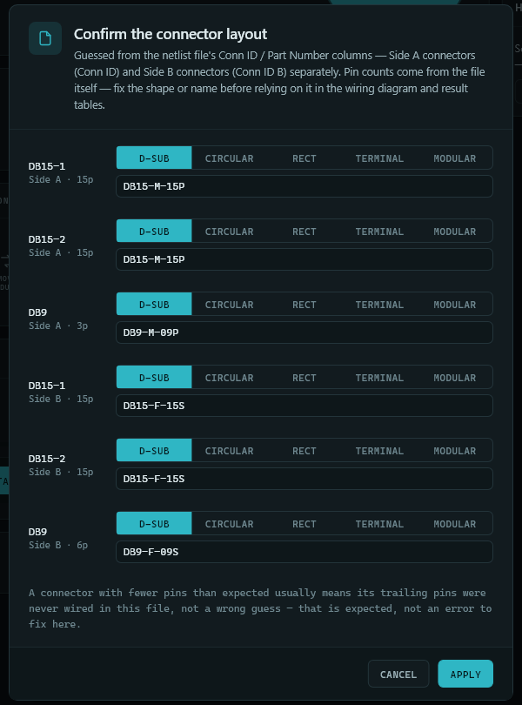
Figure 3: The Confirm the connector layout dialog.
The HV netlist is chosen when you start the insulation test (Section 6.2). It can be the same file as the MTX netlist. Before the first insulation run, also set the HV stack on the Run screen to the number of HV cards fitted in the instrument.
If you have no netlist file for a new harness type, use Auto scan (Section 6.3) to find the connections and save them as the MTX netlist.
The GUI reads an Excel file whose first sheet has a header row with a HI pin and a LO pin column, and optional columns for the net name, connectors, part numbers, pin labels and connector detail. The GUI Functional Description lists them all.

Running a Test

Mode 1: Continuity and Resistance
1. Confirm the harness is plugged into the Matrix connector (J-MTX).
2. On the Run screen press Run Mode 1 (or press F5). This starts the continuity test. Results appear live, pin by pin, and a wiring diagram and a results table update as each result arrives.
3. To use the Continuity screen instead, open it and press Run continuity. Choose Netlist mode to check the harness against the loaded netlist.
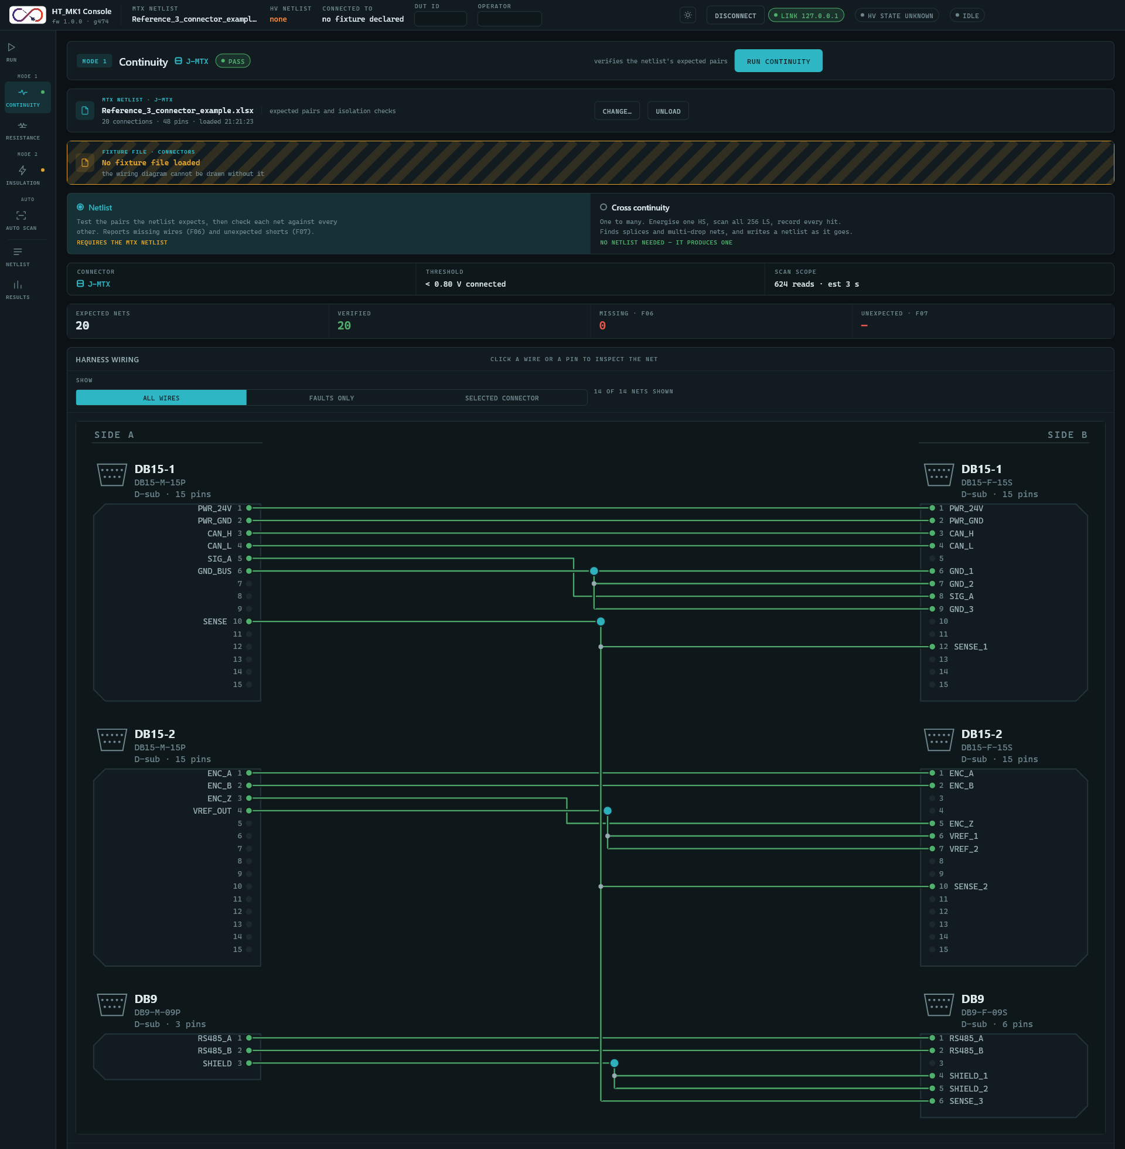
Figure 4: The Continuity screen after a passing run: result tiles and the wiring diagram.
1. When continuity has passed, open the Resistance screen (or use the Run screen) and press Run resistance. Each wire's result appears live, and a table ranks the wires by how close they are to the limit.
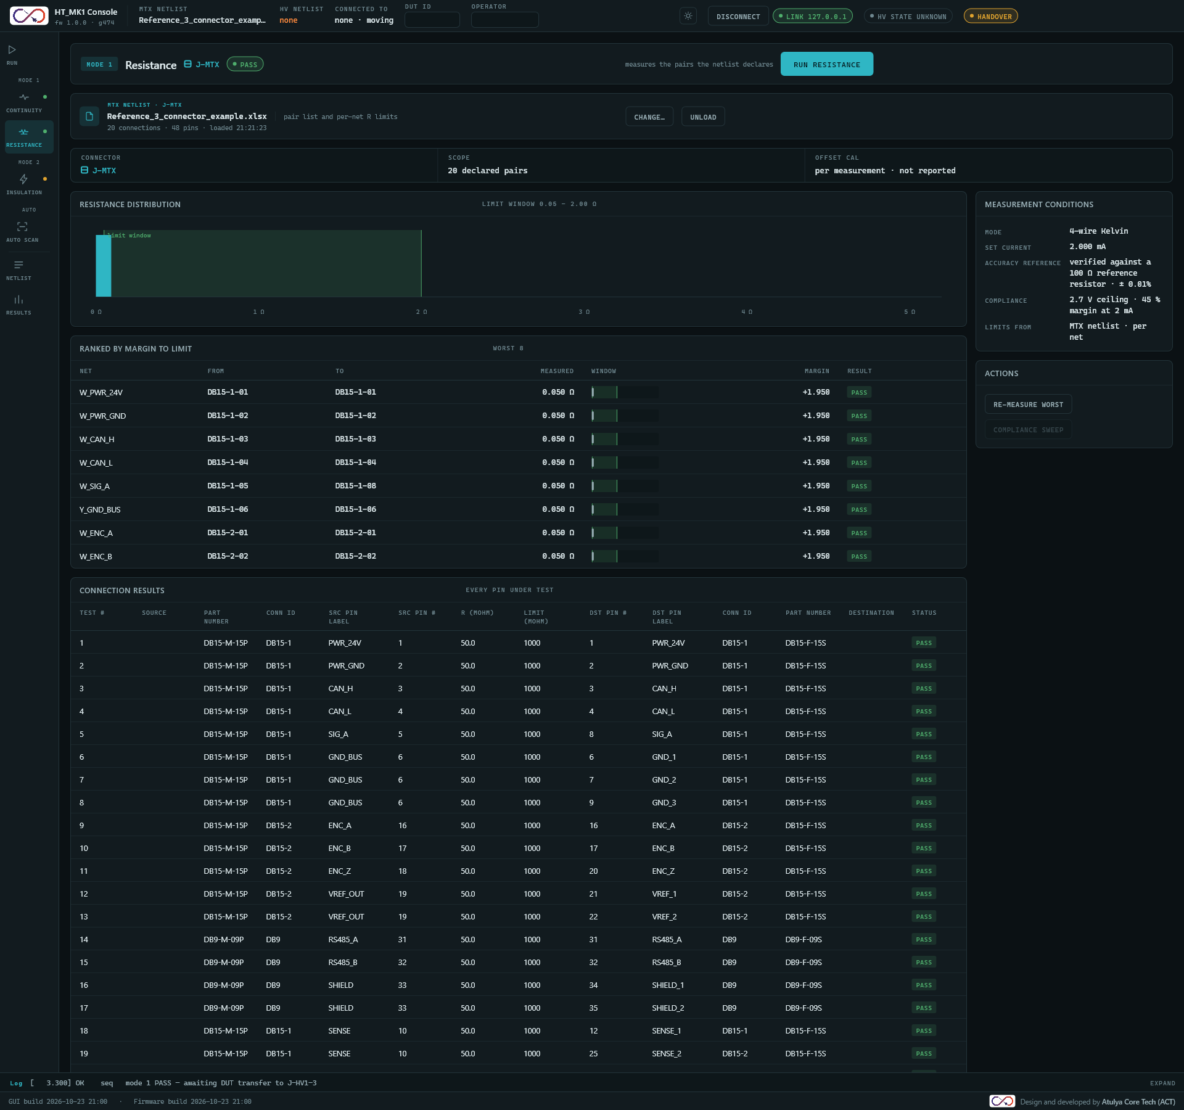
Figure 5: The Resistance screen after a passing run, ranked by margin to the limit.
When both tests pass, the Run screen shows MOVE DUT and asks you to move the harness to the HV connector (Section 6.2). If either test fails, the screen shows FAIL, the harness stays where it is and high voltage is not attempted.
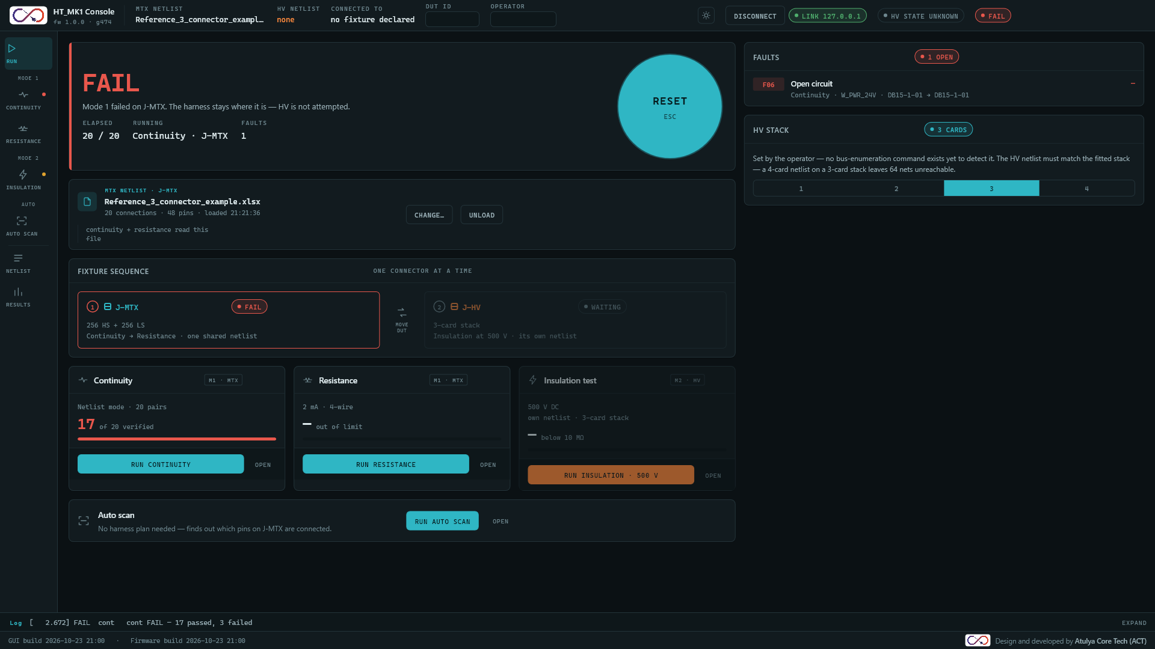
Figure 6: The Run screen after a failed continuity run: the verdict shows FAIL and the Faults panel lists the open nets.

Mode 2: Insulation
WARNING: Read Section 3 before running this test.
Once continuity and resistance both pass, the Run screen asks for the fixture handover:
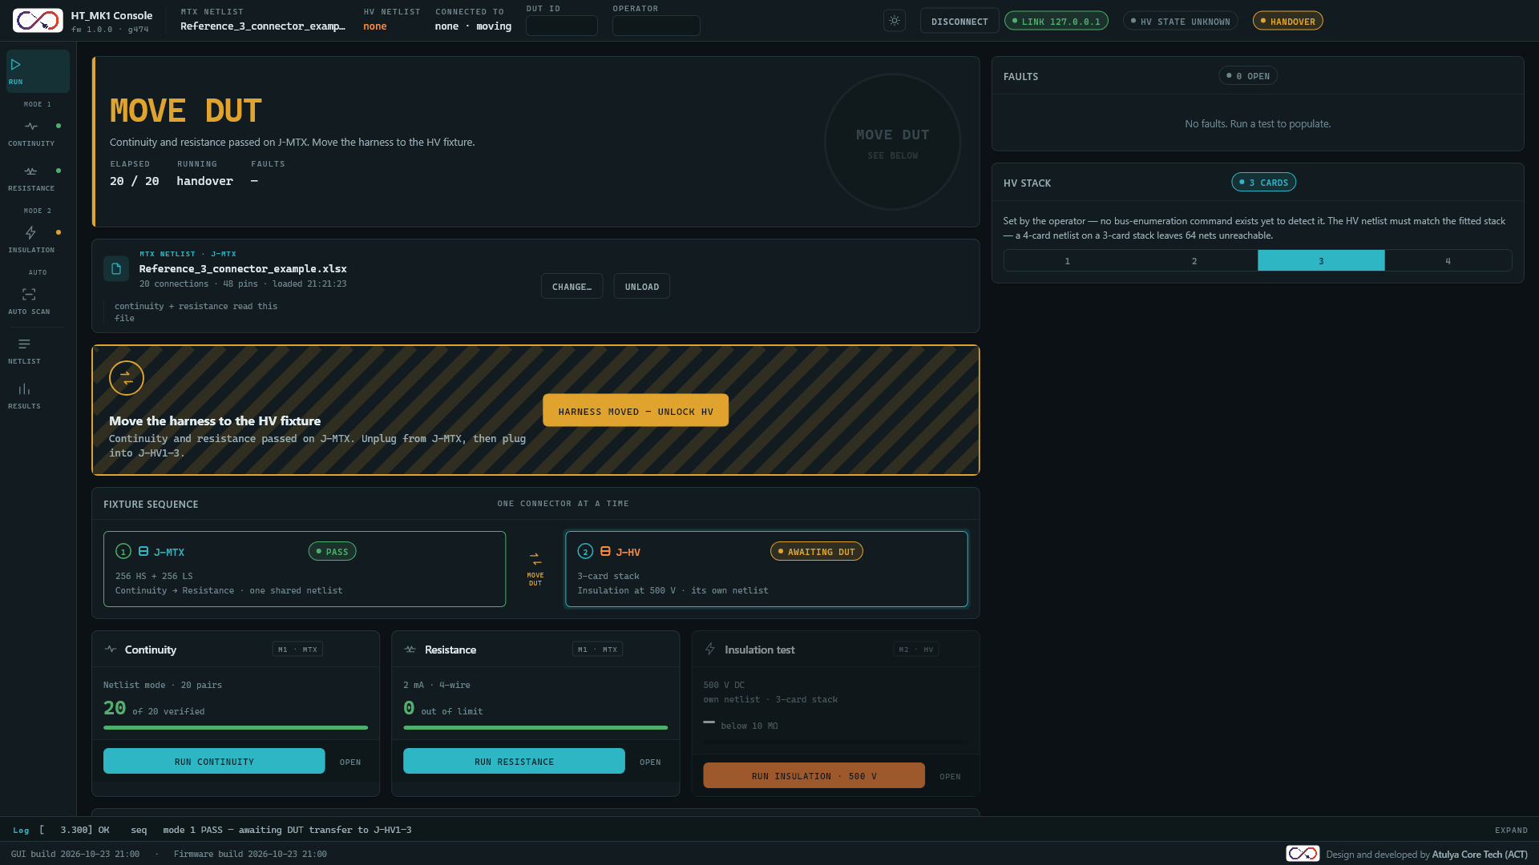
Figure 7: The handover prompt shown once Mode 1 passes.
1. Move the harness from J-MTX to the HV connector (J-HV).
2. Press Harness moved - unlock HV. The verdict changes to ARMED and the Insulation test is unlocked.
3. Check that the HV stack setting on the Run screen matches the HV cards fitted.
4. Press Run insulation (on the Run screen or the Insulation screen). If no HV netlist is loaded, choose one when asked.
5. A confirmation dialog lists the checks (continuity, resistance, fixture, netlist match, interlock). Read every row. Tick the confirmation box. The Energize 500 V button stays disabled until you do.
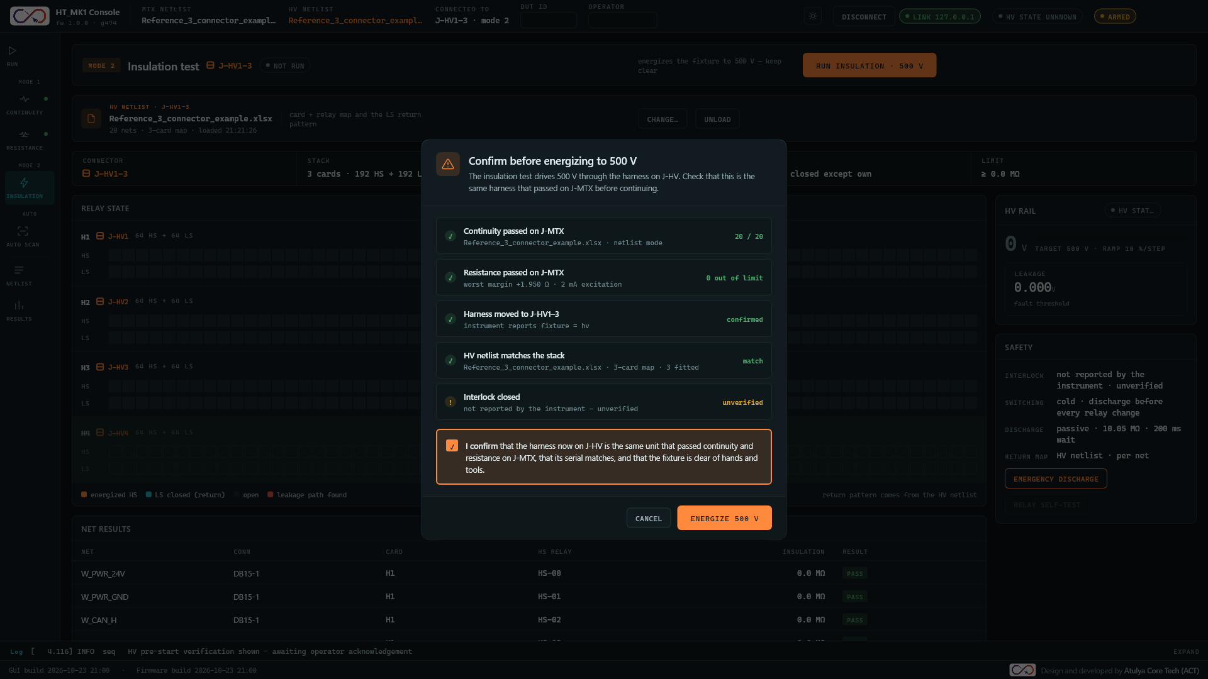
Figure 8: The pre-energize confirmation. Energize 500 V is enabled only after the box is ticked.
1. Press Energize 500 V. The instrument applies high voltage to each wire in turn and the GUI shows the results live. While voltage is present the status bar is replaced by the high-voltage banner.
2. Wait for the green HV Safe indicator before handling the harness.
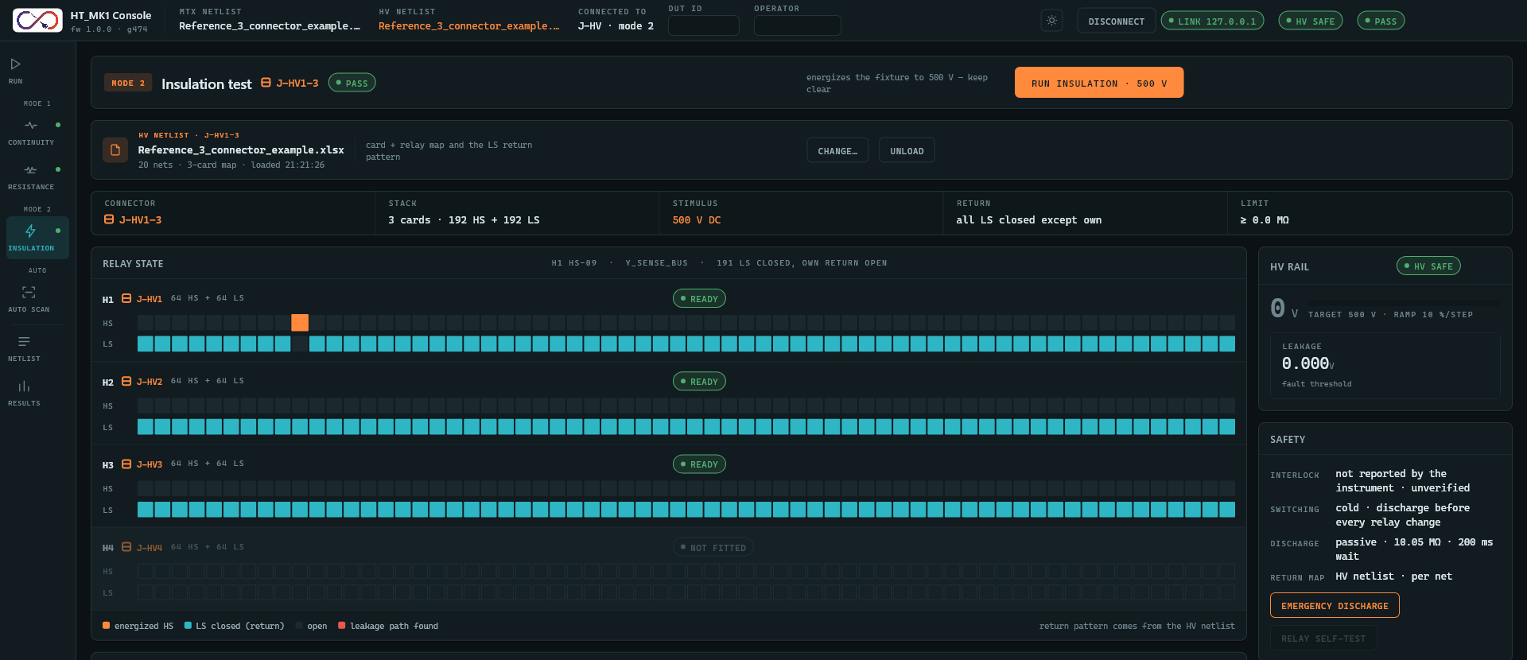
Figure 9: The Insulation screen after a run: relay state and HV rail.
Continue anyway. If you press Run insulation before Mode 1 has passed, the GUI asks Run continuity and resistance first? You can go to Mode 1, cancel, or choose Continue anyway to run insulation without any pre-test. Continue anyway tells the instrument the harness is on J-HV, so make sure it is plugged in there. The skipped tests are recorded in the log and shown as skipped in the confirmation dialog.
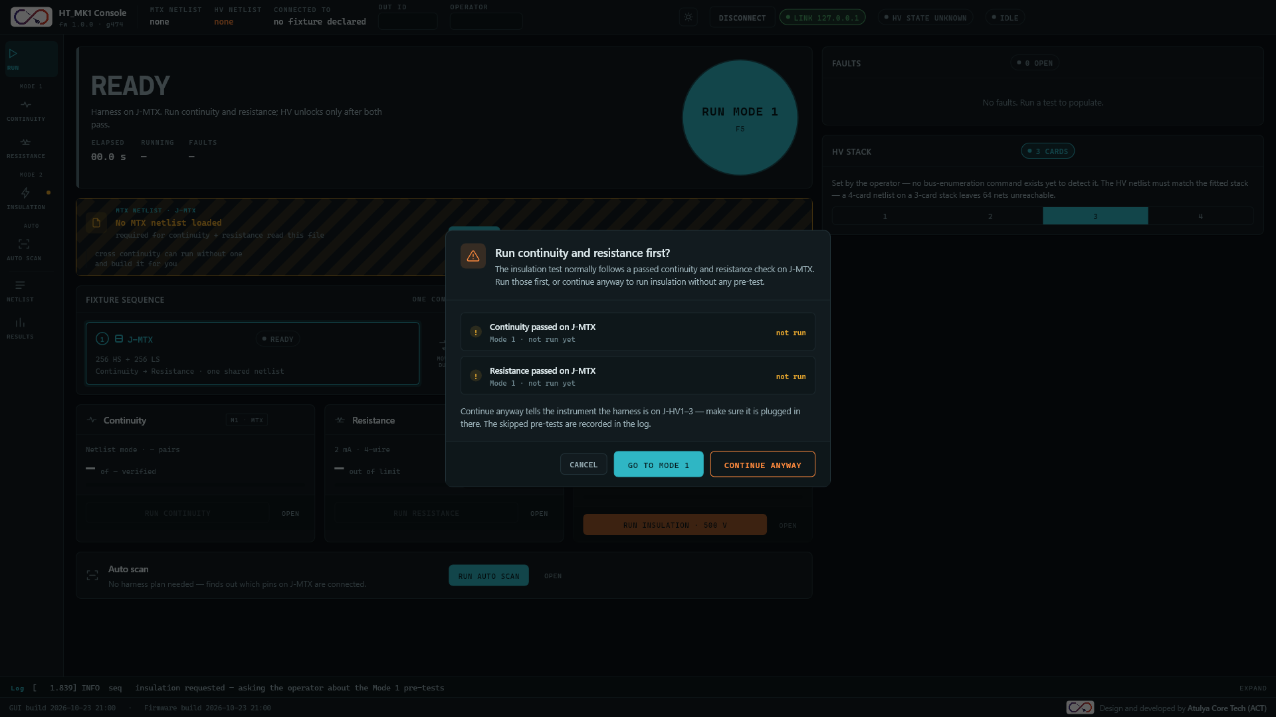
Figure 10: The prompt shown when insulation is requested before Mode 1 has passed.

Auto Scan
Auto scan finds the connections that exist on a harness without a netlist. Use it for a new or unknown harness.
1. Plug the harness into the Matrix connector (J-MTX).
2. Open the Auto scan screen and press Run auto scan.
3. The connections found appear in the table. When the scan ends, the tiles show the number of connections, pins and multi-drop nets.
4. To use the result as a netlist, press Save as MTX netlist. It is then loaded as the MTX netlist.
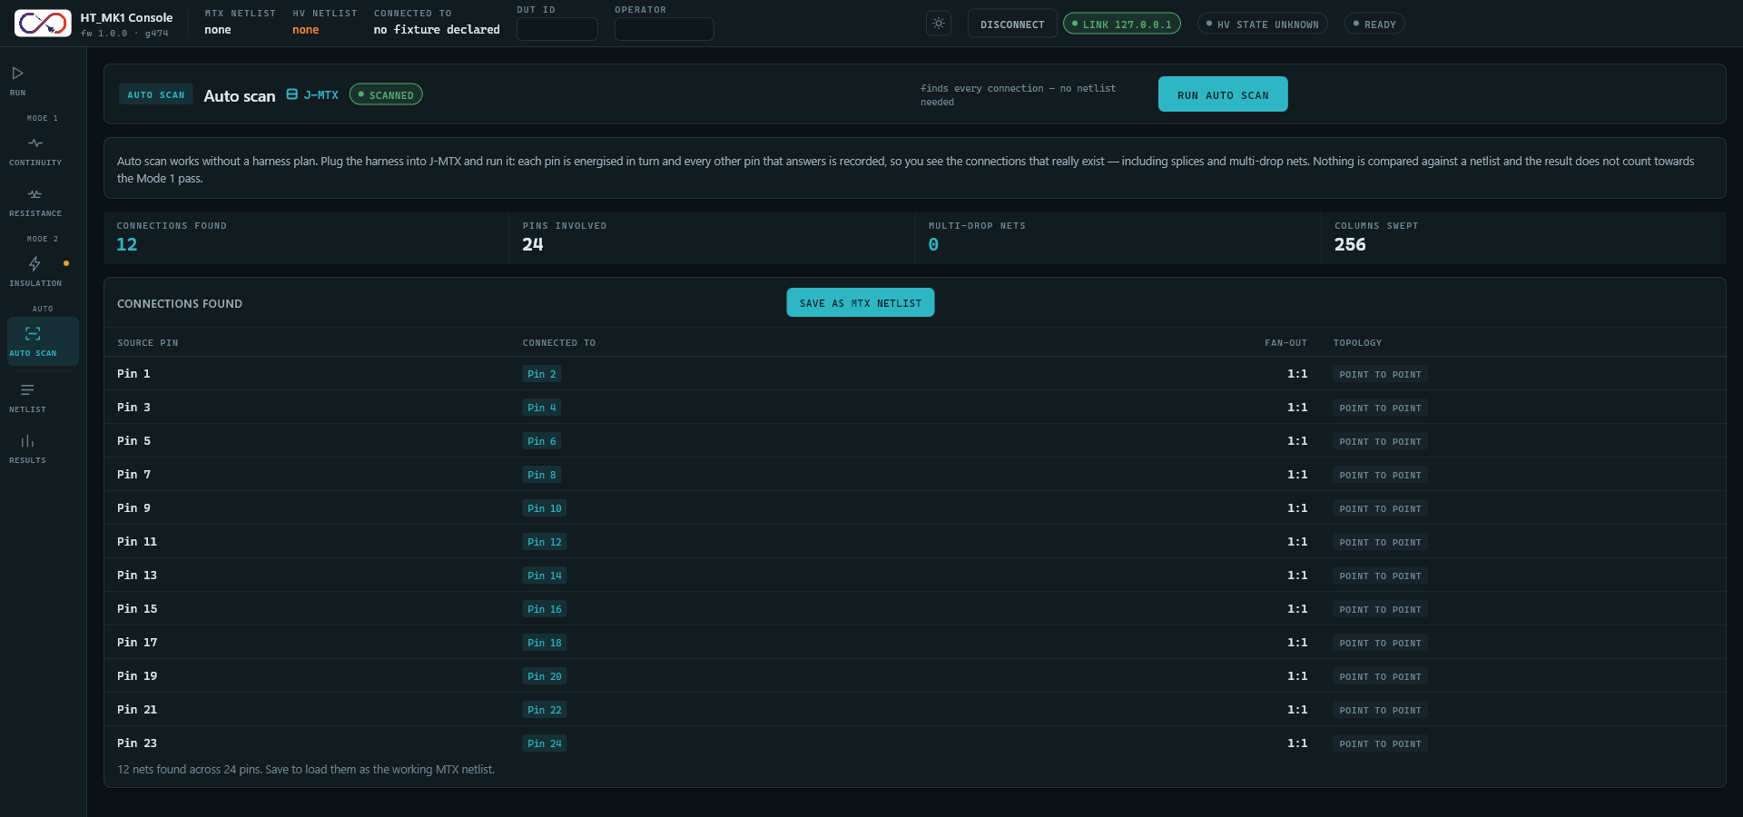
Figure 11: The Auto scan screen after a scan.
NOTE: Auto scan is a survey. It does not count toward the Mode 1 pass and cannot unlock insulation.

Reading Results
Each wire shows a pass or fail result as it arrives. The Run screen shows a verdict, the three test cards show running counts, and the Faults panel lists any failures. Pressing a fault takes you to the screen that shows it. A small dot on the navigation rail shows each test's last result: green for pass, red for fail.
Fault codes:
Code | Meaning
F06 | Open circuit: an expected connection was not found.
F07 | Unexpected connection (short) between wires that should not be joined.
F08 | Resistance outside the limit.
F04 | Insulation below the limit.
Table 3: Fault codes

Viewing Results and History

Run History
The Results screen lists past test runs, most recent first, stored on the PC running the GUI, with a recent pass-rate summary. History is kept when the GUI is closed.
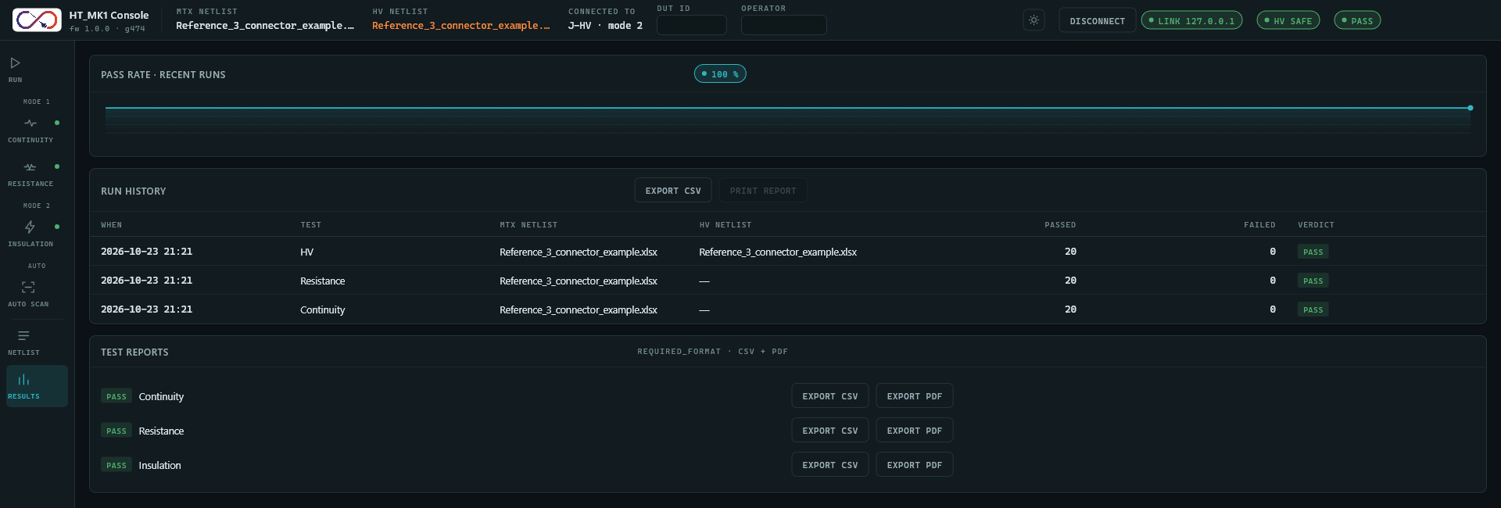
Figure 12: The Results screen: pass rate, run history and per-test reports.

Exporting a Report
1. Go to the Results screen.
2. In Test reports, find the test (Continuity, Resistance or Insulation).
3. Press Export CSV or Export PDF and choose where to save the file.
NOTE: Every completed run is also saved automatically as a CSV and a PDF in the reports folder (%LOCALAPPDATA%\HT_MK1\reports). Enter the DUT ID and Operator before the run so they appear in the report. Export CSV next to Run history saves the run history.

Troubleshooting

Common Messages
The GUI reports problems as lines in the log bar at the bottom of the window, not as pop-up windows. If a button seems to do nothing, press Expand on the log bar and read the newest lines.
Message (in the log) | Meaning | What to do
Not connected: choose the port ... | There is no link to the instrument, so Run is disabled. | Choose the port and press Connect.
refused - EBUSY | Another test is still running. | Wait for it to finish, or press Stop.
fault F03 (HV rail) | The HV rail did not reach, hold or discharge to the expected level. | The instrument has stopped and latched a fault. Check the HV card and its connections, then press Clear Fault.
refused - EFIXTURE | The harness is on the wrong connector for the requested test. | Move the harness to the correct connector and confirm it in the GUI.
refused - ENOTARMED | Insulation was requested without arming. | Start insulation from the GUI as in Section 6.2.
refused - ERANGE | A value was outside the allowed range. | Re-enter a valid value.
refused - EHW | The instrument failed to initialize one of its cards at power-on. | Power-cycle the instrument and check the card connections. If it persists, contact support.
could not read <file> | The netlist file could not be read. | Check it is an .xlsx file with a HI and a LO pin column and pin numbers from 1 to 256.
netlist upload refused | The instrument did not accept the netlist. | Check the netlist and try again.
no netlist on the instrument | No netlist is held by the instrument. | Load a netlist, or run Auto scan and save it.
Table 4: Common messages

If the Connection Is Lost
The status bar shows No link, Link lost and State unknown, and the log shows link lost. The GUI does not reconnect by itself. Check the cable, then choose the port and press Connect again. Treat the system as not safe to handle until HV Safe is shown again.

Faults
If the instrument latches a fault, the state indicator turns red and reads Fault, and a Clear Fault button appears in the status bar. The instrument refuses every run until the fault is cleared. Remove the cause (for example reseat a card), then press Clear Fault. The state returns to Idle. A fault is never cleared automatically.

Glossary
Term | Meaning
Netlist | The list of expected wire connections for the harness under test.
MTX netlist | The netlist for continuity and resistance on the Matrix connector (J-MTX).
HV netlist | The netlist for insulation on the HV connector (J-HV). It follows the number of HV cards fitted.
Mode 1 | Continuity and resistance, with the harness on J-MTX.
Mode 2 | The insulation test, with the harness on J-HV.
Auto scan | A survey that finds the connections on a harness without a netlist.
Fixture | Which physical connector the harness is on: Matrix (J-MTX) or HV (J-HV).
Arm | An explicit step required before high voltage can be applied. The GUI does it when you energize.
Verdict | The pass or fail result for one wire or for a whole test.
Leakage | The small unwanted current that flows through imperfect insulation.
Table 5: Glossary

