

HT_MK1 Harness Tester
Flashing Procedure

Document ID: | HT_MK1_FP
Document Version: | 1.0
Date: | 27 August 2026
System: | Control Card (STM32G474RET6)
Prepared by: | Azista BST Aerospace Private Limited
Prepared for: | Infinity Integration Pvt. Ltd.
Classification: | Confidential

Revision History
Version | Date | Description | Author
1.0 | 27 August 2026 | Initial release | [Author]

Table of Contents
Revision History 2
Table of Contents 2
1. Purpose and Scope 3
1.1 Purpose 3
1.2 Scope 3
1.3 Applies To 3
2. Prerequisites 3
2.1 Hardware 3
2.2 Software 3
3. Safety Precautions 3
4. Procedure — Building the Firmware 4
5. Procedure — Programming the Device 5
6. Verification 6
7. Troubleshooting 6
8. Sign-off 7

1. Purpose and Scope

1.1 Purpose
This procedure describes how to build and program (flash) the HT_MK1 firmware onto the Control Card's microcontroller.

1.2 Scope
Covers building the firmware in STM32CubeIDE and programming it through a debug probe connected to the Control Card. Does not cover firmware development, GUI operation, or functional testing — see the HT_MK1 Code Walkthrough, User Manual, and Functional Test Procedure for those.

1.3 Applies To
Control Card assemblies fitted with an STM32G474RET6 microcontroller.

2. Prerequisites

2.1 Hardware
Item | Notes
Control Card assembly | STM32G474RET6 fitted, with the JTAG/SWD connector (J6) and the console Micro-USB-B connector accessible.
Debug probe: ST-Link/V2 | Standalone ST-Link/V2 dongle. Its 20-way ARM JTAG ribbon cable connects directly to J6 — no adapter needed.
USB cable: USB-A to Mini-USB-B | Connects the ST-Link/V2 (Mini-USB-B socket on the probe) to the PC (USB-A port). Used only for programming.
USB cable: USB-A to Micro-USB-B | Connects the Control Card's console connector directly to the PC (USB-A port). Used for the serial link — verification (Section 6) and normal GUI operation.
Programming PC | Runs the software listed in Section 2.2.

NOTE: The ST-Link/V2 and its Mini-USB-B cable are used for programming only (Section 5). The Micro-USB-B console connector is separate, external to the ST-Link/V2, and carries only the firmware-GUI serial link (Section 6) — it plays no part in flashing the device.

2.2 Software
- STM32CubeIDE, version 1.19.0 or later — includes the bundled arm-none-eabi-gcc toolchain and ST-Link driver support.
- The HT_MK1 firmware project source.
- (Optional, for verification) A serial terminal application.

3. Safety Precautions
CAUTION: Power down the harness tester fully before connecting or disconnecting the debug probe. Never program the Control Card while an HV Card is energized or a test is running.

- Use standard ESD precautions (anti-static wrist strap, grounded mat) when handling the Control Card.
- Jumpers JP1 and JP2, next to connector J6, must be in their as-designed position before connecting the probe. If unsure, check their position against the Control Card schematic before proceeding.

4. Procedure — Building the Firmware
1. Open STM32CubeIDE and import the HT_MK1 project (File > Open Projects from File System, then select the project's root folder).
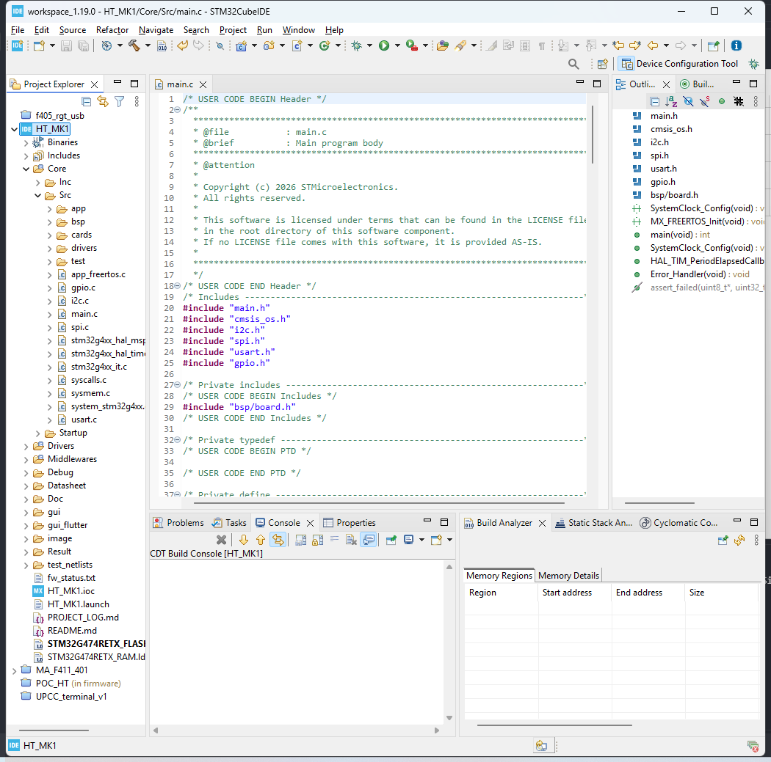
Figure 1 — The HT_MK1 project loaded in STM32CubeIDE's Project Explorer.

2. Select the Debug build configuration — the only configuration this project currently provides.
3. Build the project (Project > Build Project, or the hammer icon). A clean build compiles every source file with no errors.
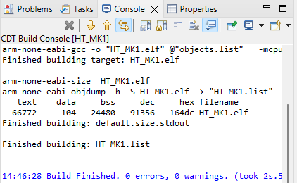
Figure 2 — A successful build: 0 errors, 0 warnings.

Alternative — command line, from the project's Debug/ folder:
make all -j8
Requires the STM32CubeIDE bundled toolchain to be on PATH — see Section 7 if make cannot find arm-none-eabi-gcc.

5. Procedure — Programming the Device
1. Connect the ST-Link/V2's 20-way ribbon cable to connector J6 on the Control Card.
2. Connect the ST-Link/V2 to the PC using the USB-A to Mini-USB-B cable.
3. Power on the Control Card.
4. In STM32CubeIDE, start a debug session (Run > Debug, or the Debug icon). STM32CubeIDE programs the device automatically as part of starting the session.
Alternative: to flash a pre-built image without opening the full project, use STM32CubeProgrammer with the .elf file produced by the build (Debug/HT_MK1.elf) and the connected debug probe.
5. Once programming completes, the microcontroller resets and starts running the new firmware automatically.

6. Verification
This step confirms the new firmware is running, using the console connector — a separate Micro-USB-B port on the Control Card, unrelated to the ST-Link/V2 and J6 used for flashing in Section 5. This port carries the same serial link the GUI uses during normal operation.
1. Connect a USB-A to Micro-USB-B cable from the PC to the Control Card's console connector.
2. On the PC, identify the new COM port and open a serial terminal on it at 115200 baud, 8 data bits, no parity, 1 stop bit (115200 8N1).
3. Power-cycle or reset the Control Card.
4. Confirm the console prints a boot line similar to:
#[boot] HT_MK1 console up @115200

5. Send the command shown below and confirm the reply is received:
>PING
<PONG

NOTE: A PONG reply confirms the new firmware is running and the serial link works. It does not confirm the Matrix Card or HV Cards are functioning — run the Functional Test Procedure for that.

COORDINATION POINT: The console connector's UART must match the UART the firmware actually initializes for the console. Confirm this before relying on the check above — see the HT_MK1 Code Walkthrough, Section 3, for the firmware's current console UART assignment.

7. Troubleshooting
Symptom | Likely Cause | What to Do
"arm-none-eabi-gcc: command not found" (command-line build) | The bundled toolchain is not on PATH. | Add STM32CubeIDE's bundled toolchain folder to PATH, or build from within the IDE instead.
Linker error referencing a path that does not exist on this PC | The build folder's linker-script rule was generated on a different machine. | Clean and rebuild the project from within STM32CubeIDE so it regenerates the build folder locally.
Debug probe not detected | Cable, connector, or driver issue. | Confirm the ribbon cable is fully seated on J6, the probe's USB cable is connected, and its driver is installed. Confirm JP1/JP2 positions (Section 3).
No boot line, or no reply to PING | Wrong COM port, wrong baud rate, or programming did not complete. | Confirm the terminal is set to 115200 8N1 on the correct COM port. Re-run Section 5 and check STM32CubeIDE's console for errors.

8. Sign-off
Field | Value
Firmware version programmed
Programmed by
Date
Verified by

