

HT_MK1 Harness Tester
User Manual

Document ID: | HT_MK1_UM
Document Version: | 1.0
Date: | 26 August 2026
System: | Control Card + Matrix Card + HV Card + Operator GUI
Prepared by: | Azista BST Aerospace Private Limited
Prepared for: | Infinity Integration Pvt. Ltd.
Classification: | Confidential

Revision History
Version | Date | Description | Author
1.0 | 26 August 2026 | Initial release | [Author]

Table of Contents
Revision History 2
Table of Contents 2
1. Introduction 4
1.1 Purpose 4
1.2 Audience 4
1.3 Related Documents 4
2. System Overview 4
3. Safety 4
3.1 High Voltage 4
3.2 Arming 4
3.3 Abort 5
3.4 "Safe to Handle" 5
4. Getting Started 5
4.1 Launching the Application 5
4.2 Connecting to the Instrument 5
4.3 Screen Layout 5
5. Loading a Netlist 6
6. Running a Test 7
6.1 Stage 1 and 2: Continuity and Resistance 7
6.2 Stage 3: Insulation 9
6.3 Reading Results 11
7. Viewing Results and History 11
7.1 Run History 11
7.2 Exporting a Report 11
8. Troubleshooting 12
8.1 Common Messages 12
8.2 If the Connection Is Lost 12
9. Glossary 12

1. Introduction

1.1 Purpose
This manual explains how to operate the HT_MK1 harness tester using the GUI application: starting the software, connecting to the instrument, loading a netlist, running each test stage, and reading results.

1.2 Audience
Operators running tests on the HT_MK1. No programming or electronics background is assumed.

1.3 Related Documents
- HT_MK1 Code Walkthrough — for engineers maintaining the firmware or GUI software.
- HT_MK1 Flashing Procedure — for programming a unit's firmware.
- HT_MK1 Functional Test Procedure — for the formal acceptance test of a built unit.

2. System Overview
The HT_MK1 tests up to 256 wires in a harness, in three stages:
Stage | Test | Checks
1 | Continuity | Each wire is connected where it should be, and not touching any other wire.
2 | Resistance | Each connected wire's resistance is within its allowed limit.
3 | Insulation | Each wire holds the required insulation at up to 500 V DC, with no leakage.

Stages 1 and 2 are run with the harness on the Matrix connector. Stage 3 is run with the harness moved to the HV connector. The system tracks which connector is in use and will not run a test on the wrong one — move the harness, then confirm the Fixture setting in the GUI matches.

3. Safety

3.1 High Voltage
WARNING: The insulation test applies up to 500 V DC to the harness under test. Never touch the harness, the HV connector, or the test fixture while a test is running or while the system is armed.

3.2 Arming
Insulation testing requires an explicit Arm step before it can run. Arming on its own does not apply high voltage — running the test does. Before arming, confirm the harness is on the HV connector and that no one is in contact with it.

3.3 Abort
The Abort control is available on every screen while a test is running. Pressing it stops the test immediately, discharges any high voltage, and opens all relays.

3.4 "Safe to Handle"
IMPORTANT: Wait for the system to show "Safe" before handling the harness — do not assume it is safe simply because a test has finished. If the connection to the instrument is lost, treat the system as unsafe until it reconnects and shows "Safe" again.

4. Getting Started

4.1 Launching the Application
Double-click the HT_MK1 GUI application. No separate installation step is required.

4.2 Connecting to the Instrument
1. Connect the instrument to the PC with the serial cable and power it on.
2. In the status bar, open the port selector and choose the instrument's serial port.
3. Confirm the status bar shows the instrument connected and its state (idle, fault, and so on).

4.3 Screen Layout
Area | Shows
Navigation rail (left) | Switches between screens: RUN, CONTIN (Continuity), RESIST (Resistance), HV, NETLIST, and RESULTS.
Status bar (top) | Connection state, the loaded MTX/HV netlist names, current Fixture (Matrix / HV / none), and the "Safe" indicator.
Log bar (bottom) | A running log of recent activity, for reference.

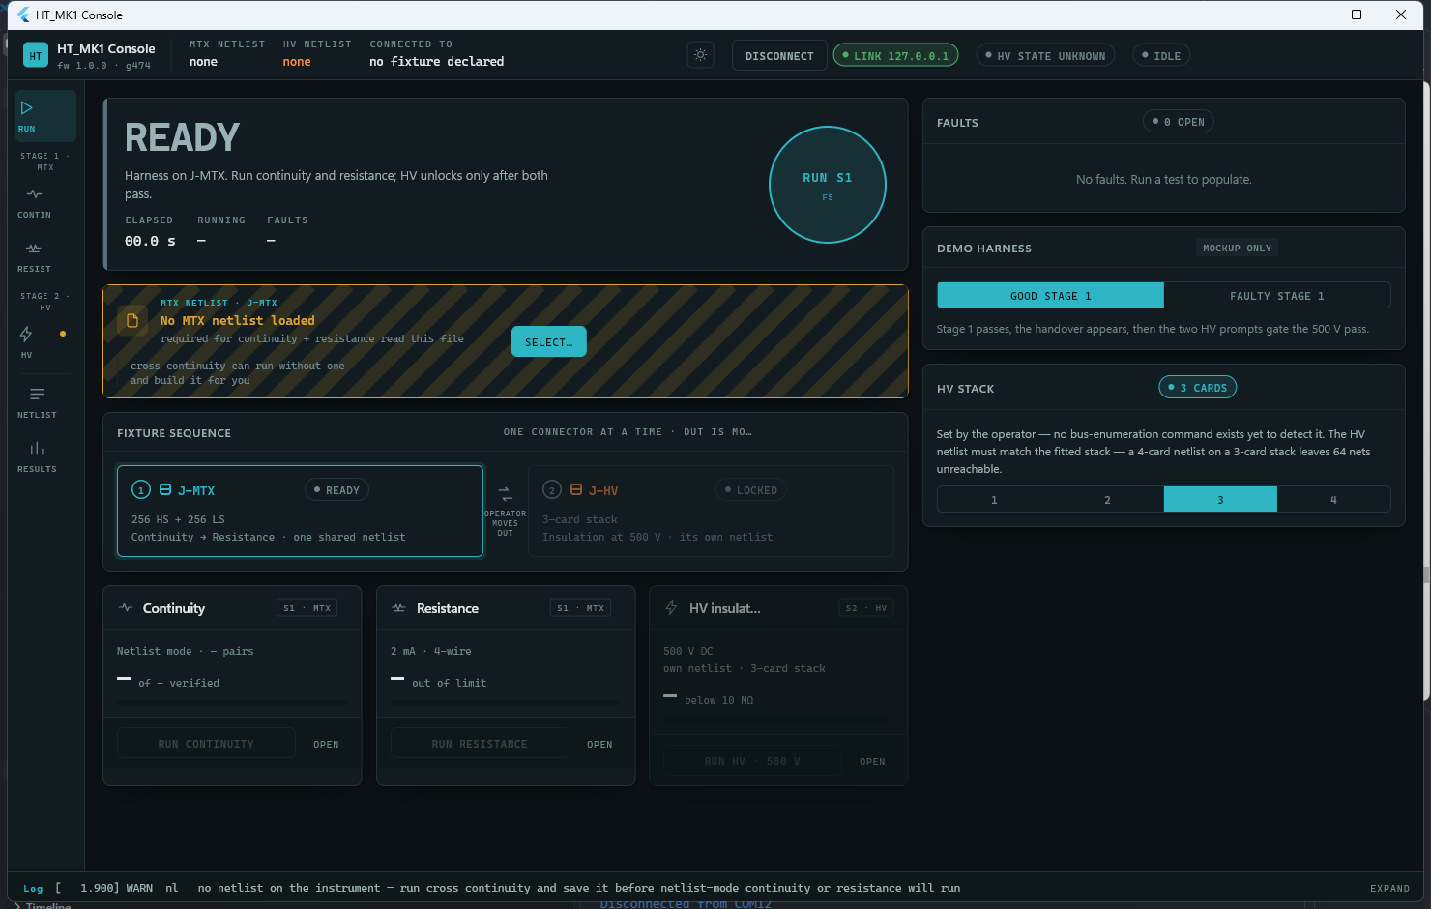
Figure 1 — The Run screen, showing the navigation rail, status bar, and log bar.

5. Loading a Netlist
A netlist is the list of wire connections a harness is expected to have. It must be loaded each session — the instrument does not remember a netlist between power cycles.
1. Go to the NETLIST screen.
2. Under "MTX netlist", press Select (or Change) and browse to the netlist file used for continuity and resistance testing.
3. Under "HV netlist", press Select (or Change) and browse to the netlist file used for insulation testing. This can be the same file, sized to the fitted HV card stack.
A netlist can also be created from a Continuity discovery scan (Section 6.1) and saved from there, if no netlist file exists yet for a new harness type.
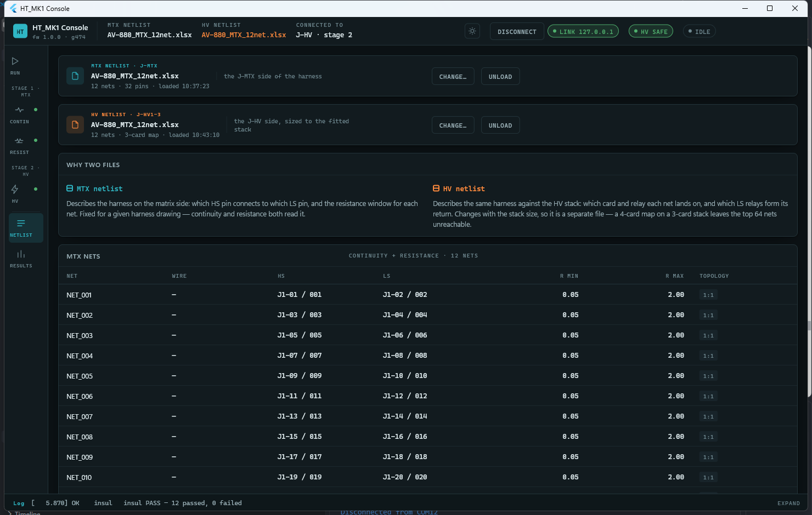
Figure 2 — The NETLIST screen, with both the MTX and HV netlists loaded.

6. Running a Test

6.1 Stage 1 and 2: Continuity and Resistance
1. Confirm the harness is plugged into the Matrix connector.
2. Go to the CONTIN screen.
3. Choose Netlist mode (checks the harness against the loaded netlist) or Cross continuity (scans an unknown harness with no netlist assumed).
4. Press Run continuity. Results appear live, pin by pin, as the test proceeds; a wiring diagram and a pass/fail table update as each result arrives.
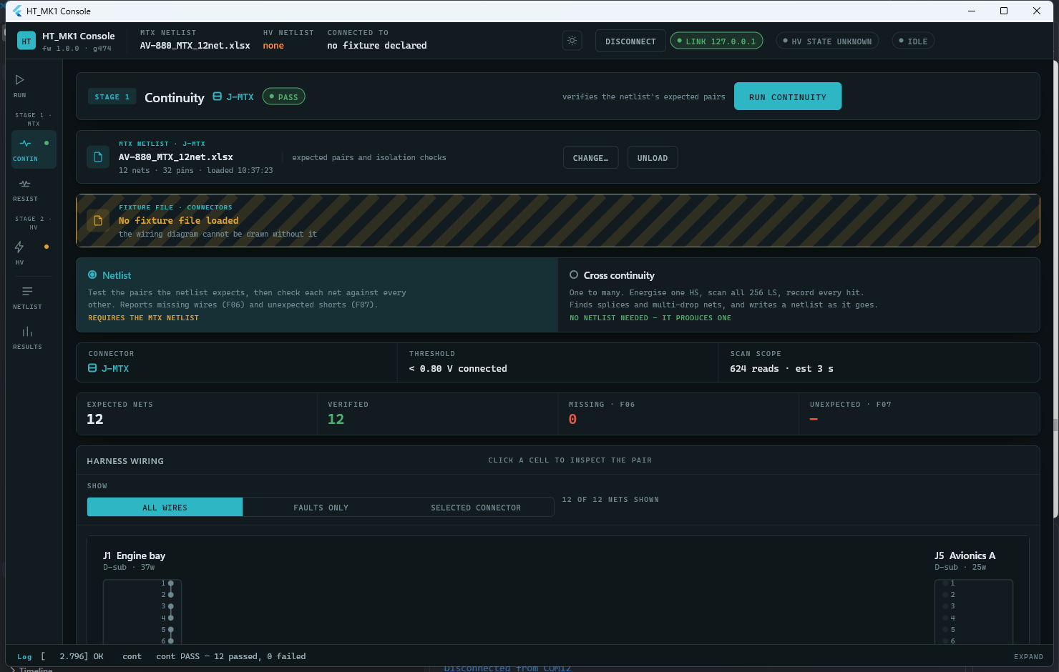
Figure 3 — The CONTIN screen after a passing run: 12 of 12 nets verified.

5. Go to the RESIST screen and press Run resistance. Each wire's result appears live, with a table ranking wires by how close they are to the limit.
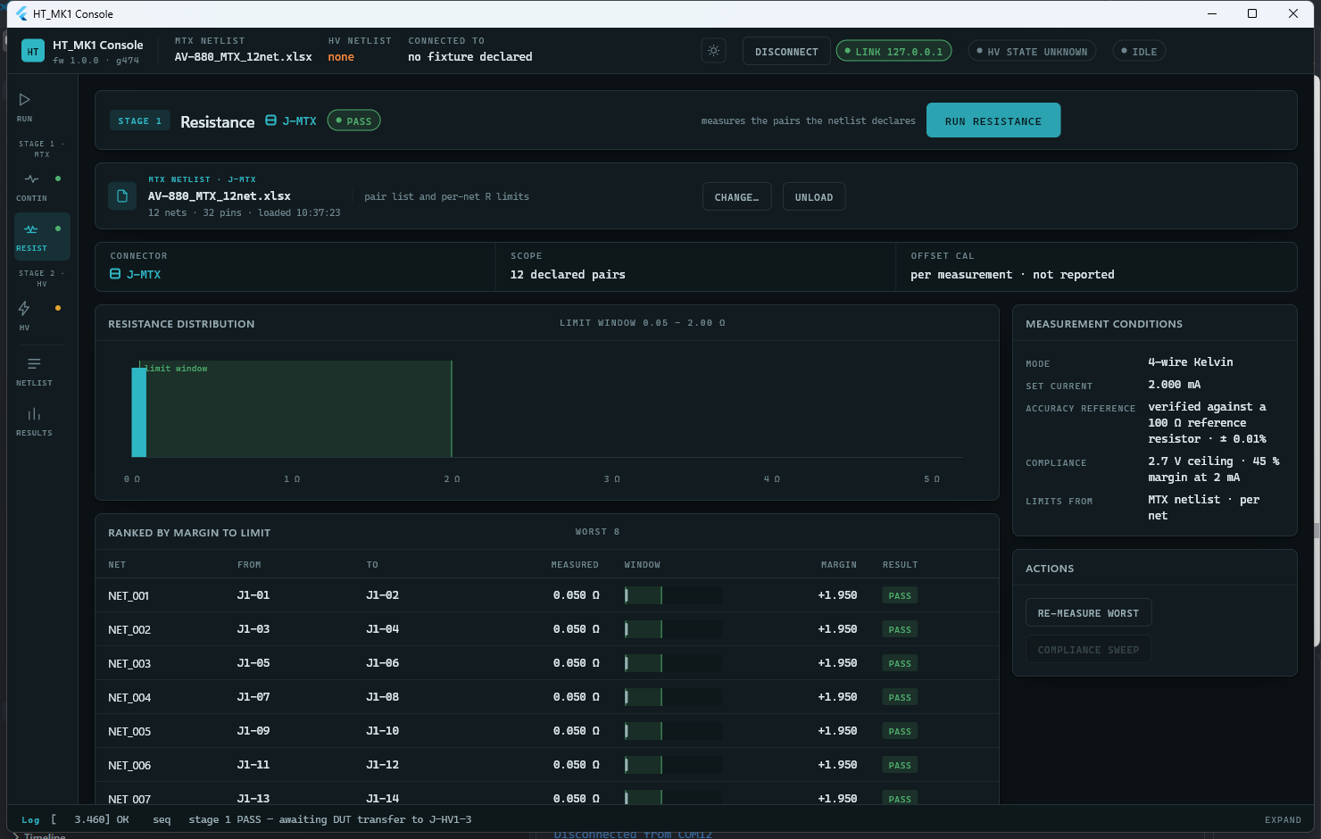
Figure 4 — The RESIST screen after a passing run, ranked by margin to the limit.

6.2 Stage 3: Insulation
WARNING: Review Section 3 before running this stage.

Once continuity and resistance both pass, the Run screen prompts for the fixture handover:
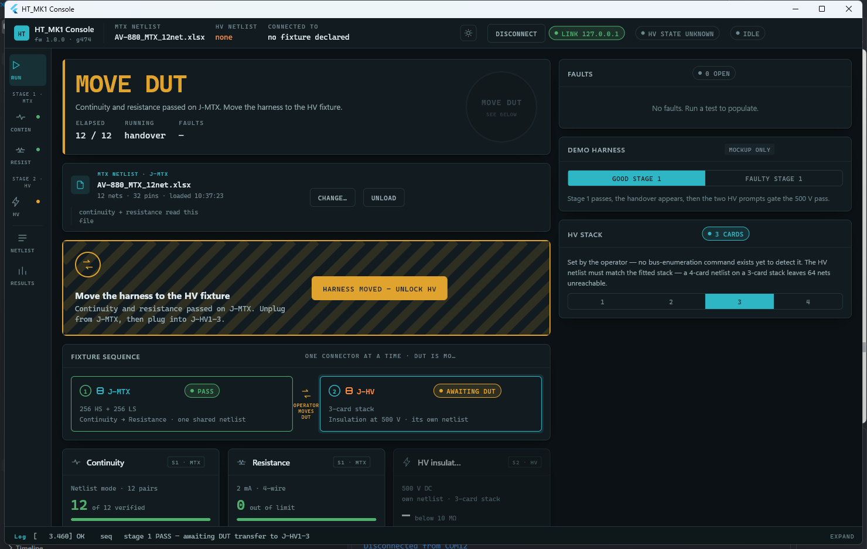
Figure 5 — The handover prompt shown once Stage 1 passes.

1. Move the harness to the HV connector.
2. Confirm the move in the GUI ("Harness moved — unlock HV"). This unlocks the HV screen.
3. Go to the HV screen. If no HV netlist is loaded yet, select one (Section 5).
4. Press Run HV. A confirmation screen lists the checks passed (continuity, resistance, fixture, netlist match) and requires an explicit tick-box confirmation before it will proceed.
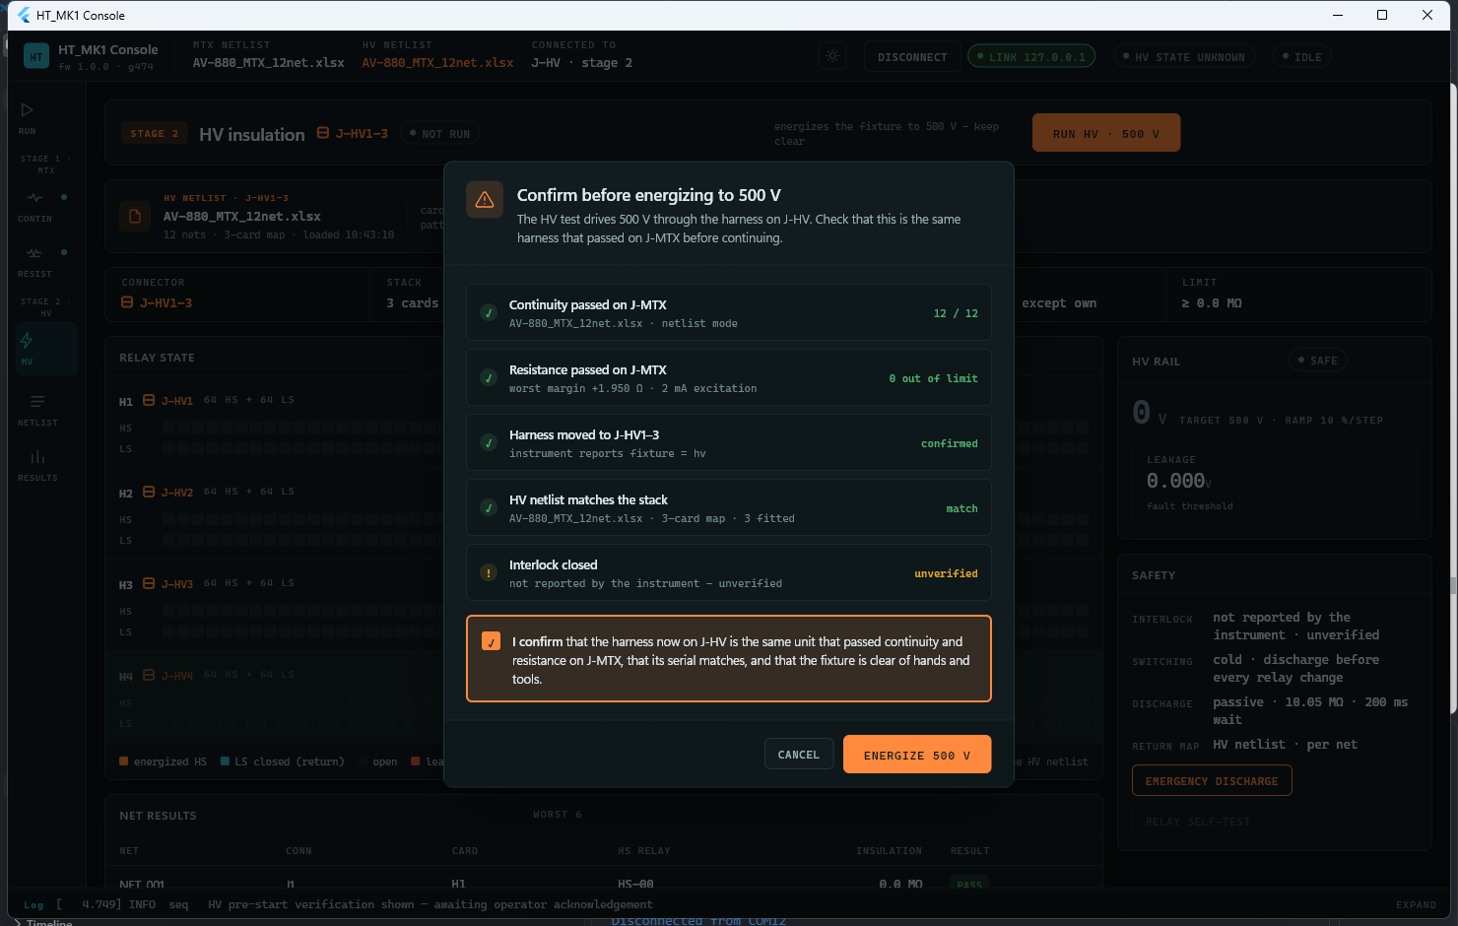
Figure 6 — The pre-energize confirmation. Energize is disabled until the box is ticked.

5. Press Energize 500 V. The system applies high voltage to each wire in turn and reports leakage results live.
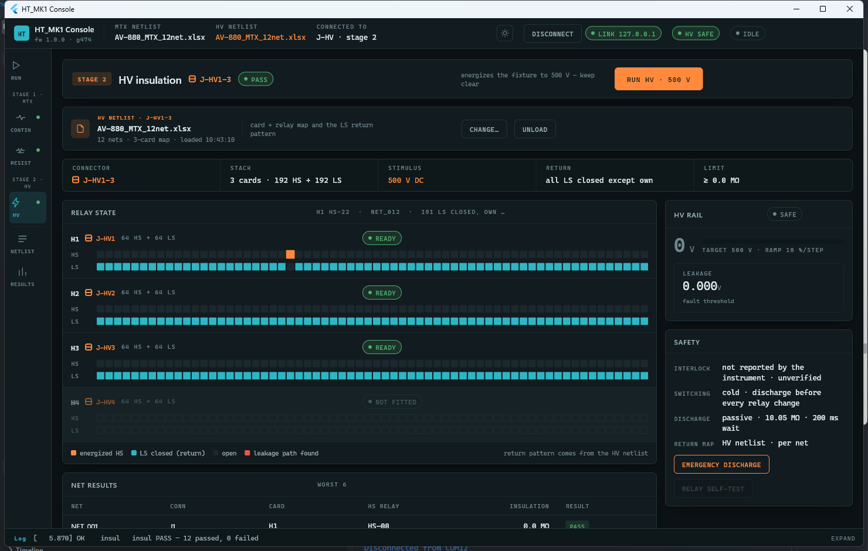
Figure 7 — The HV screen after a passing run. The status bar shows "HV SAFE".

6. Wait for the "Safe" indicator before handling the harness.

6.3 Reading Results
Each wire shows a pass or fail verdict as its result arrives. An overall pass/fail summary for the stage is shown once the run completes. If a fault occurs during a run, it appears in the faults panel with a short description.
Abort is available throughout any run (Section 3.3) and can be pressed at any time without waiting for the current wire's measurement to finish.

7. Viewing Results and History

7.1 Run History
The RESULTS screen lists past test runs, most recent first, stored on the PC running the GUI, along with a recent pass-rate summary.
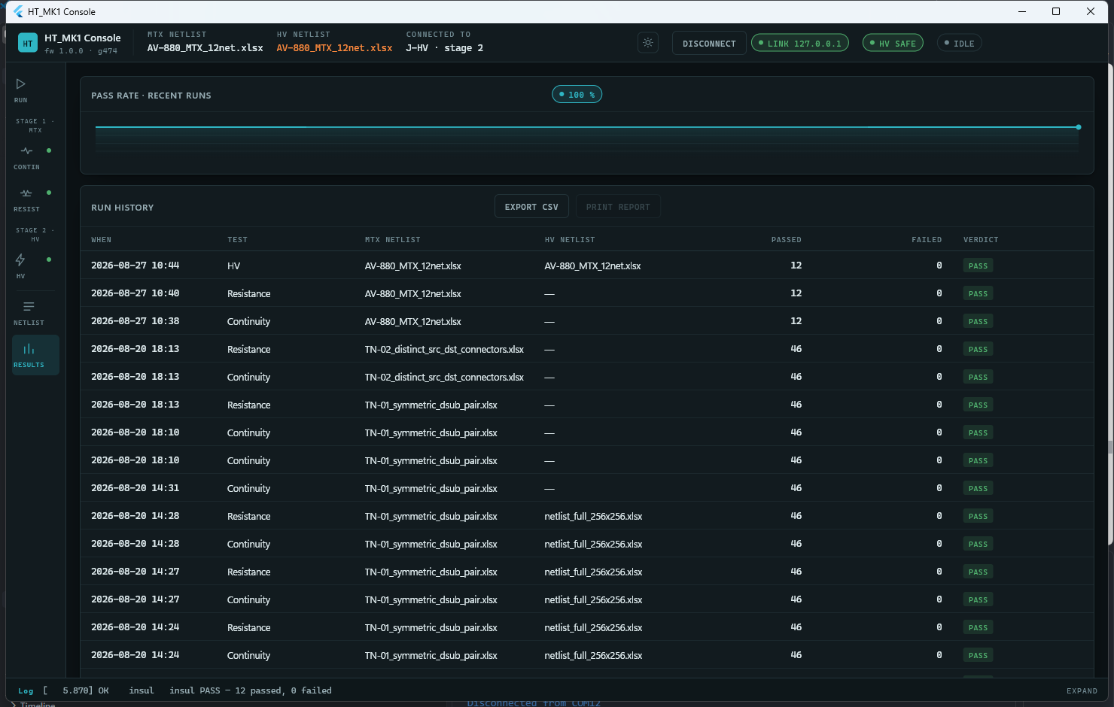
Figure 8 — The RESULTS screen: pass-rate summary and run history.

7.2 Exporting a Report
1. Go to the RESULTS screen.
2. Select the run to export.
3. Choose Export CSV to save a report for that run.

8. Troubleshooting

8.1 Common Messages
Message | Meaning | What to do
A run is already in progress | Another test is still running. | Wait for it to finish, or press Abort.
Wrong connector for this command | The harness is on the wrong connector for the requested test. | Move the harness to the correct connector and confirm the Fixture setting.
Insulation not armed | Insulation was requested without arming first. | Press Arm, then Run (Section 6.2).
Argument out of range | A value entered (for example a limit) was outside the allowed range. | Re-enter a valid value.
Hardware not ready | The instrument failed to initialize one of its cards at power-on. | Power-cycle the instrument and check the card connections. If it persists, contact support.
Command not understood | An internal communication error. | Should not normally occur. If it does, reconnect and contact support if it repeats.

8.2 If the Connection Is Lost
The status bar will show the instrument as disconnected, and the "Safe" indicator will no longer show safe. Reconnect the serial port and wait for the status bar to show the instrument connected again. Treat the system as not safe to handle until "Safe" is shown.

9. Glossary
Term | Meaning
Netlist | The list of expected wire connections for the harness under test.
Fixture | Which physical connector the harness is currently on: Matrix or HV.
Arm | An explicit confirmation step required before high voltage can be applied.
Verdict | The pass/fail result for one wire or for a whole test stage.
Leakage | The small unwanted current that flows through imperfect insulation.

