Universal Protocol Inverter
Code Walk Through

Document ID: UPI-MK0-CWT-01
Revision: 1.0
Date: 11-Jun-2026

Applicable Firmware: v2.0
Applicable GUI: 2.0
Infinity Integrations Private Limited

Table of Contents
1 Purpose of This Document 4
1.1 Audience 4
1.2 Prerequisites 4
2 Repository Layout 4
3 Firmware Architecture 4
3.1 Key design principle 5
4 Firmware Startup Flow 5
4.1 Entry points 6
5 Router Task and Any-to-All Routing 7
5.1 Message structure 7
5.2 Forwarding logic 8
6 UART Data Paths 8
6.1 RX path 8
6.2 TX path 8
6.3 RS-485 direction control 8
7 SPI and CAN Data Paths 9
7.1 SPI 9
7.2 CAN 9
8 USB CDC and Ethernet Integration 9
8.1 USB CDC 9
8.2 Ethernet 9
9 Protocol Layer 9
9.1 Frame format 10
9.2 Command dispatch table 10
10 Configuration Storage 11
10.1 Flash write flow 11
11 GUI Architecture 11
11.1 Package layout 11
12 GUI Connection Workers 12
12.1 Worker types 12
12.2 Signals emitted by workers 13
13 GUI Tabs and Protocol Dispatch 13
13.1 Main window responsibilities 13
13.2 Tab summary 13
14 Code File Reference 14
14.1 Firmware files 14
14.2 GUI files 14
15 Adding a New Interface — Developer Checklist 15
15.1 Firmware side 15
15.2 GUI side 15
16 Debugging Tips 16
16.1 Firmware 16
16.2 GUI 16

Purpose of This Document
This walkthrough is intended for firmware and GUI developers who need to maintain, extend or debug the UPCC/UPIU project. It explains the high-level architecture, the flow of data through the system, the responsibilities of each major source file, and the conventions used across the codebase.

Audience

Embedded firmware engineers working on the STM32 side.

Python/Qt developers working on the host GUI.

Test and integration engineers who need to trace data paths.

Prerequisites

STM32CubeIDE 2.1+ and ARM GCC toolchain for firmware builds.

Python 3.12+ with PyQt6 and pyserial for GUI development.

Basic understanding of FreeRTOS, lwIP, HAL and PyQt signals/slots.

Repository Layout
The repository is split into three major areas: STM32 firmware, the host GUI, and documentation. Generated build outputs and prebuilt assets are also present.
Directory | Contents | Notes
Core/ | Application firmware  Inc/ and Src/ | User code; router, protocol, config, eth server
Drivers/ | STM32F2xx HAL + CMSIS | Generated by STM32CubeMX
Middlewares/ | FreeRTOS, lwIP, USB Device library | Third-party stacks
LWIP/ | lwIP app/target configuration | Middleware glue code
USB_DEVICE/ | USB CDC class implementation | App/ and Target/
upcc_gui/ | PyQt6 desktop application | main.py + app/ package
docs/ | Markdown documentation | PROTOCOL.md, FIRMWARE.md, GUI.md
Debug/ | Build outputs | ELF, MAP, list files

Firmware Architecture
The firmware is built in layers. The application layer owns the routing logic, protocol parsing and configuration management. It sits on top of FreeRTOS, lwIP and the STM32 USB Device library, all of which call into the STM32 HAL.
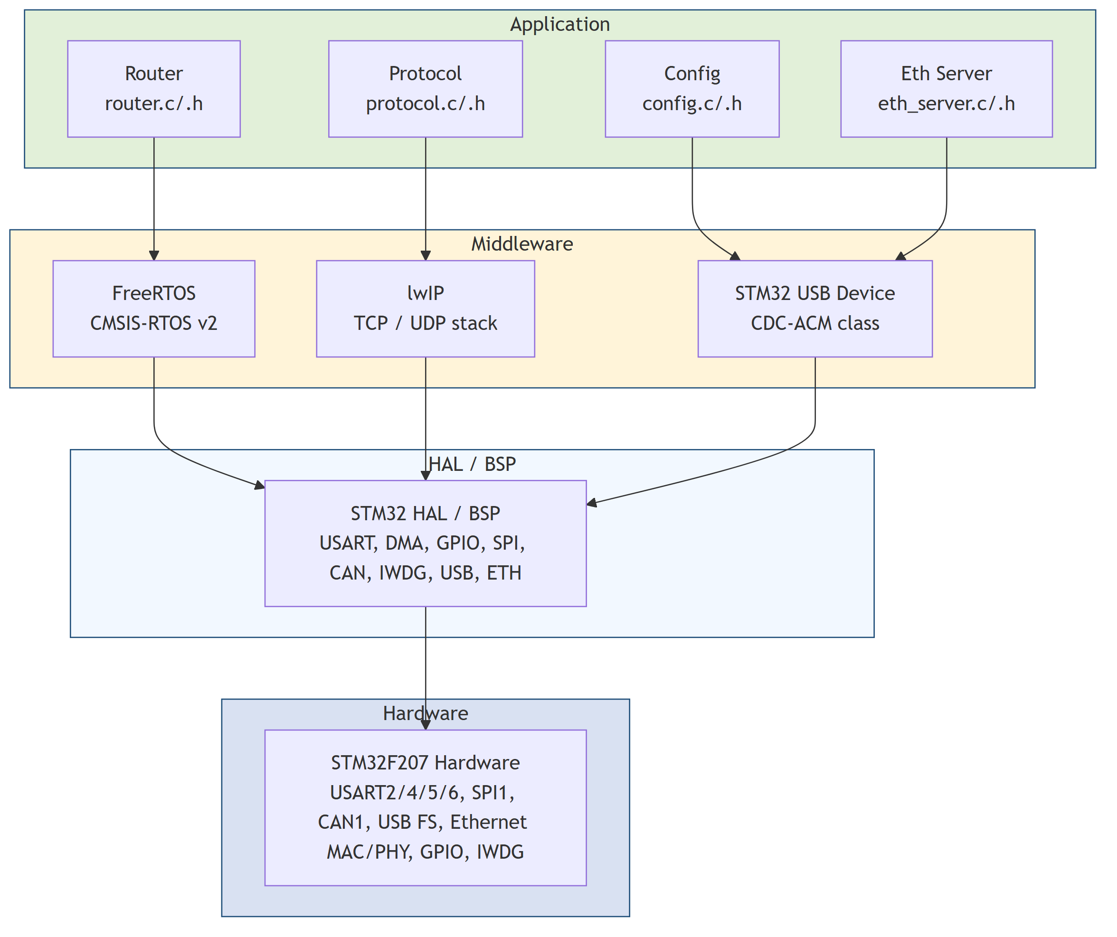
Figure 1 — Firmware high-level architecture

Key design principle

Every received byte is posted to a single FreeRTOS queue (xRouterQueue) so routing decisions happen in one task context.

UART RX uses DMA with idle-line detection; the ISR only copies a pointer/length and wakes the router task.

UART TX uses a small ring buffer per interface to absorb bursts while HAL is busy.

Protocol frames are detected inside the router task; non-frame data is forwarded verbatim.

Configuration is stored in Flash sector 11 and protected by a CRC16.

Firmware Startup Flow
After reset, main.c performs low-level initialization and then hands control to FreeRTOS. Inside FreeRTOS initialization the saved configuration is loaded, the protocol parser is reset, and the router arms DMA receivers. Tasks are started and the scheduler begins.
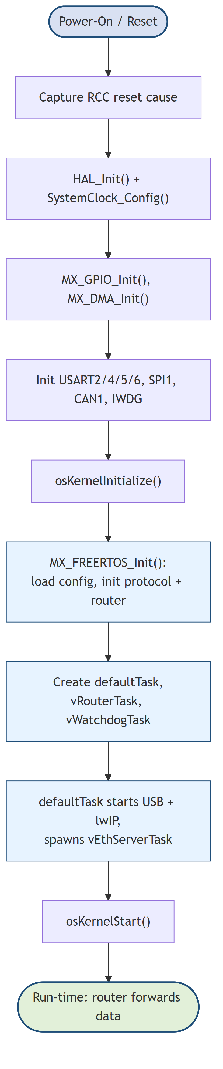
Figure 2 — Firmware startup sequence

Entry points
Item | Description
main.c | Hardware init, clock, peripherals, kernel start.
freertos.c | MX_FREERTOS_Init(): calls Config_LoadOrDefault(), Protocol_Init(), Router_Init(); creates tasks.
defaultTask | Starts USB device and lwIP, then runs vEthServerTask.
vRouterTask | Main routing loop in router.c.
vWatchdogTask | Feeds IWDG every 500 ms.

Router Task and Any-to-All Routing
vRouterTask is the heart of the firmware. It consumes RouterMsg_t structures from xRouterQueue. If a message is a valid protocol frame it is dispatched to the command handler; otherwise the raw payload is forwarded to every enabled interface except the one it arrived on.
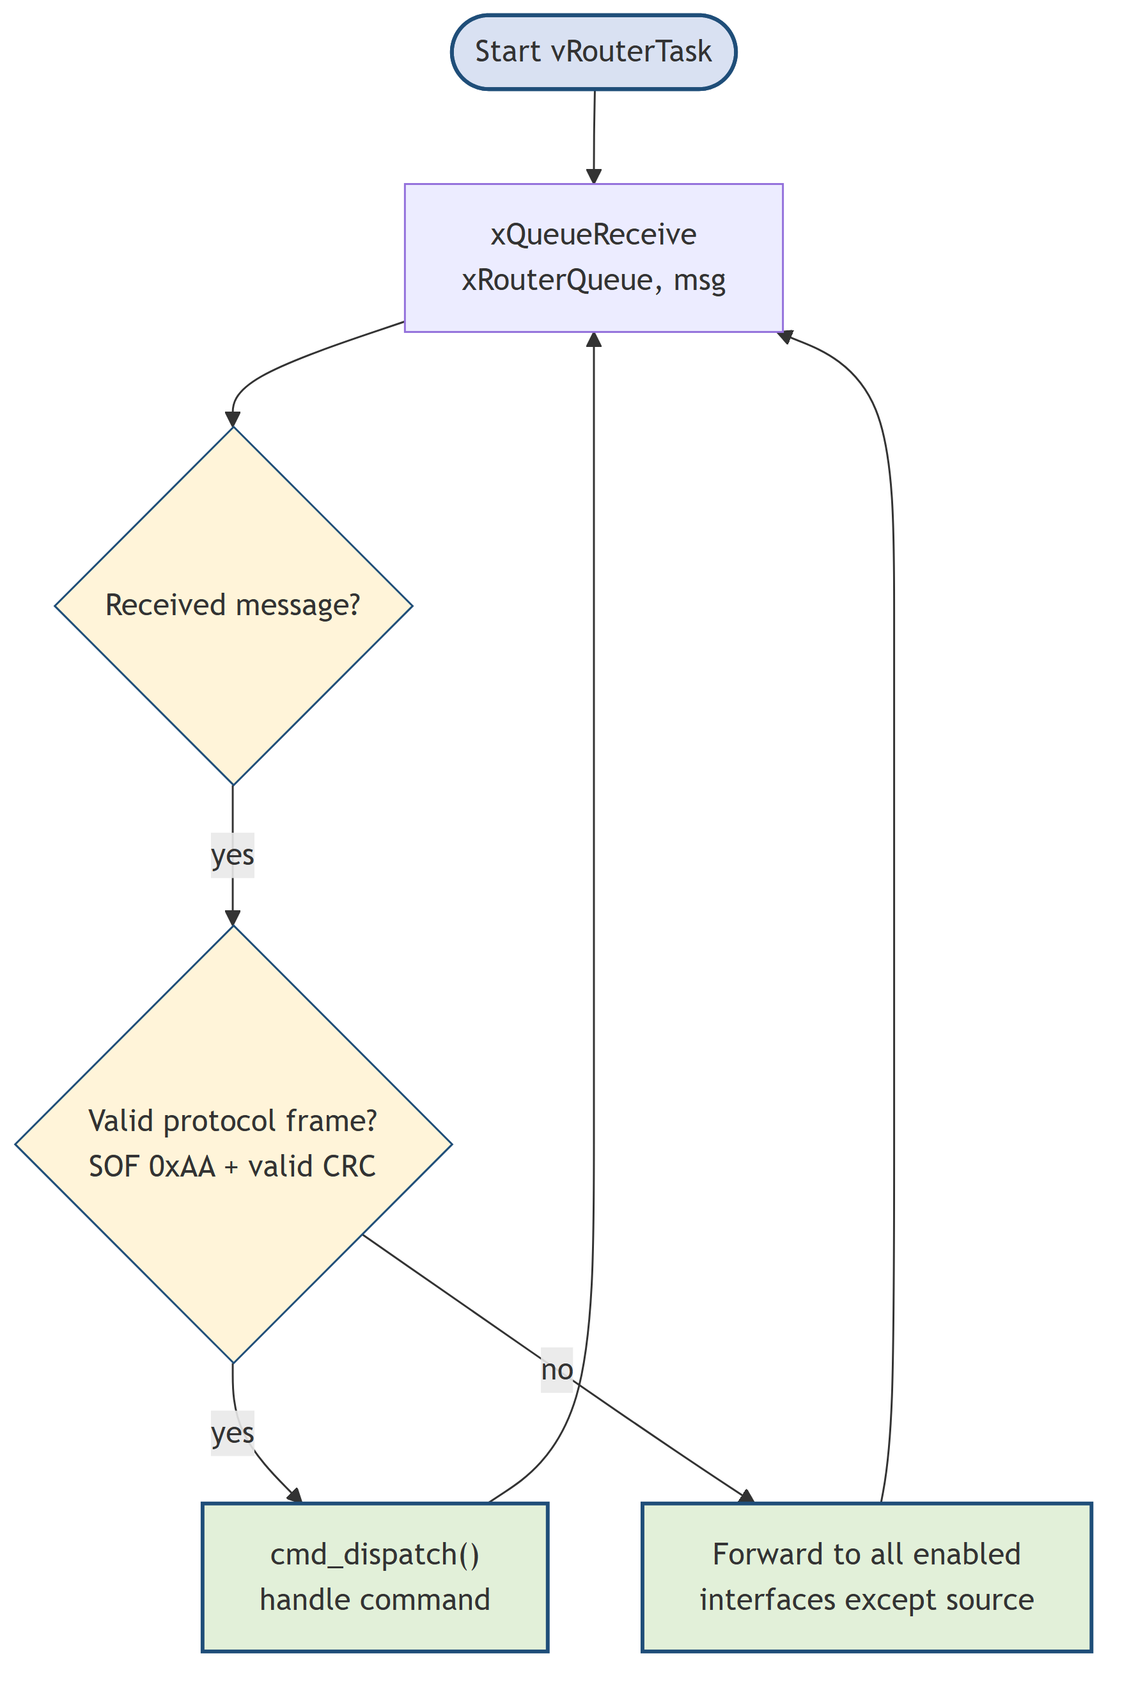
Figure 3 — Router task flowchart

Message structure
typedef struct { uint8_t src; uint16_t len; uint8_t data[256]; } RouterMsg_t;
src is the interface ID (0=UART TTL, 1=RS-232, 2=RS-422, 3=RS-485, 4=SPI, 5=USB, 6=ETH, 7=CAN). The queue depth is 8 entries; each entry can carry up to 256 bytes.

Forwarding logic
for each dst in 0..IFACE_COUNT-1:
if dst != src and (g_iface_mask & (1<<dst)):
send_to(dst, data, len)
send_to() handles interface-specific transmission: UART uses the TX ring buffer, USB uses CDC_Transmit_FS(), Ethernet calls ETH_Router_Send(), SPI uses HAL_SPI_TransmitReceive_IT(), and CAN uses HAL_CAN_AddTxMessage().

UART Data Paths

RX path
Each UART interface has its own DMA stream. HAL_UARTEx_ReceiveToIdle_DMA() arms the receiver. When the line goes idle, HAL_UARTEx_RxEventCallback() fires and posts the received chunk to the router queue from ISR context.
Figure 4 — UART RX data path

TX path
Outgoing UART data is first written to a per-interface ring buffer. If the UART is not currently transmitting, uart_tx_kick() copies up to 256 bytes into a staging buffer and starts HAL_UART_Transmit_IT(). When the transfer completes, HAL_UART_TxCpltCallback() triggers the next chunk.
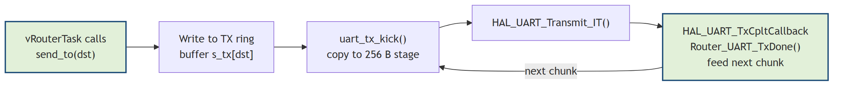
Figure 5 — UART TX data path

RS-485 direction control
For RS-485 the firmware asserts PD4 (DE/RE) before calling HAL_UART_Transmit_IT() and de-asserts it in the TxCpltCallback. This removes the need for external auto-direction hardware.

SPI and CAN Data Paths

SPI
SPI1 is configured as either master or slave with selectable CPOL/CPHA and a fixed exchange length (1–64 bytes). Router_ReconfigureSpi() applies the saved mode and arms a continuous TransmitReceive_IT exchange when in slave mode. In master mode, send_to(IFACE_SPI) performs a single exchange of the payload length and posts the received bytes back to the router.

CAN
CAN1 is initialised by CubeMX and then completed in Router_CAN_Init(): an accept-all filter is configured, HAL_CAN_Start() is called, and RX/TX interrupts are enabled. Outgoing routed data is sent with HAL_CAN_AddTxMessage() using a default STD ID of 0x7E0; received frames are read in HAL_CAN_RxFifo0MsgPendingCallback() and posted to the router.
Note: Classic CAN is limited to 8 data bytes per frame. Payloads longer than 8 bytes routed to CAN are dropped.

USB CDC and Ethernet Integration

USB CDC
USB_DEVICE/App/usbd_cdc_if.c implements the CDC-ACM class. Received USB data is forwarded to the router via Router_Post() from the USB interrupt context. Outgoing data is sent with CDC_Transmit_FS(), with up to three retries if the IN endpoint is busy.

Ethernet
eth_server.c starts after the PHY link is up. It runs DHCP with a 10-second timeout and falls back to the saved static IP. A TCP server listens on port 9000 (up to 2 clients) and a UDP socket is bound to port 9001. ETH_Router_Send() overrides the weak symbol in router.c to push routed data into the TCP send path.

Protocol Layer
protocol.c owns the binary command parser. It scans the incoming byte stream for valid frames, validates the CRC16-CCITT, and dispatches commands. Responses are sent back through the source interface using Router_SendDirect().
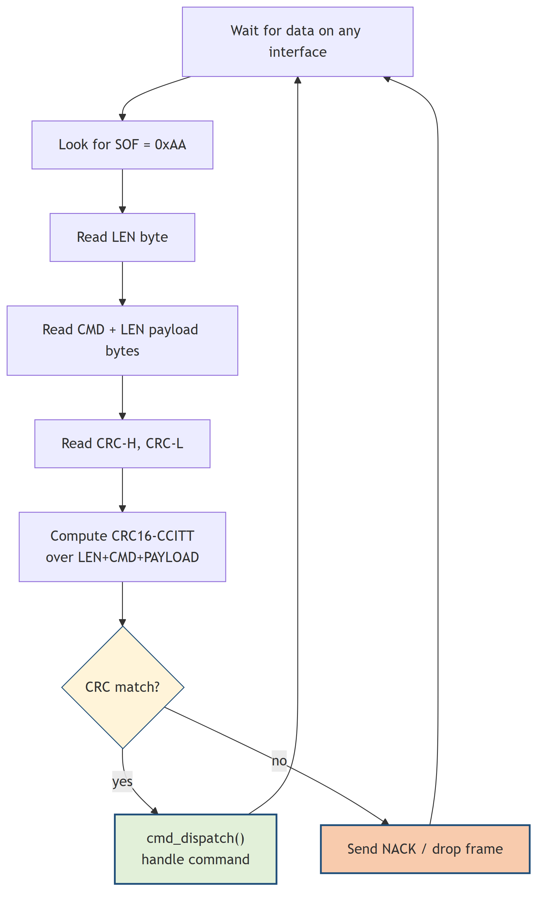
Figure 6 — Protocol frame parser flowchart

Frame format
[0xAA][LEN][CMD][PAYLOAD × LEN][CRC_H][CRC_L]

Command dispatch table
Command | Handler | Responsibility
GET_STATUS | cmd_get_status() | Report version, uptime, reset cause, mask, IP
SET_MASK | cmd_set_mask() | Enable/disable interfaces
SET_BAUD | cmd_set_baud() | Runtime UART baud-rate change
LOOPBACK | cmd_loopback() | UART echo or USB/ETH link status
SAVE_CONFIG | cmd_save_config() | Persist g_config to Flash
RESET | cmd_reset() | NVIC_SystemReset()
SET_SPI | cmd_set_spi() | Apply SPI CPOL/CPHA/master/frame-length settings
SET_ETH | cmd_set_eth() | Store DHCP/static IP settings
SET_CAN | cmd_set_can() | Apply CAN mode and bit-timing (prescaler/BS1/BS2/SJW)
GET_CONFIG | cmd_get_config() | Return full 39-byte config snapshot

Configuration Storage
The Config_t structure is stored at Flash address 0x080E0000 (sector 11). It contains a magic value, interface mask, UART baud rates, SPI settings, Ethernet settings and a CRC16.

Flash write flow

Config_Save() unlocks Flash and erases sector 11.

CRC16-CCITT is recomputed over the whole structure excluding the CRC field.

The structure is written word-by-word because STM32F2 Flash requires 32-bit programming.

Flash is locked and the function returns HAL_OK or an error code.
At boot Config_LoadOrDefault() reads the Flash copy. If the magic or CRC is invalid it falls back to defaults: all interfaces enabled, 115200 baud on every UART, DHCP enabled, fallback IP 192.168.1.100/24.

GUI Architecture
The GUI is a PyQt6 application split into a main window, reusable connection worker threads, tab widgets and support modules. Communication between threads and tabs is done through Qt signals.
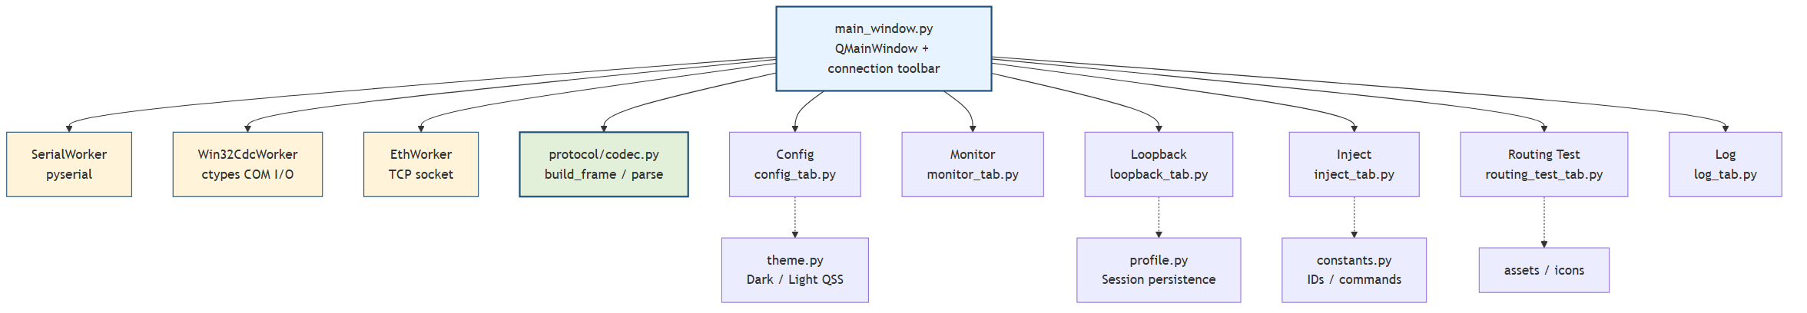
Figure 7 — GUI application architecture

Package layout
Item | Description
main.py | Application entry point; creates QApplication and MainWindow.
app/main_window.py | Connection toolbar, worker lifecycle, tab container, protocol dispatch.
app/connection/ | SerialWorker, Win32CdcWorker, EthWorker — each runs in its own QThread.
app/tabs/ | Config, Monitor, Loopback, Inject, Routing Test and Log tab widgets.
app/protocol/codec.py | build_frame(), parse_frames() and CRC16.
app/constants.py | Interface IDs, command bytes, baud list, colors.
app/theme.py | Dark and Light QSS stylesheets.
app/profile.py | Session persistence in ~/.upcc_gui/profiles/.

GUI Connection Workers
Each connection has a dedicated worker that runs in its own QThread. This keeps the UI responsive even when a blocking read or TCP recv is in progress.
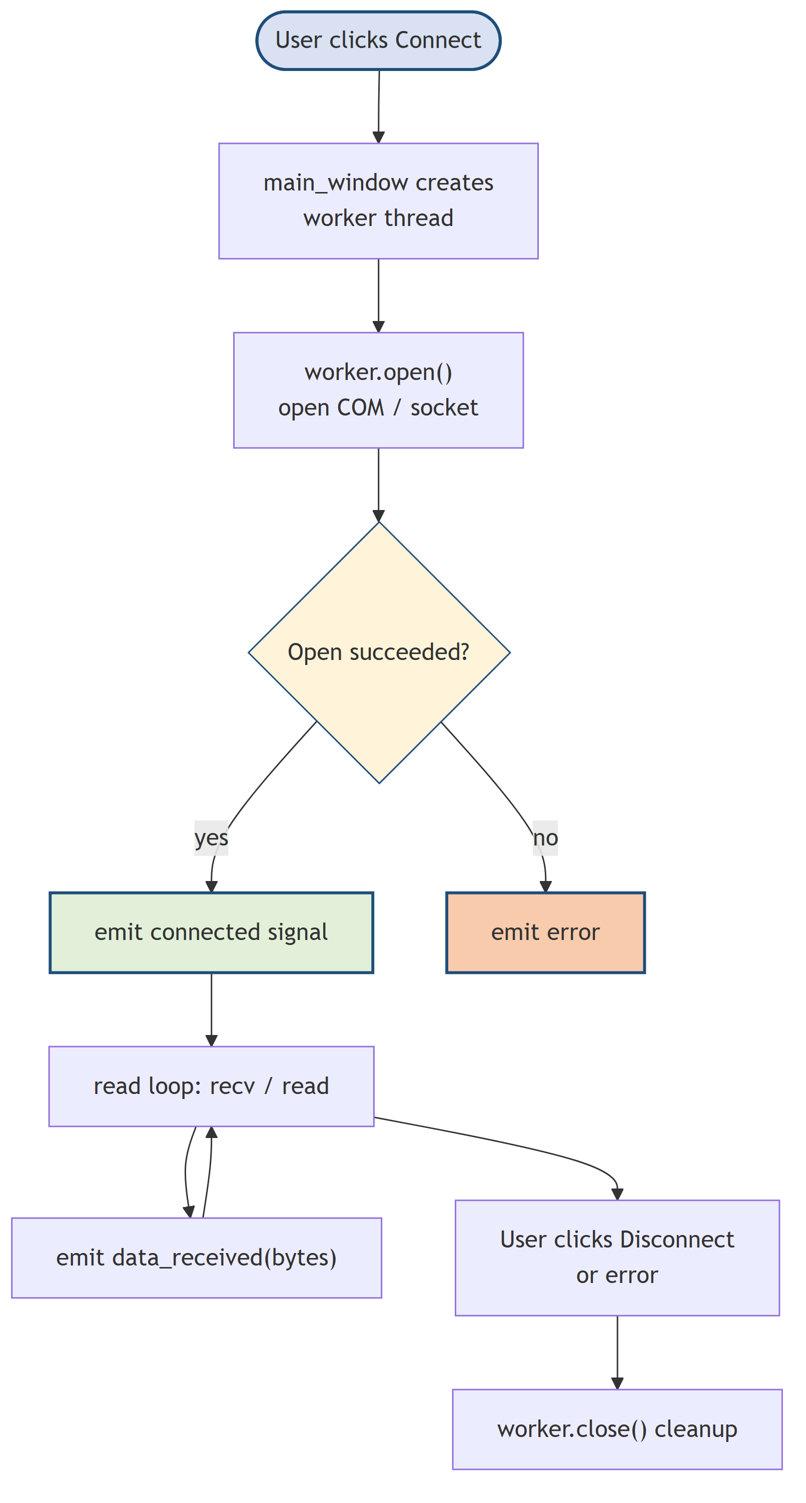
Figure 8 — Connection worker lifecycle

Worker types
Item | Description
SerialWorker | Uses pyserial for all UART variants. Polls with 50 ms timeout, reads up to 512 bytes per cycle, asserts DTR.
Win32CdcWorker | Windows-only synchronous COM I/O via ctypes. Avoids FILE_FLAG_OVERLAPPED issues seen with some USB CDC drivers.
EthWorker | TCP client to host:9000 with 100 ms recv timeout. Reconnects on socket error.

Signals emitted by workers
Item | Description
connected() | Port/socket opened successfully.
disconnected() | Port/socket closed or lost.
data_received(bytes) | Raw bytes received from the device.
error(str) | Error message for the log/status bar.

GUI Tabs and Protocol Dispatch

Main window responsibilities

Scans available COM ports and populates the Control COM and Monitor COM drop-downs.

Instantiates the selected worker and moves it to a QThread.

Routes received raw bytes to the Monitor, Routing Test and Log tabs.

Parses protocol responses and routes them to the Config and Loopback tabs.

Handles tab-generated frames (Apply config, Send inject, Run loopback) and writes them to the active worker.

Tab summary
Tab | Source file | Purpose
Config | config_tab.py | Read/write device config; set mask, baud, SPI, CAN, Ethernet; save/reset.
Monitor | monitor_tab.py | Live hex/ASCII traffic with filters and byte counters.
Loopback | loopback_tab.py | Run per-interface loopback/link tests.
Inject | inject_tab.py | Send raw text or hex bytes via TTL, USB or Ethernet.
Routing Test | routing_test_tab.py | Verify any-to-all routing across interfaces.
Log | log_tab.py | Timestamped event log with export to .txt.
Info | info_tab.py | Display GUI/firmware/protocol versions, device status, uptime, IP.

Code File Reference
The following tables map source files to their responsibilities. Use them as a quick lookup when debugging or extending the project.

Firmware files
Item | Description
Core/Src/main.c | HAL init, clock config, reset-cause capture, kernel start.
Core/Src/router.c | Any-to-all routing, UART DMA RX idle-line, TX ring buffer, RS-485 DE.
Core/Src/protocol.c | Binary frame parser, command dispatcher, CRC16, responses.
Core/Src/config.c | Flash-backed Config_t load/save/defaults at sector 11.
Core/Src/eth_server.c | lwIP TCP server (9000), UDP (9001), DHCP/static IP.
Core/Src/usart.c | USART2/4/5/6 initialization.
Core/Src/dma.c | DMA streams for UART RX idle-line.
Core/Src/gpio.c | GPIO including RS-485 DE pin PD4.
Core/Src/iwdg.c | Independent watchdog initialization.
Core/Src/spi.c | SPI1 initialization (CubeMX generated).
Core/Src/can.c | CAN1 initialization (CubeMX generated).
USB_DEVICE/App/usbd_cdc_if.c | USB CDC RX/TX bridge to router.
Core/Src/ring_buffer.c | Lock-free 2 KB ring buffer for UART TX.

GUI files
Item | Description
upcc_gui/main.py | Application entry point.
upcc_gui/app/main_window.py | Main window, worker lifecycle, protocol dispatch.
upcc_gui/app/constants.py | Interface IDs, commands, bauds, colors.
upcc_gui/app/theme.py | QSS stylesheets.
upcc_gui/app/profile.py | Session/profile persistence.
upcc_gui/app/protocol/codec.py | Frame builder/parser and CRC.
upcc_gui/app/connection/serial_worker.py | pyserial worker for UART.
upcc_gui/app/connection/win32_cdc_worker.py | Windows sync COM worker.
upcc_gui/app/connection/eth_worker.py | TCP socket worker.
upcc_gui/app/tabs/config_tab.py | Device configuration UI.
upcc_gui/app/tabs/monitor_tab.py | Live monitor UI.
upcc_gui/app/tabs/loopback_tab.py | Loopback test UI.
upcc_gui/app/tabs/inject_tab.py | Raw data injection UI.
upcc_gui/app/tabs/routing_test_tab.py | Routing verification UI.
upcc_gui/app/tabs/log_tab.py | Event log UI.
upcc_gui/app/tabs/info_tab.py | Version and device status UI.

Adding a New Interface — Developer Checklist
SPI and CAN have already been integrated using this checklist. Use it as a reference when adding future physical interfaces.

Firmware side

Add a new IfaceId_t entry in Core/Inc/router.h and update IFACE_ALL_MASK.

Implement RX path: call Router_PostISR() or Router_Post() from the new peripheral ISR/task.

Implement TX path: extend send_to() in Core/Src/router.c to handle the new IFACE_xxx.

If applicable, add loopback support in Router_LoopbackTest() or cmd_loopback().

Add SET_xxx command and config fields in protocol.c and config.h if the interface has configurable parameters.

Update GET_STATUS and GET_CONFIG responses to report the new interface state.

GUI side

Add interface name and color in app/constants.py.

Update the channel selectors in InjectTab and RoutingTestTab if the interface should be testable.

If the interface uses a new physical connection type, add a worker in app/connection/.

Add a row/card in ConfigTab if the interface has settings.

Update MonitorTab and LogTab filters to recognize the new channel.

Add version/status UI in InfoTab if the new interface reports state.

Debugging Tips

Firmware

Check g_rcc_csr in the debugger to distinguish between power-on, reset-pin and watchdog resets.

Place a breakpoint in Router_PostISR() to verify that RX interrupts are firing.

Inspect xRouterQueue with a FreeRTOS-aware debugger if messages are not reaching vRouterTask.

Use the Log tab to capture protocol responses; compare with the frame format in protocol.c.

If RS-485 data is one-directional, verify PD4 toggles with a scope.

GUI

Enable a terminal such as PuTTY or minicom on the same COM port to confirm the device responds without the GUI.

Use Win32CdcWorker on Windows if pyserial reports access-denied or overlapped-I/O errors.

Check the Log tab for malformed frames — the parser silently drops bytes until SOF 0xAA is found.

Profile sessions are stored in ~/.upcc_gui/profiles/; delete __session__.json to reset GUI state.

