HT_MK1 Harness Tester

GUI Functional Description

Document ID | HT_MK1_GUI
Revision | 1.0.0
Date | 22-10-2026
Project | HT_MK1 Harness Tester - Infinity Integrations Pvt Ltd

Approval of Document:
 | Name | Designation | Date
Prepared By |  |  | 22-10-2026
Reviewed By |  |  | 22-10-2026
Approved By |  |  | 22-10-2026

Table of Revision
Version | Note/ Comment | Date
1.0.0 | Initial release | 22-10-2026

Distribution List (For limited distribution only)
S. No. | Name | Organization / Department
1 |  | Infinity Integrations Pvt Ltd
2
3

Contact Details
S. No. | Name | Communication Details
1
2
Registered Office Address:

Contents
1 Introduction 8
1.1 Purpose 8
1.2 Audience 8
1.3 Conventions 8
1.4 Related Documents 8
2 Application Overview 8
2.1 What the GUI is 8
2.2 Program files 9
2.3 Window 9
2.4 Build stamps 9
3 Window Layout 9
4 Status Bar 10
4.1 Fields, left to right 10
4.2 Serial port controls 11
4.3 HV pill and state pill 11
4.4 High-voltage banner 11
5 Navigation Rail 12
6 Run Screen 12
6.1 Verdict panel 12
6.2 Big round button 13
6.3 Netlist strip 13
6.4 Handover panel 13
6.5 Fixture sequence panel 14
6.6 Test cards 14
6.7 Auto scan strip 15
6.8 Faults panel 15
6.9 Test details panel 15
6.10 HV stack panel 15
6.11 When the Run buttons are enabled 16
7 Continuity Screen 16
7.1 View bar 17
7.2 Netlist and fixture strips 17
7.3 Mode selector 17
7.4 Facts band 17
7.5 Result tiles 17
7.6 Harness wiring diagram 17
7.7 Connection results table 19
7.8 Net inspector and Fixture connectors 19
7.9 Cross continuity mode 19
8 Resistance Screen 20
8.1 View bar, netlist strip and facts band 20
8.2 Main column 21
8.3 Side column 21
9 Insulation Screen 21
9.1 View bar, netlist strip and facts band 21
9.2 Relay state 22
9.3 Net results and Connection results 22
9.4 HV rail and Safety panels 22
10 Auto Scan Screen 23
11 Netlist Screen 24
11.1 Netlist strip 25
11.2 MTX nets table 25
11.3 HV nets table 25
12 Results Screen 26
12.1 Pass rate 26
12.2 Run history 26
12.3 Test reports 26
12.4 CSV report content 27
12.5 PDF report content 27
13 Dialogs 27
13.1 Select the HV netlist 28
13.2 Select the MTX netlist 28
13.3 Confirm before energizing to 500 V 29
13.4 Run continuity and resistance first? / Move the harness to J-HV 30
13.5 Confirm the connector layout 31
13.6 Windows file dialogs 33
14 Log Bar and Footer 33
14.1 Log bar 33
14.2 Footer 33
15 Keyboard Shortcuts 33
16 Operating Sequences and States 34
16.1 Normal sequence 34
16.2 When a run finishes 34
16.3 Abort, Stop and Reset 34
16.4 Safe to handle 35
16.5 Faults 35
16.6 Loss of the link 35
17 Files and Folders 35
Appendix A: Netlist File Format 36
Appendix B: Start-up Options 37

List of Figures
Figure 1: The Run screen with a netlist loaded: status bar (top), navigation rail (left), screen (centre and right), log bar and footer (bottom). 9
Figure 2: The Run screen after Mode 1 passed: the verdict reads MOVE DUT and the handover panel asks for the harness to be moved. 14
Figure 3: The Continuity screen after a passing netlist-mode run. 16
Figure 4: The harness wiring diagram: connectors, pins, orthogonally routed wires, Y joints and multi-drop nodes. 18
Figure 5: A continuity run with faults: open nets are drawn in red and listed in the results table. 19
Figure 6: The Resistance screen after a passing run. 20
Figure 7: The Insulation screen after a run: relay state grid and HV rail. 21
Figure 8: The Insulation screen before a run, showing the facts band, the relay grid and the Safety panel. 23
Figure 9: The Auto Scan screen after a scan. 23
Figure 10: The Netlist screen: both netlists and the tables they define. 24
Figure 11: The Results screen: pass rate, run history and per-test reports. 26
Figure 12: The Select the HV netlist dialog. 28
Figure 13: The Select the MTX netlist dialog. 29
Figure 14: The pre-start verification dialog with the confirmation box ticked and Energize 500 V enabled. 30
Figure 15: The prerequisites dialog when Mode 1 has not been completed. 31
Figure 16: The Confirm the connector layout dialog. 32
Figure 17: The log bar expanded. 33

List of Tables
Table 1: Program files 9
Table 2: Window regions 10
Table 3: Status bar items 10
Table 4: Serial port controls 11
Table 5: HV pill values 11
Table 6: State pill values 11
Table 7: Navigation rail items 12
Table 8: Verdict headlines 13
Table 9: Big round button 13
Table 10: Fixture sequence boxes 14
Table 11: Test cards 15
Table 12: Fault codes shown in the Faults panel 15
Table 13: Run control gating 16
Table 14: Continuity modes 17
Table 15: Continuity result tiles 17
Table 16: Continuity side panels 19
Table 17: Resistance main panels 21
Table 18: Resistance side panels 21
Table 19: Relay state colours 22
Table 20: Insulation side panels 22
Table 21: Auto scan screen 24
Table 22: Netlist strip states 25
Table 23: Run history columns 26
Table 24: CSV report layouts 27
Table 25: Pre-start verification rows 30
Table 26: Prerequisites dialog 31
Table 27: Log levels 33
Table 28: Keyboard shortcuts 33
Table 29: Stopping a test 34
Table 30: Files written by the GUI 36
Table 31: Netlist columns 36
Table 32: Connector family keywords 37
Table 33: Start-up options 37

Introduction

Purpose
This document describes what the HT_MK1 Console (the GUI) does, screen by screen and button by button: what each area shows, what each control does when it is pressed, when it is enabled or disabled, and what message or state follows. It is the reference to use when you want to know exactly what a particular button, pill, table or dialog is for.

Audience
Operators and test engineers who use the HT_MK1 Console to test harnesses, and engineers who evaluate or accept the software. For step-by-step operating instructions, use the HT_MK1 User Manual instead; this document explains the software itself.

Conventions
- Button, pill, tab and column names are written in bold. On screen the GUI draws most of them in capital letters; this document writes them in normal case.
- Text the GUI shows as a message is written in monospace.
- Connector names: J-MTX is the Matrix connector (continuity, resistance, auto scan); J-HV is the HV connector (insulation). When the HV stack is N cards the GUI writes the HV connector as J-HV1 (one card) or J-HV1-N.
- Mode 1 means continuity and resistance on J-MTX. Mode 2 means the insulation test on J-HV. Auto scan is a separate survey that needs no netlist.

Related Documents
- HT_MK1 User Manual: step-by-step operation and safety.
- HT_MK1 Functional Test Procedure: the formal acceptance test of a built unit.
- HT_MK1 Flashing Procedure: programming the firmware.
- HT_MK1 Code Walkthrough: software structure and the serial protocol.
- HT_MK1 System Overview: what the instrument measures and how.

Application Overview

What the GUI is
The HT_MK1 Console is a Windows desktop application. It contains no test logic of its own: it sends commands to the instrument over a serial link, receives the results as they are measured, and presents them. Everything that decides pass or fail, and everything that switches high voltage, is done by the instrument firmware.

Program files
File | Use
HT_MK1_GUI.exe | The operator GUI for the real instrument.
HT_MK1_GUI_Demo.exe | The same GUI with a built-in simulator and no instrument. It is for practice and training. Nothing it shows is a measurement.
Table 1: Program files
Both programs are single files that unpack to a temporary folder each time they start, so the first window takes a second or two. Nothing is installed. They run on 64-bit Windows 10 and 11.

Window
The window opens maximized. Its title is HT_MK1 Console. The GUI follows the Windows light or dark setting at start-up; the sun/moon button in the status bar switches between them and the choice is remembered.

Build stamps
The footer shows when the GUI was built (GUI build YYYY-MM-DD HH:MM) and, once the instrument has answered, when its firmware was built. The status bar shows the firmware version (fw 1.0.0).

Window Layout
Every screen has the same four regions, from top to bottom: the status bar, the middle area (navigation rail on the left and the screen itself on the right), the log bar, and the footer.
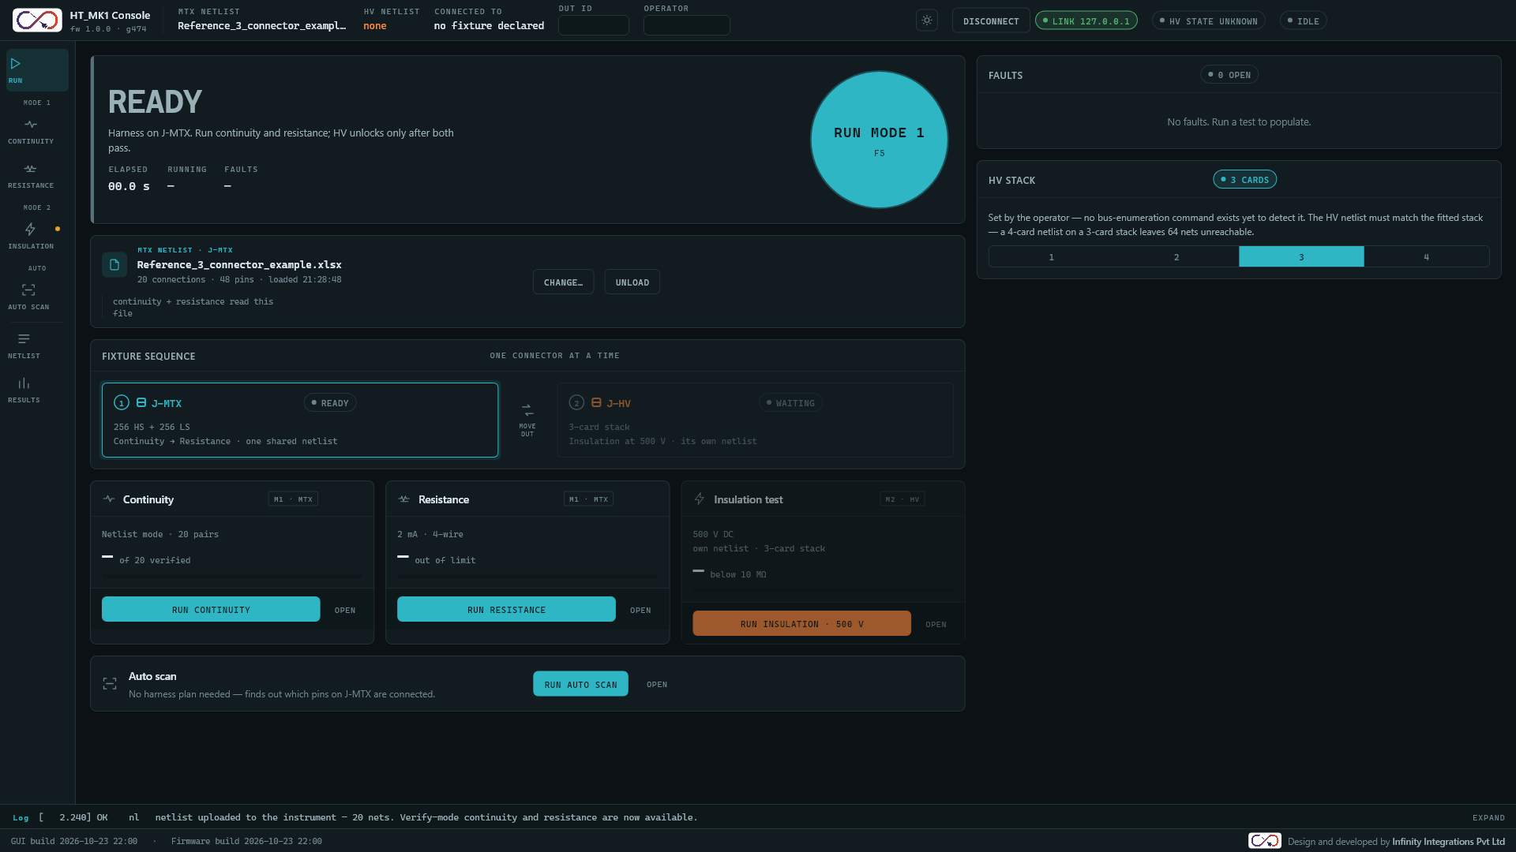
Figure 1: The Run screen with a netlist loaded: status bar (top), navigation rail (left), screen (centre and right), log bar and footer (bottom).
Region | Shows
Status bar | Connection, loaded netlists, which connector the harness is on, DUT ID and Operator fields, theme button, serial port controls and the HV and state pills (Section 4).
Navigation rail | The seven screens, grouped by mode (Section 5).
Screen | The selected screen. It scrolls when it is taller than the window.
Log bar | The most recent log line; expands to a scrolling list (Section 14).
Footer | Build stamps and the credit line (Section 14).
Table 2: Window regions
When the instrument reports high voltage on the HV rail, the status bar is replaced by the high-voltage banner (Section 4.4) so that the hazard cannot be missed. In a narrow window (about 860 pixels or less) the navigation rail becomes a horizontal strip under the header, and below about 1100 pixels the status bar scrolls sideways and the build stamps are hidden.

Status Bar

Fields, left to right
Item | What it shows or does
Logo and name | The company logo, then (in windows wider than 1200 pixels) HT_MK1 Console and the firmware version, for example fw 1.0.0 · g474. The version reads fw - until the instrument has answered.
MTX netlist | File name of the netlist loaded for continuity and resistance, or none.
HV netlist | File name of the netlist loaded for insulation, or none.
Connected to | Where the instrument believes the harness is: J-MTX · mode 1, J-HV · mode 2, no fixture declared, none · moving (during handover), J-HV1-N · mode 2 (after the harness move is confirmed) or link lost.
DUT ID | Free text. Identifies the unit under test. It is copied into every report made afterwards. It is not saved between sessions.
Operator | Free text. Name of the person running the test. Copied into reports, not saved between sessions.
Theme button | Switches between light and dark.
Port controls | Serial port list, refresh button, Connect/Disconnect button and link pill (Section 4.2).
HV pill | High-voltage state, taken only from what the instrument reports (Section 4.3).
State pill | What the instrument or the test sequence is doing (Section 4.3).
Clear Fault | Appears only while the instrument is in the fault state (Section 16.5).
Table 3: Status bar items
Note: The DUT ID and Operator fields are drawn in the status bar only when the window is wider than 1600 logical pixels. On a smaller or heavily scaled display the same two fields are shown in the Test details panel at the top of the right column of the Run screen (Section 6.9).

Serial port controls
Control | Behaviour
Port list | Shows the selected port, Select port when none is chosen, or No ports when none were found. It is enabled only while not connected. Each entry reads the port name and its description, for example the ST-LINK Virtual COM Port. Choosing an entry only selects it; it does not connect.
Refresh | Looks for serial ports again. The log reports the ports found, or that none were found. If the selected port has disappeared, the first available port is selected.
Connect | Opens the selected port. It is disabled until a port is selected. While opening, the button reads Connecting and is disabled. On success the GUI reads the instrument state, identity, calibration, limits and any netlist already held by the instrument.
Disconnect | Replaces Connect while connected. It closes the link; the GUI then shows the state as unknown.
Link pill | Link <port> (green) when connected, Opening <port> (blue) while connecting, No link (amber) otherwise.
Table 4: Serial port controls
When the GUI is started with the built-in simulator (the Demo program) the port list and refresh button are not shown, because the link is internal.

HV pill and state pill
HV pill text | Colour | Meaning
HV Safe | Green | The instrument has reported that the system is safe, and nothing since has contradicted it. This is the only indication that it is safe to handle the harness.
HV armed | Amber | The instrument is armed for an insulation run. High voltage is not yet applied.
HV LIVE n V | Red | The instrument reports the HV rail at or above 50 V.
HV state unknown | Grey | Just connected, a fault is latched, a test has run and no safe report has arrived yet, or any other case where safety has not been confirmed.
Link lost | Amber | The connection to the instrument is down. Treat the system as not safe.
Table 5: HV pill values
State pill text | Meaning
Ready | The GUI is reset and waiting for a test (initial state, and after a reset).
Idle | The instrument reports idle.
Cont, Res, Insul (blue) | A continuity, resistance or insulation run is in progress.
Fail (red) | Mode 1 finished with a failure.
Handover (amber) | Mode 1 passed; the harness must now be moved to J-HV.
Armed (amber) | The harness move was confirmed; insulation is unlocked.
Hv_armed | The instrument itself reports the armed state.
Fault (red) | The instrument has latched a fault. Press Clear Fault after resolving the cause.
State unknown (amber) | The link is down.
Table 6: State pill values

High-voltage banner
While the instrument reports the HV rail at or above 50 V, the status bar is replaced by a striped hazard banner. It shows a pulsing lightning bolt, the headline HIGH VOLTAGE LIVE - J-HV ENERGIZED, the line Insulation test running. Relays are cold-switched; the fixture stays live until discharge completes., the live Rail voltage, the live Leakage voltage and an Abort & discharge button.
- Abort & discharge sends the abort command to the instrument, writes ABORT sent to the log and then resets the GUI to its ready state. The instrument is responsible for removing the voltage and then reports when it is safe.
- The banner disappears when the rail falls below 50 V, after an abort, and when the link is lost. After link loss the status bar returns and shows Link lost and State unknown; do not assume the harness is safe.
- The other status bar controls are not reachable while the banner is shown.

Navigation Rail
The rail on the left switches between screens. Selecting an item always works; no screen is locked.
Group | Item | Screen
(none) | Run | The home screen: verdict, big run button, fixture sequence, test cards, faults.
Mode 1 | Continuity | Continuity on J-MTX.
Mode 1 | Resistance | Resistance on J-MTX.
Mode 2 | Insulation | Insulation test on J-HV.
Auto | Auto scan | Finds which pins are connected, with no netlist.
(none) | Netlist | The two netlists and what they contain.
(none) | Results | Pass rate, run history and report export.
Table 7: Navigation rail items
A small dot on the icon of Continuity, Resistance and Insulation summarizes that test:
- A green dot: the last result of that test was a pass.
- A red dot: the last result was a fail.
- An amber dot (Insulation only): the harness has not yet been declared moved to J-HV and Insulation has no result, that is, insulation is still locked.
- No dot: the test has not been run.
All dots are cleared whenever the GUI is reset.

Run Screen
The Run screen is the home screen. It has a left column with the verdict and the test controls, and a right column with the fault list and the HV stack setting. In a narrow window the right column moves below the left one.

Verdict panel
The large panel at the top left shows the overall state. A coloured rule on its left edge is grey when idle, blue while running, amber at the handover, HV colour when armed, green for a pass and red for a fail.
Headline | Sub-text
READY | Harness on J-MTX. Run continuity and resistance; HV unlocks only after both pass.
RUNNING | A line naming the test, for example J-MTX - testing the pairs the netlist expects. or J-HV - 500 V across each net in turn.
PARTIAL | One of the two Mode 1 tests has not run: Continuity has not run yet. Both must pass before HV unlocks. (or the same for Resistance).
FAIL | Mode 1 failed on J-MTX. The harness stays where it is - HV is not attempted.
MOVE DUT | Continuity and resistance passed on J-MTX. Move the harness to the HV fixture.
ARMED | Harness on J-HV1-N. Press Run Insulation - you will be asked to confirm before 500 V is applied.
Table 8: Verdict headlines
Under the headline are three values: Elapsed (00.0 s when idle; while a test runs it shows progress as done / total, for example 37 / 128), Running (the stage: Continuity · J-MTX, Resistance · J-MTX, Insulation · J-HV, handover or HV ready) and Faults (- when idle, otherwise the number of open fault entries).

Big round button
The large round button on the right of the verdict panel is the main control. Its label and effect depend on the state. The keyboard shortcut F5 does the same as pressing it, but only when no test is running.
Label (hint) | When it appears | What pressing it does
Stop (Esc) | A test is running. | Sends the abort command to the instrument, then resets the GUI (see Section 16.3).
Move DUT (see below) | Continuity and resistance have both passed and the harness has not been declared moved. | Disabled. Use the Harness moved button in the handover panel.
Run Insul (500 V) | The instrument reports the harness is on J-HV and insulation has no result. | Starts the HV start sequence (Section 13.3).
Run Mode 1 (F5) | Neither Mode 1 test has a result. | Starts continuity. If netlist mode is selected and no MTX netlist is loaded, opens the Select the MTX netlist dialog instead.
Reset (Esc) | Any other case. | If continuity passed and resistance has not run, starts resistance; otherwise resets the GUI. With no link to the instrument it does nothing except log not connected: choose the port and press Connect first.
Table 9: Big round button
Note: Run Mode 1 starts continuity only. After continuity passes, run resistance with Run resistance (or the big button, which then reads Reset but starts resistance). The two tests are not chained automatically.

Netlist strip
Below the verdict panel, a strip shows the MTX netlist. Every screen that needs a netlist shows the same strip. See Section 11.1 for its buttons.

Handover panel
When continuity and resistance have both passed, an amber striped panel appears: Move the harness to the HV fixture with the text Continuity and resistance passed on J-MTX. Unplug from J-MTX, then plug into J-HV1-N. and the button Harness moved - unlock HV.
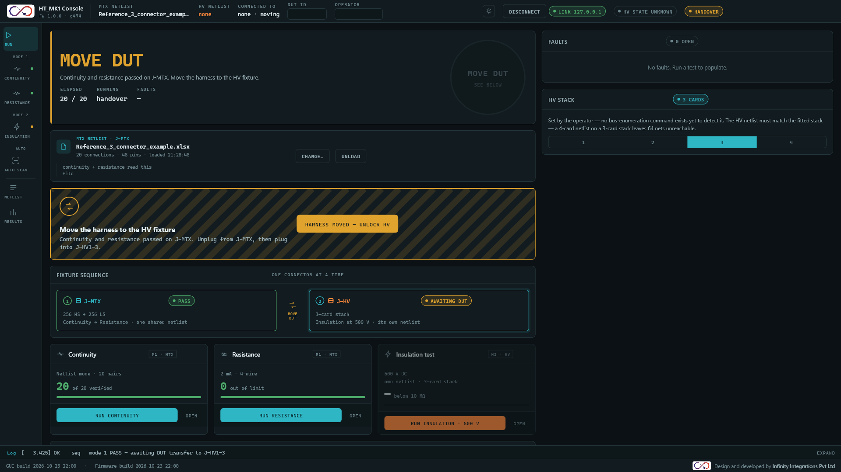
Figure 2: The Run screen after Mode 1 passed: the verdict reads MOVE DUT and the handover panel asks for the harness to be moved.
Pressing Harness moved - unlock HV tells the instrument the harness is on J-HV (a fixture command), then the GUI moves to the armed state: verdict ARMED, state pill Armed, Connected to J-HV1-N · mode 2, and the Insulation card becomes active. The log records DUT transferred to J-HV1-N - HV armed, interlock closed. If the instrument refuses the fixture change, the refusal is written to the log and the GUI stays at the handover.

Fixture sequence panel
This panel shows the two connectors in order, with a MOVE DUT arrow between them (amber when the handover is awaited).
Box | Contents | Pill values
1 J-MTX | 256 HS + 256 LS. Continuity, then resistance, sharing one netlist. | Ready, Pass (green), Fail (red), Partial (blue), Released (grey, after the handover).
2 J-HV | The N-card stack. Insulation at 500 V with its own netlist. | Waiting (grey, dimmed), Awaiting DUT (amber), Armed (amber).
Table 10: Fixture sequence boxes

Test cards
Three cards, one per test, sit side by side (they wrap when the window is narrow). Each card has a title and a stage badge, a condition text, a large count with its unit, a progress bar, a Run button and an Open link that jumps to that test's own screen.
Card | Badge | Condition text | Large number | Run button
Continuity | M1 · MTX | Netlist mode: Netlist mode · N pairs. Cross mode: Cross continuity · 65,536 reads. | Pairs passed so far, with of N verified or nets discovered. | Run continuity
Resistance | M1 · MTX | 2 mA · 4-wire | Pairs out of limit so far. | Run resistance
Insulation test | M2 · HV | 500 V DC and own netlist · N-card stack | Nets below the limit so far, with the unit below 10 MΩ. | Run insulation · 500 V
Table 11: Test cards
The card colours follow the result: green for a pass, red for a fail, blue while running. The Insulation card is dimmed until the handover has been confirmed. Run continuity and Run resistance are enabled only when the rules in Section 6.10 allow it. Run insulation · 500 V is enabled whenever no test is running; when the harness is not yet on J-HV it opens the prerequisites dialog (Section 13.4) instead of blocking.

Auto scan strip
A strip with the text No harness plan needed - finds out which pins on J-MTX are connected. and the button Run auto scan, which opens the Auto Scan screen and starts the scan. It is disabled while a test runs or when the harness is on J-HV, and shows the reason in place of its text. Open jumps to the Auto Scan screen.

Faults panel
The right column starts with the Faults panel. Its pill shows 0 open (grey) or N open (red). When empty it reads No faults. Run a test to populate. Otherwise there is one row per fault type, listing only the first failing net of each type. Pressing a row jumps to the screen that shows the fault.
Code | Title | Detail | Jumps to
F06 | Open circuit | Continuity, net name, source and destination pins | Continuity, with the wiring filter set to Faults only
F08 | Resistance high | Resistance, net name and limit; the value is the measured ohms | Resistance
F04 | Insulation below limit | HV, card, relay, net name, 500 V; the value is the insulation in MΩ | Insulation (when the harness is on HV), with that relay marked red
Table 12: Fault codes shown in the Faults panel

Test details panel
On a window that is not wide enough for the status bar to carry the DUT ID and Operator fields (1600 logical pixels or less), the first panel of the right column is Test details, with the same two text boxes. Both are copied into every report made afterwards and are not saved between sessions.

HV stack panel
The HV stack panel states how many HV cards are fitted (1 to 4, default 3). The instrument cannot detect the stack size, so the operator sets it by pressing 1, 2, 3 or 4. The choice is not sent to the instrument. It sets the HV connector name (J-HV1 to J-HV1-N), which card rows count as fitted on the Insulation screen, which nets are reachable in the HV netlist table and the HV netlist check in the pre-start dialog. The text on the panel reminds you that the HV netlist must match the fitted stack: a 4-card netlist on a 3-card stack leaves 64 nets unreachable.
Important: Set the HV stack to the number of HV cards actually fitted in the instrument before running insulation.

When the Run buttons are enabled
Control | Blocked when | Message shown beside the button
Any run control | A test is already running. | A test is already running
Any run control | There is no link to the instrument. | Not connected: choose the port and press Connect first
Run continuity | The harness is on J-HV. | Harness is on J-HV - reset to return it to J-MTX
Run continuity | Netlist mode and no MTX netlist is loaded. | Netlist mode needs the MTX netlist - or switch to cross continuity
Run resistance | The harness is on J-HV, or no MTX netlist is loaded. | Resistance needs the MTX netlist for the pair list and limits
Run insulation (on J-HV) | The harness has not been confirmed on J-HV. | Confirm the harness has been moved to J-HV first or Continuity and resistance must pass before HV unlocks
Run auto scan | A test is running, or the harness is on J-HV. | The same reasons as above
Table 13: Run control gating
Note: Without a link to the instrument no Run control is enabled. Each shows the reason Not connected: choose the port and press Connect first. Connect first (Section 4.2).

Continuity Screen
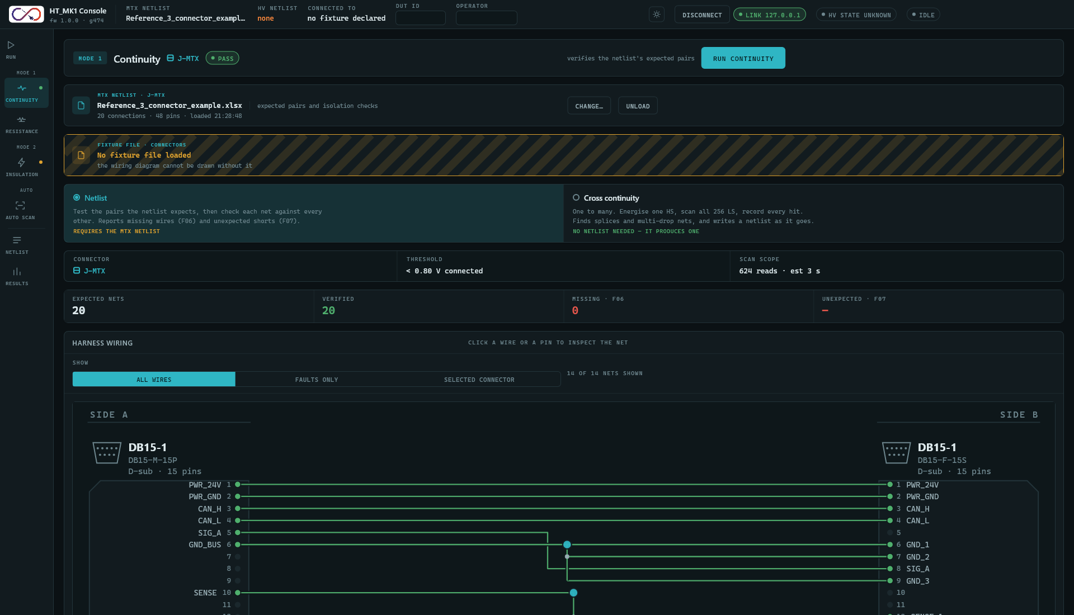
Figure 3: The Continuity screen after a passing netlist-mode run.

View bar
The first panel shows the stage badge Mode 1, the heading Continuity, the connector chip J-MTX, a status pill (Not run, Running, Pass, Fail), the reason text of Section 6.10 and the Run continuity button.

Netlist and fixture strips
The MTX netlist strip (Section 11.1) sits under the view bar. Under it, a Fixture file strip is reserved for a future connector-file feature. It currently always reads No fixture file loaded; the connector layout used for the wiring diagram comes from the netlist (Section 13.5), so this strip does not stop the diagram from being drawn.

Mode selector
Two options choose what the next run does. Selecting one takes effect immediately, even while a test is running, but it changes only the next run and which panels are shown.
Option | Description | Requirement tag
Netlist | Test the pairs the netlist expects, then check each net against every other. Reports missing wires (F06) and unexpected shorts (F07). | REQUIRES THE MTX NETLIST (amber)
Cross continuity | One to many. Energise one HS pin, scan all 256 LS pins and record every hit. Finds splices and multi-drop nets and writes a netlist as it goes. | NO NETLIST NEEDED, IT PRODUCES ONE (green)
Table 14: Continuity modes

Facts band
A row of fixed facts: Connector J-MTX; Threshold < 0.80 V connected; Scan scope 624 reads, est 3 s (netlist mode) or 65,536 reads, est 18 s (cross mode). The scan scope values are fixed text, not a calculation for the loaded harness.

Result tiles
Mode | Tile 1 | Tile 2 | Tile 3 | Tile 4
Netlist | Expected nets | Verified (green) | Missing · F06 (red) | Unexpected · F07 (red, shows a dash)
Cross | Nets discovered | Nodes mapped | Multi-drop | HS columns swept
Table 15: Continuity result tiles

Harness wiring diagram
In netlist mode, the Harness wiring panel draws the harness as two columns: Side A (the HI pins, from the Conn ID columns of the netlist) on the left and Side B (the LO pins, from the Conn ID B columns) on the right. Before a netlist is loaded the panel says No harness to draw yet. It is not shown in cross mode.
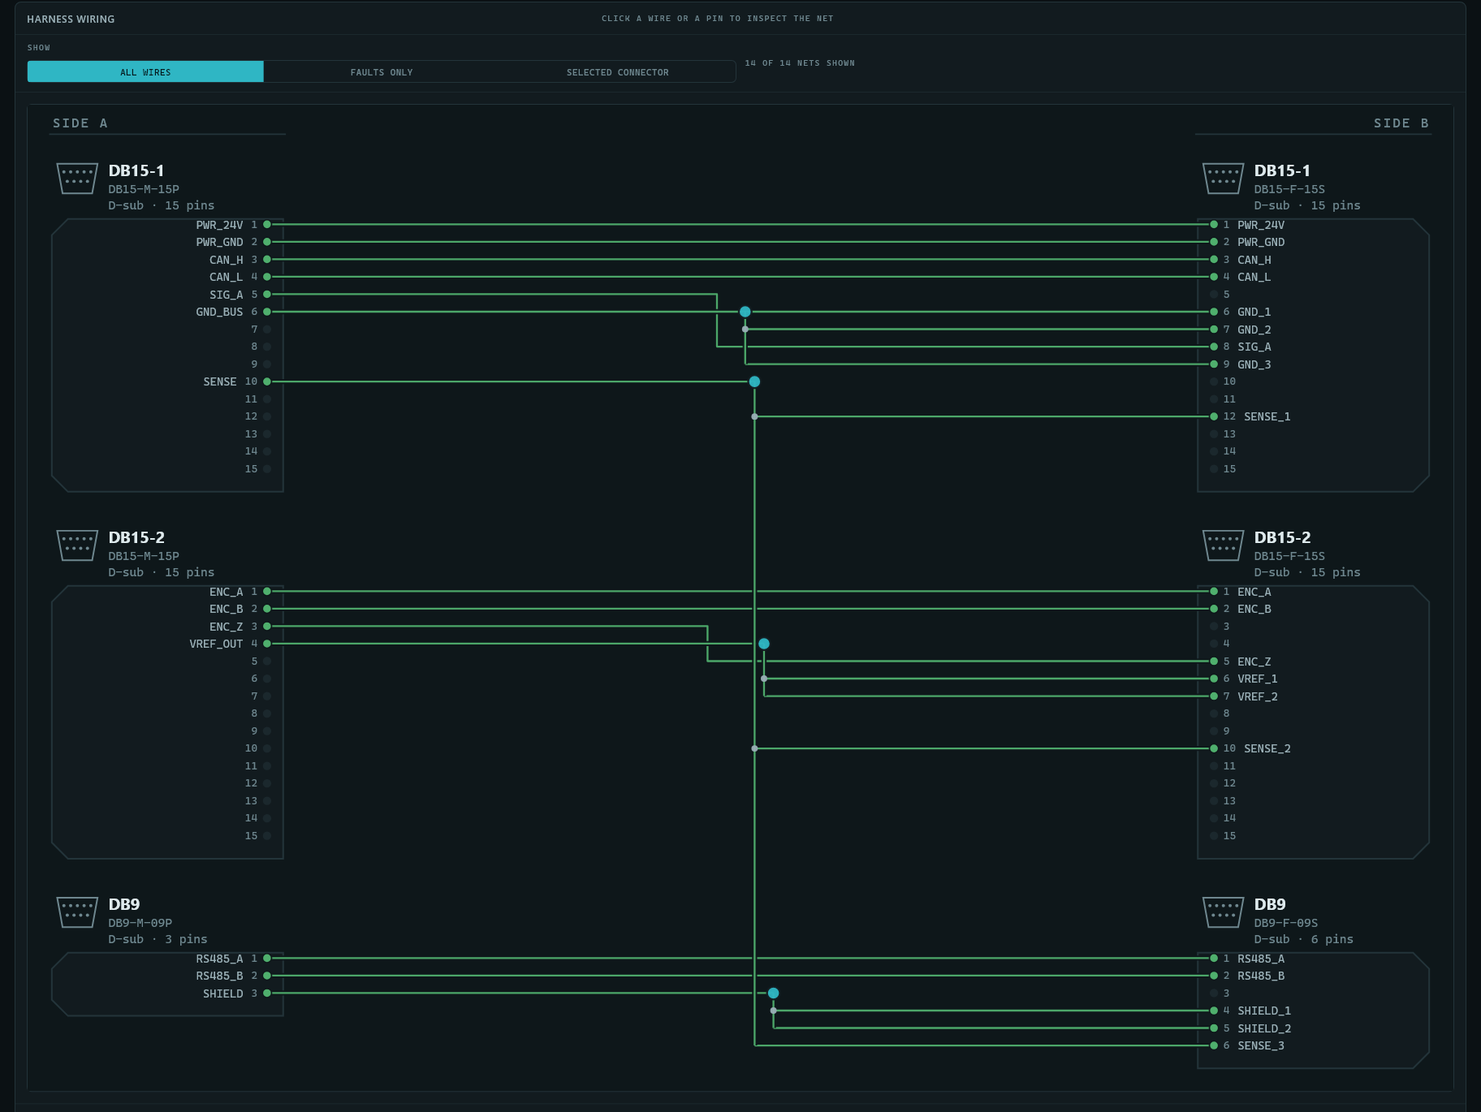
Figure 4: The harness wiring diagram: connectors, pins, orthogonally routed wires, Y joints and multi-drop nodes.
- Show filter: All wires, Faults only (nets currently in a failed state) or Selected connector (nets that touch the connector chosen in the Fixture connectors list; all nets if none is chosen). The count n of m nets shown is at the right.
- Each connector is drawn with a pictogram for its family (D-sub, circular, rectangular, terminal block, modular jack), its designator, mating part number, type and pin count, and numbered pin dots with the pin labels from the netlist.
- Wire and pin colours: green is passed, red is open or failed, grey is not tested. A Y joint (branch splice) and a multi-drop node are drawn as dots; an I joint (inline splice) is drawn as a mark on the wire.
- Hover over a wire or pin to highlight the net and see a tooltip with the net name, the pins at each end, the topology, the netlist's connector detail text and the state.
- Click a wire or pin to select the net: its pins are ringed and the Net inspector fills in. Click empty canvas to clear the selection.
- A legend under the diagram explains the colours and joint marks, and notes that Side A is the HI pins and Side B the LO pins.
Note: The firmware reports only pass or open for each pair, so the tooltip and the Net inspector show the state (not tested, connected, OPEN (F06)), not a voltage.

Connection results table
Below the diagram (netlist mode only) the Connection results table lists every pair tested, one row per result as it arrives. Columns: Test #, Source, Part Number, Conn ID, Src Pin Label, Src Pin #, Dst Pin #, Dst Pin Label, Conn ID, Part Number, Destination and Status. Source and Destination are always blank. Status is Connected (green) or Open (red). The empty table reads No results yet - run continuity to populate this table.
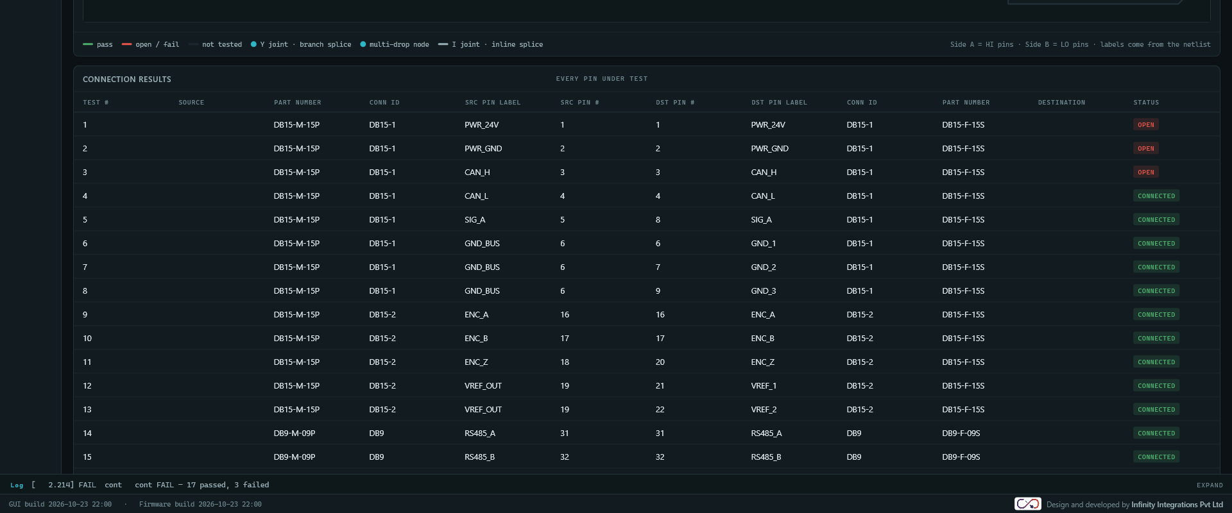
Figure 5: A continuity run with faults: open nets are drawn in red and listed in the results table.

Net inspector and Fixture connectors
Panel | Contents
Net inspector | Net name, From and To pins (connector, pin and label), Topology (1:1 point to point, Y joint 1:N branch splice, Y joint N:1 merge, Multi-drop N to M wires on one node, I joint inline butt splice), Detail (the netlist's connector detail text) and Result. A tag shows nothing selected, open, connected or not tested.
Fixture connectors | One row per connector: designator, label, a meta line (Side A · D-sub · 15 way · board HS 001-015) and a tag with its net count. Pressing a row toggles it as the selected connector, used by the Selected connector filter and dimming the other connectors in the diagram.
Discovered netlist (cross mode) | See Section 7.9.
Table 16: Continuity side panels

Cross continuity mode
Starting cross continuity clears the previous scan, sets the tiles to zero and disables saving until the scan completes. When a scan finds connections the Discovered netlist panel reads N nets found across M pins. Save to load them as the working MTX netlist. If it finds nothing it reads No nets found. Check the harness is seated on J-MTX and run again.
- Save as MTX netlist (enabled only after a scan that found pairs) sends the discovered pairs to the instrument and loads them as the MTX netlist.
- Export CSV (same condition) saves the pairs with the dialog title Export discovered netlist. The default file name is discovered_netlist_<date>-<time>.csv; the file has the header HS pin,LS pin and one line per pair.
The Discovery panel of this mode (Discovery - one to many) lists nets built from the loaded net model rather than from the pairs the scan just found. For the reliable list of what a scan found, use the Auto Scan screen.

Resistance Screen
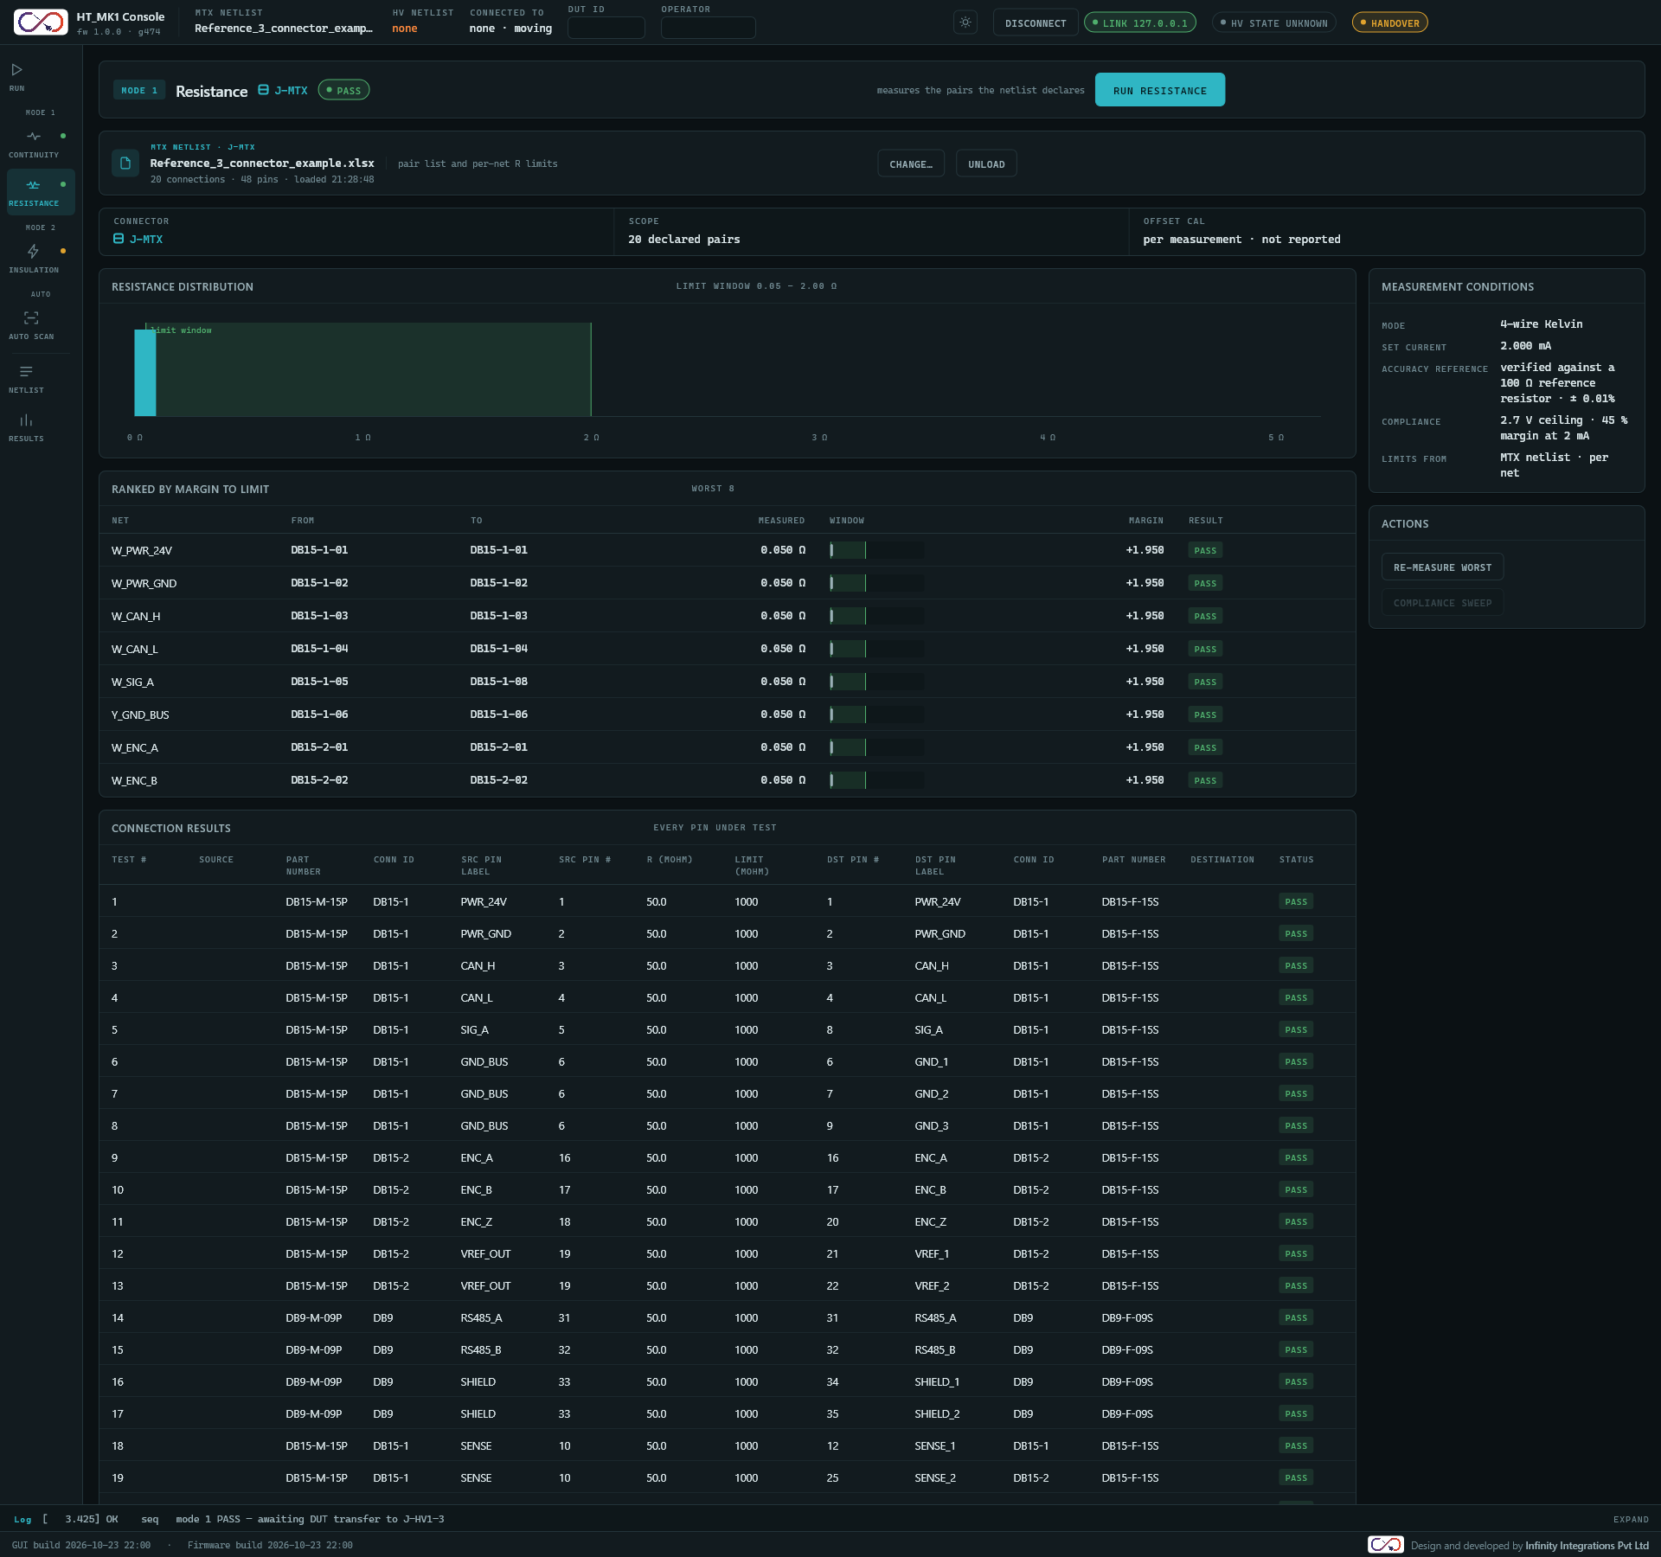
Figure 6: The Resistance screen after a passing run.

View bar, netlist strip and facts band
The view bar shows Mode 1, Resistance, J-MTX, the status pill, the reason text and Run resistance. The MTX netlist strip follows. The facts band shows Connector J-MTX, Scope (N declared pairs or no netlist) and Offset cal (per measurement · not reported).

Main column
Panel | Contents
Resistance distribution | A histogram of the measured resistance of every net, with the caption limit window 0.05 - 2.00 ohm. This window is a GUI default per net, not a value read from the instrument.
Ranked by margin to limit | The worst 8 nets. Columns: Net, From, To, Measured (x.xxx ohm), Window (a mini bar showing the allowed window and a marker for the reading), Margin (limit minus reading, signed) and Result: Pass (green), Marginal (amber, margin under 0.2) or F08 high (red).
Connection results | Every pair tested. Columns: Test #, Source, Part Number, Conn ID, Src Pin Label, Src Pin #, R (mOhm), Limit (mOhm), Dst Pin #, Dst Pin Label, Conn ID, Part Number, Destination, Status (Pass, F08 high, F08 low). Resistance is shown to one decimal place. The limit is the instrument's value for that pair.
Table 17: Resistance main panels

Side column
Panel | Contents
Measurement conditions | Mode 4-wire Kelvin; Set current 2.000 mA; Accuracy reference (verified against a n ohm reference resistor and the accuracy, or not connected); Compliance 2.7 V ceiling · 45 % margin at 2 mA; Limits from MTX netlist · per net or none loaded.
Actions | Re-measure worst runs the full resistance test again (enabled when resistance is allowed). Compliance sweep is not available and stays disabled.
Table 18: Resistance side panels

Insulation Screen
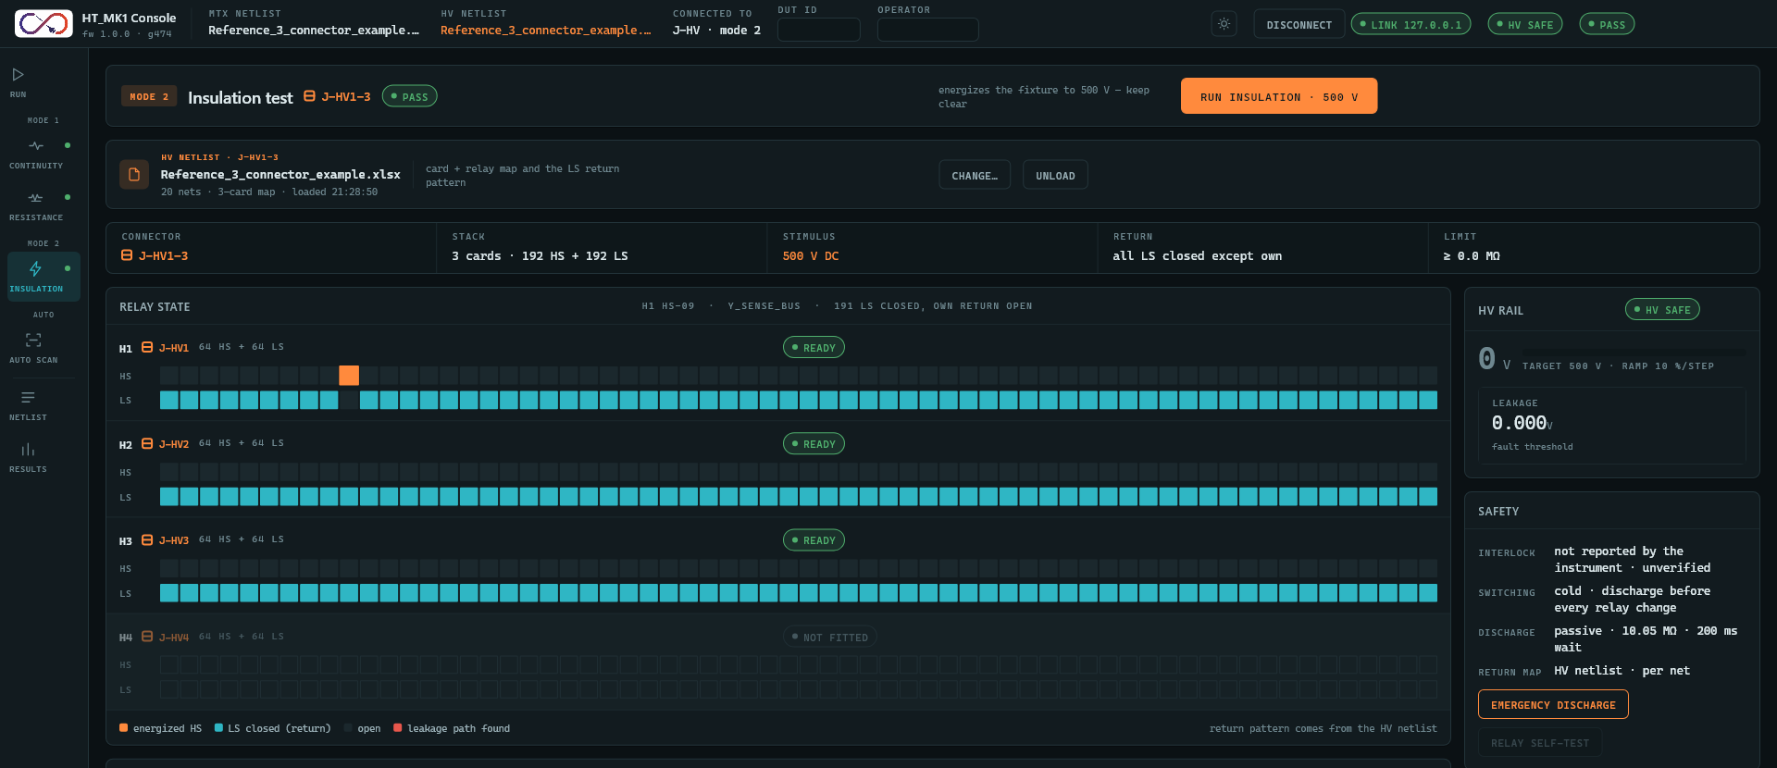
Figure 7: The Insulation screen after a run: relay state grid and HV rail.

View bar, netlist strip and facts band
The view bar shows Mode 2, Insulation test, the connector chip J-HV1-N, the status pill, the text energizes the fixture to 500 V - keep clear and the button Run insulation · 500 V. The button is enabled whenever no test is running. From J-MTX it opens the prerequisites dialog; from J-HV it goes to the HV netlist and verification dialogs (Section 13).
The HV netlist strip shows the loaded file and an amber stack mismatch pill if its card count differs from the HV stack chosen on the Run screen. The facts band shows Connector, Stack (N cards · 64N HS + 64N LS), Stimulus 500 V DC, Return all LS closed except own and Limit (the instrument's minimum insulation, >= x.x MΩ).

Relay state
Four rows, H1 to H4, one per possible HV card. Each has the card name, a connector chip (J-HV1 to J-HV4), 64 HS + 64 LS, a pill (Ready green when fitted, Not fitted grey and dimmed otherwise) and two rows of 64 cells labelled HS and LS. The caption reads idle - all relays open, or while a net is under test the card, relay and net and the number of LS relays closed.
Cell colour | Meaning
HV colour (orange) | Energized HS relay (the net under test).
Blue | LS return relay closed.
Grey | Open.
Red | Leakage path found: the failing net's HS relay.
Outlined | The card is not fitted.
Table 19: Relay state colours
The grid follows the result of the most recently tested net. It is not a live readback of the relays.

Net results and Connection results
- Net results lists the worst 6 nets. Columns: Net, Conn, Card, HS relay, Insulation (x.x MΩ), Result (Pass or Fail).
- Connection results lists every net under test. Columns: Test #, Net, HV Card, HS Pin, Leak V, Insulation (MOhm), Limit (MOhm), Status. Leak V is derived from the rail voltage and the measured insulation, not sensed directly. The empty table reads No results yet - run insulation to populate this table.

HV rail and Safety panels
Panel | Contents
HV rail | The live rail voltage as a large number with a bar and the caption target 500 V · ramp 10 %/step, and a Leakage meter in volts that turns red at or above the fault threshold. The pill in the panel title shows the same HV state as the status bar HV pill (for example HV Safe).
Safety | Four facts: Interlock not reported by the instrument · unverified; Switching cold · discharge before every relay change; Discharge passive · 10.05 MΩ · 200 ms wait; Return map HV netlist · per net.
Table 20: Insulation side panels
- Emergency discharge is always enabled. It sends the abort command to the instrument, writes ABORT sent to the log and resets the GUI, exactly as the Abort & discharge button of the high-voltage banner does.
- Relay self-test is not available and stays disabled.
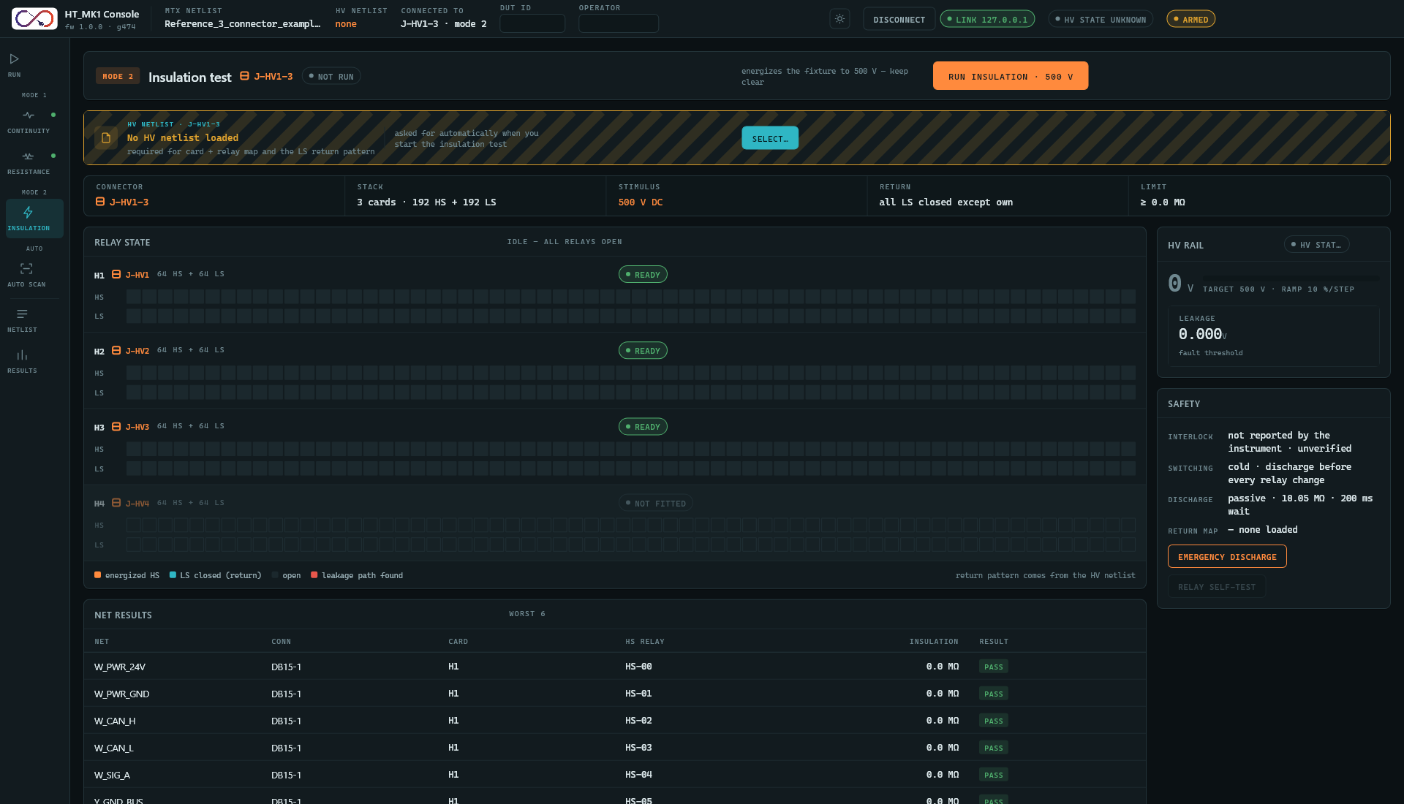
Figure 8: The Insulation screen before a run, showing the facts band, the relay grid and the Safety panel.

Auto Scan Screen
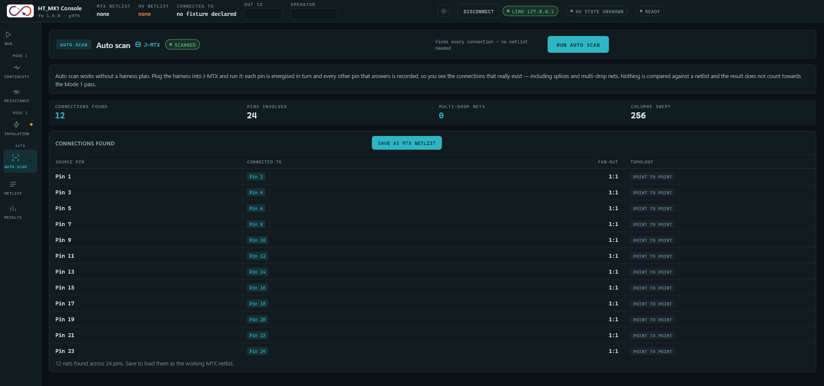
Figure 9: The Auto Scan screen after a scan.
Auto scan finds the connections that really exist on the harness without a netlist. Each pin is energized in turn and every other pin that answers is recorded, including splices and multi-drop nets. Nothing is compared with a netlist and the result does not count toward the Mode 1 pass.
Item | Contents
View bar | Stage badge Auto scan, heading, J-MTX, a pill (Not run, Scanning, Scanned), a caption (finds every connection - no netlist needed or the reason it is blocked) and Run auto scan (disabled while a test runs or when the harness is on J-HV).
Description | The paragraph above.
Tiles | Connections found, Pins involved, Multi-drop nets, Columns swept. A dash until a scan has run.
Connections found | The table of results and the Save as MTX netlist button.
Table 21: Auto scan screen
- The table columns are Source pin, Connected to, Fan-out and Topology. There is one row per source pin (Pin n), a chip for each pin that answered, a fan-out such as 1:3, and a tag multi-drop (more than one answer) or point to point. The first 300 source pins are shown, followed by N more source pins not shown - save as a netlist to keep them all.
- While scanning the table reads Scanning - connections appear here as they are found. Before any scan it reads Run auto scan to find the connections on J-MTX. After a scan: N nets found across M pins. Save to load them as the working MTX netlist.
- Save as MTX netlist (enabled only when pairs were found) sends the discovered pairs to the instrument and loads them as the MTX netlist.
When a scan finishes, the GUI discards the pass or fail it just recorded: the continuity result is cleared, the verdict returns to READY and the state pill to Idle. An auto scan therefore can never unlock insulation or raise the handover prompt. The continuity mode returns to Netlist when you leave the Auto Scan screen.

Netlist Screen
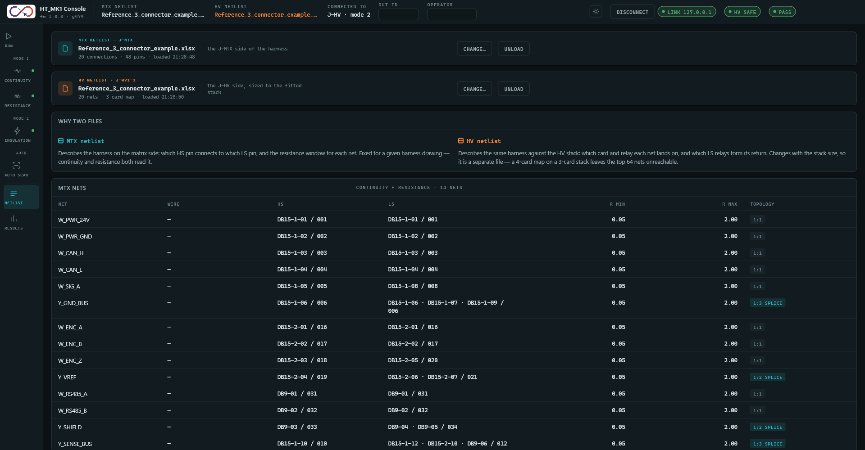
Figure 10: The Netlist screen: both netlists and the tables they define.
The Netlist screen shows the MTX netlist strip, the HV netlist strip, an explanation of why there are two files, and two tables. There is no save or export control on this screen.

Netlist strip
The same strip appears on the Run, Continuity, Resistance, Insulation and Netlist screens. From left to right: a file icon, a kind line (MTX netlist · J-MTX or HV netlist · J-HV1-N), the file name, a meta line, an optional stack mismatch pill (HV strip only), a short caption saying what reads the file, and buttons.
Strip | State | Shown | Buttons
MTX | Not loaded | No MTX netlist loaded; required for ...; amber hatched border; caption cross continuity can run without one and build it for you | Select...
MTX | Loaded | File name; N connections · M pins · loaded HH:MM:SS, plus built by cross scan when it came from a scan | Change..., Unload
HV | Not loaded | No HV netlist loaded; caption asked for automatically when you start the insulation test | Select...
HV | Loaded | File name; N nets · K-card map · loaded HH:MM:SS | Change..., Unload
Table 22: Netlist strip states
- Select... and Change... open the Select the MTX netlist or Select the HV netlist dialog (Section 13).
- Unload on the MTX strip marks the netlist as unloaded in the GUI and blocks netlist-mode continuity and resistance (MTX netlist unloaded - netlist continuity and resistance blocked). It does not erase the instrument's own copy of the pairs.
- Unload on the HV strip blocks the insulation test until another HV netlist is selected.

MTX nets table
Title MTX nets, caption continuity + resistance · N nets. Columns: Net, Wire (always a dash), HS (connector, pin and the 3-digit HS pin), LS, R min and R max (GUI defaults 0.05 and 2.00) and Topology (1:1, 1:N splice, N:1 merge, multi-drop, inline splice). The empty table reads Load an MTX netlist to see the expected nets.

HV nets table
Title HV nets, caption N nets · M pins. Columns: Net, Card (H1..), HS relay (HS-nn), Return LS (all except LS-nn), Insul min and Reachable (yes green, or card not fitted red when the net's card is beyond the chosen HV stack). The card and relay are calculated from the source pin: card = (pin - 1) / 64 and relay = (pin - 1) mod 64.

Results Screen
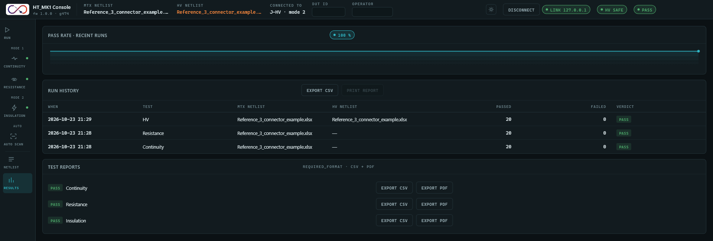
Figure 11: The Results screen: pass rate, run history and per-test reports.

Pass rate
The panel Pass rate · recent runs shows the overall pass percentage of the last 24 recorded runs in a pill, and a line of the rolling pass rate. With fewer than two runs it reads Not enough runs recorded yet this session.

Run history
One row is added for every completed run (continuity, resistance or insulation; an auto scan adds a Continuity row). The newest run is first. History is stored on the PC and is still there the next time the GUI starts (Section 17).
Column | Meaning
When | Date and time, YYYY-MM-DD HH:MM.
Test | Continuity, Resistance or HV.
MTX netlist, HV netlist | The file names in use, or a dash.
Passed, Failed | Counts for the run.
Verdict | Pass when Failed is zero, otherwise Fail.
Table 23: Run history columns
- Export CSV saves the whole history (title Export run history, default name run_history_<date>-<time>.csv). The columns are Timestamp,Kind,MTX netlist,HV netlist,Passed,Failed,Verdict, newest first, with Kind cont, res or insul. When there is nothing to export the log reads no run history to export yet.
- Print report is not available and stays disabled.

Test reports
The panel Test reports, with the caption required_format · CSV + PDF, has one row for each test that has completed with results in this session: Continuity (netlist mode only), Resistance and Insulation. Each row shows a Pass or Fail tag, the test name, Export CSV and Export PDF. A report is a snapshot of the most recent completed run of that kind, replaced when the next run of that kind completes. In addition, every completed run is saved automatically as a CSV and a PDF in the reports folder (Section 17), so a result is not lost if the GUI is closed before you press Export. With nothing to report the panel reads No completed run this session to report on yet.
The save dialog is titled Export continuity report, Export resistance report or Export insulation report. The suggested file name is report_<date>-<time>_<continuity|resistance|insulation>.<csv|pdf>.

CSV report content
Each CSV starts with comment lines (prefixed # ), then a blank line, a column header and one row per result:
# Harness Tester Results [- Resistance | - HV Insulation]
# DUT ID,<DUT ID>
# Operator,<operator>
# Netlist,<MTX netlist name>
# (test-specific lines)
# Verdict,PASS|FAIL
# Date/Time,YYYY-MM-DD HH:MM:SS
Report | Extra header lines | Columns | Status values
Continuity | none | Test #, Source, Part Number, Conn ID, Src Pin Label, Src Pin #, Status, Dst Pin #, Dst Pin Label, Conn ID, Part Number, Destination | CONNECTED, NOT CONNECTED
Resistance | Excitation Current (mA); Resistance Limit (mOhm) | Test #, Source, Part Number, Conn ID, Src Pin Label, Src Pin #, Resistance (mOhm), Limit (mOhm), Status, Dst Pin #, Dst Pin Label, Conn ID, Part Number, Destination | PASS, FAIL_HIGH, FAIL_LOW
Insulation | HV Applied (V) = 500; Insulation Limit (MOhm) | Test #, Net, HV Card, HS Pin, Leak V, Insulation (MOhm), Limit (MOhm), Status | PASS, FAIL
Table 24: CSV report layouts
The verdict is PASS only when no result failed. A pin label defaults to Pin n when the netlist gives none. Leak V is an estimate derived from the rail voltage and the measured insulation.

PDF report content
A single flowing document: the company logo, the customer name (Infinity Integrations Pvt Ltd), the title (Harness Tester Test Report, ... -- Resistance or ... -- HV Insulation), the line DUT: <id> and the coloured line VERDICT: PASS or FAIL; metadata rows (Date/Time, Operator, Netlist, the test-specific lines above, Test Duration and the total pins or nets tested); a Summary table (totals and counts, tinted green and red); and the Results table with the same columns as the CSV, each row tinted green for CONNECTED or PASS and red otherwise.

Dialogs
Dialogs are drawn over the screen with a dimmed backdrop. Pressing Esc or clicking the backdrop dismisses them. The GUI has no error dialogs: every refusal, read error, timeout or link problem is reported only as a line in the log bar (Section 14). With the log bar collapsed, only the newest line is visible.

Select the HV netlist
Opens when insulation is started with no HV netlist loaded (the log says HV start blocked - no HV netlist loaded, prompting operator), and from Select... and Change... on any HV strip. The text explains that the HV netlist is separate because the relay map depends on the number of HV cards.
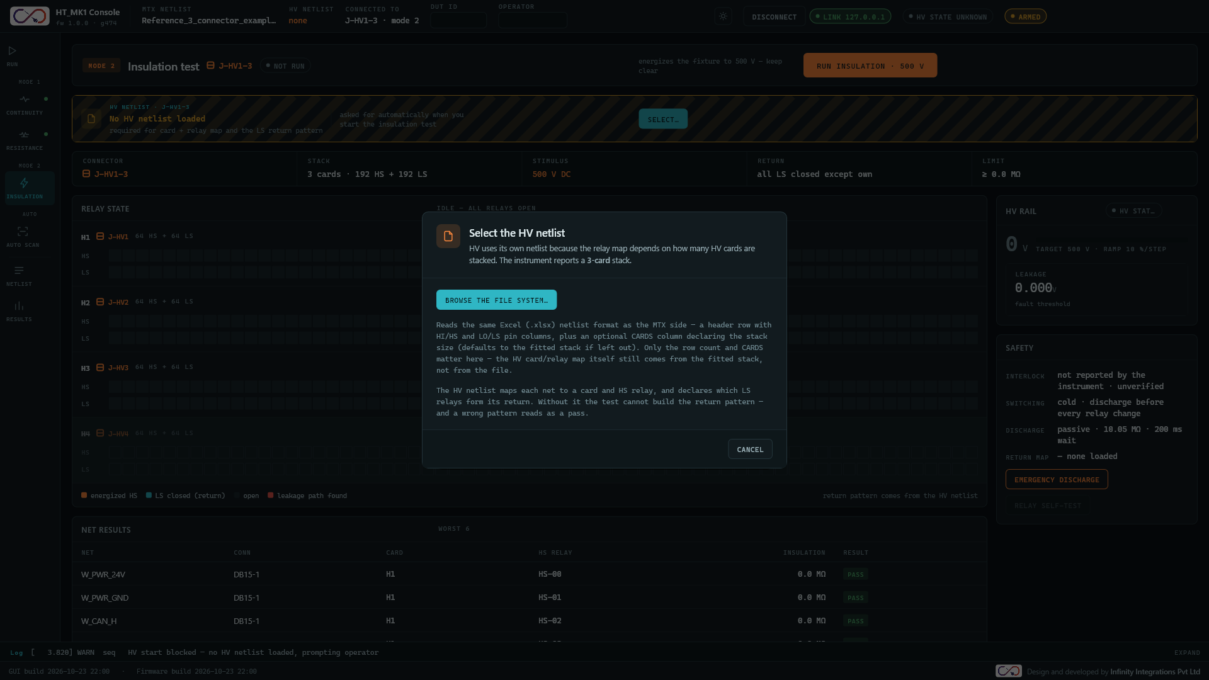
Figure 12: The Select the HV netlist dialog.
- Browse the file system... opens the Windows file dialog. The file is read on the PC and recorded in the GUI only; nothing is sent to the instrument. The GUI uses the number of rows as the net count and the largest value of the card-count column.
- On success the log reads HV netlist loaded: <name> - N nets, K-card map.; if the card count differs from the HV stack, HV netlist declares K cards, S fitted - X nets unreachable. The dialog closes and the verification dialog opens straight away.
- On a read error the log reads could not read <name> - <message> and the dialog stays open.
- Cancel closes the dialog and logs HV start cancelled by operator.

Select the MTX netlist
Opens from Select... and Change... on an MTX strip, and from the big Run Mode 1 button in netlist mode with no netlist loaded.
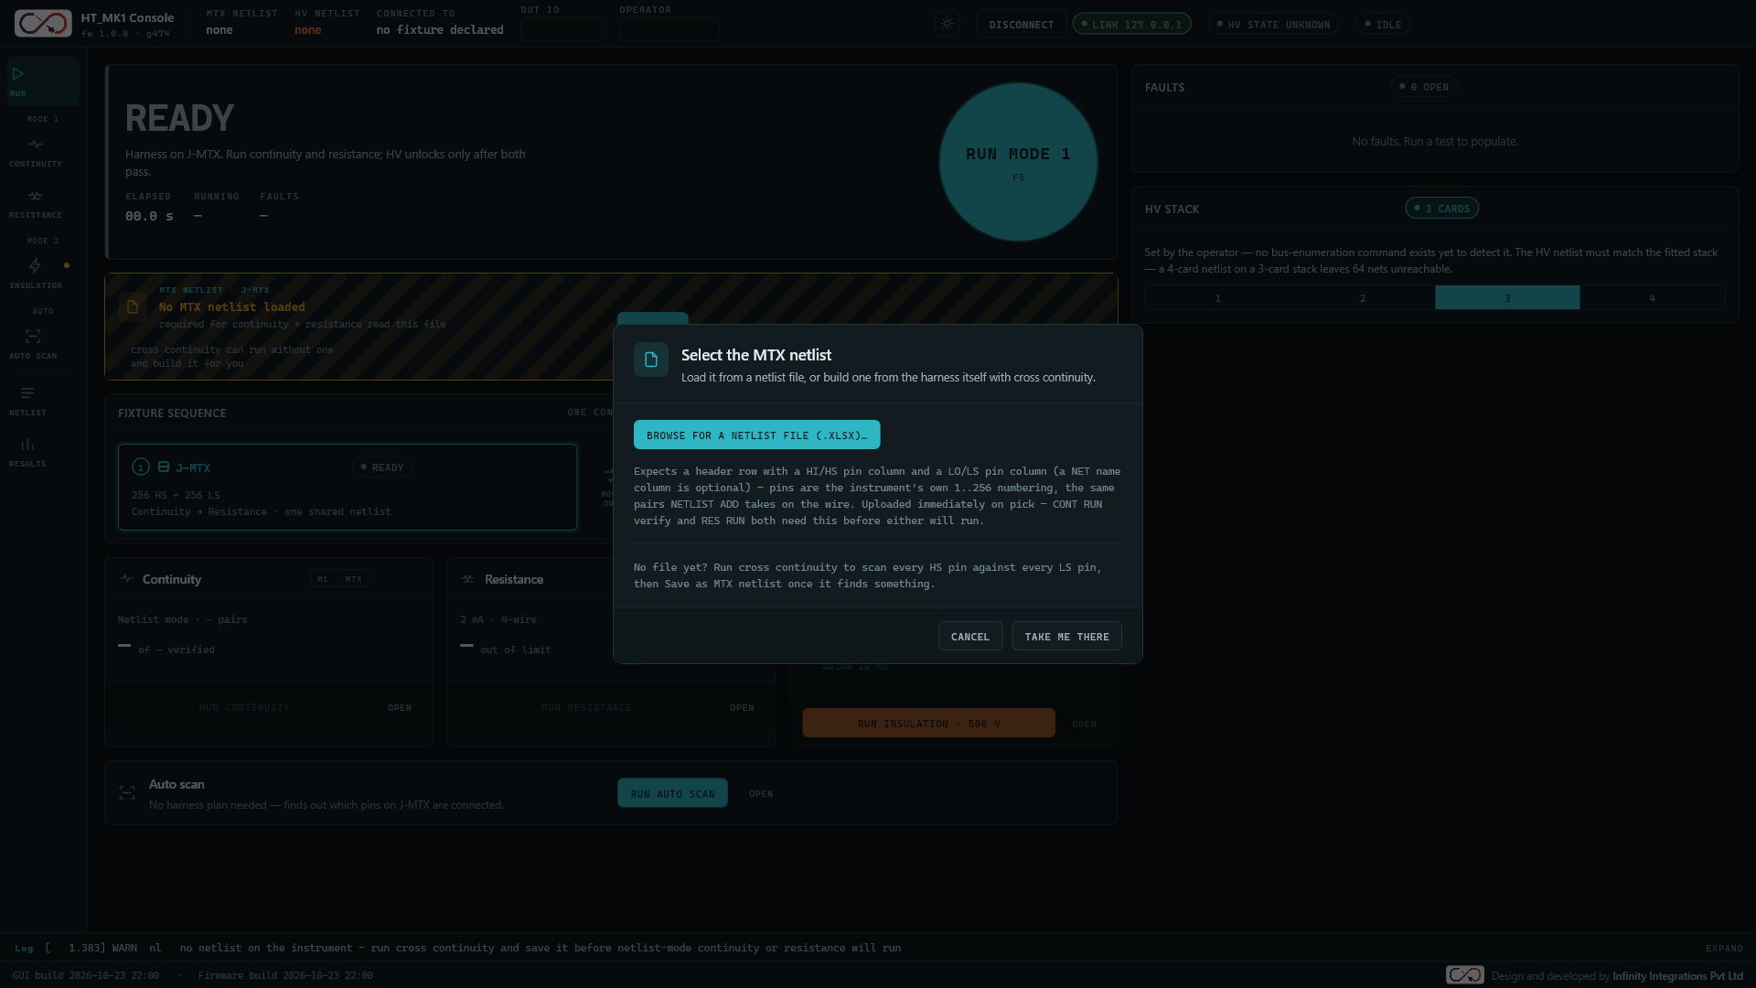
Figure 13: The Select the MTX netlist dialog.
- Browse for a netlist file (.xlsx)... opens the file dialog. The file is read, the connector layout is confirmed if the file has connector columns (Section 13.5), and the pairs are uploaded to the instrument.
- On success the log reads MTX netlist loaded: <name> - N nets. Bound to continuity and resistance. and netlist uploaded to the instrument - N nets. Verify-mode continuity and resistance are now available.
- If the instrument refuses the upload the log reads netlist upload refused - <code> <text> and the netlist is not loaded. A read error reads could not read <name> - <message>.
- Take me there closes the dialog, switches continuity to cross mode and opens the Continuity screen, for when there is no file yet.
- Cancel closes the dialog.

Confirm before energizing to 500 V
Opens on every insulation start, after the HV netlist is available. The tick box is unticked each time.
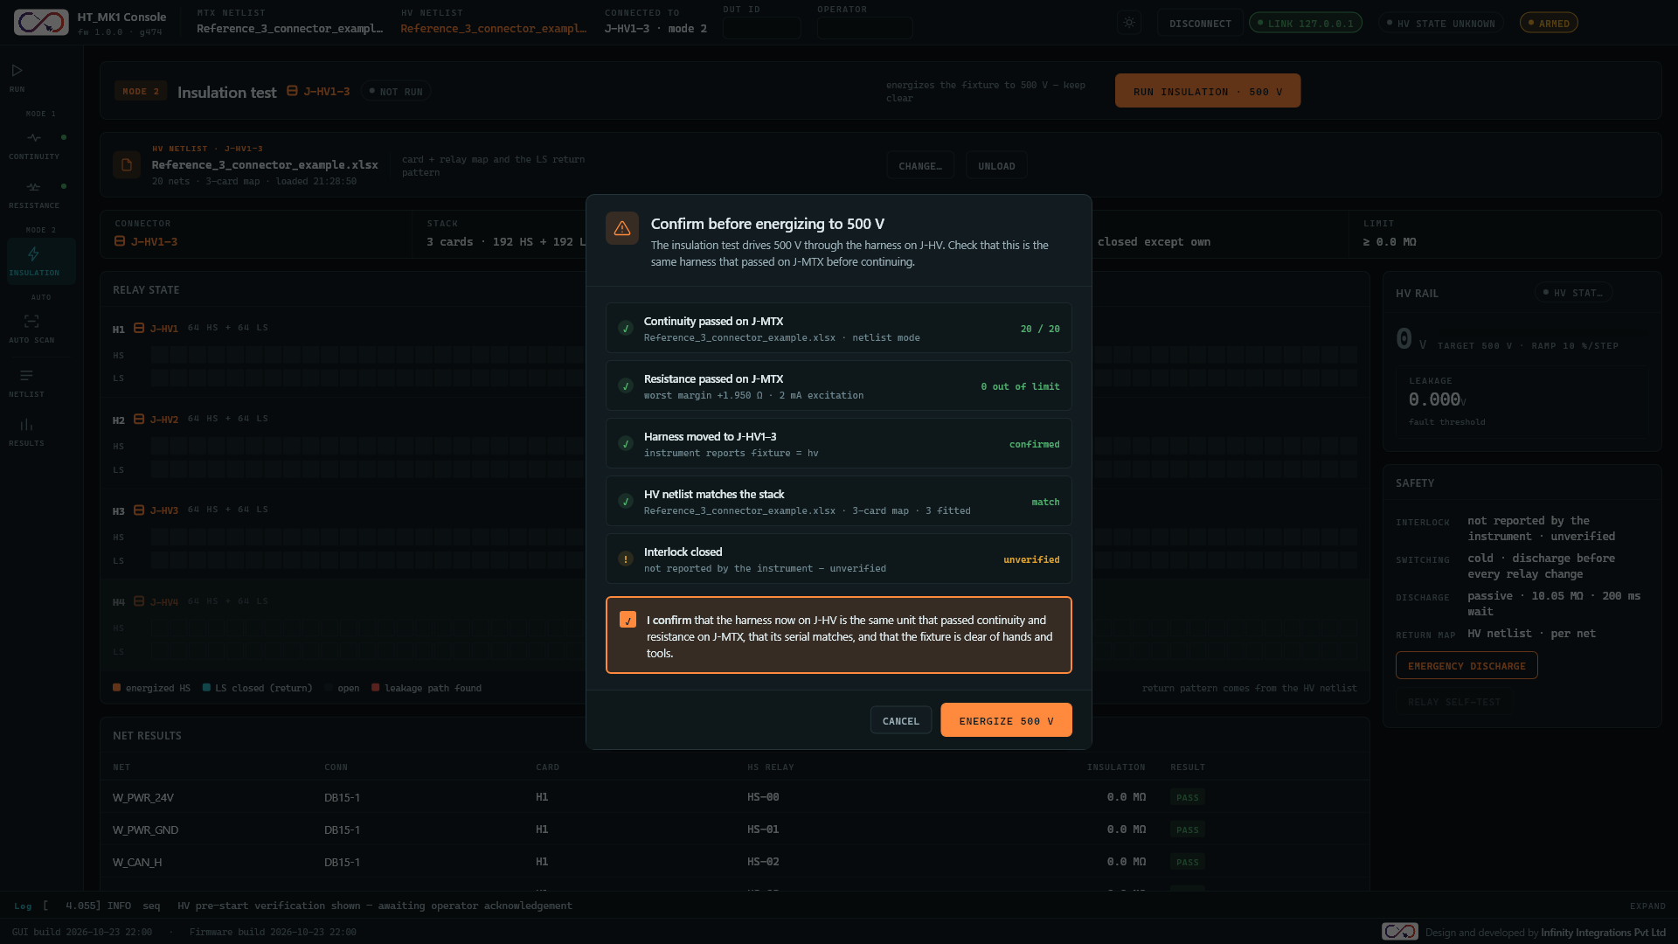
Figure 14: The pre-start verification dialog with the confirmation box ticked and Energize 500 V enabled.
Check row | Detail | Value
Continuity passed on J-MTX | MTX file name and mode | N / N (green), skipped (amber) or not passed (red)
Resistance passed on J-MTX | Worst margin and 2 mA excitation | 0 out of limit, skipped or not passed
Harness moved to J-HV1-N | instrument reports fixture = hv or instrument has not confirmed the harness moved | confirmed (green) or not confirmed (amber)
HV netlist matches the stack | File name, card map, cards fitted | match (green) or N nets unreachable (amber)
Interlock closed | not reported by the instrument - unverified | unverified (amber, always)
Table 25: Pre-start verification rows
- The confirmation text reads: I confirm that the harness now on J-HV is the same unit that passed continuity and resistance on J-MTX, that its serial matches, and that the fixture is clear of hands and tools. Clicking anywhere on the box toggles the tick.
- Energize 500 V is disabled until the box is ticked. Pressing it closes the dialog, logs operator acknowledged HV pre-start checks - energizing, then arms the instrument and starts the insulation run. If the arm command is refused, the log reads arm refused - <code> <text> and nothing starts.
- The check rows are informational. A red or amber row does not block the button; only the tick box does. Read every row before ticking.
- Cancel closes the dialog and logs HV start cancelled by operator.

Run continuity and resistance first? / Move the harness to J-HV
Opens when any Run insulation control is pressed while the harness is not on J-HV. The log reads insulation requested - asking the operator about the Mode 1 pre-tests.
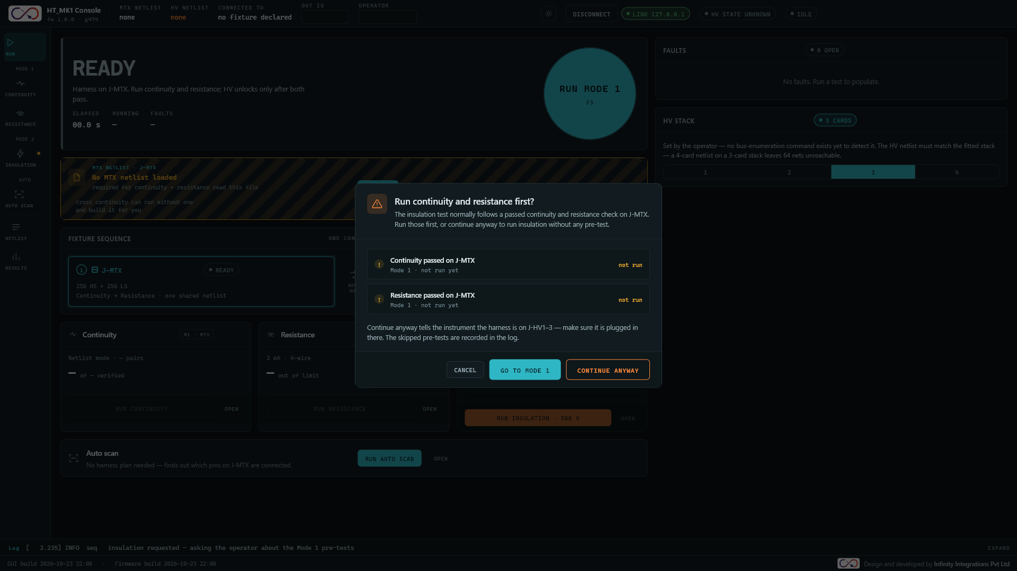
Figure 15: The prerequisites dialog when Mode 1 has not been completed.
Mode 1 state | Title | Buttons
Continuity and resistance both passed | Move the harness to J-HV1-N | Cancel, Harness moved - continue
Anything else | Run continuity and resistance first? | Cancel, Go to Mode 1, Continue anyway
Table 26: Prerequisites dialog
- Two check rows show Continuity passed on J-MTX and Resistance passed on J-MTX with the detail Mode 1 · completed on J-MTX, failed on J-MTX or not run yet and the value passed, failed or not run.
- Go to Mode 1 closes the prompt and opens the Continuity screen.
- Harness moved - continue and Continue anyway both tell the instrument the harness is on J-HV (a refusal is logged as fixture hv refused - <code> <text>), then go on to the HV netlist dialog if needed and the verification dialog.
- Continue anyway runs insulation without a completed Mode 1. The log records insulation started WITHOUT a completed continuity + resistance pass - operator chose Continue anyway, and the verification dialog shows skipped instead of not passed.

Confirm the connector layout
Opens after an MTX netlist that has Conn ID or Part Number columns is read. The guessed layout is already applied behind the dialog, and Cancel reverts to the layout that was active before.
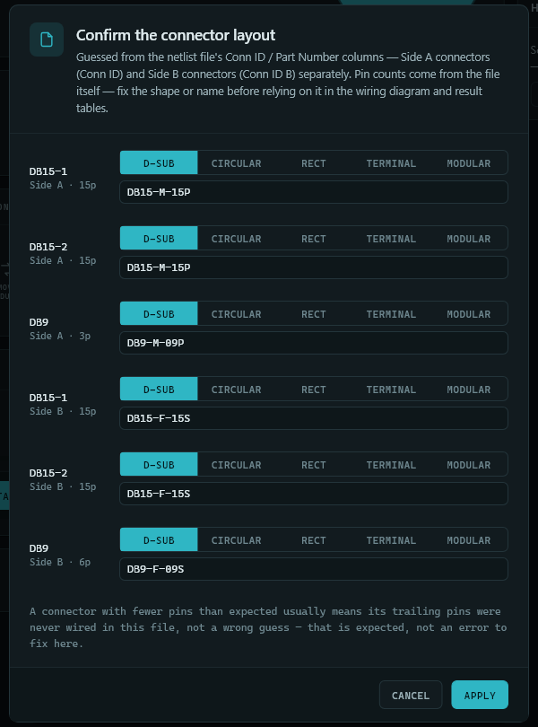
Figure 16: The Confirm the connector layout dialog.
- One row per connector: its designator, Side A or Side B and its pin count; a five-way selector for the shape (D-sub, Circular, Rect, Terminal, Modular); and a text box with the part number or friendly name. A blank name restores the designator. Pin counts, identifiers and order are not editable.
- The footnote explains that a connector with fewer pins than expected usually means its trailing pins were never wired in the file. That is normal, not an error.
- Apply keeps the layout with your shapes and names. Cancel (or Esc) reverts it.
- If a connector has more pins wired than its part number allows, the log warns Side A connector "<id>" has N pins wired but its part number (<pn>) has M. ....

Windows file dialogs
Opening a netlist uses the dialog titled Select a netlist file. Its filter lists .xlsx and .xls, but only .xlsx files can be read. Saving uses the titles Export run history, Export discovered netlist, Export continuity report, Export resistance report and Export insulation report.

Log Bar and Footer

Log bar
The log bar runs along the bottom of every screen. Its head (always visible) shows the tab Log and the newest log line in the form [time] LEVEL source message. The Expand toggle at the right opens a 150 pixel scrolling list of all lines since start-up, scrolled to the newest; Collapse closes it.
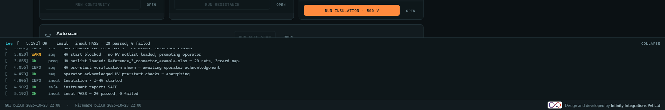
Figure 17: The log bar expanded.
Level | Colour | Used for
INFO | Grey | Ordinary events (connected, netlist read, fixture change).
OK | Green | Completed actions and passing results.
WARN | Amber | Things to check: missing netlist, mismatches, skipped pre-tests.
FAIL | Red | Refusals, read errors, link problems and failing results.
HV | HV colour | High-voltage events.
Table 27: Log levels
The time stamp in each line is a running counter of the GUI, not a wall-clock time. The list is held in memory only and has no filter, search or clear control; the permanent record is the session log (Section 17). The first line after start-up reads HT_MK1 console started - not yet connected.

Footer
The footer shows GUI build <date> <time> and, once the instrument has answered, Firmware build <date> <time>. At the right are the logo and the credit line Design and developed by Infinity Integrations Pvt Ltd.

Keyboard Shortcuts
Key | Action
F5 | Same as pressing the big round button, only when no test is running. It is not blocked by the button being disabled, so pressing F5 during the handover resets the GUI.
Esc | If the connector layout dialog is open: cancels it and reverts the layout. Otherwise, if any other dialog is open: closes it. Otherwise, if a test is running: sends the abort command to the instrument and resets the GUI. Otherwise: resets the GUI.
Table 28: Keyboard shortcuts
There are no other shortcuts.

Operating Sequences and States

Normal sequence
1. Connect. Choose the port and press Connect. The state is Idle and Connected to reads J-MTX · mode 1.
2. Load an MTX netlist (or build one with Cross continuity or Auto scan). Netlist-mode continuity and resistance are blocked without one.
3. Mode 1. Press Run Mode 1 or Run continuity. Results arrive pair by pair, and progress drives the card bar and the Elapsed value. Then press Run resistance. Each test passes only when its failed count is zero.
4. Handover. When both pass the verdict reads MOVE DUT and the handover panel appears. If either fails, the verdict reads FAIL, the harness stays on J-MTX and HV is not attempted.
5. Move the harness to J-HV and press Harness moved - unlock HV. The state becomes Armed.
6. Start insulation. Press Run Insulation. Select an HV netlist if asked, then read the verification dialog, tick the confirmation and press Energize 500 V. The instrument ramps the rail; at 50 V or more the high-voltage banner replaces the status bar.
7. Results stream in net by net. When the run ends the instrument discharges the rail and reports safe. Wait for the green HV Safe pill before touching the harness.

When a run finishes
The GUI builds the report snapshot, saves it (Section 17), adds a run-history line, colours the test card and navigation dot, clears the running state and writes a log line such as cont PASS - 20 passed, 0 failed. When insulation ends the verdict headline changes to PASS or FAIL with the line Insulation passed on J-HV1-N. Wait for HV Safe before handling the harness. (or Insulation failed ...), and the stage 2 pill and the state pill show Pass or Fail. Pressing the big button then resets to READY.

Abort, Stop and Reset
Control | What it does
Abort & discharge (high-voltage banner) | Sends ABORT to the instrument, logs ABORT sent, then resets the GUI.
Emergency discharge (Insulation screen) | The same as Abort & discharge. It is always enabled.
Stop button and Esc (a test is running) | Send ABORT to the instrument, log ABORT sent, then reset the GUI. The instrument stops after the measurement in progress, removes high voltage and reports safe.
Reset button and Esc (no test running) | Reset the GUI only. They clear results, tallies, faults and the relay display, mark the harness as back on J-MTX, close dialogs and show READY.
Table 29: Stopping a test
The instrument answers an abort with the end-of-run report of the part that ran. The GUI discards that partial result (<test> run aborted: partial result discarded): an aborted run gets no verdict, no history row and no report, so a half-finished run can never be recorded as a pass.
Warning: Wait for the green HV Safe indicator after any abort before touching the harness.
A reset does not clear the loaded netlists, the connector layout, the HV stack size, the report snapshots or the stored run history.

Safe to handle
The GUI shows the green HV Safe pill only when the instrument has sent its own safe report and nothing since has contradicted it. A run ending, silence from the instrument or the order of events never makes the GUI show safe. After connecting, the state is unknown until the instrument reports safe. A reported rail above zero, a running test, the armed state or a fault all return the GUI to live or unknown. When the safe report arrives the log reads instrument reports SAFE.

Faults
A latched fault appears as the red state pill Fault, a log line with the fault code and text, and the Clear Fault button at the right of the status bar. Every run request is refused while a fault is latched; if a run ends while in fault the log reads <test> refused - fault latched; clear the fault and retry. Remove the cause, then press Clear Fault: the instrument forces everything safe, clears the latch (a refusal is logged as fault clear refused - <code> <text>) and the state returns to Idle. A fault is never cleared automatically.

Loss of the link
The link is declared lost when the instrument does not reply to a command within 2 seconds, when no bytes arrive for 5 seconds, or when the port is closed or errors (for example the cable is pulled or the board resets). The GUI then:
- shows No link, Link lost and State unknown and Connected to link lost;
- removes the high-voltage banner and clears the running test, keeping the results already on screen;
- writes link lost - <detail> (state unknown) to the log, for example command timeout after 2.0s, no traffic for 5.0s or port closed by instrument;
- does not reconnect by itself. Press Connect again.
Link loss never shows as safe. While the link is down every command fails with link lost - state unknown; reconnect required. Treat the system as unsafe to handle until the link is back and HV Safe is shown.

Files and Folders
The GUI writes to %LOCALAPPDATA%\HT_MK1. If that location is not writable it uses another per-user location.
What | Location | Format
Session log | sessions\session-<date>-<time>.log (a new file at each Connect) | Text, one line per command, reply and event, with time stamps, flushed as written.
Run history | history\run_history.jsonl | JSON lines, one per completed run, written immediately and read again at every start.
Reports | reports\report_<date>-<time>_<test>.csv and .pdf (one pair per completed run) | The CSV and PDF test reports, saved automatically.
Theme | theme | The word dark or light.
Exports | Wherever you save them | CSV or PDF.
Table 30: Files written by the GUI
Not saved between sessions: the log bar, DUT ID and Operator, the netlist file names and details (the instrument keeps only the pin pairs), the HV stack size and the connector layout.

Appendix A: Netlist File Format
The same reader is used for both the MTX and the HV netlist. The accepted file type is Microsoft Excel .xlsx only. CSV files are not accepted as netlists. CSV is used only for exports.
- The first sheet is read; its name does not matter. Row 1 is the header row. Completely blank rows are skipped.
- Header names are matched without regard to case. Columns the GUI does not recognise are ignored.
- HI and LO must be whole numbers from 1 to 256. They are two independent address spaces (the instrument's HS and LS multiplexer banks). HI equal to LO is allowed. A repeated pair is an error.
- Rows with the same Net name form one net: one source with several rows is a Y branch; several sources into one destination is a merge; several at both ends is a multi-drop node; one row is a plain wire. Rows with no Net name stand alone and are named NET_001, NET_002 and so on.
Field | Required | Accepted header texts
HI pin (Side A, HS) | Yes | hi, hi pin, hs, hs pin, high, from, from pin, pin a, pin1, pin 1, src pin #, src pin, source pin
LO pin (Side B, LS) | Yes | lo, lo pin, ls, ls pin, low, to, to pin, pin b, pin2, pin 2, dst pin #, dst pin, destination pin
Net name | No | net, net name, name, signal
HV card count | No (HV netlist) | card, cards, hv card, stack
Side A connector | No | conn id, connector, conn
Side A part number | No | part number, part #, part no
Side B connector | No | conn id b, connector b, conn b
Side B part number | No | part number b, part # b, part no b
Source pin label | No | src pin label, source pin label, src label, pin label
Destination pin label | No | dst pin label, destination pin label, dst label
Connector detail | No | connector detail, wire detail, detail, joint
Table 31: Netlist columns
Connector detail text
The text is read by keyword, without regard to case. A detail containing splice, inline or butt declares an inline (I) splice. A detail containing y branch, y-branch or y joint declares a Y joint. Anything else (straight, crossed pin 5 -> 8, blank) declares no joint. Structure outranks text: a net with several rows is a Y or multi-drop whatever the detail says. Only the inline splice, which cannot be seen from structure, is taken from the text. The detail is shown in the Net inspector and the diagram tooltip and is never sent to the instrument.
How the connector layout is guessed
When Conn ID columns exist, Conn ID and Part Number describe the Side A connectors (HI pins) and Conn ID B and Part Number B the Side B connectors (LO pins). Each end is analysed on its own, so a designator used at both ends becomes two connectors. Connectors are ordered by their lowest pin; each connector's block runs from just after the previous block to just before the next connector's lowest pin, and the last connector runs to the highest pin used. Each side numbers its pins from 1. The family is guessed from the part number:
Family | Part number contains
Terminal block | TERMINAL, SCREW, PHOENIX, WAGO, MSTB, DINKLE, TBLOCK, TB-, TB_
Modular jack | RJ45, RJ-45, RJ11, RJ-11, RJ12, MODULAR, ETHERNET, USB, 8P8C
D-sub | DSUB, D-SUB, DB, or DA, DB, DC, DD, DE, HD followed by digits
Rectangular | RECT, CPC, MOLEX, DEUTSCH, JST (and anything not matched)
Circular | CIRC, MS3, MS27, 38999, MIL-DTL, M8, M12, M16, M23, M27, AMPHENOL
Table 32: Connector family keywords
The pin count stated by the part number is used only as a check. Without Conn ID columns the GUI uses a built-in layout, and pins outside it get connectors marked as unassigned. Confirm or correct the result in the Confirm the connector layout dialog.
What is sent to the instrument
Only the pin pairs of the MTX netlist are sent (NETLIST BEGIN, one NETLIST ADD per pair, NETLIST END). The instrument holds them in RAM and they are gone after every power-up; on connect the GUI reads them back, but names, labels and details are not held by the instrument and are lost until the file is loaded again. The HV netlist is not sent at all: the card and relay for each net are calculated from the source pin.

Appendix B: Start-up Options
The programs can be started from a command line with these options. For normal use no option is needed: start the program, choose the port and press Connect.
Option | Meaning
--serial <port> | Use that COM port and connect at start-up, for example --serial COM7. --serial auto picks the ST-LINK Virtual COM Port when exactly one is attached.
--baud <n> | Serial rate. Default 115200, 8 data bits, no parity, 1 stop bit.
--list-ports | Print the serial ports the PC can see and exit.
--log-dir <path> | Folder for the session logs.
--sim | Run the built-in simulator instead of an instrument (the Demo program). Cannot be combined with --serial.
--scenario <name> | With --sim: pass, opens_shorts, res_fail, insul_fail or disconnect.
--nets <n> | With --sim: size of the simulated harness (default 12).
--host <addr>, --port <n> | Connect over TCP instead of a serial port.
--help | Print the options and exit.
Table 33: Start-up options
With no options the program starts without connecting and asks you to choose a port in the status bar. The Demo program also shows a Demo harness panel on the Run screen (Good mode 1 or Faulty mode 1) that changes what the simulator reports.

