**Eris-Keys Password Error**

We generated a key without a password. Here is the account from our accounts.json:

"newchain_full_000": {

"address": "1AB39A6E80200A7146EFDF1E78C5D4E118BE7DA4",

"pubKey": "C01382EE2C4522B0857B4B4E2F2935A558238AEC9ACD7BE449BF253D3202AE88",

"privKey": "5E6E3BFD47EC6385B8EE8546C2B76F7B0A75F82F4483128ACF0DC2639FB24D6CC01382EE2C4522B0857B4B4E2F2935A558238AEC9ACD7BE449BF253D3202AE88"

}

We aim to sign a message. Use the endpoint (from Eris-Keys), we see that the ‘/sign’ endpoint (documented here: <https://github.com/eris-ltd/eris-keys>) requires:

/sign - Args: msg, addr, name - Return: the signature

We first generate a hash, then try to sign it. We have the daemon running with the command: eris-keys --host localhost --port 12345 server

At the end of this document, there is a javascript we ran, which returns the following error:



The first line shows us that the hash was able to be generated without a problem. But the second line shows us that we could not sign.

The most recent log is:

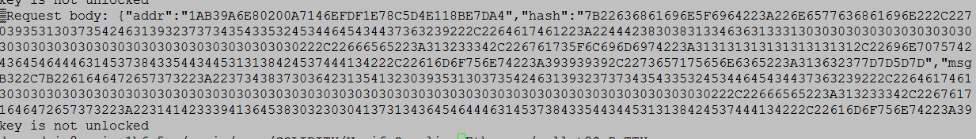

The log tells us that the key is not unlocked. However, we never generated this key with a password. Below is the javascript:

var request = require('request');

var erisVerify = 'http://localhost:12345/verify';

var erisHash = 'http://localhost:12345/hash';

var erisSign = 'http://localhost:12345/sign';

//First Hash the Message

var hashMe = "hello. I am a message. Hash me!"

request({

method: 'POST',

url: erisHash,

headers: {

'Content-Type': 'application/json'

},

body: JSON.stringify({"data": "hashMe", "type": "sha256"})

}, function (error, response, body)

{

var theHash = JSON.parse(body).Response;

console.log(theHash);

request({

method: 'POST',

url: erisSign,

headers: {

'Content-Type': 'application/json'

},

body: JSON.stringify({"msg":theHash ,"pub":"1AB39A6E80200A7146EFDF1E78C5D4E118BE7DA4" ,"name":"newchain_full_000" })

}, function (error, response, body)

{

var theSignature = JSON.parse(body).Response;

console.log(body)

}

);

}

);