**ERIS ISSUE RECREATION** **ERIS-CONTRACTS.JS Callback Value Parsing**

Summary: When a function in a smart contract returns a uint, it is noted that the result is displayed with extra parameters (S,E,C) as shown below:

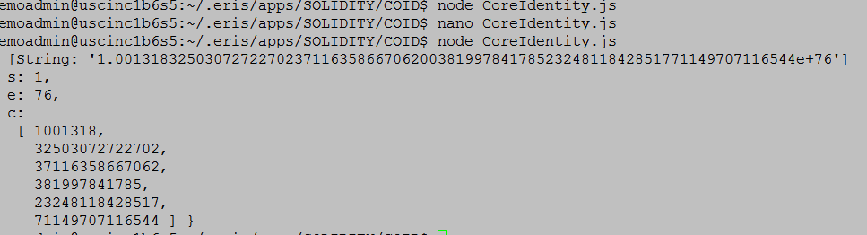

However, if one parses to a string by printing (“” + result), the correct result is shown. I am not sure if this is intended or not. I am documenting it in case it was not intended.

Issue Recreation:

To recreate this issue, one needs the EPM, the contract and the JavaScript file in this document. They appear starting on the next page.

The output of this replication is shown below:



**EPM**

jobs:

- name: Testing

job:

deploy:

contract: Testing.sol

wait: true

_____________________________________________________________________________________

**CONTRACT**

contract Testing

{

function testing() returns (uint val)

{

val = 5;

}

}

_____________________________________________________________________________________

**JAVASCRIPT**

'use strict'

var contracts = require('eris-contracts')

var fs = require('fs')

var http = require('http')

//Set up addresses for deployed contracts

var address = require('./epm.json').Testing

var abi = JSON.parse(fs.readFileSync('./abi/' + address, 'utf8'))

var accounts = require('./accounts.json')

var chainUrl

var manager

var contract

var server

var hostname = 'localhost';

var port = 8004;

chainUrl = 'http://localhost:1337/rpc'

// Instantiate the contract object manager using the chain URL and the account data.

manager = contracts.newContractManagerDev(chainUrl, accounts.chainbreaker_root_000)

// Instantiate the contract object using the ABI and the address.

contract = manager.newContractFactory(abi).at(address)

contract.testing(function(error,result)

{

console.log(result);

});