# Exploratory World Map for Digital Nomads

Description

This website was developed with the idea of enabling users to compare different countries of the world based on different criteria such as nightlife, friendliness to foreigners, access to free wifi, cost of life for locals, nomads, expats etc. The number of criteria by which the user can visualize the differences is 20.

As digital nomads are people who usually make a living by working remotely over the internet, frequently changing countries of residence, this could be an interesting tool for them when choosing a new destination.

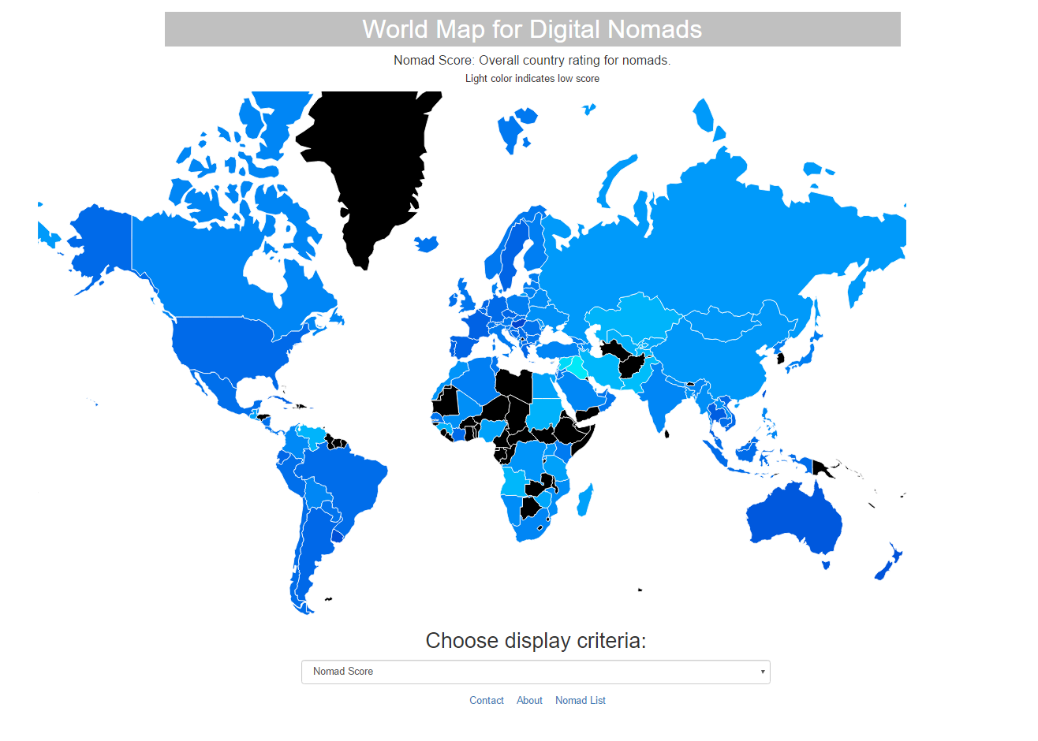

*Screenshot 1. Chosen criteria: Nomad Score*

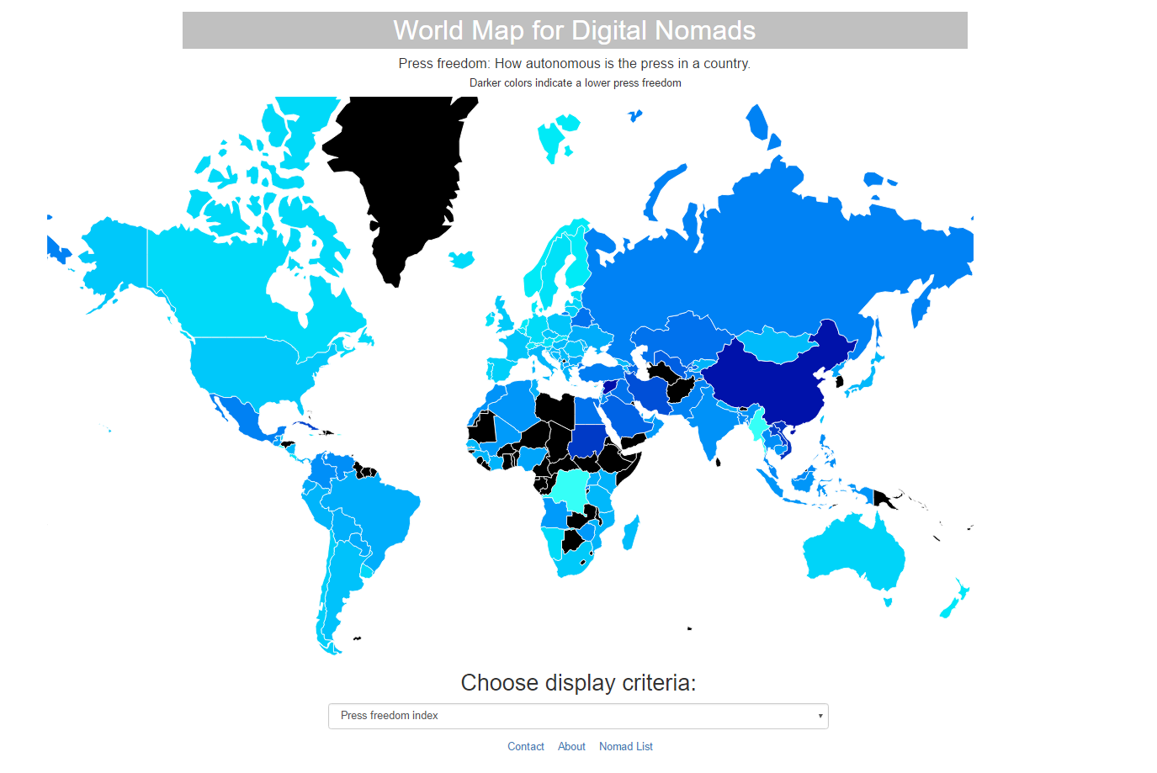

*Screenshot 2. Chosen criteria: Press Freedom Index*

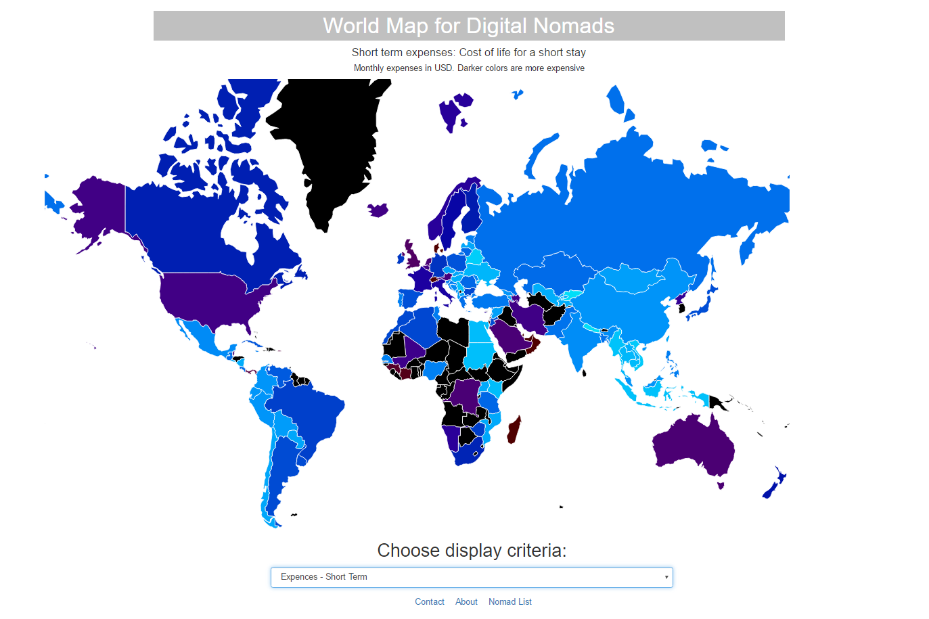

*Screenshot 3. Chosen criteria: Expenses - Short Term*

When the user hovers over a country with the cursor, a pop up with country name and score appears.

Each time the user changes the criteria for display, he can see a brief explanation of the criteria they selected under the title.

Data

The data was collected from the [Nomad List](http://nomadlist.com/) API, which has been closed during the previous week. Fortunately we have saved the aggregated data on our machines. The owner of the website is willing to give api keys to people who are not trying to copy the website. We have contacted him in order to have live data.

Tools

The server was written in python, using the web.py library and the data munging was performed using the pandas library.

The visualisations on the client side were made by using the datamaps library and Java Script.