<https://sa-book.github.io/>

If you simply want to download the data and code required for reproducing the results can access the chapter-specific zip files on this [overview page](https://sa-book.github.io/rChapter0-0.html)

<https://sa-book.github.io/rChapter0-0.html>

If you change the directory structure or the names of directories you might need adjust the scripts accordingly.

To access this material please turn to the chapter-specific sub.pages.

https://sa-book.github.io/rChapter3-2.html

Using the ?seqalign` command, we obtain a summary of the optimal number and costs of operations: the OM identifies as the cheapest to align the three sequences pairwise:

The next test correspond to the Hamming distance setting, that is, only substitution costs are used. The costs setting will be:

<https://sa-book.github.io/rChapter4-1.html>

With use non-squared dissimilarities (see the method option) and weights (see the members option, where we have to specify to which data.frame the vector with the weights belongs to).

<https://sa-book.github.io/rChapter4-2.html>

Notice that we recommend do always display the distance-to-medoid plot for each cluster at least in the appendix of your article:

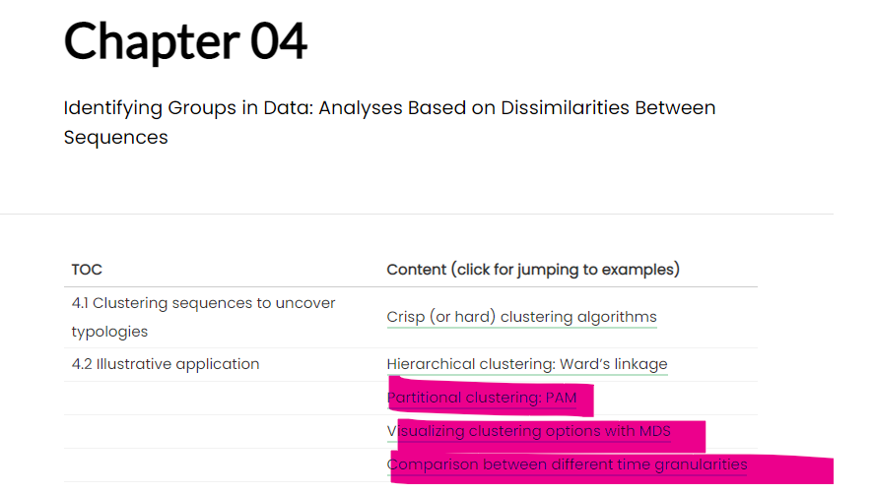

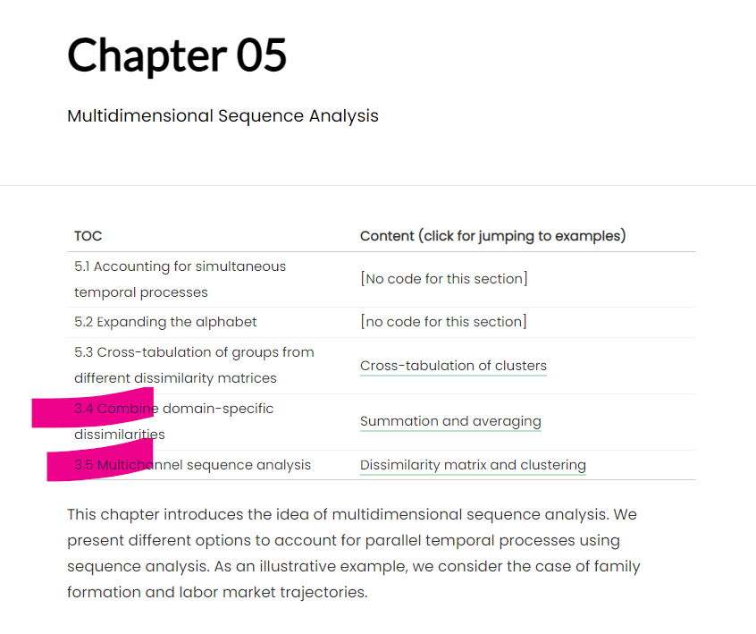

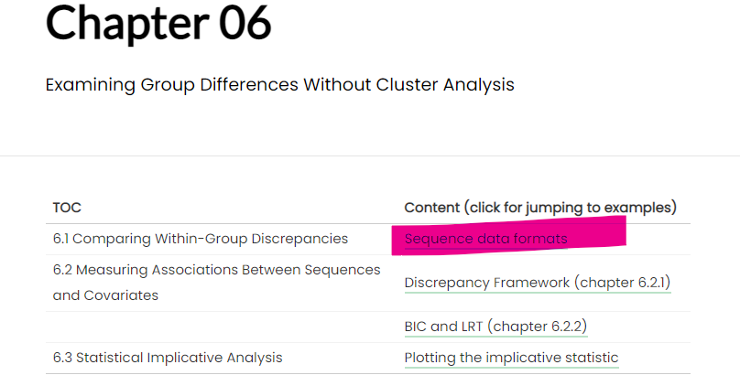

<https://sa-book.github.io/rChapter6-0.html>

Chapter 2 introduces the basic concepts and discusses how to define sequence data.