A DEMO
1 Machines:
ceMaster:
Machine1: 192.168.2.84(192.168.3.84)
Workers:
Machine2: 192.168.2.76 (192.168.3.76)
Machine3: 192.168.2.77 (192.168.3.77)
Machine4: 192.168.2.78 (192.168.3.78)
Note that the IP “192.168.2.84” indicates that Machine1 is run on the 40Gbps InfiniteBand network, and the IP “192.168.3.84” indicates that Machine1 is run on the 1Gbps Ethernet.
2 Source code is deployed on Machine1
3 Compile the CE-Graph on Machine1
# cd /cegraph/preprocessing; make
# cd /cegraph/exec; make
#cd /cegraph/exec/src; make
4 Modify configuration files on Machine1
# vi /cegraph/exec/conf/hosts.slave
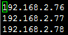
# vi /cegraph/preprocessing/conf/CE_Graph.local.cnf
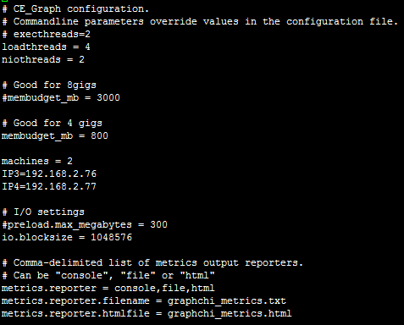
5 distribute CE-Graph to Workers
#scp -r /cegraph root@Machine2:/
#scp -r /cegraph root@Machine3:/
#scp -r /cegraph root@Machine4:/
6 The dataset LiveJournal is deployed on Machine4: /cegraph/preprocessing/
7 Preprocessing (Constructing subgraphs)
Machine2 and Machine3 run sharder_basic with sub mode:
#cd /cegraph/preprocessing
#bin/sharder_basic
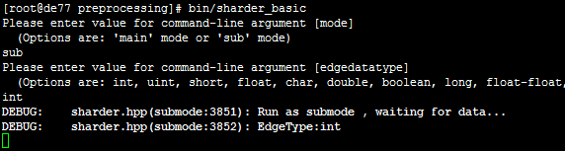
Machine4 run sharder_basic with main mode:
#cd /cegraph/preprocessing
#bin/sharder_basic
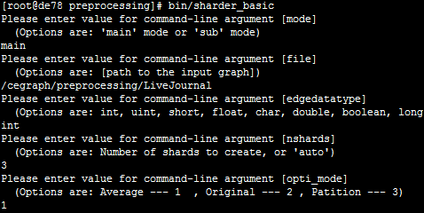
7 Run the pagerank (or SSSP) On the 40Gbps InfiniteBand
Machine2, Machine3 and Machine4 run pagerank (or SSSP) :
# cd /cegraph/exec
#bin/example_apps/sssp file /cegraph/preprocessing/LiveJournal nshards 3
Machine1 run ceMaster:
#cd /cegraph/exec
#bin/ceMaster file /cegraph/preprocessing/LiveJournal nshards 3 niters 10
8 Run the pagerank (or SSSP) on the 1Gbps Ethernet:
Modify the IP Addresses in the configuration /cegraph/exec/conf/hosts.slave to repeat the step 7.
9 Comparisons
CE-Graph on the 40Gbps InfiniteBand is 6x-7x faster than on the 1Gbps Ethernet. It significantly outperforms existing distributed graph-processing frameworks GPS and GraphLab, particularly when the system is supported by a high-bandwidth network.

