The effect of radiotherapy on the transcriptional profile of human cell lines

Abstract placeholder

# Specifications

|  |  |
| --- | --- |
| Organism/cell line/tissue | Human, Normal Dermal Fibroblasts, Normal Epidermal Keratinocytes, Pericytes, Microvascular Blood Endothelial Cells, Lymphatic Endothelial Cells and Adipose Derived Stem Cell |
| Sex | N/A |
| Data format | Unmapped fastq and summarised counts. |
| Experimental factors | RNA was obtained from each cell line under normal conditions and after being treated with a single dose of radiotherapy. The adipose stem cells and lymphatic endothelial cells were treated with additional fractionated doses of radiotherapy. |
| Experimental features | Effect of radiotherapy at dosages of 0Gy versus (2Gy x 5) versus 10Gy. |
| Consent | N/A |
| Sample source location | Melbourne, Australia |

# Direct link to deposited data

# Introduction

# Experimental Design, Materials and Methods

## Sample information

The effect radiotherapy has on gene expression was measured in 6 different human embryonic cell-lines consisting of normal dermal fibroblasts (NDF), normal epidermal keratinocytes (NEK), pericytes (PC), microvascular blood endothelial cells (MEC), lymphatic endothelial cells (LEC) and adipose derived stem cells (ASC). Each cell-line was subjected to a single dose of radiotherapy (10Gy) or no radiotherapy (0Gy, control). For the ASC and LEC cell-lines, there was also a fractionated dose (5 x 2Gy over a 48 hour period). Two replicates of each cell-line/treatment combination were available.

## RNA-seq sample preparation and sequencing

[1]

Standardized numbers of MEC were plated in cell culture flasks and irradiated once 80-90% confluence was achieved. RNA extraction was undertaken at 4 hours using the QIAGEN® RNEasy Plus Universal Kit as per manufacturers instructions. Samples were then tested for purity and quality control using the Nanodrop Spectrophotometer (Thermo Fischer Scientific) and stored at -80 °C, until further processing. Extraction of RNA at a 4-hour time point post radiotherapy-injury was utilized. Each sample underwent RNA sequencing (100 base pair single end) in the Illumina HiSeq machine at the Australian Genome Research Facility (AGRF) in Melbourne.

## Quality-control and data preprocessing

Sequences were mapped to the *hg19* reference genome using the *Rsubread* program with default settings and gene-level counts were obtained by the *featureCounts* procedure using default settings. Transcripts were annotated using the *org.Hs.eg.db* package. Analysis of the resulting counts matrix was performed using the *edgeR* and *limma* R/Bioconductor packages. First, counts per million (cpm) were computed for each gene to remove differences caused by different library sizes. One sample, PERI1_10Gy, had its libraries split across three sequencing lanes, thus its cpm values were merged together. Genes were retained for further analysis if they had a baseline expression level of 0.5 cpm in at least 2 samples. Counts were normalised using the trimmed mean of M-values (TMM) method.

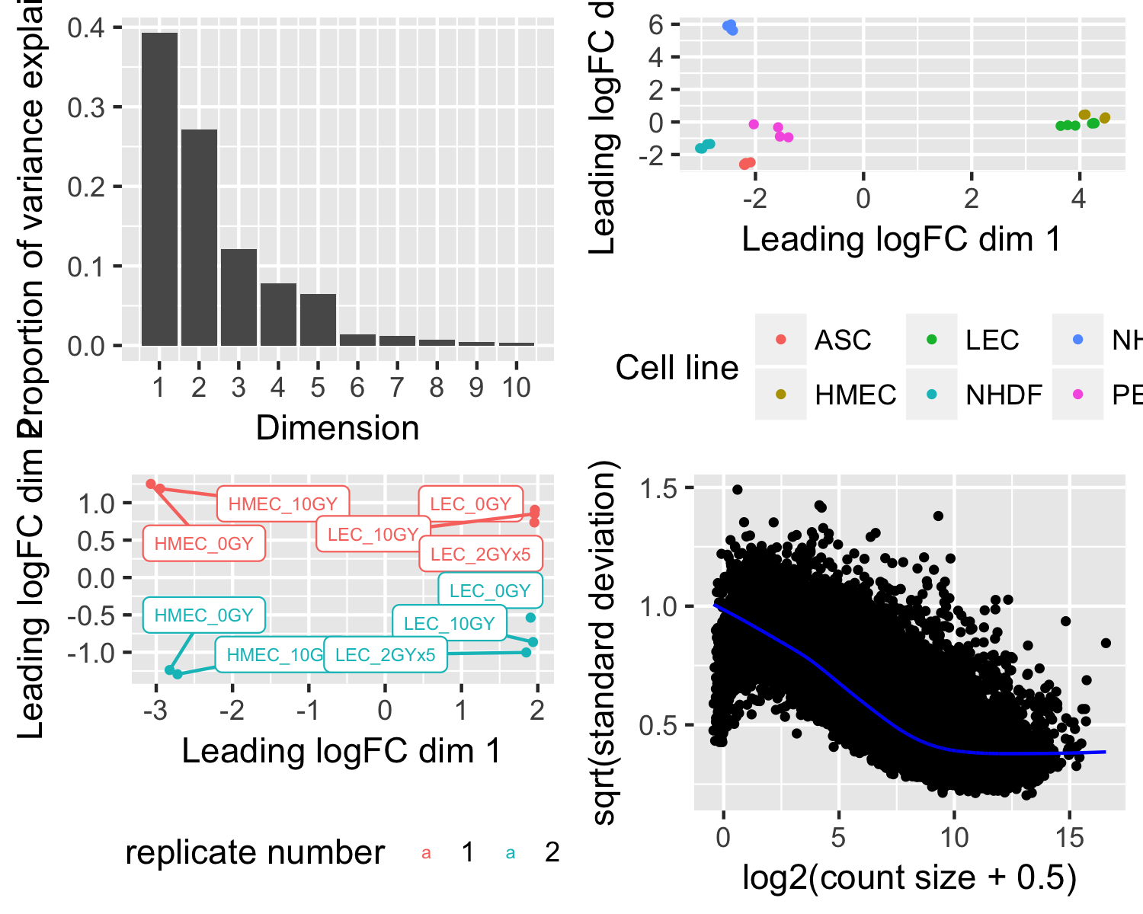

*Figure 1* ***A*** *The variance explained by each dimension from the eigenvalues of the multidimensional scaling.* ***B*** *MDS plot coloured by cell-line.* ***C*** *MDS plot of the LEC and MEC celllines. There is clear differential expression between treatment and celltype, but also confounding caused by replicate number.* ***D*** *Mean-variance trend in expression estimated by voom.*

During exploratory data analysis we performed multidimensional scaling (MDS) on the expression matrix with cpm values. The first and second dimension explain 39 per cent and 27 of the variation in the data, respectively (figure 1). There is a clear separation between the different cell-lines and the replicate number from the MDS plots. We model the heteroscedasticty in gene counts using the *voomWithQualityWeights* procedure the radiotherapy treatment as a main effect (figure 1) and adjusting for cell-line and replicate number. This results in down-weighting genes with systematically higher variation. Furthermore, given the clear difference between replicate samples observed in the MDS plot, the *voomWithQualityWeights* procedure also down-weights samples that are more variable compared to others.

## Differential expression analysis

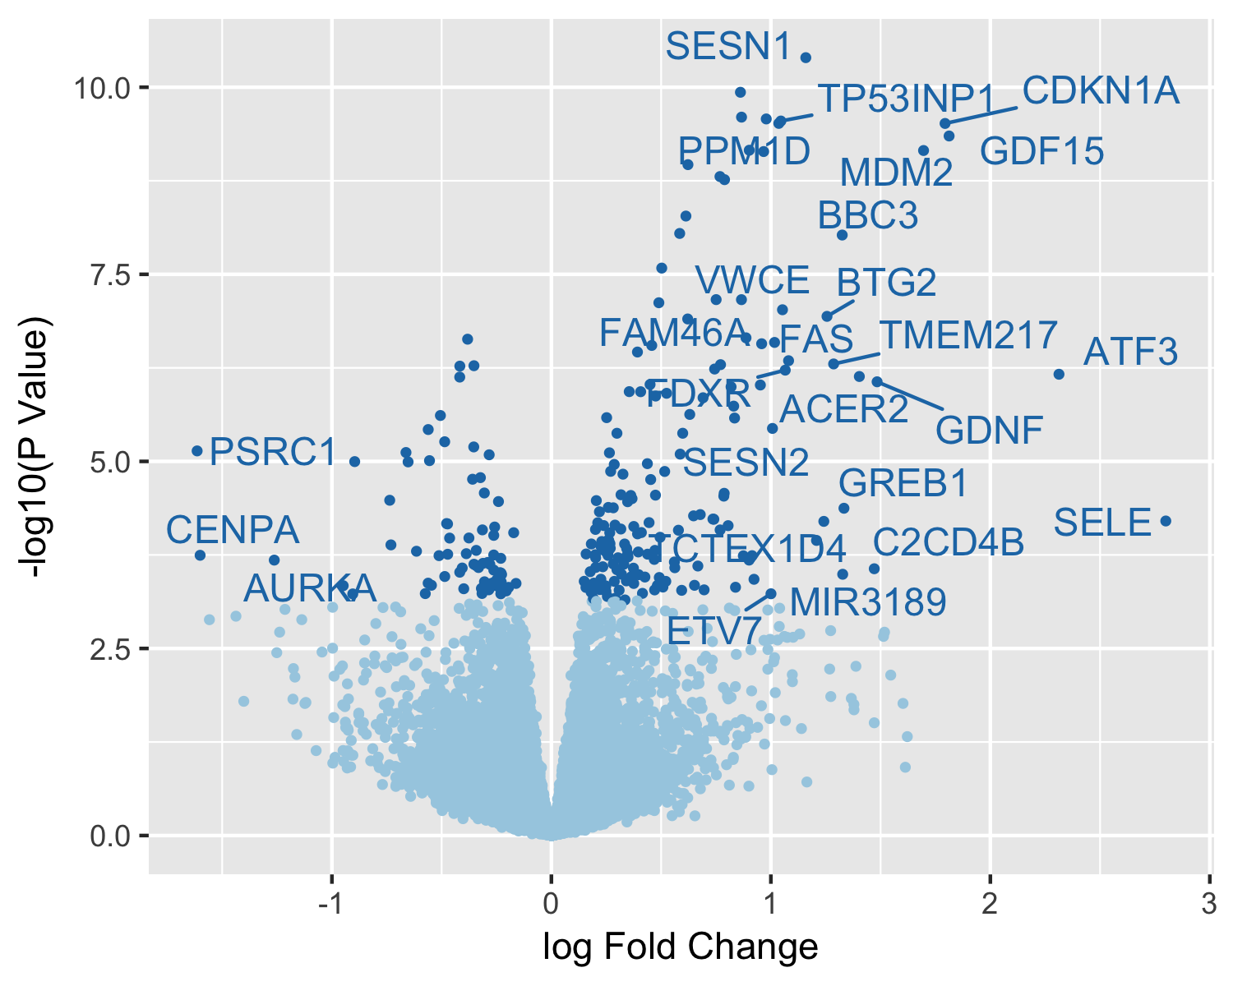

*Figure 2 Results summary from differential expression analysis. Volcano plot of differential gene expression between full radiotherapy treatment and controls. The x-axis represents the log2 fold change in gene expression and the y-axis represents the negative log10 P-value of a gene being differentially expressed. The dark blue points indicate a differentially expressed gene using an FDR of 5 per cent. Labelled genes are significantly differentially expressed genes with a log2 fold change greater than 1.*

As we are interested in the global consequences of radiotherapy across all cell-lines, we used limma to fit a linear model on the counts matrix and estimate coefficients for the effect between te three radiotherapy treatments. After modelling the heteroscedasticty in the counts matrix, we used empirical Bayes moderation to compute more precise estimates of gene-wise variability and remove the dependence between the variance and mean expression level. Differential expression between all contrasts (10Gy vs. control, 10Gy vs. 2Gyx5, and 2GYx5 vs 0Gy) were assessed using moderated t-statistics using a false-discovery rate (FDR) of 5 per cent. Using this criteria, there were 42 total differentially expressed genes in at least one contrast.

# Results

There were no differentially expressed genes between cell lines treated with fractionated doses of radiotherapy and the full radiotherapy. We note that only two cell lines were subject to fractionated doses, which is why we may not be seeing an effect.

On the other hand, we do find differential expression between the cell-lines treated with fractionated dosage of radiotherapy and the control treatment. There were 70 differentially expressed genes, with 6 genes down regulated in the control cell lines and 64 genes upregulated in the fractionated dosage group. Of these the differentially expressed gene with the largest fold change was CHAC1 a gene that is upregulated in the fractionated dosage cell lines and is associate with increased risk of breast cancer recurrence. However, since there are only two cell lines that received fractionated dosages, these differentially expressed genes could be the result of cell-line differences rather than treatment effects.

Between full radiotherapy and control treatments, there were 243 differentially expressed genes. Of these 73 genes were down regulated in the control cell lines, while 170 upregulated in when exposed to full-dosage radiotherapy treatments (figure 2). The two differentially expressed genes with the highest log fold changes were SELE (E-selectin) and ATF3 (activating transcription factor 3) . These genes were both upregulated in the treatment group, and the former SELE, is only expressed in LECs and plays a role in inflammation. Similarly, ATF3 is known to be activated when a tissue is under stress.

# Discussion

1. note: this is only for MEC need to check with Lipi the same protocol was used for each cell type. Lipi to write section.