/usr/local/lib/python3.10/dist-packages/sklearn/metrics/_classification.py:1344: UndefinedMetricWarning: Precision is ill-defined and being set to 0.0 in labels with no predicted samples. Use `zero_division` parameter to control this behavior.

_warn_prf(average, modifier, msg_start, len(result))

Epoch 1/25, Train Loss: 1.4396, Val Loss: 1.7681, Train Accuracy: 0.38, Val Accuracy: 0.21, Train Precision: 0.3533, Val Precision: 0.0771, Train Recall: 0.3762, Val Recall: 0.2100, Train F1 Score: 0.3480, Val F1 Score: 0.0884

Epoch 2/25, Train Loss: 1.2244, Val Loss: 1.2504, Train Accuracy: 0.50, Val Accuracy: 0.49, Train Precision: 0.4883, Val Precision: 0.6186, Train Recall: 0.5031, Val Recall: 0.4875, Train F1 Score: 0.4907, Val F1 Score: 0.4696

Epoch 3/25, Train Loss: 1.1508, Val Loss: 1.2113, Train Accuracy: 0.52, Val Accuracy: 0.52, Train Precision: 0.5110, Val Precision: 0.5440, Train Recall: 0.5194, Val Recall: 0.5200, Train F1 Score: 0.5043, Val F1 Score: 0.5002

Epoch 4/25, Train Loss: 1.0805, Val Loss: 1.0788, Train Accuracy: 0.56, Val Accuracy: 0.56, Train Precision: 0.5471, Val Precision: 0.6105, Train Recall: 0.5594, Val Recall: 0.5650, Train F1 Score: 0.5497, Val F1 Score: 0.5607

Epoch 5/25, Train Loss: 1.0485, Val Loss: 1.0797, Train Accuracy: 0.58, Val Accuracy: 0.55, Train Precision: 0.5763, Val Precision: 0.5810, Train Recall: 0.5825, Val Recall: 0.5500, Train F1 Score: 0.5755, Val F1 Score: 0.5389

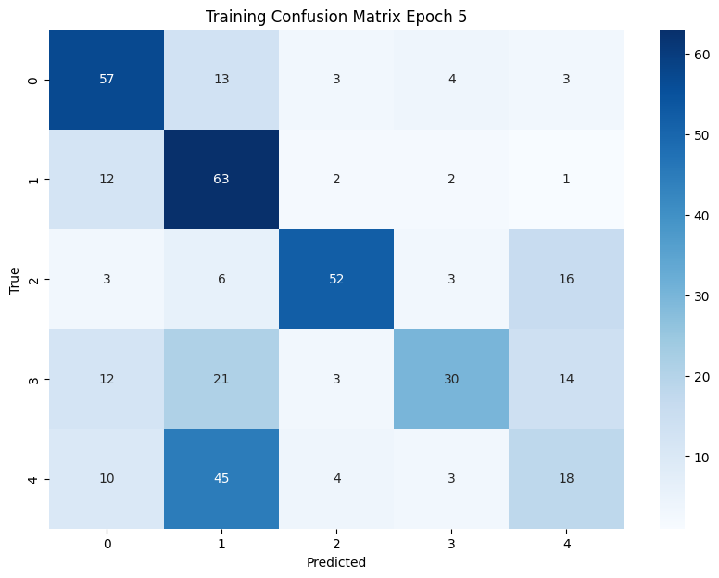

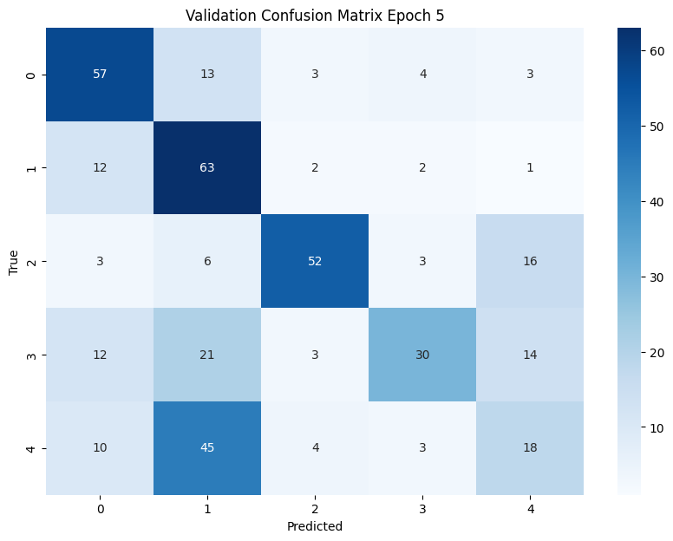

Epoch 6/25, Train Loss: 0.9729, Val Loss: 1.1854, Train Accuracy: 0.60, Val Accuracy: 0.55, Train Precision: 0.5950, Val Precision: 0.6384, Train Recall: 0.6000, Val Recall: 0.5525, Train F1 Score: 0.5954, Val F1 Score: 0.5238

Epoch 7/25, Train Loss: 0.9401, Val Loss: 1.0182, Train Accuracy: 0.64, Val Accuracy: 0.59, Train Precision: 0.6281, Val Precision: 0.6700, Train Recall: 0.6375, Val Recall: 0.5950, Train F1 Score: 0.6294, Val F1 Score: 0.5917

Epoch 8/25, Train Loss: 0.8573, Val Loss: 0.8442, Train Accuracy: 0.66, Val Accuracy: 0.69, Train Precision: 0.6629, Val Precision: 0.6940, Train Recall: 0.6637, Val Recall: 0.6950, Train F1 Score: 0.6623, Val F1 Score: 0.6929

Epoch 9/25, Train Loss: 0.8099, Val Loss: 0.8305, Train Accuracy: 0.70, Val Accuracy: 0.68, Train Precision: 0.6939, Val Precision: 0.6800, Train Recall: 0.6994, Val Recall: 0.6775, Train F1 Score: 0.6942, Val F1 Score: 0.6779

Epoch 10/25, Train Loss: 0.8052, Val Loss: 0.8251, Train Accuracy: 0.68, Val Accuracy: 0.69, Train Precision: 0.6815, Val Precision: 0.6932, Train Recall: 0.6837, Val Recall: 0.6900, Train F1 Score: 0.6815, Val F1 Score: 0.6881

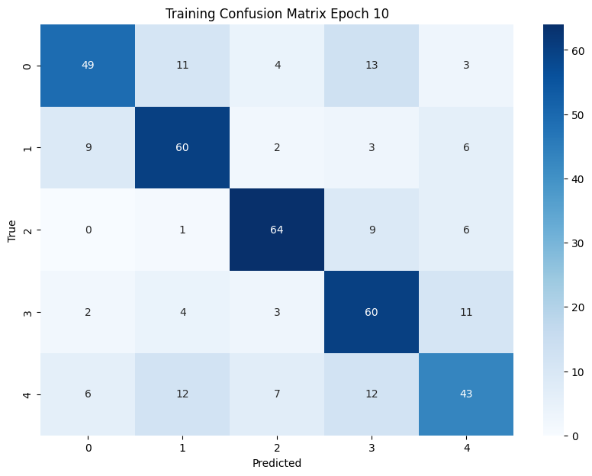

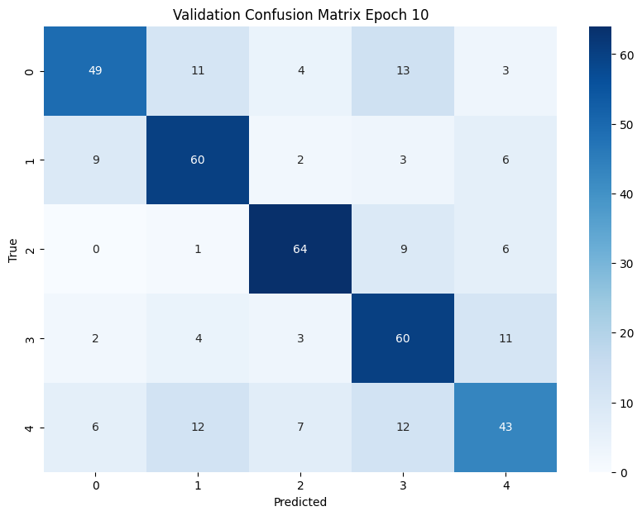

Epoch 11/25, Train Loss: 0.7815, Val Loss: 0.8319, Train Accuracy: 0.70, Val Accuracy: 0.69, Train Precision: 0.6924, Val Precision: 0.7133, Train Recall: 0.6963, Val Recall: 0.6950, Train F1 Score: 0.6918, Val F1 Score: 0.6966

Epoch 12/25, Train Loss: 0.7566, Val Loss: 0.7914, Train Accuracy: 0.72, Val Accuracy: 0.69, Train Precision: 0.7245, Val Precision: 0.6953, Train Recall: 0.7244, Val Recall: 0.6950, Train F1 Score: 0.7231, Val F1 Score: 0.6946

Epoch 13/25, Train Loss: 0.7547, Val Loss: 0.8071, Train Accuracy: 0.70, Val Accuracy: 0.68, Train Precision: 0.6988, Val Precision: 0.6871, Train Recall: 0.7031, Val Recall: 0.6825, Train F1 Score: 0.7000, Val F1 Score: 0.6802

Epoch 14/25, Train Loss: 0.7598, Val Loss: 0.8168, Train Accuracy: 0.73, Val Accuracy: 0.70, Train Precision: 0.7229, Val Precision: 0.7154, Train Recall: 0.7262, Val Recall: 0.7000, Train F1 Score: 0.7237, Val F1 Score: 0.7003

Epoch 15/25, Train Loss: 0.7181, Val Loss: 0.7961, Train Accuracy: 0.74, Val Accuracy: 0.69, Train Precision: 0.7366, Val Precision: 0.6987, Train Recall: 0.7356, Val Recall: 0.6900, Train F1 Score: 0.7358, Val F1 Score: 0.6911

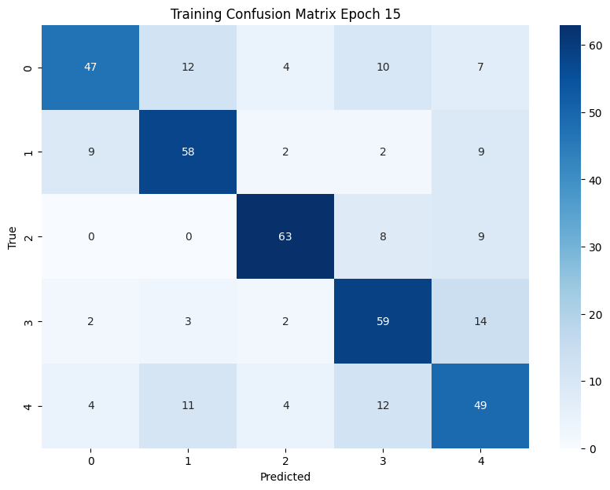

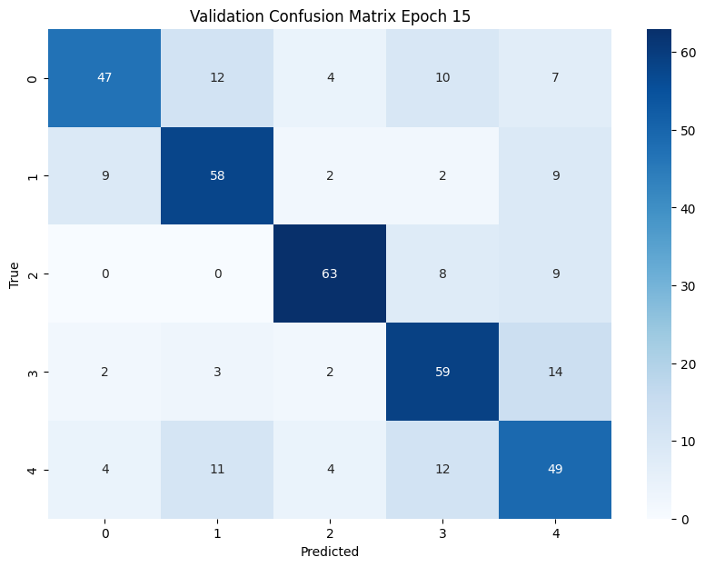

Epoch 16/25, Train Loss: 0.7282, Val Loss: 0.7874, Train Accuracy: 0.73, Val Accuracy: 0.69, Train Precision: 0.7266, Val Precision: 0.7029, Train Recall: 0.7288, Val Recall: 0.6950, Train F1 Score: 0.7272, Val F1 Score: 0.6966

Epoch 17/25, Train Loss: 0.7454, Val Loss: 0.7886, Train Accuracy: 0.72, Val Accuracy: 0.70, Train Precision: 0.7219, Val Precision: 0.7065, Train Recall: 0.7244, Val Recall: 0.6975, Train F1 Score: 0.7224, Val F1 Score: 0.6990

Epoch 18/25, Train Loss: 0.7409, Val Loss: 0.7886, Train Accuracy: 0.71, Val Accuracy: 0.71, Train Precision: 0.7081, Val Precision: 0.7155, Train Recall: 0.7106, Val Recall: 0.7075, Train F1 Score: 0.7085, Val F1 Score: 0.7086

Epoch 19/25, Train Loss: 0.7236, Val Loss: 0.7895, Train Accuracy: 0.73, Val Accuracy: 0.69, Train Precision: 0.7254, Val Precision: 0.6967, Train Recall: 0.7288, Val Recall: 0.6925, Train F1 Score: 0.7262, Val F1 Score: 0.6930

Epoch 20/25, Train Loss: 0.7350, Val Loss: 0.7925, Train Accuracy: 0.72, Val Accuracy: 0.69, Train Precision: 0.7146, Val Precision: 0.7019, Train Recall: 0.7188, Val Recall: 0.6950, Train F1 Score: 0.7160, Val F1 Score: 0.6954

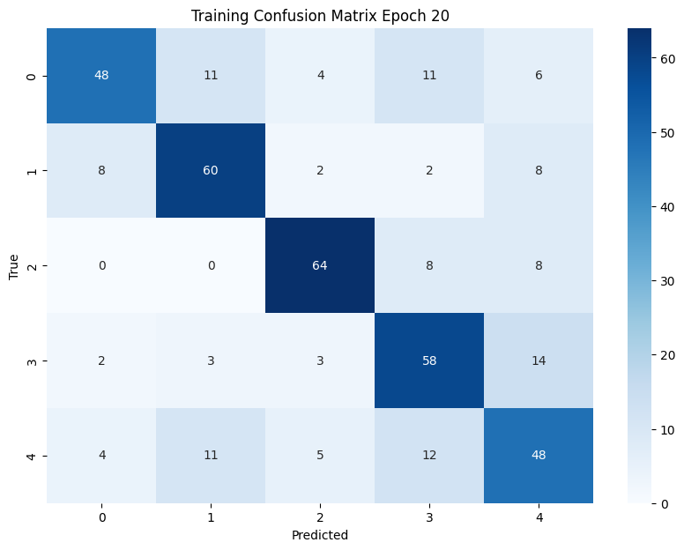

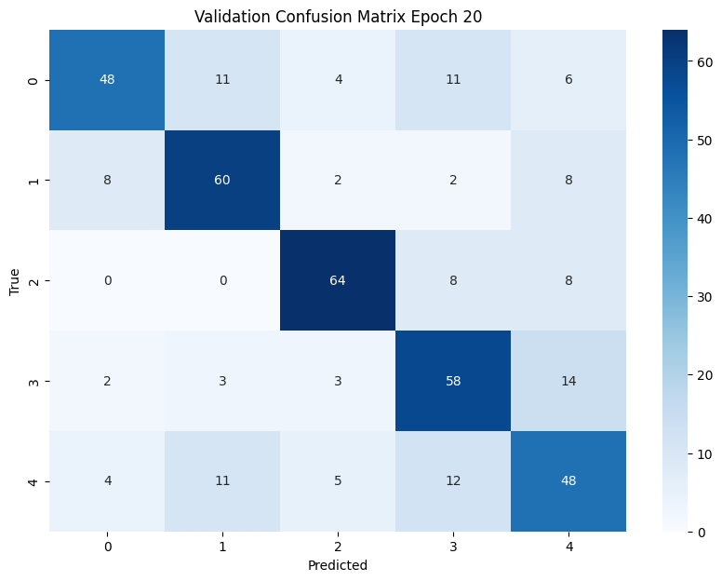

Epoch 21/25, Train Loss: 0.7119, Val Loss: 0.7912, Train Accuracy: 0.73, Val Accuracy: 0.71, Train Precision: 0.7314, Val Precision: 0.7157, Train Recall: 0.7350, Val Recall: 0.7075, Train F1 Score: 0.7319, Val F1 Score: 0.7084

Epoch 22/25, Train Loss: 0.7133, Val Loss: 0.7913, Train Accuracy: 0.73, Val Accuracy: 0.70, Train Precision: 0.7255, Val Precision: 0.7122, Train Recall: 0.7281, Val Recall: 0.7050, Train F1 Score: 0.7254, Val F1 Score: 0.7057

Epoch 23/25, Train Loss: 0.7197, Val Loss: 0.7910, Train Accuracy: 0.72, Val Accuracy: 0.70, Train Precision: 0.7190, Val Precision: 0.7071, Train Recall: 0.7219, Val Recall: 0.7000, Train F1 Score: 0.7196, Val F1 Score: 0.7008

Epoch 24/25, Train Loss: 0.7302, Val Loss: 0.7859, Train Accuracy: 0.72, Val Accuracy: 0.70, Train Precision: 0.7148, Val Precision: 0.7062, Train Recall: 0.7181, Val Recall: 0.7000, Train F1 Score: 0.7153, Val F1 Score: 0.7007

Epoch 25/25, Train Loss: 0.7212, Val Loss: 0.7909, Train Accuracy: 0.74, Val Accuracy: 0.71, Train Precision: 0.7369, Val Precision: 0.7175, Train Recall: 0.7419, Val Recall: 0.7100, Train F1 Score: 0.7374, Val F1 Score: 0.7107

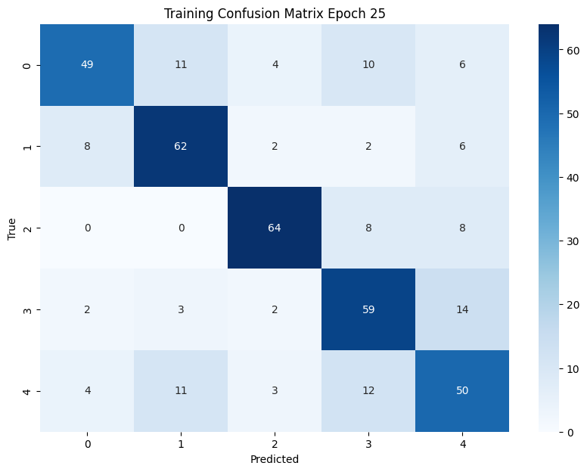

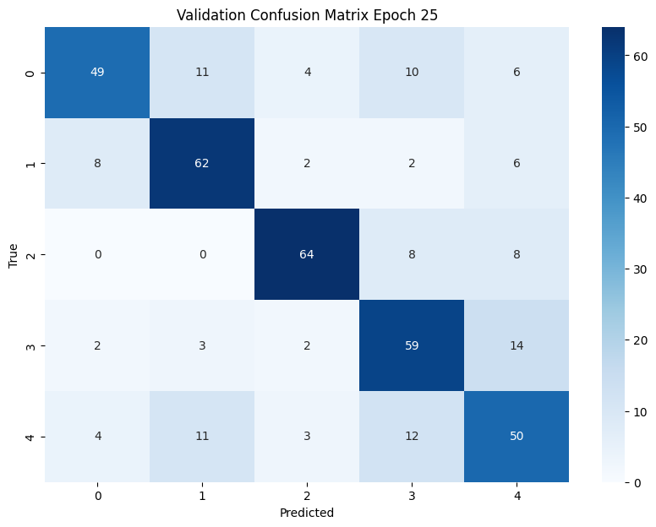

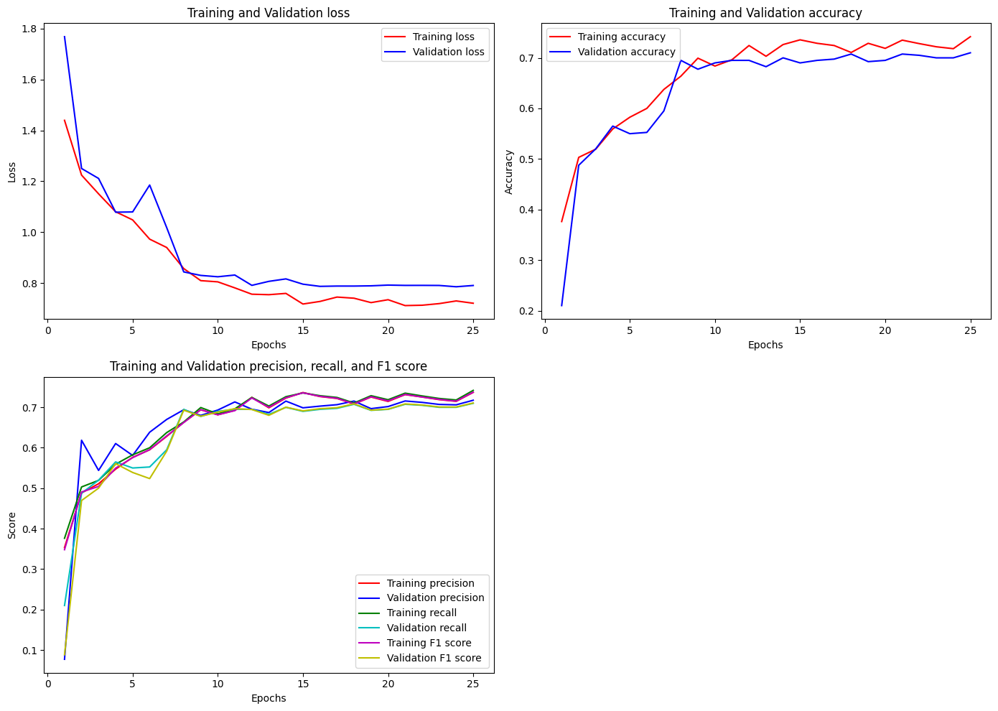

Test Accuracy: 0.68, Test Precision: 0.6819, Test Recall: 0.6820, Test F1 Score: 0.6809

Confusion Matrix:

[[75 7 3 10 5]

[ 3 82 0 2 13]

[ 4 4 76 10 6]

[11 7 3 58 21]

[12 11 8 19 50]]

