Fluid & Thermal Engg. Lab

MEC431

Name - *Sayan Mondal*

Roll No - *19EE8063*

Subject Code - *MEC431*

Semester - *3rd Sem Lab*

Date - *30th June 2021*

Phone Number - *9564870544*

# Experiment 1: Performance test of Diesel Engine using rope brake dynamometer under variable load condition

**OBJECTIVE:**

To carry out performance test of single cylinder diesel engine with the help of rope brake dynamometer and to draw the following graphs

* Brake Power Versus Specific Fuel Consumption
* Brake Power Versus Brake Thermal Efficiency

**SETUP:**

Preparation of the engine consists of checking of cooling water line, lubrication line and fuel reserve necessary for completion of the experiment. Engine used is a single cylinder, water cooled, vertically mounted with rope brake dynamometer and is of the following specification

* Rated Power-6HP (4.5 KW) at 600RPM
* Diameter of piston-114 mm
* Length of stroke: 140 mm
* Diameter of rope(d)=16mm
* Diameter of brake wheel(D) = 60 cm
* Mean radius of wheel and rope= (D+d)/2=308 mm
* Calorific value of fuel – 41800 KJ/kg
* Weight of 35cc of fuel- 28.8 gm

**THEORY:**

**BRAKE POWER:**Brake power of an engine is the useful power which is obtained at the output shaft. It is measured by a dynamometer using a brake attached to the engine’s drive shift.

Brake Power = [Indicated Power]- [Lasses] of Engine

Mathematically,

**BRAKE THERMAL EFFICIENCY:** Ratio of the heat equivalent of brake power output to the heat supplied to the engine.

)=

**BRAKE SPECIFIC FUEL CONSUMPTION**: It literally means the amount of fuel which is consumed by engine in one hour to produce 1 kw brake power.

The unit of BSFC is gram per joule(g/J)

**SCHEMATIC DIAGRAM:**

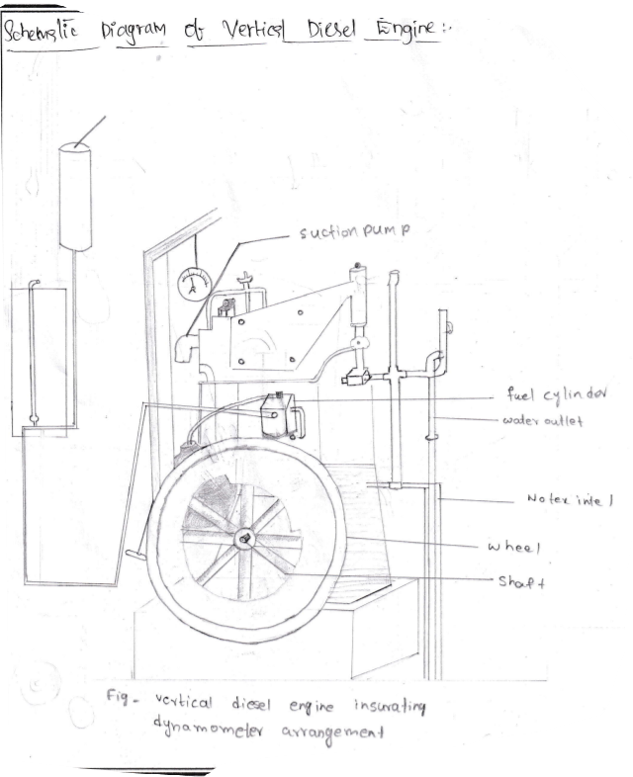

**CALCULATIONS:**

For run number 2 -

**OBSERVATIONS**

|  |  |  |  |  |
| --- | --- | --- | --- | --- |
| Roll No: | 1 | 2 | 3 | 4 |
| Break Load ( | 0 | 4.6 | 9.4 | 14.7 |
| RPM | 600 | 600 | 600 | 600 |
| Spring Balance Reading(s) | 0 | 0.7 | 1.3 | 2.4 |
| Time for 35cc fuel consumption | 389 | 255 | 197 | 155 |
| Net Load | 0 | 3.9 | 8.1 | 12.3 |

|  |  |  |  |  |  |  |  |
| --- | --- | --- | --- | --- | --- | --- | --- |
| Sl No | Break Load ( | Spring Balance Load(s) | Time for 35cc fuel consumption(sec) | Brake Power (HP) | Fuel Power (HP) | Break Thermal Efficiency | Specific Consumption(kg/kgf) |
| 1 | 0.0 | 0.0 | 389 | 0 | 4.15 | 0 | ∞ |
| 2 | 4.6 | 0.7 | 255 | 1.01 | 6.33 | 15.96 | 0.5396 |
| 3 | 9.4 | 1.3 | 197 | 2.09 | 8.19 | 25.52 | 0.3376 |
| 4 | 14.7 | 2.4 | 155 | 3.17 | 10.41 | 30.45 | 0.2828 |

**PLOTS:**

* Brake Power Versus Specific Fuel Consumption

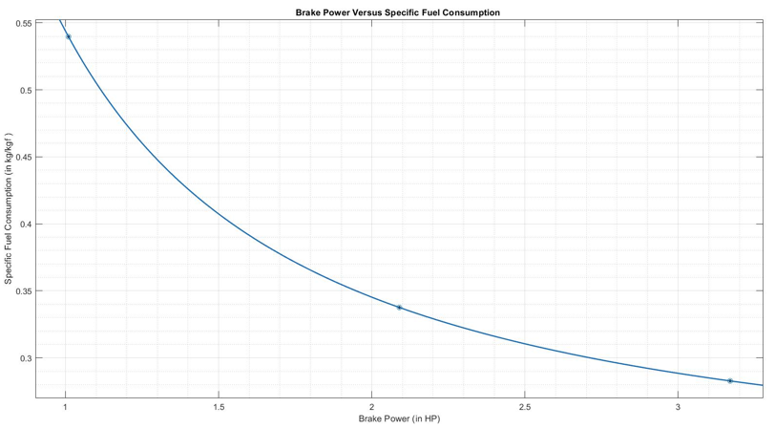

* Brake Power Versus Brake Thermal Efficiency

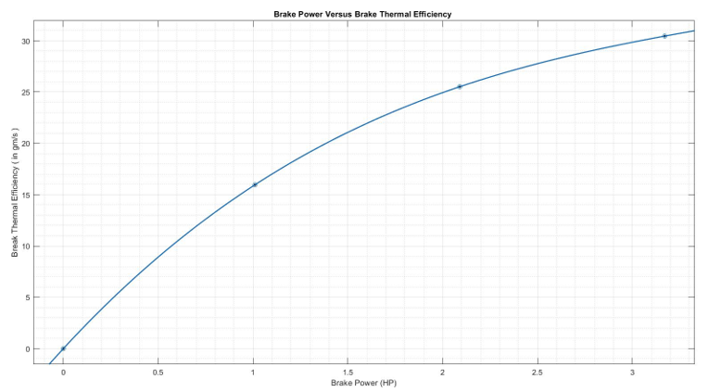

**CONCLUSION:**

In this experiment we studied about the performance of the diesel engine using rope brake dynamometer under variable load condition. In the experiment when we plot a graph between the brake power and brake thermal efficiency then with increase in the break power brake thermal efficiency is also increased slowly and when we plot brake power versus specific fuel consumption then with increase in break power specific fuel consumption decreases.

# Experiment- 2: To study the four Stroke Petrol engine.

**OBJECTIVE:** To study the four Stroke Petrol engine.

**THEORY:**

HEAT ENGINE: An engine that drives heat energy from the combustion of fuel or any other source and converts energy into mechanical form.

CYLINDER BLOCK: It is the main supporting structure of various components. It is cast as a single unit.

CYLINDER: It is the space in which the piston persecutes all the process of working fluid occurs in it and it is supported by cylinder block.

PISTON: It is the cylindrical component field into the cylinder creating the moving boundary of the combustion system. It fits perfectly into the cylinder providing the gas-tight space with the rings and lubricant.

INLET MANIFOLD: The pipe which connects the inlet to the inlet valve of the engine and through which air-fuel mixture is drawn into the cylinder is called the inlet manifold.

EXHAUST MANIFOLD: The pipe which connects the exhaust system to the exhaust valve of the engine and through which the product of the engine escape into the atmosphere is called the exhaust manifold.

INLET AND EXHAUST VALVE: Valves are commonly mushroom-shaped. these are provided either of the cylinder head on the side of the cylinder for resolution of charge coming into the cylinder(inlet valve) and for escaping the product of combustion( exhaust valve) from the cylinder.

SPARK PLUG: It is a component to mistle the combustion process in Spark-ignition engine And is located on the cylinder head.

CRANK SHAFT: It converts the reciprocating motion of the piston into useful rotary motion of the dp shaft. It is increased in the crankcase.

PISTON - PIN: Piston ring fitted into the shafts around the piston provider types sale between the Piston and the cylinder well and has prevented leakage of combustion gas.

FLY - WHEEL: The net torque imparted to the crankshaft during one complete cycle of operation of the engine causing a change in the angular velocity of the shaft in order to achieve uniform torque on extra mass in the form of a wheel is stretched to the output shaft and this wheel is called the flywheel.

**OPERATION OF A FOUR STROKE SI ENGINE:**

The cycle of operation for an ideal four-stroke Si engine consists of the following four strokes:

* SUCTION
* COMPRESSION
* EXPANSION
* EXHAUST

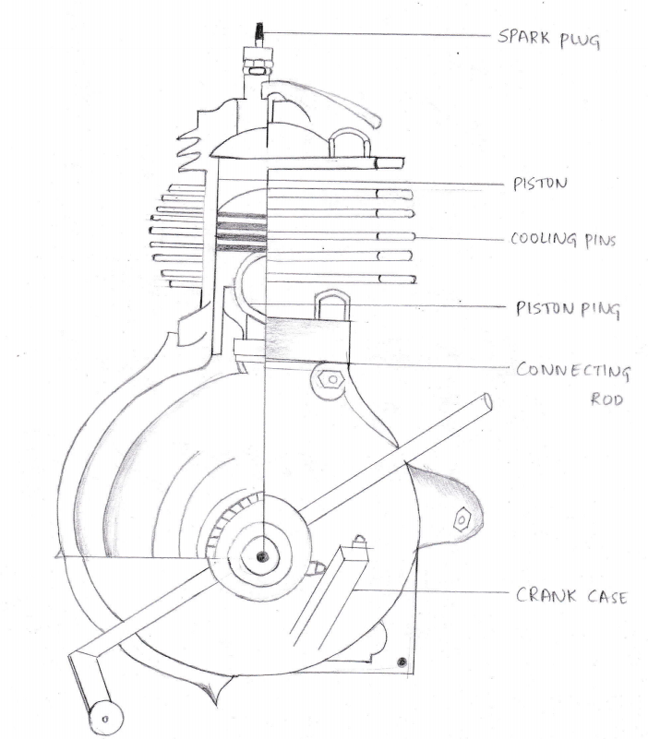

SUCTION: Suction starts when the piston is TDC and about to move downwards. The inlet valve is open at the time an exhaust valve is closed. Due to the suction created by the motion of the piston the charge consisting of fuel-air - the mixture is drawn into the cylinder. When the Piston reaches BDC that suction stroke ends and the inlet valve closes.

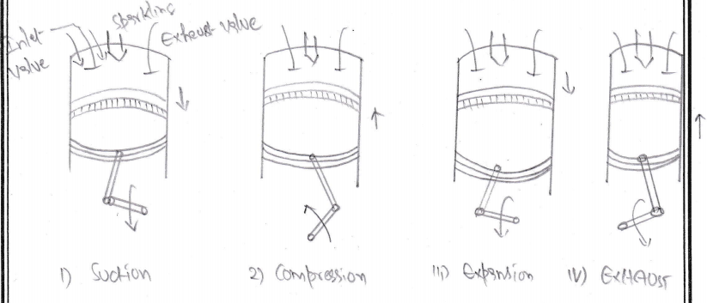

COMPRESSED STROKE: The charge taken into the cylinder during the suction stroke is compressed to the return stroke of the piston during the stroke both inlet and exhaust valve are in the closed position the mixture is compressed into the clearance volume at the end of the compression stroke the mixture is ignited with the help of spark plug located on the cylinder head. During the process, the chemical energy e of the fuel is converted into heat energy and produces a temperature rise of 2000 Celsius

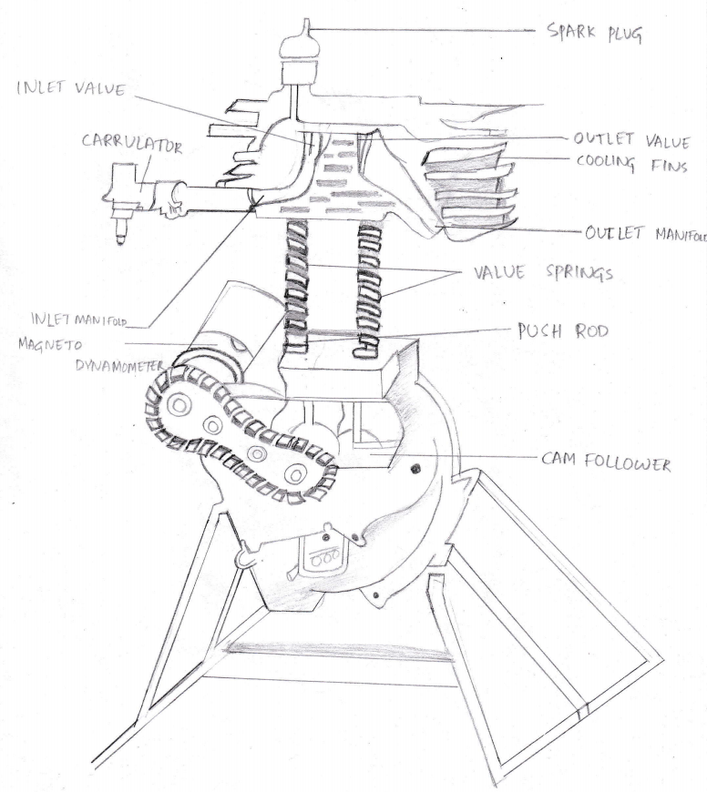

EXPANSION STROKE: The high pressure of the burnt gases forces the piston towards BDC both valves are in the closed position. In the case of a four-stroke engine only during the stroke power is produced both pressure and temperature decrease during the process.

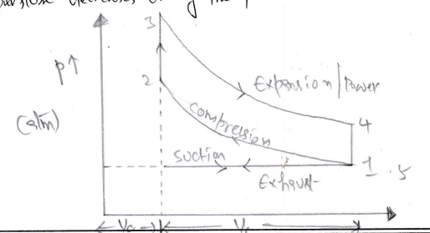

EXHAUST STROKE: At the end of the expansion stroke the exhaust valve opens and the inlet valve prevents closed the pressure falls to atmospheric level as the world gases escape the Piston starts moving towards the BDC and to TDC and sweeps the burnt gases out from the cylinder at most atmospheric pressure the exhaust valve closes when the Piston reaches at TDC at the end of the exhaust stroke and some residual gases kept in the clearance volumes remain in the cylinder.

# Experiment-3: Model Study of Lancashire Boiler

Objective

Model study of Lancashire Boiler

Theory

1. **Definition:** A boiler is a closed vessel that produces steam at high pressure and high temperature.
2. **Size of boiler:** Length 8-10 m, Diameter 2- 4 m, Plate thickness 6-12 mm
3. **Types of boiler:**
   1. Horizontal or Vertical type
   2. Stationery or Mobile boiler
   3. Coal or Oil fired boiler
   4. Fire tube or Water tube boiler
4. **Manting and accessories:**
   1. Mantings - They are safety devices in a boiler.
   2. Accessories - They are used for increasing the efficiency.
5. **Deadweight safety valve:** It is located at the top of the boiler. Its weight is designed such that it can give an amount of pressure. If the pressure of the steam In the boiler exceeds the working pressure then the safety valve allows off the excess quantity of the steam to the atmosphere. But if the pressure of the steam is less than the working pressure then the valve gets closed.
6. **High-pressure low water safety valve:** It acts as an auxiliary safety valve. Its weight is designed to give more amount of pressure than the deadweight safety valve. Thus if the deadweight safety valve does not work for some reason then it is used.

On the other hand, when the water level falls below the normal level it also gets opened and there is an alarm that rings to alert everyone.

1. **Steam stop valve:** It is located on the top of the boiler. It regulates the steam supply to use.
2. **Anti-priming device:** It is used to separate dry stream and moisten steam because dry steam should be supplied from the boiler otherwise moisten steam can damage the turbine.
3. **Man-hole cover:** It is generally closed when the boiler works. But for maintenance purposes, the cover should be taken out from the hole.
4. **Steam pressure gauge:** A pressure gauge is fitted in front of a boiler in such a position that the operator can conveniently read it. It reads the pressure of the steam.
5. **Water level indicator:** It indicates the level of water in the boiler.
6. **Feedwater check valve:** The feedwater check valve is fitted to the boiler slightly below the working level of the boiler. By this valve, we feed water to the boiler.

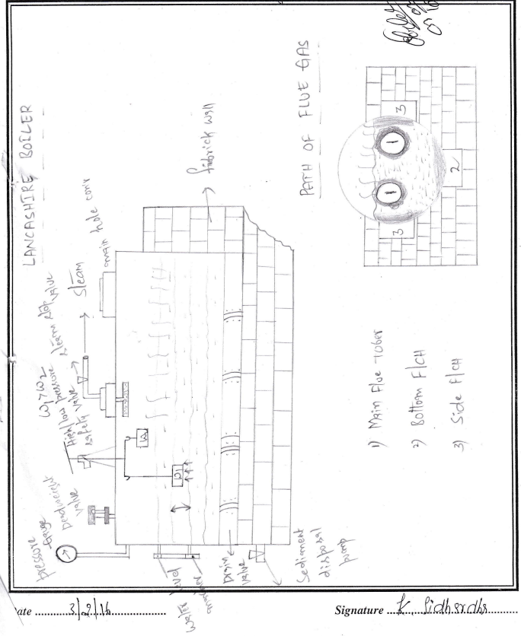

1. **Fuel charging doors:** By these doors we produce heat. At the upper doors, we give coal and at the lower doors, we give fire. The upper doors get closed after giving coal. But the lower doors remain open.
2. **Drain valve:** After 3-4 hours of working of the boiler, this valve gets opened and the wastages come out from the boiler.
3. **Boiler drum:** Two flue tubes are kept in this boiler drum.
4. **Fire brick wall:** It gives rigidity to the system. It supports the total system.
5. **Path of the flue gas:** flue gas is produced by the burning of coal. the gas has three parts - (1) Main Flue, (2) Bottom Flue, and (3) Side Flue.

The gas passes through the internal tubes and then passes downwards. The flue gas passes through the bottom to the left side of the boiler from the right side. Then it splits into paths and flows through the sides and finally gets discharged to the atmosphere.

The purpose of using those paths is (i) to maximize heat and (ii) to get steam as quickly as we can. We can get steam more quickly by giving more heat.

# Experiment 4: Calibration of Vacuum Gauge

WORKING PRINCIPLE:

A bourdon gauge works on the principle of the following

* BERNOULLI’S THEOREM: The theorem states that for an inviscid flow of a non conducting fluid, an increase in the speed of fluid occurs simultaneously with a decrease in the pressure or a decrease in the fluid potential energy.

)

* CONTINUITY EQUATION: This equation describes the transport of some quantity. It is particularly simple and powerful when applied to a conserved quantity but it can be generalized to apply to any extensive property.

DESCRIPTION:

As the fluid pressure enters bourdon tube, it tries to be reformed and cause of a free tip available, this action causes the trip to travel in free space and tube unwinds, the simultaneous actions of sending and tension due to internal pressure make a non-linear movement of free tip. This travel is amplified for the measurement of internal pressure.

A lot of compound stresses originate in the tube as soon as the pressure is applied. This makes the travel of tip to be non-linear in nature. If the tip travel is small, the stresses can be considered to produce a linear motion that is parallel to the axis of link. Small linear tip movement is matched with rotational pointer movement. This is multiplication which can be adjusted by adjusting the length of the lever. But the same amount of tip travel a shorter level gives larger rotation.

Like all elastic elements a bourdon tube also has some hysteresis in a given pressure cycle. By proper choice of material and its heat treatment this may be kept within 0.1% and 0.5% of the maximum pressure cycle. Sensitivity of tip movement of a bourdon tube a teammate without restraint can be as high as 0.01% of full range pressure reducing to 0.1% with restraint as central point.

PRECAUTION:

1. Open the nozzle with full safety otherwise there might be a possibility that sudden opening may cause water to mix with mercury.
2. While observing the mercury level in the U-tube manometer, due clear must be taken to reduce any type of error.

Calibration of Vacuum Gauge

|  |  |  |  |
| --- | --- | --- | --- |
| MAKE OF GAUGE | BOURDON | DATE OF EXPERIMENT | 30/06/2021 |
| RANGE | 0-76 cm of Hg | PAPER CODE | MES 481 |
| BAROMETER READING | 76 cm of Hg | ROLL NUMBER |  |

OBSERVATION

|  |  |  |  |  |  |  |  |
| --- | --- | --- | --- | --- | --- | --- | --- |
| SL NO | MANOMETER | | | | BOURDON GAUGE | | % ERROR |
| LEFT (cm of Hg) | RIGHT (cm of Hg) | DIFFERENCE (cm of Hg) | ABSOLUTE (cm of Hg) | READING (cm of Hg) | ABSOLUTE (cm of Hg) |
| 1 | 72.16 | 81 | 8.4 | 67.6 | 10 | 66 | 2.366 |
| 2 | 71 | 82 | 11 | 65 | 12 | 64 | 1.53 |
| 3 | 70 | 82.6 | 12.6 | 63.4 | 14 | 62 | 2.21 |
| 4 | 69 | 83.8 | 14.8 | 61.2 | 16 | 60 | 1.96 |
| 5 | 68 | 84.4 | 16.4 | 59.6 | 18 | 58 | 2.68 |
| 6 | 66 | 85.3 | 19.3 | 56.7 | 20 | 56 | 1.23 |
| 7 | 65.3 | 86.6 | 21.3 | 54.7 | 22 | 54 | 1.28 |

CALCULATION

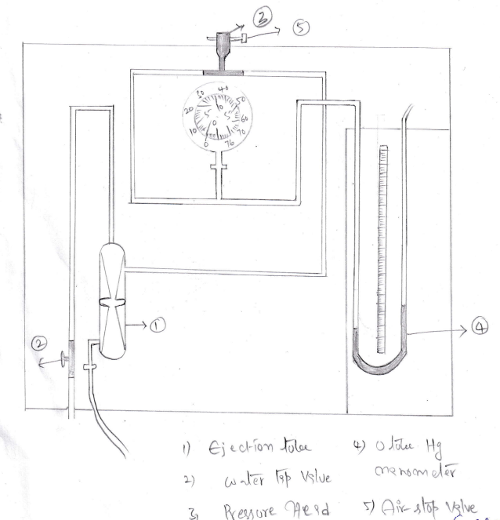

**PLOTS:**

