
Syrian Private University
Faculty of Artificial Intelligence
Engineering

Department of Information Security Systems Engineering

Enhancing Intrusion Detection Systems using
Support Vector Machine, Random Forest Classifiers,
and Dempster-Shafer Theory Fusion

Submitted by:
Sultan Al-Ali
Wadah Hasseyeh

Under the Supervision of:
Dr. Wassim Al-Janidi
Eng. Abdulrahman Arar

2026/2027

Abstract

Table of contents
Introduction 8
1.1 Introduction 8
1.2 Problem Statement and Motivation 9
1.3 Project Objectives 9
1.4 Scope and Limitations 10
1.5 Previous Studies and Related Work 10
1.6 Research Gap and Contribution 12
Chapter 1: Theoretical Framework and Literature Review 13
2.1 Overview of Intrusion Detection Systems 14
2.2 Support Vector Machines (SVM) 15
2.3 Random Forest Classifier 17
2.4 Dempster-Shafer Theory for Evidence Fusion 17
2.5 CSE-CIC-IDS2018 Dataset 19
2.6 Performance Metrics 20
2.7 Chapter Summary 21

List of Figures
Figure 1: Network Intrusion Detection System Architecture 14
Figure 2: Support Vector Machine Decision Boundary in 2D Feature Space 16
Figure 3: Random Forest Ensemble Method with Multiple Decision Trees 17
Figure 4: Dempster-Shafer Belief and Plausibility Functions 18
Figure 5: CSE-CIC-IDS2018 Dataset Network Topology 19
Figure 6: Confusion Matrix for Binary Classification 20

List of Tables
Table 1: Literature Review - Related Research Papers 11
Table 2: Comparison of Signature-Based vs. Anomaly-Based IDS 15
Table 3: SVM Kernel Functions and Mathematical Formulations 16
Table 4: CSE-CIC-IDS2018 Dataset Composition and Statistics 20

List of Abbreviations

Abbreviation | Definition
AI | Artificial Intelligence
BBA | Basic Belief Assignment
CSE | Communications Security Establishment
DDoS | Distributed Denial of Service
DST | Dempster-Shafer Theory
F1 | F1-Score (Harmonic Mean)
FN | False Negative
FP | False Positive
IDS | Intrusion Detection System
ML | Machine Learning
PCA | Principal Component Analysis
RF | Random Forest
RBF | Radial Basis Function
SVM | Support Vector Machine
TN | True Negative
TP | True Positive

List of Symbols

Symbol | Definition
X, y | Feature matrix and target labels
n | Number of samples/training instances
d | Number of features/dimensions
w | Weight vector in SVM
b | Bias term in linear classifier
C | Regularization parameter (SVM)
γ | Gamma parameter (RBF kernel)
ε | Slack variable (tolerance)
m(A) | Mass function assigned to set A (DST)
Bel(A) | Belief function for set A
Pl(A) | Plausibility function for set A
θ | Frame of discernment (DST)
⊕ | Dempster combination rule
P(A) | Probability of event A
Acc | Classification accuracy

Introduction

1.1 Introduction
Cybersecurity has become one of the most critical concerns in modern information technology systems. The exponential growth in network traffic, combined with increasingly sophisticated cyber threats, has made the development of effective security mechanisms essential for protecting sensitive data and maintaining the integrity of information systems. Among the various security technologies, Intrusion Detection Systems (IDS) have emerged as a fundamental component of network defense infrastructure.
Traditional perimeter defenses such as firewalls and access control lists operate mainly on static rules: they allow or block traffic according to addresses, ports and protocols. While these controls remain necessary, they cannot inspect the behavior of traffic that is permitted to pass, and they offer little protection once an attacker uses a legitimate channel or an authorized account. An IDS complements these controls by continuously monitoring network or host activity and raising alerts when that activity matches a known attack pattern or deviates significantly from normal behavior.
Over the last decade, Machine Learning (ML) has become a central tool for building IDS solutions. Instead of relying solely on manually written signatures, ML-based detectors learn the statistical characteristics of benign and malicious traffic from labeled data, which allows them to generalize to attack variants that were not explicitly described by an analyst. Classifiers such as Support Vector Machines (SVM) and Random Forest (RF) have repeatedly shown strong performance on intrusion detection benchmarks, each with its own strengths: SVM is effective in high-dimensional feature spaces, while RF is robust to noise and provides stable predictions through ensemble voting.
However, no single classifier is correct in every situation. Different models make different errors, and each produces its decision with a certain degree of uncertainty. This project therefore investigates how the outputs of SVM and Random Forest can be combined using Dempster-Shafer Theory (DST), a mathematical framework for reasoning under uncertainty that allows evidence from several sources to be fused into a single, more reliable decision. The goal is an IDS that is more accurate and produces fewer false alarms than either classifier alone.

1.2 Problem Statement and Motivation
Despite significant progress in the field, contemporary Intrusion Detection Systems still face several critical challenges that limit their effectiveness in real environments:
- High false positive rates: anomaly-based and ML-based detectors frequently classify legitimate traffic as malicious. In a production network that processes millions of connections per day, even a small false positive rate generates thousands of alerts, overwhelming security analysts and causing real attacks to be overlooked (a phenomenon known as alert fatigue).
- Limited detection of novel attacks: signature-based systems can only recognize attacks whose patterns are already stored in their database, which leaves the network exposed to zero-day exploits and modified versions of known attacks.
- Classifier uncertainty: a single ML model outputs a label or a probability, but it does not explicitly express how confident it is or when its evidence is insufficient. Treating every prediction as equally reliable leads to wrong decisions in borderline cases.
- Lack of proper evidence fusion: when several detectors are used together, their outputs are usually combined with simple rules such as majority voting or averaging. These rules ignore the reliability of each detector and cannot represent conflict or ignorance between sources.
These limitations motivate the need for a more sophisticated approach. Combining complementary classifiers through a formal evidence-fusion framework offers a way to exploit the strengths of each model, to quantify uncertainty explicitly, and to reduce both missed attacks and false alarms. This is the main motivation behind the framework proposed in this project.

1.3 Project Objectives
The primary objectives of this project are:
- Develop an enhanced Intrusion Detection System that integrates Support Vector Machines and Random Forest classifiers
- Implement a Dempster-Shafer Theory-based fusion mechanism to combine predictions from multiple classifiers
- Evaluate the proposed framework using the CSE-CIC-IDS2018 dataset
- Demonstrate that DST fusion improves classification metrics compared to individual classifiers
Achieving these objectives requires a complete experimental pipeline: preparing and cleaning the dataset, training and tuning each classifier, converting classifier outputs into belief assignments suitable for DST, applying the Dempster combination rule, and finally comparing the fused results with the individual models using standard evaluation metrics. Each of these stages is described in detail in the following chapters.

1.4 Scope and Limitations
Scope: This project focuses on binary classification of network traffic, where each network flow is labeled either as benign (normal) or as an attack, regardless of the specific attack type. The work uses the CSE-CIC-IDS2018 dataset as its single source of data, and it is limited to two base classifiers, Support Vector Machine and Random Forest, whose outputs are fused using Dempster-Shafer Theory. The evaluation is performed offline on recorded traffic, using Accuracy, Precision, Recall and F1-Score as the main metrics.
Limitations: Several aspects are intentionally left outside the scope of this project and are considered directions for future work:
- Multi-class categorization: the system detects whether a flow is malicious but does not identify the exact attack category (for example DoS, brute force or botnet).
- Real-time deployment: the framework is evaluated on a stored dataset and is not integrated into a live network sensor, so issues such as packet capture speed and streaming processing are not addressed.
- Efficiency optimization: training time, memory usage and prediction latency are reported where relevant but are not the main optimization target.
- Dataset dependence: since only one dataset is used, the results may not generalize directly to networks with very different traffic characteristics.

1.5 Previous Studies and Related Work
Extensive research has explored machine learning approaches for intrusion detection. This section summarizes four highly relevant research papers that directly informed this project. Together they cover the three building blocks of the proposed framework: the Random Forest classifier, the SVM classifier, and Dempster-Shafer evidence fusion.
Anjani et al. (2026) evaluated the performance of Decision Tree and Random Forest algorithms for intrusion detection. Their work is relevant because it supports the choice of Random Forest as one of the base classifiers and highlights the advantages of ensemble methods over a single decision tree.
Galdames et al. (2025) proposed a Dempster-Shafer fusion-based approach for malware detection. Although their application domain is malware rather than network intrusion, the study demonstrates how the outputs of several detectors can be converted into belief assignments and combined with DST, which is the same fusion principle adopted in this project.
Almaiah, Almomani et al. (2022) investigated the performance of different SVM kernels for intrusion detection. Their study guides the selection of the kernel function and its parameters for the SVM classifier used in this work.
Sahu and Davis (2022) applied inter-domain fusion based on Dempster-Shafer Theory to enhance intrusion detection in power systems. Their work shows that DST fusion of heterogeneous evidence sources can improve detection in a critical infrastructure setting, confirming the suitability of DST for the IDS domain.
Table 1 summarizes these studies, their publication venues and their relevance to the present project.
Table 1: Literature Review - Related Research Papers
Paper Title | Research Paper | Problem Addressed | Solution Provided
  Benefit to Our Project
Performance Evaluation of Decision Tree and Random Forest Algorithms for IDS | Anjani et al. (2026) | Which ensemble (RF vs DT) is best for IDS? | Experimental evaluation showing RF superior | Empirical validation for RF selection; benchmarks
A Dempster–Shafer Fusion-Based Approach for Malware Detection | Galdames et al. (2025) | How to combine evidence from multiple sources? | DST framework: mass functions, belief, Dempster rule | Mathematical foundation for SVM+RF fusion
Performance Investigation of SVM Kernels for IDS | Almaiah et al. (2022) | Which SVM kernel best for IDS? | Comparative study proving RBF optimal | Validation for RBF kernel selection; tuning guidance
Inter-Domain Fusion for Enhanced IDS in Power Systems | Sahu & Davis (2022) | How to implement DST practically? | Real-world implementation with conflict resolution | Implementation strategies for fusion system

1.6 Research Gap and Contribution
The reviewed literature shows that Random Forest and SVM have each been studied extensively for intrusion detection, and that Dempster-Shafer Theory has been applied successfully to fuse evidence in related security domains such as malware detection and power system protection. However, the integration of SVM and Random Forest through DST-based fusion, evaluated on a modern and realistic dataset such as CSE-CIC-IDS2018, remains underexplored.
The main contributions of this project are therefore:
- A complete IDS framework that combines two complementary classifiers, SVM and Random Forest, instead of relying on a single model.
- A method for transforming the output of each classifier into a Basic Belief Assignment (BBA) that explicitly represents both the evidence for each class and the remaining uncertainty.
- The application of the Dempster combination rule to fuse these belief assignments into a final decision.
- A systematic comparison between the individual classifiers and the fused system on CSE-CIC-IDS2018, showing whether and how much DST fusion improves detection performance.

Chapter 1: Theoretical Framework and Literature Review

2.1 Overview of Intrusion Detection Systems
An Intrusion Detection System (IDS) is a network security solution designed to monitor and analyze network traffic or system activity in order to detect unauthorized access attempts and malicious activities. When suspicious behavior is identified, the IDS generates an alert so that administrators or automated response mechanisms can take action. Unlike a firewall, an IDS does not usually block traffic by itself; its primary role is detection and reporting, while an Intrusion Prevention System (IPS) extends this role by actively stopping the detected attack.
According to where they are deployed, IDS solutions are divided into two main types. A Network-based IDS (NIDS) is placed at strategic points in the network, such as behind the firewall or at the core switch, and inspects the traffic passing between hosts. A Host-based IDS (HIDS) runs on an individual machine and monitors local events such as system logs, file changes and running processes. This project focuses on network-based detection, since the CSE-CIC-IDS2018 dataset describes network flows.
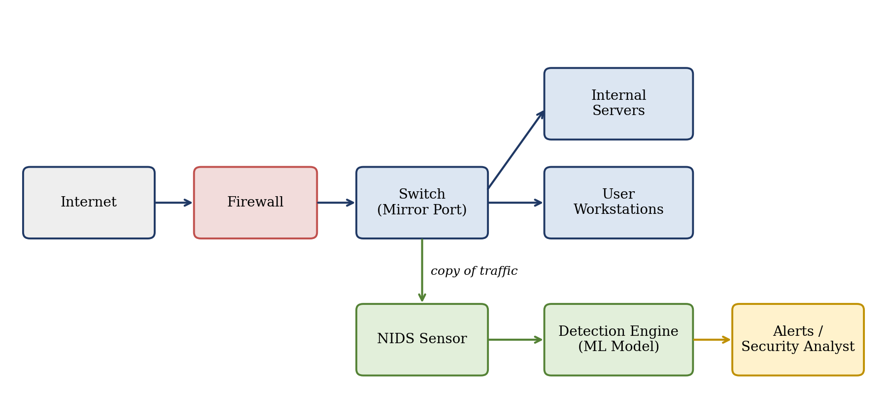
Figure 1
Figure 1: Network Intrusion Detection System Architecture
According to the detection method, IDS solutions follow one of three main approaches, compared in Table 2. Signature-based detection compares observed activity with a database of known attack patterns; it is very accurate for known threats but cannot detect new ones. Anomaly-based detection first builds a model of normal behavior and flags significant deviations as potential attacks; it can discover unknown attacks but tends to produce more false alarms. Machine learning-based detection learns the boundary between normal and malicious behavior directly from labeled data, offering a balance between adaptability and accuracy, provided that a sufficiently large and representative dataset is available.
Table 2: Comparison of Signature-Based vs. Anomaly-Based IDS
Detection Type | Methodology | Advantages | Disadvantages
Signature-Based | Compares against known patterns | High accuracy | Cannot detect zero-day attacks
Anomaly-Based | Establishes baseline and flags deviations | Detects unknown attacks | High false positives
Machine Learning | Learns from training data | Adaptability | Requires large datasets

2.2 Support Vector Machines (SVM)
The Support Vector Machine is a supervised learning algorithm used for classification and regression. For binary classification, SVM searches for the optimal hyperplane that separates the two classes with the maximum possible margin, where the margin is the distance between the hyperplane and the closest training samples of each class. These closest samples are called support vectors, since they alone determine the position of the decision boundary.
For a linearly separable training set {(xᵢ, yᵢ)}, where xᵢ is a feature vector and yᵢ ∈ {−1, +1} is its label, the hyperplane is defined as w·x + b = 0. Maximizing the margin 2/||w|| is equivalent to minimizing ½||w||² subject to yᵢ(w·xᵢ + b) ≥ 1 for all samples. In practice, network traffic is rarely perfectly separable, so the soft-margin formulation introduces slack variables ξᵢ and a regularization parameter C that controls the trade-off between a wide margin and the number of misclassified training samples.
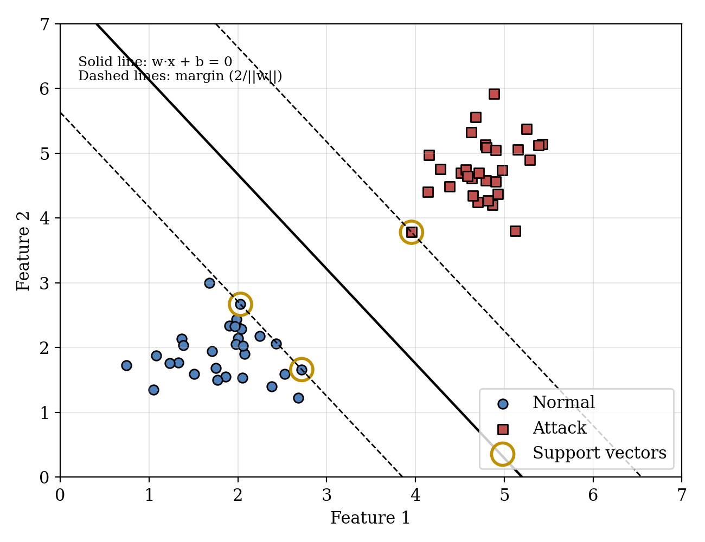
Figure 2: Support Vector Machine Decision Boundary in 2D Feature Space
When the classes cannot be separated by a straight hyperplane, SVM uses kernel functions. A kernel K(xᵢ, xⱼ) computes the similarity between two samples as if they were mapped into a higher-dimensional space, where a linear separation becomes possible, without performing this mapping explicitly (the kernel trick). The most common kernels are listed in Table 3. The Radial Basis Function (RBF) kernel is widely recommended for intrusion detection because it can model complex, non-linear boundaries with only two parameters to tune: C and γ.
SVM is well suited to intrusion detection because it performs well in high-dimensional feature spaces, it is less prone to overfitting thanks to margin maximization, and its decision depends only on the support vectors. Its main drawbacks are the training cost on very large datasets and its sensitivity to feature scaling, which is why normalization of the input features is an essential preprocessing step.
Table 3: SVM Kernel Functions and Mathematical Formulations
Kernel Type | Formula | Use Cases
Linear | K(xᵢ, xⱼ) = xᵢᵀxⱼ | Linearly separable data
Polynomial | K(xᵢ, xⱼ) = (γxᵢᵀxⱼ + r)ᵈ | Moderate non-linearity
RBF | K(xᵢ, xⱼ) = exp(-γ||xᵢ - xⱼ||²) | Recommended for IDS

2.3 Random Forest Classifier
Random Forest is an ensemble learning method that constructs a large number of decision trees during training and combines their predictions. A single decision tree splits the data recursively according to feature values, choosing at each node the split that best separates the classes, typically measured by the Gini impurity: Gini = 1 − Σ pₖ², where pₖ is the proportion of samples of class k at that node. Individual trees are easy to interpret but tend to overfit the training data.
Random Forest reduces this overfitting through two sources of randomness. First, each tree is trained on a bootstrap sample, a random sample drawn with replacement from the training set (bagging). Second, at each split only a random subset of the features is considered, commonly √d features out of d. As a result, the trees are diverse, and their individual errors tend to cancel out when combined. For classification, the final prediction is obtained by majority voting, and the fraction of trees voting for each class can be used as an estimate of class probability.
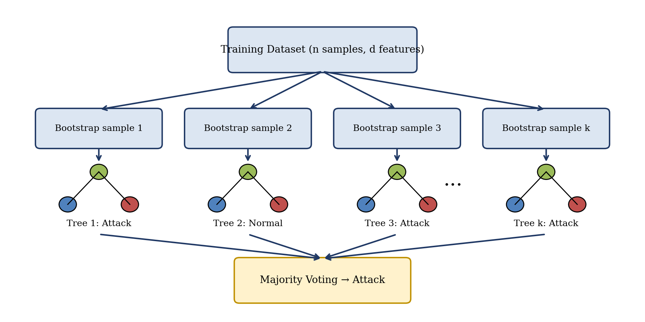
Figure 3: Random Forest Ensemble Method with Multiple Decision Trees
Random Forest offers several advantages for intrusion detection: it handles a large number of features without extensive preprocessing, it is robust to outliers and noise, it is less sensitive to class imbalance when class weights are adjusted, and it provides feature importance scores that help identify which traffic attributes are most indicative of attacks. These properties make it a strong and complementary partner to SVM in the proposed framework.

2.4 Dempster-Shafer Theory for Evidence Fusion
Dempster-Shafer Theory, also called the theory of belief functions, is a mathematical framework for reasoning under uncertainty and for combining evidence from multiple sources. Unlike classical probability, which must assign all probability to individual outcomes, DST allows part of the belief to be assigned to sets of outcomes, which makes it possible to represent ignorance explicitly.
The theory starts with a frame of discernment Θ, the set of all possible hypotheses. In this project Θ = {Normal, Attack}. A Basic Belief Assignment (BBA), or mass function, m assigns to each subset A of Θ a value m(A) between 0 and 1, such that m(∅) = 0 and the masses of all subsets sum to 1. The mass m(Θ) assigned to the whole frame represents the uncertainty of the source: the part of the evidence that cannot be attributed to either class.
From a mass function two measures are derived. The belief Bel(A) is the sum of the masses of all subsets contained in A, and represents the total evidence that directly supports A. The plausibility Pl(A) is the sum of the masses of all subsets that intersect A, and represents the extent to which A is not contradicted by the evidence. The true degree of support for A lies in the interval [Bel(A), Pl(A)], whose width reflects the remaining uncertainty.
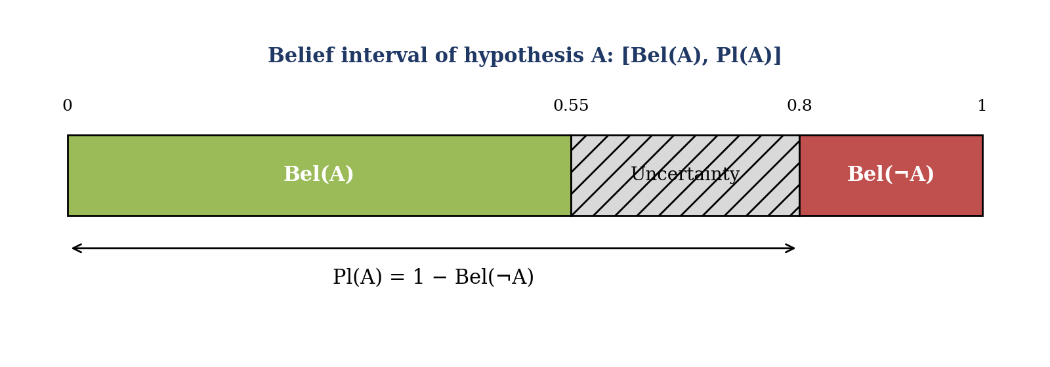
Figure 4: Dempster-Shafer Belief and Plausibility Functions
Evidence from two independent sources with mass functions m₁ and m₂ is fused using the Dempster combination rule: m(A) = [Σ m₁(B)·m₂(C) over all B ∩ C = A] / (1 − K), for every non-empty A, where K = Σ m₁(B)·m₂(C) over all B ∩ C = ∅ is the degree of conflict between the sources. Dividing by (1 − K) redistributes the conflicting mass among the remaining hypotheses.
In the proposed framework, the outputs of the SVM and Random Forest classifiers are converted into two BBAs over Θ, where part of the mass is reserved for Θ to reflect each classifier's uncertainty. The two BBAs are combined with the Dempster rule, and the class with the highest resulting belief is selected as the final decision. In this way, a confident classifier has a stronger influence on the result than an uncertain one, which is the key advantage of DST over simple majority voting.

2.5 CSE-CIC-IDS2018 Dataset
CSE-CIC-IDS2018 is a public intrusion detection dataset produced through a collaboration between the Communications Security Establishment (CSE) and the Canadian Institute for Cybersecurity (CIC). It was created to overcome the main weaknesses of older datasets such as KDD Cup 99 and NSL-KDD, which contain outdated attacks and traffic that no longer represents modern networks.
The dataset was generated in a controlled network environment that simulates a real organization, with victim machines and attacker machines, and it includes both normal user activity and a range of attack scenarios, including brute-force attacks, Denial of Service (DoS) and Distributed Denial of Service (DDoS), web attacks, infiltration from inside the network, and botnet activity. Network traffic was captured and converted into flow records using the CICFlowMeter tool, where each flow is described by a large set of statistical features such as flow duration, packet counts and sizes, inter-arrival times and TCP flag counts, together with a label indicating whether the flow is benign or belongs to a specific attack.
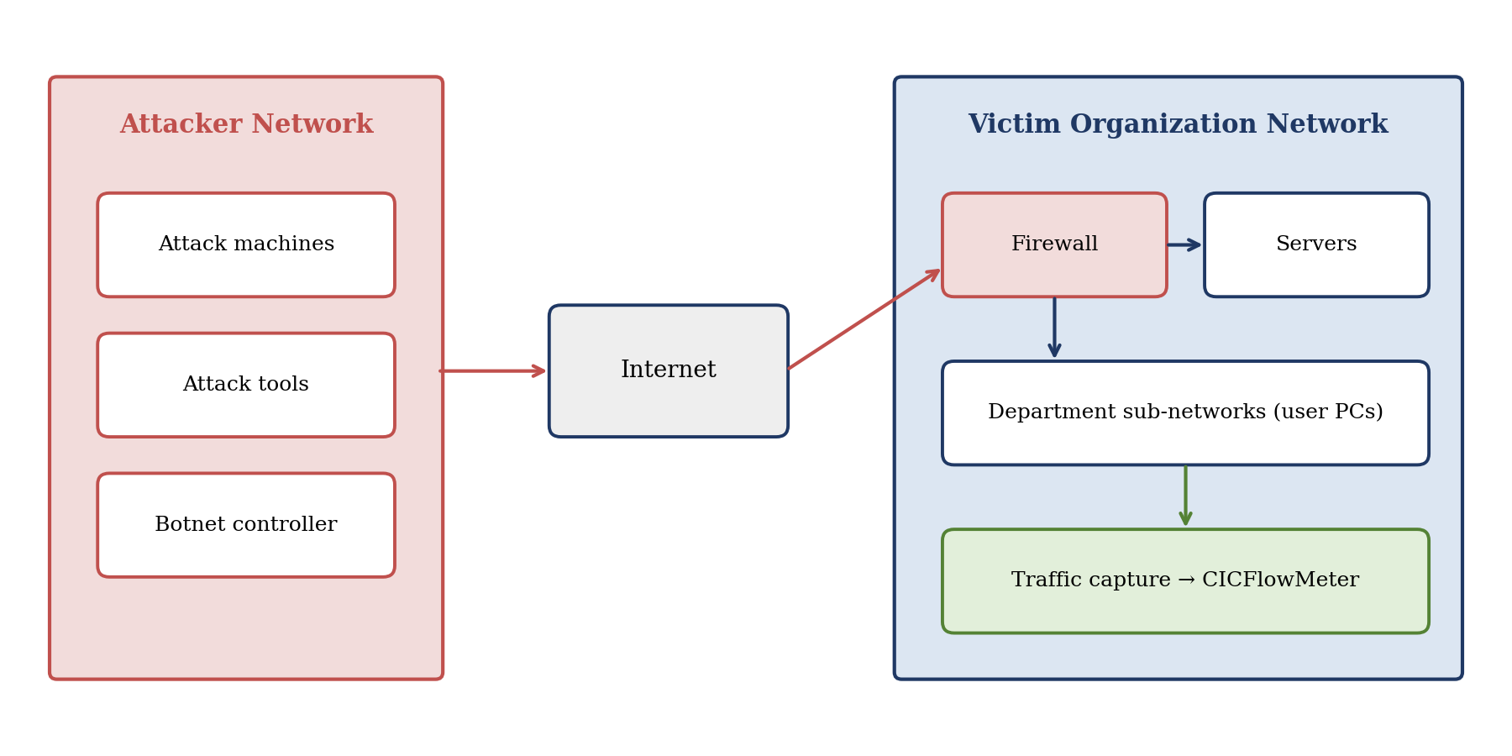
Figure 5: CSE-CIC-IDS2018 Dataset Network Topology
The main statistics of the data used in this project are summarized in Table 4. As the table shows, the dataset is imbalanced, with benign traffic far more frequent than malicious traffic. This imbalance must be considered during training and evaluation, since a model that always predicts the majority class could still achieve a high accuracy while missing most attacks.
Before training, several preprocessing steps are required: removing duplicate records and columns that carry no useful information (such as identifiers and timestamps), handling missing and infinite values, converting the multi-class labels into binary labels (Normal / Attack), scaling numerical features, which is essential for SVM, and splitting the data into training and testing sets while preserving the class ratio.
Table 4: CSE-CIC-IDS2018 Dataset Composition and Statistics
Metric | Value | Description
Total Network Flows | 655,988 | Individual connections
Network Features | 83 | Attributes per flow
Benign Traffic | ~80% | Normal activity
Malicious Traffic | ~20% | Attack types
Capture Duration | 9 days | June 14-22, 2018
Class Imbalance Ratio | ~4:1 | Normal:Attack

2.6 Performance Metrics
Evaluating an IDS requires more than one metric, because the cost of different errors is not equal and the dataset is imbalanced. All the metrics used in this project are derived from the confusion matrix, which counts four outcomes, where the Attack class is considered positive:
True Positive (TP): an attack correctly detected as an attack. True Negative (TN): normal traffic correctly classified as normal. False Positive (FP): normal traffic wrongly flagged as an attack (a false alarm). False Negative (FN): an attack wrongly classified as normal (a missed attack).
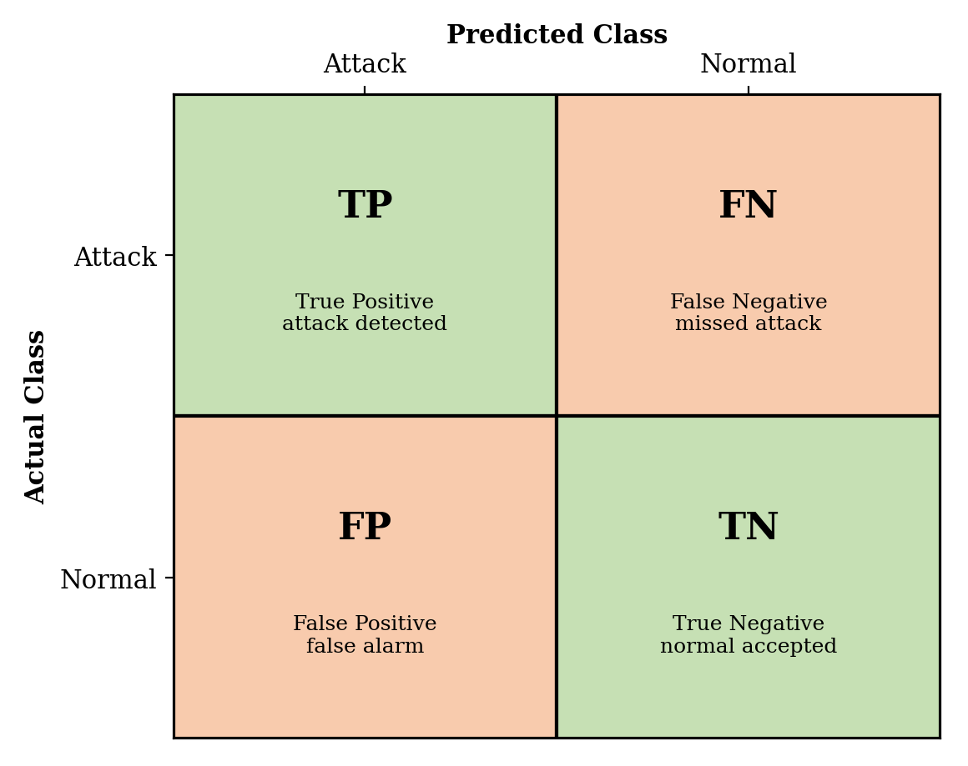
Figure 6: Confusion Matrix for Binary Classification
- Accuracy = (TP + TN) / (TP + TN + FP + FN): the proportion of all flows classified correctly. It is easy to interpret but can be misleading on imbalanced data.
- Precision = TP / (TP + FP): the proportion of raised alerts that are real attacks. High precision means few false alarms.
- Recall (Detection Rate) = TP / (TP + FN): the proportion of real attacks that are detected. High recall means few missed attacks.
- F1-Score = 2 × (Precision × Recall) / (Precision + Recall): the harmonic mean of precision and recall. Because it is high only when both are high, the F1-Score is the recommended primary metric for imbalanced datasets such as CSE-CIC-IDS2018, and it is used in this project as the main criterion for comparing the individual classifiers with the fused system.

2.7 Chapter Summary
This chapter established the theoretical foundations of the proposed framework. It reviewed the role and types of Intrusion Detection Systems and compared the main detection approaches. It then explained the two base classifiers: the Support Vector Machine, which separates classes with a maximum-margin hyperplane and uses kernel functions for non-linear data, and Random Forest, which combines many randomized decision trees through voting.
The chapter also presented Dempster-Shafer Theory as the mechanism for fusing the classifiers' outputs, including the concepts of the frame of discernment, basic belief assignment, belief and plausibility, and the Dempster combination rule. Finally, it described the CSE-CIC-IDS2018 dataset and the evaluation metrics that will be used to measure performance. The next chapter builds on these foundations to describe the design and implementation of the proposed system.

