**PEDIATRIC CHRONIC CARE**

**A PROJECT REPORT**

***Submitted by,***

**MR.SHAIK SAMIULLA -20201CEI0052**

**MR.SHAIK MUNAF -20201CEI0055**

**MR.A PAVAN KUMAR REDDY -20201CEI0006**

***Under the guidance of,***

**Mr. MUTHURAJU V**

***in partial fulfillment for the award of the degree of***

**BACHELOR OF TECHNOLOGY**

**IN**

**COMPUTER ENGINEERING [ARTIFICIAL INTELLIGENCE & MACHINE**

**LEARNING]**

**At**



**PRESIDENCY UNIVERSITY**

**BENGALURU**

**JANUARY 2024**

**PRESIDENCY UNIVERSITY**

**SCHOOL OF COMPUTER SCIENCE AND ENGINEERING**

**CERTIFICATE**

This is to certify that the Project report “**PEDIATRIC CHRONIC CARE**” being submitted by Shaik Samiulla, Shaik Munaf, A Pavan Kumar Reddy bearing roll number(s) 20201CEI0052, 20201CEI0055, 20201CEI0006 in partial fulfilment of requirement for the award of degree of Bachelor of Technology in Computer Engineering [Artificial Intelligence and Machine Learning] is a bonafide work carried out under my supervision.

|  |  |  |
| --- | --- | --- |
| **Mr. MUTHURAJU V**  Assistant Professor  School of CSE  Presidency University |  | **Dr.GOPAL K.SHYAM**  Prof. & HoD  School of CSE  Presidency University |
| **Dr. C. KALAIARASAN**  Associate Dean  School of CSE  Presidency University | **Dr. L. SHAKKEERA**  Associate Dean  School of CSE  Presidency University | **Dr. Md. SAMEERUDDIN KHAN**  Dean  School of CSE  Presidency University |

**PRESIDENCY UNIVERSITY**

**SCHOOL OF COMPUTER SCIENCE AND ENGINEERING** **DECLARATION**

We hereby declare that the work, which is being presented in the project report entitled **PEDIATRIC CHRONIC CARE** in partial fulfilment for the award of Degree of Bachelor of Technology in Computer Engineering **[Artificial Intelligence and** **Machine Learning]**, is a record of our own investigations carried under the guidanceof **Dr.Muthuraju V, Assistant Professor, School of Computer Science Engineering & Information Science, Presidency University, Bengaluru**, School of Computer Science Engineering ,Presidency University, Bengaluru.

We have not submitted the matter presented in this report anywhere for the award of any other Degree.

|  |  |  |
| --- | --- | --- |
| **Names** | **Roll Numbers** | **Signature** |
|  |  |  |
| Shaik Samiulla | 20201CEI0052 |  |
| Shaik Munaf | 20201CEI0055 |  |
| A Pavan Kumar Reddy | 20201CEI0006 |  |

**ABSTRACT**

Pediatric chronic care refers to the ongoing management of long-term health conditions in children. This care involves a comprehensive approach that integrates medical, emotional, and social support to improve the child's quality of life.

The abstract of a study or paper on pediatric chronic care would likely summarize the key aspects of managing these conditions, including the challenges faced, effective strategies for treatment, the importance of family involvement, and the impact on a child's development and well-being.

Pediatric chronic care involves the long-term management of medical conditions in children. These conditions typically persist for extended periods, requiring ongoing monitoring, treatment, and support. Some common pediatric chronic conditions include asthma, diabetes, cystic fibrosis, congenital heart disease, and autoimmune disorders.

The methodology of pediatric chronic care revolves around proactive management, encompassing regular assessments, screenings, and interventions to prevent complications and optimize health outcomes. A key aspect involves a multidisciplinary team of specialists who collaborate to create individualized care plans tailored to the unique needs of each child. Moreover, it places a significant emphasis on empowering families through education, support, and access to resources, enabling them to effectively manage the child's condition at home.

Psychosocial support and attention to the child's emotional and developmental needs are integral components of this care approach, aiming to improve the child's quality of life and resilience in coping with the challenges posed by their condition. Additionally, the transition from pediatric to adult care is a critical focus, ensuring a smooth transfer of care that maintains continuity and supports the adolescent's increasing independence in managing their health.

In essence, pediatric chronic care represents a holistic and patient-centered approach that seeks to optimize the health and well-being of children with chronic conditions. Through a combination of medical expertise, family involvement, psychosocial support, and ongoing advancements in care methodologies, it aims to provide these children with the necessary tools and support for a fulfilling life despite the challenges posed by their conditions.

Keywords

EHR, Data Analysis and Visualization, Mobile Application, Security and Privacy, AI&ML.

**ACKNOWLEDGEMENT**

First of all, we indebted to the **GOD ALMIGHTY** for giving me an opportunity to excel in our efforts to complete this project on time.

We express our sincere thanks to our respected dean **Dr. Md. Sameeruddin Khan**, Dean, School of Computer Science and Engineering & School of Information Science, Presidency University for getting us permission to undergo the project.

We record our heartfelt gratitude to our beloved Associate Deans **Dr. Kalaiarasan C and Dr. Shakkeera L,** School of Computer Science and Engineering & School of Information Science, Presidency University and Dr. Gopal K. Shyam, Head of the Computer Engg., School of Computer Science and Engineering, Presidency University for rendering timely help for the successful completion of this project.

We are greatly indebted to our guide **Mr. MUTHURAJU V, Assistant Professor**, School of Computer Science and Engineering, Presidency University for his inspirational guidance, and valuable suggestions and for providing us a chance to express our technical capabilities in every respect for the completion of the project work.

We would like to convey our gratitude and heartfelt thanks to the University Project-II Coordinators **Dr. Sanjeev P Kaulgud, Dr. Mrutyunjaya MS** and also the department Project Coordinators **Dr. Sasidhar Babu S., Dr. Sudha P., and Ms. Yogeetha B. R.** We thank our family and friends for the strong support and inspiration they have provided us in bringing out this project.

**Shaik Samiulla (1)**

**Shaik Munaf (2)**

**A Pavan Kumar Reddy (3)**

**LIST OF FIGURES**

|  |  |  |  |
| --- | --- | --- | --- |
| **Sl. No.** | **Figure Name** | **Caption** | **Page No.** |
| 1 | Figure 1 | Time Line | 13 |
| 2 | Figure 2 | User Result page | 15 |
|  |  |  |  |

**Table of Contents**

CHAPTER-1 1

INTRODUCTION 1

1.1 Motivation 1

1.2 Problem Statement 1

CHAPTER-2 3

LITERATURE SURVEY 3

CHAPTER-3 4

RESEARCH GAPS OF EXISTING METHODS 4

3.1 Existing systems 4

3.1.1 Medical Management 4

3.1.2 Care Coordination 4

3.1.3 Psychosocial Support 4

3.1.4 Transition to Adult Care 4

CHAPTER-4 6

PROPOSED MOTHODOLOGY 6

4.1 Appointment Scheduling 6

4.2 Medication Management 6

4.3 Symptoms Tracking 6

4.4 Emergency Assistance 7

4.5 Integrated Care and Approach 7

4.6 Transition Support and Continuity 7

CHAPTER-5 9

OBJECTIVES 9

CHAPTER-6 10

SYSTEM DESIGN & IMPLEMENTATION 10

6.1 Installing Eclipse IDE 10

6.2 Installing MySQL Connector 11

6.3 Installing XAMPP 11

6.4 Access phpMyAdmin 12

6.5 Create a Database 12

CHAPTER-7 14

TIMELINE FOR EXECUTION OF PROJECT 14

CHAPTER-8 15

OUTCOMES 15

8.1 Enhanced Health Management 15

8.3 Empowered Patients and Families 15

8.4 Smooth Transition to Adult Care 15

8.5 Integrated and Collaborative Care 15

CHAPTER-9 16

RESULTS AND DISCUSSINONS 16

Reduced Health Care Disparities 16

CHAPTER-10 17

CONCLUSION 17

REFERENCES 18

APPENDIX-A 21

PSUEDOCODE 21

APPENDIX-B 31

SCREENSHOTS 31

ENCLOSURES 44

# CHAPTER-1

# INTRODUCTION

## 1.1 Motivation

The motivation driving the focus on pediatric chronic care stems from a fundamental need to address the complex and enduring challenges faced by children living with chronic health conditions.

Moreover, the motivation lies in acknowledging the significant impact that chronic illnessesIn summary, the context of finding a nearby hospital encompasses a spectrum of situations ranging from urgent emergencies to routine healthcare needs. The integration of technology has streamlined this process, making it easier for individuals to locate and access the medical care they require promptly.

Whether in times of crisis or for routine health management, the ability to quickly identify and reach a nearby hospital is a crucial aspect of modern health careseeking behavior. can have on a child's development, education, and long-term health outcomes. By prioritizing pediatric chronic care, the healthcare community aims to mitigate these impacts, striving to ensure that these children receive comprehensive support tailored to their specific needs. This motivation is deeply rooted in the belief that every child deserves the opportunity to thrive despite the challenges posed by their health condition.

## 1.2 Problem Statement

The landscape of pediatric chronic care is characterized by a myriad of challenges that significantly impact the health and well-being of children living with chronic health conditions. The primary challenge lies in the multifaceted nature of these conditions, which demand ongoing and comprehensive management, often straining healthcare resources and necessitating a more holistic approach to care. One of the core issues is the fragmentation of care, where the complexities of managing chronic conditions often result in disjointed care delivery. This fragmentation can lead to gaps in communication between healthcare providers, inadequate coordination of services, and a lack of continuity in the care provided, ultimately impacting the child's health outcomes. Furthermore, pediatric chronic care faces challenges related to the psychosocial aspects of these conditions. Children with chronic illnesses often encounter difficulties in coping with the emotional and social implications of their health condition, which can adversely affect their mental health, educational attainment, and social integration. In essence, the problem within pediatric chronic care lies in the need for a more integrated, comprehensive, and patient-centered approach that addresses the multifaceted challenges faced by these young patients and their families. Bridging the gaps in care coordination, enhancing psychosocial support, improving accessibility to specialized services, and streamlining transitions of care are imperative to overcome these challenges and ensure better outcomes for children living with chronic health conditions. Project Introduction This project aims to redefine the landscape of pediatric chronic care, recognizing the intricate needs of children grappling with enduring health conditions. The initiative emerges from a collective aspiration to revolutionize the care paradigm for these young patients, fostering a more inclusive, comprehensive, and effective approach that transcends conventional medical interventions. The motivation behind this project stems from the acknowledgment of the complexities inherent in managing pediatric chronic conditions. These conditions not only necessitate ongoing medical attention but also demand a holistic understanding that encompasses the child's development, emotional well-being, and familial support systems.

The Project is driven by a commitment to address the multifaceted challenges faced by these children and to ensure they receive care that optimizes their health outcomes and overall quality of life.

By integrating multidisciplinary collaboration, leveraging technological advancements, and prioritizing patient-centered approaches, the project seeks to bridge existing gaps in care delivery. It endeavors to create a cohesive and supportive ecosystem that caters to the unique needs of each child, fostering resilience and empowerment among both the children and their families. This project introduction sets the stage for a concerted effort aimed at redefining the

standards of care for pediatric chronic conditions.

By delving into the multifaceted nature of these challenges and exploring innovative solutions, this initiative aspires to lay the groundwork for a more compassionate, effective, and inclusive approach to pediatric chronic care. Through collaboration, innovation, and a steadfast commitment to the well-being of these young patients, the project endeavors to make meaningful strides in improving their health outcomes and overall quality of life.

.

# CHAPTER-2

# LITERATURE SURVEY

# 

Title:BrainTracker:mHealth app for Remote Assessment of Pediatric Epilepsy and Comorbidities,2020. Authors:Kevin Gary, Mason Cole, Dipak Purbey, Meng-Jung Lin,Krishnakantha, Jayashree,Chandrashekhar.Journal/Conference:IEEE publisher.published in 2020.Advantages:We have developed a mobile health application) with tasks and surveys that target areas of functioning that are commonly at risk in children across medicaldisorders.disadvantages:a. Not all patients have access to smartphones or the internet,

potentially creating healthcare disparities.

Title:Integrating Patient-Generated Observations of Daily Living into Pediatric Cancer Care: AFormative User Interface Design Study,2018.Authors:Udaya Lakshmi ,Mathew hong,Lauren wilco.

Journal/Conference:IEEE Publisher Published in 2018.Advantages:. prior work largelfocuses on capturing clinician-defined, patient-generated data in adult oncology care. Disadvantages Patient-entered data may not always be accurate or complete, leading to potential inaccuracies in treatment decisions.

Title:An mHealth System for Toxicity Monitoring of Paediatric Oncological Patients usingNear Field Communication Technology,2015.Authors:Katharina Duregger, Dieter Hayn,Jürgen Morak, Ruth Ladenstein and Günter Schreier.

Journal/Conference:IEEE Publisher Published in 2015.Advantages:A pre-existing telemonitoring system for elderly, chronically ill patients [13-15] has been extended and adapted in order to fulfil the requirements of paediatric oncological

settings.Disadvantages:The uncertainty associated with the long-term prognosis of chronic conditions can create anxiety for both children and their families.hospitals in a city, it is not enough to simply provide ambulances with information about hospital distances, resources and current resource usage. We use a hospital ranking for each victim based on the above criteria, allowing victims to make informed and informed choices from a manageable list of options. Finally, we compare the performance of the ranking method with the near-hospital detection method using different scenarios.

# CHAPTER-3

# RESEARCH GAPS OF EXISTING METHODS

## 3.1 Existing systems

### **3.1.1 Medical Management**

Current systems primarily center on pharmacological treatments and symptom management. However, there's a need to expand these approaches, integrating preventive care, personalized treatment plans, and a focus on patient and family education for more effective long-term disease management. Incorporating telemedicine and remote monitoring can enhance accessibility to specialized care.

### **3.1.2 Care Coordination**

Existing systems struggle with fragmented care delivery due to limited communication among various healthcare providers involved. Establishing centralized care plans, utilizing electronic health records for streamlined information sharing, and implementing care navigators can bridge gaps, ensuring seamless coordination among specialists, primary care physicians, and support services.

### **3.1.3 Psychosocial Support**

While some systems offer basic psychological support, addressing the emotional and social needs of children and families facing chronic illnesses remains insufficient. Enhancing access to mental health services, counseling, peer support networks, and educational resources can fortify the holistic support framework, aiding in coping mechanisms and resilience-building.

### **3.1.4 Transition to Adult Care**

Current systems lack standardized procedures for transitioning adolescents to adult healthcare settings, leading to potential disruptions in care. Developing structured transition programs, educating both patients and healthcare providers about the process, and ensuring continuous support during this transition phase are imperative to facilitate a smoother shift and maintain consistent care continuity.

Developing structured transition programs, educating both patients and healthcare providers about the process, and ensuring continuous support during this transition phase are imperative to facilitate a smoother shift and maintain consistent care continuity.

# CHAPTER-4

# PROPOSED MOTHODOLOGY

## 4.1 Appointment Scheduling

Appointment scheduling plays a pivotal role in the methodology of pediatric chronic care, serving as a cornerstone for effective management. In this framework, the emphasis lies not only on the frequency of appointments but also on the efficiency and accessibility of the scheduling process. Implementing a robust appointment scheduling system aims to streamline access to care while promoting adherence and continuity. Ultimately, a well-structured appointment scheduling system within pediatric chronic care aims to optimize access, adherence, and continuity of care. By leveraging technology, ensuring flexibility, and integrating the expertise of the care team, this approach seeks to alleviate the burden on families while prioritizing the health and well-being of children with chronic conditions.

## 4.2 Medication Management

Medication management stands as a cornerstone in the methodology of pediatric chronic care, crucial for ensuring proper treatment adherence and optimizing health outcomes. The approach encompasses various strategies aimed at facilitating medication adherence, tracking dosages, and ensuring timely prescription refills, all tailored to meet the unique needs of children with chronic conditions and their families. In essence, medication management within pediatric chronic care aims to optimize treatment adherence and therapeutic outcomes. By leveraging technology, tracking dosages, ensuring consistent access to medications, and providing education and support, this approach strives to empower families in effectively managing their child's medication regimen, ultimately contributing to improved health and well-being for children with chronic conditions.

## 4.3 Symptoms Tracking

Symptom tracking plays a pivotal role in pediatric chronic care, offering a valuable tool for both healthcare providers and families to monitor a child's health condition over time. This methodology involves keeping a comprehensive record of symptoms, changes in health status, and any notable developments, empowering families to actively participate in managing their child's care. In essence, symptom tracking within pediatric chronic care empowers families to actively participate in monitoring their child's health, facilitates more informed discussions during healthcare visits, and contributes to more personalized and effective care plans. This proactive approach not only enhances the quality of care but also empowers families to be advocates for their child's well-being.

## 4.4 Emergency Assistance

Emergency assistance stands as a critical component in the methodology of pediatric chronic care, ensuring swift and effective support during unforeseen critical situations. This aspect acknowledges the unpredictable nature of chronic conditions and aims to equip families with the necessary resources to manage emergencies efficiently. Ultimately, the integration of emergency assistance within pediatric chronic care aims to enhance the safety and well-being of children facing chronic conditions. By providing families with resources, education, and technological support, this approach ensures a more proactive and coordinated response to emergencies, ultimately contributing to better outcomes and improved peace of mind for both children and caregivers.

## 4.5 Integrated Care and Approach

An integrated care and approach in pediatric chronic care signifies a paradigm shift towards a comprehensive and holistic model that transcends traditional medical interventions. This methodology is built upon the fundamental principle of addressing not only the physical health aspects but also the emotional, social, and developmental needs of children with chronic conditions, integrating various facets into a cohesive support system. In essence, the integrated care and approach in pediatric chronic care pave the way for a more holistic, comprehensive, and patient-centered model. By intertwining medical, social, and emotional support, this methodology aims to provide a more cohesive and inclusive care framework that addresses the diverse needs of children with chronic conditions, ultimately promoting better health outcomes and improved quality of life.

## 4.6 Transition Support and Continuity

Transition support and continuity in pediatric chronic care encompass structured strategies designed to facilitate the seamless shift from pediatric to adult healthcare settings, ensuring uninterrupted care for adolescents transitioning from childhood to adulthood.

This critical phase demands careful planning, collaboration, and support to mitigate disruptions in care and maintain continuity, vital for the well-being of individuals managing chronic conditions. Ultimately, transition support and continuity in pediatric chronic care aim to ensure a cohesive and supportive framework that safeguards the well-being of adolescents transitioning into adult healthcare. By implementing structured programs, maintaining continuity of care, and addressing psychosocial aspects, this methodology facilitates a seamless transition, empowering adolescents to navigate their healthcare journey with confidence and resilience.

# CHAPTER-5

# OBJECTIVES

In pediatric chronic care, the objectives are multifaceted, aiming to address the diverse needs of children facing long-term health conditions and their families. These objectives are desig ned to create a comprehensive and patient-centered approach , emphasizing various aspects crucial for effective management and improved outcomes. Firstly, the primary objective revolves around enhancing health outcomes. This involves optimizing the management of chronic conditions to minimize complications, reduce hospitalizations, and improve overall health indicators. The focus is not just on treating symptoms but on fostering better health through comprehensive care approaches that consider the physical, emotional, and developmental needs of the child. Another critical objective is to provide holistic support. Beyond medical interventions, this objective encompasses offering comprehensive support that addresses psychosocial, educational, and familial needs. It aims to create an ecosystem that supports the overall well being and quality of life of children facing chronic conditions and their families, acknowledging that these conditions often affect various aspects of a child's life. Moreover, the objective of ensuring smooth transition to adult care is paramount. This involves developing protocols and resources for a seamless transition from pediatric to adult healthcare settings. The goal is to ensure continuity and quality of care during this critical phase, preventing interruptions and maintaining the progress achieved in managing the condition during childhood. In essence, the objectives in pediatric chronic care are centered around optimizing health outcomes, providing holistic support, empowering families, ensuring smooth transitions, and integrating innovative strategies. Achieving these objectives aims to redefine care approaches, foster resilience, and ultimately improve the overall well-being and quality of life for children living with chronic health conditions.

# CHAPTER-6

# SYSTEM DESIGN & IMPLEMENTATION

## 6.1 Installing Eclipse IDE

6.1.1 Download Eclipse

Visitthe Eclipse official website at https://www.eclipse.org/downloads/.

Choose the appropriate version based on your operating system (e.g., Windows 64-bit, macOS, Linux).

Clickonthe "Download" button corresponding to your choice.

6.1.2 install Eclipse

Oncethedownload completes, locate the downloaded file.

Extract the downloaded archive file to a location on your computer (e.g., C:\Program Files for Windows)

There is no formal installation process for Eclipse; it's a portable application that runs directly from its folder.

LaunchEclipse

6.1.3 Navigate to the folder where you extracted Eclipse

Inside the Eclipse folder, double-click on the executable file named eclipse (or eclipse.exe for Windows) to start Eclipse.

6.1.4 Set Up Workspace

When Eclipse starts for the first time, it will prompt you to choose a workspace directory where your projects will be stored.

Select a suitable folder location and click "Launch" to proceed.

6.1.5 Install Java Development Kit (JDK)

Ensure you have Java Development Kit (JDK) installed on your system. If not, download and install it from Oracle's website.

OpenEclipse, go to Window > Preferences.

Navigate to Java > Installed JREs and add your installed JDK by clicking on "Add" and selecting the JDK folder.

## 6.2 Installing MySQL Connector

6.2.1 Download MySQL Connector/J

GototheMySQLConnector/J download page: MySQL Connector/J.

Choosetheappropriate platform and click on the download link for the ZIP archive School of

Computer Science Engineering & Information Science, Presidency University

6.2.3 Extract MySQL Connector/J

Oncethedownload completes, locate the downloaded ZIP file.

Extract the contents of the ZIP archive to a known location on your computer.

6.2.4 Add MySQL Connector/J to Eclipse Project

OpenEclipse IDE where your project resides.

Right-click on your project in the Project Explorer, select Properties.

Navigate to Java Build Path > Libraries > Add External JARs.

Browseandselect the mysql-connector-java-x.x.xx.jar file you extracted earlier.

Click "Apply" and then "OK" to add the MySQL Connector/J to your project's build path.

## 6.3 Installing XAMPP

6.3.1 Download XAMPP

Visitthe official XAMPP website: [https://www.apachefriends.org/index.html.](https://www.apachefriends.org/index.html)

Download the version of XAMPP suitable for your operating system (e.g., Windows, macOS, Linux).

6.3.2 Install XAMPP

Oncethedownload completes, locate the downloaded file and run the installer.

Followthe installation instructions provided by the XAMPP installer.

Choosethe components you want to install (Apache, MySQL, PHP, etc.).

Select the installation directory (the default is usually recommended).

Complete the installation process by clicking "Next" and then "Finish."

6.3.3 Setting up MySQL in XAMPP

Start XAMPPandLaunch MySQL

Open the XAMPP Control Panel (you can find it in the installation directory or via Start Menu on Windows).

Start the Apache and MySQL services by clicking on the "Start" buttons next to their names.

## 6.4 Access phpMyAdmin

Openawebbrowser and go to [http://localhost/phpmyadmin/.](http://localhost/phpmyadmin/)

Log in using the default username (root) and leave the password field empty (if you didn't set a password during XAMPP installation)

## 6.5 Create a Database

Inside phpMyAdmin, click on the "Databases" tab.

Enter a name for your database in the "Create database" field and choose a collation (usually utf8_general_ci).

Click"Create" to create the database.

6.5.1 Creating a Dynamic Web Project

Open Eclipse Launch Eclipse IDE if it's not already open. Create a Dynamic Web Project:

GotoFile>New>Dynamic WebProject.

Enteranamefor your project.

Select the target runtime (Apache Tomcat, if available) and set the Dynamic web module version.

Click"Next" and configure further settings if needed.

Click"Finish" to create the Dynamic Web Project.

Importing Your Project:

OpenExisting Project in Eclipse:

Ifyour project is not already within the Eclipse workspace:

GotoFile>Import.

ChooseGeneral > Existing Projects into Workspace.

Click"Next," then select the root directory of your project using the "Browse" button.

Ensureyour project is selected in the list and click "Finish" to import it into Eclipse.

6.5.2 Setting up Apache Tomcat Server

Goto the Servers tab at the bottom of the Eclipse window (if you don’t see it, go to Window > Show View > Servers).

Right-click in the Servers tab area and select New > Server.

Choosetheversion of Apache Tomcat you have installed and click "Next."

6.5.3 Set Tomcat Installation Directory

Clickonthe "Browse" button next to the "Tomcat installation directory" field.

Navigate to the directory where Apache Tomcat is installed and select it.

Click"Finish" to add the Tomcat server to Eclipse.

6.5.4 Configure Project to Use Tomcat

Right-click on your Dynamic Web Project in Eclipse.

School of Computer Science Engineering & Information Science, Presidency University

Page 13 of 48

Project Title

Select Properties > Project Facets.

Check the box for "Dynamic Web Module" and click "Further configuration available..."

Choosetheinstalled Apache Tomcat server from the dropdown and click "OK." Click"Apply" and then "OK" to close the project properties.

6.5.5 Starting Your Project

Right-click on your project in Eclipse.

Select Run As > RunonServer.

Choosetheconfigured Tomcat server and click "Finish" to deploy and run your project.

6.5.6 Access Your Project

Onceyourproject is running on Tomcat, open a web browser.

Enterthe URLprovided in the Console window of Eclipse.

# CHAPTER-7

# TIMELINE FOR EXECUTION OF PROJECT

**Project Timeline**

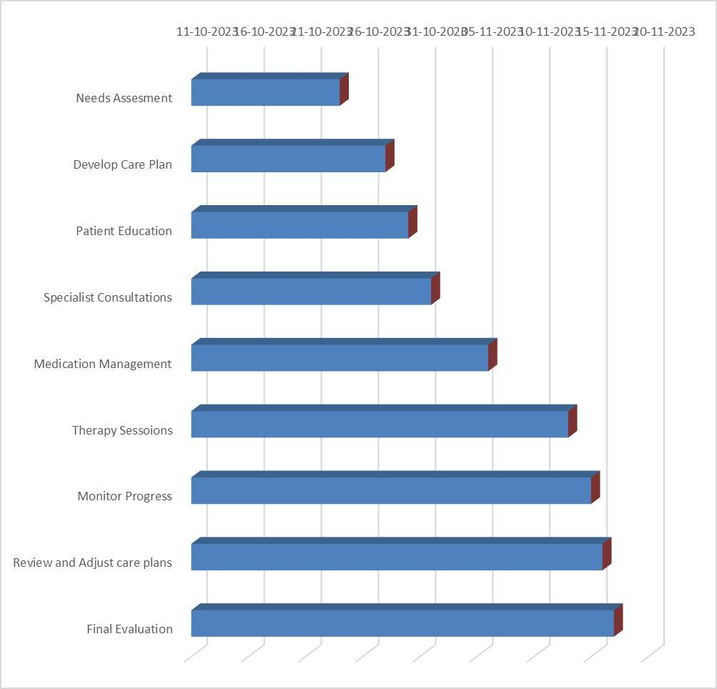

**Figure 1: TimeLine**

# CHAPTER-8

# OUTCOMES

## 8.1 Enhanced Health Management

Improved management of chronic conditions leads to better control of symptoms, reduced hospitalizations, and minimized complications, ultimately enhancing the child's health status. **8.2 Improve Quality of Life**

Comprehensive care approaches address not only medical needs but also psychosocial, developmental, and educational aspects, contributing to a better quality of life for the child and their family.

## 8.3 Empowered Patients and Families

Education and empowerment initiatives equip families with tools and knowledge to actively participate in managing the child's condition, fostering independence and confidence in handling healthcare decisions.

## 8.4 Smooth Transition to Adult Care

Successful transitions to adult healthcare settings ensure continuity of care, preventing interruptions and maintaining progress achieved in managing the condition during childhood.

## 8.5 Integrated and Collaborative Care

Implementation of innovative strategies, including technology integration and multidisciplinary collaboration, redefines care standards, fostering cohesive and patient centered approaches in managing chronic conditions.

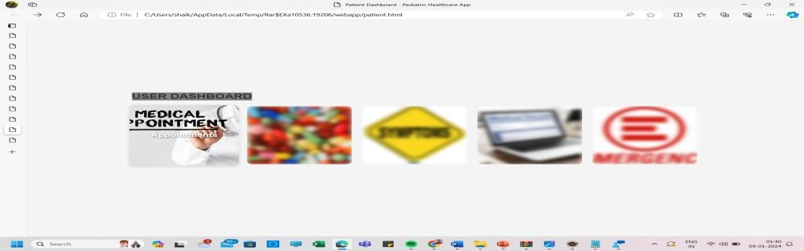

**Figure 2: User Result page**

# CHAPTER-9

# RESULTS AND DISCUSSINONS

# Reduced Health Care Disparities

Addressing accessibility and equity issues ensures that all children, regardless of their socio economic status or geographic location, have access to quality care and support.

The success of pediatric chronic care is measured not just by medical outcomes but by the overall well-being and quality of life it affords the child and their family. When executed effectively, this approach yields several notable results. Firstly, it fosters a sense of empowerment and confidence in families as they become active participants in managing their child's condition. Education and support enable them to navigate the complexities of the condition and its treatment, leading to improved adherence to care plans and better health outcomes for the child. Moreover, a comprehensive pediatric chronic care methodology often results in reduced hospitalizations and emergency room visits. By emphasizing preventive care, regular check ups, and early intervention, it minimizes the likelihood of complications or exacerbations of the condition, thereby decreasing the need for acute medical interventions. Additionally, this approach tends to positively impact the child's developmental, emotional, and social well-being. By addressing not only the medical aspects but also the psychosocial implications of chronic illness, it helps children lead fuller lives. Psychological support, educational resources, and access to community services contribute to a better overall quality of life for the child and their family. In conclusion, effective pediatric chronic care goes beyond medical management; it embodies a holistic and patient-centered approach that encompasses various aspects of a child's life. When implemented diligently, this methodology results in improved health outcomes, reduced healthcare utilization, enhanced quality of life, and better overall well being for children living with chronic conditions and their families. Continual advancements in this field are crucial for further refining strategies and ensuring that every child receives the comprehensive care they deserve.

# CHAPTER-10

# CONCLUSION

In the realm of pediatric chronic care, the culmination of our project illuminates a transformative journey towards redefining care paradigms for children facing long-term health challenges. Our endeavor delved deep into the multifaceted aspects of chronic conditions, recognizing that effective care extends far beyond medical interventions. It encompasses a holistic ecosystem of support, nurturing not just the physical health but also the emotional resilience and social well-being of these young patients and their families. Our project's conclusion marks a pivotal moment, highlighting the significance of a comprehensive approach. It's a testament to the power of collaboration, innovation, and patient-centered care models in shaping the landscape of pediatric chronic care. Through meticulous exploration and implementation of various modules, from medical management to technology integration and psychosocial support, we've strived to craft a blueprint that transcends the conventional boundaries of healthcare.

As we reflect on this journey, it's evident that the essence of pediatric chronic care lies in empowerment and compassion. It's about empowering families with knowledge and tools to become advocates for their child's health, fostering a sense of agency and partnership in care decisions. It's about approaching each case with compassion, recognizing the unique needs and challenges that these children face and tailoring our support accordingly.

Our project's conclusion is not the termination of efforts but a launching pad for continued progress. It's a call to action, urging us to build upon the foundation laid, to refine strategies, innovate further, and advocate for inclusive, equitable care for every child. It's an affirmation of our commitment to a future where children with chronic conditions not only survive but thrive, where their lives are defined by hope, resilience, and possibilities.

In essence, the conclusion of our pediatric chronic care project marks a significant milestone— a testament to dedication, collaboration, and unwavering commitment to making a meaningful difference in the lives of these remarkable children and their families.

# REFERENCES

1. Krivitzky LS, Walsh KS, Fisher EL, Berl MM.
2. Executive functioning profiles from the BRIEF across pediatric medical disorders: Age and diagnosis factors. Child Neuropsychol 2015:1–19. [3] Kolk A, Ennok M, Laugesaar R, Kaldoja M-L, Talvik T. Long-term cognitive outcomes after pediatric stroke. Pediatr Neurol 2011;44:101–9.2.

[4] Brinkman TM, Krasin MJ, Liu W, Armstrong GT, Ojha RP, Sadighi

ZS,et al. Long-Term Neurocognitive Functioning and Social Attainment in Adult Survivors of Pediatric CNS Tumors: Results From the St Jude ifetime Cohort Study. J Clin Oncol Off J Am Soc Clin Oncol 2016. [4] Sehlo MG, Kamfar HZ. Depression and quality of life in children with sickle cell disease: the effect of social support. BMC Psychiatry 2015;15:. [5] Yeates KO, editor. Pediatric neuropsychology: research, theory, and practice. 2nd ed. New York: Guilford Press; 2010Escoffery, C., McGee, R., Bidwell, J., Sims, C., Thropp, E. K., Frazier, C., & Mynatt, E. D.

(2018). A review of mobile apps for epilepsy self-management. Epilepsy & Behavior, 81, 62-69.

1. Deonna, T. (2008). Childhood epilepsy: secondary prevention is crucial.

Developmental Medicine & Child Neurology, 45, pp.38-41.

1. Cardamone, L., Salzberg, M., O'Brien, T. and Jones, N. (2013). Antidepressant therapy in epilepsy: can treating the comorbidities affect the underlying disorder?. British Journal of Pharmacology, 168(7), pp.1531-1554.
2. Russ SA, Larson K, Halfon N. A National Profile of Childhood Epilepsy and Seizure Disorder. PEDIATRICS 2012;129:256–6 [9] 2014 NINDS Benchmarks for Epilepsy Research.

[10] Kumar S, Nilsen WJ, Abernethy A, Atienza A, Patrick K, Pavel M, et al. Mobile Health Technology Evaluation. Am J Prev Med 2013;45:228–36. [11] Sieverink, F., Kelders, S. M., & van Gemert-Pijnen, J. E. (2017).

Clarifying the Concept of Adherence to eHealth Technology: Systematic

Review on When Usage Becomes Adherence. Journal of Medical Internet Research, 19(12), e402. [12] Park, L. G., Howie-Esquivel, J., & Dracup, K. (2014). A quantitative systematic review of the efficacy of mobile phone interventions to improve

medication adherence. Journal of Advanced Nursing, 70(9), 1932–1953.

1. Oppenheimer, Julia, Alan Leviton, Madeline Chiujdea, Annalee

Antonetty, Oluwafemi William Ojo, Stephanie Garcia, Sarah Weas, Eric W. Fleegler, Eugenia Chan, and Tobias Loddenkemper. "Caring electronically for young outpatients who have epilepsy." Epilepsy & Behavior 87 (2018):

226-232.

1. Shegog, Ross, Lana Braverman, and John D. Hixson. "Digital and technological opportunities in epilepsy: Toward a digital ecosystem for enhanced epilepsy management." Epilepsy & Behavior 102 (2020):

106663.

1. Escoffery, Cam, Robin McGee, Jonathan Bidwell, Christopher Sims, Eliana Kovitch Thropp, Cherise Frazier, and Elizabeth D. Mynatt. "A review of mobile apps for epilepsy self-management." Epilepsy & Behavior 81 (2018): 62-69.
2. Stoyanov, Stoyan R., Leanne Hides, David J. Kavanagh, Oksana Zelenko, Dian Tjondronegoro, and Madhavan Mani. "Mobile app rating scale: a new tool for assessing the quality of health mobile apps." JMIR mHealth and uHealth 3, no. 1 (2015): e27.
3. Ader, Deborah N. "Developing the patient-reported outcomes measurement information system (PROMIS)." (2007): S1-S2.
4. Carlozzi, Noelle E., Jennifer L. Beaumont, David S. Tulsky, and Richard C. Gershon. "The NIH toolbox pattern comparison processing speed test:

normative data." Archives of Clinical Neuropsychology 30, no. 5 (2015):

359-368.

1. Eriksen, Charles W., and Derek W. Schultz. "Information processing in visual search: A continuous flow conception and experimental results."

Perception & psychophysics 25, no. 4 (1979): 249-263. [20] Corsi, Philip M. "Human memory and the medial temporal region of the brain." PhD diss., ProQuest Information & Learning, 1973. [21] Witt, Suzanne T., Angela R. Laird, and M. Elizabeth Meyerand. "Functional neuroimaging correlates of finger-tapping task variations: an ALE meta-analysis." Neuroimage 42, no. 1 (2008): 343-356.

[22] Patwardhan, M., Stoll, R. Hamel, D.B., Amresh, A., Gary, K.A., and Pina, A. “Designing a mobile application to support the indicated prevention and early intervention of childhood anxiety.” In Proceedings of the conference on Wireless Health 2015 (WH ’15). Association for Computing Machinery, New York, Article 8, 1–8 (2015). [23] Gary, K.A. et al., "An mHealth hybrid app for self-reporting pain measures for sickle cell disease," 2016 IEEE Healthcare Innovation PointOf-Care

Technologies Conference (HI-POCT), Cancun, (2016), pp. 179182.

[24]Gary, K.A. et al., "An mHealth hybrid app for self-reporting pain measures for sickle cell disease," 2016 IEEE Healthcare Innovation PointOf-Care Technologies Conference (HIPOCT), Cancun, (2016), pp. 179-18.

# APPENDIX-A

# PSUEDOCODE

<!DOCTYPE html>

<html lang="en">

<head>

<meta charset="UTF-8">

<meta name="viewport" content="width=device-width, initial-scale=1.0">

<title>Pediatric Healthcare App</title>

<style>

/* Resetting default margin and padding */

* { margin: 0; padding: 0; box-sizing: border-box;

}

/* Basic styling */ body {

font-family: Arial, sans-serif; background-color: #f4f4f4; color: #333; line-height: 1.6; text-align: center; padding: 50px;

}

h1 { margin-bottom: 30px;

} .btn {

display: inline-block; padding: 10px 20px; text-decoration: none; color: #fff; background-color: #007bff; border-radius: 5px; transition: background-color 0.3s ease;

}

.btn:hover { background-color: #0056b3;

}

footer { margin-top: 50px; text-align: center; padding: 20px 0; background-color: #ddd;

}

</style>

</head>

<body>

<h1>Welcome to Pediatric Chronic Care</h1>

<a href="signin.html" class="btn">Sign In</a>

<a href="sig.html" class="btn">Sign Up</a>

<footer>

<p>&copy; 2023 Pediatric Healthcare App</p>

</footer>

</body>

</html>

<!DOCTYPE html>

<html lang="en">

<head>

<meta charset="UTF-8">

<meta name="viewport" content="width=device-width, initial-scale=1.0">

<title>Patient Dashboard - Pediatric Healthcare App</title>

<style>

/* Resetting default margin and padding */

* {

margin: 0; padding: 0; box-sizing: border-box;

}

/* Basic styling */ body {

font-family: Arial, sans-serif; background-color: #f4f4f4; color: #333; display: flex; justify-content: center; align-items: center; height: 100vh;

}

h1 { text-align: center; font-size: 24px;

text-transform: uppercase; margin-bottom: 20px; background-color:gray; display:inline-block ;

}

.tiles { display: flex; flex-wrap: wrap; gap: 20px;

}

.tile {

width: 200px; height: 200px; border-radius: 10px; overflow: hidden; position: relative; transition: 0.3s; background-color: transparent; cursor: pointer;

}

.tile img { width: 100%;

height: 100%; object-fit: cover; border-radius: 10px; filter: blur(5px); transition: 0.3s; }

.tile:hover img { filter: blur(0);

}

.tile::before { content: attr(data-title);

position: absolute; top: 50%; left: 50%;

transform: translate(-50%, -50%); opacity: 0;

color: transparent; font-size: 18px; font-weight: bold; text-shadow: 1px 1px 5px rgba(0, 0, 0, 0.5); z-index: 2; transition: 0.3s;

}

.tile:hover::before { opacity: 1; color: #fff;

}

.tile:hover { box-shadow: 0 4px 8px rgba(0, 0, 0, 0.1); transform: scale(1.05);

}

</style>

</head>

<body>

<div class="ad">

<h1>USER DASHBOARD</h1>

<div class="tiles">

<div class="tile" onclick="window.location.href='a.html'" data-title="Appointments">

<img src="appointments_image.jpg" alt="Appointments">

</div>

<div class="tile" onclick="window.location.href='mesd'" data-title="Medication">

<img src="medication_image.jpg" alt="Medication">

</div>

<div class="tile" onclick="window.location.href='symptom.html'" data- title="Symptoms">

<img src="symptoms_image.jpg" alt="Symptoms">

</div>

<div class="tile" onclick="window.location.href='hrs'" data-title="Health Records">

<img src="health_records_image.jpeg" alt="Health Records">

</div>

<div class="tile" onclick="window.location.href='HelloPopupServlet'" data- title="Emergency">

<img src="emergency_image.jpg" alt="Emergency">

</div>

</div> </div>

</body>

</html>

<!DOCTYPE html>

<html lang="en">

<head>

<meta charset="UTF-8">

<meta name="viewport" content="width=device-width, initial-scale=1.0">

<title>Sign Up - Pediatric Healthcare App</title>

<style>

/* Resetting default margin and padding */

* { margin: 0; padding: 0; box-sizing: border-box;

}

/* Basic styling */ body {

font-family: Arial, sans-serif; background-color: #f4f4f4; color: #333; line-height: 1.6; text-align: center; padding: 50px;

}

h1 { margin-bottom: 30px;

}

form { display: flex; flex-direction: column; align-items: center; margin-top: 30px;

}

input[type="text"], input[type="password"], select {

width: 300px; padding: 10px; margin-bottom: 20px; border-radius: 5px; border: 1px solid #ccc;

}

.btn { display: inline-block; padding: 10px 20px; text-decoration: none; color: #fff; background-color: #007bff; border-radius: 5px; transition: background-color 0.3s ease;

}

.btn:hover { background-color: #0056b3;

}

footer { margin-top: 50px; text-align: center; padding: 20px 0; background-color: #ddd;

}

</style>

</head>

<body>

<h1>Sign Up for Pediatric Chronic Care</h1>

<form action="si" method="post">

<input type="text" name="username" placeholder="Username" required><br>

<input type="password" name="password" placeholder="Password" required><br>

<select name="role" required>

<option value="">Select Role</option>

<option value="doctor">Doctor</option>

<option value="patient">Patient</option>

</select><br>

<input type="submit" value="Sign Up" class="btn">

</form>

<footer>

<p>&copy; 2023 Pediatric Chronic Care</p>

</footer>

</body>

</html>

<!DOCTYPE html>

<html lang="en">

<head>

<meta charset="UTF-8">

<meta name="viewport" content="width=device-width, initial-scale=1.0">

<title>Sign In - Pediatric Chronic Care</title>

<style>

/* Resetting default margin and padding */

* { margin: 0; padding: 0; box-sizing: border-box;

}

/* Basic styling */ body {

font-family: Arial, sans-serif; background-color: #f4f4f4; color: #333; line-height: 1.6; text-align: center; padding: 50px;

}

h1 { margin-bottom: 30px;

}

form { display: flex;

flex-direction: column; align-items: center; margin-top: 30px;

}

input[type="text"], input[type="password"] { width: 300px; padding: 10px; margin-bottom: 20px; border-radius: 5px; border: 1px solid #ccc;

}

.btn { display: inline-block; padding: 10px 20px; text-decoration: none; color: #fff; background-color: #007bff; border-radius: 5px; transition: background-color 0.3s ease;

}

.btn:hover { background-color: #0056b3;

}

footer {

margin-top: 50px; text-align: center; padding: 20px 0; background-color: #ddd;

}

</style>

</head>

<body>

<h1>Sign In to Pediatric Chronic Care</h1>

<form action="signinservlet" method="post">

<input type="text" name="username" placeholder="Username" required><br>

<input type="password" name="password" placeholder="Password" required><br>

<input type="submit" value="Sign In" class="btn">

</form>

<footer>

<p>&copy; 2023 Pediatric Healthcare App</p>

</footer>

</body>

</html>

# APPENDIX-B

# SCREENSHOTS

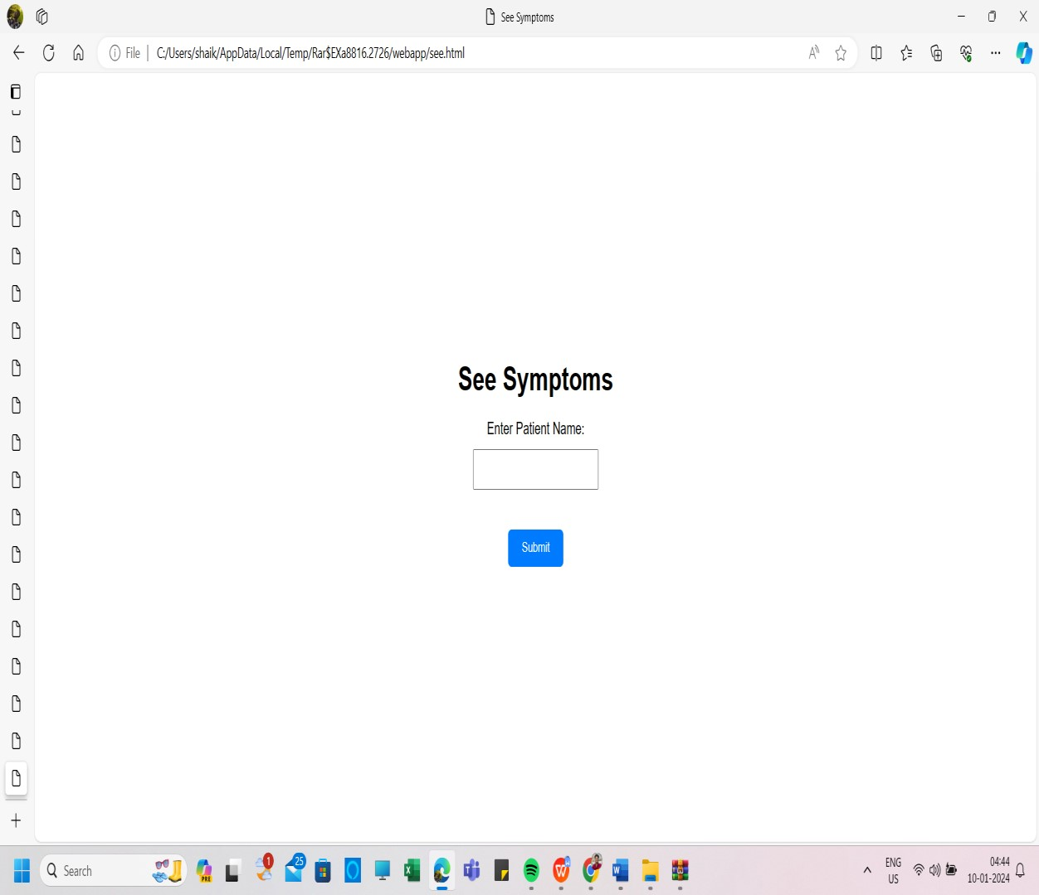

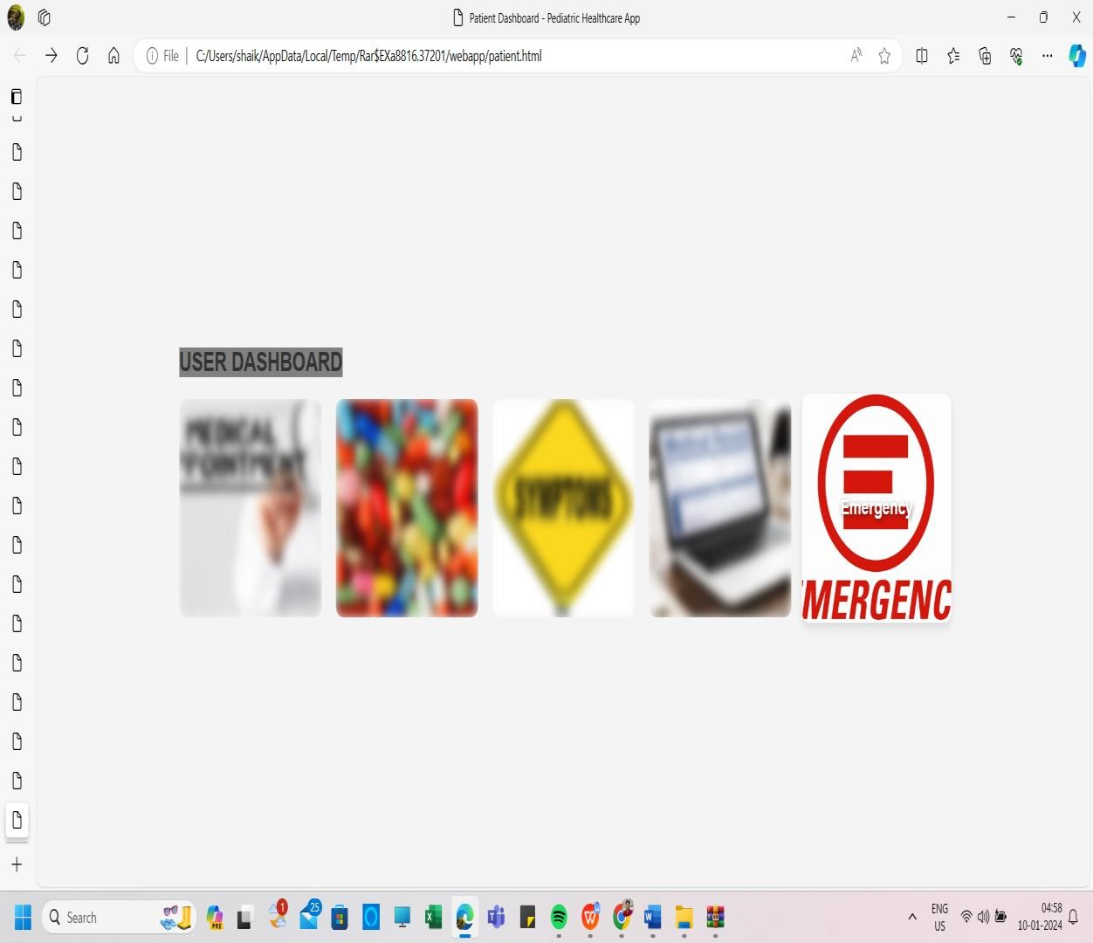

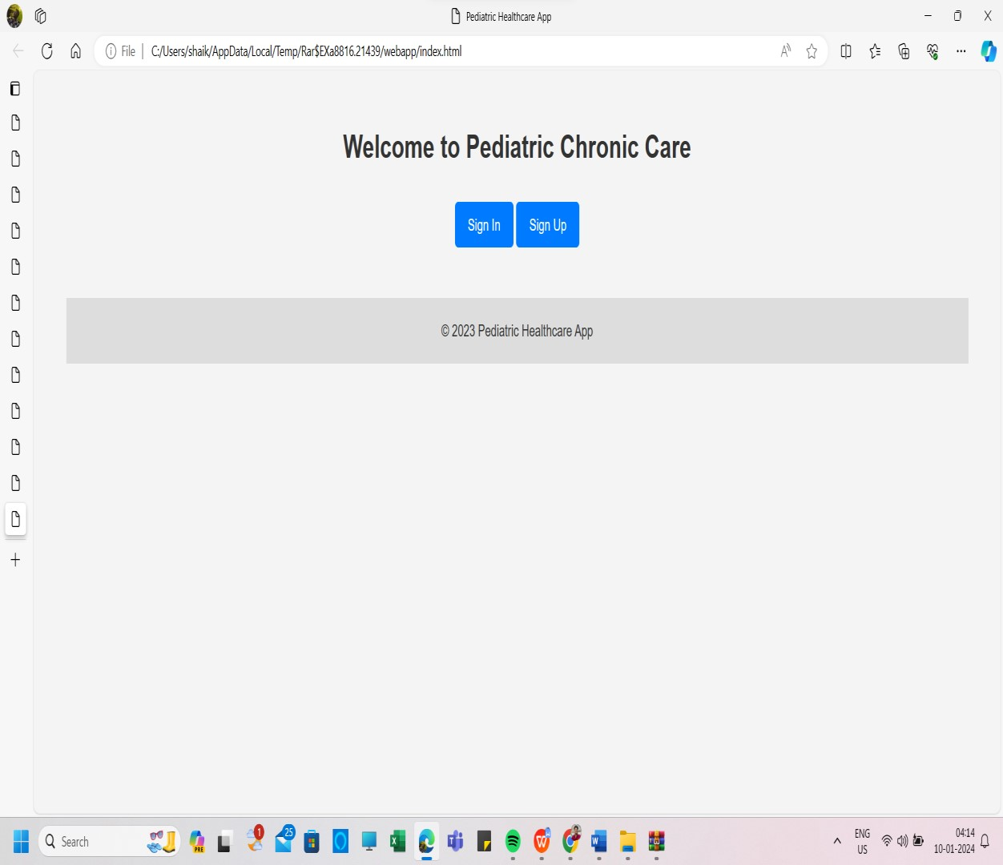

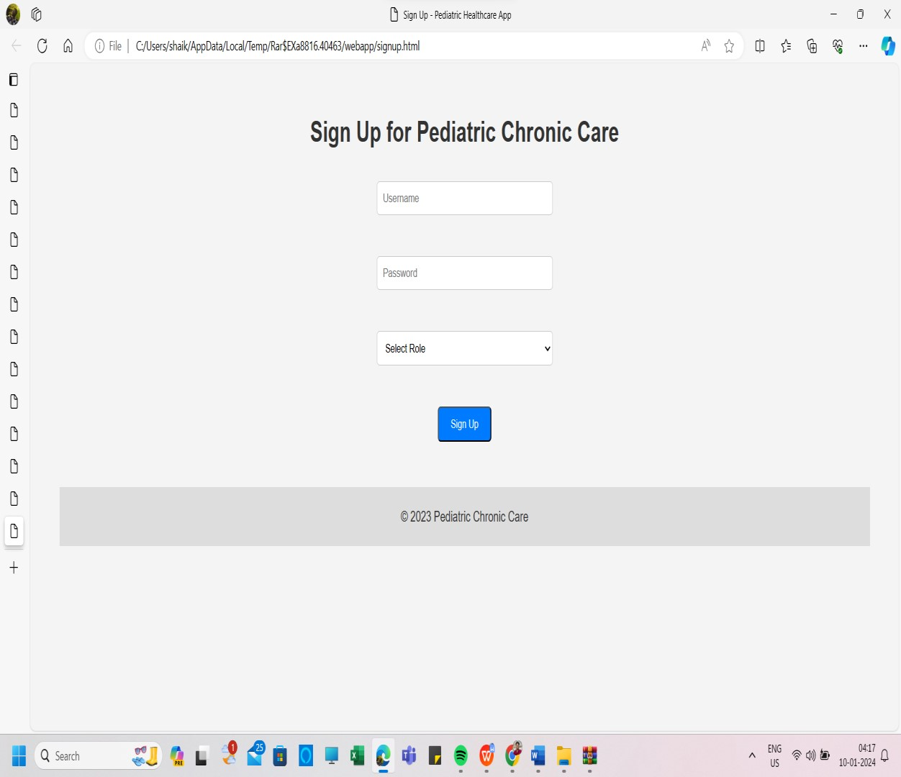

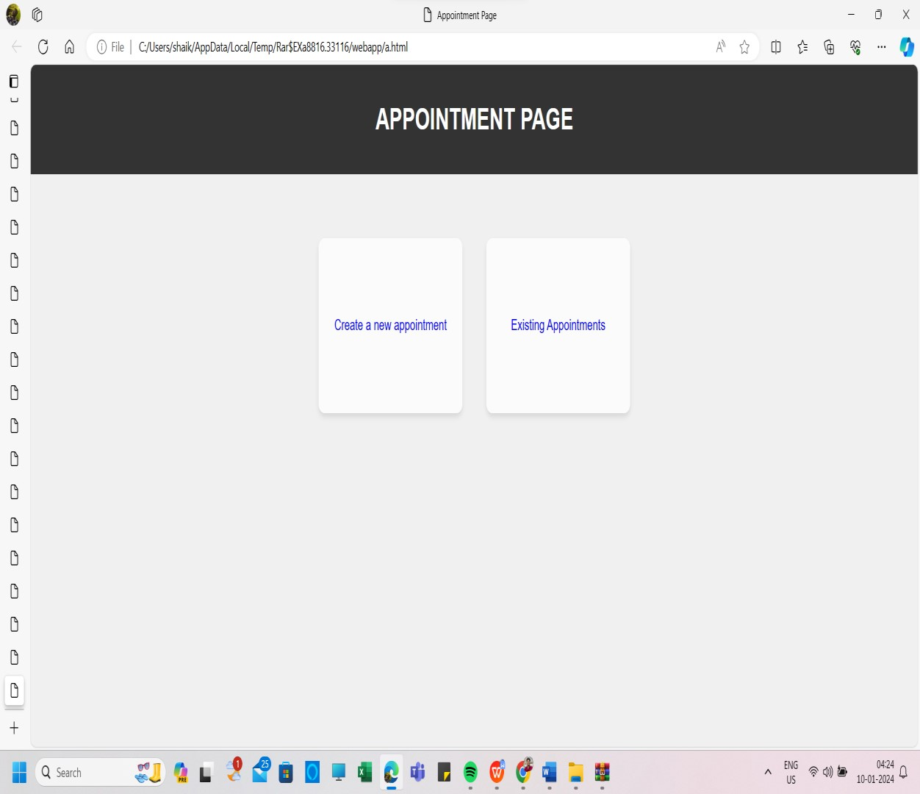

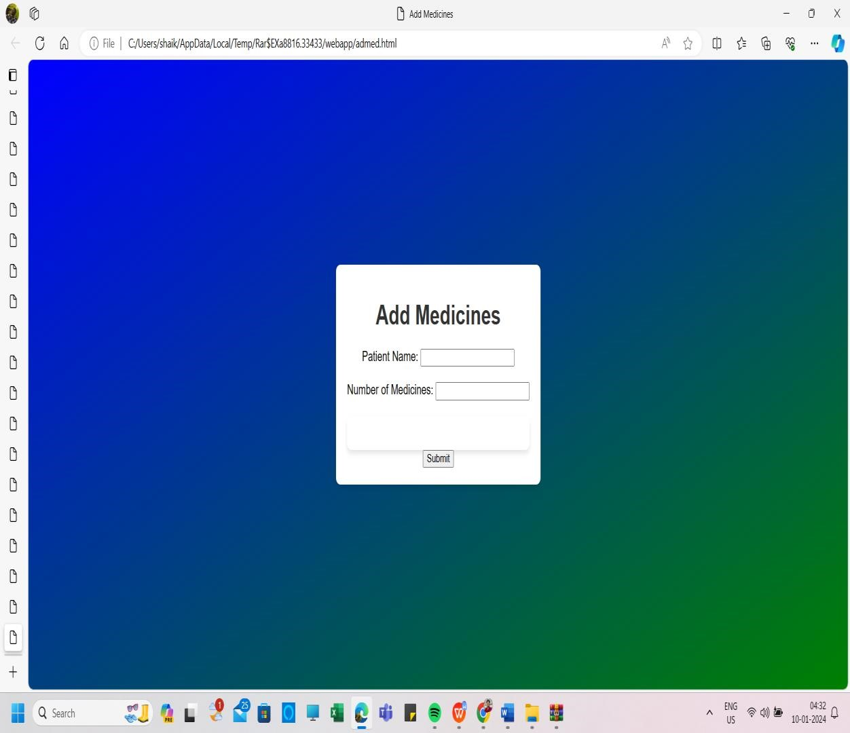

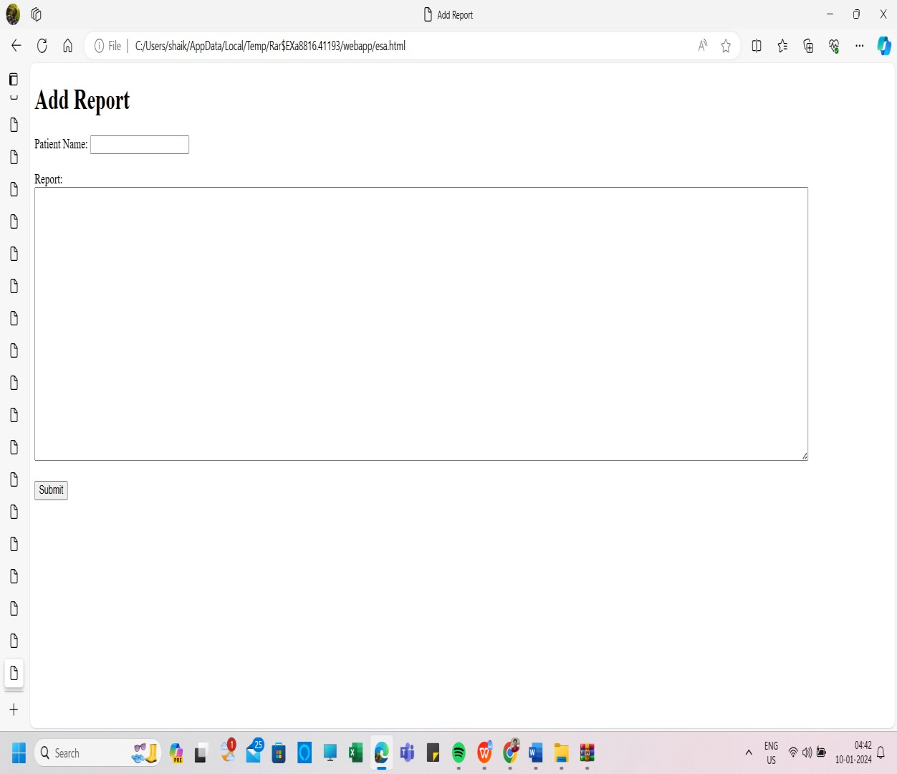

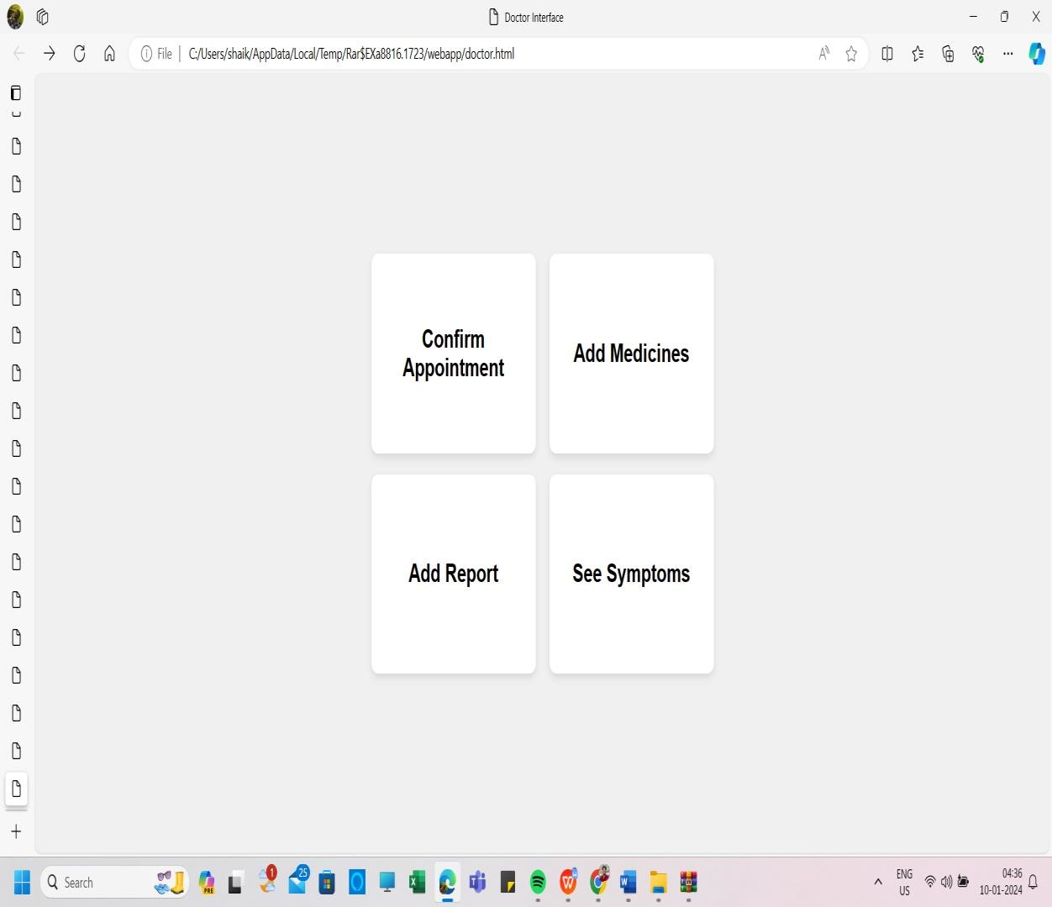



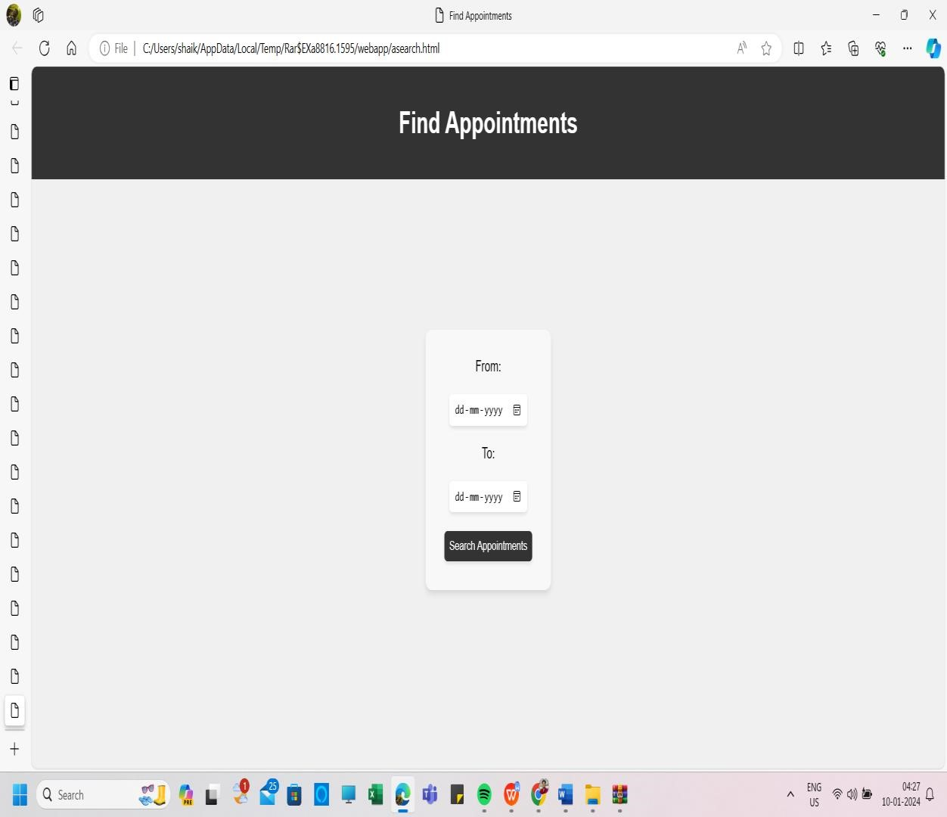

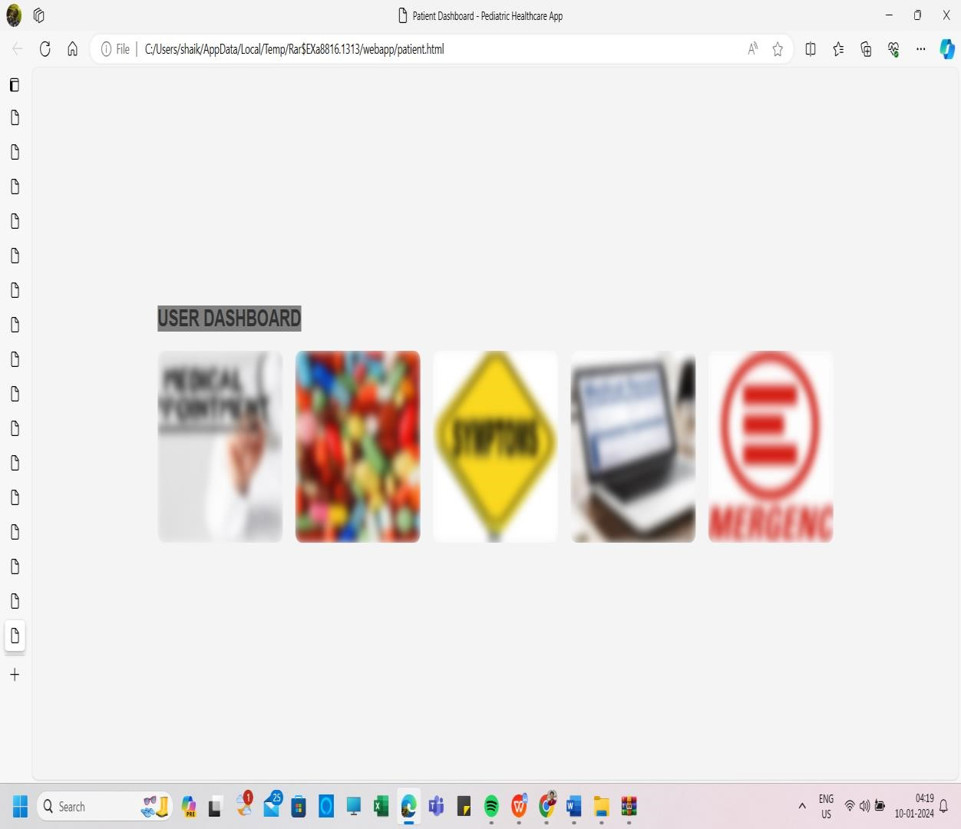

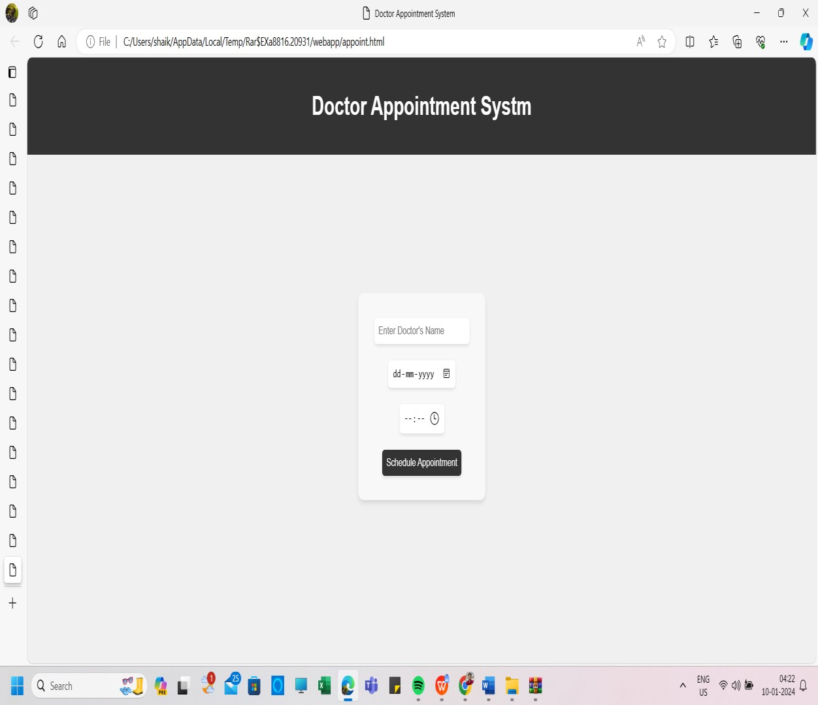

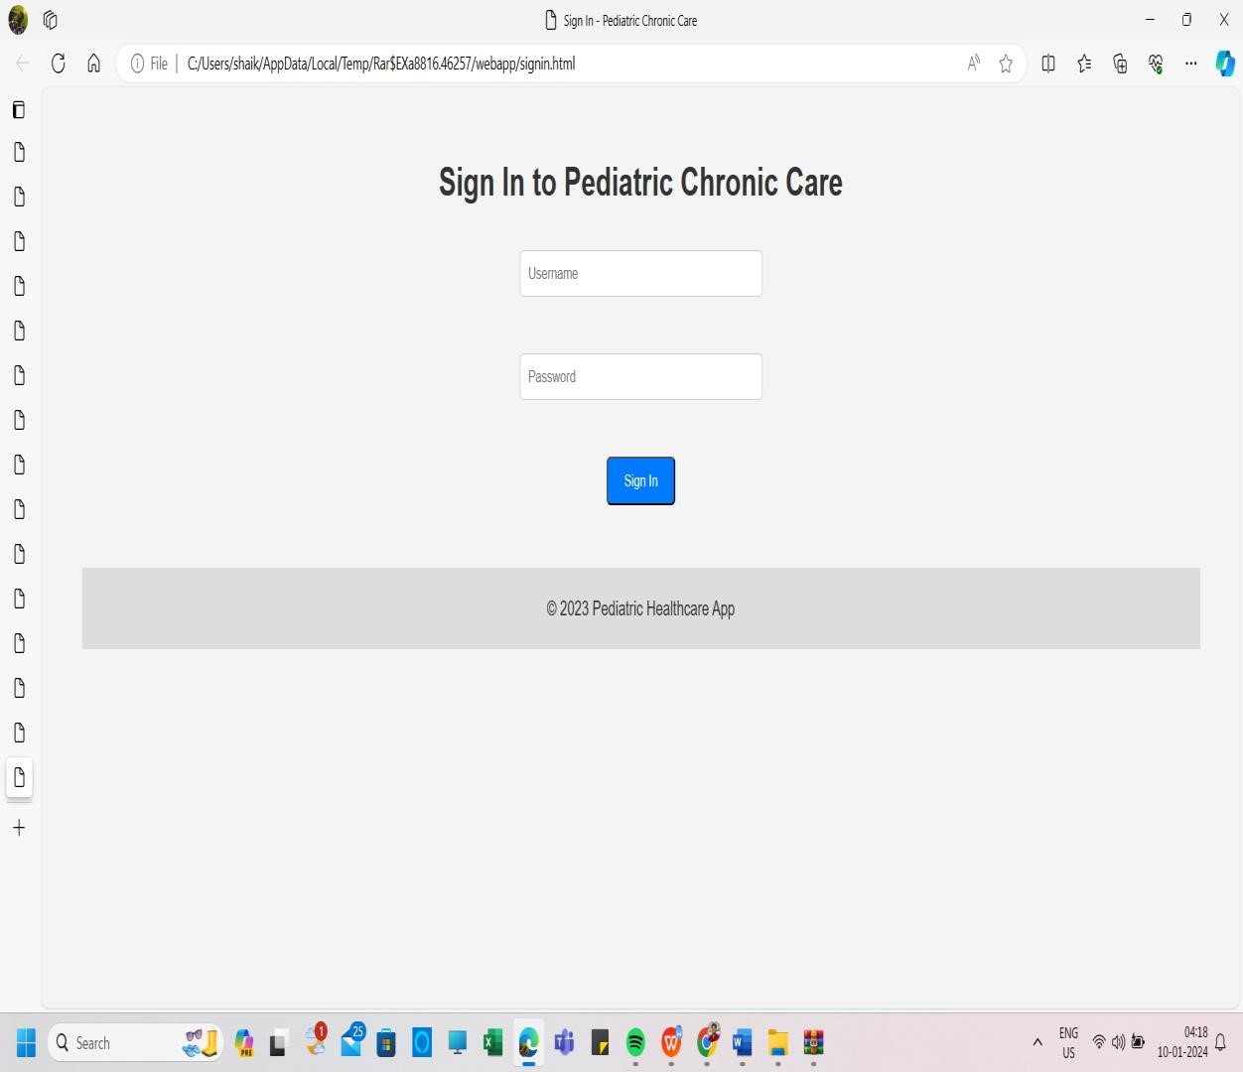

# ENCLOSURES

1.Conference Paper Presented Certificates of all students.

2.Similarity Index / Plagiarism Check report.

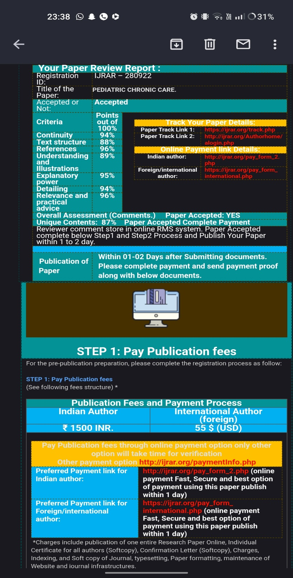

**Plagiarism check report for report:**

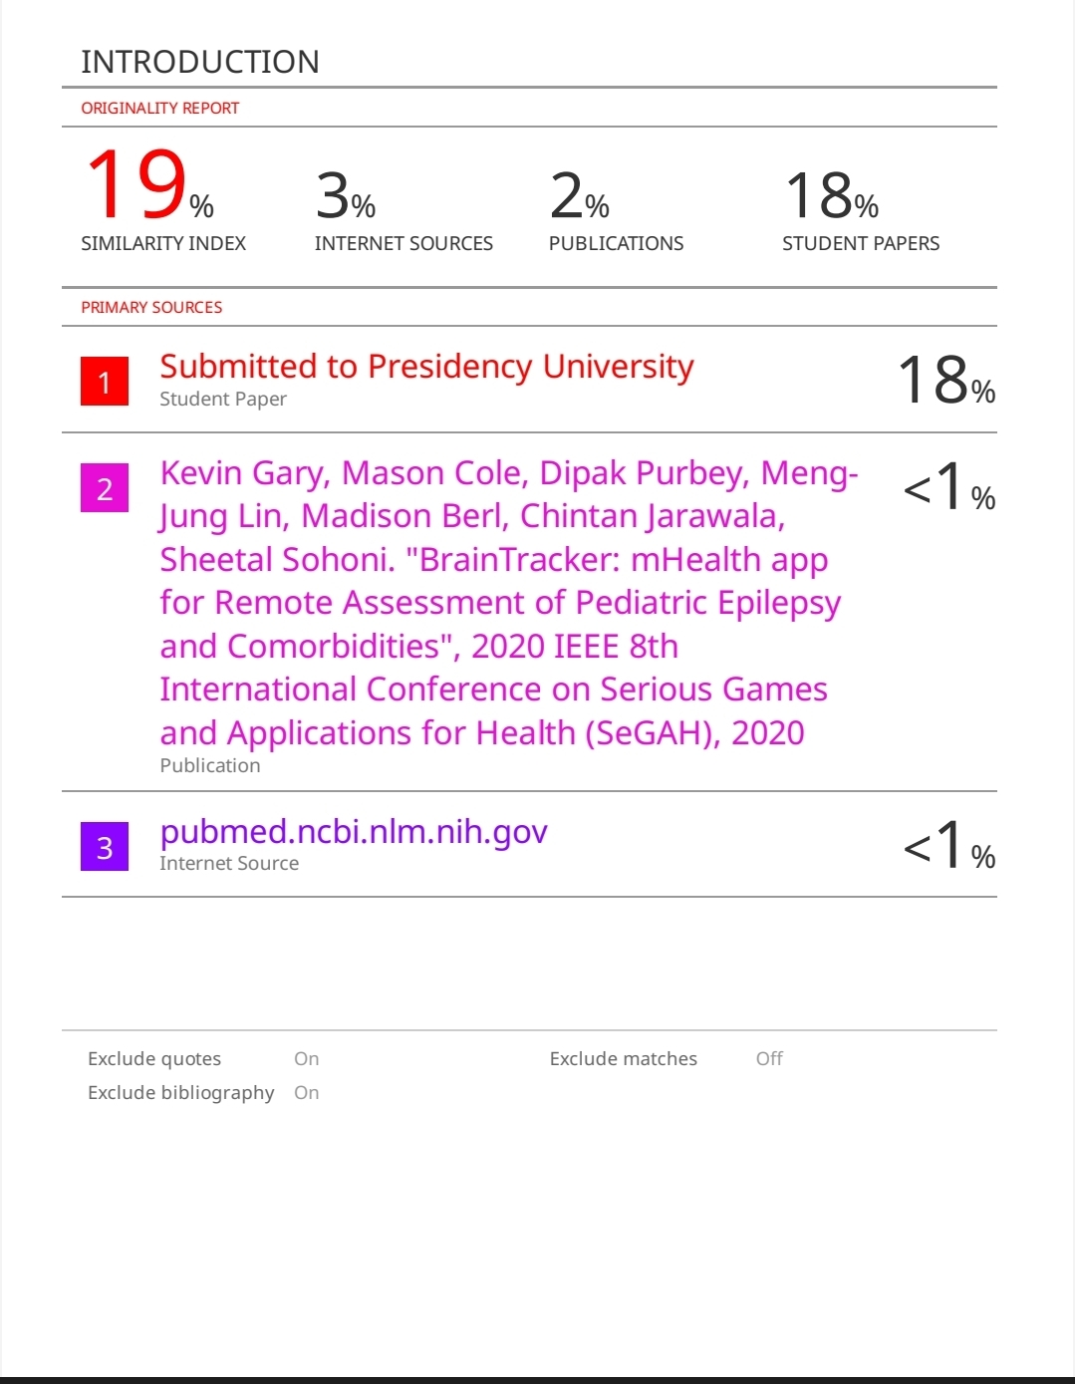

**Plagiarism check report for research paper:**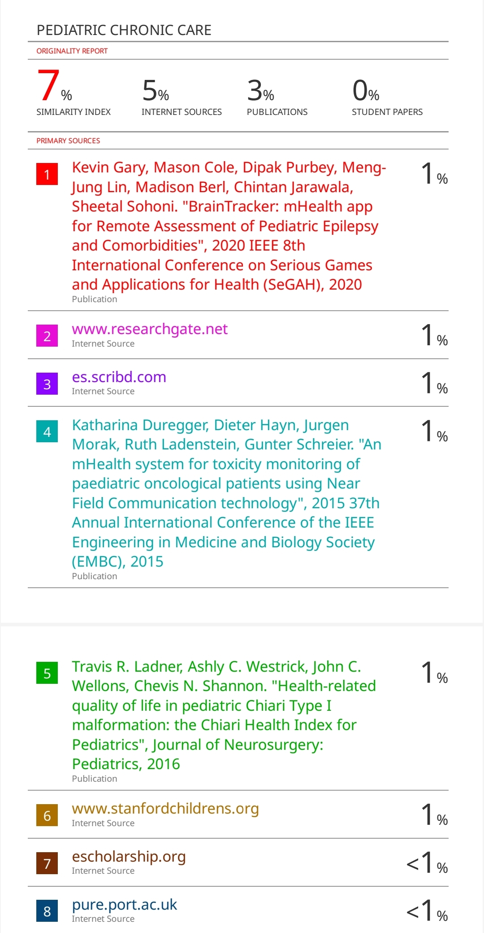



The Project work caried out here is mapped to SDG-3 Good Health Well-Being.

Pediatric chronic care ensures continuous monitoring and management of children's health conditions, promoting early intervention and prevention. It fosters a holistic approach, addressing not only physical but also emotional and developmental aspects for comprehensive well-being. By facilitating regular check-ups and personalized care plans, it enhances the quality of life for children with chronic illnesses and supports their families. Ultimately, pediatric chronic care contributes to improved health outcomes and a better overall quality of life for young patients.