# Save Page

Website link

<https://htmlstream.com/preview/space-v1.2/html/home/classic-business.html>

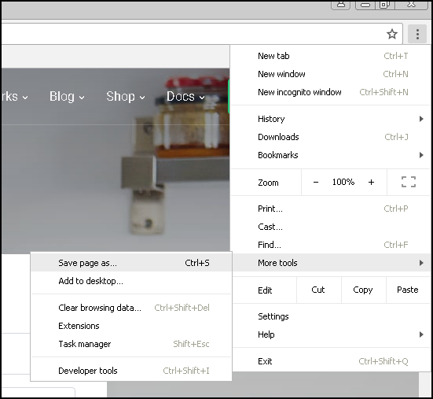

After saving : Folder contains – css , js , images , fonts

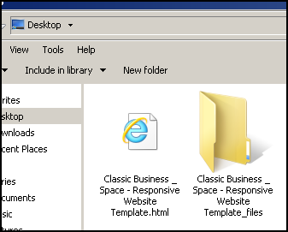

# Sort the content of folder by Type

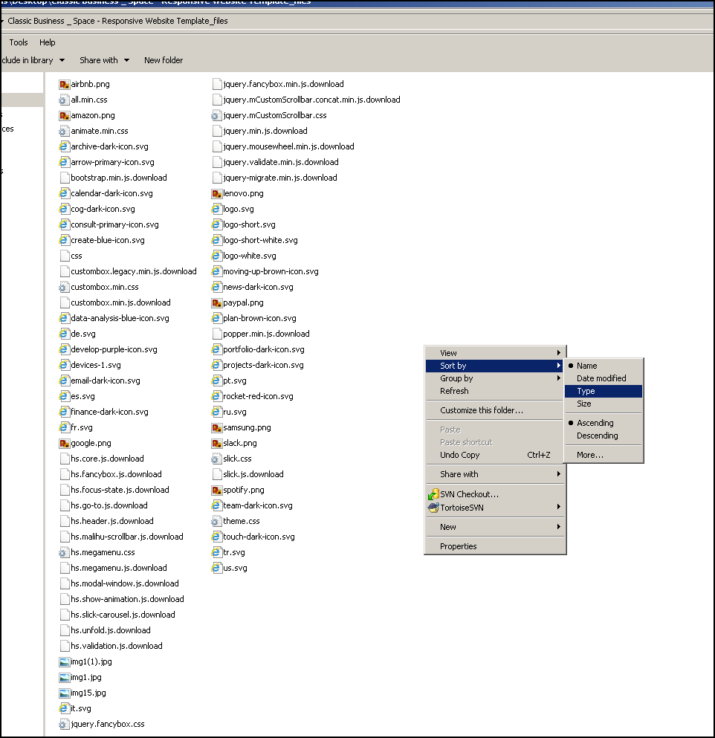

Divide the css js and images in 3 different folders

|  |  |
| --- | --- |
|  |  |
| .css | Put in css folder |
| .js.download | Put in js folder. We also need to rename the file to .js |
| .jpg  .png  .svg | Put in images folder |
| Filename :  css | Don’t copy this file |

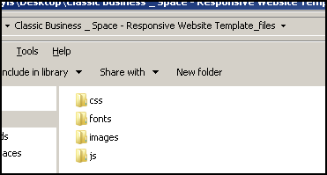

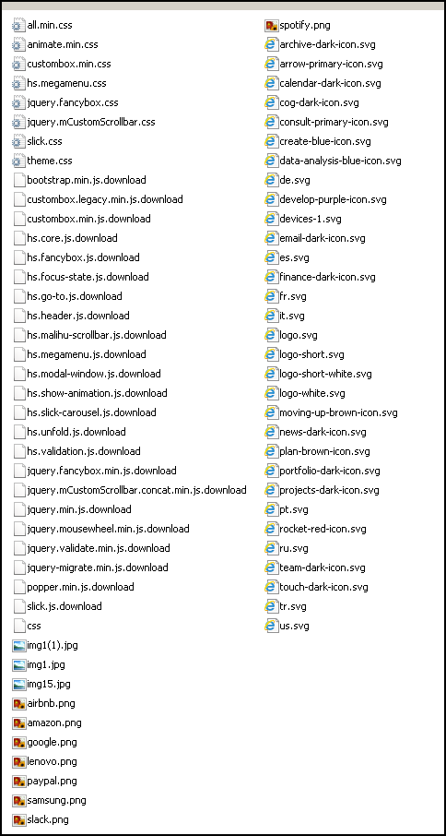

# Rename html file to index.html

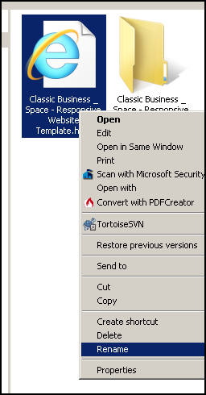

# Cut & Paste in the folder

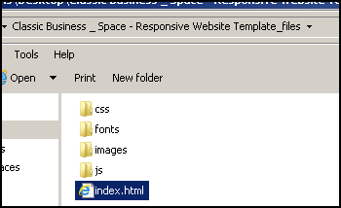

# Find & Replace in index.html

|  |  |
| --- | --- |
| Find | Replace |
| .js.download | **js** |
| ./Classic Business _ Space - Responsive Website Template_files | images  css  js  **Depending upon whether the file is js/css/images** |
| &quot; | “ |
| Replace the website link with blank  [*https://htmlstream.com/preview/space-v1.2/html/home/classic-business.html*](https://htmlstream.com/preview/space-v1.2/html/home/classic-business.html) |  |
| Replace css file – Google fonts by inspecting and copying directly from website |  |
| After replacing it will become |  |
|  |  |

# Fixing icons

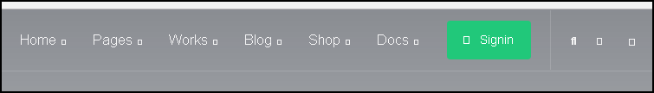

Click here

Find the css where the font is taken from.

In this case it is all.min.css:5

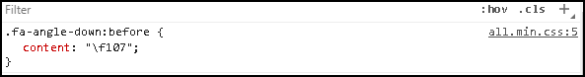

From all.min.css , we found that it is taken from font awesome

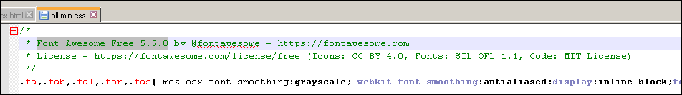

So, we need to go to font awesome. Copy the font path.

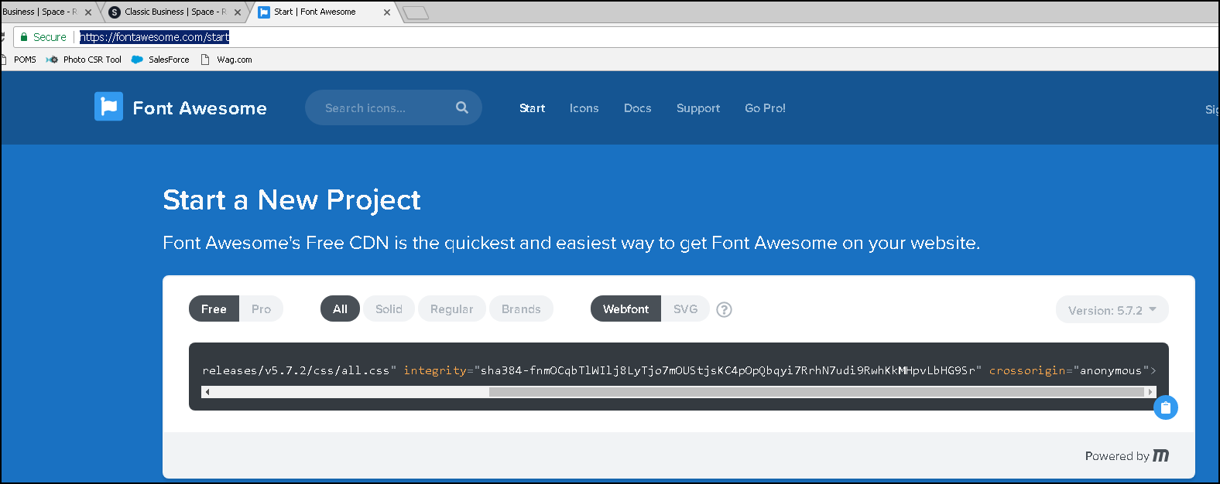

Click here

Replace the path of all.min.css



Replace with



# Fixing some images not found



Click here and download the image

Inspect and see the path of the images

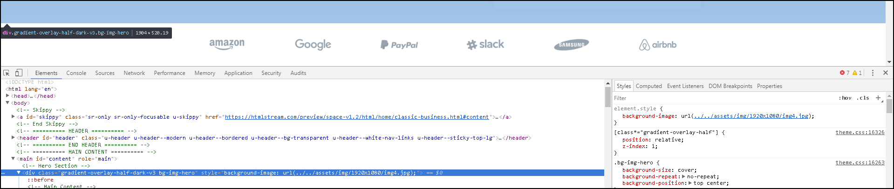

Update the path of the image

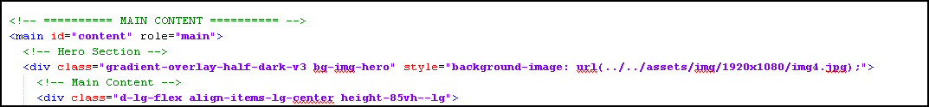

# Fixing slider if not working



Find which is the slider used by inspecting the code.

**In this case it is SLICK-CAROUSEL.**



Find a sample code in google , how the slick carousel works



See how the code changes from HTML to actual view

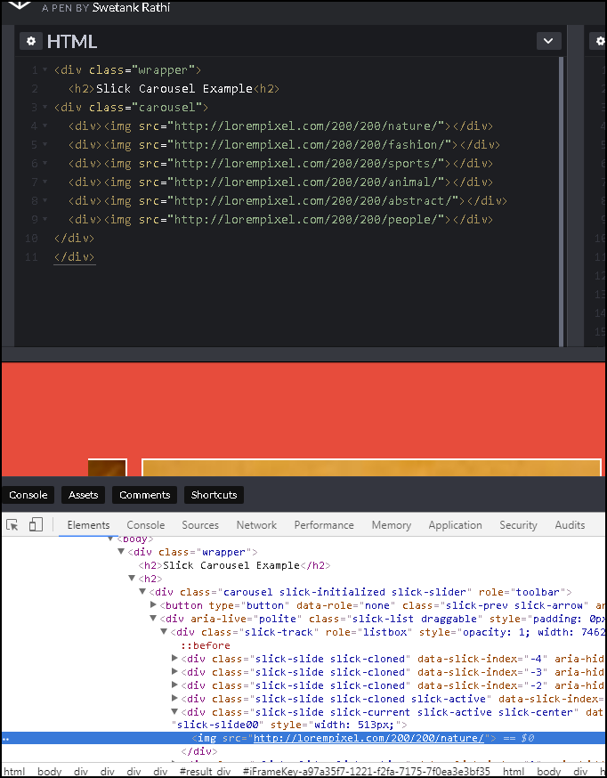

Remove the code that is not required by seeing the google example.

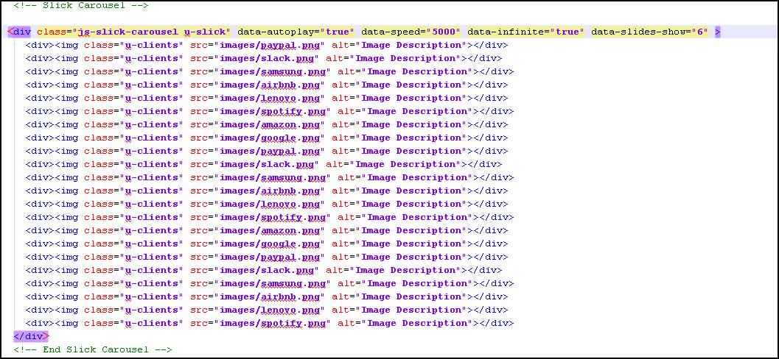

Now the code will work.

