



# Creating Menus





function register_theme_menus(){

register_nav_menu( 'primary_menu','Primary Menu' );

}

add_action('init','register_theme_menus');

1_Create all Pages

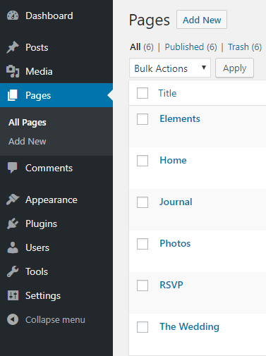

2_ Create a new Menu – Primary Menu



3_Select the Primary Menu – checkbox > Save Menu

4_Add li classes



5_Changing static html to dynamic content in Menu

<!-- Primary Menu start -->

<nav id="main_menu" class="menugray">

<ul>

<li><a class="selected fade-page" href="index.html"><span data-hover="HOME">HOME</span></a></li>

<li class="menu-item-has-children"><a><span data-hover="THE WEDDING">THE WEDDING</span></a>

<ul class="sub-menu menuwhite">

<li><a href="#" class="fade-page">CEREMONY</a></li>

<li><a href="#" class="fade-page">LOCATION</a></li>

<li><a href="#" class="fade-page">BRIDESMAIDS</a></li>

</ul>

</li>

<li><a href="#" class="fade-page"><span data-hover="JOURNAL">JOURNAL</span></a></li>

<li><a href="#" class="fade-page"><span data-hover="PHOTOS">PHOTOS</span></a></li>

<li><a href="#" class="fade-page"><span data-hover="ELEMENTS">ELEMENTS</span></a></li>

<li><a href="#" class="fade-page"><span data-hover="RSVP">RSVP</span></a></li>

</ul>

</nav>

<?php

$args = array(

'theme_location' => 'primary_menu',

'menu' => 'Primary Menu',

'container' => 'nav',

'container_class' => 'menugray sticky',

'container_id' => 'main_menu'

);

wp_nav_menu($args);

?>

<!-- Primary Menu end -->

<https://developer.wordpress.org/reference/functions/wp_nav_menu/>

# Table Size Used

SELECT   A.tablespace_name tablespace, D.mb_total,

         SUM (A.used_blocks * D.block_size) / 1024 / 1024 mb_used,

         D.mb_total - SUM (A.used_blocks * D.block_size) / 1024 / 1024 mb_free

FROM     v$sort_segment A,

         (

         SELECT   B.name, C.block_size, SUM (C.bytes) / 1024 / 1024 mb_total

         FROM     v$tablespace B, v$tempfile C

         WHERE    B.ts#= C.ts#

         GROUP BY B.name, C.block_size

         ) D

WHERE    A.tablespace_name = D.name

GROUP by A.tablespace_name, D.mb_total;