Pearl Mart Milestone 1 Report
SID: 202403264 Student Name: AlMayasa Al-Khelaifi
SID: 202402368 Student Name: Shamma Al-kaabi
SID: 202305215 Student Name: Sarah Al-Hajri
SID: 202314077 Student Name: Hafsa Moulana Hafez
*Effort: All students contributed to 25% of this project leading to a total of 100%*

Course number: B51
Submission date: 18/10/26
Theory: L52
GitHub Repository: https://github.com/sa2305215/PearlMart-MileStone1

Declaration: We hereby certify that no part of this project or product has been copied from any other student’s work or from any other sources except where due acknowledgement is made in the project. No part of this project/product has been written/produced for us by any other persons.

Data Flow Diagrams:

Level 0 DFD: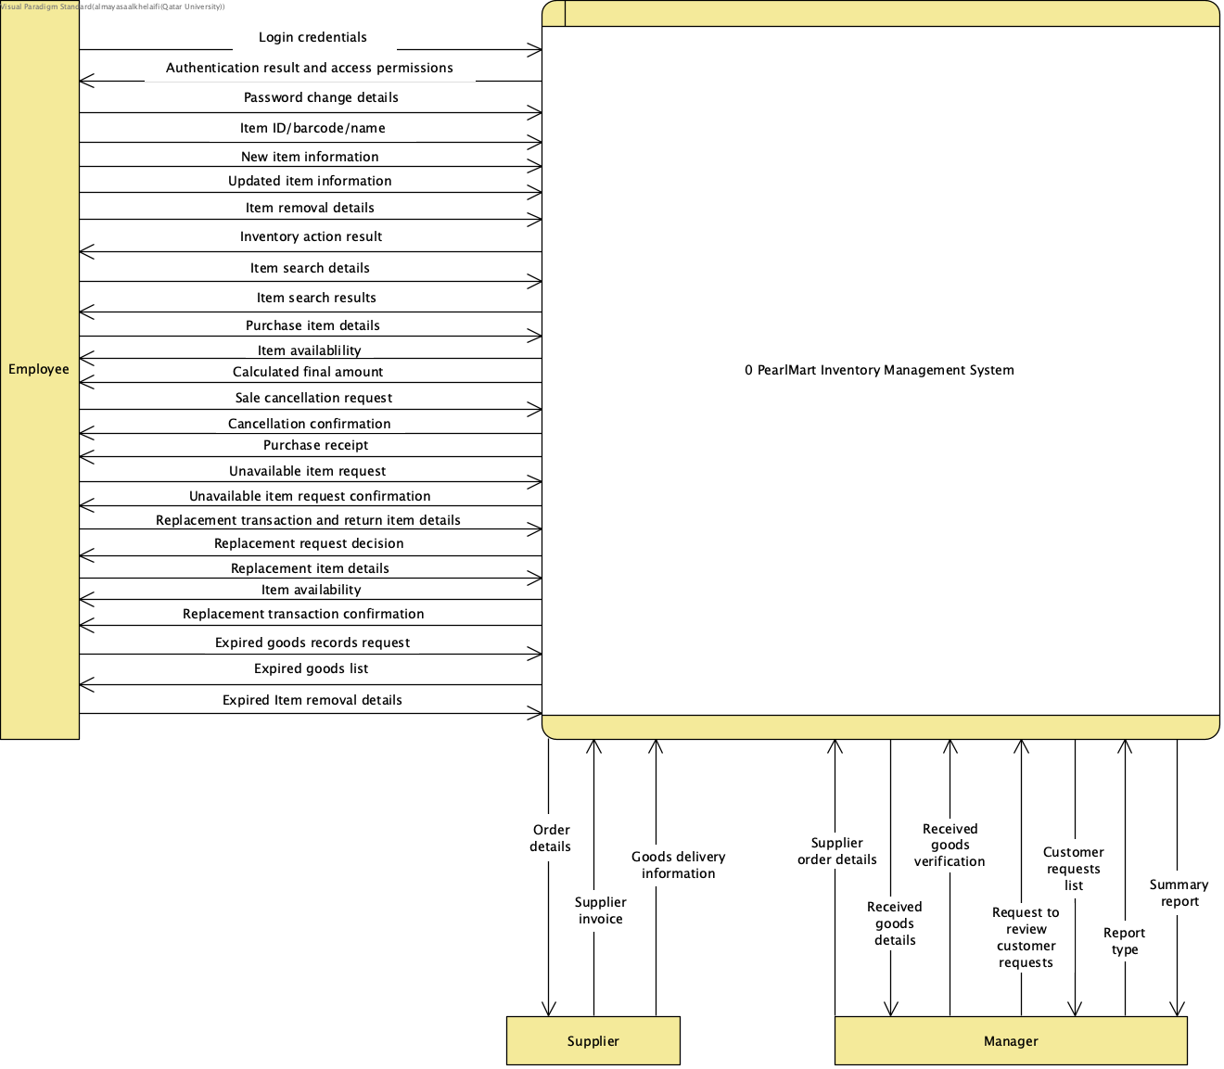

Level 1 DFD:
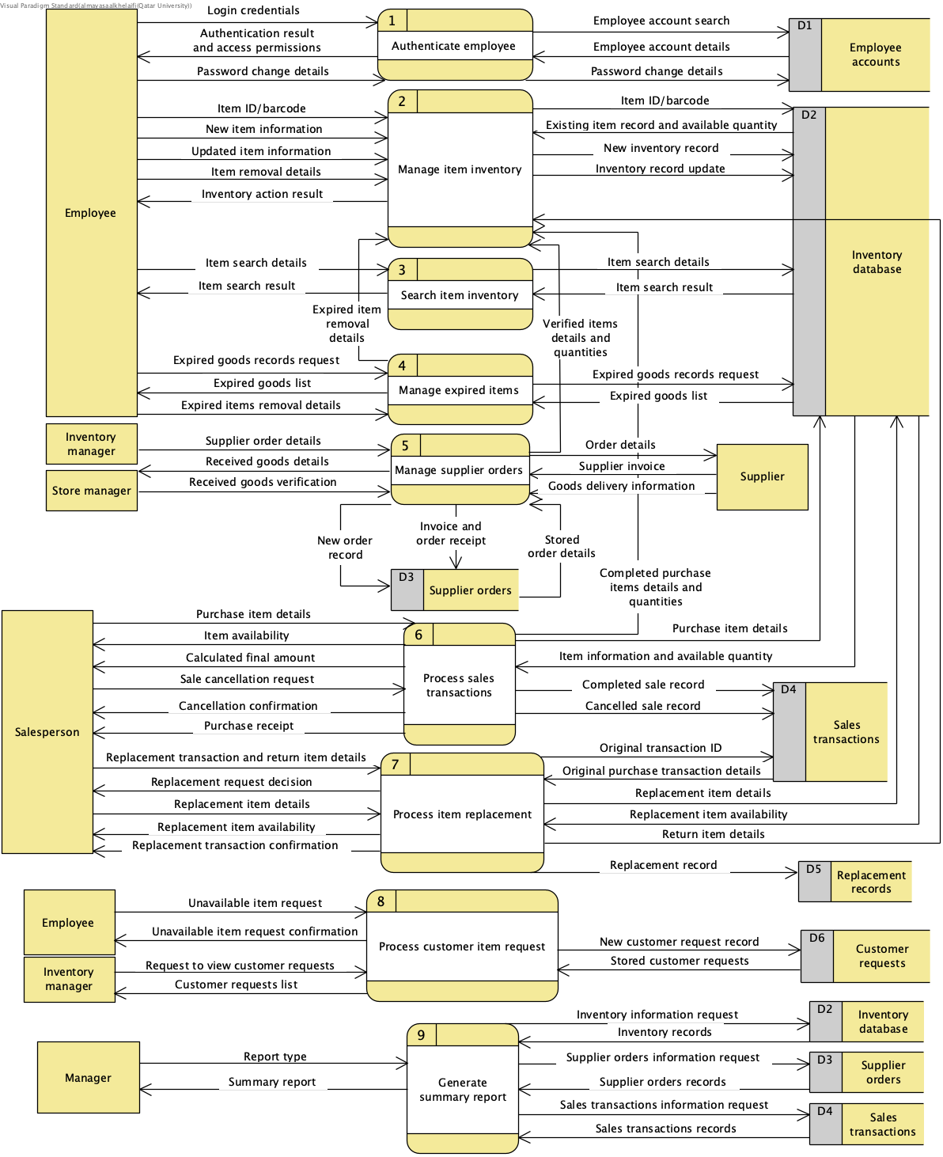

Level 2 DFD:
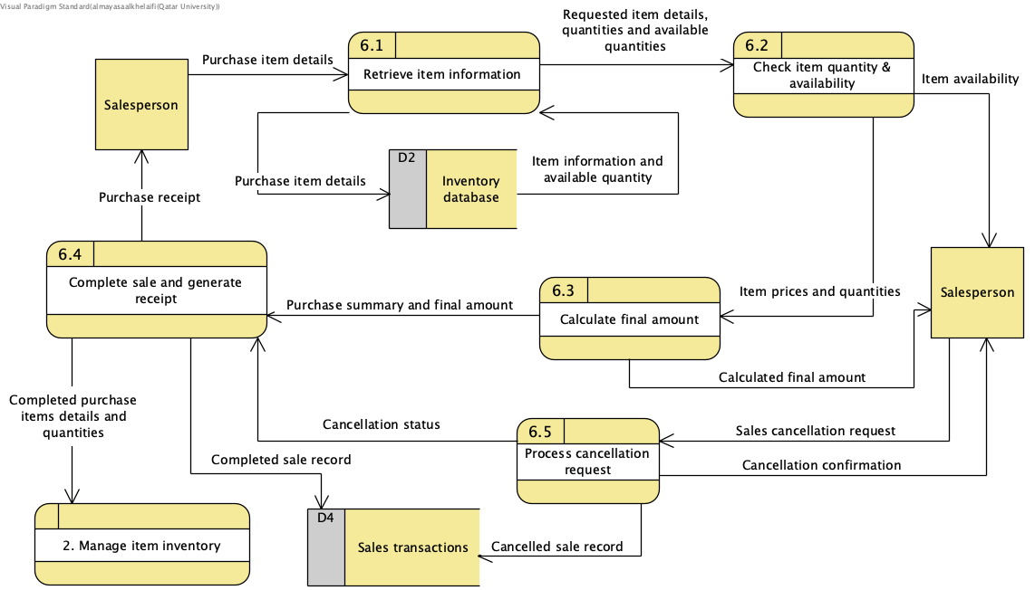
DFD-0 and DFD-1 balancing |  | DFD-1 and DFD-2 balancing
Level 0 Data Flow | Level 1 | Level 1 Data Flow | Level 2
Login credentials | Balanced | Purchase item details | Balanced
Authentication result and access permissions | Balanced | Item availability | Balanced
Password change details | Balanced | Calculated final amount | Balanced
Item ID/barcode/name | Balanced | Sale cancellation request | Balanced
New item information | Balanced | Cancellation confirmation | Balanced
Updated item information | Balanced | Purchase receipt | Balanced
Item removal details | Balanced | Completed purchase item details and quantities | Balanced
Inventory action result | Balanced | Item information and available quantity | Balanced
Item search details | Balanced | Completed sale record | Balanced
Item search results | Balanced | Cancelled sale record | Balanced
Purchase item details | Balanced | N/A | N/A
Item availability | Balanced | N/A | N/A
Calculated final amount | Balanced | N/A | N/A
Sale cancellation request | Balanced | N/A | N/A
Cancellation confirmation | Balanced | N/A | N/A
Purchase receipt | Balanced | N/A | N/A
Unavailable item request | Balanced | N/A | N/A
Unavailable item request confirmation | Balanced | N/A | N/A
Replacement transaction and return item details | Balanced | N/A | N/A
Replacement request decision | Balanced | N/A | N/A
Replacement item details | Balanced | N/A | N/A
Item availability | Balanced | N/A | N/A
Replacement transaction confirmation | Balanced | N/A | N/A
Expired goods records request | Balanced | N/A | N/A
Expired goods list | Balanced | N/A | N/A
Expired item removal details | Balanced | N/A | N/A
Order details | Balanced | N/A | N/A
Supplier invoice | Balanced | N/A | N/A
Goods delivery information | Balanced | N/A | N/A
Supplier order details | Balanced | N/A | N/A
Received goods details | Balanced | N/A | N/A
Received goods verification | Balanced | N/A | N/A
Request to review customer requests | Balanced | N/A | N/A
Customer requests list | Balanced | N/A | N/A
Report type | Balanced | N/A | N/A
Summary report | Balanced | N/A | N/A

Assumption table - Data Flow Diagram
Assumption | Justification
Authorized employees can perform inventory management operations according to their assigned roles and access permissions. | The requirements identify different employee roles but do not specify which roles are permitted to perform each inventory operation.
Summary reports are generated using records from Inventory Database, Supplier Orders and Sales Transactions data stores. | The requirements state that authorized managers can request summary reports based on inventory activities but there are no further details. Our assumption is that the summary reports will be generated through these three data stores as they represent the main inventory activities.
Supplier invoices and goods receipt information are stored in the Supplier Orders data store. | The requirements state that supplier orders are recorded but do not specify how. We assumed that recording relevant supplier information (invoices and receipts) will be most practical for processing deliveries and generating reports.
Process 2, Manage Item Inventory, is responsible for handling inventory updates initiated by other processes | Process 2 handles changes to inventory records in order to avoid duplicating operations. Process 4 passes expired item removal details, process 6 passes completed purchase item details and quantities, process 7 forwards returned and replacement item details for the corresponding inventory updates. These processes are able to to retrieve information about item availability from the inventory database directly, but modifications to the inventory are delegated to process 2.
The system provides confirmation messages and request decisions to employees after processing certain operations. | The requirements describe inventory updates, sales cancellations, item replacements and unavailable item requests. We assumed that after these are performed, the system notifies the employee if the operation has been completed successfully, and in the case of a request the system communicates a rejection or acceptance decision.
The system checks the availability of the requested replacement item before completing a replacement. | The requirements do not mention checking if the requested replacement item is available. We added it to prevent the system from accepting replacements that request unavailable items.

Use-case Diagram:
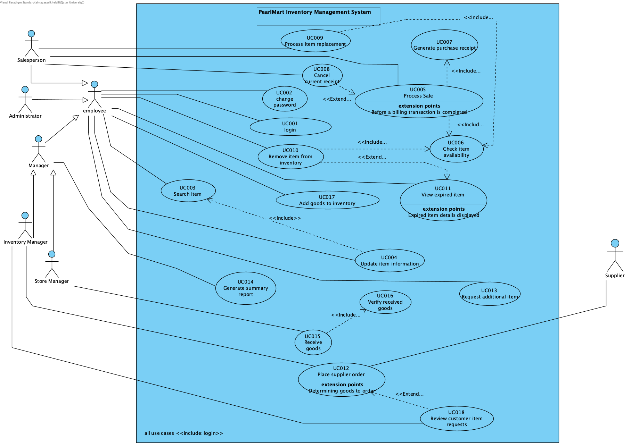

Assumption table – use case diagram
Assumption | Justification
Customer interactions are handled through employees, so Customer is not shown as a separate actor. | Salespersons enter sales and replacement details and authorized employees record customer item requests.
Employee groups the common actions of employee roles, while each role can access only its permitted functions. | The description says “authorized employee” without assigning every function to a specific role.
Manager is a general actor specialized in Inventory Manager and Store Manager. | Groups their shared ability to request summary reports.
Update Item Information includes Search Item, treating item retrieval as the same search behavior. | The employee must locate the item before changing its information.
Removal can be initiated while viewing expired goods, after their details are displayed. | Supports the optional «extend» relationship from Remove Item to View Expired Item.

UCD vs DFD comparison:
Data flow diagram:
- Strengths:
  - Shows how data is recorded in the system through the data stores.
  - Provided detailed information about information exchange between the individual processes.
- Limitations:
  - Does not show the responsibilities and permissions of actors.
  - Does not show the conditions required for certain actions to be performed.

Use case diagram:
- Strengths:
  - Shows which actors interact with the use cases through associations.
  - Represents relationships between use cases through include and extend relationships.
  - Demonstrates the conditions required for a specific use case to initiate (through ‘extend’ relationships).
- Limitations:
  - Does not show what data is needed to perform the specific processes, just the actors
  - Does not show how data is stored and when it is recorded.

Conclusion:
For the analysis question “How does PearlMart process and record a customer purchase?”, the ideal diagram would be a data flow diagram, as it displays in detail the movement of data between external entities and processes, data stores and processes, as well as between processes.The retrieval and storage of data is clearly represented in the diagram, which showcases inventory activities (and this is a main goal of the system).

For the analysis question “Which users are responsible for performing different operations?”, the use case diagram is more suitable as the use of actors in this diagram clearly represents the scope of an employee’s interaction with the system depending on their role.

Use Case Specifications:
1.
Use case ID: | UC009: Process item replacement
Brief description | Salesperson processes a request to replace a previously purchased item. The system retrieves the details of the original transaction and verifies the replacement request (following store policies). The replacement is recorded and the inventory is updated accordingly.
Primary actors | Salesperson
Trigger | The salesperson places an item replacement request on behalf of the customer.
Preconditions | - The salesperson is logged in the system
Postconditions | The replacement transaction is recorded and the inventory quantities are updated accordingly.
Main success scenario
Actor action | System response
- Salesperson initiates an item replacement request.
- Salesperson enters original transaction ID and item details. | - System retrieves the original transaction details (see 3.a for alternative flow).
 | - System verifies the item’s eligibility for replacement according to store policies. (see 4.a for alternative flow).
- Salesperson enters replacement item details. | - System retrieves the replacement item information.
 | - <<include: Check Item Availability>> (check 7.a for alternative flow).
- Salesperson confirms the replacement | - System records the replacement transaction.
 | - System updates inventory by deducting the replacement item’s quantity and recording the returned item.
Alternative flows
3.a System cannot locate the original transaction and displays an error message. Inventory remains unchanged, no replacement is recorded and the use case terminates.
4.a System rejects the replacement request as the item does not qualify for replacement; the replacement is not recorded, inventory is unaffected and the use case terminates.
7.a System identifies that the requested replacement item is unavailable and displays an error message. Inventory remains unchanged, no replacement is recorded and the use case terminates.

2.
Use case ID: | UC012 Place supplier order
Brief description | The Inventory Manager prepares an order for additional goods specifying the required order details. The system records the order and forwards the necessary order information to the selected Supplier.
Primary actors | Inventory Manager. Secondary actor: Supplier.
Trigger | The Inventory Manager starts placing an order when additional goods are needed.
Preconditions | - The Inventory Manager is logged into the system and authorized to place supplier orders.
Postconditions | - The order details are recorded in the system.  - The necessary order information has been forwarded to the selected Supplier.
Main Success Scenario
Actor Action | System Response
- The Inventory Manager requests to view recorded customer item requests. | - If [review requested], the system extends to Review Customer Item Requests (UC018) «extend». The system retrieves and displays the recorded customer item requests.
- The Inventory Manager reviews the requests, selects a Supplier and enters the required item, quantity, delivery address, contact information, and any additional relevant comments. | - The System validates required fields and quantity values. (check 4.a and 4.b for alternative flow)
- The Inventory Manager confirms and submits the order. | - The System records the supplier order.
 | - The System forwards the necessary order information to the selected Supplier.
Alternative flows:

4.a. Invalid quantity: If the quantity is zero or negative, the system rejects the order submission and informs the Inventory Manager; the use case ends.
4.b. Missing required information: If required order information is missing, the system rejects the order submission and informs the Inventory Manager; the use case ends.

3.
Use Case ID and Title: | UC010: Remove Item from Inventory
Brief Description | Employee removes a specified quantity of an item from the store inventory.
Primary Actors | Employee
Trigger | Employee enters an item identifier.
Preconditions | - Employee is logged in.  - Employee authorized to access and manage inventory.
Postconditions | Selected quantities of items were removed from the inventory.
Main Success Scenario: Item was removed from the inventory and recorded.
Actor Action | System Response
- Employee identifies item.
- Employee specifies a quantity of the item to be removed. | - System retrieves item information based on provided identifier.
 | - <<include: check item availability>UC006>
 | - System reduces the available quantity of the item in the inventory.
 | - System records the changes inventory database.
Alternative flows:
3.a. Item is not in the inventory, and the system’s search returns an error and aborts the operation.
4.a The available quantity is less that the amount to be removed, the system does not process the request and the quantity remains the same.

4.
Use case ID | UC05 — Process Sale
Brief description | Allows the Salesperson to process customer purchases, calculate the final amount, issue a receipt, and update inventory after successful completion.
Primary actors | Salesperson
Trigger | Salesperson starts a sale for a customer.
Preconditions | Salesperson is logged in and authorized to process sales; inventory records are accessible.
Postconditions | Sale is recorded, a receipt is generated, and purchased quantities are deducted from inventory.
Main Success Scenario
Actor Action | System Response
1. Salesperson starts a new sale transaction. | 2. Open a new sale transaction.
3. Salesperson scans an item barcode or enters its identifier. | 4. Retrieve and display item information.
5. Salesperson enters the quantity to purchase. | 6. <include: check item availability>
 | 7. Calculate the selling amount, including applicable discounts and taxes, for an available item; update the running total.
9. Salesperson repeats steps 3–7 for each additional item.
10. Salesperson indicates that item entry is complete. | 11. Calculate and display the final amount to be paid.
 | 12. <extend: Cancel Receipt> if the Salesperson requests cancellation before the transaction is completed; end the sale without permanently deducting stock.
13. Salesperson confirms completion of the sale. | 14. <include: Generate Receipt>
 | 15. Record the completed sale and deduct purchased quantities from inventory.
 | 16. Mark the transaction completed and confirm success.
17. Salesperson provides the receipt to the customer.
Alternative Flows
4a. If no item matches the entered identifier or barcode, display an item-not-found error. End the use case without completing a sale or changing inventory.
6a. If the requested quantity exceeds available stock and the customer does not request the unavailable quantity, display an insufficient-stock message and the available quantity. End the use case without completing a sale or changing inventory.

Design class diagram:
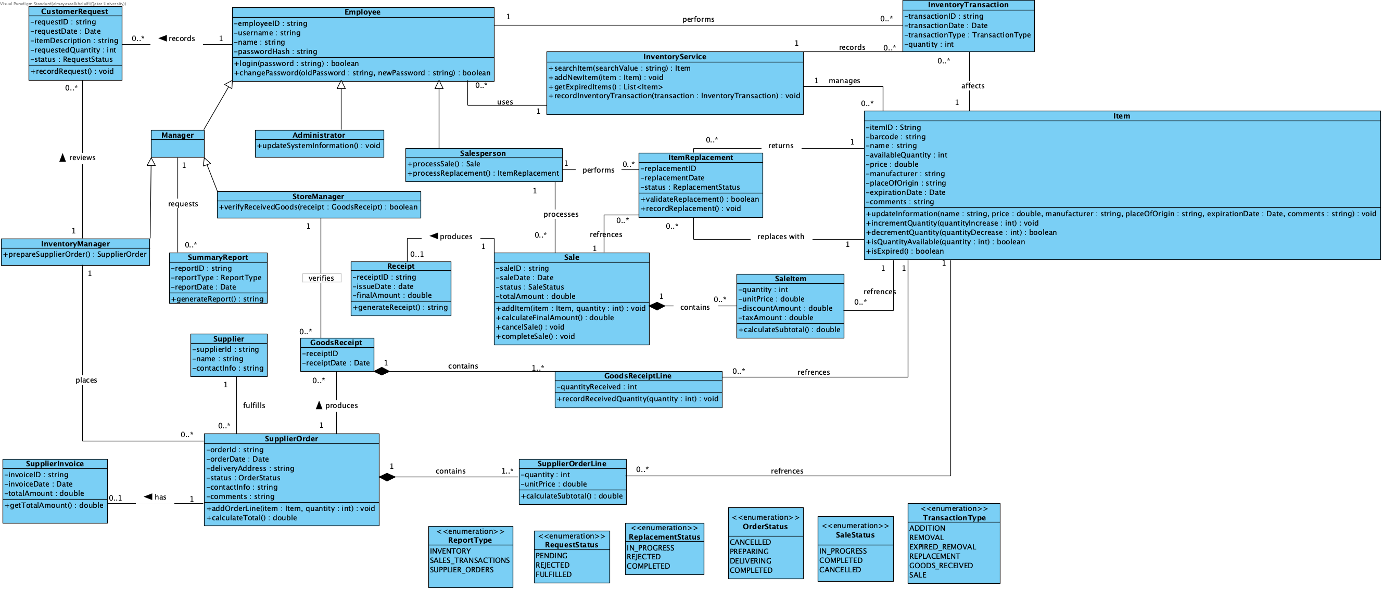
Design responsibility explanation:
- Responsibility assignment: operations are assigned to classes based on their purpose. InventoryService class coordinates inventory operations such as searching for items, adding new items, retrieving expired items and recording inventory transactions. Item class manages the individual item information with methods such as incrementQuantity, decrementQuantity, updateInformation. InventoryTransaction stores the type of transaction being performed, transaction id, date and quantity.
- Encapsulation: the system encapsulates sensitive data by setting accessibility modifiers to attributes and declaring them as public (+) or private (-). Item class, for one, contains attributes such as itemID and name that are private and are modified through methods such as updateInformation(). Similarly, Employee class includes credentials as private attributes, and methods like changePassword() provide controlled ways of using the data or updating it.
- Abstraction: abstraction is applied through having a set number of simplified interfaces that represent the essential functionalities of the class while hidding the internal implementation details. The system achieves that in classes like InventoryService class , which states methods such as searchItem() that allow high level understanding of the main operations while not exposing the internal details such as row searchs or retrievals. In similar fashion, the Sale class provides methods such as calculateFinalAmount() that allow collapsing multiple internal operations into one function, without having to handle every calculation or item information retrieval.
- Modularity: the system is designed so groups of classes perform specific functions to support the concept of modularity. For instance, InventoryService coordinates broader inventory operations while Item controls individual item information and InventoryTransaction maintains records of inventory transactions. Similarly, SupplierOrder, SupplierOrderLine, SupplierInvoice and GoodsReceipt divide responsibilities related to supplier orders.
- Justification of class relationships:
  - Inheritance: Employee is inherited by Salesperson, Administrator and Manager. Manager is inherited by StoreManager and InventoryManager. This is justified because employees share similar attributes and responsibilities but they also have class-specific responsibilities.
  - Composition: composition occurs between SupplierOrder and SupplierOrderLine, Sale and SaleItem, GoodsReceipt and GoodsReceiptLine. This is justified because the former classes have strong ownership over the latter classes, e.g. SaleItem cannot exist independently of Sale.
  - Association: represents interaction without strong ownership, which is the case for most class interactions, e.g. Employee uses InventoryService, InventoryService manages Item and records InventoryTransaction objects.

Assumption table - Class Diagram
Assumption | Justification
InventoryService centrally manages inventory operations. | InventoryService coordinates searching and adding new item records to support system requirements. Item class handles individual item details and quantities; this ensures there are no redundancies in assigning responsibilities.
Every inventory transaction is associated with one employee. | Transactions are related to one employee to maintain responsibility and accountability.
Each inventory transaction affects one item. | Inventory changes are recorded separately for each item even when multiple items are included in a sale or goods delivery.
A supplier order produces exactly 1 invoice. | An order can exist before an invoice is received, and orders can be cancelled by the supplier. Only one invoice is associated with a fulfilled order.
A supplier order can have multiple receipts. | A receipt may not be generated if the order is not accepted by the supplier. Multiple receipts can be generated if the order is delivered in multiple installments or if the delivery is split into multiple shipments.
A sale can contain multiple items, each item in a sale is represented by SaleItem class. | SaleItem stores the quantity and price for each item as well as applicable taxes and discounts.
Only completed sales generate receipts. | Sale can have 0 or 1 receipts, which supports the sale cancellation functionality.
ItemReplacement references one original sale and a sale can have multiple replacement requests. | Item replacement is associated with a single sale, referencing the original sale, and a single sale can have multiple replacement requests.
Each replacement transaction has one returned item and one replacement item. | ItemReplacement class has two associations with Item class to represent the item being returned and the item being provided as a replacement.
Customer requests are recorded through authorized employees. | CustomerRequest stores customer comments and requested item quantities while Employee records the request.
Summary reports are classified into inventory, sales transactions and supplier order reports. | This is consistent with our assumption in our level 1 DFD of how summary reports are categorized.

Trace table
Trace Table
Requirement | DFD process | Use case | Class
Authenticate authorized employee and allow password changes. | Authenticate employee | Login  Change password | Employee
Managing inventory: add new items, update existing item information, remove items. | Manage item inventory | Add goods to inventory  Update item information  Remove item from inventory | InventoryService  Item  InventoryTransaction
Search item by barcode, ID or name and retreive their information. | Search item inventory | Search item | InventoryService,  Item
Locate expired items and support their removal from inventory. | Manage expired items | View expired items Remove item from inventory | InventoryService  Item  InventoryTransaction
Place supplier orders, verify received goods and update inventory accordingly. | Manage supplier orders | Place supplier order  Receive goods  Verify Received Goods | InventoryManager  StoreManager  Supplier  SupplierOrder  SupplierOrderLine  GoodsReceipt  GoodsReceiptLine  Item
Processing sales: Process purchases, check item availability, calculate totals, generate receipts, update inventory accordingly and support sale cancellations. | Process sales transactions | Process sale  Check item availability  Generate purchase receipt  Cancel current receipt | Salesperson  Sale  SaleItem  Receipt  Item  InventoryService
Item replacement: Verify replacement request against original transaction and store policy, record eligible replacements and update inventory. | Process item replacement | Process item replacement | Salesperson  ItemReplacement  Sale  Item  InventoryService
Record customer requests for unavailable items, allow review by Inventory Manager. | Process customer item request | Request additional item  Review customer item request | CustomerRequest  Employee  InventoryManager
Generate summary reports according to inventory activities. | Generate summary report | Generate summary report | Manager  SummaryReport  Sale  SupplierOrder  Item

Scrum Project Management:

1 Scrum team responsibilities:
Scrum Master — Sarah Al-Hajri: Coordinates Scrum activities, facilitates communication, monitors sprint progress, and helps address obstacles.
Product Owner — Almayasa Alkhelaifi: Maintains and prioritizes the Product Backlog, clarifies requirements, and checks that deliverables support the project objectives.
Developers — Sarah Al-Hajri, Almayasa Alkhelaifi, Shamma Alkaabi, and Hafsa Moulana Hafez: Collaborate on DFDs, use case models and specifications, class design, documentation, and peer review. Scrum Master and Product Owner also contribute to development work.

2 - Product Goal
To design a comprehensive Inventory Management System for PearlMart that supports sales processing, inventory management, supplier ordering, and customer-related operations while ensuring accurate inventory records and efficient store operations.

Definition of Done
The following completion criteria are proposed for the team’s Milestone 1 deliverables:
1. The deliverable satisfies the applicable project requirements.
2. The work is consistent with the PearlMart system description.
3. Diagrams and specifications follow the professor’s instructions.
4. Another team member has reviewed the deliverable.
5. Identified errors or inconsistencies have been corrected.
6. The work is documented in its corresponding GitHub issue.
7. Relevant changes are submitted through a pull request.
8. The final reviewed version is included in the appropriate project deliverables.

3 - Sprint Planning Summary
The PearlMart Inventory Management System project was organized into two sprints using Scrum. Tasks were recorded as GitHub issues, assigned to team members, and monitored through the Project board, Table view, and Roadmap.

Sprint 1 — Requirements Analysis and System Modeling (1–9 October 2026)
Sprint goal: Understand the PearlMart requirements and prepare the initial analysis models, including the data flow diagrams and use case diagram.
Sprint backlog: #1 Define System Scope and Stakeholders; #2 Prepare Context DFD; #3 Prepare Level 1 DFD; #4 Decompose Process Sale into Level 2 DFD; #5 Document Sprint 1 Review and Retrospective; and #15 Prepare Use Case Diagram. All six tasks were marked Done in the Sprint 1 board screenshot.
The team reviewed the diagrams for consistency and balancing. Revisions were needed across DFD levels, and uncertain requirements were clarified with the lab instructors. The retrospective emphasized communication, shared understanding, and reviewing connected diagrams together.

Sprint 2 — Detailed Design and Documentation (10–18 October 2026)
Sprint goal: Prepare four detailed use case specifications, complete the design class diagram, explain object-oriented decisions, finalize assumptions and traceability, and prepare the Milestone 1 submission.
Sprint backlog: #9 Four Use Case Specifications (Done); #10 Design Class Diagram (Done); #11 Object-Oriented Design Decisions (Done); #12 Assumptions and Traceability (Done); #13 Assemble and Verify Milestone 1 Submission (In Progress); and #14 Sprint 2 Review and Retrospective (In Progress). These statuses reflect the supplied planning screenshots and may change after final submission.
During Sprint 2, the team divided work according to availability and supported one another around exams and quizzes. Team discussions and professor consultations helped resolve uncertainties and maintain consistency among the specifications, diagrams, and design explanations.

Sprint Planning and Tracking
The Sprint 1 and Sprint 2 boards show task progress; the Table view groups issues by assignee; and the Roadmap displays planned start and target dates. Linked pull requests document review and follow-up. The screenshots in the Scrum Project Management Evidence section provide supporting evidence.
GitHub Project: https://github.com/users/sa2305215/projects/2

3 - Product backlog: GitHub Board progress
Snapshot
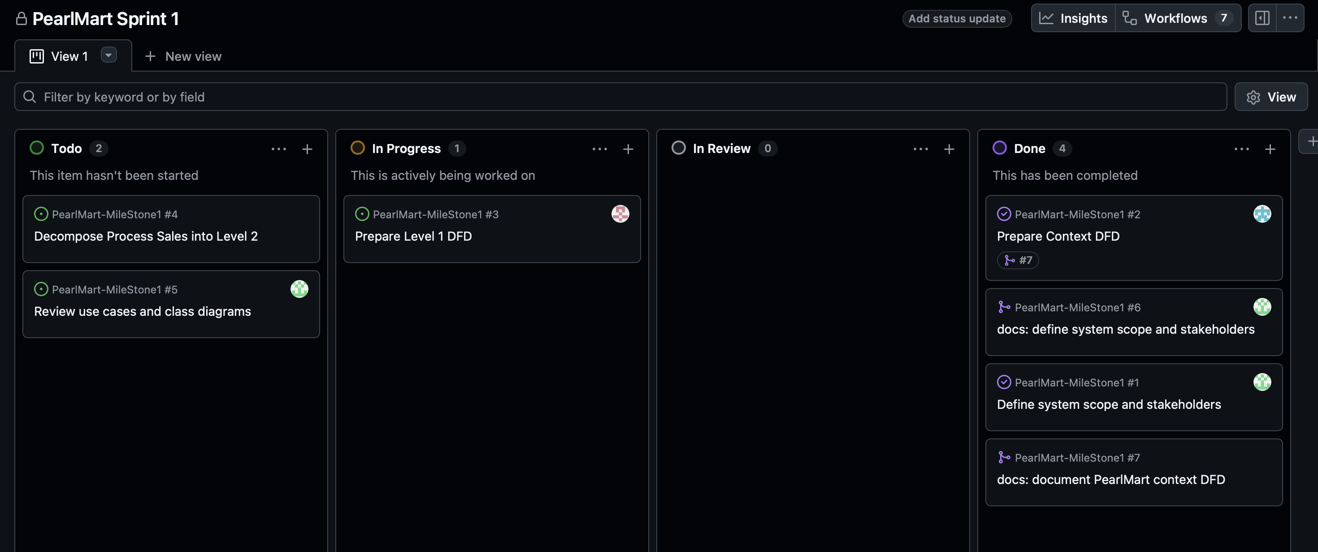
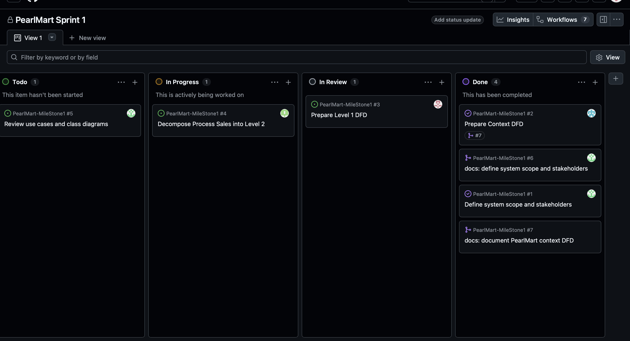
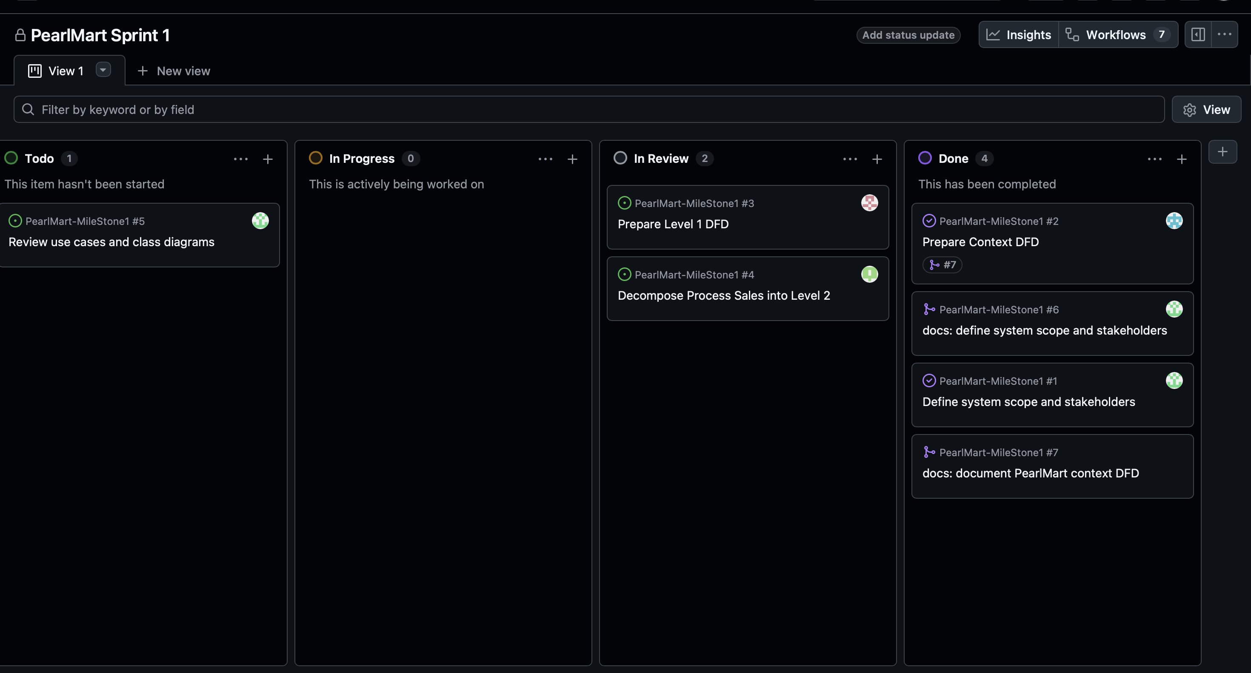
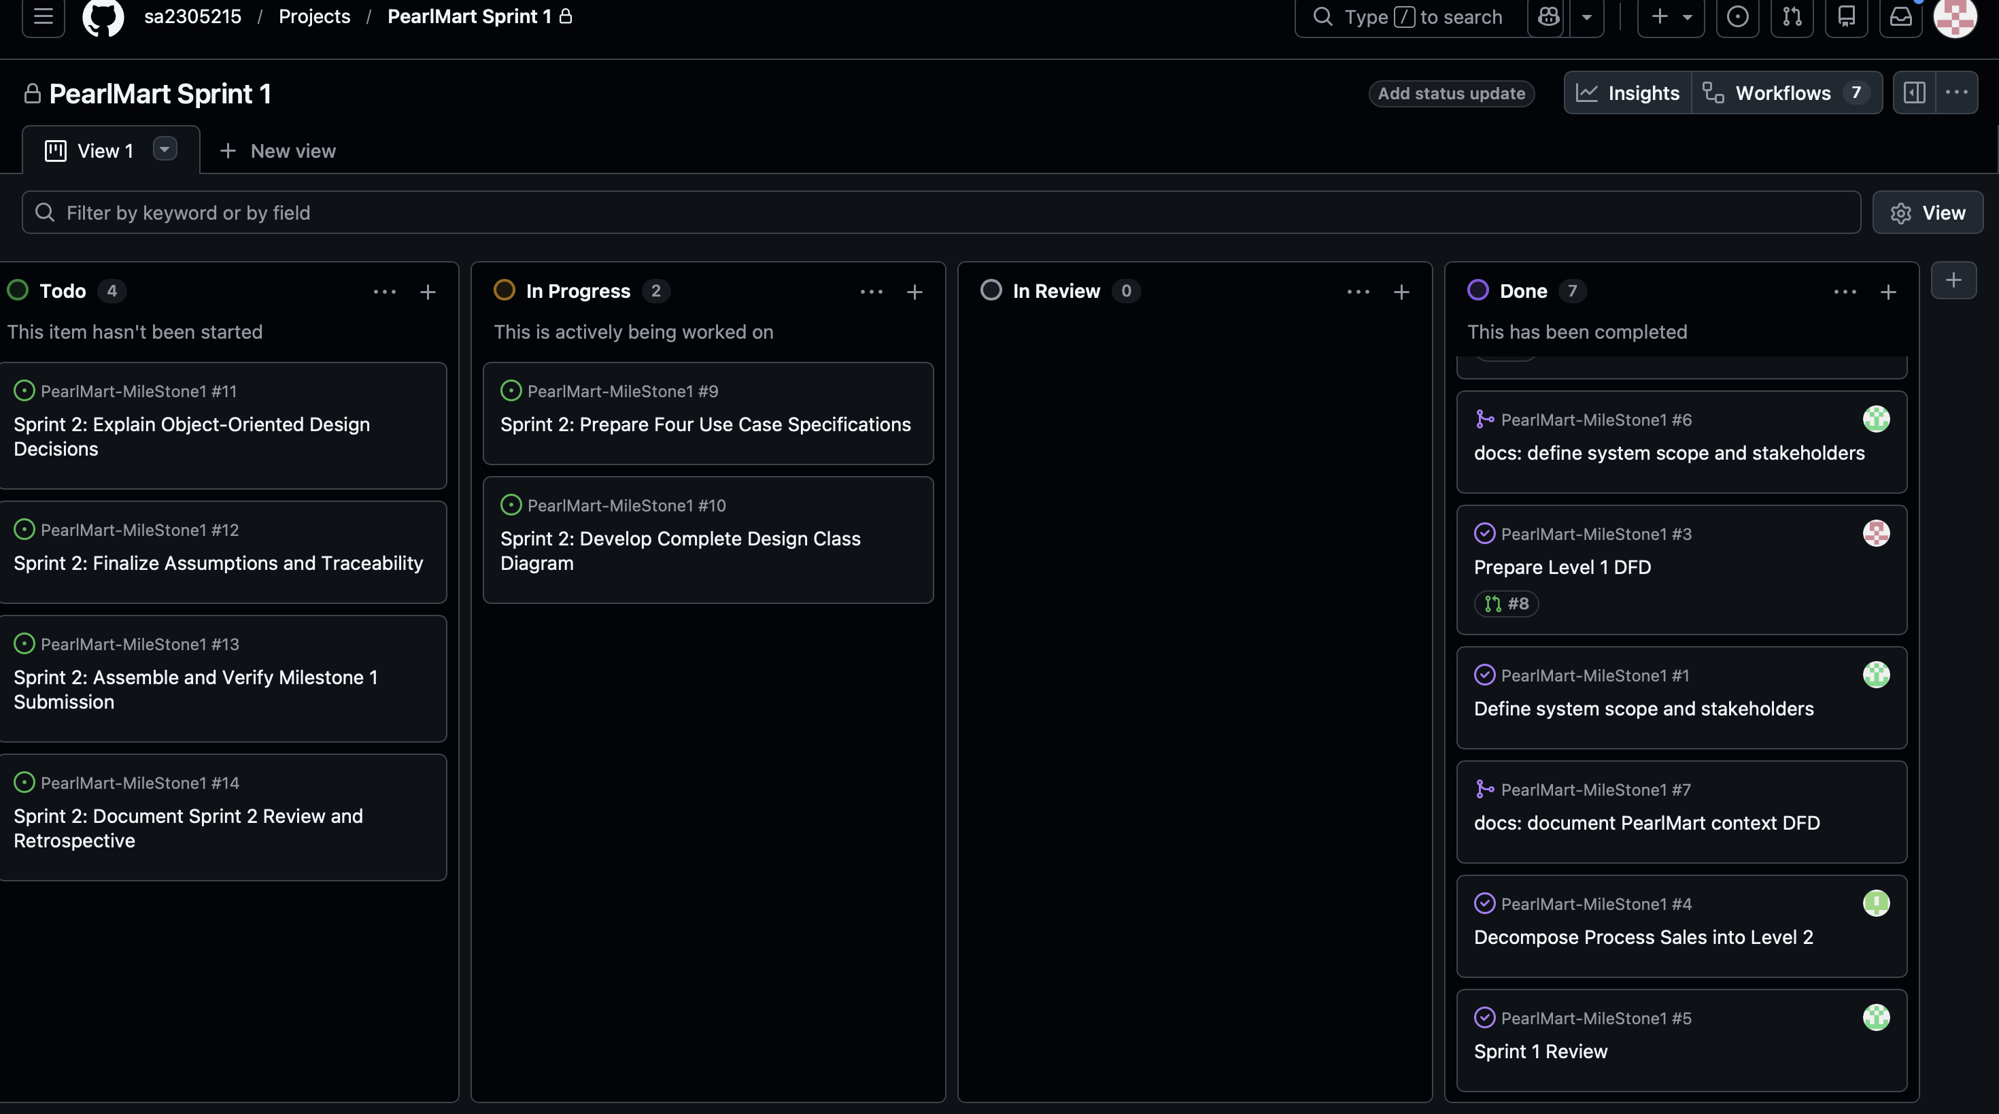
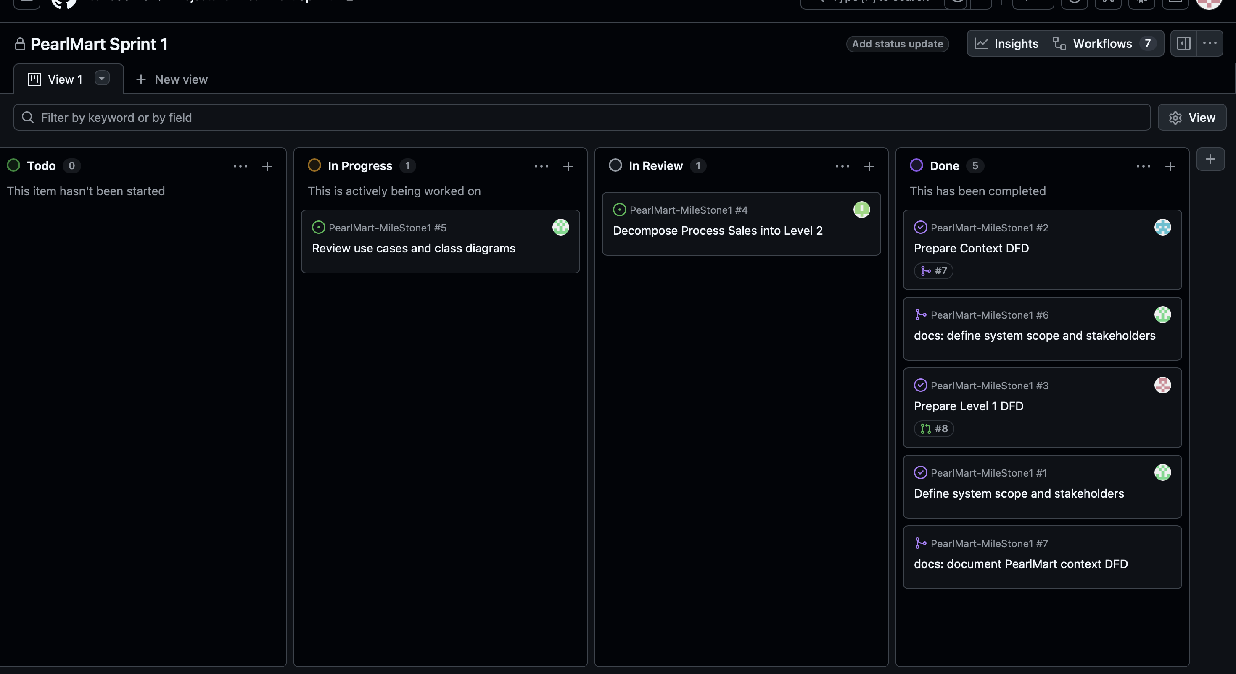
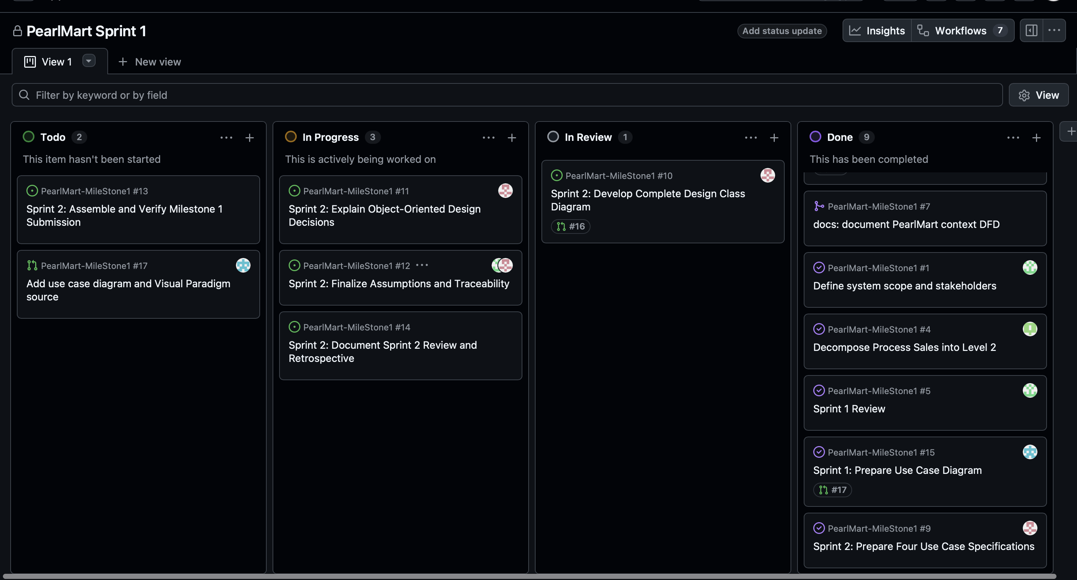
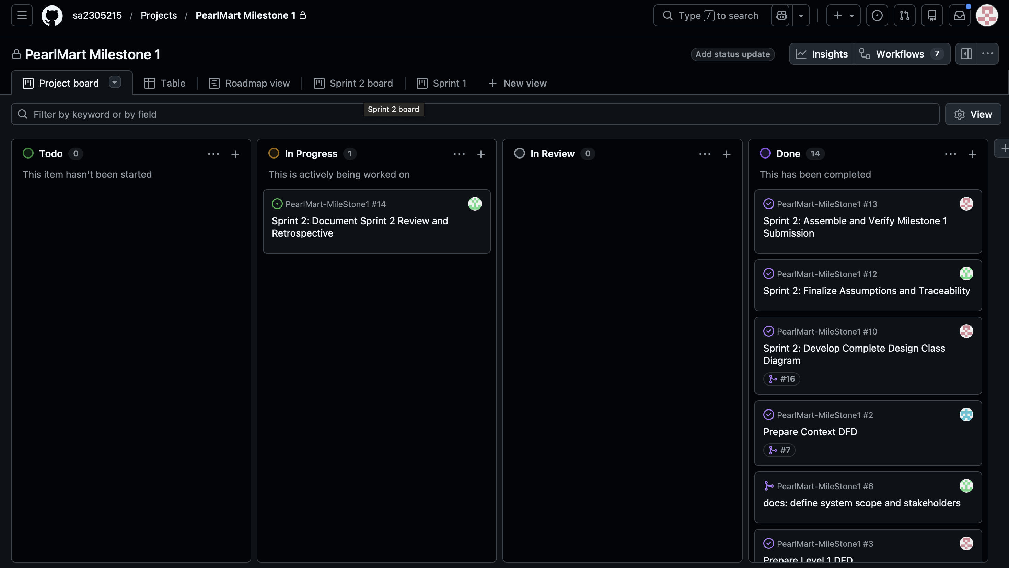
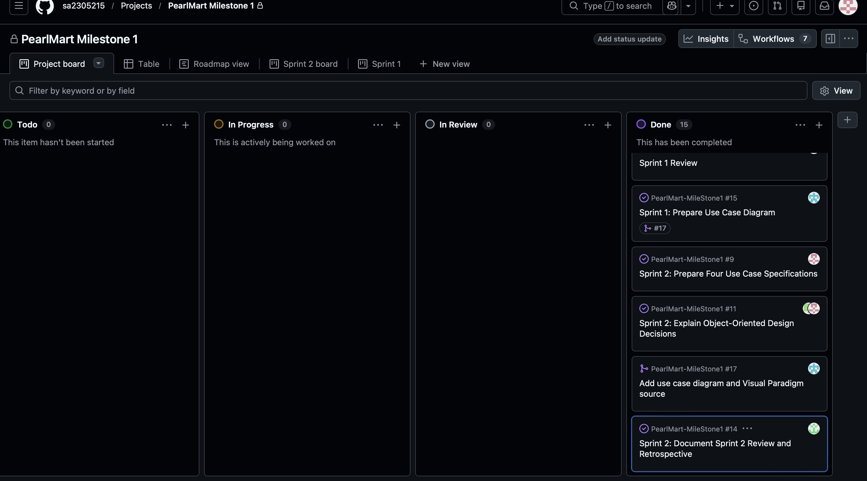

4 - Sprint 1 Retrospective:
During sprint 1, our team successfully collaborated on the initial planning and design for the Pearl Mart inventory management system. Consistent communication was maintained throughout the process and we were able to successfully complete the tasks of sprint 1.

What went well:
We were able to assign responsibilities to team members effectively and coordinate the completion of different tasks. Communication meant that active feedback was given through github and changes were applied accordingly.

What challenges we faced:
The main challenge was keeping elements of the different DFDs consistent across members. This meant that many drafts of each diagram were produced as many adjustments had to be made for there to be balance across all diagrams. Another challenge was misunderstanding of requirements. We had to consult our lab instructor (the client) multiple times throughout the process to finalize different aspects of our diagrams.

What we will apply to sprint 2:
Now that the requirements are clearer, we believe that the second sprint will be completed faster and more efficiently. We will continue communicating consistently to ensure that every aspect of the sprint is understood and approved by all team members.

5 - Sprint 2 retrospective:
The team continued developing the PearlMart analysis and design artifacts and reviewed their consistency with the project description. Whenever a team member was unsure about a use case specification, a diagram relationship, or a requirement, the team discussed possible solutions and then sought confirmation from the lab instructors before settling on the approach. This helped improve the team's understanding of the requirements and reduced the risk of contradictory models.

What went well
Team members increasingly discussed their work together and cross-checked how the DFDs, use cases, specifications, and class diagram related to each other. Regular instructor consultations made the requirements easier to understand and helped the team make more confident decisions. Team members also supported work beyond their initial individual assignments to keep the sprint moving.

Difficulties encountered
Sprint 2 coincided with different exams, quizzes, and university commitments, making it difficult to find times when all four members were available. Because the artifacts depended on each other, one person's delay could affect other tasks. The team responded by communicating about availability and helping teammates with work when necessary.

How Sprint 2 applied the Sprint 1 retrospective
The Sprint 1 retrospective identified two main problems: repeated DFD revisions to maintain balancing/consistency, and misunderstandings of requirements that required instructor clarification. It also committed to continuing consistent communication and shared understanding. During Sprint 2, the team applied these lessons by:
- Cross-checking related models together, instead of treating each diagram or specification as isolated work.
- Discussing uncertain requirements as a team and confirming decisions with instructors, continuing the clarification process established in Sprint 1.
Maintaining communication and sharing workload, especially when exams and quizzes prevented some members from working at the same time.
Sprint 1 anticipated that greater clarity would make Sprint 2 faster; however, the scheduling difficulties meant that faster completion cannot be claimed. The clearer requirements and improved collaboration did help the team approach modeling decisions more confidently.

Improvement actions
For future work, agree on shared work sessions earlier, flag academic scheduling conflicts as soon as possible, allow time for dependent-model reviews, keep instructor clarifications documented, and cross-check the final artifacts before submission.

Scrum Project Management Evidence
The following screenshots were captured from the PearlMart Milestone 1 GitHub Project on 18 October 2026. They document the sprint boards, assignment distribution, and planned timeline. Board statuses represent the state shown at the time of capture.

Figure 1. Sprint 1 board
All six Sprint 1 issues are shown in Done: scope and stakeholders (#1), Context DFD (#2), Level 1 DFD (#3), Level 2 Sales decomposition (#4), Sprint 1 Review (#5), and Use Case Diagram (#15).
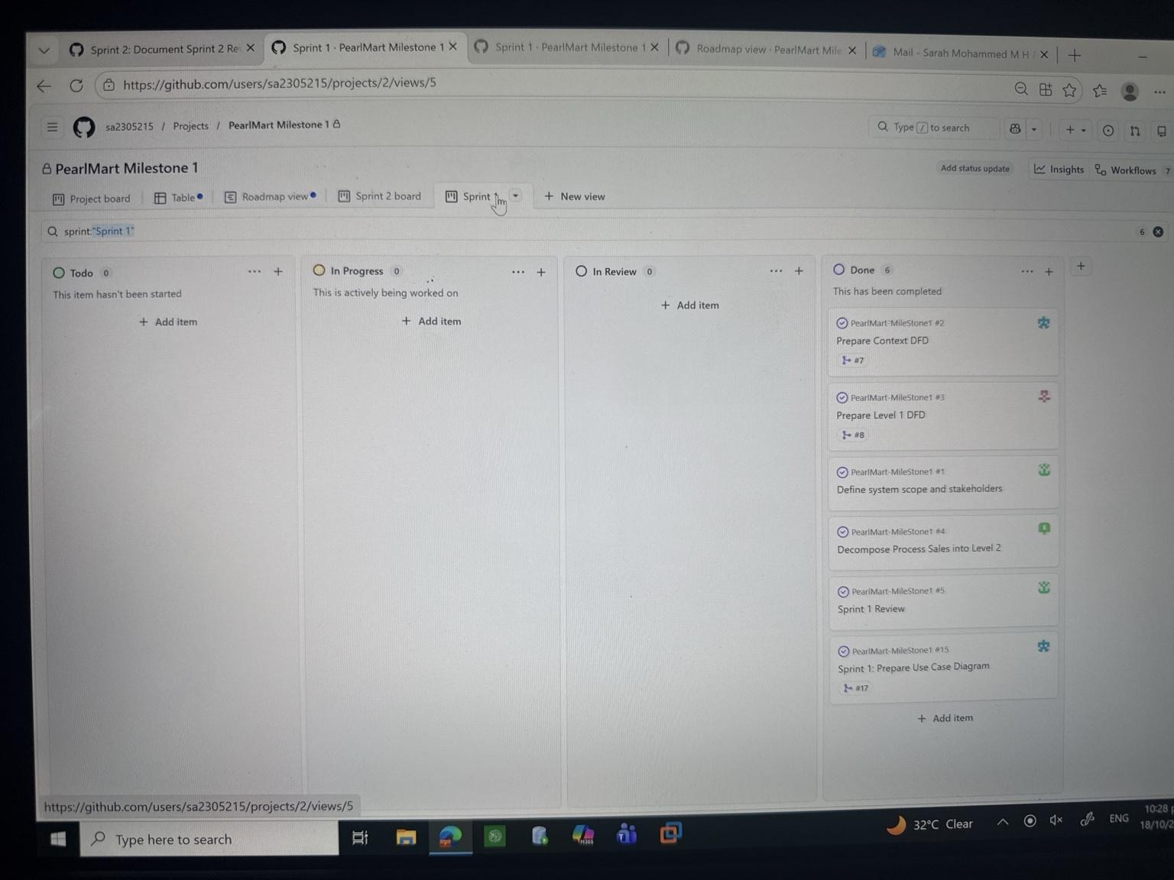
Evidence source: GitHub Project — https://github.com/users/sa2305215/projects/2

Figure 2. Sprint 2 board
Four Sprint 2 issues are Done (#9–#12); final submission verification (#13) and Sprint 2 review and retrospective (#14) remain In Progress in this snapshot.
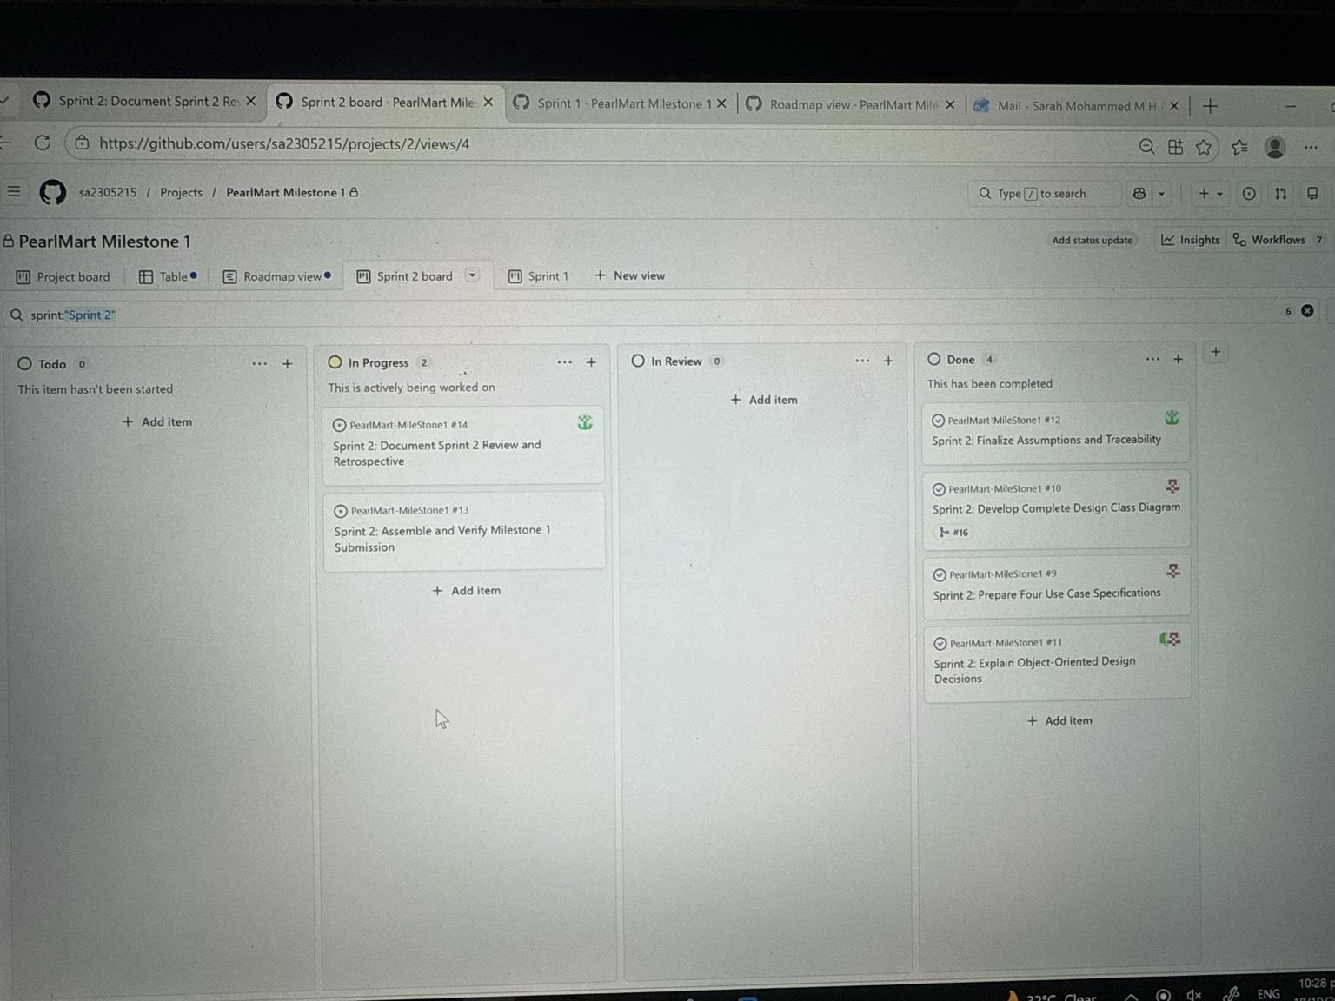
Evidence source: GitHub Project — https://github.com/users/sa2305215/projects/2

Figure 3. Table view grouped by assignees (upper portion)
The Table view groups work items by assignee and displays status, linked pull requests, and sprint assignments.
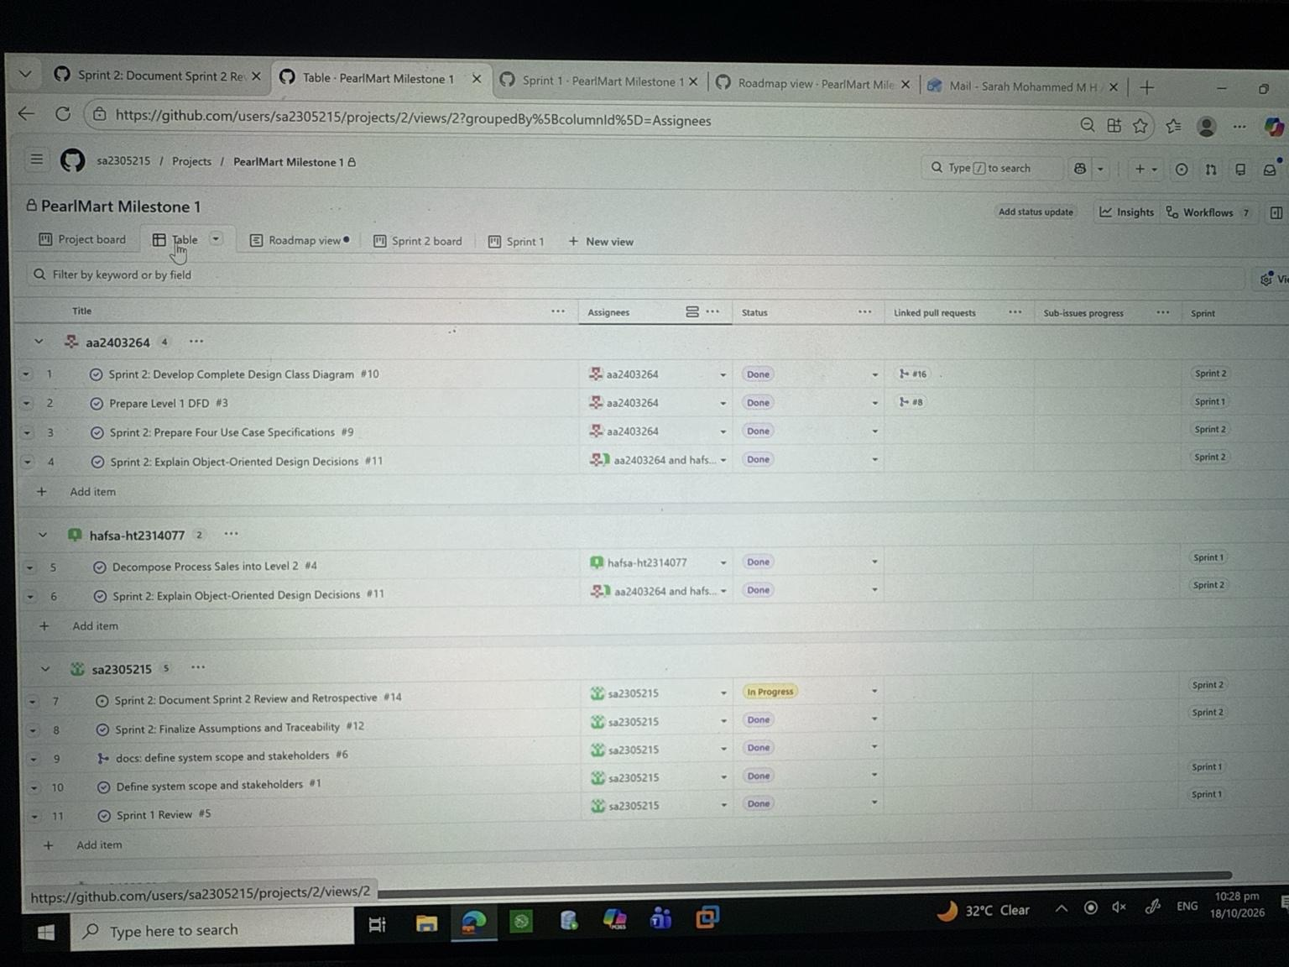
Evidence source: GitHub Project — https://github.com/users/sa2305215/projects/2

Figure 4. Table view grouped by assignees (all four members)
All four assignee groups are visible: aa2403264, hafsa-ht2314077, sa2305215, and sa2402368. Shared Issue #11 appears under both assigned members.
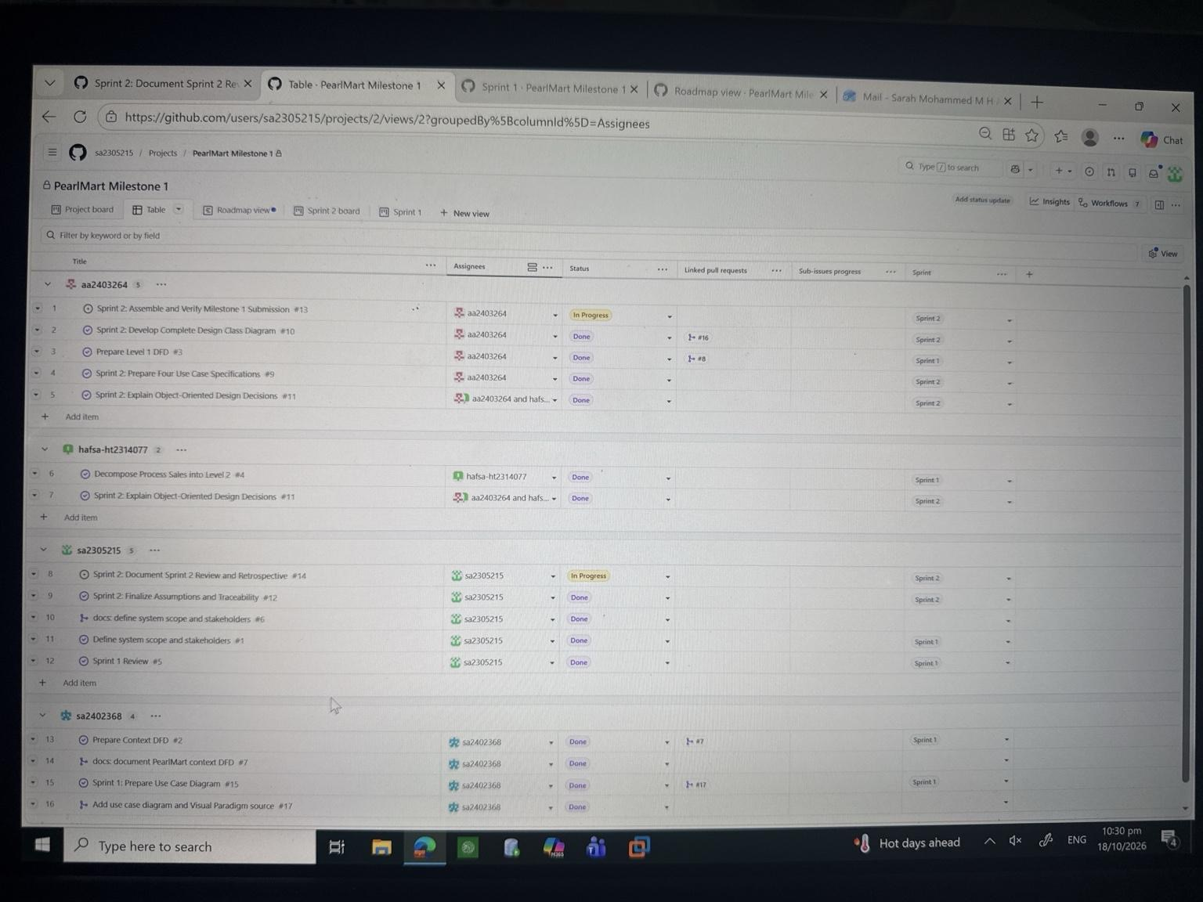
Evidence source: GitHub Project — https://github.com/users/sa2305215/projects/2

Figure 5. Roadmap view
The Roadmap shows task start and target dates across October 2026, including final submission and Sprint 2 review tasks scheduled through 18 October.
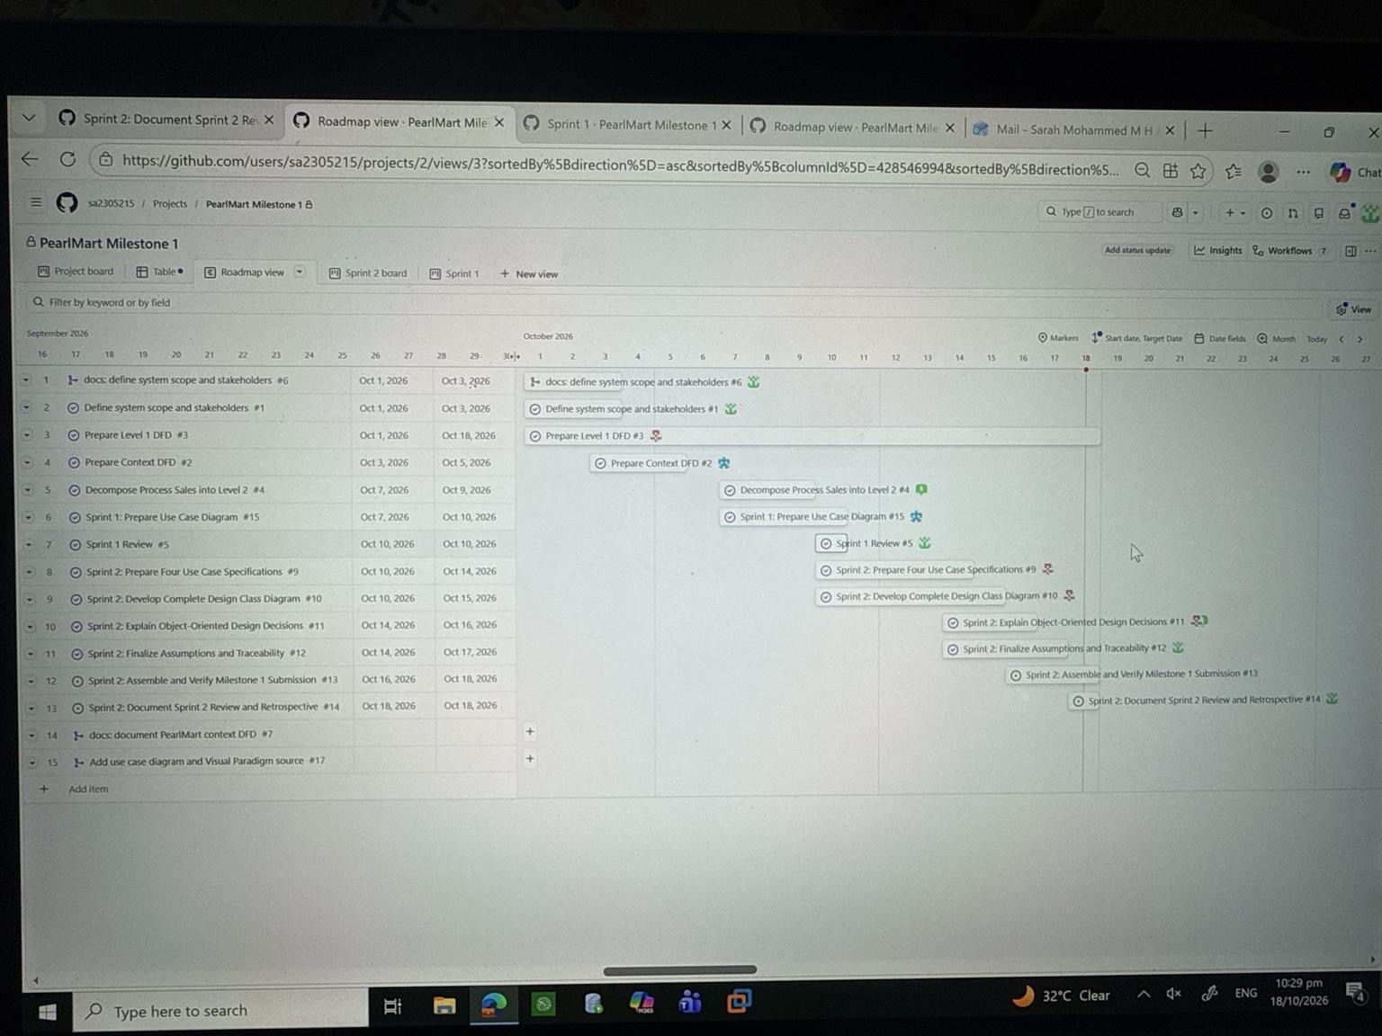
Evidence source: GitHub Project — https://github.com/users/sa2305215/projects/2

Issue-to-Branch-to-Pull-Request Traceability and Teammate Reviews
The following table records the GitHub issues, corresponding working branches, pull requests, and actual teammate feedback used during PearlMart Milestone 1. Review comments are reported as comments rather than formal approvals unless approval was independently confirmed.
Issue | Branch | Pull request | Review evidence
#1 – Define system scope and stakeholders | feature/scope-and-stakeholders | #6 | Shamma reviewed the scope and stakeholder documentation and confirmed that it matched the project requirements.
#2 – Prepare Context DFD | feature/context-dfd | #7 | Sarah reviewed the main process, external entities, and data flows for consistency with the project scope.
#3 – Prepare Level 1 DFD | 3-prepare-level-1-dfd | #8 | Sarah identified four modeling issues. The diagram was revised, and Sarah confirmed that the four points had been addressed.
#4 – Decompose Process Sales into Level 2 | docs/issue-4-level2-dfd-review | #18 | Shamma requested corrected data flows. Hafsa provided an updated diagram, and Shamma compared the revision with the earlier version.
#5 – Sprint 1 Review and Retrospective | docs/issue-5-sprint1-retrospective | #19 | Hafsa confirmed that the Sprint 1 account was accurate and its evidence links worked.
#15 – Prepare Use Case Diagram | feature/use-case | #17 | Sarah commented that the revised use case diagram reflected professor feedback and team discussions.
#10 – Develop Design Class Diagram | 10-sprint-2-develop-complete-design-class-diagram | #16 | Sarah requested specific corrections to relationships and attributes, then confirmed that the written feedback had been followed.
#9 – Prepare Four Use Case Specifications | docs/issue-9-usecase-specification-review | #20 | Almayasa provided substantive comments on the specifications, including UC005 and UC010.
#11 and #12 – Design decisions, assumptions and traceability | docs/issues-11-12-design-rationale-traceability | #21 | Sarah recorded a follow-up review of the rationale and traceability evidence. An independent teammate review was not verified.
Review Evidence Notes
Pull requests #18, #19, #20 and #21 primarily document and link existing deliverables; they should not be described as containing all original source diagrams or specifications. Review comments do not necessarily constitute formal GitHub approval.
Repository: https://github.com/sa2305215/PearlMart-MileStone1

