3D POINT CLOUD GENERATION AND MATCHING WITH ICP ALGORITHM
Sahil Arora ; Matriculation Number: 32953

Abstract: The scope of this project is to reconstruct the scene using a pair of images captured by a smartphone camera. This process of re-generating scene from multiple 2D images is called 3D reconstruction which is helpful in application areas like Robotic Mapping, Medicine and more (https://en.wikipedia.org/wiki/3D_reconstruction#cite_note-18). The concept of Structure from Motion is used here in which we capture images from a two or more angles around the scene. The same point in space is viewed from different angles by different cameras and the collective information of transformations from one view to other is determined by finding camera extrinsic parameters. This involves finding features in a pair of images and registering those set of matching features. Further, using concept of Triangulation, depth of a point relative to a camera scene is computed.

I. INTRODUCTION

The process requires a few tools and libraries which need to be set up. This whole project is developed on Ubuntu 18.4 platform on a Intel i7 machine with dedicated 4GB NVIDIA GPU and 16GB RAM. Source code is written in Python 3.6 with support libraries like NumPy and MatPlotLib. Additionally, OpenCV library is set up which provides access to various function from the computer vision library. For evaluation of the algorithm with the trusted truth, we use a famously-known tool Visual SFM to generate sparse cloud and then use Cloud Compare to evaluate our results against those from Visual-SFM.

2. CAMERA INTRINSIC PARAMETERS & UNDISTORT

As soon as we decide which camera is being used for capturing we would want to calibrate the camera and find Camera Matrix (K). K matrix is a 3*3 matrix which converts the 3D co-ordinates (x1, x2, x3) to 2D points in pixel co-ordinate system of the said camera (z1, z2).

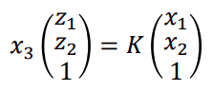
Where K is defined as:

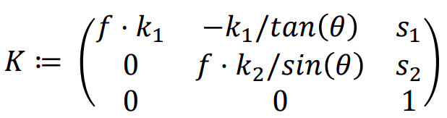
Where f is focal length of the lens and kp1, kp2 are parameters of pixels per unit mm
s1 and s2 are difference between Optical Center and Image Center.

We estimate the camera matrix based on library functions in OpenCV. A check-board as illustrated in fig 2.1 is printed on a piece of paper. With the camera we capture few images of this checker-board from different perspectives. In 3D world system, we denote the co-ordinates as x1, x2, x3. Since, the checker-board was pasted on a flat wall we can assume that x3 = 0. Size of the squares will remain constant through out so we can denote x1,x2 as c * (m1, m2) m1, m2 are Natural numbers. The library function finds the corner points in images through corner detection algorithm and Camera Matrix is then estimated by solving the below equation for K:
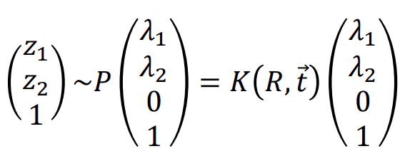
We already have denoted x1 and x2. Using corner detection z1 and z2 are found but in this equation R,t is not known. We denote the product of K.R,t as H matrix (called Homography) and then matrix K is estimated based on Cholesky Factorization of linear equations formed by H matrix and equation 2.a . Fig 2.2 shows image from source code where corners points are detected and drawn for visualization. It is better to use images having lot of different perspectives to get better approximation of K. In our setup we have used 16 images and it took the program 12 seconds to run and detect all images. The output of K is generated as a numpy array and is stored in local directory for usage. As a checkpoint, we try to re-project the world co-ordinates mathematically with the calculated matrix K and compare it with the point co-ordinates detected as corners. This calculation gave a re-projection error of 26 % error in our source code.
Apart from Camera Matrix (K), another parameter is unknown, namely the Lens-Distortion coefficients. Ideally, straight lines in real world should also appear straight in images but this is hardly true. Lenses produce effect like Pincushion Distortion, Barrel Distortion etc which has to be undone to carry out further procession with minimal errors.
The function L that distorts the point (z1, z2) is depending upon distance (r) of this point from optical center of camera. Function L can be expanded with Taylor Series and written as :

where k1, k2, k3.. are distortion coefficients. Checker-board function again uses sub-pixel accuracy to improve the position of all corners on a straight line and gives the output as an array of Distortion Coefficients which is again stored as a numpy array. The set of images used and source code can be found on github [mygit]. To undistort an image we simply use the previously estimated Camera Matrix and Distortion Coefficients to call the function. The function transforms the given image to rectify the distortions caused by lens.

3. FEATURE MATCHING IN PAIR OF IMAGES

The first step in reconstructing a scene would be to find Fundamental Matrix (F). More explanation about Fundamental Matrix will follow in next section. But, to find the Fundamental matrix we have to find pair of points that are visible in both the images. Feature points are defined by pixel areas in a image in the neighborhood of which the sum of squared difference (SSD) in x- direction and y-direction change rapidly. SSD is defined as equation below:

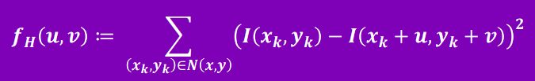
There exist multiple techniques for Feature Matching, for this project we will use ORB (Oriented FAST and BRIEF). This is a combination of feature finder technique FAST (Features from Accelerated Segment Test) which classifies a point as corner if n out of 16 neighbouring pixels are brighter or darker than the pixel under consideration (default n is taken as 12 and naturally a threshold t is defined to classify any pixel as brighter or darker). Further BRIEF (Binary robust independent elementary features) is a feature descriptor which defines a feature as a vector which can later be compared to other vectors using Euclidean Distance / Hamming Distance to decide if it the same point or not. Fig 3.1 shows an illustration of found features in one of the images.

Now we need to match features in two corresponding images. Since, we are using a powerful computer processor we don’t really are much concerned about time. Therefore, we choose Brute Force matcher as the first choice. It simply compares every single feature description A from first image to every single feature descriptor B in other image and chooses the one with lowest Hamming Distance. This technique is easy to implement and promises good results. But since one feature point A can be matched t various points B, we have used k-Nearest Neighbour matching with k=2. Since there can also be outlier points in feature matching, we use Ratio Test explain by D. Lowe in his paper. Fig 3.3 shows two images with straight lines connecting matching feature points.

4. FUNDAMENTAL MATRIX

By definition, it a matrix denoted here by F which can be used to calculate any Epipolar line in 2nd image for any given point x0 in first image. A slight explanation about Epipolar lines : We already know that 3D points (x1, x2, x3) can be converted into pixel co-ordinated (z1, z2) by below equation.
Z1#, z2#, z3# = K * (x1,x2,x3)
and z1, z2 = 1/z3# * (z1#, z2#)

Also, we know that 3D world co-ordinates (l1, l2, l3) can be converted into 3D camera co-ordinates by below equation.
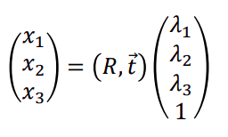
We have previously seen that this can be written in shorthand notation.
X0# = p * P0
where (x0# = z1, z2, 1, d) ; p = (l1,l2,l3,1) and P0 = K*(R,t) Camera matrix.
So we can get p if we know x0 and Camera matrix ie p = Inv(P0) * x0#
The problem during reconstruction is that the 3rd coordinate of z3 is not known. So for any arbitrary value of this z3 will give us multiple points in 3 dimension. See fig 4.1 as an illustration of this.
However, these points when projected onto the 2nd Image plane by pre-multiplying with Camera Matrix P1, a line if formed for various possibilities of p. This line is termed as Epipolar line. We can use the fundamental matrix F to find any Epipolar line corresponding to a point x0.
L1 = F * x0
since x1 lies on L1 , we can say x1T * L1 = 0
so x1T * F * x0 = 0

So to calculate the Fundamental Matrix we need to have at most 9 pair of matching points x0 and x1, so that we can set up 9 linear equations and solve for F matrix. We have used our matched points (shown in fig 3.2) and used the OpenCV library function to compute F. We have used with RANSAC filter approach to avoid outliers. Our results shows that the rank of F matrix is 2, which confirm that it is not a full rank matrix and has 1 singular value equal to 0.

5. ESSENTIAL MATRIX and CAMERA EXTRINSICS

Essential matrix satisfies the almost same constraint of Epipolar line as the F matrix did, but with a slight variation. We denote E as essential matrix, then x1hatT * E * x0hat = 0

where x0hat = inv(K) * x0
So to find the Essential Matrix we use the same approach as we did in Fundamental Matrix. We should have enough matches and known Camera Matrix K to set up a set of linear equations and then solve for Matrix E. We use the library function to estimate the value of E. We have used with RANSAC filter approach to avoid outliers. Our results shows that the rank of E matrix is 2, which confirm that it is not a full rank matrix and has 1 singular value equal to 0.

This essential matrix is quite useful for us to find the Camera Extrinsic. We can use R and t to calculate any point p1 in world co-ordinates given a point p0.
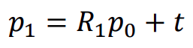
If we would have know the disparity value of point x0 = (z1,z2) we could write:
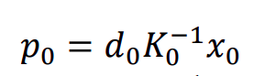
by mapping : p1 = (d1 * x1hat) = (R*p0 + t) = R *(d0 * x_hat0) + t ---------------- eq (5.1)
The right hand side of equation 5.1 is cross multiplied by t vector to covert 2nd term as 0.
d 1 [t] × x̂ 1 = d 0 [t] × Rx̂ 0
Taking dot product with x_hat1 vector gives
d 0 x̂ ^{T} 1 ([t] × R)x̂ 0 = d 1 x̂ ^{T} 1 [t] × x̂ 1 = 0
this looks like the equation we wrote while defining Essential Matrix using normalized co-ordinates
We can safely say : E = [t] × R
Now the whole point is to extract t and R from known E matrix so that we can have the Camera Matrix Fully defined.

We use the Singular Value Decomposition to get two orthogonal matrices (U and V) and a diagonal matrix (Σ):
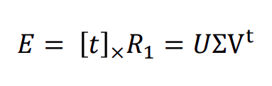
To find out T and R matrix we define
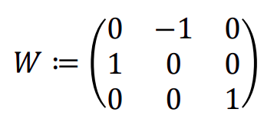
𝑇 ≔ 𝑈𝑊ΣUt and 𝑅 ≔ 𝑈𝑊−1𝑉t

where T is the matrix representation of cross product
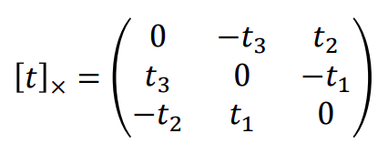
if we know T we can generate our t_hat vec using above notation.

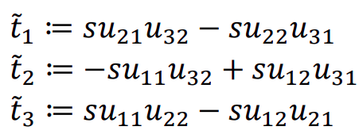
But the obtained t_hat vec and R matrix are not unique solutions. The right hand side of Epipolar equation is zero and thus any scalar multiplied to E would also work. This will directly affect the translation vector and any scalar multiple of t_hat would then also be a valid solution. For different t vectors we get different R vectors.

So in nut shell there can be 4 possible solution if we work with normalized t vectors. With these 4 possible sets we can calculate 4 different 3D positions of a point but all of them will not make sense physically. See fig 5.1 illustrating 4 different camera positions. In only 1 of the case the 3D point will lie in front of both the cameras. We do it by hit and trial method to check which combination of R and t is suitable. We take all the feature matched points in Section 3 and use the full Camera matrix to re-project them in 3D. Then we ensure that z co-ordinate of both these points shall be positive. If one of the points come out to negative we change the Rotation or Translation Matrix and recalculate the points. Below is a pseudo code for better explanation.
Now we have our Camera Intrinsics and Camera Extrinsic we can re-project all our feature points to 3D co-ordinates.
6. Triangulation

We have previously seen in equation 9 that with disparity information of any point in image co-ordinate system we can reconstruct the world co-ordinates. But since disparity is not known we do not only get one unique point but a whole 3-D line which has infinite number of candidates. We know the position of same point in image co-ordinates of 2nd camera and we could also get a 3D line on which the said point can lie.
Ideally, these two 3D lines should intersect and we can find the exact location of a point in world co-ordinate, but this is hardly the case. There are multiple techniques available but we use OpenCV library function that uses Least square method. It computes the error between two depthless rays and minimizes the error. This may not give an exact solution but we try to equate equate Jacobian matrix and compute its zero. Refer to Fig 6.1 for illustration of rays and their intersection.

7. RESULT AND EVALUATION

The output of OpenCv function is an numpy arrow of type f = (x,y,z,w). This is converted into homogeneous co-ordinates of the type ftilde = (x,y,z,1). This array is then stored is a text file using python numpy so that it can be directly imported in Cloud Compare. Cloud Compare is here used to compare two point cloud generated. Fig 7.1 shows the point cloud obtained from Triangulation. Fig 7.2 shows the point cloud obtained from Visual SFM.

7. FUTURE WORK

We have used only 2 images to generate the point cloud. However, very less features are detected in these images. Triangulation can only reporject thse points which are found as pair of matching feautres. As a result, what we get is a Sparse Point Cloud. We need to capture more pictures from different perpectives. This will find corresponding points from al pair of images and the resulting point cloud will be having a lot more points. We could also follow another method for regenration of point cloud. Since we have already computed the Camera Matrices we can go for Rectifaction of the images. One of the images is adjusted and remapped in such sense that the pair has same orientation but there is a baseline translation. This is very similar to Stereo geometry and thus pixel-wise depth can be computed and stored as disparty map.

x. STRUCTURE FROM MOTION

The concept of Structure from Motion is used in which we try to capture images from a two or more angles around the scene. We assume that (relative) camera extrinsic parameters like Rotation and Translation are known.
We assume the first camera as origin to define orientation R0 = 0.

p0 = (d0 * x_hat0) : where p0 is observed location of point p in first image
by mapping : p1 = (d1 * x1) = (R*p0 + t) = R *(d0 * x_hat0) + t ---------------- eq (x.1)

where x_hat0 is a vector directed towards normal ray and has been normalized by inv(K).
x_hat0 = inv(K) * x0
The right hand side of equation x.1 is cross multiplied by t vector to covert 2nd term as 0.
d 1 [t] × x̂ 1 = d 0 [t] × Rx̂ 0

Taking dot product with x_hat1 vector gives
d 0 x̂ ^{T} 1 ([t] × R)x̂ 0 = d 1 x̂ ^{T} 1 [t] × x̂ 1 = 0

with this equation we define the Essential Matrix as x1^{T} * E * x_hat0 = 0
E = [t] × R

IN-FRONT(x1,x2, Rot, Trans)
for all feature points
3dpt = solve by eq (7)
if z co-ordinate of 3dpt < 0
return False
return True

if not IN-FRONT(x1,x2, Rot, Trans)
Trans = - Trans
if not IN-FRONT(x1,x2, Rot, Trans)
Rot = U.dot(W).dot(V^{t})
if not IN-FRONT(x1,x2, Rot, Trans)
Trans = - Trans

IN-FRONT(x1,x2, Rot, Trans)
for all feature points
3dpt = solve by eq (7)
if z co-ordinate of 3dpt < 0
return False
return True

if not IN-FRONT(x1,x2, Rot, Trans)
Trans = - Trans
if not IN-FRONT(x1,x2, Rot, Trans)
Rot = U.dot(W).dot(Vt)
if not IN-FRONT(x1,x2, Rot, Trans)
Trans = - Trans

fp1 = 2 X N array of Features point (as float 32) from Image 1
fp2 = 2 X N array of Features point (as float 32) from Image 2

TRIANGULATION(Camera Mat1, Cam Mat2, fp1, fp2)
return X

# X is output of 4 X N array (x,y,z,w)
X /= X[3] #to homogenize

List of Figures

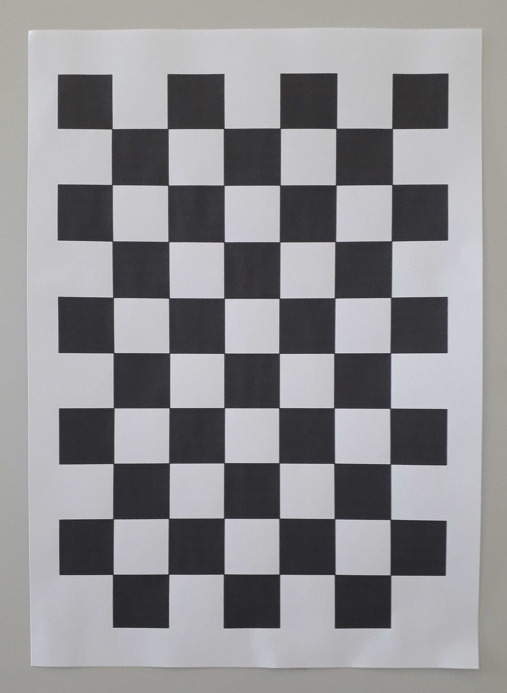
fig 2.1 Illustration of Checker-board used for calibration

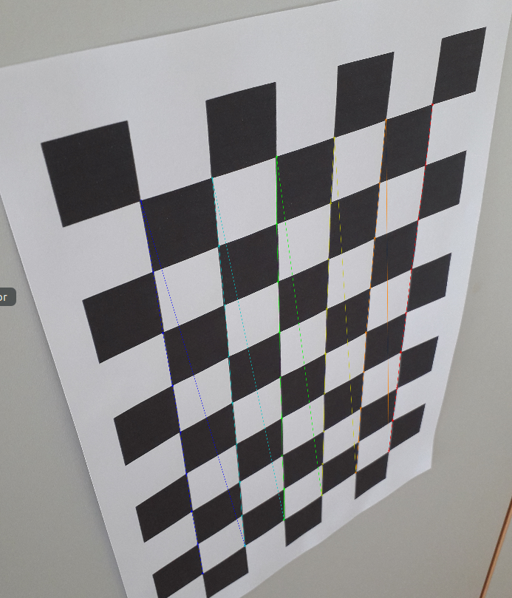
fig 2.2 Checker-board corners detected and drawn

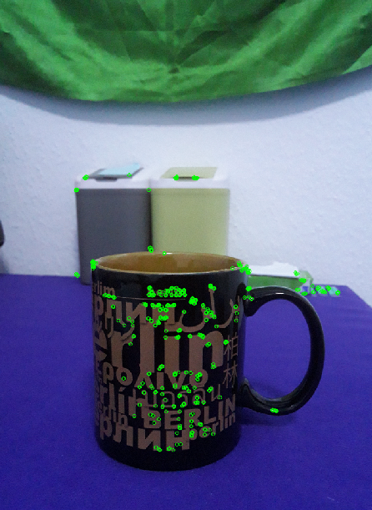
fig 3.1 Corner detection using FAST feature finder

fig 3.2 Feature matching using Brute Force

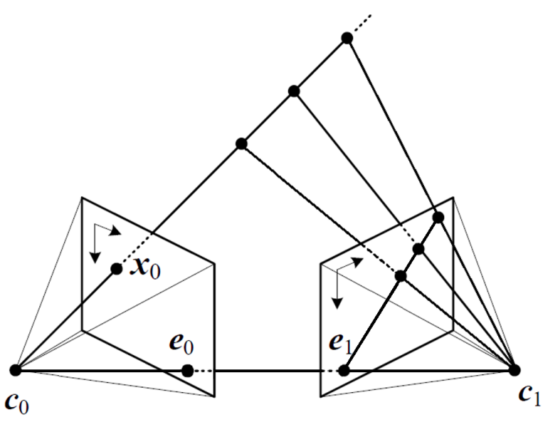
fig 4.1 source Szeliski

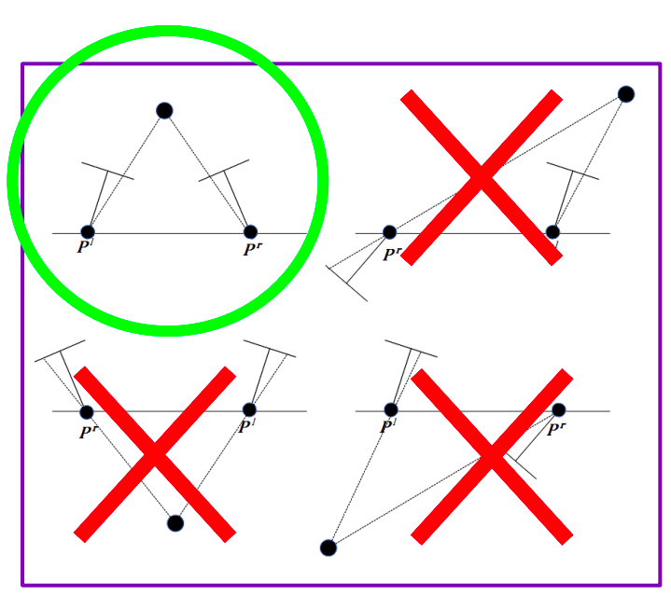
fig 5.1 showing 4 different cases

