**Soda Vending Machine**

**By Saurav Kumar**

**Implementation method:**

We are designing a user interface for a soda vending machine which is a single page application. Application interacts with the user and dynamically displaying list of products.

1. **Design Considerations:** With respect to design consideration we are adding few features to keep design as flexible and maintainable.

* We have divided screen into two sections: -
  1. One section of screen contains all buttons with equal spacing into three rows.
  2. Second section of screen contains fields for respective event associated with buttons such as: -
     + Error message
     + Coin insertion slot
     + Successful message
     + List of products

**Technical Considerations:** We are using JavaScript, Bootstrap, HTML and CSS.

This application is responsive application that will work in all device compatibility.

1. **Technical Architecture Design:**

The architecture design of Vending machine is as follows: -

* Divide screen into two sections using Bootstrap class grid system.
* System using bootstrap container put all buttons inside it.
* Design button using bootstrap class (btn and btn-primary)
* Write down functions for each button
* Call that function using onclick method
* Embed change in DOM using method called innerHTML.

1. **Methods to use the developed system:** This vendor machine is built with the logic that once you buy your first drink if you are left with some coin you can again buy drink as per your wish. You can also use this system for single dispense only. Please find below details of how to use different functionalities of this machine.

**Operating steps:** The Operating steps are mentioned below for single time use and for multiple time use: -

* Go to Home Screen (open html page in your browser)

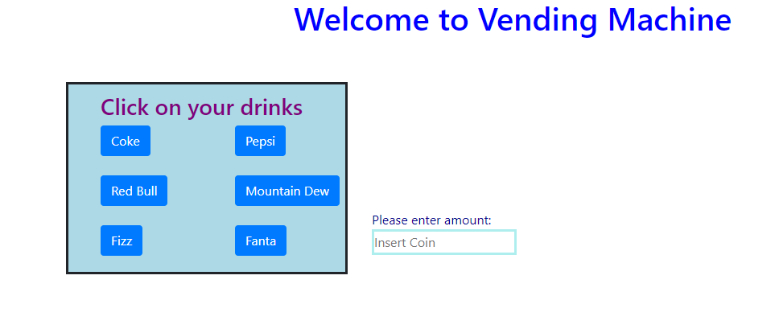

* If user click on any drink button it will show you amount that need to insert

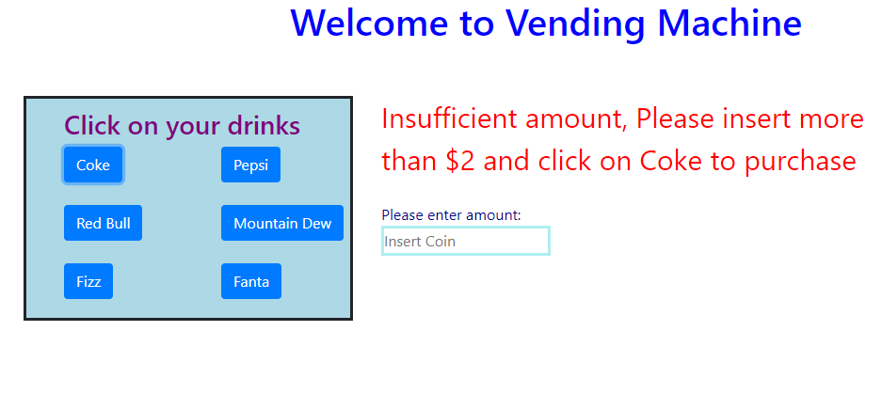

* User can enter any amount less than price mentioned again it will ask to enter sufficient amount

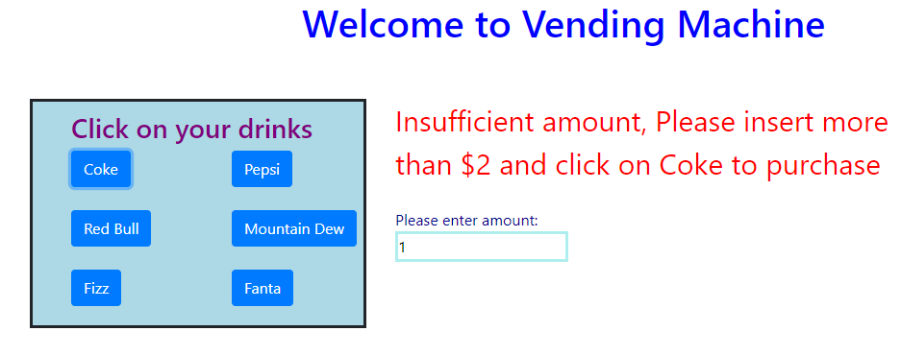

* Once user entered greater than or equal to product price and on click on of selected product it will show success message and return the amount if any excess and shows the list of purchased products

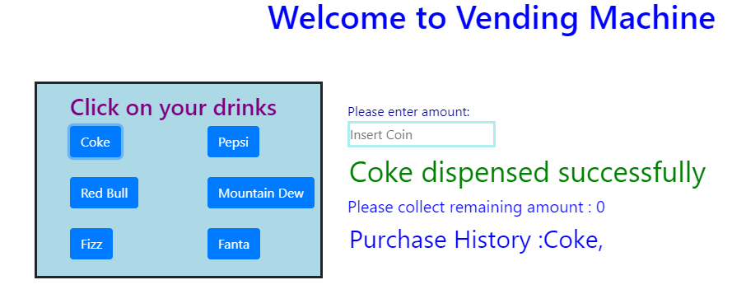

1. **Class & Sequence Diagram:**

Out of Soda

Has Quarters

Insert quater Ejects quaters

Soda Sold

No quarters

Push Soda

Soda Remaining=0

Dispense Soda