Name: Shrouk Ali Elsaid Ali Abo Elenen

ID: 4221153

Subgroup: C1

Task2

\***Write a small research about REGEXP**

-A Regex can be a combination of different data types such as integer, special characters, Strings, images, etc. Generally, these patterns are used in String searching algorithms in order to perform find or find and replace operations on Strings, or for validating the input.

1. It provides a powerful and flexible pattern match.
2. Helps in implementing powerful search utilities for the database systems
3. Get customers that its contactFirstName starts with 'je' or ‘le’.

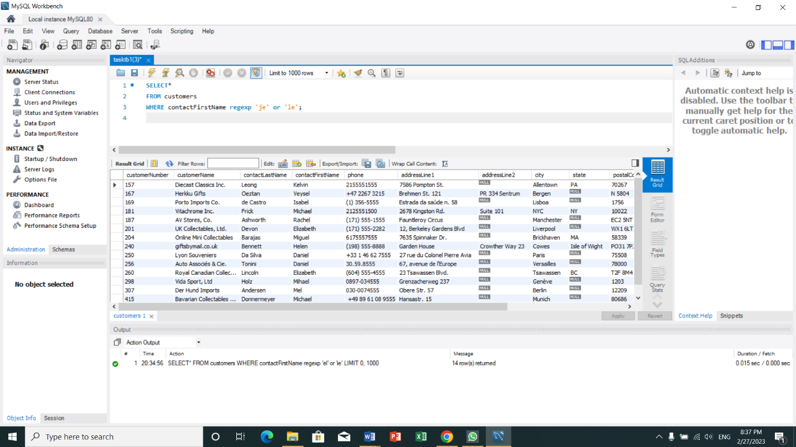

1. Get customers that its contactFirstName is endded with 'el' or contains ‘ie’.

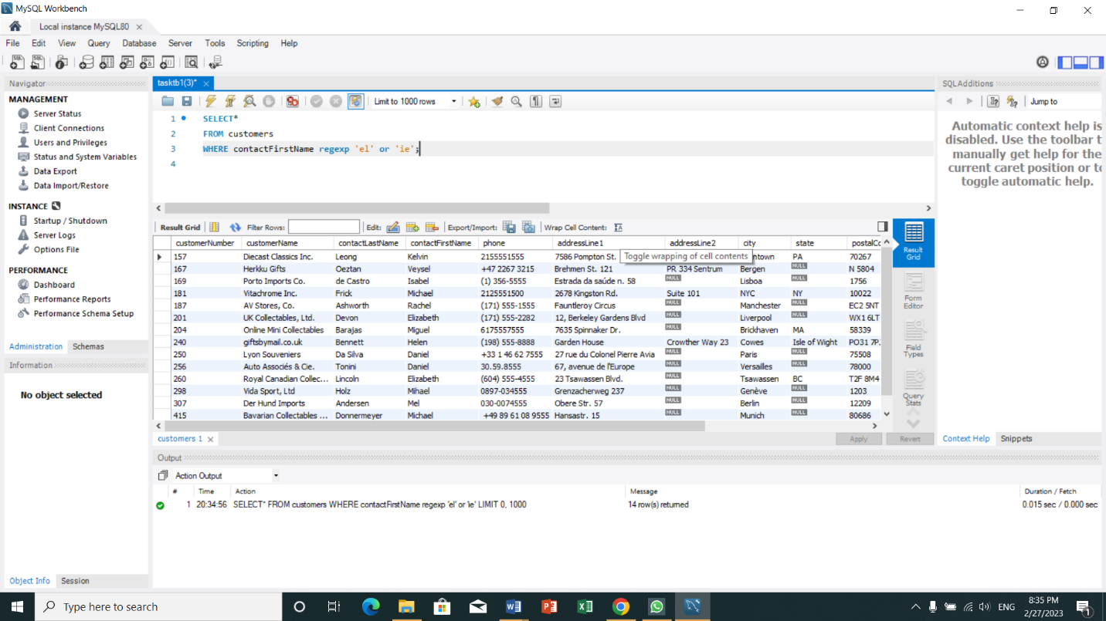

1. Get customers that its contactFirstName contains 'b' followed by g or a.

