Assignment 2
Due, Thursday, June 18, 2020 for 100% credit
Friday, June 19, 2020 for 90% credit
Saturday, June 20, 2020 for 80% credit
Sunday, June 21, 2020 for 70% credit

Scenario
You are starting your own business in a traditional brick-and-mortar facility and you want to develop your own Website for advertising and will eventually incorporate E-commerce. The website will be developed in stages. Each assignment represents an upgrade to your website.

Assignment 2 Update the Website Using CSS
- Apply HTML Layout to your website
- Create the external Cascading Style Sheet (.css) for your website. Include the following:
- Remove all style attributes from your HTML pages
- Must use at least three class attributes; your CSS must reference these class attributes
- Must use at least three id attributes; your CSS must reference these id attributes
- Link the external CSS in each of your website pages
- Background
  - Set the background color of the page or be an image
  - Set the background color of another tag element of the page (e.g. h1, h2, article)
- Font
  - Set the color of the text
  - Set the font of the text
  - Set the size of the font
  - Set the style of the font for different tag elements in the page
  - Set the boldness of the font for different tag elements in the page
- Links
  - Use different colors to identify links visited and unvisited
- Lists
  - Modify the default marker for the list used
- Advanced CSS
  - Add a box shadow to an image
  - Add text shadow to some element on your page
  - Modify one of your images using the 2d or 3d transform style
  - Round the corners of an image or element using the border-radius style
  - Add color gradient to some element on your page using linear, radial, or repeating
  - Add a border image to one of your images on a page
- Comments as necessary
- The directory structure of the website must be in good form:
  - Parent folder of the website has the index.html file only, see figure 2
  - An html folder for all other pages of the site, see figure 2
  - An images folder for all images, see figure 2
  - Pathing must be relative not absolute, see figure 3

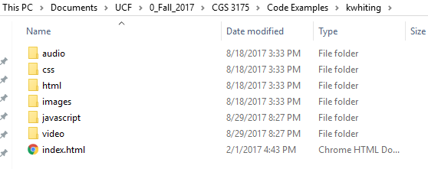
Figure 1 Parent directory is kwhiting
Figure 2 Pathing is relative to where file index.html exists

- Submit the assignment in a compressed format (e.g. .zip, .tgz, .tar, etc…) that includes all resources (i.e. compress at the parent directory level)

