
Research Paper
For Azerbaijan Artificial Intelligence Lab
Eigenvalue And Eigenvector
Sabuhi Nazarov

Eigenvalues and Eigenvectors
Imagine you are standing outside on a sunny day, and you notice the shadow of a tall tree on the ground. As the sun moves across the sky, the shadow of the tree changes in length and position, it always points in the opposite direction from the sun. Now, imagine a special kind of shadow that does not change direction, no matter how the sun moves. This shadow would always stretch or shrink along the same line, just like an eigenvector under a linear transformation.
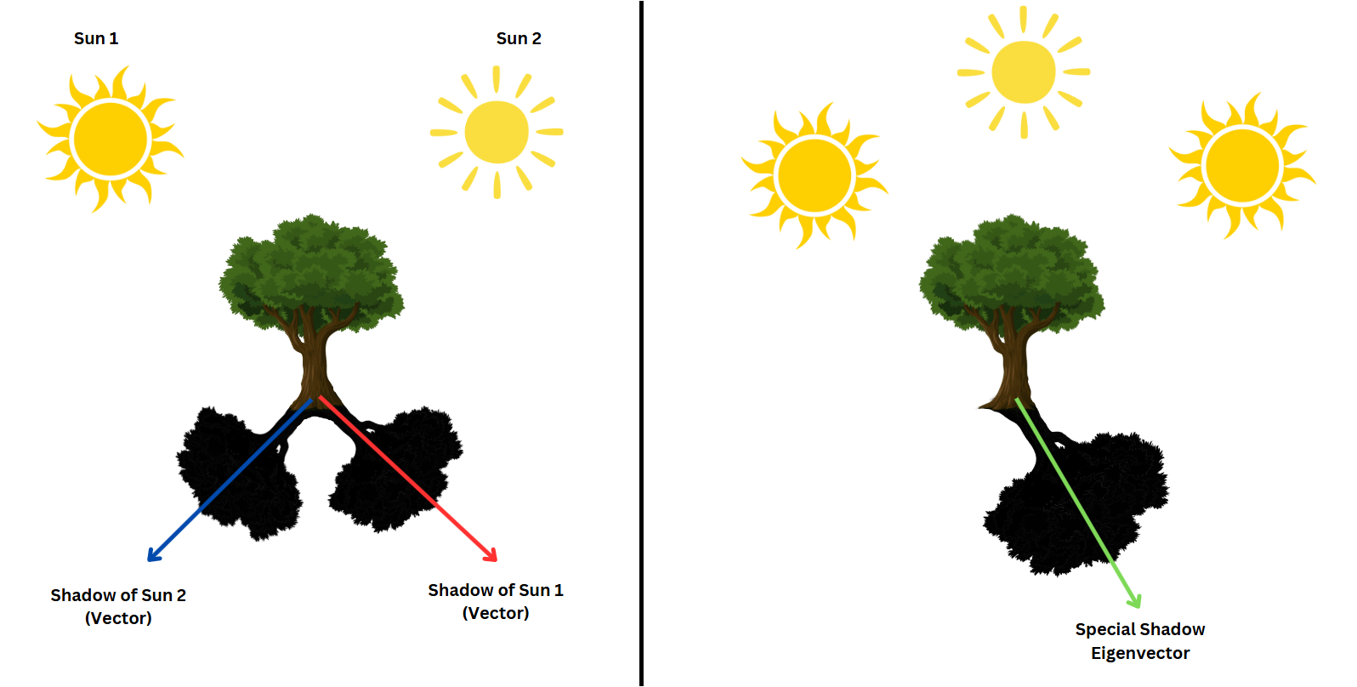
In mathematics, eigenvectors are like these special shadows. They are vectors that, when transformed by a matrix (or linear operator), do not change direction—they only get scaled by a certain factor, called the eigenvalue. This unique property makes eigenvectors incredibly powerful for understanding how transformations work and for solving real-world problems in fields like physics, engineering, and data science.
In this paper, we will explore what eigenvalues and eigenvectors are, how to compute them, and why they are so important. By the end, you will see how these concepts are not just abstract mathematical ideas but tools that help us understand and simplify complex systems.
To understand eigenvalues and eigenvectors better, let’s first talk about linear transformations. A linear transformation is like a "movement" of coordinate space, where every point (or vector) gets moved to a new location. The key idea is that these transformations are linear, meaning they keep lines parallel and evenly spaced. When you multiply a vector by a matrix, you are applying a linear transformation to that vector.
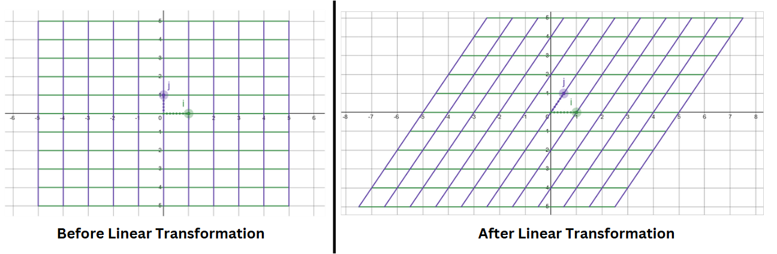
Source: Desmos
When a transformation is applied to a vector, it usually changes both its direction and magnitude. However, some special vectors remain in the same direction after the transformation-they are simply stretched, shrunk, or possibly flipped. These special vectors are called eigenvectors, and the factor by which they are scaled is known as the eigenvalue. Together, they form what we call an eigenpair.
A key property of eigenpairs is that a single transformation can have multiple eigenvectors sharing the same eigenvalue. This means that different vectors might experience the same stretching factor while still pointing in different directions. In some cases, eigenvalue can be one, indicating that the eigenvector remains unchanged in length. Additionally, when dealing with more complex transformations, eigenvalues can be complex numbers, leading to deeper mathematical interpretations.
This relationship is expressed mathematically as:
Av=λv
where:
- A is a matrix representing the transformation.
- v is an eigenvector that remains aligned in its original direction.
- λ is the eigenvalue, which determines how v is scaled.
This equation tells us that instead of being altered unpredictably, eigenvectors experience a controlled transformation-they are either stretched, shrunk, flipped, or left unchanged.
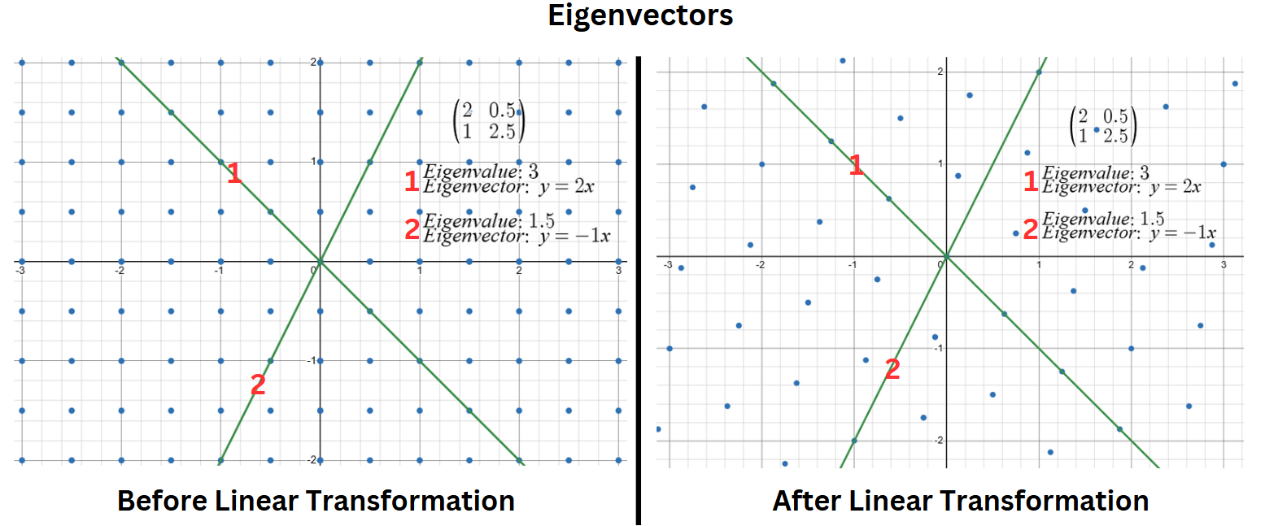
Source: Desmos
For example, if λ>1, the eigenvector is stretched.
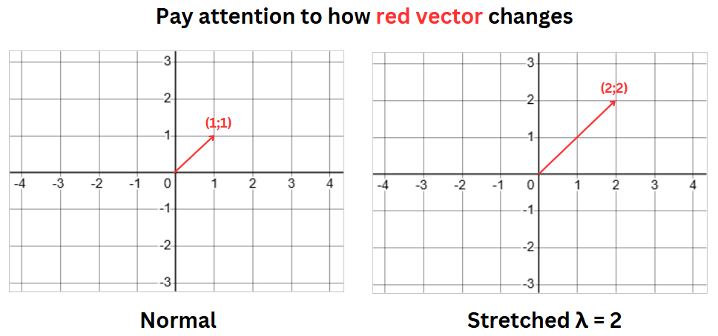
If 0<λ<1, the eigenvector is compressed.
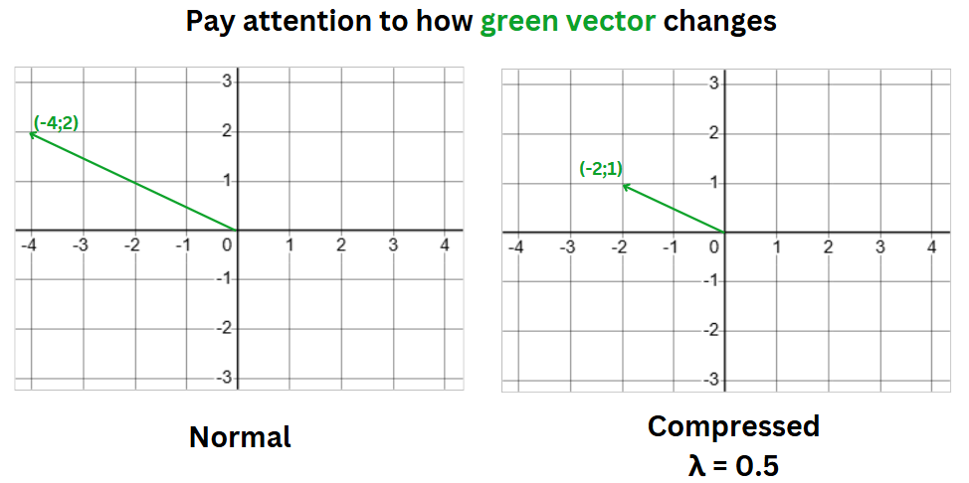
If λ<0, the eigenvector flips direction in addition to being stretched or compressed.
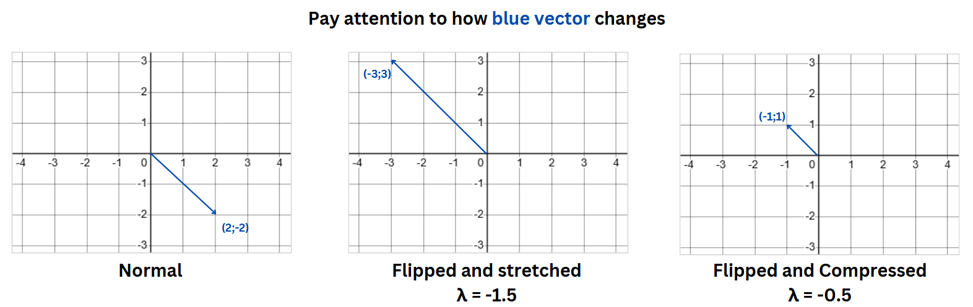
Let’s see how we can calculate Eigenvectors and Eigenvalues. For calculations, we should also have a clear intuition about determinants. A determinant is a scalar value that provides key information about a square matrix. It helps determine if a matrix is invertible (a nonzero determinant) or singular (a zero determinant). The determinant of a 2×2 matrix
$$\left[\begin{matrix}a & b \\ c & d\end{matrix}\right]$$
is calculated as:
det(A)=ad−bc
Eigenvalues and eigenvectors are found using the characteristic equation, which is derived from the matrix equation:
Av=λv
Av−λv=0
(A−λI)v=0
For this equation to have nontrivial solutions (nonzero eigenvectors), the matrix A−λI must be singular, meaning its determinant must be zero:
det(A−λI)=0
where A is a square matrix, I is the identity matrix of the same dimension, and λ represents the eigenvalues. Expanding this determinant results in a polynomial equation whose roots give the eigenvalues. Once the eigenvalues are determined, eigenvectors are found by solving:
(A−λI)v=0
where v is the eigenvector corresponding to λ.
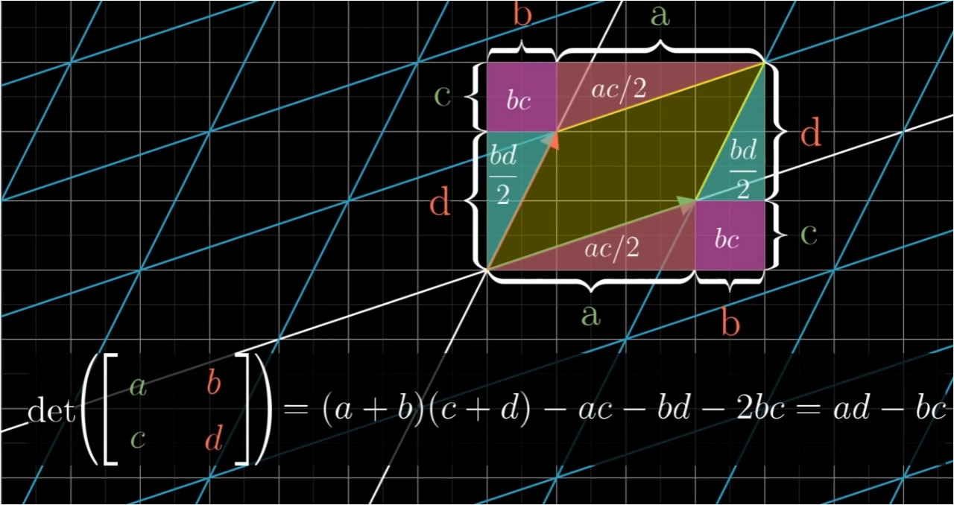
Calculation of determinant (source)
Sometimes, a matrix can have eigenvalues that are complex numbers instead of real numbers. This happens when the characteristic equation of the matrix has no real solutions. When a matrix has complex eigenvalues, its eigenvectors also contain complex numbers, but they still follow the same eigenvalue equation. In real-world applications, complex eigenvalues often indicate rotation and scaling rather than just stretching or shrinking. For example, in physics and engineering, they help describe systems that oscillate or rotate, like waves, electrical circuits, and mechanical vibrations.
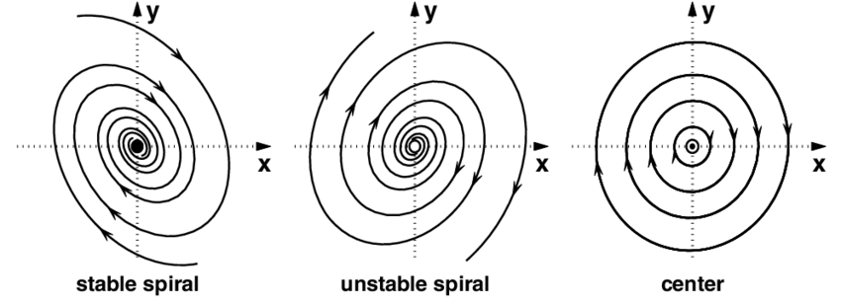

Eigendecomposition. Eigendecomposition is a method of breaking down a matrix into simpler components using its eigenvalues and eigenvectors. Specifically, for a square matrix A that has a full set of linearly independent eigenvectors, it can be decomposed as:
$$A=QΛQ^{-1}$$
where $Q$ is a matrix whose columns are the eigenvectors of A, and $Λ$ is a diagonal matrix whose diagonal entries are the eigenvalues of A.
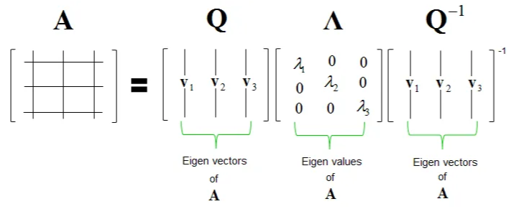
(source)
This decomposition shows that the original matrix can be rewritten in terms of its eigenvectors and eigenvalues, which makes matrix operations much easier. For example, computing powers of a matrix, exponentiating a matrix, or solving differential equations becomes much simpler when using eigendecomposition.
However, if A is a symmetric matrix (A^{T}=A), then it has an orthogonal eigendecomposition where the eigenvectors form an orthogonal matrix Q (meaning Q^{T}=Q⁻¹). In this special case, the decomposition is written as:
A=QΛQ^{T}
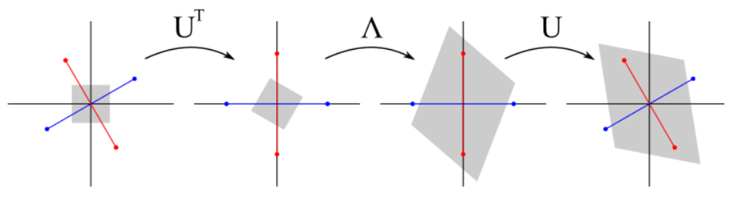
(source)

Importance of Eigenvalues and Eigenvectors
So why should we even bother with this? Eigenvalues and eigenvectors are foundational tools in mathematics and applied sciences, offering profound insights into the mechanics of linear transformations in an elegant and streamlined manner. Unlike most vectors, which shift unpredictably in direction and magnitude under a transformation, eigenvectors possess a unique property: they retain their orientation, merely stretching or contracting by a factor known as the eigenvalue. This remarkable behavior allows us to decompose intricate transformations into their core building blocks, transforming complex problems into manageable, intuitive components.
The power of eigenvalues lies in their ability to unveil critical characteristics of a transformation—whether it preserves orientation, reverses it, compresses space, or amplifies certain directions. This clarity is invaluable across disciplines, from physics to data science, where understanding a system’s intrinsic properties is essential. Moreover, by focusing on the dominant eigenvectors, those tied to the largest eigenvalues-we can distill high-dimensional systems into their most influential features. This dimensionality reduction preserves essential information while slashing computational and conceptual complexity, a boon for tackling real-world challenges like machine learning or structural engineering.
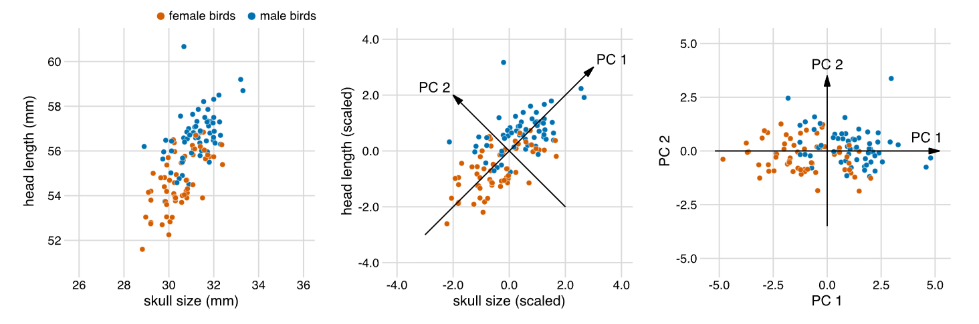
(source)
Beyond simplification, eigenvalues are key to predicting long-term dynamics in evolving systems. They reveal whether components will amplify, decay, or stabilize over time, providing a window into stability, emergent patterns, and underlying relationships. In practical terms, this makes them indispensable for analyzing everything from vibrating bridges to economic models or neural networks. By bridging abstract mathematics with tangible outcomes, eigenvalues and eigenvectors empower us to not only understand but also manipulate and optimize the systems that shape our world.
The Tacoma Narrows Bridge collapsed due to aerodynamic flutter, a phenomenon where wind caused uncontrollable oscillations, and eigenvalue analysis alone couldn’t have prevented the failure because it focuses on linear systems, while the bridge's response to wind was highly nonlinear. At the time, engineers lacked the understanding of aerodynamic forces and tools like wind tunnel testing to address such issues, but today, eigenvalue analysis is part of a broader toolkit, combined with advanced methods like computational fluid dynamics and wind tunnel testing, to design safe and stable structures that avoid such catastrophic failures.
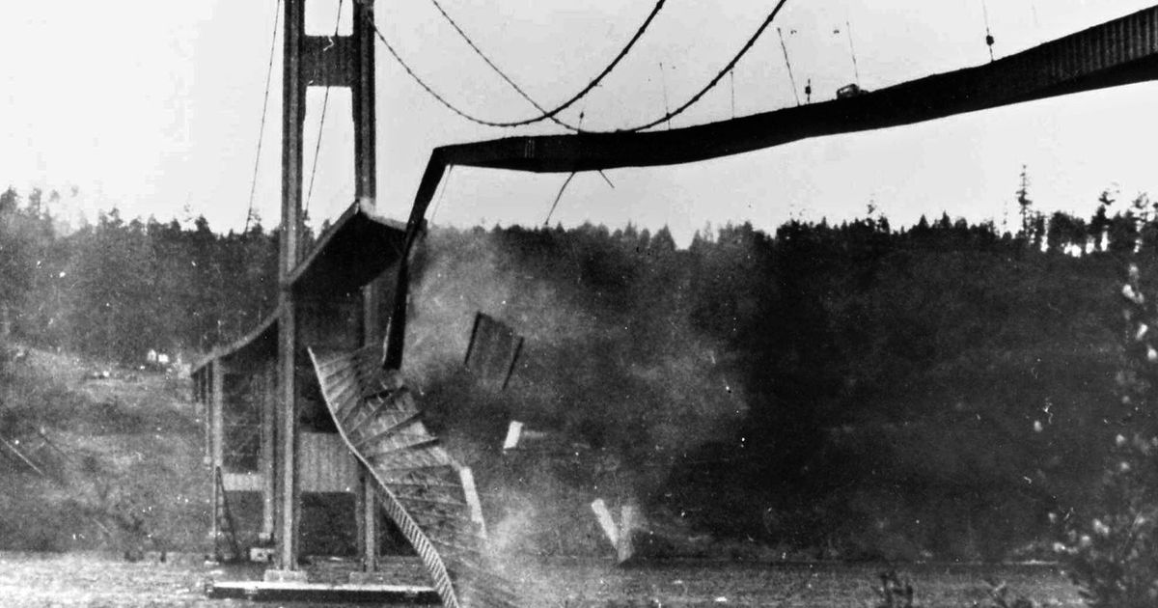
The Tacoma Narrows Bridge Collapse (source1)(source2)
Applications of Eigenvalues and Eigenvectors
Eigenvectors and eigenvalues have a broad range of applications across various fields, but in this paper, I will focus on the most significant, practical, and widely encountered applications that have a direct impact on our daily lives and modern technology.
Car Stereo System Design. Eigenvalues and eigenvectors help optimize sound propagation in car stereo systems by analyzing how sound waves reflect off surfaces, creating resonances and distortions. Engineers model these reflections using wave equations, where eigenvalues represent resonant frequencies and eigenvectors define vibration patterns. Understanding these properties allows for better speaker placement, equalization, and digital filtering, ensuring clear and balanced audio while minimizing unwanted echoes and distortions.(source)

Google's PageRank algorithm. Google's PageRank algorithm, which revolutionized web search, is based on eigenvalues and eigenvectors. It treats the internet as a massive network, where each webpage is a node, and links between pages represent connections. Instead of ranking pages simply by counting links, PageRank assigns importance based on how pages are connected.
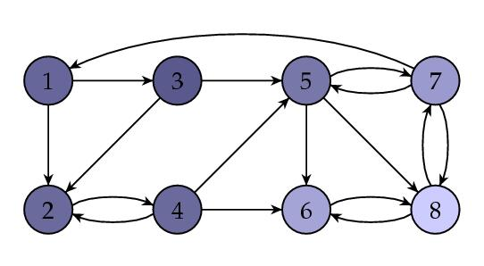
At its core, the algorithm represents this network using a large matrix that describes how users navigate between webpages. The key idea is that a page’s importance is influenced not just by how many links it has but by the importance of the pages linking to it. This is where eigenvectors come in—PageRank finds a special vector (the dominant eigenvector) that represents a stable ranking of all webpages. The values in this vector show how important each page is relative to the others.
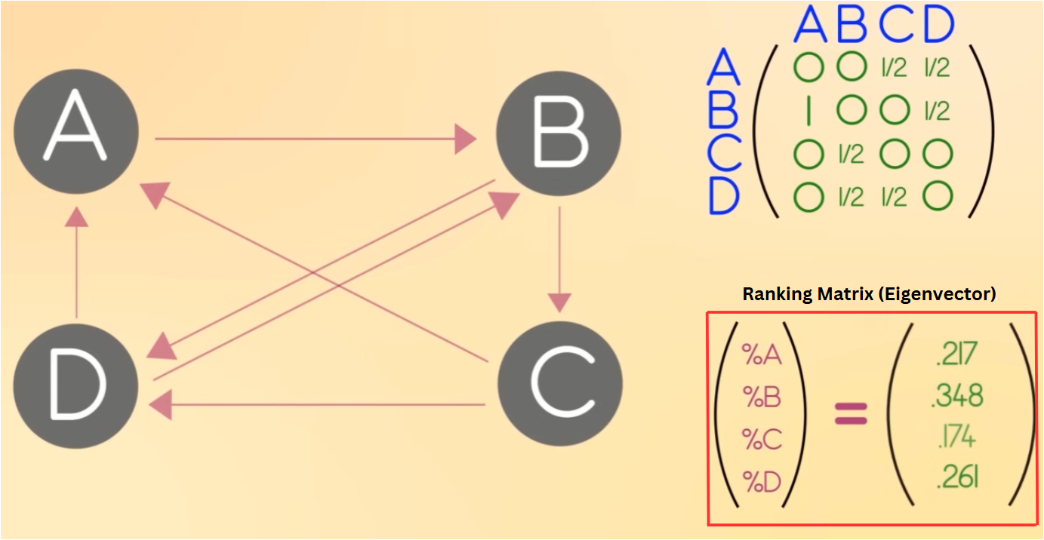
(source)
The algorithm calculates the dominant eigenvector of the ranking matrix, which represents a stable ranking of all webpages. This vector indicates the relative importance of each page, showing how their rankings are influenced by the quality and importance of the pages that link to them.
By using eigenvectors to analyze web connections, PageRank enables Google to rank billions of pages efficiently, ensuring that the most relevant and authoritative content appears at the top of search results. This approach transformed how information is organized and accessed on the internet. (source)
Communication Channel Capacity. Eigenvalues play a crucial role in understanding the theoretical limits of information transmission through communication channels, such as telephone lines or wireless signals. By representing the communication channel as a mathematical matrix, engineers analyze how data flows and determine the most efficient way to transmit information. The eigenvalues of this matrix reveal the strength and capacity of different transmission pathways. Larger eigenvalues correspond to stronger, more reliable channels, while smaller ones indicate weaker, noisier paths. To maximize data transmission, a technique known as waterfilling is applied, which strategically allocates power across the available eigenchannels based on their eigenvalues. This ensures that stronger channels receive more data while minimizing losses in weaker ones.
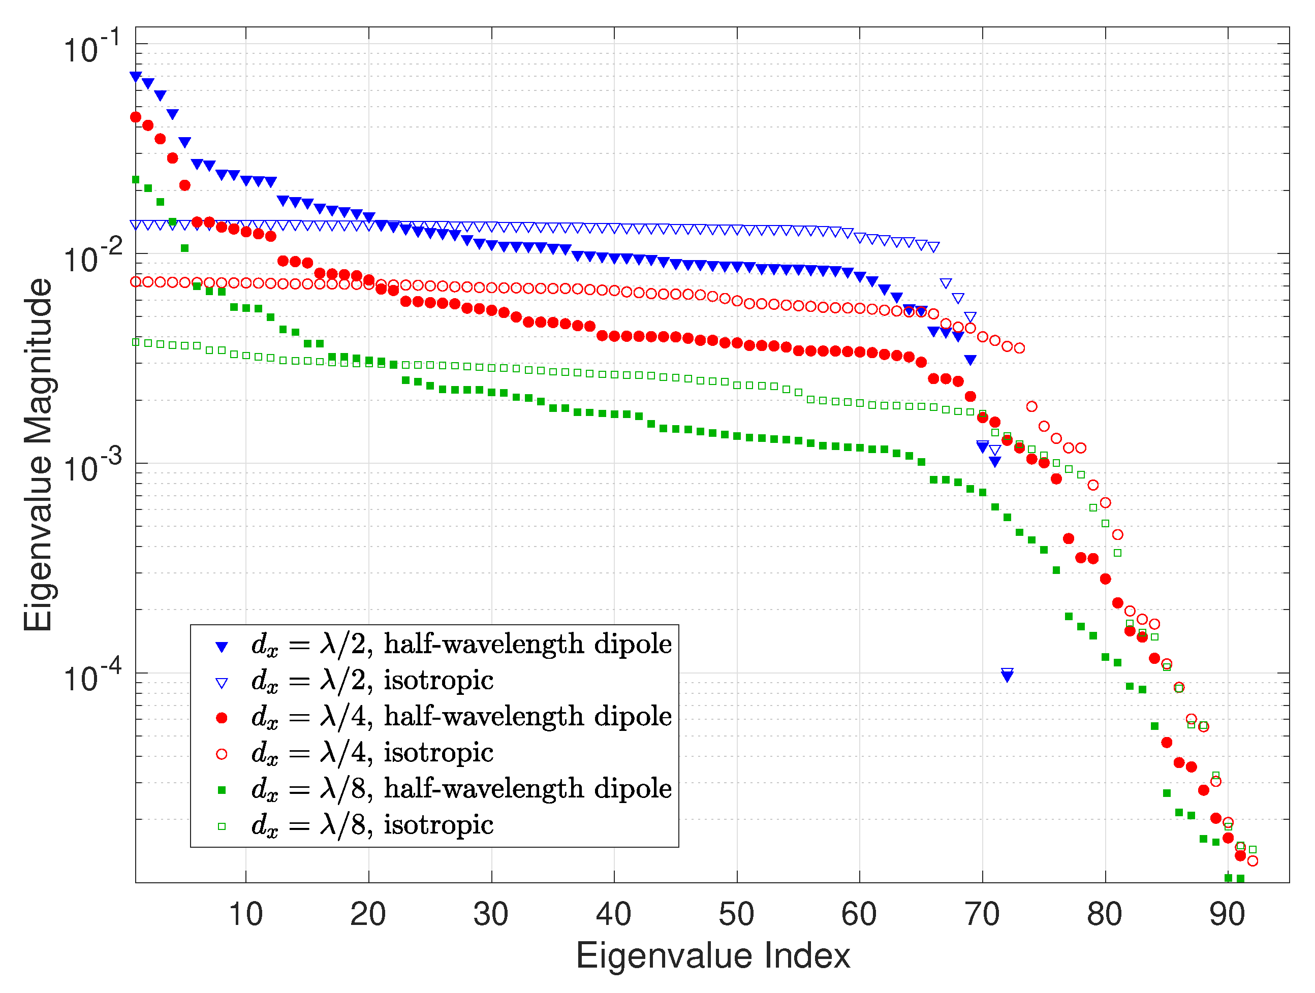
I know it looks very complicated, but believe me, it’s way simpler than it looks. This image shows a graph of eigenvalue magnitudes (y-axis) versus eigenvalue indices (x-axis) for different antenna models (half-wavelength dipoles and isotropic antennas at various sizes: λ/2, λ/4, λ/8). The declining curves indicate how eigenvalues decrease in importance, helping identify the most significant components—key for understanding system behavior, stability, and patterns, which aligns with the role of eigenvectors and eigenvalues in simplifying complex systems.
By leveraging eigenvalues and eigenvectors, engineers can optimize bandwidth usage, improve signal quality, and enhance overall communication efficiency, helping to push the boundaries of how much information can be reliably sent over different transmission mediums.(source)
Dimensionality Reduction. Principal Component Analysis (PCA) is a technique that uses eigenvectors and eigenvalues to reduce the dimensionality of data while preserving as much meaningful information as possible. In PCA, we compute the eigenvectors of the data's covariance matrix, which represents the directions of maximum variance in the dataset. The corresponding eigenvalues indicate the amount of variance captured by each eigenvector. By selecting the top eigenvectors with the highest eigenvalues, we transform the data into a new coordinate system where the most important patterns are emphasized, and less significant variations (often noise) are ignored.
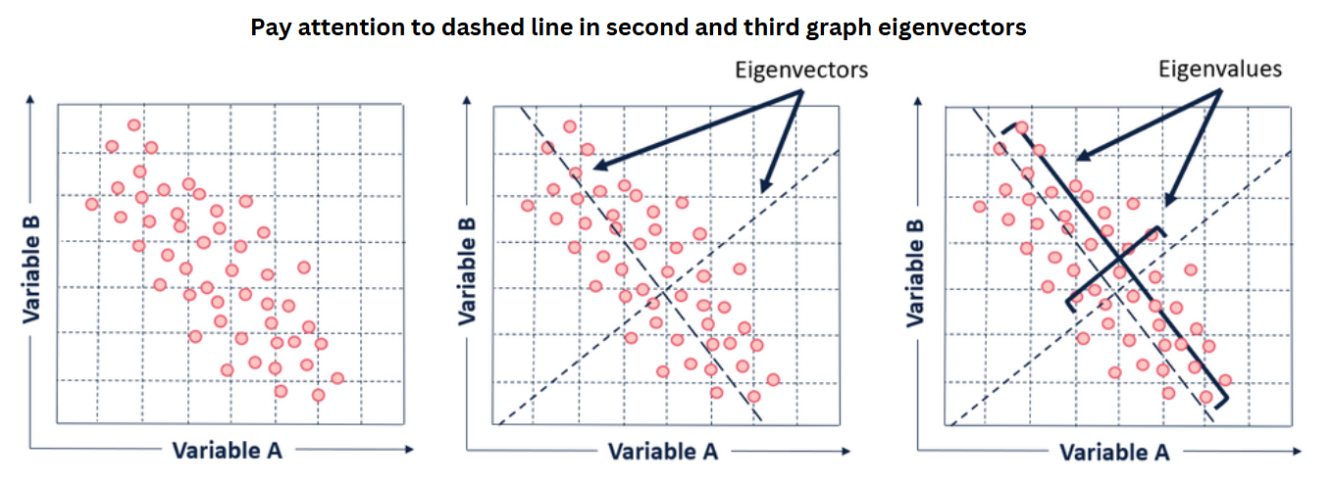
PCA is widely used in real-life applications where high-dimensional data needs to be simplified without losing essential information. In image compression, PCA helps reduce the number of pixels while keeping the key visual features intact. In finance, it is used to analyze stock market trends by identifying dominant patterns in asset prices. In genetics, PCA helps researchers study variations in DNA by identifying key genetic markers. Additionally, in machine learning, PCA is often applied for feature reduction, improving model performance by removing redundant or irrelevant information.(source)
Oil mining. In oil exploration, eigenvectors are used to analyze seismic data and identify patterns that indicate potential hydrocarbon reserves. By transforming seismic traces into a set of eigenvectors, explorationists can isolate key features that differentiate oil-rich zones from non-productive areas. These eigenvectors represent the dominant directions of variation in the data, allowing for efficient classification of subsurface structures, such as porous or non-porous rock layers. This approach enhances the accuracy of interpreting seismic data, enabling more precise targeting of drilling sites. Thus, eigenvectors serve as a fundamental tool in modern oil exploration, helping to optimize resource discovery and reduce exploration risks.(source)
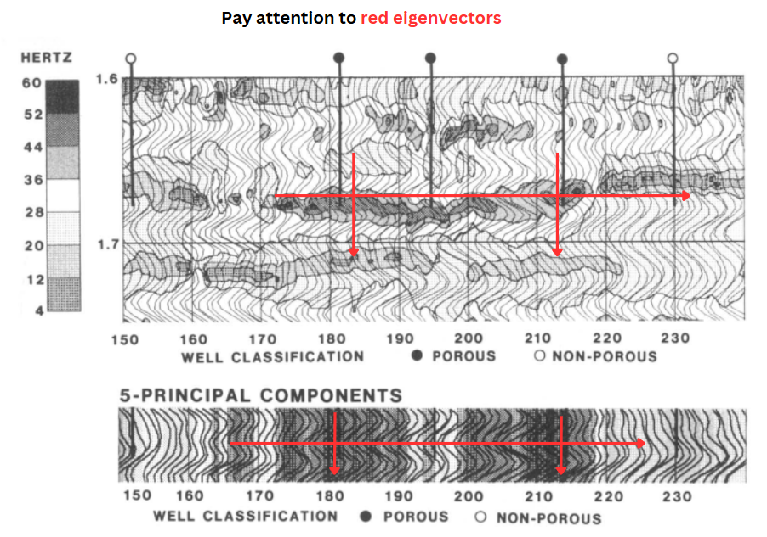
Image Compression. Singular Value Decomposition (SVD) is a powerful technique in linear algebra that is widely used for image compression. It factorizes an image matrix A into three matrices:
A=UΣV^{T}
where U and V are orthogonal (or unitary) matrices, and Σ is a diagonal matrix containing singular values. The singular vectors in U and V correspond to the eigenvectors of AA^{T} and A^{T}A, respectively, and they represent essential structural patterns in the image.
In image compression, we can reduce the file size by keeping only the most significant singular values in Σ while discarding smaller ones. Since singular values indicate the importance of their corresponding singular vectors, this method effectively removes less important details while preserving key features. By selecting only the top k singular values and their corresponding vectors, we obtain a low-rank approximation of the image, significantly reducing storage space while maintaining visual quality. This technique is widely used in formats like JPEG compression and in reducing noise while preserving essential details in images.

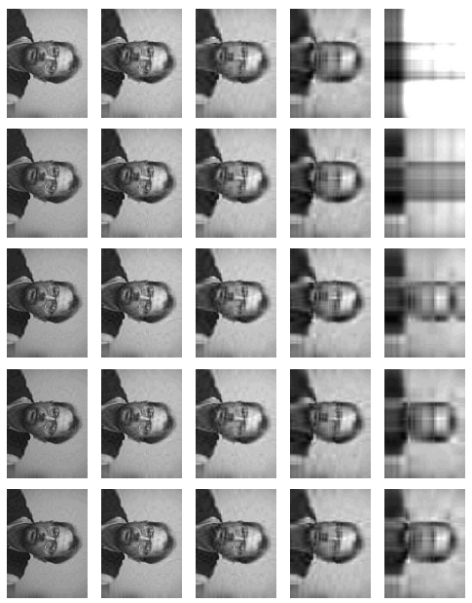
(source)
Eigenvectors and eigenvalues have far more applications than those discussed in this paper, and while I have explored a selection of the most significant and practical examples, their use extends into countless other fields, demonstrating their fundamental importance in both theoretical and applied sciences.
I would like to extend my gratitude to the readers for their time and attention in exploring eigenvectors and eigenvalues presented in this paper. I have strived to provide a comprehensive overview of their significance, and I hope this work offers valuable insights into their wide-ranging impact across various fields.

