SyncUp Project

Software Engineering Cost Estimation Report

1. Code Metrics
Analyzing the codebase size and structure.
Metric | Value | Description
Total Lines of Code (LOC) | 11,681 | Actual code written
KLOC (Kilo Lines of Code) | 12 KLOC | Total in thousands (rounded)
Effective LOC | 10,065 | Excluding comments/blank lines
Comment Lines | 166 | Documentation
Total Files | 165 | TypeScript/JavaScript files

2. COCOMO Model Effort Estimation
Using the Constructive Cost Model (COCOMO) to estimate effort and development time.
Parameter | Value | Formula/Basis
Project Type | Organic | Web application, familiar tech
KLOC | 12 | Lines of code in thousands
Effort (Person-Months) | 32.61 PM | E = 2.4 × (KLOC)^1.05
Development Time (Months) | 9.4 months | T = 2.5 × (E)^0.38
Team Size | 3 developers | E / T

Result: 32.61 person-months over 9.4 months with 3 developers

3. Cost Estimation by Resource
Breaking down costs by developer roles and expertise levels.
Resource | Rate ($/hour) | Effort (hours) | Total Cost ($)
Senior Developer | $75 | 1,000 | $75,000
Mid-level Developer | $50 | 2,000 | $100,000
Junior Developer | $35 | 1,500 | $52,500
UI/UX Designer | $60 | 300 | $18,000
QA Engineer | $45 | 400 | $18,000
Project Manager | $80 | 200 | $16,000
TOTAL |  | 5,400 | $279,500

Cost Distribution by Resource
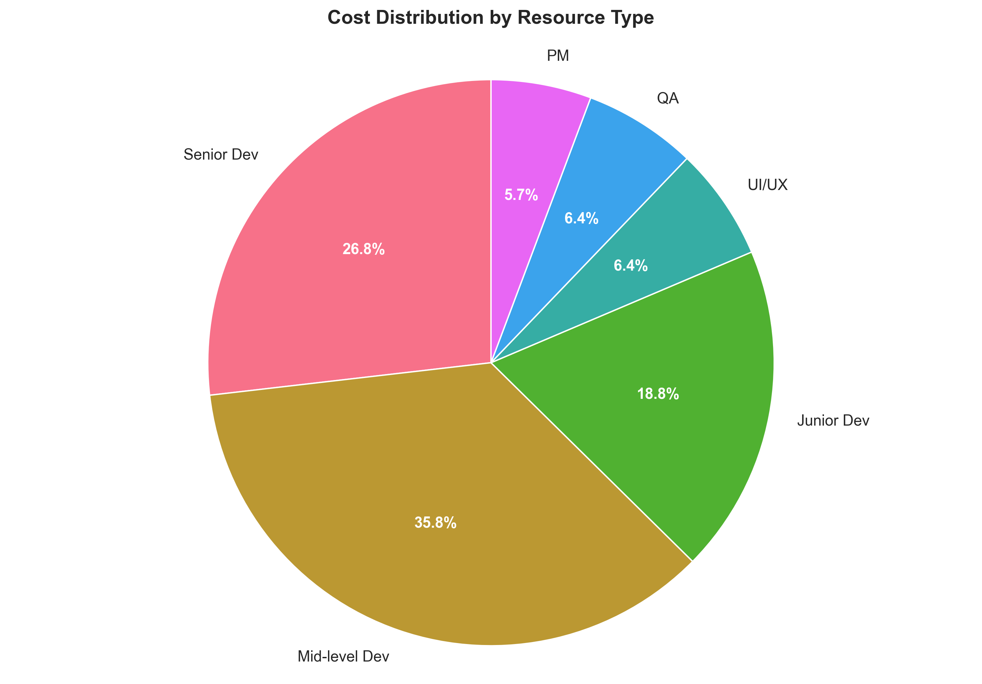

4. Function Point Analysis
Estimating project complexity using Function Points.
Component | Count | Complexity | Function Points
External Inputs | 25 | Medium | 100
External Outputs | 18 | Medium | 90
External Queries | 30 | Simple | 90
Internal Files | 12 | Complex | 180
External Interfaces | 5 | Complex | 75
TOTAL | - | - | 535

Total Function Points: 535 FP
Cost per Function Point: $522.43/FP

5. Productivity Metrics
Metric | Value | Industry Standard
LOC per Person-Month | 358 LOC/PM | 250-500 LOC/PM
Cost per LOC | $23.93 | $15-25/LOC
Defect Density | 2-3 defects/KLOC | 1-5 defects/KLOC
Code Reusability | 30% | 20-40%

6. Component-wise Development Cost
Component | Technology Used | Dev Cost | Monthly (Dev) | Monthly (Prod)
Frontend | Next.js 15, React 19, TypeScript | $8,000 | $0 | $20
Backend | Next.js API Routes, Prisma ORM | $6,000 | $0 | $20
Database | Supabase PostgreSQL | $2,000 | $0 | $25
Authentication | Clerk | $1,500 | $0 | $25
AI Processing | Ollama (Mistral, Llama2) | $5,000 | $0 | $0
Vector Database | Pinecone | $2,000 | $0 | $70
File Storage | AWS S3 | $1,000 | $3 | $15
Email Service | Resend | $500 | $0 | $20
Integrations | Google, Slack, Jira, Asana, Trello | $4,000 | $0 | $0
UI/UX Design | Tailwind CSS, ShadcN UI | $3,000 | $0 | $0
Testing & QA | Manual + Automated | $2,000 | $0 | $0
TOTAL |  | $35,000 | $3 | $195

Component Cost Breakdown
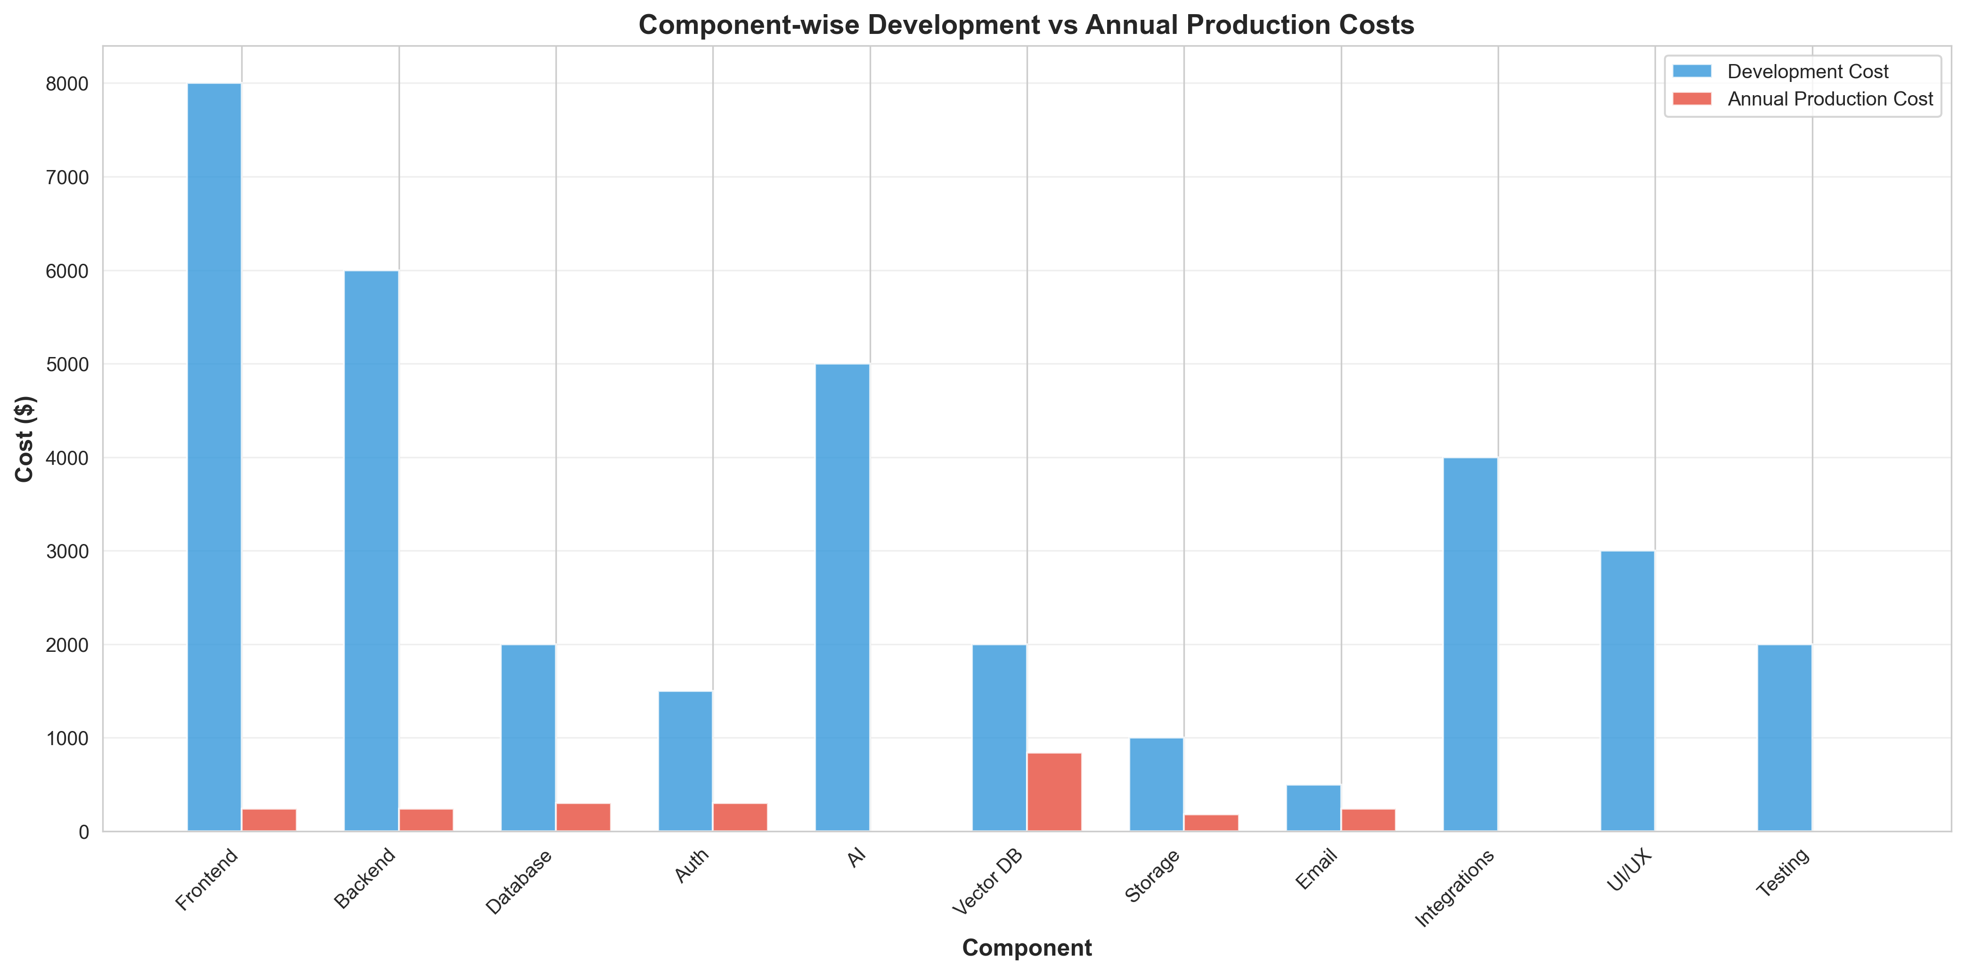

7. Project Scenarios Comparison
Scenario | Team Size | Duration (months) | Total Cost
Academic Project | 2 | 4 | $0
Startup MVP | 3 | 6 | $90,000
Professional Development | 5 | 9 | $279,500
Enterprise Grade | 8 | 12 | $450,000

Scenario Comparison Visualization
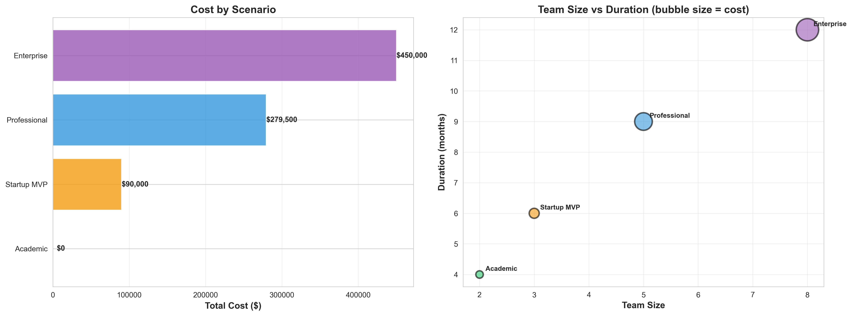

8. Summary Breakdown
Phase | Total Cost
Development (One-time) | $35,000
Development Deployment | $3/month
Production (100-500 users) | $195/month
Production (1000+ users) | $500-800/month

9. Final Project Summary
Metric | Value
KLOC | 12 KLOC
Total LOC | 11,681
Effort (Person-Months) | 32.61 PM
Development Time | 9.4 months
Team Size | 3 developers
Function Points | 535 FP
Dev Cost (Professional) | $279,500
Dev Cost (Academic) | $0
Monthly Production Cost | $195
LOC per PM | 358 LOC/PM
Cost per FP | $522.43/FP

Key Findings
- SyncUp Project - Professional equivalent value: $279,500
- Actual academic development cost: $0 (using free tiers)
- Estimated effort: 32.61 person-months over 9.4 months with 3 developers
- Total function points: 535 FP at $522/FP
- Codebase: 11,681 lines of code (12 KLOC) across 165 files
- Monthly production cost: $195 for 100-500 users
- Code productivity: 358 LOC/PM (within industry standard of 250-500 LOC/PM)

Note: Development costs assume professional rates ($50-75/hour). As a student project, actual cost is $0 using free tiers of Supabase, Pinecone, Clerk, Vercel, and self-hosted Ollama for AI processing.

