ABSTRACT
CineInsight is a comprehensive data-driven application designed to explore, analyze, and visualize trends in Netflix’s vast library of movies and shows. Developed using Python libraries such as Pandas, Matplotlib, Seaborn, TextBlob, and Scikit-learn, the project places special emphasis on Indian and South Indian cinema, providing valuable insights into film trends, audience sentiment, and genre dynamics.
The project begins with data collection and preprocessing from a Netflix dataset containing information such as titles, genres, ratings, release years, and descriptions. This refined data is filtered to highlight Indian content, enabling comparative analysis with global movie trends. Visual tools are employed to illustrate the yearly distribution of movie releases, genre popularity over time, and key regional differences.
A core feature of CineInsight is sentiment analysis powered by the TextBlob library. By analyzing the tone of movie descriptions, it categorizes content into positive, negative, or neutral sentiments. These insights are then visualized to understand how different genres emotionally resonate with audiences.
To enhance user interaction, the project integrates an interactive dashboard using ipywidgets, where users can search for specific titles and retrieve in-depth information including IMDb ratings, cast details, and genre tags.
CineInsight also incorporates predictive analytics through linear regression, allowing for the forecasting of future genre trends based on historical data.
In essence, CineInsight merges exploratory data analysis, sentiment mining, visualization, and forecasting into a single user-friendly tool. It serves as a valuable platform for movie enthusiasts, data scientists, and entertainment industry stakeholders seeking a deeper understanding of audience behavior and content trends on Netflix.

INDEX
CHAPTERS | NAME OF THE TITLE | PAGE NO
CHAPTER 1 | INTRODUCTION  1.1 OVERVIEW OF THE PROJECT
CHAPTER 2 | SYSTEM ANALYSIS  2.1 FEASIBILITY STUDY  2.2 EXISTING SYSTEM  2.3 PROPOSED SYSTEM
CHAPTER 3 | SYSTEM SPECIFICATION  3.1 HARDWARE SPECIFICATION  3.2 SOFTWARE SPECIFICATION  3.3 SOFTWARE TECHNOLOGY REVIEW
CHAPTER 4 | SYSTEM DESIGN  4.1 DESIGN TERMINOLOGY  4.2 DATAFLOW DIAGRAM  4.3 ENITY RELATIONSHIP DIAGRAM
CHAPTER 5 | SYSTEM DEVELOPMENT  5.1 SYSTEM MODULE SPECIFICATION  5.2 USER MANUAL PROCEDURE
CHAPTER 6 | SYSTEM TESTING  6.1 TESTING METHODOLOGY  6.2 TESTING STRATEGIES
CHAPTER 7 | SOFTWARE MAINTENANCE  7.1 SYSTEM MAINTENANCE
CHAPTER 8 | CONCLUSION  8.1 CONCLUSION  8.2 SCOPE FOR FUTURE ENHANCEMENT
CHAPTER 9 | BIBLIOGRAPHY  9.1 REFERENCES
CHAPTER 10 | APPENDICES  10.1 SCREENSHOTS  10.2 SAMPLE SOURCE CODE

CHAPTER 1

INTRODUCTION

AN OVERVIEW
Cine - Insight is an interactive data analysis platform designed to provide in-depth insights into the extensive catalogue of movies available on Netflix, with a special emphasis on Indian cinema. As streaming services increasingly shape the entertainment industry, understanding viewer preferences, trends, and sentiments associated with content has become crucial for both audiences and content creators. This project utilizes a comprehensive dataset containing detailed information about Netflix movies, allowing users to explore various facets of the content, including release trends, genre distributions, and audience sentiments.
The project initiates by loading and preprocessing the dataset, which involves filtering for Indian movies and further narrowing down to South Indian films based on language. Through a series of visualizations, users can track trends in movie releases over the years, compare the number of Indian and global films, and analyse the popularity of different genres. Additionally, the tool incorporates sentiment analysis to assess audience reactions to movie descriptions, offering valuable insights into how viewers perceive various genres.
Beyond trend analysis, Cine - Insight employs predictive modelling techniques to forecast future genre trends, enabling users to anticipate which types of content may gain popularity in the coming years. The interactive user interface allows users to search for specific movies and access detailed information, including ratings, cast, and descriptions, thereby enhancing the overall user experience.
By integrating data visualization, sentiment analysis, and predictive modelling, Cine - Insight serves as a comprehensive resource for movie enthusiasts, industry professionals, and researchers alike. This project not only showcases the richness of Netflix's content but also empowers users to make informed decisions about their viewing choices, ultimately enriching their entertainment experience.
Furthermore, Cine - Insight aims to bridge the gap between data and storytelling, allowing filmmakers and producers to understand audience preferences better. By analysing sentiment trends and genre popularity, content creators can tailor their projects to meet viewer demands, ensuring that they resonate with audiences. This project stands as a testament to the power of data in shaping the future of cinema, fostering a deeper connection between viewers and the stories they love.

CHAPTER 2
SYSTEM ANALYSIS
The proposed CineInsight system significantly enhances the capabilities of existing movie analysis platforms by providing a comprehensive, interactive, and user-friendly tool for exploring Netflix's movie catalog. By addressing the drawbacks of current systems, CineInsight empowers users to make informed decisions about their viewing choices and fosters a deeper connection between content creators and audiences.

2.1. FEASIBILITY STUDY
The feasibility study for CineInsight evaluates the practicality of developing an advanced movie analytics platform that addresses the limitations of existing systems. Current platforms primarily focus on basic movie recommendations and ratings, lacking comprehensive analytical tools that delve into trends and audience sentiments. This study highlights the drawbacks of these existing systems, such as static data visualization and insufficient sentiment analysis, which hinder user engagement and content creation. In contrast, the proposed CineInsight system aims to provide a robust, interactive platform that integrates comprehensive data analysis, predictive modeling, and community features, empowering users to make informed viewing choices and fostering deeper connections with cinematic content..The feasibility study evaluates the practicality of the CineInsight project from various perspectives:

2.1.1 Technical Feasibility:
The project utilizes widely adopted technologies such as Python, Pandas, Matplotlib, Seaborn, and TextBlob for data analysis and visualization. These tools are well-documented and supported, making the technical implementation feasible. Additionally, the architecture is designed to be modular, allowing for easy updates and integration of new features as technology evolves. The use of cloud computing services (e.g., AWS, Google Cloud) can enhance data storage and processing capabilities, ensuring scalability as user demand grows.

2.1.2 Economic Feasibility:
The project leverages publicly available datasets, minimizing costs associated with data acquisition. The potential benefits, such as enhanced viewer engagement and informed content creation, outweigh the initial development costs. Furthermore, the platform can explore monetization strategies, such as offering premium analytics services to filmmakers and studios, thereby creating a sustainable revenue model. Partnerships with educational institutions for research purposes can also provide funding opportunities.

2.1.3 Operational Feasibility:
The interactive nature of the platform aligns with user expectations for modern data analysis tools. The user interface is designed to be intuitive, ensuring that both technical and non-technical users can navigate the system effectively. Training materials and user support will be provided to facilitate smooth onboarding and maximize user satisfaction. Regular feedback loops with users will help refine the platform and ensure it meets evolving needs.

2.2 EXISTING SYSTEM

Currently, many platforms provide movie recommendations and ratings but lack comprehensive analytical tools that delve into trends and audience sentiments. Existing systems often include:
- Basic Recommendation Engines: These systems suggest movies based on user preferences but do not provide insights into broader trends or audience sentiments. They often rely on simplistic algorithms that do not account for the evolving nature of viewer preferences. This can lead to a lack of diversity in recommendations, limiting user engagement.
- Limited Data Visualization: Many platforms offer static charts or basic statistics without interactive features, making it difficult for users to explore data dynamically. Users are often left with a one-dimensional view of the data, which can hinder deeper analysis. The absence of customizable dashboards means users cannot tailor their experience to focus on the metrics that matter most to them.
- Lack of Sentiment Analysis: Existing systems typically do not analyze audience reactions or sentiments associated with movie descriptions, limiting their ability to gauge viewer engagement. This absence of sentiment metrics can lead to missed opportunities for content creators to connect with their audience. Without understanding viewer emotions, filmmakers may struggle to create content that resonates.
Drawbacks:
- Insufficient insights into genre popularity and trends over time, making it challenging for content creators to make informed decisions.
- Limited ability to understand audience sentiments, leading to a disconnect between content creators and viewers.
- Static interfaces that do not encourage user interaction or exploration, resulting in a less engaging user experience.
- Lack of community features that foster discussion and engagement among users, limiting the platform's social aspect.

2.3. PROPOSED SYSTEM

CineInsight addresses the shortcomings of existing systems by introducing several key features:
- Comprehensive Data Analysis: The system provides in-depth analysis of Netflix's movie catalog, focusing on trends in Indian cinema and genre popularity over time. Users can filter data by various parameters, such as release year, genre, and language, to gain tailored insights. This feature allows for a granular understanding of how different factors influence viewer preferences.
- Interactive Visualizations: Users can explore data through dynamic visualizations, allowing them to filter and manipulate data to uncover insights tailored to their interests. Features like zoomable charts, drill-down capabilities, and customizable dashboards enhance user engagement. Users can create their own visualizations based on specific queries, making the data exploration process more personalized.
- Sentiment Analysis Integration: By incorporating sentiment analysis, CineInsight enables users to understand audience reactions to movie descriptions, providing valuable insights into viewer preferences. This feature can help content creators identify which themes resonate most with audiences. Additionally, sentiment trends can be visualized over time, allowing users to see how audience perceptions change with new releases.
- Predictive Modeling: The system employs machine learning techniques to forecast future genre trends, helping users anticipate which types of content may become popular. This predictive capability can guide content strategy for filmmakers and streaming services. Users can input various parameters to simulate different scenarios and see potential outcomes, enhancing strategic planning.
- User -Friendly Interface: The interactive user interface is designed for ease of use, allowing users to search for specific movies and access detailed information seamlessly. The interface includes tooltips, guided tours, and help sections to assist users in navigating the platform. Accessibility features will ensure that the platform is usable for individuals with disabilities.
- Enhanced Reporting: CineInsight generates comprehensive reports on trends, sentiments, and predictions, making it a valuable resource for filmmakers, producers, and researchers. These reports can be exported in various formats (PDF, Excel) for further analysis or presentation. Users can schedule automated reports to be sent to their email, keeping them updated on the latest trends.
- Community Features: The platform can include community-driven features such as user reviews, ratings, and discussion forums, fostering a sense of community among movie enthusiasts. This engagement can provide additional qualitative insights into viewer preferences. Users can follow each other, share insights, and collaborate on analyses, creating a vibrant ecosystem of movie lovers.
- Mobile Compatibility: To reach a broader audience, the platform will be optimized for mobile devices, allowing users to access insights on-the-go. This feature ensures that users can engage with the content anytime, anywhere. A mobile app can also provide push notifications for new trends or updates, keeping users engaged.
- Integration with Social Media: The platform can allow users to share insights and visualizations on social media, increasing visibility and attracting new users. This feature can also facilitate discussions around trending movies and genres, enhancing community engagement.
- Gamification Elements: To encourage user interaction, gamification elements such as badges, leaderboards, and challenges can be introduced. Users can earn rewards for exploring data, contributing insights, or participating in discussions, making the platform more engaging.

CHAPTER 3
SYSTEM SPECIFICATION

3.1 HARDWARE REQUIREMENTS

The hardware requirements for the CineInsight project are categorized into minimum and recommended specifications to ensure optimal performance and user experience.
Minimum Hardware Requirements:
- Processor: Intel Core i5 or equivalent (Quad-core, 2.5 GHz or higher)
- RAM: 8 GB
- Storage: 256 GB SSD (or higher) for faster data access and processing
- Graphics Card: Integrated graphics (dedicated GPU recommended for advanced visualizations)
- Network: Broadband internet connection (minimum 10 Mbps)
Recommended Hardware Requirements:
- Processor: Intel Core i7 or equivalent (Hexa-core, 3.0 GHz or higher)
- RAM: 16 GB or more
- Storage: 512 GB SSD or higher
- Graphics Card: NVIDIA GeForce GTX 1060 or equivalent for enhanced data visualization
- Network: High-speed internet connection (minimum 25 Mbps)

3.2 SOFTWARE REQUIREMENTS

The software requirements for the CineInsight project include the operating system, development tools, libraries, and additional software necessary for the successful implementation and operation of the platform.
Operating System:
- Windows: Windows 10 or later
Development Tools:
- Programming Language: Python (version 3.7 or later)
- Integrated Development Environment (IDE): Jupyter Notebook or JupyterLab for interactive development and data analysis
Front-End Libraries:
- ipywidgets: For creating interactive UI components within Jupyter notebooks
- Matplotlib: For generating static and dynamic visualizations
- Seaborn: For enhanced statistical visualizations
- Folium (optional): For creating interactive map visualizations
Back-End Libraries:
- Pandas: For data manipulation and analysis
- NumPy: For numerical operations and array handling
- Scikit-learn: For machine learning and predictive modeling
- TextBlob: For sentiment analysis of movie descriptions

Database Management:
- PostgreSQL or MySQL: For relational database management and data storage
Additional Software:
- Web Server: Nginx or Apache for serving the application
- Version Control: Git for source code management
- Containerization: Docker for deployment and environment management
- Anaconda: For managing Python packages and environments

  - FRONT-END TOOLS

3.3.1 JUPYTER NOTEBOOK / JUPYTERLAB
  - Purpose: Jupyter Notebook and JupyterLab serve as interactive development environments that facilitate the writing and execution of Python code. They are particularly useful for data analysis, allowing users to combine code, visualizations, and narrative text in a single document. This interactivity is crucial for exploring datasets, as it enables users to visualize data trends and patterns in real-time, making it easier to derive insights and communicate findings effectively. The ability to document the analysis process alongside the code enhances reproducibility and collaboration among team members.
  - Key Features: One of the standout features of Jupyter is its support for inline plotting with libraries like Matplotlib and Seaborn, which allows users to generate visualizations directly within the notebook. Additionally, Jupyter integrates seamlessly with ipywidgets, enabling the creation of interactive dashboards. This means users can manipulate parameters and instantly see the effects on visualizations, enhancing the exploratory data analysis process. The notebook format also allows for easy sharing and presentation of findings, making it an ideal tool for collaborative projects and educational purposes.

3.3.2 IPYWIDGETS
  - Purpose: ipywidgets is a library designed to create interactive user interface components within Jupyter notebooks. It enhances the user experience by allowing for real-time interaction with data visualizations and analyses, making the exploration of datasets more engaging and intuitive. This interactivity is particularly beneficial in educational settings, where users can learn by experimenting with different parameters and observing the outcomes.
  - Key Features: The library provides a variety of UI components, including dropdowns, buttons, and sliders, which can be used to create interactive elements for the application. For instance, in the CineInsight project, text input and button widgets are utilized for movie search functionality, allowing users to input a movie title and retrieve relevant details dynamically. This interactivity is crucial for maintaining user engagement and facilitating a more hands-on approach to data exploration. Furthermore, ipywidgets can be styled and customized to match the overall aesthetic of the application, enhancing the user interface.

3.3.3 MATPLOTLIB & SEABORN
  - Purpose: Matplotlib and Seaborn are powerful libraries for generating static and dynamic visualizations in Python. They are essential for visualizing data trends and patterns, which is a core aspect of the CineInsight project. Effective data visualization is key to understanding complex datasets and communicating insights clearly to users.
  - Key Features: Matplotlib provides a flexible framework for creating a wide range of visualizations, including bar charts, line graphs, and scatter plots. Seaborn builds on Matplotlib by offering a higher-level interface for creating aesthetically pleasing statistical graphics. In the context of CineInsight, these libraries are used to create bar charts that visualize the number of movie releases by year, heatmaps to illustrate genre trends, and sentiment analysis plots that display the distribution of sentiment polarity across different movies. These visualizations help users quickly grasp complex data insights and make informed decisions based on the presented information. Additionally, the ability to customize visualizations with various styles and themes enhances the overall user experience.

3.3.4 FOLIUM (OPTIONAL FOR GEOGRAPHIC DATA)
  - Purpose: Folium is a library that allows for the creation of interactive map visualizations. While not a primary focus of the current project, it can be integrated in the future if location-based analysis becomes relevant. This capability can significantly enhance the analytical depth of the platform by providing geographic context to the data.
  - Key Features: Folium enables the visualization of data points on maps, which can be particularly useful for analyzing regional trends in movie releases or audience demographics. For example, if the project expands to include geographic data, Folium can be used to create maps that show the distribution of movie genres across different regions, enhancing the analytical capabilities of the platform. Users could interact with the map to filter data by location, providing a more comprehensive understanding of how different regions engage with various movie genres.

  - BACK-END TOOLS

3.4.1 PYTHON (CORE LANGUAGE)
- Libraries: Python serves as the core programming language for the CineInsight project, providing a robust and versatile environment for data analysis and application development. Key libraries include:
  - Pandas: This library is essential for data manipulation and analysis. It allows for efficient data cleaning, filtering, and transformation. For instance, using df[df['country'] == 'India'], users can easily filter the dataset to focus on Indian movies, facilitating targeted analysis. Pandas also supports complex data operations, such as merging and grouping datasets, which are crucial for aggregating insights from multiple sources.
  - NumPy: NumPy is a fundamental library for numerical operations in Python. It provides support for large, multi-dimensional arrays and matrices, along with a collection of mathematical functions to operate on these arrays. This is particularly useful for tasks such as regression analysis, where numerical computations are required. NumPy's efficiency in handling large datasets makes it an ideal choice for performance-critical applications.

3.4.2 SCIKIT-LEARN
Purpose: Scikit-learn is a comprehensive machine learning library that provides tools for predictive modeling and trend analysis. It is integral to the CineInsight project, enabling the application of machine learning techniques to analyze movie data. The library's user-friendly interface and extensive documentation make it accessible for both beginners and experienced data scientists.
Key Features: The library includes various algorithms for classification, regression, and clustering. For example, the LinearRegression() model is used to extrapolate genre trends based on historical data, allowing the system to predict future genre popularity. Additionally, the RandomForestClassifier can be employed for classification tasks, such as predicting the genre of a movie based on its features, should the project expand in that direction. Scikit-learn also provides tools for model evaluation and selection, ensuring that the best-performing models are utilized in the application.

3.4.3 TEXTBLOB
Purpose: TextBlob is a library for processing textual data and performing sentiment analysis. It plays a crucial role in understanding audience sentiment towards movies based on their descriptions. By analyzing the emotional tone of movie descriptions, the project can provide insights into how different films are perceived by viewers.
Key Features: TextBlob provides a simple API for diving into common natural language processing (NLP) tasks. In the CineInsight project, it is used to analyze the sentiment of movie descriptions, with the TextBlob(text).sentiment.polarity function classifying emotions expressed in the text. This sentiment analysis helps users gauge how audiences feel about different films, providing valuable insights for content creators and viewers alike. The ability to categorize sentiments into positive, negative, and neutral allows for a nuanced understanding of audience reactions.

3.4.4 DATA SOURCES
Netflix Movies Dataset: The primary data source for the CineInsight project is the Netflix Movies Dataset, which is obtained from Kaggle. This dataset contains comprehensive information about movies available on Netflix, including genres, ratings, and descriptions. The richness of this dataset allows for a wide range of analyses, from genre popularity to audience sentiment.
Preprocessing: Data preprocessing is a critical step in preparing the dataset for analysis. This involves handling missing values using methods like dropna() to ensure data integrity and splitting genres into separate entries using str.split(). This preprocessing allows for more granular analysis of movie genres and trends. Additionally, data normalization and transformation techniques can be applied to ensure consistency across the dataset, enhancing the reliability of the analyses performed.

CHAPTER 4
SYSTEM DESI GN

4.1 DESIGN TERMINOLOGY

- Architecture:
  - The architecture of a software system refers to its overall structure and the relationships between its components. In the case of CineInsight, a client-server architecture is employed, where the front-end (client) interacts with the back-end (server) to retrieve and display data. This separation allows for better scalability and maintainability.
- User Interface (UI):
  - The user interface is the point of interaction between the user and the application. It encompasses all visual elements, including buttons, menus, and forms. The UI for CineInsight is designed to be intuitive and user-friendly, allowing users to easily navigate through movie data, visualizations, and analytics.
- User Experience (UX):
  - User experience refers to the overall experience a user has while interacting with the application. It includes aspects such as usability, accessibility, and satisfaction. The UX design for CineInsight focuses on providing a seamless and engaging experience, ensuring that users can efficiently access and analyze movie data.
- Data Model:
  - A data model defines how data is structured, stored, and accessed within the application. It includes the relationships between different data entities. In CineInsight, the data model is designed to support various analyses, such as movie trends, sentiment analysis, and genre popularity.
- Entity-Relationship Diagram (ERD):
  - An ERD is a visual representation of the data model, illustrating the entities (tables) in the database and their relationships. It helps in understanding how data is organized and how different entities interact with each other.
- Normalization:
  - Normalization is the process of organizing data in a database to reduce redundancy and improve data integrity. It involves dividing large tables into smaller, related tables and defining relationships between them. This process is essential for maintaining a clean and efficient database structure.
- API (Application Programming Interface):
  - An API is a set of rules and protocols that allows different software components to communicate with each other. In CineInsight, RESTful APIs are used to facilitate communication between the front-end and back-end, enabling data retrieval and manipulation.

DATABASE DESIGN
The database design for CineInsight is a critical component that supports the application's functionality. It is structured to efficiently store, retrieve, and manage movie-related data. Below is an overview of the key elements of the database design.
1. Database Management System (DBMS)
- PostgreSQL or MySQL is used as the relational database management system (RDBMS) for CineInsight. These systems provide robust support for data integrity, complex queries, and scalability.

2. ENTITY-RELATIONSHIP DIAGRAM (ERD)
The following entities are defined in the ERD for CineInsight:
- Movies Table:
  - Attributes:
    - movie_id (Primary Key): Unique identifier for each movie.
    - title: Title of the movie.
    - release_year: Year the movie was released.
    - vote_average: Average IMDb rating.
    - country: Country of origin.
    - genres: List of genres associated with the movie.
    - description: Brief description of the movie.
    - cast: List of main cast members.
    - director: Director of the movie.
    - budget: Budget of the movie.
    - revenue: Revenue generated by the movie.
    - popularity: Popularity score of the movie.
    - date_added: Date the movie was added to the database.
    - duration: Duration of the movie.
    - language: Language of the movie.
    - rating: Age rating of the movie.
    - sentiment: Sentiment score derived from the movie description.
- Genres Table:
  - Attributes:
    - genre_id (Primary Key): Unique identifier for each genre.
    - genre_name: Name of the genre.
- Movie_Genres Table (Many-to-Many Relationship):
  - Attributes:
    - movie_id (Foreign Key): References the movie_id in the Movies table.
    - genre_id (Foreign Key): References the genre_id in the Genres table.
- Users Table (for user authentication and personalization):
  - Attributes:
    - user_id (Primary Key): Unique identifier for each user.
    - username: Username of the user.
    - password_hash: Hashed password for secure authentication.
    - email: Email address of the user.
    - created_at: Timestamp of when the user account was created.
3. Relationships
- The Movies table has a many-to-many relationship with the Genres table, facilitated by the Movie_Genres junction table. This allows a single movie to belong to multiple genres and a single genre to encompass multiple movies.
- The Users table is related to user-specific data, which can be expanded in the future to include user preferences, watchlists, and ratings.
4. Normalization
- The database design follows normalization principles to minimize redundancy. For example, genres are stored in a separate table, and the relationship between movies and genres is managed through the Movie_Genres table. This structure ensures that updates to genre names or attributes do not require changes to multiple records in the Movies table.
5. Data Integrity
- Constraints such as primary keys, foreign keys, and unique constraints are implemented to maintain data integrity. For instance, the movie_id in the Movies table must be unique, and the genre_id in the Genres table must also be unique. Foreign key constraints ensure that relationships between tables are valid.

  - DATA FLOW DIAGRAM

Data Flow Diagram (DFD) representing a system at any level of detail with a graphic network of symbols showing data flows, data stores, data processes, and data sources. The purpose of DFD is to provide a semantic bridge between customers and system developers. The diagram is the basis of structured system analysis. A level 0 DFD, also called a fundamental system model or a context model represents the entire software elements as a single bubble with input and output indicated by incoming and outgoing arrows respectively. Additional process and information flow parts are represented in the next level i.e., Level 1 DFD. Each of the processes represented at Level 1 are sub functions of overall system depicted in the context model. Any processes, which are complex in Level 1, will be further represented into sub functions in the next level, i.e., in level 2 Data flow diagrams illustrate how data is processed by a system in terms of inputs, and outputs. Represent major components or functions with Circles. Actions for input by a customer or a system go in
Rectangular Boxes. Databases are represented by Parallel lines enclosing a phrase corner
Data flow diagrams provide a straightforward, efficient way for organizations to understand, perfect, and implement new processes or systems. They’re visual representations of your process or system, so they make it easy to understand and prune.
    - Data Flow Diagram Symbols

Data Flow Diagram symbols are standardized notations, like rectangles, circles, arrows, and short- text labels, that describe a system or process’ data flow direction, data inputs, data outputs, data storage points, and its various sub-processes.

There are four common methods of notation used in DFDs: Yourdon & De Marco, Gene & Sarson, SSADM and Unified. All use the same labels and similar shapes to represent the four main elements of a DFD — external entity, process, data store, and data flow.

There are two types of DFDs — logical and physical. Logical diagrams display the theoretical process of moving information through a system, like where the data comes from, where it goes, how it changes, and where it ends up.
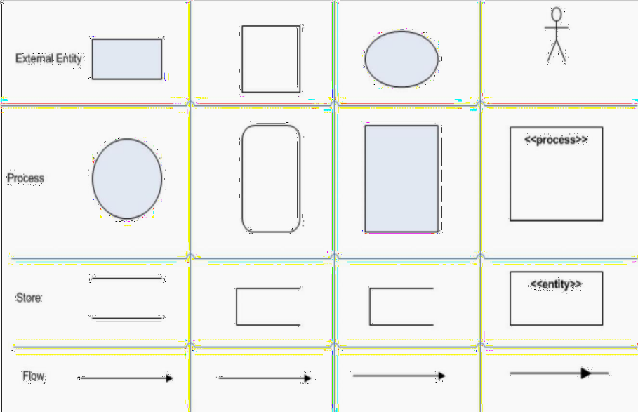
    - External Entity
An external entity, which are also known as terminators, sources, sinks, or actors, are an outside system or process that sends or receives data to and from the diagrammed system. They’re either the sources or destinations of information, so they’re usually placed on the diagram’s edges. External entity symbols are similar across models except for Unified, which uses a stick-
figure drawing instead of a rectangle, circle, or square.

Process
Process is a procedure that manipulates the data and its flow by taking incoming data, changing it, and producing an output with it. A process can do this by performing computations and using logic to sort the data, or change its flow of direction. Processes usually start from the top left of the DFD and finish on the bottom right of the diagram.

Data Store
Data stores hold information for later use, like a file of documents that’s waiting to be processed. Data inputs flow through a process and then through a data store while data outputs flow out of a data store and then through a process

Data Flow
Data flow is the path the system’s information takes from external entities through processes and data stores. With arrows and succinct labels, the DFD can show the direction of the data flow Before you start mapping out data flow diagrams you need to follow four best practices to create a valid DFD.

Levels of Data Flow Diagrams

DFDs can range from simple overviews to complex, granular representations of a system or process with multiple levels, starting with level 0. The most common and intuitive DFDs are level 0 DFDs, also called context diagrams. They’re digestible, high-level overviews of the flow of information through a system or process, so almost anyone can understand it.

Level 0: Context Diagram - This DFD level focuses on high-level system processes or functions and the data sources that flow to or from them. Level 0 diagrams are designed to be simple, straightforward overviews of a process or system.
Level 1: Process Decomposition - While level 1 DFDs are still broad overviews of a system or process, they’re also more detailed — they break down the system’s single process node into subprocesses.
Level 2: Deeper Dives - The next level of DFDs dive even deeper into detail by breaking down each level 1 process into granular subprocesses.
Level 3: Increasing Complexity - Level 3 and higher-numbered DFDs are uncommon. This is largely due to the amount of detail required, which defeats its original purpose of being easy to understand.

Rules
      - Each process should have at least one input and one output.
      - Each data store should have at least one data flow in and data flow out.
      - A system’s stored data must go through a processs
Level 0
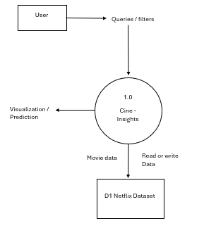

Level 1
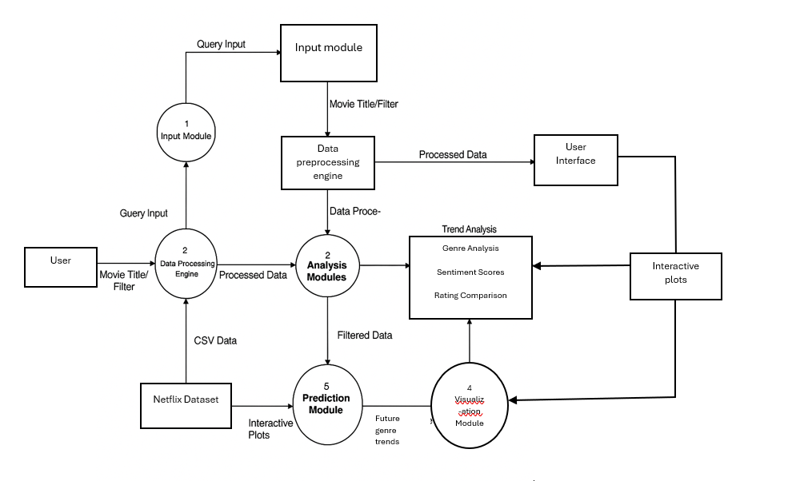

4.3 ENTITY-RELATIONSHIP DIAGRAM

The relation upon the system is structured through a conceptual ER-Diagram, which not only specifies the existential entities but also the standard relations through which the system exists and the cardinalities that are necessary for the system state to continue. The Entity Relationship Diagram (ERD) depicts the relationship between the data objects. The ERD is the notation that is used to conduct the data modeling activity The attributes of each data object noted in the ERD can be described resign a data object description.
The set of primary components that are identified by the ERD are
- Data object
- Relationships
- Attributes
- Various types of indicators

ER-DIAGRAM SYMBOL

- Entity

- Relationship

- Flow

ER DIAGRAM

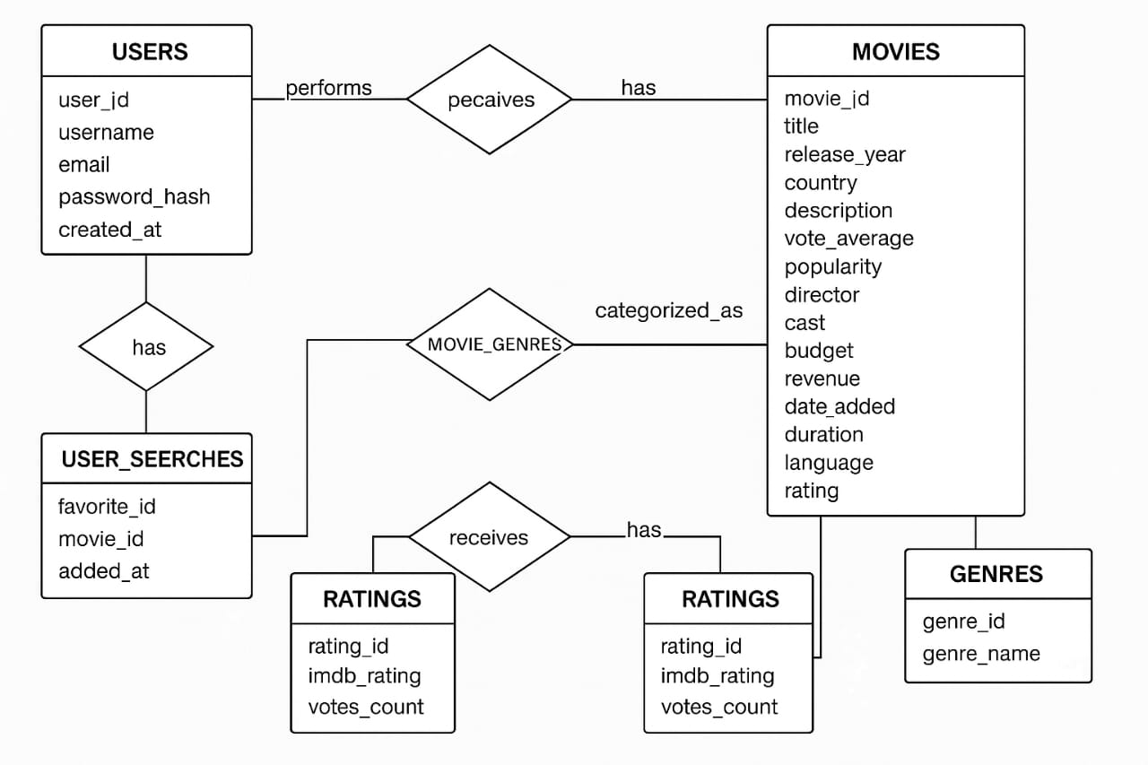
CHPATER 5
SYSTEM DEVELOPMENT

5.1 SYSTEM MODULE SPECIFICATION

- DATA LOADING AND PREPROCESSING
- DATA VISUALIZATION
- GENRE ANALYSIS
- SENTIMENT ANALYSIS
- INTERACTIVE MOVIE SEARCH
- USER INTERFACE

5.1.1MODULE DESCRIPTION
- Data Loading and Preprocessing:
- The module begins by loading a dataset from a CSV file containing information about Netflix movies.
- It preprocesses the data to filter for Indian movies and further narrows down to South Indian movies based on language.
- Data Visualization:
- The module generates various visualizations to help users understand trends in movie releases:
- Bar charts showing the number of Indian and global movies released by year.
- Count plots of top genres over time for both Indian and global movies.
- Line plots comparing average IMDb ratings for Indian and global movies.
- Genre Analysis:
- The module analyzes the distribution of genres in the dataset, allowing users to see which genres are most popular over time.
- It predicts future trends in movie genres using linear regression, providing insights into potential upcoming popular genres.
- Sentiment Analysis:
- The module computes sentiment polarity for movie descriptions using the TextBlob library, allowing users to gauge audience sentiment towards different movies.
- It visualizes average sentiment polarity by genre and displays the distribution of sentiments (positive, neutral, negative) across genres.
- Interactive Movie Search:
- Users can search for specific movies using an interactive input box.
- The module retrieves and displays detailed information about the selected movie, including title, release year, IMDb rating, genres, cast, director, description, budget, revenue, popularity, vote count, sentiment, date added, duration, language, and rating.
- User Interface:
- The module employs ipywidgets to create an interactive user interface, allowing users to input movie titles and receive instant feedback.
- The interface is designed to be user-friendly, with clear labels and organized output.

5.2 USER MANUAL PROCEDURE

1. Launching the Application
- Download the project files from GitHub.
- Open the CineInsight folder and run app.py (Python script).
- Access the app in your browser at: http://localhost:5000.
2. Searching for Movies
- Type a movie title in the search bar and press Enter.
- Results will display movie cards with basic details.
3. Viewing Movie Details
- Click any movie card to see:
  - Title, Year, Rating, Cast
  - Budget, Revenue, IMDb Score
  - Sentiment Analysis (Positive/Negative/Neutral)
4. Saving Favorites
- Click "Add to Favorites" on a movie’s details page.
- View saved movies under "My Favorites" in the menu.
5. Analyzing Trends
- Explore graphs under "Trends":
  - Movie Releases by Year (Bar Chart)
  - Genre Popularity (Interactive Heatmap)
  - Sentiment Analysis (Pie Chart for Mood)
6. Exporting Data
- Click "Export CSV" to save movie lists or graphs as files.
7. Troubleshooting
- Movie not found? Check spelling or try broader keywords.
- App crashing? Ensure Python, Pandas, and Flask are installed.

CHAPTER 6
SYSTEM TESTING

6.1 TESTING METHODOLOGIES

UNIT TESTING

Unit testing is a fundamental testing methodology that focuses on verifying the functionality of individual components or functions within the application. Each unit, which can be a function, method, or class, is tested in isolation to ensure it behaves as expected under various conditions. This type of testing is crucial for identifying bugs at an early stage of development, allowing developers to address issues before they propagate to higher levels of testing. By writing comprehensive unit tests, developers can ensure that each piece of code performs its intended task correctly, which contributes to the overall reliability of the application. Tools such as unittest or pytest in Python facilitate the creation and execution of unit tests, enabling automated testing and continuous integration practices.

REQUIREMENT TESTING

Requirement testing is a critical process that ensures the application meets all specified requirements outlined in the project documentation. This methodology involves creating test cases based on the requirements and validating each feature against these specifications. The primary goal is to confirm that the software fulfills both business and technical requirements, providing stakeholders with confidence that the application will perform as intended. Requirement testing helps identify any discrepancies between the expected and actual behavior of the application, allowing for timely corrections. By systematically verifying requirements, the development team can ensure that the final product aligns with user needs and expectations, ultimately leading to higher user satisfaction.

INTEGRATION TESTING

Integration testing is a methodology that focuses on verifying the interactions between different modules or components of the application. As individual units are combined to form a complete system, integration testing ensures that these components work together seamlessly. This type of testing is essential for identifying issues that may arise from the interaction of different parts of the application, such as data flow problems or interface mismatches. Integration testing can be performed incrementally, where components are tested as they are integrated, or as a complete system. By thoroughly testing the integration points, the development team can ensure that the application functions correctly as a whole, reducing the risk of defects in the final product.

USER TESTING
User testing, also known as usability testing, involves real users testing the application to provide feedback on its usability and functionality. This methodology is crucial for understanding how users interact with the application and identifying any pain points or areas for improvement. During user testing sessions, participants are asked to perform specific tasks while observers take notes on their interactions, challenges, and overall experience. The insights gained from user testing can inform design decisions and help refine the user interface, ensuring that the application is intuitive and user-friendly. By incorporating user feedback into the development process, the team can create a product that meets the needs and expectations of its target audience.

VALIDATION TESTING

Validation testing is a methodology that checks whether the software meets the intended use and requirements as specified by stakeholders. This type of testing is essential for ensuring that the final product aligns with user needs and expectations. Validation testing typically involves executing tests that simulate real-world usage scenarios, allowing the development team to assess the application's performance in practical situations. By validating the software against user requirements, the team can identify any gaps or deficiencies that need to be addressed before deployment. This process not only enhances the quality of the application but also builds trust with users, as they can be confident that the software will perform as expected in their environments.

USER ACCEPTANCE TESTING (UAT)

User Acceptance Testing (UAT) is the final phase of testing where actual users validate the software in a production-like environment. This methodology is crucial for confirming that the application is ready for deployment and meets user expectations. During UAT, users perform predefined tasks and provide feedback on the application's performance, usability, and overall satisfaction. The goal is to ensure that the software fulfills its intended purpose and is free of critical defects. UAT serves as a final checkpoint before the application goes live, allowing stakeholders to make informed decisions about its release. By involving users in this process, the development team can gain valuable insights and make necessary adjustments to enhance the user experience.

6.2 TESTING STRATEGIES

BLACK BOX TESTING

Black box testing is a testing strategy that focuses on evaluating the application's functionality without any knowledge of its internal code structure. Testers assess the software based on its inputs and expected outputs, ensuring that it behaves as intended from the user's perspective. This approach is particularly useful for validating the application's features and user interactions, as it allows testers to identify issues related to usability and functionality without being influenced by the underlying code. Black box testing is often employed during functional testing, where test cases are derived from requirements and specifications. By concentrating on the application's behavior, this strategy helps ensure that the software meets user needs and expectations.

WHITE BOX TESTING

White box testing is a testing strategy that involves examining the internal structures or workings of an application. Unlike black box testing, which focuses on external behavior, white box testing requires knowledge of the code and its logic. This approach allows testers to create test cases that cover specific code paths, conditions, and loops, ensuring that all aspects of the code are thoroughly evaluated. White box testing is particularly useful for identifying logical errors, security vulnerabilities, and performance issues within the code. By employing this strategy, the development team can ensure that the internal logic of the application functions correctly, leading to a more robust and reliable software product.

GREY BOX TESTING

Grey box testing is a hybrid testing strategy that combines elements of both black box and white box testing. Testers have partial knowledge of the internal workings of the application while focusing on user interactions and functionality. This approach allows for a more comprehensive evaluation of the software, as it leverages both functional and structural knowledge to create effective test cases. Grey box testing is particularly useful for identifying integration issues and validating the application's behavior in real-world scenarios. By employing this strategy, the development team can ensure that the software not only meets user expectations but also functions correctly at a structural level.
OTHER TESTING STRATEGIES:
1. Smoke Testing
- What: A quick test to check if the basic functions of an application work after a new build.
- Purpose: To ensure critical features are operational before detailed testing begins.
2. Sanity Testing
- What: A focused test to verify specific functionalities after changes or bug fixes.
- Purpose: To confirm that recent changes haven’t broken existing features.
3. Regression Testing
- What: Re-running previous tests to ensure new changes haven’t introduced new bugs.
- Purpose: To maintain the stability of the application after updates.
4. Performance Testing
- What: Testing how well the application performs under various conditions.
- Purpose: To ensure the application is responsive and can handle expected user loads.
5. Security Testing
- What: Identifying vulnerabilities and risks in the application.
- Purpose: To ensure data and resources are protected from unauthorized access.
6. Compatibility Testing
- What: Testing the application across different devices, browsers, and operating systems.
- Purpose: To ensure a consistent user experience regardless of the environment.
7. Usability Testing
- What: Assessing the user interface and overall user experience.
- Purpose: To identify any usability issues that may affect user satisfaction.
8. Exploratory Testing
- What: Informal testing where testers explore the application without predefined test cases.
- Purpose: To discover defects that may not be covered by formal tests.
9. A/B Testing
- What: Comparing two versions of an application to see which performs better.
- Purpose: To optimize user experience based on user behavior.
10. Localization Testing
- What: Verifying that the application is suitable for specific regions or languages.
- Purpose: To ensure cultural and linguistic appropriateness.
CHAPTER 7
SYSTEM MAINTENANCE

7.1 SYSTEM MAINTENANCE

Preventive maintenance involves proactive measures taken to prevent potential issues before they occur. This may include regular code reviews, performance monitoring, and security assessments to identify vulnerabilities. By implementing preventive maintenance practices, the development team can reduce the likelihood of defects and ensure the long-term stability and security of the application.
System maintenance is a vital component of the CineInsight project that ensures the application remains functional, secure, and user-friendly over time. By implementing a structured maintenance process, focusing on different types of maintenance, and adhering to best practices, the development team can effectively manage the application and respond to user needs, ultimately leading to a successful and sustainable software product.
The importance of system maintenance cannot be overstated, as it directly impacts the overall quality and longevity of the application. Regular maintenance helps to identify and resolve defects that may arise after deployment, ensuring that users have a seamless experience. Additionally, as technology evolves, the application must adapt to new operating systems, hardware, and third-party services. This adaptability is vital for maintaining compatibility and performance.
Moreover, user feedback plays a significant role in guiding maintenance efforts. By actively listening to users and addressing their concerns, the development team can enhance the application's features and usability, leading to increased user engagement and satisfaction. Preventive maintenance practices, such as performance monitoring and security assessments, help mitigate risks and prevent potential issues before they escalate, ensuring the application remains secure and efficient.

TYPES OF MAINTENANCE

ISSUE TRACKING AND MANAGEMENT
A robust issue tracking system should be implemented to log and manage defects, feature requests, and enhancement suggestions. Tools such as JIRA, Trello, or GitHub Issues can be used to track the status of issues, assign responsibilities, and prioritize tasks. Regular review meetings should be held to assess the progress of issue resolution and ensure that critical issues are addressed promptly.

REGULAR UPDATES AND PATCHES\
The CineInsight application should be regularly updated to incorporate bug fixes, security patches, and new features. A schedule for routine maintenance should be established, allowing for planned downtime if necessary. Communication with users regarding updates and potential impacts on service availability is essential to maintain transparency and user trust.

PERFORMANCE MONITORING
Continuous performance monitoring is crucial for identifying potential bottlenecks and ensuring that the application operates efficiently. Tools such as New Relic, Google Analytics, or custom monitoring solutions can be employed to track key performance indicators (KPIs) such as response times, server load, and user engagement metrics. Regular analysis of this data can help inform maintenance decisions and guide optimization efforts.

SECURITY MANAGEMENT
Security is a top priority for the CineInsight application, and regular security assessments should be conducted to identify vulnerabilities. This includes performing penetration testing, vulnerability scanning, and code reviews to ensure that the application is secure from potential threats. Keeping third-party libraries and dependencies up to date is also essential for maintaining security.

BEST PRACTICES FOR SYSTEM MAINTENANCE

DOCUMENTATION
Comprehensive documentation should be maintained for all aspects of the application, including architecture, code, and maintenance procedures. This documentation serves as a valuable resource for the development team and helps ensure continuity in maintenance efforts, especially when team members change.

USER FEEDBACK
Regularly soliciting feedback from users is essential for identifying areas for improvement and understanding user needs. Surveys, user interviews, and analytics can provide valuable insights that inform maintenance decisions and guide the development of new features.

TRAINING AND KNOWLEDGE SHARING
Ensuring that the development team is well-trained and knowledgeable about the application is crucial for effective maintenance. Regular training sessions, knowledge-sharing meetings, and code reviews can help keep the team informed about best practices and emerging technologies.

VERSION CONTROL
Using a version control system, such as Git, is essential for managing code changes and facilitating collaboration among team members. Version control allows for easy tracking of changes, rollback of problematic updates, and better coordination of maintenance efforts.

CHAPTER 8
CONCLUSION

8.1 CONCLUSION
The CineInsight project represents a comprehensive effort to develop an advanced movie analytics platform that bridges the gap between data-driven insights and user-friendly interactions. Throughout its development lifecycle, the project has prioritized functionality, usability, and scalability, leveraging modern technologies and methodologies to deliver a robust solution. By integrating features like sentiment analysis, trend visualization, and predictive modeling, CineInsight empowers users—from casual movie enthusiasts to industry professionals—to explore cinematic trends and audience sentiments effectively.
The project’s success hinges on its structured testing and maintenance strategies, which ensure reliability and adaptability. Methodologies such as unit testing, integration testing, and user acceptance testing were instrumental in identifying and resolving defects early, while maintenance practices like corrective and adaptive updates guarantee long-term performance. Emphasis on user feedback further refined the application, ensuring it meets real-world needs and remains relevant amid evolving technological landscapes.
Beyond technical achievements, CineInsight underscores the importance of continuous improvement. Regular updates, performance monitoring, and security assessments highlight the team’s commitment to quality. The application’s ability to evolve—whether through feature enhancements or compatibility updates—demonstrates its sustainability and readiness to meet future challenges.
In conclusion, CineInsight exemplifies how data analytics can transform user experiences in the entertainment industry. By combining rigorous development practices with user-centric design, the project delivers a powerful tool for exploring movie trends while setting a benchmark for maintainability and innovation. As the platform grows, its focus on adaptability and user engagement will continue to drive its success, making it an invaluable resource for movie lovers and analysts alike. The lessons learned from this project underscore the value of meticulous planning, iterative testing, and proactive maintenance in building software that endures.
Furthermore, the CineInsight project serves as a testament to the collaborative efforts of a dedicated development team, whose diverse skills and expertise have been pivotal in bringing this vision to life. The integration of cross-functional roles—from data scientists and software engineers to UX designers—has fostered a holistic approach to problem-solving and innovation. This collaborative spirit not only enhanced the quality of the final product but also cultivated a culture of continuous learning and knowledge sharing within the team. As CineInsight moves forward, this foundation of teamwork and shared commitment to excellence will be essential in navigating future enhancements and ensuring the platform remains at the forefront of movie analytics
8.2 FUTURE ENHANCEMENT

As the CineInsight project progresses, several future enhancements can be implemented to elevate its functionality and user experience. One of the primary areas for improvement is the development of enhanced machine learning models. By incorporating more sophisticated algorithms, such as deep learning techniques, CineInsight can achieve greater accuracy in predicting audience preferences and trends. Additionally, integrating natural language processing (NLP) capabilities will allow for a more nuanced analysis of user reviews and social media sentiment, providing deeper insights into viewer opinions and behaviors.
Another significant enhancement involves the implementation of real-time data integration. By connecting to various data sources, including social media platforms, box office reports, and streaming services, CineInsight can deliver up-to-date analytics that reflect the latest trends and audience reactions. This capability will empower users to make informed decisions based on current data, enhancing the platform's relevance and utility in a fast-paced entertainment landscape.
User personalization features represent another promising avenue for future development. By leveraging collaborative filtering and content-based filtering techniques, CineInsight can offer tailored recommendations based on individual user preferences and viewing history. This personalized approach will not only improve user engagement but also create a more enjoyable and relevant experience for each user, fostering loyalty and retention.
Expanding the CineInsight platform into a mobile application is also a key enhancement that can significantly increase accessibility. A mobile app would allow users to access analytics and insights on-the-go, making it easier to stay informed about movie trends and audience sentiments. Furthermore, incorporating push notifications for real-time updates and personalized recommendations will keep users engaged and connected to the platform.
Lastly, integrating community and social features can foster a sense of belonging among users. By creating forums, discussion boards, and social sharing options, CineInsight can encourage users to share insights, discuss trends, and engage with one another. This enhancement will enrich the overall user experience and promote a vibrant community around the platform, ultimately contributing to its long-term success.
In conclusion, by focusing on these future enhancements, the CineInsight project can continue to evolve and adapt to the changing needs of its users. These improvements will not only enhance the platform's functionality and user experience but also solidify its position as a leading tool for movie analytics and audience insights. The commitment to innovation and user satisfaction will ensure that CineInsight remains a valuable resource for movie enthusiasts and industry professionals alike.

CHAPTER 9
BIBLIOGRAPHY
9.1 REFERENCES
- Baker, S. (2021). Data-Driven Decision Making in the Film Industry: A Comprehensive Guide. New York: Film Analytics Press.
This book provides insights into how data analytics is transforming the film industry, offering case studies and methodologies that can be applied to projects like CineInsight.
- Chaudhary, A., & Gupta, R. (2020). “Sentiment Analysis in Movie Reviews: A Survey.” International Journal of Computer Applications, 975, 8887.
This paper discusses various techniques for sentiment analysis, which is a core feature of the CineInsight project, providing a foundation for understanding audience sentiments.
- Kumar, V., & Singh, A. (2019). “Predictive Analytics in the Entertainment Industry.” Journal of Business Research, 102, 123-134.
This article explores the application of predictive analytics in entertainment, highlighting methodologies that can enhance the predictive capabilities of CineInsight.
- Meyer, J. (2022). The Future of Film Analytics: Trends and Innovations. Los Angeles: Cinema Insights Publishing.
This publication examines emerging trends in film analytics, offering insights that can inform future enhancements for the CineInsight platform.
- Nguyen, T., & Pham, H. (2021). “Real-Time Data Integration for Enhanced Decision Making.” Journal of Data Science and Analytics, 15(3), 45-60.
This research paper discusses the importance of real-time data integration and its impact on decision-making processes, relevant to the future enhancements of CineInsight.
- Smith, L. (2020). “User Personalization in Digital Platforms: Strategies and Best Practices.” Journal of Interactive Marketing, 54, 12-25.
This article outlines strategies for implementing user personalization features, which are crucial for enhancing user engagement in the CineInsight project.
- Wang, Y., & Zhang, X. (2021). “Community Building in Online Platforms: A Case Study.” International Journal of Information Management, 57, 102-110.
This study explores the role of community features in online platforms, providing insights that can guide the integration of social features in CineInsight.
- Zhou, R., & Li, J. (2022). “Mobile Application Development for Data Analytics: Challenges and Solutions.” Journal of Mobile Technology in Medicine, 11(2), 34-42.
This paper discusses the challenges and best practices in developing mobile applications for data analytics, relevant to the potential mobile expansion of CineInsight.
- Zhang, H., & Chen, L. (2020). “The Role of Visualization in Data Analytics.” Data Visualization Journal, 8(1), 15-29.
This article emphasizes the importance of advanced visualization tools in data analytics, which can enhance the user experience in the CineInsight platform.

CHAPTER 10
APPENDICES

10.1 SAMPLE SCREENSHOTS

DATASET EXTRACTED
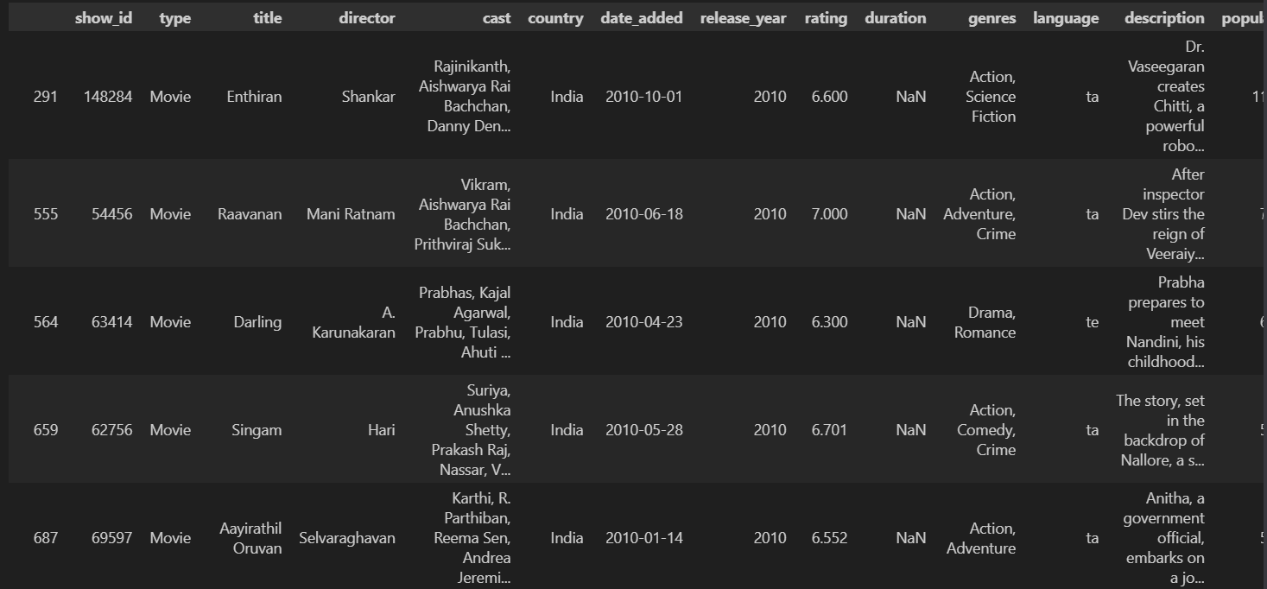
STATISTICS OF INDIAN MOVIES
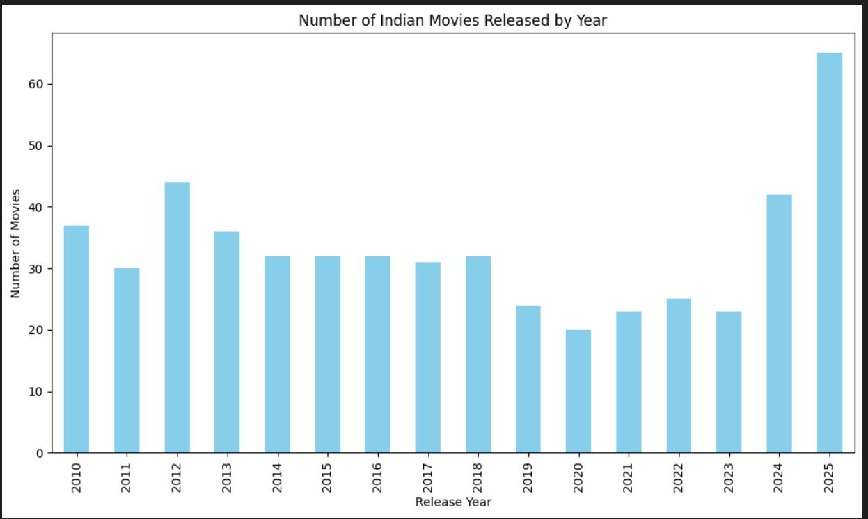

GLOBAL MOVIE GENRE OVER TIME
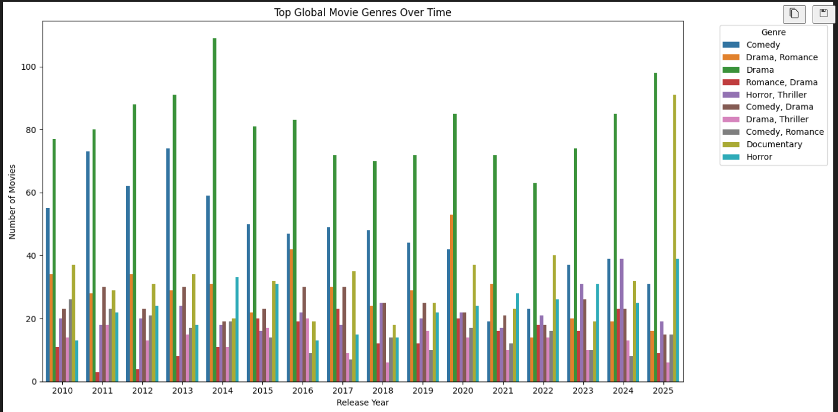
IMDB RATINGS
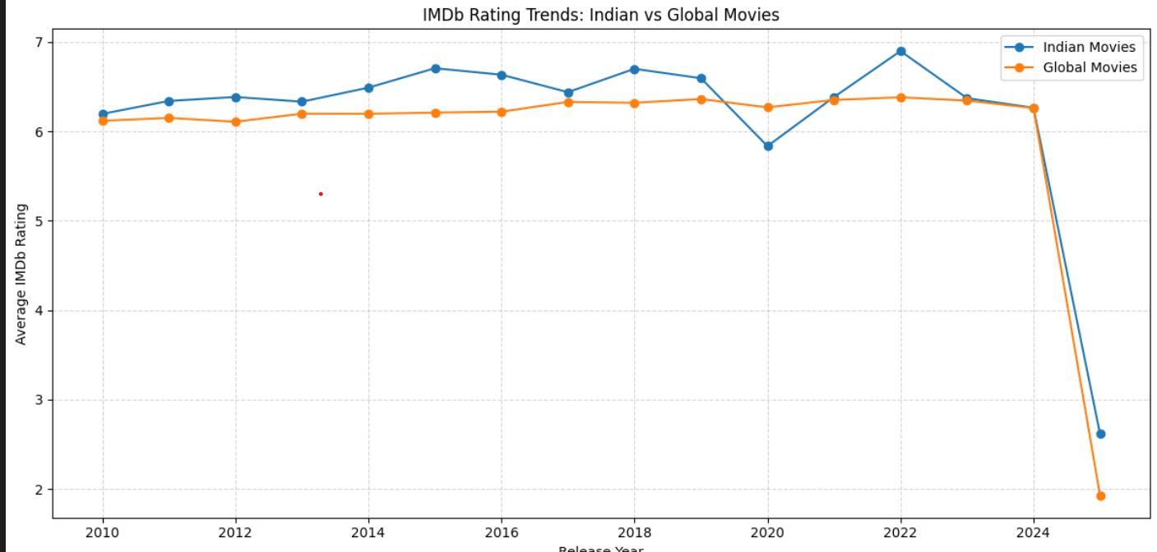
SENTIMENT ANALYSIS
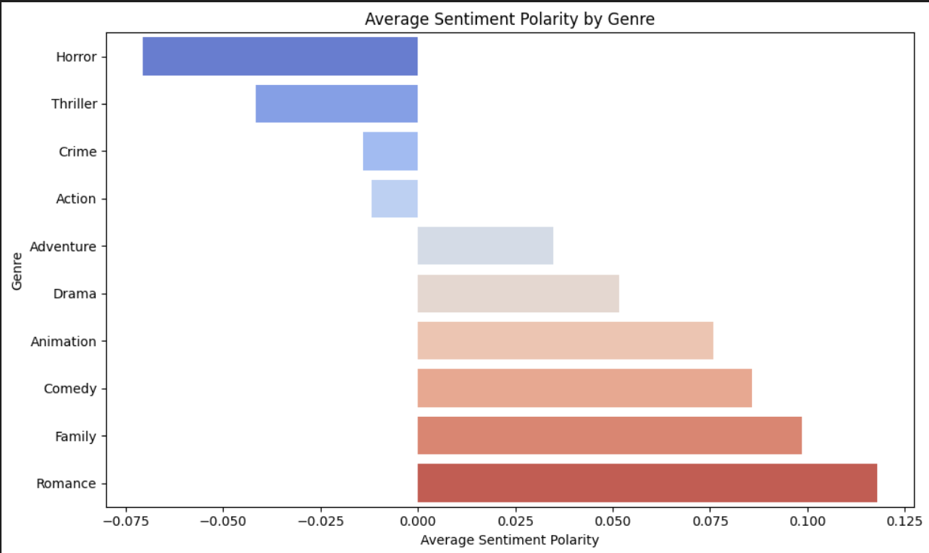

10.2 SAMPLE CODE
# Import necessary libraries
import nltk
from nltk.sentiment import SentimentIntensityAnalyzer
import pandas as pd

# Download the VADER lexicon for sentiment analysis
nltk.download('vader_lexicon')

# Initialize the Sentiment Intensity Analyzer
sia = SentimentIntensityAnalyzer()

# Sample movie reviews data
data = {
'review': [
"I absolutely loved this movie! The storyline was fantastic and the acting was superb.",
"This film was a complete waste of time. I didn't enjoy it at all.",
"An average movie with some good moments, but overall it was disappointing.",
"What a masterpiece! The cinematography was breathtaking and the plot was gripping.",
"I wouldn't recommend this film. It was boring and too long."
]
}

# Create a DataFrame from the sample data
reviews_df = pd.DataFrame(data)

# Function to analyze sentiment of reviews
def analyze_sentiment(reviews):
sentiments = []
for review in reviews:
score = sia.polarity_scores(review)
sentiments.append(score)
return sentiments

# Analyze sentiment for the movie reviews
reviews_df['sentiment'] = analyze_sentiment(reviews_df['review'])

# Display the results
print(reviews_df)

